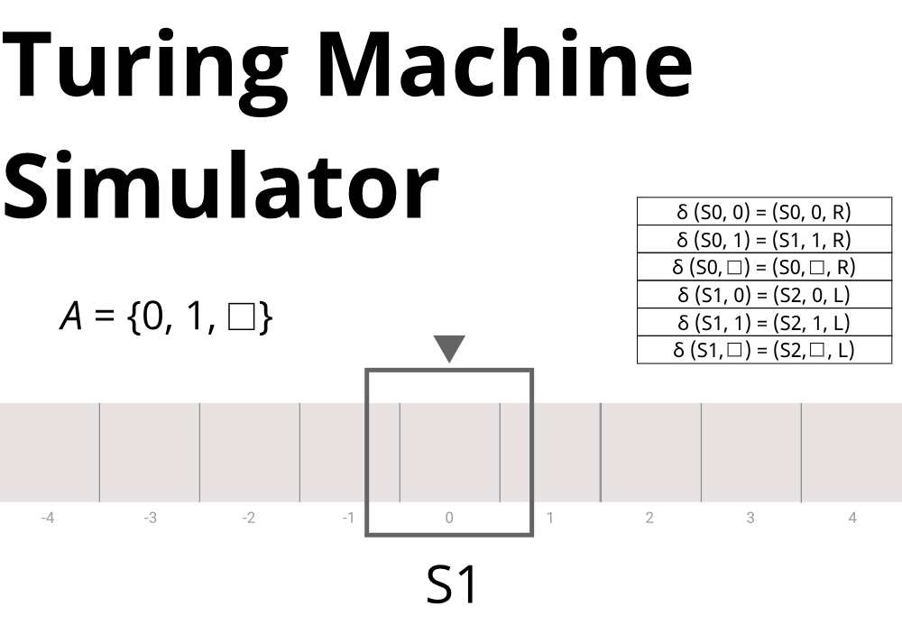

Contents

Requirement Analysis 8

Review Of Technology 9

Requirement Research 11

Sponsor Interview 11

Current Solution Research 13

End User Interviews 17

Alternate Solution Research 20

Summary Of User Needs 22

Technical Requirements, Limitations & Objectives 24

Requirements 24

Limitations 25

Objectives & SMART Targets 26

Technical Analysis 28

Programming Language 28

User Interface 30

WPF 30

Godot 31

MonoGame 32

Chosen Technologies 34

Architecture Overview 35

General Architecture 35

File Architecture 36

Front End Architecture 37

Gap Analysis 38

Prototypes 39

Core Model Prototype 40

Backend Prototype 48

Front End Prototype 73

Functional Design 102

Core Model Design 102

Backend Design 110

Networking Design 112

File Persistence & Management 117

Networking and File Security 122

Front End Design 124

Networking 128

File Management 130

UI Designs 131

UI System 147

Technical Design 151

Overview 151

Class Design 155

Core Library 156

Turing Server Library 200

Desktop Front End Implementation 250

File Storage Format 459

Additional Libraries 460

Technical Solution 461

Core Library 462

TuringCore.Files.ProjectSaveFile 462

TuringCore.Files.Alphabet 463

TuringCore.Files.TapeTemplate 464

TuringCore.Files.Tape 466

TuringCore.Files.CompilableFile 468

TuringCore.Files.TransitionFile 469

TuringCore.Files.Transition 471

TuringCore.Files.VisualProgrammingFile 472

TurignCore.Files.Node 473

TuringCore.Files.ActionNode 474

TuringCore.Files.StateNode 475

TuringCore.Systems.TuringMachine 476

TuringCore.Systems.StateTable 479

TuringCore.Systems.InstructionCollection 480

TuringCore.Systems.InstructionVariant 481

TuringCore.Systems.TuringAction 482

TuringCore.Systems. ChangeStateAction 483

TuringCore.Systems. MoveHeadAction 484

TuringCore.Systems. WriteAction 485

TuringCore.Networking.RequestHeader 486

TuringCore.Networking.ErrorNotificationMessage 487

TuringCore.Networking.FileDataMessage 488

TuringCore.Networking.FolderDataMessage 489

TuringCore.Networking.LogDataMessage 490

TuringCore.Networking.ProjectDataMessage 491

TuringCore.Networking.Packet 492

TuringCore.Networking.ClientSendPacketFunctions 496

Server Library 500

TuringServer.BackendInterface 500

TuringServer.FileManager 501

TuringServer.CreateProjectReturnData 507

TuringServer.ServerSide.Server 508

TuringServer.ServerSide.ServerClientSlot 512

TuringServer.ServerSide.TCPInterface 513

TuringServer.ServerSide.ServerRecieveFunctions 516

TurignServer.ServerSide.ServerSendPacketFunctions 539

TuringServer.ServerSide.NetworkingUtils 542

TuringServer.Logging.CustomLogging 543

TuringServer.Data.ProjectData 545

TuringServer.Data.CacheFileData 546

TuringServer.Data.DirectoryFile 547

TuringServer.Data.DirectoryFolder 549

TuringServer.Data.ObjectMetadataFile 550

Desktop Front End Implementation 551

TuringSimulatorDesktop.MainWindow 551

TuringSimulatorDesktop.GlobalProjectAndUserData 556

TuringSimulatorDesktop.ConnectedProjectData 558

TuringSimulatorDesktop.FileData 559

TuringSimulatorDesktop.Files.LocalUserData 560

TuringSimulatorDesktop.Files.FileInfoWrapper 561

TuringSimulatorDesktop.Debugging.CustomLogging 562

TuringSimulatorDesktop.Networking.Client 563

TuringSimulatorDesktop.Networking.ClientReceiveFunctions 568

TuringSimulatorDesktop.Input.ActionGroup 570

TuringSimulatorDesktop.Input.IClickable 571

TuringSimulatorDesktop.Input.IDragListener 572

TuringSimulatorDesktop.Input.InputManager 573

TuringSimulatorDesktop.Input.IPollable 578

TuringSimulatorDesktop.Input.KeyboardModifiers 579

TuringSimulatorDesktop.UI.UIEventManager 580

TuringSimulatorDesktop.UI.GlobalInterfaceData 582

TuringSimulatorDesktop.UI.GlobalUIRenderer 588

TuringSimulatorDesktop.UI.Mesh 590

TuringSimulatorDesktop.UI.UIUtils 592

TuringSimulatorDesktop.UI.ICanvasInteractible 594

TuringSimulatorDesktop.UI.IClosable 595

TuringSimulatorDesktop.UI.IRunnable 596

TuringSimulatorDesktop.UI.ISaveable 597

TuringSimulatorDesktop.UI.IUndoRedoable 598

TuringSimulatorDesktop.UI.IView 599

TuringSimulatorDesktop.UI.IVisualElement 600

TuringSimulatorDesktop.UI.Button 601

TuringSimulatorDesktop.UI.ColorButton 602

TuringSimulatorDesktop.UI.DraggableCanvas 605

TuringSimulatorDesktop.UI.ElementCollection 609

TuringSimulatorDesktop.UI.HorizontalLayoutBox 611

TuringSimulatorDesktop.UI.Icon 616

TuringSimulatorDesktop.UI.InputBox 618

TuringSimulatorDesktop.UI.Label 622

TuringSimulatorDesktop.UI.TextureButton 626

TuringSimulatorDesktop.UI.VerticalLayoutBox 629

TuringSimulatorDesktop.UI.MainScreenView 634

TuringSimulatorDesktop.UI.ProjectScreenView 640

TuringSimulatorDesktop.UI.Prefabs.CreateProjectMenu 647

TuringSimulatorDesktop.UI.Prefabs.JoinProjectMenu 654

TuringSimulatorDesktop.UI.Prefabs.LoadProjectMenu 657

TuringSimulatorDesktop.UI.Prefabs.RecentFilesMenu 662

TuringSimulatorDesktop.UI.Prefabs.RecentFileItem 664

TuringSimulatorDesktop.UI.Prefabs.AlphabetEditorView 666

TuringSimulatorDesktop.UI.Prefabs.FileBrowserView 672

TuringSimulatorDesktop.UI.Prefabs.FileCreationMenu 680

TuringSimulatorDesktop.UI.Prefabs.FileDisplayItem 684

TuringSimulatorDesktop.UI.Prefabs.FileEditMenu 689

TuringSimulatorDesktop.UI.Prefabs.FolderHierarchyItem 695

TuringSimulatorDesktop.UI.Prefabs.HelpMenu 698

TuringSimulatorDesktop.UI.Prefabs.DefinitionAlphabetInputItem 701

TuringSimulatorDesktop.UI.Prefabs.NodeCreationMenu 703

TuringSimulatorDesktop.UI.Prefabs.NodeEditMenu 706

TuringSimulatorDesktop.UI.Prefabs.StateTransitionItem 710

TuringSimulatorDesktop.UI.Prefabs.TextProgrammingView 714

TuringSimulatorDesktop.UI.Prefabs.TapeEditorView 724

TuringSimulatorDesktop.UI.Prefabs.TapeCell 728

TuringSimulatorDesktop.UI.Prefabs.TapeVisualItem 731

TuringSimulatorDesktop.UI.Prefabs.TuringMachineView 735

TuringSimulatorDesktop.UI.Prefabs.VisualProgrammingView 749

TuringSimulatorDesktop.UI.Prefabs.Window 751

TuringSimulatorDesktop.UI.Prefabs.WindowHeaderItem 755

TuringSimulatorDesktop.UI.Prefabs.RunProjectItem 758

Functional Demonstration 760

Creating a Project 760

Loading a Project 762

Connecting to a Project 765

Managing Files 767

Creating an Alphabet, Program and Tape 773

Running a Program 778

Viewing Help Menu 784

Videos 787

Testing 790

Objective Testing 793

Test 1 793

Test 2 795

Test 3 798

Test 4 799

Test 5 801

Test 6 802

Test 7 804

Test 8 805

Test 9 807

Test 10 808

Test 11 809

Test 12 815

Test 13 816

Test 14 817

User Interaction Testing 818

Test 15 818

Test 16 819

Test 17 820

Test 18 821

Test 19 822

Test 20 823

Test 21 824

Test 22 827

Test 23 828

Test 24 829

Test 25 830

Test 26 832

Test 27 834

Test 28 837

Test 29 840

Test 30 844

Test 31 846

Test 32 848

Evaluation 851

Sponsor Interview 851

End-User Interviews 853

Interview With Alex 853

Interview With Luke 854

Interview Summary 854

Objective Review 855

Improvements 858

Summary 860

# Requirement Analysis

My project is to create a Turing Machine Simulator capable of modelling a Turing machine being executed in an educational and interactive manner.

This will include providing an interface that teaches and gives users the ability to program a Turing machine either visually or textually and then execute it using customizable inputs. This will be able to be used in a learning environment where a teacher can either demonstrate or students could individually research the functioning of Turing Machines themselves.

This project demands that it be designed to allow both KS5 students with no prior knowledge of Turing Machines to effectively learn and operate them, and for KS4 students to be able to interact with them in a meaningful way, due to events like opening evenings where this tool can be used to show KS4 students the KS5 curriculum and what it entails.

Additionally, this project is created with networking and collaboration in mind, as to allow students to work on creating a Turing Machine collaboratively and allow the teacher to send out materials to student's projects remotely, making the process of education both more enjoyable for students and simpler for the teacher.

## Review Of Technology

This project will demonstrate the development and functionality of a Turing Machine.

**What is a Turing Machine?**

The Turing machine is a mathematical model, invented by Alan Turing in 1936, describing an abstract computational model of a machine, that can manipulate symbols on a piece of tape according to series of rules.

They are a vital part of the topic computability, the Turing Machine was the first practical computational model devised and was the source of a variety of theorems, such as the Church-Turing thesis, which dictates that every problem that could be solved by a person using a pen, paper and finite set of algorithms, can be computed by a Turing Machine, or further proved some problems as incomputable, as shown through the through the halting problem.

A Turing Machine is made of three core components; a tape, a read/write head and a statetable.

**Tape**

The tape is simply a representation of an infinitely long piece input, that is split into single cells, with each cell containing a symbol written on it, this could include letters, words, numbers, Unicode characters or blank cells where an empty space on them is itself a symbol.

**Read/Write Head**

The read/write head is the second component, it is the so-to-speak brain of the Turing machine. It will have a current state and a statetable. The read/write head will be looking at some cell on the tape, read it and then use the read symbol and current state to look up what actions to perform based on a statetable.

**Statetables**

Statetables are simply a set of instructions of what actions the read/write head should perform based on a given input (that is read from the tape) and current state of the read/write head.

In a classically defined Turing Machine, after looking up the input and current state, the read/write head will be ordered to change the current state, it can be to the same one as is currently or a new one, write a value onto the current cell on the tape, and ordered whether to move left or right one space along the tape.

**Types Of Turing Machine**

Building on the Turing Machine is the Universal Turing Machine, it is a Turing Machine setup with a statetable such that it can simulate any computable algorithm given to the Turing Machine during runtime, this was the first example of a dynamically programmable computer model.

Next are non-classical TM’s. Non-classical Turing Machines mean that the Turing Machines statetable won't necessarily order a state change, write action, and move action each instruction, instead each instruction can perform as many or as few actions as the user wants, for example only move the R/W head a number of spaces, without any state or tape value changes, with an example of such an implementation being in one of the existing Turing Machine simulation tools, TuringKara.

As this is an educational tool, with the goal of also teaching students to program Turing machines in a variety of ways, the idea of programming classical TM’s will be the focus, but as extension feature if development time suffices will be to allow for non-classical Turing machines to be defined for user (especially students) to train their programming skills while learning about Turing Machines simultaneously.

## Requirement Research

The purpose of this section is to determine the wants and needs of the program from the sponsor and end users as to be able to define a clear set of features and requirements for the final program.

### Sponsor Interview

The sponsor of this project is Mr Maher, my computer science teacher.

The questions will be as follows:

|  |  |
| --- | --- |
| **Question** | **Purpose** |
| “What tools or methods do you use to teach Turing machines currently in A level Computer Science?” | This is to determine what existing solutions I should research as know what features should be included in my project as standard. |
| “Do you think these tools are intuitive and give meaningful help and understanding to students using them?” | This is to determine how good existing methods are as to see what features should and shouldn’t be included compared to other solutions in my project. |
| “Do you think that the current solution is user friendly enough or could use additional features?” | This is to determine development of my user interface, whether certain design choices should be kept the same as in current solutions, are I f they should be completely redesigned form y project. |
| “How powerful are the computer systems used here, and do they all operate on Windows 10 OS?” | Identifying any restrictions in regard to computer systems is important in the technical development of my project. |
| “Would kind of interfaces would you like to see in a potential new solution?” | Helps identify what platforms a new solution would need to target and helps identify what kind of design architecture this then would require. |

**Interview With Mr Maher**

**What tools or methods do you use to teach Turing machines currently in A level Computer Science?**

*Currently we use PowerPoint presentations, and an application called TuringKara to teach Turing Machines.*

**Do you think these tools are intuitive and give meaningful help and understanding to students using them?**

*The presentations contain all necessary information to educate the students to the requirements of the spec but offer very little practise in creating and the viewing Turing Machines as they are running, on the other hand TuringKara fulfils these two other requirements, but it also comes with its own problems of not being intuitive, lacking any prompts or educational information's as part of the interface and doesn’t simulate proper Turing Machines, as the user can program multiple actions per state change on the Turing Machine.*

**Do you think that the current solution is user friendly enough or could use additional features?**

*As stated TuringKara could be more intuitive and offer the functionality to restrict its simulation to only true Turing Machines.*

**How powerful are the computer systems used here, and do they all operate on Windows 10 OS?**

*The computers around most of the school are comparatively low performance, while B11 and B15 have better performance computers. Yes, all the machines use Windows 10 as their operating system.*

**Would kind of interfaces would you like to see in a potential new solution?**

*A desktop executable would be the core interface the tool would require, but a web-based interface that students could then use anywhere would be a great addition that would be very useful in the current day.*

**Interview Summary**

This interview provided a good insight into the requirements of my sponsor for my project. Currently Turing Machines are taught using either a method that lacks interactivity or one that is very difficult to use. This means I have a source to draw from to look for what not to design my project like, also certain vital features of Turing Machines, such as their behaviour isn’t properly modelled in the current solution, making them possible an inaccurate and thus ineffective learning tool, these issues would have to be addressed in my solution.

Furthermore, TuringKara is only available for use on computers on the school network, meaning that the only currently interactive manner of learning TM’s is inaccessible at home, this resource should be accessible to students independently for revision so should be easily available at home.

### Current Solution Research

This simulator would be used to replace current/standard teaching methods for Turing Machines such as white board diagrams, PowerPoints, and existing interactive solutions such as TuringKara. This simulator can replace these as a more interactive and user-friendly alternative. This would be good for students that require a more hands on approach or are visual learners thanks to the interactivity and visualisation features that would be implemented as demanded by the interviewed parties.

**PowerPoint**

The first method of teaching TM’s are PowerPoints.

These provide useful information in an easy to present format where information is delivered in typically small, easy to read/digest points.

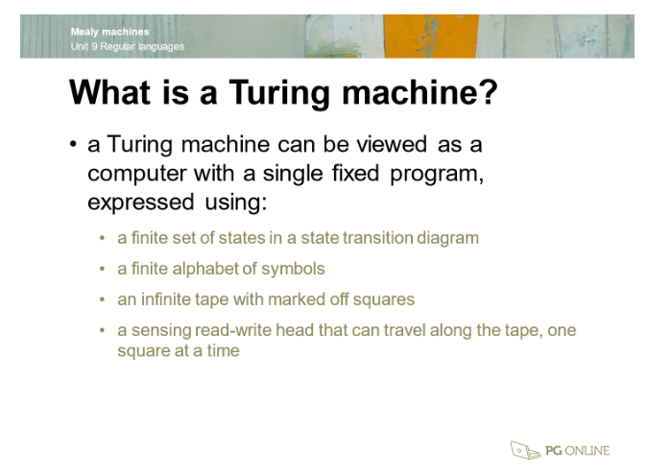

However, these points can quickly snowball into a swath of small points being thrown at you before having the slide be moved onto the next one, where you can't process each individual piece of information in time, which is exasperated by the ease to lose focus on the PowerPoint due to its format, complete lack of direct interaction.

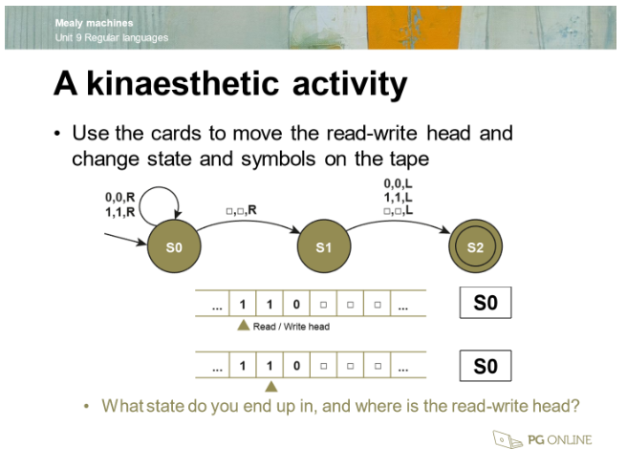

This means that users/students who aren’t following the PowerPoint with constant full attention and understanding can quickly fall behind what Is being shown on the PowerPoint, this problem especially becomes clear when a single PowerPoints is shown to a whole class, where certain students in the class will be less abled than other students in the class, leading to people learning unequal amounts from the PowerPoint.

A system that explains the TM curriculum while allowing direct interaction, such as a simulator with visual notes on it, would firstly allow students to learn in a more engaging, memorable manner, where this requirement of direct focus ensures the students absorb the information more thoroughly, giving an improved end understanding of the curriculum.

Secondly a system of this nature allows students to learn at their own paces, where advanced students can practice advanced creation of TM’s, or can look at specific notes contained in the system while less abled students can use all the notes presented in a step-by-step manner and use pre-set TM’s to gain a better understating in creating TM’s from scratch.

**TuringKara**

The second method of teaching TM’s is a visual development tool called TuringKara.

TuringKara allows the visual creation of TM's through nodes and buttons that are used to program said TM and allows for the user to then view the TM executed step-by-step.

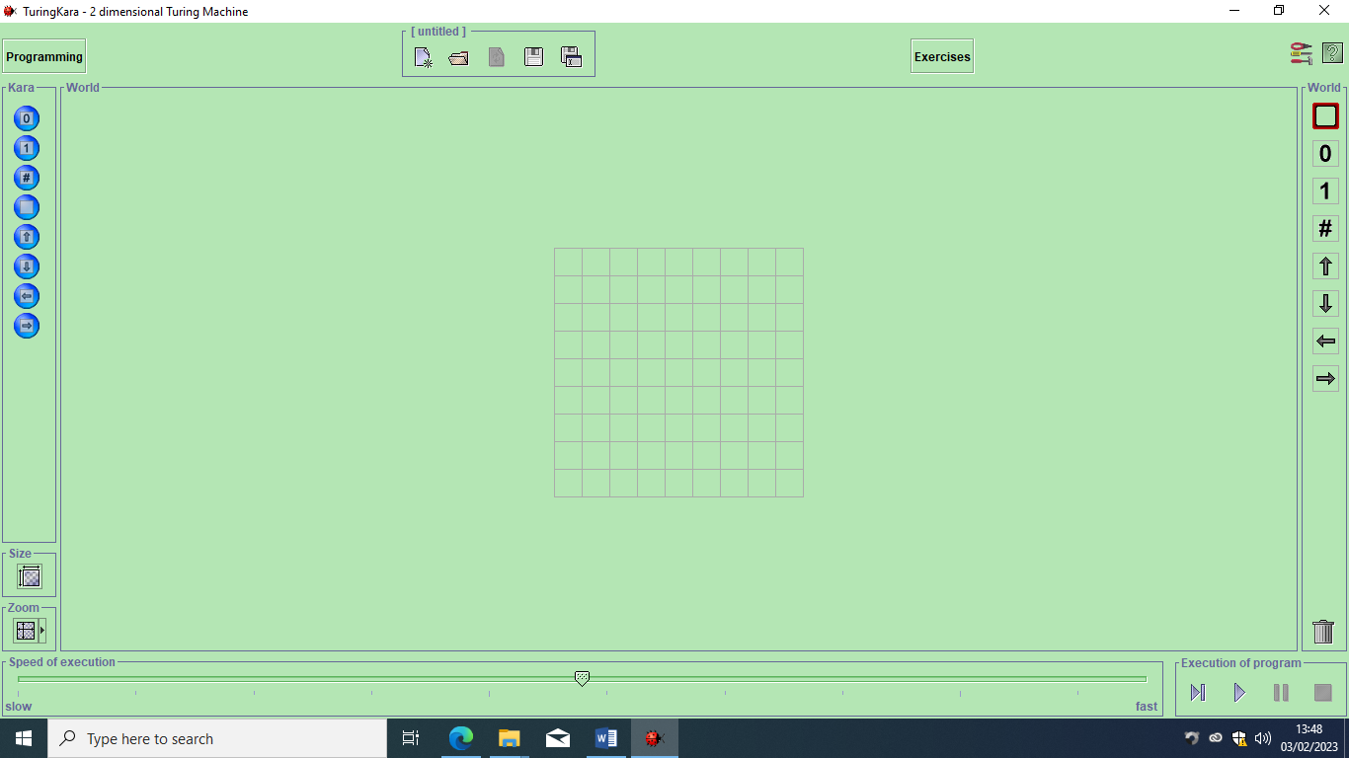

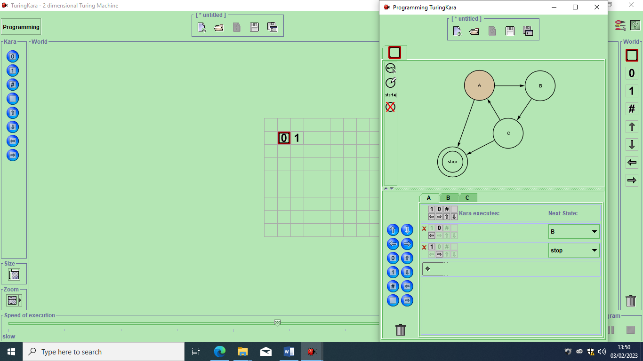

There however lie many problems with this interactive solution, first it has bugs, preventing the user from being able to save their TM or project, making bigger projects impossible in this tool. Next the UI is outdated and contains no helpful tooltips or other information regarding the usage of the interface and the theory of TM’s that is required for the usage of this solution. Finally, this solution isn’t factually correct regarding the design of TM’s, where this is meant to be the core feature of this entire solution, the simulator allows for the TM to perform many different actions per read operation unlike theoretically correct TM’s where each read operation means 1 write, 1 move and 1 state change operation.

As such there is space to create a new interactive solution as many features and changes are required to the current one.

### End User Interviews

These interviews are with other Computer Science students who have experience with the current methods of teaching TM’s and who may use this new tool in the future.

The questions will be as follows:

|  |  |
| --- | --- |
| **Question** | **Purpose** |
| “How strong are you with the theory of, and designing of Turing machines?” | Guage how well the current solutions are working. |
| “Do you feel any lacking's in knowledge are the result of inadequate support from current teaching methods and tools available to you?” | Gives explicit opinion from end users on current solutions. |
| “Are you engaged by PowerPoint presentations currently used” | Gauges whether this presentation method is helpful and could be incorporated into project. |
| “Do you consider TuringKara to be engaging and intuitive to use?” | Gauges what user interface designs to take inspiration from and which to fully redesign from current solution. |
| “Do you consider TuringKara to show the workings and theory of Turing Machine well?” | Gauges what features to take inspiration from and which to fully redesign from current solution. |
| “Do you consider a dedicated tool for interacting with and visualising Turing Machines would benefit you in your long-term retention of knowledge about Turing Machines?” | Gauges user interest in a new solution and gauges whether currently planned main features of new solution would be helpful. |
| “What operating system do you use at home?” | Gauges what OS’s I will require to support ion my project. |

#### Interview With Alex

**How strong are you with the theory of, and designing of Turing machines?**

*Relatively strong*

**Do you feel any lacking's in knowledge are the result of inadequate support from current teaching methods and tools available to you?**

*Not particularly.*

**Are you engaged by PowerPoint presentations currently used?**

*Not particularly, it would be an improvement if we had a more practical/hands on approach available.*

**Do you consider TuringKara to be engaging and intuitive to use?**

*It’s quite clunky and difficult to use but the interactivity is an improvement over the PowerPoint, although without the PowerPoints I would have no idea what to do within TuringKara due to its lack of any help related tooltips, having some of the theoretical knowledge of Turing Machines included somewhere or some example projects would be very beneficial.*

**Do you consider TuringKara to show the workings and theory of Turing Machine well?**

*Yes, but it could be easier to interact with and should offer some materials regarding state transitions.*

**Do you consider a dedicated tool for interacting with and visualising Turing Machines would benefit you in your long-term retention of knowledge about Turing Machines?**

*Yes, it would help in the long term.*

W**hat operating system do you use at home?**

*Windows 11.*

#### Interview With Luke

**How strong are you with the theory of, and designing of Turing machines?**

*I am very strong with the theory but have had limited chance to practically design Turing Machines.*

**Do you feel any lacking's in knowledge are the result of inadequate support from current teaching methods and tools available to you?**

*No, but some of the tools could be improved to make the process more effective.*

**Are you engaged by PowerPoint presentations currently used?**

*I am sufficiently engaged by the PowerPoints.*

**Do you consider TuringKara to be engaging and intuitive to use?**

*The UI is outdated and difficult to use, with certain functionality not even working which meant that I had an overall unpleasant time designing Turing Machines and trying to run them in TuringKara.*

**Do you consider TuringKara to show the workings and theory of Turing Machine well?**

*When it works, it will sufficiently show Turing Machines working but it has the issue of allowing you to create a Turing Machine that wouldn’t be allowed per its original definition.*

**Do you consider a dedicated tool for interacting with and visualising Turing Machines would benefit you in your long-term retention of knowledge about Turing Machines?**

*Yes.*

**What operating system do you use at home?**

*Windows 10.*

#### Additional Data

Some additional students were queried on what Operating System they use at home, without having a full interview conducted with them, this is as enough feedback was gathered from previous interviews for other questions. These totals include interviewed users.

Results:

Windows 10: 4

Windows 11: 1

Mac OS: 1

#### Interview Summary

These interviews reinforced the points highlighted in the interview with the Project Sponsor.

There is a multitude of problems with current tools of PowerPoint and TuringKara.

The first problem is with the lack of interactivity of PowerPoint, as all students can do is simply read and look at the PowerPoint, much information is hard to retain, especially in the long term. The interactivity of the alternative tool, TuringKara, has been praised but to limited extent, where its effectiveness is limited by its difficulty to use due to bad UI design, bugs, lack of usage tooltips, and lack of any theory displayed.

Furthermore, TuringKara has only had compatibility tested with Windows 10 machines, while as seen in the additional data collection, users also use Windows 11 and MacOS, meaning TuringKara could not be used as a home study tool.

### Alternate Solution Research

Before considering our solution, we must first consider already existing solutions that current students, teachers or other general users could turn to, when designing the requirements for our new solution, we must make it be a better alternative than the existing competition, otherwise this will be a futile project. These existing solutions also provides us with practical information on what features are commonly implemented in Turing teaching tools, and which features work, and which do not work.

**TuringMachine.io**

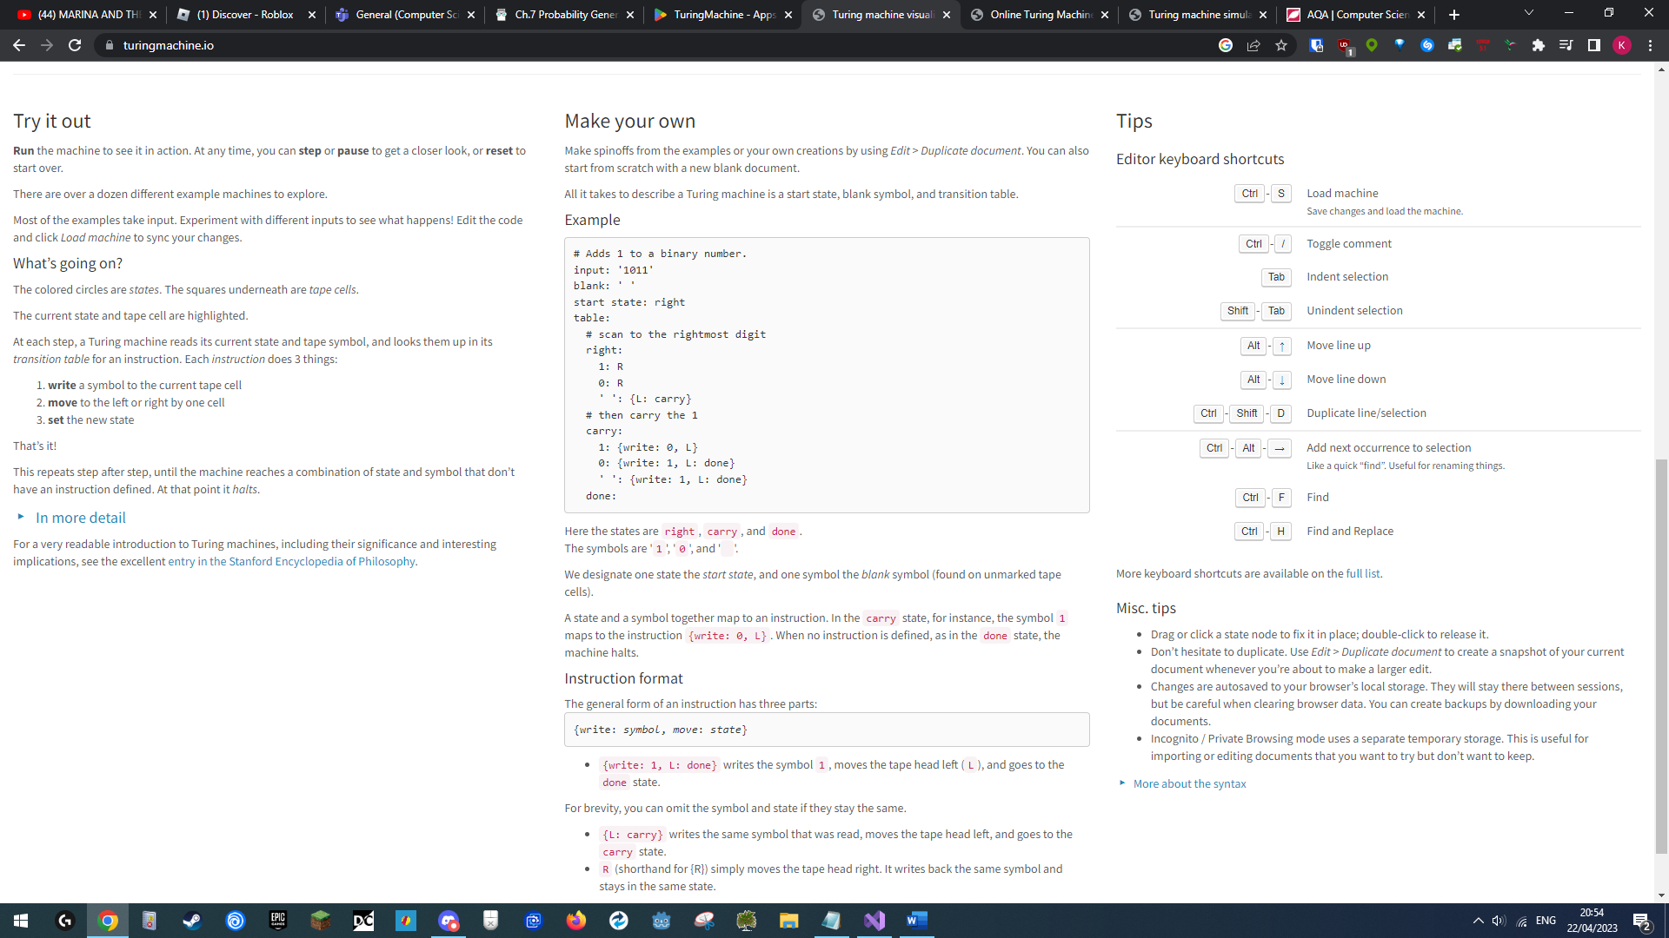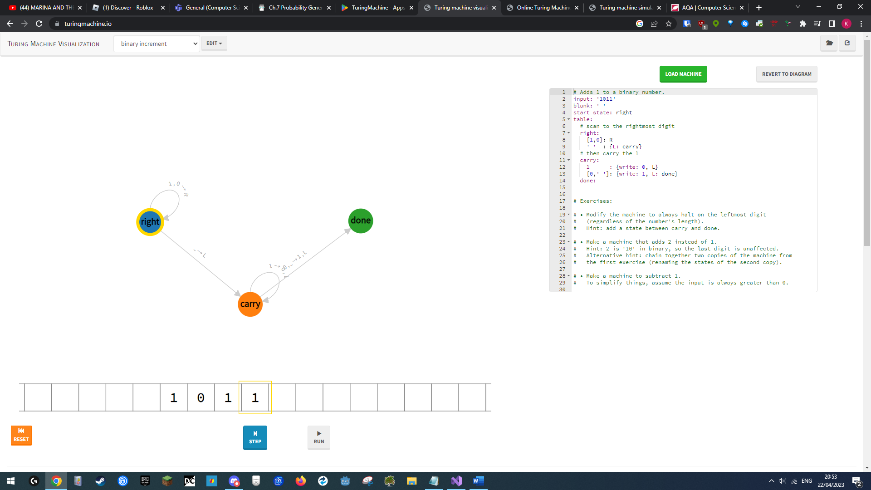TuringMachine.io (https://turingmachine.io/) is a web based Turing Machine programming and simulation tool. It uses text based programming for the Turing Machine, but also automatically translate the program written into a finite state machine diagram, giving the user an intuitive visual display of their program.

The tool also features a series of informational sections about the Turing Machine itself, which can be accessed by hitting the “In more detail” dropdown. This alternate solution is very intuitive to use, is visually well designed, and provides some extent of information about Turing Machines. As such, this is a highly competitive product, and sets us a higher bar in our projects requirements, where we must include educational information, and an intuitive programming/program display methodology within our final product.

**TuringMachine (Android)**

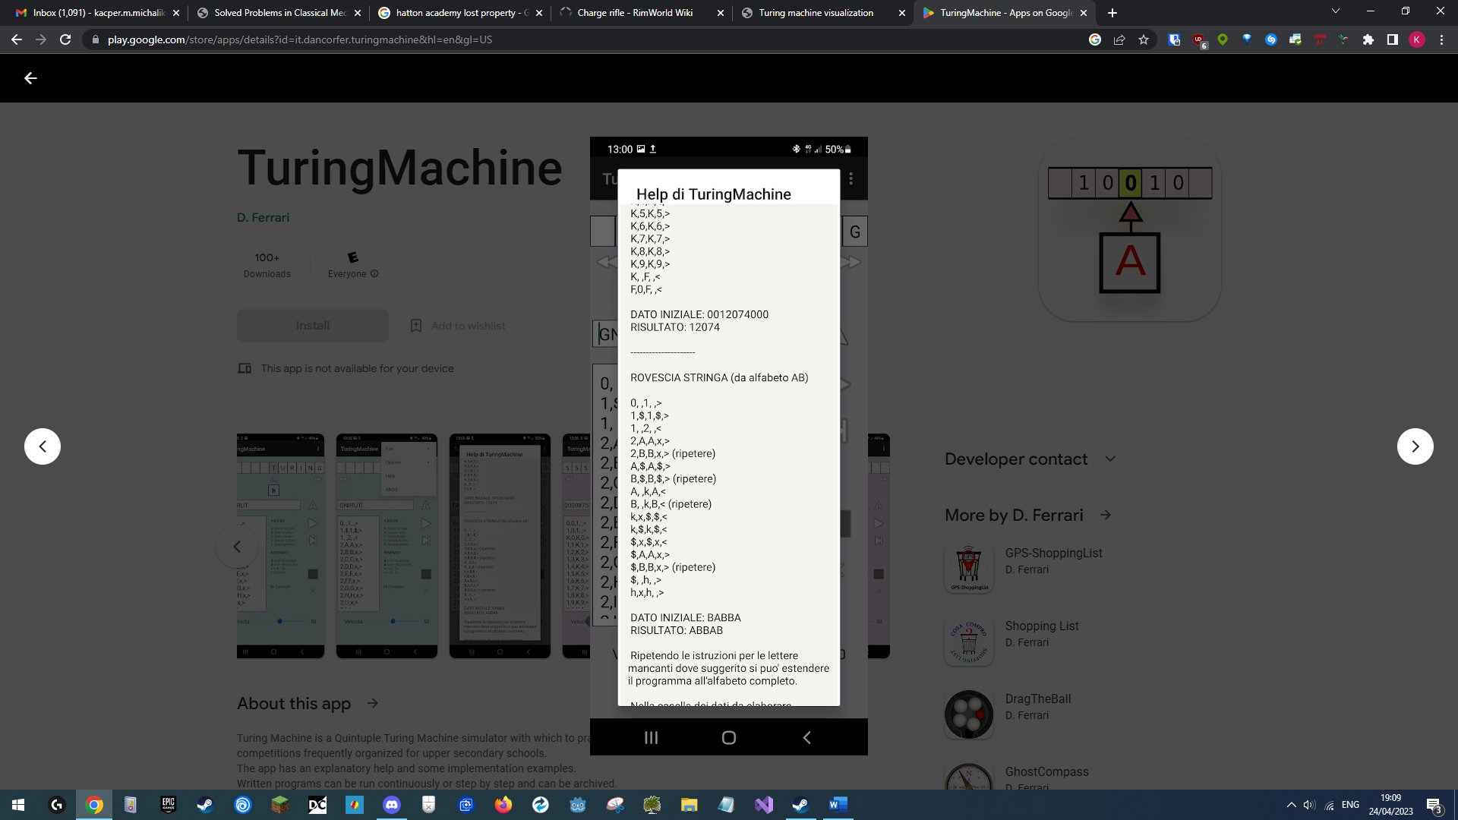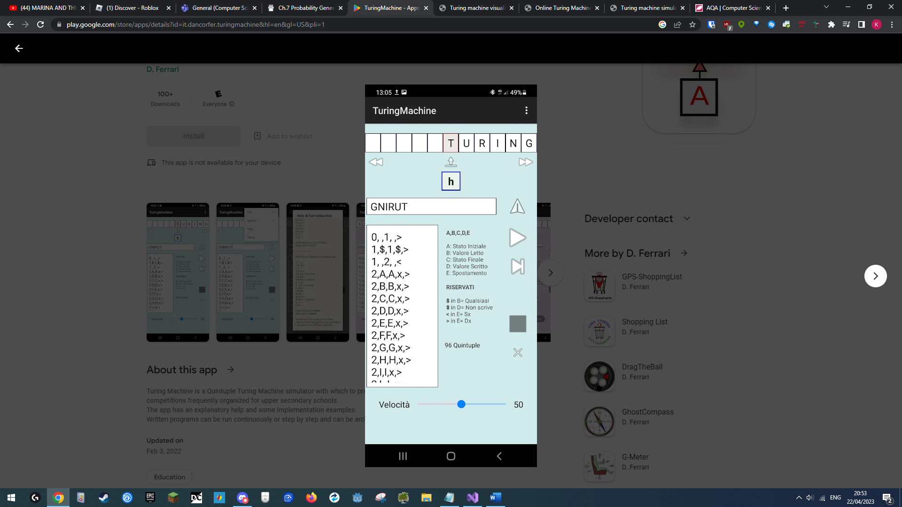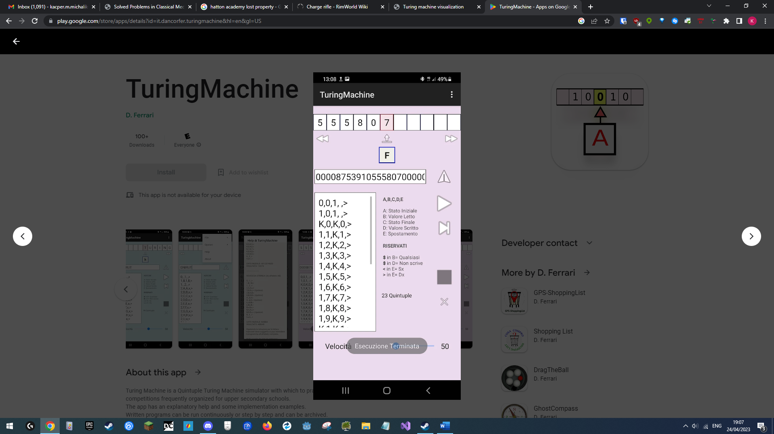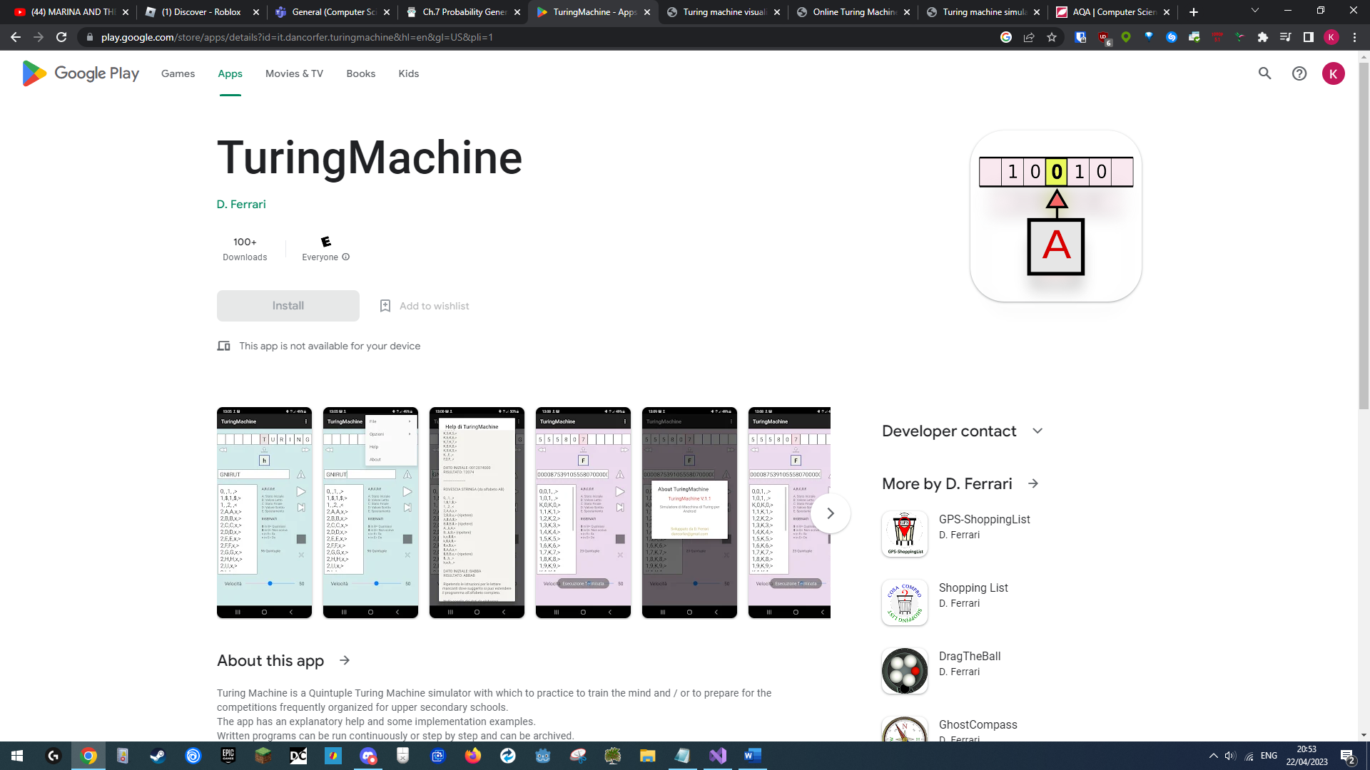TuringMachine is an android phone device application which allows the user to create Turing Machines using text based state transitions. It also contains some help panels which contain some very limited information about Turing Machines. It allows the user to write, save and then reload their programs, which users may find very helpful to be able to refer to a specific program for revision later.

Its biggest challenge for us is in terms of portability. The ability to use this application on a mobile device makes it a very strong for learning anywhere you would want, which is an important quality for students who will be the biggest user base of the product we are going to develop. This alongside its save feature, mean that our product will also need to be portable, or at least have the possibility to expand device for other devices easily, and have the ability to create and save Turing Machine programs by the user.

### Summary Of User Needs

After interviewing my project Sponsor, researching current solutions, and then interviewing possible end users, we have a clearly defined set of requirements and expectations from the users regarding what they want my project to become.

At their core, the user needs could be summarised as these three points:

* Intuitive and Engaging Interface
* Entire Spec Coverage
* Usage Guidance
* Portability

**Intuitive and Engaging Interface**

This new simulator will be used to replace current/standard teaching methods for Turing Machines such as white board diagrams, PowerPoints, and the existing interactive solution TuringKara. The goal of this tool is to replace these with a more interactive and user-friendly alternative. Both end users suggested that a visually rich and hands-on approach was far more beneficial to them when learning about mechanics and concepts of TM’s as these topics can contain lots of information and be difficult to visualise, especially with classic teaching methods extensively lacking in practical application of TM’s.

To satisfy this need of a visually rich and interactive interface, the users should be able to program TM’s visually using visual transitions and possibly as an extension using custom graphs, then be able to see a Turing Machine as it being run, for example where a tape and read/write head with their states/values are drawn on screen, with buttons to operate the TM.

**Entire Spec Coverage**

Users need this new tool to be usable as a revision tool for Turing Machines, this means that the tool should be compliant with the educational spec regarding the theory of TM’s.

This means that this tool should be able to simulate classical Turing Machines and contain some sort of interface which presents theory about TM’s, these could be for example short notes, or longer paragraphs of information like the “Review Of Technology” section of this write-up, which appear as popups or expandable windows on the screen.

**Usage Guidance**

Users who are unfamiliar with the tool or TM’s want template projects to be included in tool, these being projects with pre-programmed TM’s, tapes, and possibly some notes on how these templates function, so that these users can load and then interact with these templates as to gain an improved understanding on the usage of the tool.

**Portability**

Users want to use this tool for learning and revision both at school and at home, this means that this tool should be portable across many different devices, be it screen resolutions, operating systems, and computer processing powers.

## Technical Requirements, Limitations & Objectives

### Requirements

Following research, consisting of existing solutions, sponsor/end-user interviews and data analysis, we can determine a clear set of technical requirements for the new solution that will be developed in this project.

We will look at the technical requirements through the lens of user needs.

**Intuitive & Engaging Interface**

The first requirement of the application is that it must offer an intuitive yet effective visual interface that give the user the ability to create, interact with and view the step-by-step workings of Turing Machines.

Users of this program will for majority of cases have had previous experience with IDE’s due to how the school curriculum for computer science looks like, one of the most popular IDE’s used being Visual Studio. We can use the fact that people who will be using this tool will either have of already used or will most likely go on to use VS if they haven’t already, to design the user interface for this solution in a similar manner as in VS. Doing so requires creating a modular graphical interface, where the user will be able to create dedicated windows using which they can use all related Turing function/features of this project, some example windows being:

* File browsing window
* Custom Graph TM programming window
* Transition TM programming window
* Turing Machine execution window

The user will be able to click open or drag and drop files from the file browser window into other windows, for example into the visual node programming window, as to view/use these files. This allows for dedicated, tailored graphical workspaces, thus allowing the user of optimise their usage of the UI. In terms of software development, the tool will require a UI toolkit that allows for event based and/or polling-based interaction and allows for creating complex canvases like that that would occur in the Custom Graph Programming Window, where many nodes, connections and interactions will be required to be processed and rendered.

**Entire Spec Coverage**

Secondly, as requested during project sponsor/end user interviews, it is essential that the solution covers the computing A-level course theory regarding Turing Machines by allowing users to program Turing Machines as is defined in theory, by using state transitions, and that the project can then simulate the classical model of a Turing Machine.

But as stated earlier, an extension of the simulator would be to also allows non classical Turing Machines to be programmed, meaning TM’s that would also have the ability to work outside of their typical bounds, this is as to allow the users to be additionally able to use the tool not just to learn the theoretically/specification accurate workings of a Turing Machine as part of their preparation for exams or other education, but to also allow them to create more advanced Turing Machines as to improve certain functionalities/skills, such as general programming or state machines writing skills in addition to those of interpreting and programming Turing machines specifically. This means designing/programming the Turing Machine execution class or creating UI imposed input restrictions in such a way that the software can both support and restrict its behaviour to specifically simulate either classical or non-classical Turing Machines.

Additionally, the interface should offer image or text based educational information so that the user can learn the Turing Machine specification while using the interface, making it an all-in-one and effective learning tool. This can be implemented through tooltips on the user controls within the UI and help/additional information buttons being integrated into the windows, where larger notifications/pop ups will appear with spec accurate technical information in them, the contents of these pop-ups can be stored as JSON and loaded in when the user requests these additional information po-ups.

**Usage Guidance**

Since some users want to be able to open template projects to view and learn from, alongside a need for the users to be able to save their own projects, the tool will need to implement a save/load system that stores all the projects files and folders, the optimal solution for this is to implement JSON save files for the project.

This will allow us to predefine projects and makes the user save/load system very quick to implement as the JSON interpreter library is already written for us.

**Portability**

Users want this tool to be usable at both home and school, this means this tool will need to support multiple operating systems and levels of processing power from devices. As such using a cross platform framework for development is necessary, alongside the use of a low weight UI system for the front end. The programming language used for this project should be high performance and as such preferably be a compiled language.

The tool would currently be a desktop implementation, but as seen in interviews, the tool should have the potential to be reimplemented with new front ends, such as a web based one, this means the front end and business logic of the project need to be completely separated. This combination of requiring to be networked and complete frontend and backend separation means we can consider developing the project as a client-server system, this means that the backend can run standalone be it the same device or another device, to which client with independent frontends can then connect to. This also gives the bonus of potentially offloading processing off the client device should it connect to a project hosted on another device, meaning more low-power devices can access the tool, meeting our criteria of portability.

### Limitations

The largest limitation of this project is the time requirement. It must be completed before the 2022 exam season so that students can use the software to aid their revision in preparation for their A-Level Examination, as such the scope of the project must be limited appropriately and as such only one frontend will be created, a desktop extubate, despite the request of a web based one from interviewed parties.

Secondly as students must be able to use this software for independent study, the program should be able to run on a large range of computers, be it at an educatory facility or at home. This means the software must have support for Windows 10/11, Mac OS, and Linux, must be able to run on machines with low level of computing power and storage and have a scalable interface. This will require the project to utilise platform independent libraries, scalable user interfaces and have a small file size.

### Objectives & SMART Targets

**SMART Targets**

SMART targets discuss 5 specific ideas on whether a target is:

* Specific
* Measurable
* Achievable
* Realistic
* Time Based

Based on our requirements and limitations we can generate a selection of core objectives using the SMART Target layout.

**Intuitive & Engaging Interface**

Based on this requirement, we can in theory form a variety of visual design related targets, the problem with this is that whether a visual design is intuitive is very subjective and difficult to measure, meaning we can only apply the and Achievable, Realistic categories to generate these, as such it simpler to instead of having many hard to measure objective, one objective that we follow as a general philosophy throughout the design, this being that every interface element should be determined as intuitive, interactive and engaging by user feedback.

**Entire Spec Coverage**

Using this requirement we can generate very specific and measurable targets, that we design a Turing Machine simulation system that exactly follows the behaviour of a Turing Machine, which can be measured through to comparing race tables with ones from online educational material, or that the interface should contain information regarding Turing Machines, that matches computer science A Level mark schemes.

**Usage Guidance**

We can again generate a very measurable and specific target based on this requirement, of having a template system within our project, where users can view predefined Turing Machines, alongside notes about how to use our final application, where these notes could be added to the Entire Spec Coverages theory help information target.

**Portability**

Based on this requirement we can also generate a very specific, measurable and achievable target of having our final implementation be able to run on a variety of devise, namely Windows 10, 11, Mac OS and Linux devices, with varying powers.

**Time Limitations**

This limitation gives us a Specific, Time Based and Measurable and Achievable objective, where we must finish the entire project, meaning both software development and this NEA, before the exam season, meaning before easter half-term, who’s following term has my first exams.

Condensing these considerations, our final SMART Target objectives for this project can be summarised as:

1. Project should simulate classical TM’s.

(SMAR)

1. User interface should be intuitive, interactive, and engaging.

(AR)

1. User should be able to visually and/or textually program Turing Machines.

(SMAR)

1. Interface should contain optional educational guides/information on the functioning and usage of TM’s.

(SAR)

1. User should be able to view predefined templates/projects.

(MAR)

1. User should be able to save created TM’s for later reference.

(SMAR)

1. Project must be portable and capable of running on a low power Windows 10/11, Linux, or Mac OS machine.

(SMAR)

1. Project must be complete before exam season.

(SMT)

1. (EXTENSION) Project should simulate non-classical TM’s.

(SMAR)

# Technical Analysis

Here we will discuss the possible technologies that will be used in developing the project.

## Programming Language

There are several programming languages that could be used in the development of this project, the 3 that I have experience with that are applicable are Python, C#, and C++.

Here we will go through the objectives and see how achievable each one is using the three technologies.

|  |  |  |  |
| --- | --- | --- | --- |
| Objective | Python | C# | C++ |
| Project should simulate classical and non-classical TM’s. | Python can be used to quickly write an implementation of a classical interface, but would be difficult to use to create a proper OOP class structure which is required when creating an implementation that supports classical and non-classical TM behaviour. | C# can fully support an implementation that supports classical/non-classical TM’s thanks to its support of OOP. | C++ can fully support an implementation that supports classical/non-classical TM’s thanks to its support of OOP. |
| User interface should be intuitive, interactive, and engaging. | Python does not support suitable GUI toolkits, ones like TKinter look outdated and are inferior to alternatives like WPF or Qt. | C# supports a wide variety of platform independent UI toolkits that go from prebuilt and easy to use, such as WPF or Monogame/Unity to fully built-it-yourself kits like MonoGame. | C++ supports a wide variety of GUI platform independent toolkits such as Qt or Unreal. |
| User should be able to visually and textually program Turing Machines | Python has poor for toolkits for UI and rendering, as such creating interfaces for these would be incredibly difficult. | C# has great libraries for creating interactive user interfaces, as such would be able to fulfil this objective well. | C++ has great libraries for creating interactive user interfaces, as such would be able to fulfil this objective well. |
| Interface should contain optional educational guides/information on functioning and usage of TM’s. | Same as above. | Same as above. | Same as above. |
| User should be able to view predefined templates/projects. | Python has an existing JSON Library which would make implementation quick, but the lack of a well written class system makes the programming and then reading/writing of files difficult and as such time consuming. | C# comes with many implementations of JSON pre-written and with all of these being well integrated into the OOP pattern of C#, programming, loading, and writing JSON files is very quick and easy. | C++ does have JSON libraries available, but due to how C++ works and the fact the library isn't natively integrated means that programming save files with C++ is a difficult and time-consuming process. |
| User should be able to save created TMs for later reference. | Same as above. | Save as above. | Same as above. |
| Project must be capable of running on a low power Windows 10/11, Linux, or Mac OS machine. | Python is the slowest of the three languages here as it fully interpreted, making it least optimal for this objective. | C# is a high-performance language as it is compiled into bytecode ahead of time before being interpreted, making it suitable for this objective. | C++ is fully complied and is exactly what is used to write high performance code, meaning that a solution made using C++ would be the highest performance one for low end devices. |
| Project must be complete before exam season | For a project of this scope, Pythons lack of proper OOP support, and poor UI toolkits means there is no feasible way this project could be completed in time using it. | C# is built with OOP and good file structuring in mind, supports easy to use GUI toolkits, and is very easy to debug, as such allows fastest development time from the three choices. | C++ is designed with OOP and good file structuring in mind, and supports easy to use GUI toolkits like Qt, but is extremely difficult to debug and is the slowest to develop in from these three choices. |

Comparing the three languages, we can immediately discard python as a candidate, unfortunately it falls short in many of the categories required for our desired programming language.

From between C++ and C#, C# is the language I have the most experience in, and outperforms C++ is a few categories involved with ease/speed of development, which his going to be a very important factor in a time limited project like this one. As such C# come out as the most optimal choice of programming language for our project.

## User Interface

There are a variety of packages for user interfaces for C#, based on my previous experience I have chosen three packages to discuss: WPF, Godot UI, and MonoGame.

### WPF

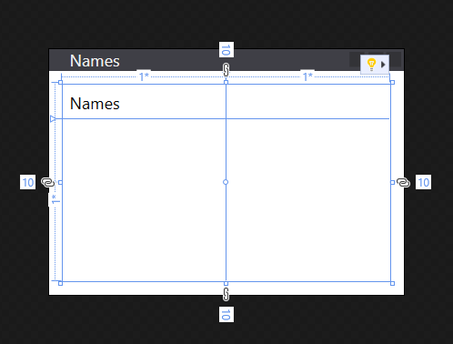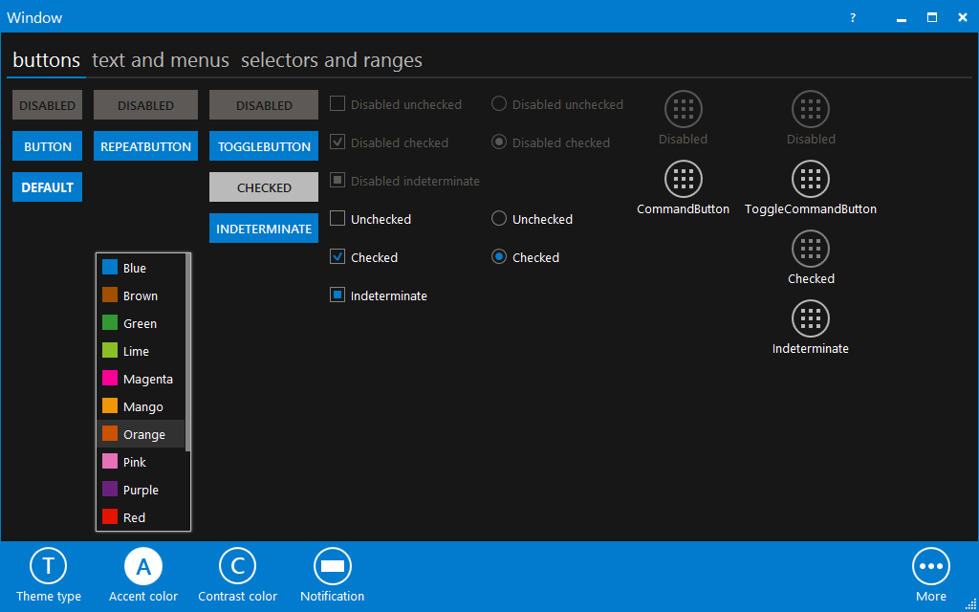

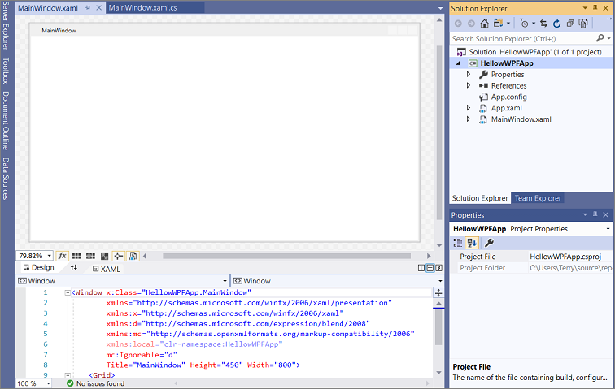

WPF is a GUI system developed by Microsoft and that provides a large variety of existing UI elements. These include buttons, text boxes, labels, scroll views, etc. This is a fully prewritten package that also uses native windows rendering meaning that it is very quick to start developing with and is high performance, matching some of this project’s requirements. Unfortunately, it will only compile and work on Windows machines, which conflicts with one of the major objectives of this project, where it is to be cross-platform compatible.

**Pros**

* Native to Windows meaning high performance on Windows OS devices.

**Cons**

* Only supported by Windows OS devices.
* Does not support custom windows.

### Godot

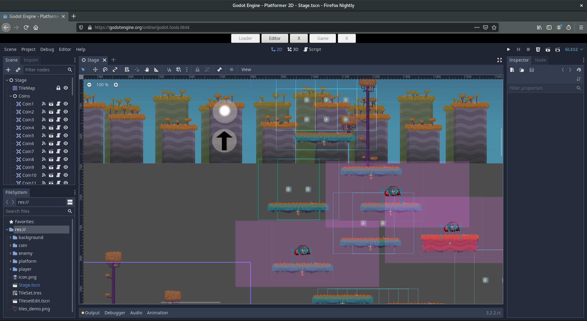

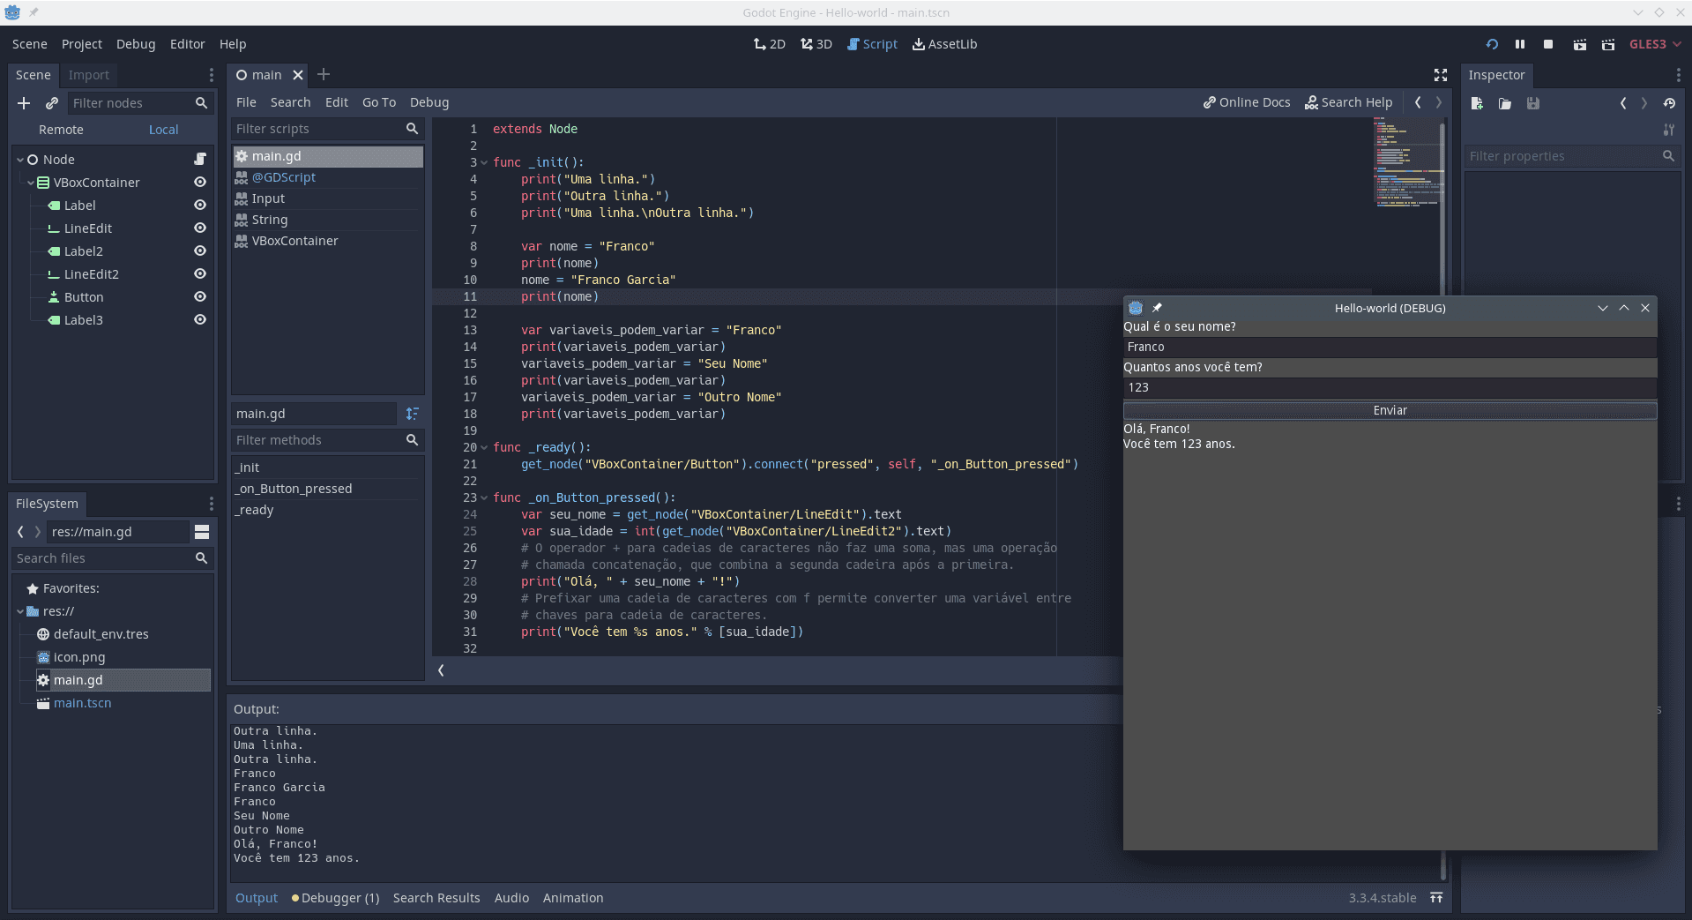

Godot is an open source 2D and 3D game engine, it comes with its own prewritten UI implementation. It is cross platform, allowing deployment to Windows, Mac OS, and Linux, and is highly performant when stripped of unused packages, matching some of this project’s requirements.

Unfortunately, the documentation for using Godot’s built in UI package is very lacklustre for the C# implementation and is finnicky to use, meaning that it will be difficult to use, which also applies to the process of stripping the Godot binaries, which is also lacks documentation and as such is difficult to do, this means a long development time.

**Pros**

* Has a prewritten UI Library which can be modified to support custom windows.
* Allows for stripping of the engine to remove used features and reduce file size.

Cons

* Poor documentation for c#, most is only in native GDScript language.
* Stripping difficult to set-up.
* Still large file size after stripping.

### MonoGame





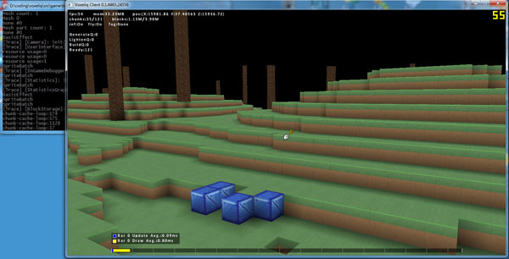

MonoGame is less of a UI toolkit but a platform for developing cross platform applications, all rendering/UI must be implemented from the ground up by the programmer as this toolkit only provides access to basic sprite/3d rendering pipelines, which allows the programmer to completely control how they implement the applications UI.

The drawback to this is a long development time as I will need learn about to implementing and then implement my own UI library.

**Pros**

* Fully customizable – Developer implements UI to their specific requirements.
* Performant – Is very minimal library, where all performance can be controlled by the developer.

**Cons**

* Long development time – Developer must design and implement all functionality from scratch.
* Large technical gap – Developer must understand 2D and 3D rendering to be able to use provided graphical API.

## Chosen Technologies

Based on the previous analysis and additional prototyping, the final technologies that I have chosen are C# and MonoGame.

**C#**

C# consistently drew with or outperformed the other two choice of programming language available, be it by offering inbuilt functionalities, offering high performance, wide compatibility, and additionally stacks up with my long experience using it, making it optimal in terms of my ability to work with it and the speed I can develop with it.

**MonoGame**

Wanting a high performance, cross-platform UI system that supports features like custom windowpanes and could be natively interacted with in C# meant that the most optimal UI toolkit for this project was the MonoGame platform.

This allows me to implement my own C# user interface which will contain all the features I want, contain only necessary functionality as such making it highly performant, and will allow for cross-platform deployment of this front-end to Windows, OS X, and Linux, meeting my projects objectives.

## Architecture Overview

### General Architecture

One of the technical goals of this project is to allow the core business logic to be able to connect to any front end, as to have the possibility of additional front ends in the future such as a web version. As discussed, this means completely separating the backend and front end of the project so that the front end is interchangeable. To achieve this a common protocol or method of communicating data/user actions/business logic is required between the front end and the backend.

Looking at standard industry practices in terms of implementing such a system, the most common and effective method of doing this is through a REST API.

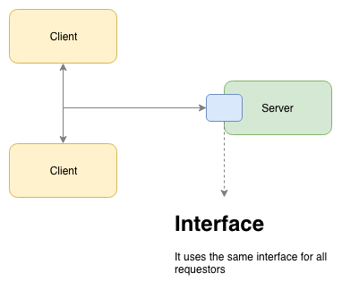A REST API is an architectural style for Client-Server communication, where the client knows identifiers to resources, i.e., project files, and then sends requests, which contain one of these identifiers and an operation from a list of predefined operations, to a server, which then processes this request, executing the operation and in return sending back a representational state of this resource, i.e. the data for the requested file.

https://hub.packtpub.com/defining-rest-architectural-styles/

This architecture allows for complete decoupling of the front-end and backend, as simply a single universal protocol needs to be used to communicate between the client and server meaning that any frontend that adheres to the protocol can integrate itself with this backend seamlessly. This architecture perfectly matches our needs, allowing for future addition of a web-based front-end implementation, and is what will be utilised for creating our backend.

To implement a REST API system, the project has been split into 3 solutions.

A core function/data library is the first solution, this will contain C# files describing the JSON objects/classes/packets that will be used to communicate between the backend and front-end, this will also contain an implementation for all the core functionality of Turing System itself (such as the Statetables, Turing Machines, etc.), as to give any interface the necessary code to correctly integrate itself with all the data and functions of this projects backend.

A server library, this library will be a desktop implementation of the backend. It will be responsible for all local file management, (i.e. creating, moving, updating, loading project files), management and communication with clients (i.e. connecting/disconnecting clients, receiving, processing, and sending requests/responses appropriately) using TCP sockets.

A front-end implementation, which in this case will be a cross platform desktop implementation using Monogame.

### File Architecture

Users will first have to create a Project; this is similar to how Visual Studio or Unity work. When a new project is created, in the location it is saved a Project Information file and Project Data folder will be created. The Project Information File will contain information and settings regarding the project, such as the project name or its strictness setting (strictness meaning whether the project allows for nonclassical Turing Machines to be executed in it). The Project Data folder will be where all the contents of the projects will be stored, i.e. all folders and files contained in the project.

Project themselves will support 4 core file types:

* Alphabet File
* Tape Pre-set File
* State Transition Programming File
* Custom Graph Programming File

These files will be used both by the core library, to store the data required for programming and running Turing Machines, and the front end to display the data to be altered by the user and display additional identifying information such as file names and types.

As such we need a file system that will allow us to store the relevant data to the file type, such as a list of Symbols in an Alphabet or Tape Pre-set, or lists of objects (Transitions) or links to other files such as the definition alphabet in a State Transition File, and allow us to store appropriate metadata for each of these files.

In terms of metadata, we will need to store the file names, their types, and some sort of data to allow for linking files together. Specifically, we will use GUID’s to satisfy this last requirement. GUID stands for Global Unique Identifier, it is a 128-bit identifier that can be generated independently by any computer and practically speaking is guaranteed to be globally unique, this GUID for each file will allow files to reference each other as required, for example, by the State Transition and Custom Graph Files, which must point to some defining Alphabet file.

As to satisfy these requirements, our file storage system will be based on a two file system, meaning that every “file” the frontend/users sees will be actually stored as two files, a metadata-file and a main-data-file, where the metadata- file will contain pure metadata, such as the name, file type, GUID and any future metadata we want to add regarding the main-data-file, which is where all the data for the object/project-file being saved will be stored.

All data for the project objects/files will be encoded as UTF-8 JSON text stored inside the main data folder. The JSON templates will be written in C#, using an existing JSON library.

Using a central data folder, a 2-File system and JSON for encoding objects gives us a variety of benefits:

* Security
  + Since all folders and files will be stored inside the one main data folder, the backend can block of access to any other parts of the system from clients.
* Ease of future development
  + Easy to add new metadata fields.
  + Saved objects are completely independent of how our storage system.
* High performance
  + Main-data-file can be directly read and sent by the server to clients.
  + Altering metadata only requires accessing metadata file which has a small size/performance footprint.

### Front End Architecture

The front end implemented in this write up will be a cross-platform desktop version.

It will work on an event-based system. Specifically, this means the user will be able to execute an “event”, i.e. press a button, which will in return fire off some sort of action, for example call a function to open a file. Certain visual features will require a polling system, such as dragging across a canvas or UI animations but all the functionality interacting with the backend will be event based in nature.

To communicate with the backend, this implementation of the front-end will also use TCP sockets. When a user executes a certain event, for example clicks to open a file from the current project, an event will be fired in the front-end, which will construct the appropriate request packet, send it to the server using the open TCP socket, and setup an appropriate call-back event. Once the server sends back a response, the frontend will trigger the appropriate call-back event and forward the received data to this event, allowing the received data to be then processed by the appropriate front end element which will update and display the new data to the user, completing the overall request.

The core model logic (i.e. simulation of Turing Machines) isn’t done by the backend, although this can in future easily be added to the server API, instead the core model is handled by the core library, which provides the front-end an implementation of the core model. The front-end can store an instance of a Turing Machine from the core library for example, and then simply supply the TM instance by requesting required data from the server and forwarding the received data to that instance of the Turing machine. To interact with the core model, the core model logic is event based, meaning the front-ends events, such as button presses, can directly subscribe to the core model to call events for it to update, for example making the TM to update one step forward when the user presses an execute button.

## Gap Analysis

Concluding from the architecture design we see the project will require the creation and or usage of a series of technologies:

* User Interface Library
* Client-Server/Socket Communication Library
* JSON Library

First is the User Interface, as I have decided to create my own library from scratch to meet my needs, I will need to learn about Computer Graphics, and the workings of the Monogame Engine. For this I have found a series of websites with tutorials and sample code snippets regarding 2D/3D graphics and using them in the Monogame Engine, additionally there are a series of YouTube videos which show real implementation of these systems in Monogame, which I can learn from and then use appropriately in my project, some of these resources include:

* <http://rbwhitaker.wikidot.com/xna-tutorials>
* <https://docs.monogame.net/articles/tutorials.html>
* <https://www.youtube.com/watch?v=ZqwfoMjJAO4>

In terms of creating or using a JSON system, C#’s inbuilt implementation from Microsoft has a very expansive documentation set on the Microsoft developer’s website, with many guides and code samples being present there, which is more than enough for me to understand and then use this library in my project:

* <https://learn.microsoft.com/en-us/dotnet/standard/serialization/system-text-json/how-to?pivots=dotnet-7-0>

Regarding Client-Server and socket communication, I have found a YouTube series where a basic implementation of a client-server system which could use either TCP or UDP sockets is written using C#. I will use this tutorial series as a guide for writing writing mine, which will be a custom implementation to match my own needs:

* <https://www.youtube.com/watch?v=uh8XaC0Y5MA&list=PLXkn83W0QkfnqsK8I0RAz5AbUxfg3bOQ5>

## Prototypes

As identified by my Gap Analysis, there are 3 keys gaps in my knowledge that require learning and prototyping, a 2D rendering system, a client-server communication system, and integrating the Microsoft JSON library.

Too, we must be confident that we can simulate the core model of the Turing Machine

Therefore, I have decided to create 3 prototypes:

* Core Model Prototype – To display the core model being simulated
* Backend Prototype – To Implement TCP Networking & use JSON files
* Front End Prototype – To implement my own UI library

Each of these prototypes give me a clean base structure from which I can draw on from later in the final project.

### Core Model Prototype

The first prototype made for this project was the model library prototype.

This prototype served as a base implementation of a Turing Machine that would accept a set of transition definitions (a Turing Program) and an input tape, using which it would then simulate the given Turing Program.

Additionally, a first compilation system was implemented, translating a set of text based transitions into actual instructions understood by the Turing Machine, this system will be important later for when we finally have to compile what our user program using a front end, into a set of compatible instructions for our core model

As this prototype is of the core simulation model, and does not care how this will be displayed to the user, it was implemented using a console interface, which draws a basic state of the model. This allowed this code to be written quickly and cleanly.

#### Program

using System;

using System.Collections.Generic;

namespace TuringMachine

{

class Program

{

static void Main(string[] args)

{

#region Implementation details

//This variable would in the future be assigned from a textbox, from which the string is taken and then used to generate a program.

string[] TuringMachineProgram;

//FOR THIS ONE ENTER A BINARY NUMBER -> IF NUMBER IS A PALINDROME MACHINE WILL RETURN halt-accept

string[] PalindromeExample = new string[]

{

"0 0 _ r 1o",

"0 1 _ r 1i",

"0 _ _ * halt-accept",

"1o _ _ l 2o",

"1o * * r 1o",

"1i _ _ l 2i",

"1i * * r 1i",

"2o 0 _ l 3",

"2o _ _ * halt-accept",

"2o * * * halt-reject",

"2i 1 _ l 3",

"2i _ _ * halt-accept",

"2i * * * halt-reject",

"3 _ _ * halt-accept",

"3 * * l 4",

"4 * * l 4",

"4 _ _ r 0"

};

//FOR THIS ONE ENTER A BINARY NUMBER -> IF NUMBER MOD 3 == 0 MACHINE WILL RETURN halt-accept

string[] BinaryDivisbleBy3Example = new string[]

{

"0 0 0 r 0",

"0 1 1 r q1",

"q1 0 0 r q2",

"q1 1 1 r 0",

"q1 _ * * halt-reject",

"q2 0 0 r q1",

"q2 1 1 r q1",

"0 _ _ * halt-accept"

};

//Change active example here

TuringMachineProgram = PalindromeExample;

//Definition of instruction:

//Current state, Current symbol, New symbol, Direction, New state

//Special New States:

//halt-accept -> End program with accept output

//halt-reject -> End program with reject output

//Special characters and cases:

// _ Equal to the space character -> Means an empty cell on the tape if used as symbol

// * Wildcard for matching to current symbol or current state -> Non wildcards are prioritised, meaning: if current state instruction has no variant for current symbol on tape, should the current state instruction have a wildcard variant only then will the wildcard variant be used

// * Means no change in new symbol or new state or do not move in any direction

#endregion

#region Tape Setup

Console.WriteLine("Please give in tape starting value");

string TapeStartingValue = Console.ReadLine();

//Tape is a dictionary in case it is reversed past index 0, i.e.. -1, which a list or array would not allow for but a dictionary does.

Dictionary<int, char> Tape = new Dictionary<int, char>();

for (int i = 0; i < TapeStartingValue.Length; i++)

{

Tape.Add(i, TapeStartingValue[i]);

}

#endregion

#region Turing Machine Build Instructions

const string AcceptState = "halt-accept";

const string RejectState = "halt-reject";

Dictionary<string, Instruction> Instructions = new Dictionary<string, Instruction>();

for (int i = 0; i < TuringMachineProgram.Length; i++)

{

string[] Data = TuringMachineProgram[i].Split(' ');

if (Data.Length != 5) throw new Exception("Turing code not properly formatted");

char LookupSymbol = Data[1][0];

if (Data[1] == "_")

{

LookupSymbol = ' ';

}

char NewSymbol = Data[2][0];

if (Data[2] == "_")

{

NewSymbol = ' ';

}

MoveHeadDirection SetDirection;

if (Data[3] == "r") SetDirection = MoveHeadDirection.R;

else if (Data[3] == "l") SetDirection = MoveHeadDirection.L;

else if (Data[3] == "*") SetDirection = MoveHeadDirection.STAY;

else throw new Exception("Direction doesnt exist");

if (Instructions.ContainsKey(Data[0]))

{

Instructions[Data[0]].AddVariant(LookupSymbol, NewSymbol, SetDirection, Data[4]);

}

else

{

Instructions.Add(Data[0], new Instruction(LookupSymbol, NewSymbol, SetDirection, Data[4]));

}

}

#endregion

#region Main

string CurrentState = "0";

int CurrentTapeIndex = 0;

int LowestTapeIndex = 0;

while (CurrentState != AcceptState && CurrentState != RejectState)

{

//Print off machine

Console.WriteLine();

PrintTape();

Console.WriteLine();

Console.WriteLine(CurrentState);

//Expand Tape

if (!Tape.ContainsKey(CurrentTapeIndex))

{

Tape.Add(CurrentTapeIndex, ' ');

if (CurrentTapeIndex < LowestTapeIndex) LowestTapeIndex = CurrentTapeIndex;

}

//Main Turing Machine Code

InstructionVariant CurrentInstruction;

if (Instructions[CurrentState].ContainsVariant(Tape[CurrentTapeIndex]))

{

CurrentInstruction = Instructions[CurrentState][Tape[CurrentTapeIndex]];

if (Tape[CurrentTapeIndex] == ' ') Console.WriteLine("Next: " + CurrentState + "___" + "BLANK");

else Console.WriteLine("Next: " + CurrentState + "___" + Tape[CurrentTapeIndex]);

}

else

{

CurrentInstruction = Instructions[CurrentState]['*'];

Console.WriteLine("Next: " + CurrentState + "___*");

}

if (CurrentInstruction.NewSymbol != '*') Tape[CurrentTapeIndex] = CurrentInstruction.NewSymbol;

if (CurrentInstruction.NewState != "*") CurrentState = CurrentInstruction.NewState;

if (CurrentInstruction.Direction == MoveHeadDirection.L) CurrentTapeIndex--;

else if (CurrentInstruction.Direction == MoveHeadDirection.R) CurrentTapeIndex++;

}

Console.WriteLine();

Console.WriteLine(CurrentState);

Console.ReadLine();

#endregion

#region Helper Functions

void PrintTape()

{

for (int i = LowestTapeIndex; i < CurrentTapeIndex+1; i++)

{

if (i == CurrentTapeIndex)

{

Console.Write("H");

}

else

{

Console.Write(" ");

}

}

Console.WriteLine("");

for (int i = LowestTapeIndex; i< Tape.Count; i++)

{

if (Tape[i] == ' ') Console.Write("_");

else Console.Write(Tape[i]);

}

}

#endregion

}

}

}

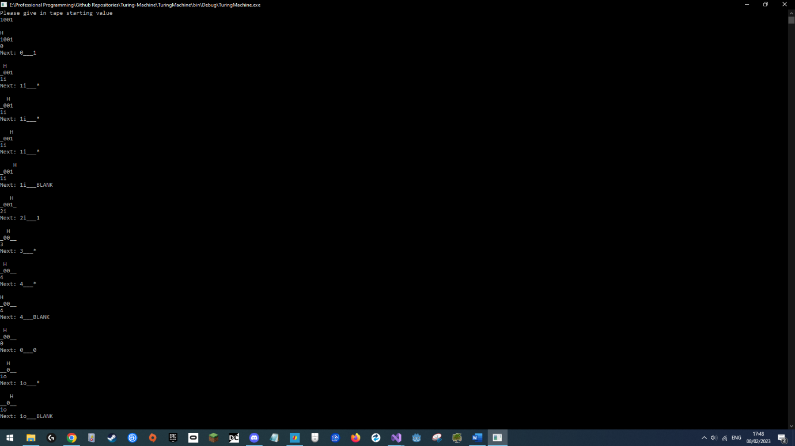

#### Instruction

using System;

using System.Collections.Generic;

namespace TuringMachine

{

public enum MoveHeadDirection { R, L, STAY };

public class Instruction

{

Dictionary<char, InstructionVariant> InstructionVariantLookup;

public InstructionVariant this[char Index]

{

get

{

if (InstructionVariantLookup.TryGetValue(Index, out InstructionVariant Variant))

{

return Variant;

}

else

{

throw new Exception("Trying to access variant data that doesn't exist! Index: "+Index.ToString());

}

}

}

public Instruction()

{

InstructionVariantLookup = new Dictionary<char, InstructionVariant>();

}

public Instruction(char LookupSymbol, char NewSymbol, MoveHeadDirection Direction, string NewState)

{

InstructionVariantLookup = new Dictionary<char, InstructionVariant>();

AddVariant(LookupSymbol, NewSymbol, Direction, NewState);

}

public void AddVariant(char LookupSymbol, char NewSymbol, MoveHeadDirection Direction, string NewState)

{

InstructionVariantLookup.Add(LookupSymbol, new InstructionVariant(NewSymbol, Direction, NewState));

}

public bool ContainsVariant(char LookupSymbol)

{

return InstructionVariantLookup.ContainsKey(LookupSymbol);

}

}

}

#### InstructionVariant

using System;

using System.Collections.Generic;

namespace TuringMachine

{

public class InstructionVariant

{

public char NewSymbol;

public MoveHeadDirection Direction;

public string NewState;

public InstructionVariant(char SetNewSymbol, MoveHeadDirection SetDirection, string SetNewState)

{

NewSymbol = SetNewSymbol;

Direction = SetDirection;

NewState = SetNewState;

}

}

}

#### Summary

For testing, we implemented two Turing Programs found online.

The first one being to determine whether a given binary string was a palindrome.

Source: <https://turingmachinesimulator.com/shared/dmdgpyvezk> Examples -> Binary Palindrome

We supplied the program as a list of specifically formatted strings, and then supplied a tape (an input) of “1001”.

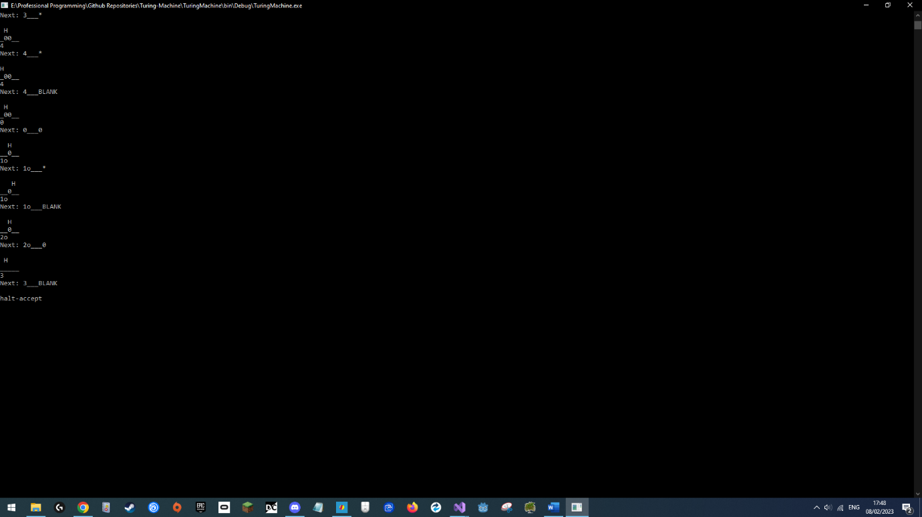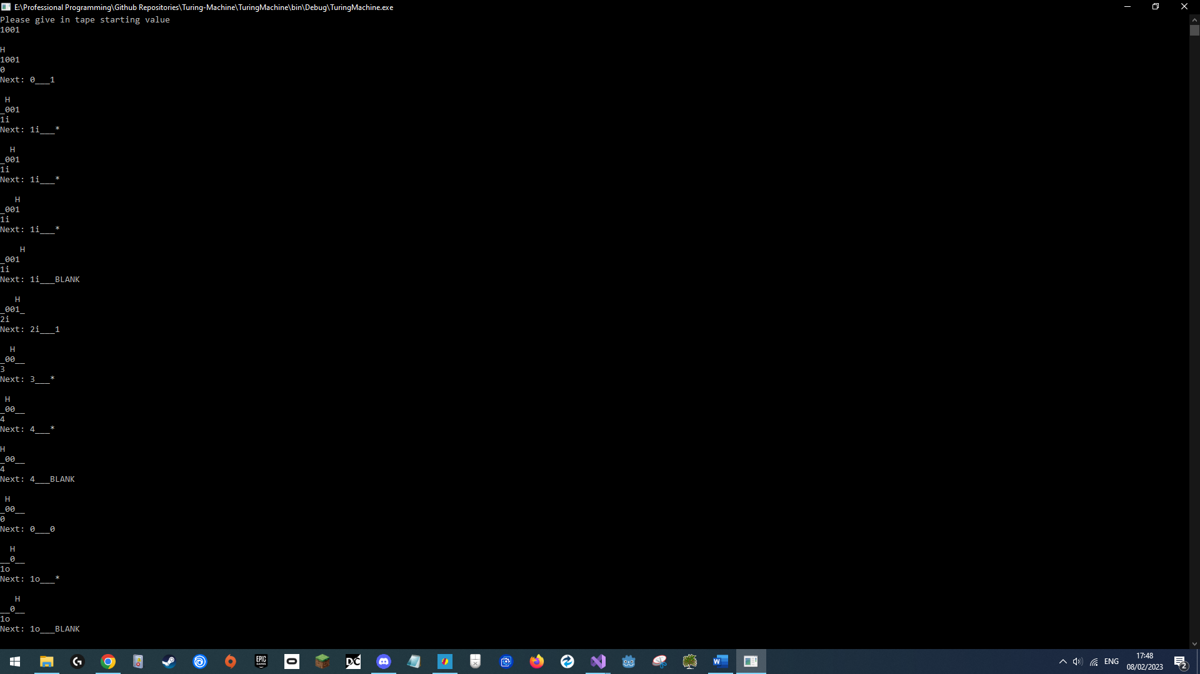

As expected, the program was successfully compiled and run, and the Turing Machine simulated the correct final response, returning that “1001” is indeed a palindrome.

The second program attached was the binary divisibility by 3 checker program. Source: <https://turingmachinesimulator.com/shared/dmdgpyvezk> Examples -> Divisibility by 3

This prototype will serve as the base of the core library and will be developed into the final version of said library.

### Backend Prototype

The second prototype made for this project was the networking and JSON prototype. This prototype served as the base implementation of the networking system for both the front end and backend and implements a JSON system that successfully allows us to read and write a class to disk during runtime.

As this prototype is of the networking and backend JSON system, it does not care how this will be displayed to the user, it was implemented using a console interface, which is enough to allow us the whole process of the server and client communicating using TCP sockets, and allows us to see the data we loaded in using the JSON system, and also gives us the interface to change it. Using a console frontend allowed this code to be written quickly and cleanly.

#### Program

using System;

using System.Threading;

using System.Text.Json;

using System.Collections.Generic;

using System.Text;

using System.Net;

using NetworkTesting;

using System.IO;

namespace TuringTesting

{

class Program

{

static void Main(string[] args)

{

bool Continue = true;

while (Continue)

{

if (Console.KeyAvailable)

{

//ConsoleKeyInfo key = Console.ReadKey(true);

Console.WriteLine("Finish command to start logging!");

string Option = Console.ReadLine();

switch (Option.ToUpper())

{

case ("HELP"):

Console.WriteLine("QUICK - Starts server, loads project from last specified directory and connects to it\n" +

"SERVER - Starts server\n" +

"STOP SERVER - Stops server\n" +

"LOCAL - Starts + connects to local server\n" +

"CONNECT - Takes IP and connects to that server\n" +

"DISCONNECT - Disconnects client from server\n" +

"KILLFIRSTCLIENT - Disconnects first client from server\n" +

"MESSAGE - Sends the server a text message\n");

break;

case ("LOCAL"):

BackendInterface.StartProjectServer(2, 28104);

Client.ConnectToServer(IPAddress.Parse("127.0.0.1"), 28104);

break;

case ("START SERVER"):

BackendInterface.StartProjectServer(2, 28104);

break;

case ("STOP SERVER"):

BackendInterface.CloseProject();

break;

case ("CONNECT"):

string IP = Console.ReadLine();

Client.ConnectToServer(IPAddress.Parse(IP), 28104);

break;

case ("DISCONNECT"):

Client.Disconnect();

break;

case ("KILLFIRSTCLIENT"):

Server.Clients[0].DisconnectClientFromServer();

break;

case ("MESSAGE"):

Console.WriteLine("Type in your message: ");

Client.SendTCPData(ClientSendPacketFunctions.SendMessage(Console.ReadLine()));

break;

case ("CHANGE MESSAGE"):

Console.WriteLine("Type in new server response: ");

string NewMessage = Console.ReadLine();

File.WriteAllText(Environment.CurrentDirectory + @"\ResponseFile.txt", JsonSerializer.Serialize( new ResponseTemplateFile(NewMessage)));

break;

default:

break;

}

}

Client.ProcessPackets();

}

}

}

}

#### Packet

using System;

using System.Collections.Generic;

using System.Text;

namespace NetworkTesting

{

//Request types the client can send

public enum ClientSendPackets

{

Message

}

//Response types the server can send

public enum ServerSendPackets

{

Response

}

public class Packet

{

byte[] ReadBuffer;

public List<byte> TemporaryWriteBuffer;

public int ReadPointerPosition;

public Packet()

{

TemporaryWriteBuffer = new List<byte>(0);

ReadPointerPosition = 0;

}

//Create Packet with existing binary data

public Packet(byte[] Data)

{

TemporaryWriteBuffer = new List<byte>(0);

ReadPointerPosition = 0;

ReadBuffer = Data;

}

#region Writes

//Each write function writes to the temporary write buffer, this is as to allow dynamically increasing the size of the packet as more data is written to it

//AddLength controls whether the length of the byte[] is inserted before the byte[], it might not always be required if the size is known ahead of time and saves us memory

public void Write(byte[] Data, bool AddLength = true)

{

if (AddLength) Write(Data.Length);

TemporaryWriteBuffer.AddRange(Data);

}

public void Write(float Data)

{

TemporaryWriteBuffer.AddRange(BitConverter.GetBytes(Data));

}

public void Write(int Data)

{

TemporaryWriteBuffer.AddRange(BitConverter.GetBytes(Data));

}

public void Write(Guid Data)

{

TemporaryWriteBuffer.AddRange(Data.ToByteArray());

}

public void Write(short Data)

{

TemporaryWriteBuffer.AddRange(BitConverter.GetBytes(Data));

}

public void Write(bool Data)

{

TemporaryWriteBuffer.AddRange(BitConverter.GetBytes(Data));

}

public void Write(string Data)

{

Write(Data.Length);

TemporaryWriteBuffer.AddRange(Encoding.ASCII.GetBytes(Data));

}

#endregion

#region Reads

//We read from the final ReadBuffer

//MovePointer indicates whether we want the pointer to have moved the amount of data we have read after the read is complete

public byte[] ReadBytes(int Length, bool MovePointer = true)

{

if (ReadPointerPosition + Length > ReadBuffer.Length) throw new Exception("ReadBytes Length out of bounds!");

byte[] Result = new byte[Length];

Array.Copy(ReadBuffer, ReadPointerPosition, Result, 0, Length);

if (MovePointer) ReadPointerPosition += Length;

return Result;

}

public byte[] ReadByteArray(bool MovePointer = true)

{

int Length = ReadInt();

if (ReadPointerPosition + Length > ReadBuffer.Length) throw new Exception("ReadBytes Length out of bounds!");

byte[] Result = new byte[Length];

Array.Copy(ReadBuffer, ReadPointerPosition, Result, 0, Length);

if (MovePointer) ReadPointerPosition += Length;

else ReadPointerPosition -= 4;

return Result;

}

public int ReadInt(bool MovePointer = true)

{

if (ReadPointerPosition + 4 > ReadBuffer.Length) throw new Exception("ReadInt Length out of bounds!");

int Result = BitConverter.ToInt32(ReadBuffer, ReadPointerPosition);

if (MovePointer) ReadPointerPosition += 4;

return Result;

}

public Guid ReadGuid(bool MovePointer = true)

{

if (ReadPointerPosition + 16 > ReadBuffer.Length) throw new Exception("ReadGuid Length out of bounds!");

return new Guid(ReadBytes(16, MovePointer));

}

public short ReadShort(bool MovePointer = true)

{

if (ReadPointerPosition + 2 > ReadBuffer.Length) throw new Exception("ReadShort Length out of bounds!");

short Result = BitConverter.ToInt16(ReadBuffer, ReadPointerPosition);

if (MovePointer) ReadPointerPosition += 2;

return Result;

}

public bool ReadBool(bool MovePointer = true)

{

if (ReadPointerPosition + 1 > ReadBuffer.Length) throw new Exception("ReadBool Length out of bounds!");

bool Result = BitConverter.ToBoolean(ReadBuffer, ReadPointerPosition);

if (MovePointer) ReadPointerPosition += 1;

return Result;

}

public string ReadString(bool MovePointer = true)

{

int Length = ReadInt();

if (ReadPointerPosition + Length > ReadBuffer.Length) throw new Exception("ReadString Length out of bounds!");

string Result = Encoding.ASCII.GetString(ReadBuffer, ReadPointerPosition, Length);

if (MovePointer) ReadPointerPosition += Length;

else ReadPointerPosition -= 4;

return Result;

}

#endregion

#region Helper Functions

public int Length()

{

return ReadBuffer.Length;

}

//Unread number of bytes of the packet

public int UnreadLength()

{

return ReadBuffer.Length - ReadPointerPosition;

}

//Inserts the size of the packet in bytes in the front of the TemporaryWriteBuffer

public void InsertPacketLength()

{

TemporaryWriteBuffer.InsertRange(0, BitConverter.GetBytes(TemporaryWriteBuffer.Count + 4));

}

//This is used by the server to overwrite the length of the packet (which will be no longer necessary when the packet is fully received) with the ID of the client who sent the packet to the server, which is important for further processing, this method of simply overwriting the beginning of the packet means we don't need to pass around multiple parameter in the server functions other than this packet and makes it quick to insert the sender ID

public void InsertPacketSenderIDUnsafe(int SenderID)

{

byte[] IDToBytes = BitConverter.GetBytes(SenderID);

ReadBuffer[0] = IDToBytes[0];

ReadBuffer[1] = IDToBytes[1];

ReadBuffer[2] = IDToBytes[2];

ReadBuffer[3] = IDToBytes[3];

}

//Saves the write buffer to the final read buffer (which is used for sending/reading packet)

public byte[] SaveTemporaryBufferToPernamentReadBuffer()

{

ReadBuffer = TemporaryWriteBuffer.ToArray();

return ReadBuffer;

}

//Clear the packet to be empty

public void Reset()

{

ReadBuffer = null;

TemporaryWriteBuffer = new List<byte>();

ReadPointerPosition = 0;

}

#endregion

}

}

#### BackendInterface

using System.Threading;

namespace NetworkTesting

{

//Provides an API for front ends to use this library

public static class BackendInterface

{

//Start Server

public static bool StartProjectServer(int SetMaxClients, int SetPort)

{

Thread ServerThread = new Thread(() => Server.StartServer(SetMaxClients, SetPort));

ServerThread.Start();

return true;

}

//Close Server

public static void CloseProject()

{

Server.CloseServer();

}

}

}

#### Server

using System;

using System.Collections.Generic;

using System.Net;

using System.Net.Sockets;

using System.Threading;

namespace NetworkTesting

{

public static class Server

{

public static bool IsServerOn;

public static int MaxClients { get; private set; }

public static int Port { get; private set; }

public static Thread ServerThread { get; private set; }

static TcpListener ServerTcpListener;

public static Dictionary<int, ServerClientSlot> Clients { get; private set; }

static Queue<Packet> PacketProcessingQueue = new Queue<Packet>();

static Queue<Packet> PacketsBeingProcessed;

static bool MarkForClosing;

//Sets up server

public static void StartServer(int SetMaxPlayers, int SetPort)

{

MaxClients = SetMaxPlayers;

Port = SetPort;

Console.WriteLine("THREAD NOTIF SERVER: SERVER INITIATED ON THREAD " + Thread.CurrentThread.ManagedThreadId.ToString());

IsServerOn = true;

MarkForClosing = false;

//Create slot for every possible client

Clients = new Dictionary<int, ServerClientSlot>();

for (int i = 0; i < MaxClients; i++)

{

Clients.Add(i, new ServerClientSlot(i));

}

//Start listening for any incoming TCP connections

ServerTcpListener = new TcpListener(IPAddress.Any, Port);

ServerTcpListener.Start();

Console.WriteLine("SERVER: Server Started on port: " + Port.ToString());

//When a TCP connection is found, call this function

ServerTcpListener.BeginAcceptTcpClient(new AsyncCallback(NewTCPClientConnectedCallback), null);

RunServer();

}

//Sends a packet to specific client

public static void SendTCPData(int ClientID, Packet Data)

{

Data.InsertPacketLength();

Clients[ClientID].TCP.SendDataToClient(Data.SaveTemporaryBufferToPernamentReadBuffer());

}

//Sends a packet to all connected clients

public static void SendTCPToAllClients(Packet Data)

{

Data.InsertPacketLength();

byte[] FinalData = Data.SaveTemporaryBufferToPernamentReadBuffer();

for (int i = 0; i < MaxClients; i++)

{

if (Clients[i].TCP.ConnectionSocket != null)

{

Clients[i].TCP.SendDataToClient(FinalData);

}

}

}

//Server main loop

static void RunServer()

{

//Continue while not told to close

while (!MarkForClosing)

{

if (PacketProcessingQueue.Count > 0)

{

//Copy queued packets

lock (PacketProcessingQueue)

{

PacketsBeingProcessed = new Queue<Packet>(PacketProcessingQueue);

PacketProcessingQueue.Clear();

}

int Length = PacketsBeingProcessed.Count;

for (int i = 0; i < Length; i++)

{

Packet Data = PacketsBeingProcessed.Dequeue();

//Check packet has valid header

if (Data.Length() >= 8)

{

//Packet Length has been replaced with sender ID

int SenderID = Data.ReadInt();

//Get Packet Type

int PacketType = Data.ReadInt();

//Check if Packet Type Valid + Process Packet

if (Enum.IsDefined(typeof(ClientSendPackets), PacketType))

{

ServerReceiveFunctions.PacketToFunction[PacketType](SenderID, Data);

}

else

{

Console.WriteLine("SERVER: Invalid Packet received");

}

}

}

}

}

//Once the server has finished processing packets and was told turn off, we shut it down

ShutDown();

}

public static void CloseServer()

{

MarkForClosing = true;

}

//Allows another thread to add a packet to the processing queue for the main server thread

public static void AddPacketToProcessOnServerThread(int SenderID, Packet PacketToAdd)

{

//Locking the queue means that the main server loop has to wait until the queue is unlocked to use it, guaranteeing that the server thread doesn't copy the processing queue while more packets are being added to it

lock (PacketProcessingQueue)

{

PacketToAdd.InsertPacketSenderIDUnsafe(SenderID);

PacketProcessingQueue.Enqueue(PacketToAdd);

}

}

//This gets called when a new TCP connection is incoming

static void NewTCPClientConnectedCallback(IAsyncResult Result)

{

if (!IsServerOn) return;

Console.WriteLine("SERVER: Server dealing with new connection on thread " + Thread.CurrentThread.ManagedThreadId.ToString());

//Accept the connection

TcpClient NewClient = ServerTcpListener.EndAcceptTcpClient(Result);

//Listen for any more incoming connections

ServerTcpListener.BeginAcceptTcpClient(new AsyncCallback(NewTCPClientConnectedCallback), null);

//Find next available slot for client to connect to, if none found, we reach the NewClient.Close() function at the end, closing the connection

for (int i = 0; i < MaxClients; i++)

{

if (Clients[i].TCP.ConnectionSocket == null)

{

Clients[i].TCP.ConnectClientToServer(NewClient);

return;

}

}

Console.WriteLine("SERVER: " + NewClient.Client.RemoteEndPoint.ToString() + " failed to connect: Server Full!");

NewClient.Close();

}

//Shuts down all TCP connections and cleans up server

static void ShutDown()

{

IsServerOn = false;

ServerTcpListener.Stop();

ServerTcpListener = null;

Clients = null;

PacketProcessingQueue.Clear();

PacketsBeingProcessed = null;

Console.WriteLine("SERVER: Server Closed");

}

}

public class ServerClientSlot

{

private int ClientId;

public TCPInterface TCP;

public static int DefaultDataBufferSize = 4096;

//Constructor

public ServerClientSlot(int SetClientID)

{

ClientId = SetClientID;

TCP = new TCPInterface(ClientId);

}

public class TCPInterface

{

public TcpClient ConnectionSocket;

NetworkStream DataStream;

readonly int ID;

byte[] ReceiveDataBuffer;

int DataBufferSize = DefaultDataBufferSize;

Packet PacketCurrentlyBeingRebuilt;

public TCPInterface(int SetID)

{

ID = SetID;

}

//Setups up socket information and data stream once a connection is completed

public void ConnectClientToServer(TcpClient SetConnectionSocket)

{

ConnectionSocket = SetConnectionSocket;

ConnectionSocket.ReceiveBufferSize = DataBufferSize;

ConnectionSocket.SendBufferSize = DataBufferSize;

DataStream = ConnectionSocket.GetStream();

ReceiveDataBuffer = new byte[DataBufferSize];

PacketCurrentlyBeingRebuilt = new Packet();

DataStream.BeginRead(ReceiveDataBuffer, 0, DataBufferSize, OnReceiveDataFromClient, null);

Console.WriteLine("SERVER: Client at " + ConnectionSocket.Client.RemoteEndPoint.ToString() + " has been connected to server!");

}

//Writes data to the data stream, sending it to the client

public void SendDataToClient(byte[] Data)

{

if (ConnectionSocket == null) return;

try

{

DataStream.BeginWrite(Data, 0, Data.Length, null, null);

}

catch (Exception E)

{

Console.WriteLine("SERVER: Error Sending Data To Client " + ID.ToString() + ": " + E.ToString());

}

}

// Packet rebuilding algorithm as detailed in the Backend Networking Section

private void OnReceiveDataFromClient(IAsyncResult Result)

{

Console.WriteLine("SERVER: Server dealing with incoming data on thread " + Thread.CurrentThread.ManagedThreadId.ToString()+ ". From client: " + ID.ToString());

//Check if the socket is still active (this function may get called on a disconnect according to Microsoft Docs)

if (!ConnectionSocket.Connected)

{

TCPInternalDisconnect();

Console.WriteLine("SERVER: Client " + ID.ToString() + " has disconnected!");

return;

}

//Read incoming data

int IncomingDataLength = DataStream.EndRead(Result);

//Copy into temp buffer

byte[] UsefuldataBuffer = new byte[IncomingDataLength];

Array.Copy(ReceiveDataBuffer, UsefuldataBuffer, IncomingDataLength);

//Copy into Packet

PacketCurrentlyBeingRebuilt.Write(UsefuldataBuffer, false);

PacketCurrentlyBeingRebuilt.SaveTemporaryBufferToPernamentReadBuffer();

//Check if a full packet has been received, if so, add to packet processing queue

if (PacketCurrentlyBeingRebuilt.UnreadLength() >= 4)

{

int PacketLength = PacketCurrentlyBeingRebuilt.ReadInt(false);

while (PacketCurrentlyBeingRebuilt.UnreadLength() >= PacketLength && PacketCurrentlyBeingRebuilt.UnreadLength() >= 4)

{

Packet ProcessedPacket = new Packet(PacketCurrentlyBeingRebuilt.ReadBytes(PacketLength));

Server.AddPacketToProcessOnServerThread(ID, ProcessedPacket);

if (PacketCurrentlyBeingRebuilt.UnreadLength() >= 4)

{

PacketLength = PacketCurrentlyBeingRebuilt.ReadInt(false);

}

}

if (PacketCurrentlyBeingRebuilt.UnreadLength() == 0)

{

PacketCurrentlyBeingRebuilt.Reset();

}

}

//Start reading the incoming data again

if (ConnectionSocket != null) DataStream.BeginRead(ReceiveDataBuffer, 0, DataBufferSize, OnReceiveDataFromClient, null);

}

//Disconnect and clean up the TCP socket and data stream

public void TCPInternalDisconnect()

{

ConnectionSocket?.Close();

ConnectionSocket = null;

DataStream = null;

ReceiveDataBuffer = null;

PacketCurrentlyBeingRebuilt = null;

}

}

//Shuts down TCP connection with this client

public void DisconnectClientFromServer()

{

Console.WriteLine("SERVER: " + TCP.ConnectionSocket.Client.RemoteEndPoint.ToString() + " aka. Client N:" + ClientId.ToString() + " has been disconnected from the server!");

TCP.TCPInternalDisconnect();

}

}

}

#### ServerReceiveFunctions

using System;

using System.Collections.Generic;

using System.IO;

using System.Text.Json;

using System.Text.Json.Serialization;

namespace NetworkTesting

{

static class ServerReceiveFunctions

{

//Since every request has a request type ID, we can use this ID to create a function lookup dictionary, where we get returned a function pointer to the appropriate function to call to process this request, allowing us to skip a large case/if block of code, making it cleaner, and easy to modify, as new functions to process requests only have to be added to this dictionary to be used to the server

public delegate void PacketFunctionPointer(int SenderClientID, Packet Data);

//Here we map the request ID's to the appropriate functions

public static Dictionary<int, PacketFunctionPointer> PacketToFunction = new Dictionary<int, PacketFunctionPointer>()

{

{(int)ClientSendPackets.Message, UserSentMessage}

};

/* -PACKET LAYOUT-

*/

public static void UserSentMessage(int SenderClientID, Packet Data)

{

Console.WriteLine("");

Console.WriteLine("SERVER RECEIVED MESSAGE FROM CLIENT " + SenderClientID.ToString() + ": " + Data.ReadString());

Server.SendTCPData(SenderClientID, ServerSendPacketFunctions.ReceivedMessage());

}

}

}

#### ServerSendPacketFunctions

using System;

using System.Collections.Generic;

using System.Text.Json.Serialization;

using System.Text.Json;

using System.IO;

namespace NetworkTesting

{

static class ServerSendPacketFunctions

{

//Generates a response packet

public static Packet ReceivedMessage()

{

Packet Data = new Packet();

//Writing our Header information

Data.Write((int)ServerSendPackets.Response);

//Writing our Payload

ResponseTemplateFile Template = JsonSerializer.Deserialize<ResponseTemplateFile>(File.ReadAllBytes(Environment.CurrentDirectory + @"\ResponseFile.txt"));

Data.Write(Template.Response);

return Data;

}

}

}

#### Client

using System;

using System.Collections.Generic;

using System.Net;

using System.Net.Sockets;

using System.Threading;

namespace NetworkTesting

{

public static class Client

{

public static bool IsConnected

{

get

{

return TCP.ConnectionSocket != null ? TCP.ConnectionSocket.Connected : false;

}

}

public static bool IsConnecting;

static TCPInterface TCP = new TCPInterface();

static int DataBufferSize = 4096;

class TCPInterface

{

public TcpClient ConnectionSocket;

private NetworkStream DataStream;

private byte[] ReceiveDataBuffer;

private Packet PacketCurrentlyBeingRebuilt;

public void Connect(IPAddress TargetIP, int Port, int Timeout)

{

try

{

ConnectionSocket = new TcpClient();

ConnectionSocket.ReceiveBufferSize = DataBufferSize;

ConnectionSocket.SendBufferSize = DataBufferSize;

ReceiveDataBuffer = new byte[DataBufferSize];

ConnectionSocket.BeginConnect(TargetIP, Port, OnConnectCallBack, ConnectionSocket);

Thread.Sleep(Timeout);

IsConnecting = false;

if (!IsConnected)

{

Console.WriteLine("CLIENT: Connection timed out.");

TCPInternalDisconnect();

}

}

catch (Exception E)

{

Console.WriteLine("CLIENT: Connection attempt failure! " + E.ToString());

TCPInternalDisconnect();

}

}

public void OnConnectCallBack(IAsyncResult Result)

{

try

{

if (ConnectionSocket == null) return;

Console.WriteLine("CLIENT: Connect callback called.");

ConnectionSocket.EndConnect(Result);

DataStream = ConnectionSocket.GetStream();

PacketCurrentlyBeingRebuilt = new Packet();

DataStream.BeginRead(ReceiveDataBuffer, 0, DataBufferSize, OnReceiveDataFromServer, null);

}

catch (Exception E)

{

Console.WriteLine(E.ToString());

TCPInternalDisconnect();

}

}

public void SendDataToServer(Packet Data)

{

try

{

Console.WriteLine("CLIENT: Client is writing data to server");

Data.InsertPacketLength();

DataStream.BeginWrite(Data.SaveTemporaryBufferToPernamentReadBuffer(), 0, Data.Length(), null, null);

}

catch (Exception E)

{

Console.WriteLine("CLIENT: Error Sending Data To Server! " + E.ToString());

}

}

private void OnReceiveDataFromServer(IAsyncResult Result)

{

try

{

if (ConnectionSocket == null || !ConnectionSocket.Connected)

{

Console.WriteLine("CLIENT: Server disconnected me!");

TCPInternalDisconnect();

return;

}

int IncomingDataLength = DataStream.EndRead(Result);

byte[] UsefuldataBuffer = new byte[IncomingDataLength];

Array.Copy(ReceiveDataBuffer, UsefuldataBuffer, IncomingDataLength);

PacketCurrentlyBeingRebuilt.Write(UsefuldataBuffer, false);

PacketCurrentlyBeingRebuilt.SaveTemporaryBufferToPernamentReadBuffer();

if (PacketCurrentlyBeingRebuilt.UnreadLength() >= 4)

{

int PacketLength = PacketCurrentlyBeingRebuilt.ReadInt(false);

while (PacketCurrentlyBeingRebuilt.UnreadLength() >= PacketLength && PacketCurrentlyBeingRebuilt.UnreadLength() >= 4)

{

Packet ProcessedPacket = new Packet(PacketCurrentlyBeingRebuilt.ReadBytes(PacketLength));

AddPacketToProcessOnMainThread(ProcessedPacket);

if (PacketCurrentlyBeingRebuilt.UnreadLength() >= 4)

{

PacketLength = PacketCurrentlyBeingRebuilt.ReadInt(false);

}

}

if (PacketCurrentlyBeingRebuilt.UnreadLength() == 0)

{

PacketCurrentlyBeingRebuilt.Reset();

}

}

if (ConnectionSocket != null) DataStream.BeginRead(ReceiveDataBuffer, 0, DataBufferSize, OnReceiveDataFromServer, null);

}

catch (Exception E)

{

Console.WriteLine(E.ToString());

}

}

public void TCPInternalDisconnect()

{

ConnectionSocket?.Close();

ConnectionSocket = null;

DataStream = null;

ReceiveDataBuffer = null;

PacketCurrentlyBeingRebuilt = null;

}

}

static Queue<Packet> PacketProcessingQueue = new Queue<Packet>();

static Queue<Packet> PacketsBeingProcessed;

static void AddPacketToProcessOnMainThread(Packet PacketToAdd)

{

lock (PacketProcessingQueue)

{

PacketProcessingQueue.Enqueue(PacketToAdd);

}

}

public static void ProcessPackets()

{

if (PacketProcessingQueue.Count > 0)

{

lock (PacketProcessingQueue)

{

PacketsBeingProcessed = new Queue<Packet>(PacketProcessingQueue);

PacketProcessingQueue.Clear();

}

int Length = PacketsBeingProcessed.Count;

for (int i = 0; i < Length; i++)

{

Packet Data = PacketsBeingProcessed.Dequeue();

//Get rid of packet size

Data.ReadInt();

//Get Type

int PacketType = Data.ReadInt();

//Execute function

if (ClientReceiveFunctions.PacketToFunction.ContainsKey(PacketType))

ClientReceiveFunctions.PacketToFunction[PacketType](Data);

}

}

}

public static void ConnectToServer(IPAddress IP, int Port)

{

if (IsConnecting || IsConnected) return;

IsConnecting = true;

Thread ConnectThread = new Thread(() => TCP.Connect(IP, Port, 1000));

ConnectThread.Start();

}

public static void SendTCPData(Packet Data)

{

TCP.SendDataToServer(Data);

}

public static void Disconnect()

{

Console.WriteLine("CLIENT: DISCONNECTING FROM SERVER!");

TCP.TCPInternalDisconnect();

}

}

}

#### ClientReceiveFunctions

using System;

using System.Collections.Generic;

using System.Linq;

using System.Text;

using System.Threading.Tasks;

namespace NetworkTesting

{

static class ClientReceiveFunctions

{

public delegate void PacketFunctionPointer(Packet Data);

public static Dictionary<int, PacketFunctionPointer> PacketToFunction = new Dictionary<int, PacketFunctionPointer>()

{

{(int)ServerSendPackets.Response, ReceiveResponse}

};

public static void ReceiveResponse(Packet Data)

{

Console.WriteLine();

Console.WriteLine("CLIENT: RESPONSE FROM SERVER: " + Data.ReadString());

}

}

}

#### ClientSendPacketFunctions

using System;

using System.Text;

namespace NetworkTesting

{

//This class simplifies the process of creating a request packet for clients by having them have to simply call a function with the appropriate parameters, and the request packet is generated automatically.

public static class ClientSendPacketFunctions

{

//Generates Message Request Packet

public static Packet SendMessage(string Message)

{

Packet Data = new Packet();

Data.Write((int)ClientSendPackets.Message);

Data.Write(Message);

return Data;

}

}

}

#### ResponseFileTemplate

using System;

using System.Collections.Generic;

using System.Linq;

using System.Text;

using System.Text.Json.Serialization;

using System.Threading.Tasks;

namespace NetworkTesting

{

public class ResponseTemplateFile

{

[JsonInclude]

public string Response;

public ResponseTemplateFile()

{

}

public ResponseTemplateFile(string NewResponse)

{

Response = NewResponse;

}

}

}

#### Summary

For testing, we ran the console program, and started a local server and connected to it using the localhost IP.

We then first tested the JSON system, the ResponseTempalteFile.txt was empty when we launched the application:

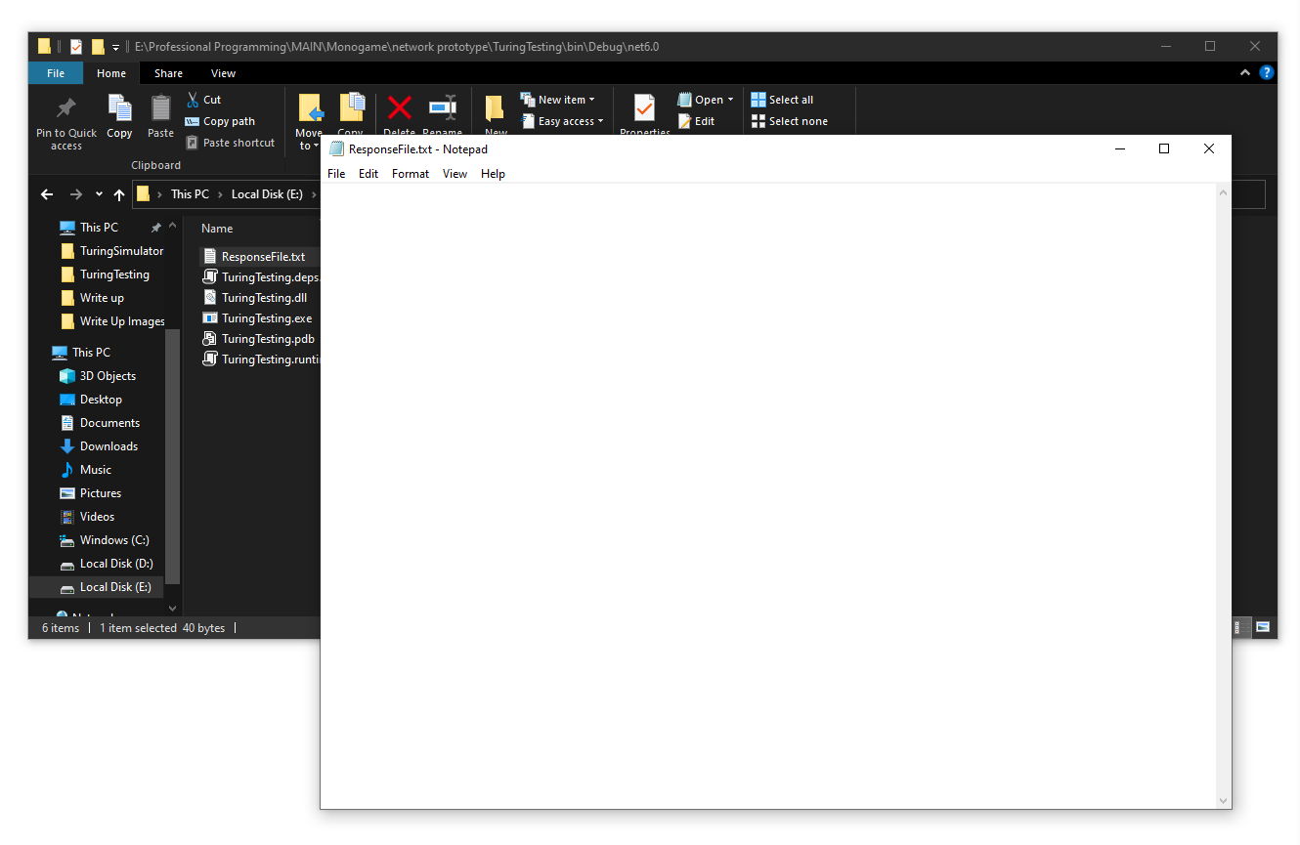

Next, we used the console to define and save a new response:

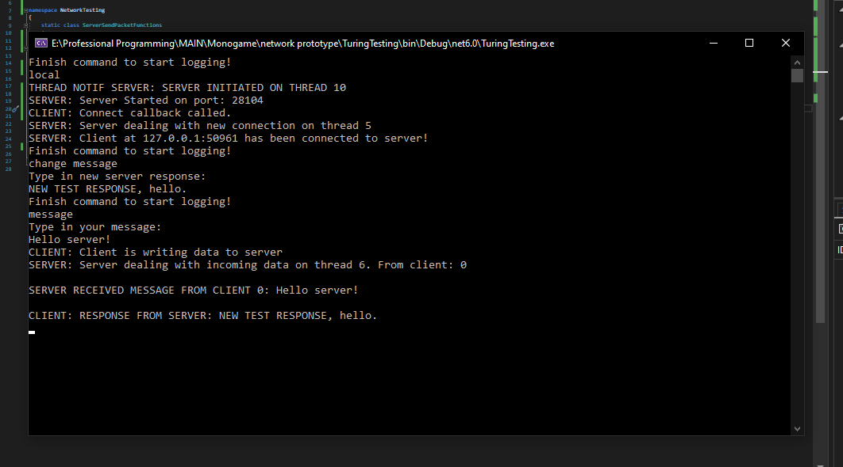

Following this, the ResponseTempalteFile.txt now looked like this:

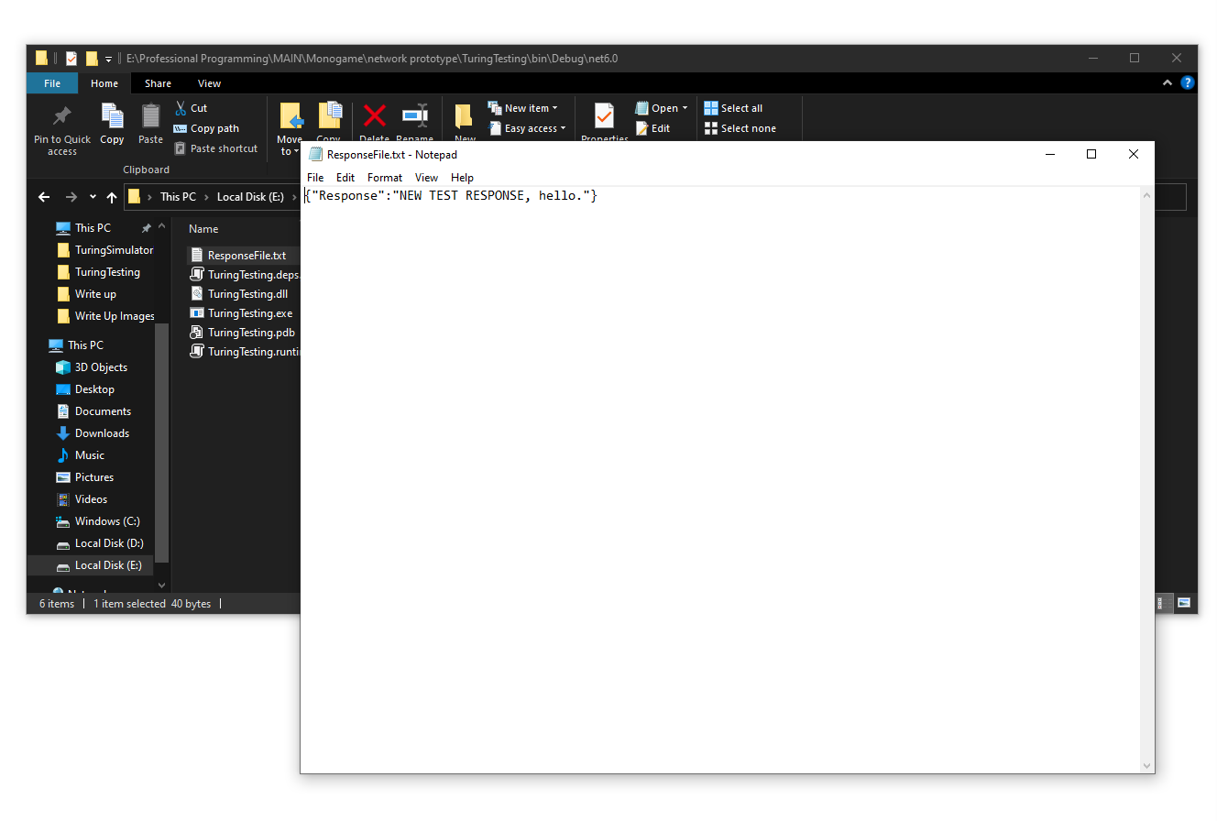

We then finally tested communication between the server and client by sending back and forth a message:



We managed to successfully send and reconstruct messages between two threads using a TCP connection, proving our prototype successful.

### Front End Prototype

The final prototype made for this project was the front-end prototype. This prototype served as a base implementation of a rendering, view, and input system.

This implementations main goal was to help find us a possible approach to implementing our UI hierarchy/structure and how it would consume user input from a technical sense.

#### Program

using var game = new TuringSimulatorDesktop.MainWindow();

game.Run();

#### Main Window

using System;

using System.Collections.Generic;

using Microsoft.Xna.Framework;

using Microsoft.Xna.Framework.Graphics;

using Microsoft.Xna.Framework.Input;

using TuringBackend;

using TuringBackend.Networking;

using TuringSimulatorDesktop.Input;

using TuringSimulatorDesktop.UI;

namespace TuringSimulatorDesktop

{

public class MainWindow : Game

{

public GraphicsDeviceManager GraphicsManager;

SpriteBatch ScreenBatch;

public View CurrentView;

public MainWindow()

{

GraphicsManager = new GraphicsDeviceManager(this);

GraphicsManager.PreparingDeviceSettings += (object s, PreparingDeviceSettingsEventArgs args) =>

{

args.GraphicsDeviceInformation.PresentationParameters.RenderTargetUsage = RenderTargetUsage.PreserveContents;

};

Content.RootDirectory = "Content";

IsMouseVisible = true;

IsFixedTimeStep = false;

}

protected override void Initialize()

{

base.Initialize();

}

protected override void LoadContent()

{

ScreenBatch = new SpriteBatch(GraphicsDevice);

Window.AllowUserResizing = true;

Window.ClientSizeChanged += OnResize;

//LOAD HERE

SpriteFont MainFont = Content.Load<SpriteFont>("BaseFont");

GlobalGraphicsData.TextureLookup.Add(TextureLookupKey.StateNodeBackground, Content.Load<Texture2D>("StateNodeBackgroundTest"));

GlobalGraphicsData.BaseWindow = this;

GlobalGraphicsData.Device = GraphicsDevice;

GlobalGraphicsData.Font = MainFont;

GlobalGraphicsData.TabHeight = 25;

CurrentView = new MainScreenView(GraphicsDevice.PresentationParameters.BackBufferWidth, GraphicsDevice.PresentationParameters.BackBufferHeight);

}

protected override void Update(GameTime gameTime)

{

base.Update(gameTime);

}

protected override void Draw(GameTime gameTime)

{

if (GamePad.GetState(PlayerIndex.One).Buttons.Back == ButtonState.Pressed || Keyboard.GetState().IsKeyDown(Keys.Escape))

{

Exit();

}

GlobalGraphicsData.Time = gameTime;

InputManager.Update();

if (GlobalGraphicsData.UIRequiresRedraw)

{

GraphicsDevice.SetRenderTarget(null);

GraphicsDevice.Clear(Color.CornflowerBlue);

CurrentView.Draw();

ScreenBatch.Begin(SpriteSortMode.Deferred, null, null, null, null, null, Matrix.Identity);

DebugManager.Draw(GraphicsDevice, ScreenBatch);

ScreenBatch.End();

}

else

{

//only redraw debug menu

}

base.Draw(gameTime);

}

public void OnResize(object Sender, EventArgs Args)

{

CurrentView.ViewResize(GraphicsDevice.PresentationParameters.BackBufferWidth, GraphicsDevice.PresentationParameters.BackBufferHeight);

}

protected override void OnExiting(Object sender, EventArgs args)

{

base.OnExiting(sender, args);

Server.CloseServer();

}

}

}

#### IPoll

using System;

using System.Collections.Generic;

using System.Linq;

using System.Text;

using System.Threading.Tasks;

using TuringSimulatorDesktop.Input;

namespace TuringSimulatorDesktop.UI

{

public interface IPoll

{

public void PollInput();

}

}

#### IClickable

using System;

using System.Collections.Generic;

using System.Linq;

using System.Text;

using System.Threading.Tasks;

using TuringSimulatorDesktop.Input;

namespace TuringSimulatorDesktop.UI

{

public interface IClickable

{

//bool indicates if PassThrough Allowed -> True == Click is allowed to pass through, False == Click is terminated

//Passthrough enabled object are not eligble for Click away

public bool Clicked();

public void ClickedAway();

public bool IsMouseOver();

}

}

#### View

using Microsoft.Xna.Framework;

using Microsoft.Xna.Framework.Graphics;

using System;

using System.Collections.Generic;

using System.Linq;

using System.Text;

using System.Threading.Tasks;

namespace TuringSimulatorDesktop.UI

{

public abstract class View

{

public abstract void Draw();

public abstract void ViewResize(int NewWidth, int NewHeight);

}

}

#### UIElement

using System;

using System.Collections.Generic;

using System.Linq;

using System.Text;

using System.Threading.Tasks;

using Microsoft.Xna.Framework;

using Microsoft.Xna.Framework.Graphics;

namespace TuringSimulatorDesktop.UI

{

public abstract class UIElement

{

Vector2 position;

public Vector2 Position {

get { return position; }

set {

position = value;

if (MeshData != null) MeshData.MeshTransformations = Matrix.CreateWorld(new Vector3(position.X, position.Y, 0f), Vector3.Forward, Vector3.Up);

}

}

public bool Hidden;

Mesh meshData;

public Mesh MeshData

{

get { return meshData; }

set

{

meshData = value;

MeshData.MeshTransformations = Matrix.CreateWorld(new Vector3(position.X, position.Y, 0f), Vector3.Forward, Vector3.Up);

}

}

public abstract Vector2 GetBounds();

}

}

#### InputManager

using Microsoft.Xna.Framework;

using Microsoft.Xna.Framework.Input;

using System;

using System.Collections.Generic;

using System.Linq;

using System.Text;

using System.Threading.Tasks;

using TuringSimulatorDesktop.UI;

namespace TuringSimulatorDesktop.Input

{

public static class InputManager

{

//will be probnlem in future -> clikc priority -> maybe group ui elements for click priorty?

//group would be index via an id, lets yuou move whoel iwndow priority at a time, also would support grou bounds -> means eeach ui elementdoesnt have to store a scissor area

static List<IClickable> ClickableObjects = new List<IClickable>();

static IClickable PreviouslyClickedObject;

static List<IPoll> PollableObjects = new List<IPoll>();

static List<IClickable> ClickableObjectsToAdd = new List<IClickable>();

static List<IPoll> PollableObjectsToAdd = new List<IPoll>();

static List<IClickable> ClickableObjectsToRemove = new List<IClickable>();

static List<IPoll> PollableObjectsToRemove = new List<IPoll>();

static bool ClearOnQueue;

public static MouseState MouseData;

public static Vector2 CurrentMousePosition;

public static Vector2 PreviousMousePosition;

public static Vector2 MouseDelta;

public static bool LeftMousePressed;

public static bool LeftMouseReleased;

static ButtonState PreviousLeftClickState;

public static bool RightMousePressed;

public static bool RightMouseReleased;

static ButtonState PreviousRightClickState;

public static int PreviousScrollWheel;

public static int ScrollWheelDelta;

public static ButtonState VPWScrollInput;

public static float VPWZoomInput;

public static ButtonState VPWActionMenuInput;

public static void Update()

{

MouseData = Mouse.GetState();

LeftMousePressed = false;

LeftMouseReleased = false;

if (MouseData.LeftButton == ButtonState.Pressed && PreviousLeftClickState == ButtonState.Released) LeftMousePressed = true;

if (MouseData.LeftButton == ButtonState.Released && PreviousLeftClickState == ButtonState.Pressed) LeftMouseReleased = true;

PreviousLeftClickState = MouseData.LeftButton;

RightMousePressed = false;

RightMouseReleased = false;

if (MouseData.RightButton == ButtonState.Pressed && PreviousRightClickState == ButtonState.Released) RightMousePressed = true;

if (MouseData.RightButton == ButtonState.Released && PreviousRightClickState == ButtonState.Pressed) RightMouseReleased = true;

PreviousRightClickState = MouseData.RightButton;

PreviousMousePosition = CurrentMousePosition;

//get rid off

CurrentMousePosition = new Vector2(MouseData.X, MouseData.Y);

MouseDelta = CurrentMousePosition - PreviousMousePosition;

ScrollWheelDelta = MouseData.ScrollWheelValue - PreviousScrollWheel;

PreviousScrollWheel = MouseData.ScrollWheelValue;

VPWScrollInput = MouseData.MiddleButton;

VPWActionMenuInput = MouseData.RightButton;

VPWZoomInput = (float)ScrollWheelDelta * 0.001f;

if (LeftMousePressed)

{

int i = ClickableObjects.Count-1;

bool RecepientFound = false;

while (i > -1 && !RecepientFound)

{

if (ClickableObjects[i].IsMouseOver())

{

bool PassThrough = ClickableObjects[i].Clicked();

if (!PassThrough)

{

if (PreviouslyClickedObject != null && ClickableObjects[i] != PreviouslyClickedObject) PreviouslyClickedObject.ClickedAway();

PreviouslyClickedObject = ClickableObjects[i];

RecepientFound = true;

}

}

i--;

}

if (PreviouslyClickedObject != null && RecepientFound == false) PreviouslyClickedObject.ClickedAway();

}

for (int i = 0; i < PollableObjects.Count; i++)

{

PollableObjects[i].PollInput();

}

if (!ClearOnQueue)

{

for (int i = 0; i < ClickableObjectsToRemove.Count; i++)

{

ClickableObjects.Remove(ClickableObjectsToRemove[i]);

}

for (int i = 0; i < PollableObjectsToRemove.Count; i++)

{

PollableObjects.Remove(PollableObjectsToRemove[i]);

}

for (int i = 0; i < ClickableObjectsToAdd.Count; i++)

{

ClickableObjects.Add(ClickableObjectsToAdd[i]);

}

for (int i = 0; i < PollableObjectsToAdd.Count; i++)

{

PollableObjects.Add(PollableObjectsToAdd[i]);

}

ClickableObjectsToRemove.Clear();

PollableObjectsToRemove.Clear();

ClickableObjectsToAdd.Clear();

PollableObjectsToAdd.Clear();

}

else

{

ClickableObjects.Clear();

PollableObjects.Clear();

PreviouslyClickedObject = null;

ClearOnQueue = false;

}

}

public static void RegisterClickableObjectOnQueue(IClickable Object)

{

ClickableObjectsToAdd.Add(Object);

}

public static void RegisterPollableObjectOnQueue(IPoll Object)

{

PollableObjectsToAdd.Add(Object);

}

public static void RemoveListenersUnsafe()

{

ClickableObjects.Clear();

PollableObjects.Clear();

PreviouslyClickedObject = null;

}

public static void RemoveListenersOnQueue()

{

ClearOnQueue = true;

}

public static void RemoveClickableObjectOnQueue(IClickable Object)

{

ClickableObjectsToRemove.Add(Object);

}

public static void RemovePollableObjectOnQueue(IPoll Object)

{

PollableObjectsToRemove.Add(Object);

}

}

}

#### GlobalGraphicsData

using Microsoft.Xna.Framework;

using Microsoft.Xna.Framework.Graphics;

using System;

using System.Collections.Generic;

using System.Linq;

using System.Text;

using System.Threading.Tasks;

using TuringSimulatorDesktop.UI;

namespace TuringSimulatorDesktop

{

public static class GlobalGraphicsData

{

public static bool UIRequiresRedraw = true;

public static MainWindow BaseWindow;

public static GameTime Time;

public static GraphicsDevice Device;

public static SpriteFont Font;

public static int TabHeight;

public static Color BackgroundColor = Color.White;

public static Color AccentColor = Color.DarkSlateGray;

public static Color FontColor = Color.Black;

public static Dictionary<TextureLookupKey, Texture2D> TextureLookup = new Dictionary<TextureLookupKey, Texture2D>();

}

public enum TextureLookupKey

{

StateNodeBackground,

MenuBar

}

}

#### MainScreenView

using System;

using System.Collections.Generic;

using System.Linq;

using System.Text;

using System.Threading.Tasks;

using System.Windows.Forms;

using TuringSimulatorDesktop.UI;

using TuringBackend;

using System.IO;

using Microsoft.Xna.Framework.Graphics;

using Microsoft.Xna.Framework;

using Microsoft.Xna.Framework.Content;

using TuringSimulatorDesktop.Input;

namespace TuringSimulatorDesktop.UI

{

public class MainScreenView : View

{

MeshRenderer Renderer;

public Button NewProjectButton;

public Button LoadProjectButton;

public Button JoinProjectButton;

public OpenFileDialog Dialog;

public MainScreenView(int Width, int Height)

{

Renderer = new MeshRenderer(GlobalGraphicsData.Device, Width, Height);

NewProjectButton = new Button(new Vector2(100f,100f), Mesh.CreateRectangle(Vector2.Zero, 100f, 30f, Color.White));

LoadProjectButton = new Button(new Vector2(100f, 150f), Mesh.CreateRectangle(Vector2.Zero, 100f, 30f, Color.Red));

LoadProjectButton.ClickEvent += SelectProjectLocation;

JoinProjectButton = new Button(new Vector2(100f, 200f), Mesh.CreateRectangle(Vector2.Zero, 100f, 30f, Color.Blue));

Renderer.AddMesh(NewProjectButton.MeshData);

Renderer.AddMesh(LoadProjectButton.MeshData);

Renderer.AddMesh(JoinProjectButton.MeshData);

}

~MainScreenView()

{

Renderer.Dispose();

}

public void SelectProjectLocation(Button Sender)

{

ProjectInstance.StartProjectServer("E:\\Professional Programming\\MAIN\\TestLocation", 1, 28104);

InputManager.RemoveListenersOnQueue();

GlobalGraphicsData.BaseWindow.CurrentView = new ProjectScreenView();

}

public override void Draw()

{

Renderer.Draw();

}

public override void ViewResize(int NewWidth, int NewHeight)

{

Renderer.RecalculateProjection(0, 0, NewWidth, NewHeight);

}

}

}

#### ProjectScreenView

using System;

using System.Collections.Generic;

using System.Linq;

using System.Text;

using System.Threading.Tasks;

using TuringSimulatorDesktop.Input;

using Microsoft.Xna.Framework;

namespace TuringSimulatorDesktop.UI

{

public class ProjectScreenView : View, IPoll

{

MeshRenderer Renderer;

Button AddWindowButton;

List<WindowView> Windows;

WindowView CurrentlyFocusedWindow;

bool IsDragging;

WindowView DebugWindow;

public ProjectScreenView()

{

Renderer = new MeshRenderer(GlobalGraphicsData.Device, GlobalGraphicsData.Device.PresentationParameters.BackBufferWidth, GlobalGraphicsData.Device.PresentationParameters.BackBufferHeight);

AddWindowButton = new Button(new Vector2(20f, 20f), Mesh.CreateRectangle(Vector2.Zero, 40, 20, Color.Yellow));

AddWindowButton.ClickEvent += AddNewWindow;

Renderer.AddMesh(AddWindowButton.MeshData);

Windows = new List<WindowView>();

WindowView Win1 = new WindowView(350, 300);

Win1.MoveWindow(100, 100);

Windows.Add(Win1);

DebugWindow = Win1;

WindowView Win2 = new WindowView(100, 400);

Win2.MoveWindow(0, 25);

Windows.Add(Win2);

InputManager.RegisterPollableObjectOnQueue(this);

}

~ProjectScreenView()

{

Renderer.Dispose();

}

public void PollInput()

{

if (DebugWindow != null) DebugWindow.ViewResize(Convert.ToInt32(Math.Clamp(350 * Math.Cos(GlobalGraphicsData.Time.TotalGameTime.TotalSeconds), DebugWindow.TabHeight, 350f)), Convert.ToInt32(Math.Clamp(300 * Math.Sin(GlobalGraphicsData.Time.TotalGameTime.TotalSeconds), DebugWindow.TabHeight, 300f)));

int i = Windows.Count - 1;

bool AssignedFocus = false;

if (!IsDragging)

{

while (!AssignedFocus && i > -1)

{

if (Windows[i].IsMouseOverWindow())

{

AssignedFocus = true;

CurrentlyFocusedWindow = Windows[i];

DebugManager.CurrentWindow = CurrentlyFocusedWindow;

if (InputManager.LeftMousePressed)

{

Windows.RemoveAt(i);

Windows.Add(CurrentlyFocusedWindow);

}

}

i--;

}

if (!AssignedFocus) DebugManager.CurrentWindow = null;

}

if (IsDragging)

{

CurrentlyFocusedWindow.MoveWindow(Convert.ToInt32(MathF.Round(InputManager.MouseDelta.X, MidpointRounding.AwayFromZero)), Convert.ToInt32(MathF.Round(InputManager.MouseDelta.Y, MidpointRounding.AwayFromZero)));

if (InputManager.LeftMouseReleased)

{

IsDragging = false;

}

}

if (!IsDragging && InputManager.LeftMousePressed && CurrentlyFocusedWindow != null && CurrentlyFocusedWindow.IsMouseOverTab())

{

IsDragging = true;

}

}

public void AddNewWindow(Button Sender)

{

WindowView Win = new WindowView(350, 300);

Windows.Add(Win);

}

public override void Draw()

{

for (int i = 0; i < Windows.Count; i++)

{

Windows[i].Draw();

}

Renderer.Draw();

}

public override void ViewResize(int NewWidth, int NewHeight)

{

Renderer.RecalculateProjection(0, 0, NewWidth, NewHeight);

}

}

}

#### Button

using Microsoft.Xna.Framework;

using Microsoft.Xna.Framework.Graphics;

using System;

using System.Collections.Generic;

using System.Linq;

using System.Security.Policy;

using System.Text;

using System.Threading.Tasks;

using TuringSimulatorDesktop.Input;

namespace TuringSimulatorDesktop.UI

{

public delegate void OnClick(Button Sender);

public class Button : UIElement, IClickable

{

public string Text;

public int BoundRight;

public int BoundDown;

public event OnClick ClickEvent;

public Button(Vector2 SetPosition, Mesh SetMeshData, string SetText = "")

{

Position = SetPosition;

MeshData = SetMeshData;

Text = SetText;

BoundRight = Convert.ToInt32(MathF.Round(MeshData.GetFurthestRightVertexPoint(), MidpointRounding.AwayFromZero));

BoundDown = Convert.ToInt32(MathF.Round(MeshData.GetFurthestDownVertexPoint(), MidpointRounding.AwayFromZero)); ;

InputManager.RegisterClickableObjectOnQueue(this);

}

bool IClickable.Clicked()

{

ClickEvent?.Invoke(this);

return false;

}

void IClickable.ClickedAway()

{

}

public bool IsMouseOver()

{

return (InputManager.LeftMousePressed && InputManager.MouseData.X >= Position.X && InputManager.MouseData.X <= Position.X + BoundRight && InputManager.MouseData.Y >= Position.Y && InputManager.MouseData.Y <= Position.Y + BoundDown);

}

public override Vector2 GetBounds()

{

return new Vector2(BoundRight, BoundDown);

}

}

}

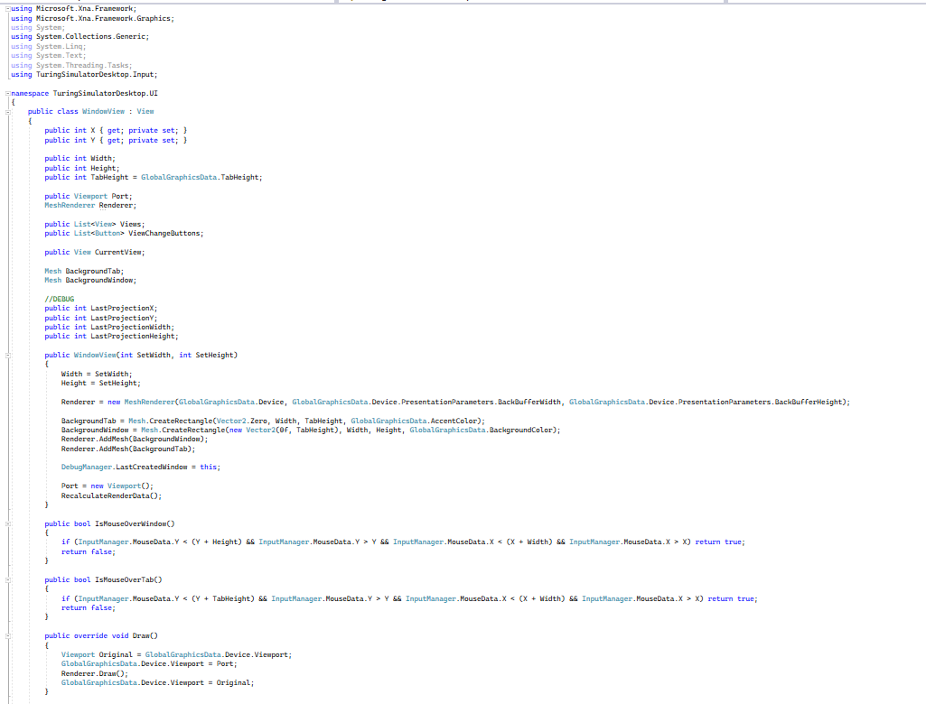

#### WindowView

using Microsoft.Xna.Framework;

using Microsoft.Xna.Framework.Graphics;

using System;

using System.Collections.Generic;

using System.Linq;

using System.Text;

using System.Threading.Tasks;

using TuringSimulatorDesktop.Input;

namespace TuringSimulatorDesktop.UI

{

public class WindowView : View

{

public int X { get; private set; }

public int Y { get; private set; }

public int Width;

public int Height;

public int TabHeight = GlobalGraphicsData.TabHeight;

public Viewport Port;

MeshRenderer Renderer;

public List<View> Views;

public List<Button> ViewChangeButtons;

public View CurrentView;

Mesh BackgroundTab;

Mesh BackgroundWindow;

//DEBUG

public int LastProjectionX;

public int LastProjectionY;

public int LastProjectionWidth;

public int LastProjectionHeight;

public WindowView(int SetWidth, int SetHeight)

{

Width = SetWidth;

Height = SetHeight;

Renderer = new MeshRenderer(GlobalGraphicsData.Device, GlobalGraphicsData.Device.PresentationParameters.BackBufferWidth, GlobalGraphicsData.Device.PresentationParameters.BackBufferHeight);

BackgroundTab = Mesh.CreateRectangle(Vector2.Zero, Width, TabHeight, GlobalGraphicsData.AccentColor);

BackgroundWindow = Mesh.CreateRectangle(new Vector2(0f, TabHeight), Width, Height, GlobalGraphicsData.BackgroundColor);

Renderer.AddMesh(BackgroundWindow);

Renderer.AddMesh(BackgroundTab);

DebugManager.LastCreatedWindow = this;

Port = new Viewport();

RecalculateRenderData();

}

public bool IsMouseOverWindow()

{

if (InputManager.MouseData.Y < (Y + Height) && InputManager.MouseData.Y > Y && InputManager.MouseData.X < (X + Width) && InputManager.MouseData.X > X) return true;

return false;

}

public bool IsMouseOverTab()

{

if (InputManager.MouseData.Y < (Y + TabHeight) && InputManager.MouseData.Y > Y && InputManager.MouseData.X < (X + Width) && InputManager.MouseData.X > X) return true;

return false;

}

public override void Draw()

{

Viewport Original = GlobalGraphicsData.Device.Viewport;

GlobalGraphicsData.Device.Viewport = Port;

Renderer.Draw();

GlobalGraphicsData.Device.Viewport = Original;

}

public void SetWindowPosition(int SetX, int SetY)

{

X = SetX;

Y = SetY;

Renderer.Effect.View = Matrix.CreateTranslation(X, Y, 0f);

RecalculateRenderData();

}

public void MoveWindow(int SetX, int SetY)

{

X += SetX;

Y += SetY;

Renderer.Effect.View = Matrix.CreateTranslation(X, Y, 0f);

RecalculateRenderData();

}

public override void ViewResize(int SetWindowWidth, int SetWindowHeight)

{

TabHeight = GlobalGraphicsData.TabHeight;

Width = SetWindowHeight;

Height = SetWindowHeight;

Renderer.DeleteMesh(BackgroundTab);

Renderer.DeleteMesh(BackgroundWindow);

BackgroundTab = Mesh.CreateRectangle(Vector2.Zero, Width, TabHeight, GlobalGraphicsData.AccentColor);

BackgroundWindow = Mesh.CreateRectangle(new Vector2(0f, TabHeight), Width, Height, GlobalGraphicsData.BackgroundColor);

Renderer.AddMesh(BackgroundWindow);

Renderer.AddMesh(BackgroundTab);

RecalculateRenderData();

}

public void RecalculateRenderData()

{

Port.X = X;

Port.Y = Y;

Port.Width = Width;

Port.Height = Height;

LastProjectionX = X;

LastProjectionY = Y;

LastProjectionWidth = Width;

LastProjectionHeight = Height;

Renderer.RecalculateProjection(X, Y, Width, Height);

}

}

}

#### Mesh

using Microsoft.Xna.Framework;

using Microsoft.Xna.Framework.Graphics;

using System;

using System.Collections.Generic;

using System.Linq;

using System.Text;

using System.Threading.Tasks;

namespace TuringSimulatorDesktop.UI

{

public class Mesh

{

public Matrix MeshTransformations;

public VertexPositionColor[] Vertices;

public int[] Indices;

public Texture2D Texture;

public Mesh()

{

MeshTransformations = Matrix.CreateWorld(new Vector3(0, 0, 0), Vector3.Forward, Vector3.Up);

}

public Mesh(VertexPositionColor[] SetVertices, int[] SetIndices, Texture2D SetTexture = null)

{

Vertices = SetVertices;

Indices = SetIndices;

Texture = SetTexture;

MeshTransformations = Matrix.CreateWorld(new Vector3(0, 0, 0), new Vector3(0, 0, 1), new Vector3(0, -1, 0));

}

public float GetFurthestRightVertexPoint()

{

float FurthestPoint = 0f;

for (int i = 0; i < Vertices.Length; i++)

{

if (Vertices[i].Position.X > FurthestPoint) FurthestPoint = Vertices[i].Position.X;

}

return FurthestPoint;

}

public float GetFurthestDownVertexPoint()

{

float FurthestPoint = 0f;

for (int i = 0; i < Vertices.Length; i++)

{

if (Vertices[i].Position.Y > FurthestPoint) FurthestPoint = Vertices[i].Position.Y;

}

return FurthestPoint;

}

public static Mesh CreateRectangle(Vector2 Offset, float Width, float Height, Color BackgroundColor)

{

Mesh Data = new Mesh();

Data.Vertices = new VertexPositionColor[]

{

new VertexPositionColor(new Vector3(Offset.X, Offset.Y + Height, 0f), BackgroundColor),

new VertexPositionColor(new Vector3(Offset.X, Offset.Y, 0f), BackgroundColor),

new VertexPositionColor(new Vector3(Offset.X + Width, Offset.Y, 0f), BackgroundColor),

new VertexPositionColor(new Vector3(Offset.X + Width, Offset.Y + Height, 0f), BackgroundColor),

};

Data.Indices = new int[]

{

0, 1, 2, 0, 2, 3

};

return Data;

}

}

}

#### MeshRenderer

using Microsoft.Xna.Framework;

using Microsoft.Xna.Framework.Graphics;

using System;

using System.Collections.Generic;

namespace TuringSimulatorDesktop.UI

{

public class MeshRenderer : IDisposable

{

bool IsDisposed;

GraphicsDevice Device;

public BasicEffect Effect;

/*

VertexPositionColor[] Vertices;

int[] Indices;

*/

List<Mesh> Meshes;

public MeshRenderer(GraphicsDevice SetDevice, int Width, int Height)

{

Device = SetDevice;

Meshes = new List<Mesh>();

Effect = new BasicEffect(Device);

Effect.TextureEnabled = true;

Effect.FogEnabled = false;

Effect.LightingEnabled = false;

Effect.VertexColorEnabled = true;

Effect.World = Matrix.Identity;

Effect.View = Matrix.Identity;

RecalculateProjection(0, 0, Width, Height);

}

public void RecalculateProjection(int X, int Y, int Width, int Height)

{

Effect.Projection = Matrix.CreateOrthographicOffCenter(X, X + Width, Y + Height, Y, 0f, 1f);

}

public void AddMesh(Mesh Data)

{

Meshes.Add(Data);

}

public void DeleteMesh(Mesh Data)

{

Meshes.Remove(Data);

}

public void Draw()

{

foreach (Mesh Data in Meshes)

{

if (Data.Texture != null)

{

Effect.Texture = Data.Texture;

Effect.TextureEnabled = true;

}

else

{

Effect.Texture = null;

Effect.TextureEnabled = false;

}

Effect.World = Data.MeshTransformations;

foreach (EffectPass Pass in Effect.CurrentTechnique.Passes)

{

Pass.Apply();

Device.DrawUserIndexedPrimitives<VertexPositionColor>(PrimitiveType.TriangleList, Data.Vertices, 0, Data.Vertices.Length, Data.Indices, 0, Data.Indices.Length / 3);

}

}

}

public void Dispose()

{

if (IsDisposed) return;

Effect?.Dispose();

Meshes.Clear();

IsDisposed = true;

}

}

}

#### DebugManager

using Microsoft.Xna.Framework;

using Microsoft.Xna.Framework.Graphics;

using System;

using System.Collections.Generic;

using System.Linq;

using System.Text;

using System.Threading.Tasks;

using TuringSimulatorDesktop.Input;

using TuringSimulatorDesktop.UI;

namespace TuringSimulatorDesktop

{

public static class DebugManager

{

public static WindowView CurrentWindow;

public static WindowView LastCreatedWindow;

public static void Draw(GraphicsDevice Device, SpriteBatch spriteBatch)

{

Device.SetRenderTarget(null);

spriteBatch.DrawString(GlobalGraphicsData.Font, "Cur Mouse Pos: " + InputManager.MouseData.X.ToString() + ", " + InputManager.MouseData.Y.ToString(), Vector2.One, GlobalGraphicsData.FontColor);

spriteBatch.DrawString(GlobalGraphicsData.Font, "ViewPort: Width: " + GlobalGraphicsData.Device.Viewport.Width.ToString() + ", Y: " + GlobalGraphicsData.Device.Viewport.Height.ToString(), new Vector2(1f, 20f), GlobalGraphicsData.FontColor);

if (CurrentWindow != null) spriteBatch.DrawString(GlobalGraphicsData.Font, "Window Data: Pos - " + CurrentWindow.X.ToString() + ", " + CurrentWindow.Y.ToString(), new Vector2(1f, 40f), GlobalGraphicsData.FontColor);

else spriteBatch.DrawString(GlobalGraphicsData.Font, "Window Data: Null", new Vector2(1f, 40f), GlobalGraphicsData.FontColor);

if (CurrentWindow != null) spriteBatch.DrawString(GlobalGraphicsData.Font, "Window Data: Port X : " + CurrentWindow.Port.X.ToString() + ", Y: " + CurrentWindow.Port.Y.ToString() + " Width: " + CurrentWindow.Port.Width.ToString() + ", Height: " + CurrentWindow.Port.Height.ToString(), new Vector2(1f, 60f), GlobalGraphicsData.FontColor);

else spriteBatch.DrawString(GlobalGraphicsData.Font, "Window Data: Null", new Vector2(1f, 60f), GlobalGraphicsData.FontColor);

if (CurrentWindow != null) spriteBatch.DrawString(GlobalGraphicsData.Font, "Window Data: Projection X : " + CurrentWindow.LastProjectionX.ToString() + ", Y: " + CurrentWindow.LastProjectionY.ToString() + " Width: " + CurrentWindow.LastProjectionWidth.ToString() + ", Height: " + CurrentWindow.LastProjectionHeight.ToString(), new Vector2(1f, 80f), GlobalGraphicsData.FontColor);

else spriteBatch.DrawString(GlobalGraphicsData.Font, "Window Data: Null", new Vector2(1f, 80f), GlobalGraphicsData.FontColor);

if (LastCreatedWindow != null) spriteBatch.DrawString(GlobalGraphicsData.Font, "Last Window Data: Port X : " + LastCreatedWindow.Port.X.ToString() + ", Y: " + LastCreatedWindow.Port.Y.ToString() + " Width: " + LastCreatedWindow.Port.Width.ToString() + ", Height: " + LastCreatedWindow.Port.Height.ToString(), new Vector2(1f, 100f), GlobalGraphicsData.FontColor);

if (LastCreatedWindow != null) spriteBatch.DrawString(GlobalGraphicsData.Font, "Last Window Data: Projection X : " + LastCreatedWindow.LastProjectionX.ToString() + ", Y: " + LastCreatedWindow.LastProjectionY.ToString() + " Width: " + LastCreatedWindow.LastProjectionWidth.ToString() + ", Height: " + LastCreatedWindow.LastProjectionHeight.ToString(), new Vector2(1f, 120f), GlobalGraphicsData.FontColor);

}

}

}

#### Summary

To test the prototype, we ran it and interacted with a designed testing interface.

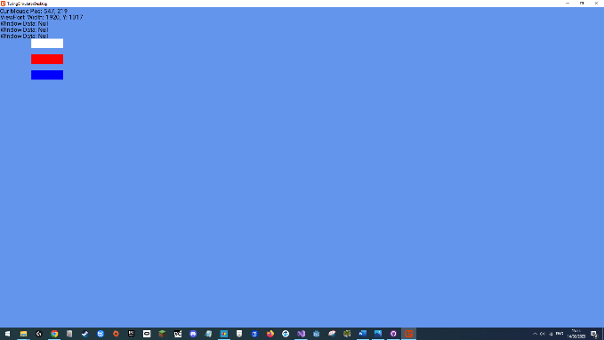We are first greeted by a main menu, which has three buttons the user can press.

When the user clicks the white button they get shown a new screen:

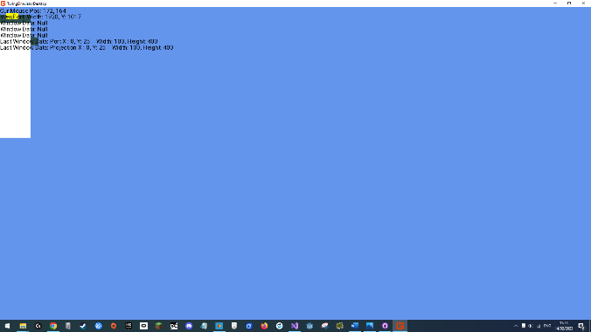

Here we can see a window and yellow button. Both of these are interactable, where pressing the yellow button causes new windows to appear, and the windows themselves can be dragged and resized.

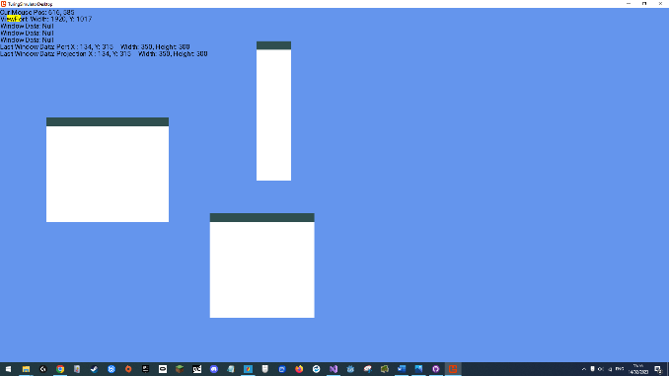Here we can see the result after pressing the yellow button twice more and moving around some windows:

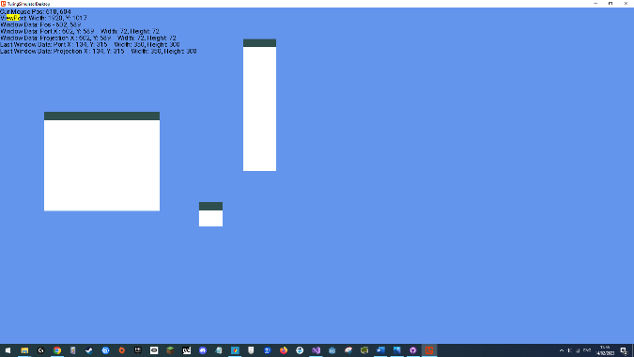Here is one of the windows being resized:

The prototype works on a screen based hierarchy, rendering and allowing the user to interact with one screen at a time, namely the main menu and window screens. The screens are then made of a toolbox of existing elements, namely buttons and windows. All items that are drawn on screen inherit from the UIElement class, while all the interactable elements are controlled through a single input management system (which is invisible to the user), which evaluates and fires off events on all visual elements that inherit the IClickable/IPollable interfaces. As these are interfaces, any class can implement, this combination of OOP/composition gives us great flexibility and speed with development of additional user controls that integrate seamlessly into the entire rendering and input system.

# Functional Design

## Core Model Design

**The Turing Machine**

At the core of the entire system is the Turing Machine. As described in the analysis, the Turing machine is an abstract computational model of a machine that can manipulate symbols on a piece of tape according to series of transition rules.

A Turing Machine performs one simple loop, repeating forever or until it reaches a Halt-State (meaning an end state), this loop can be simply explained as:

* Read the tape
* Lookup the read value in a statetable
* Perform resulting operations

A Turing Machine can perform three different operations:

**Change State**

The Change State operation takes an operand, this being the new state, and causes the Turing Machines state to change to the newly defined one.

**Write**

The Write function also takes in an operand, this one being the new value that is to be written to the tape, when called this operation will then write this new value onto the cell on the tape over which the read/write head is over currently.

**Move**

The move functions in a classically defined Turing Machine takes in an operand of move left or move right, but in our implementation, to support classical and nonclassical Turing Machines, we will take in an integer operand which signifies how many spaces the Read/Write head will move, for example this means when the move function is called an operand of -1 will cause the R/W head to move one space left and a operand of 3 will cause the R/W head to move right 3 spaces.

Now that we understand how a Turing Machine works, we need to discuss how our model will simulate this machine and give us access to all the necessary data to be able to display this whole process the user.

First we can start with the data model.

To define a functioning Turing Machine three inputs are required:

* A Statetable
* An Alphabet
* A Tape

Keeping the exact implementation of our Turing Machine algorithm from above, a black box, we can represent a Turing Machine alongside its required inputs like this on a diagram:

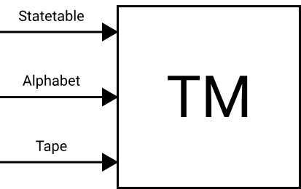

Next, we need to establish some outputs for our Turing Machine, we need the user to be able to see certain properties of the Turing Machine, namely we want to see the resulting state of the tape the machine is working on, the state of the machine and where the read/write head is currently located.

Now that we have defined what outputs are required for our machine, we can display them on our diagram:

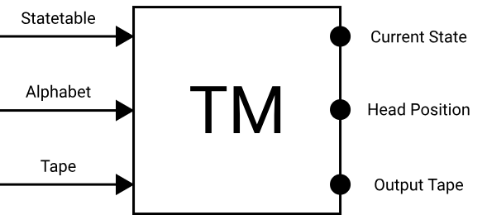

Creating these public properties allows any front end to directly plug into an instance of a Turing Machine and be provided all the required data to present a fully functioning Turing machine to the user:

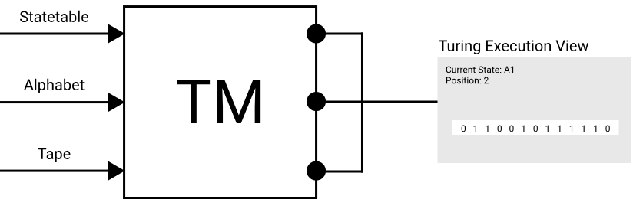

Now that we have defined a Turing Machine data model that has clear inputs and outputs, we can explore in more detail what the inputs, namely the state table, alphabet, and tape, mean to our data model.

**The Alphabet & Statetable**

An alphabet is simply a collection of symbols, in other words characters, that are allowed to appear on the Turing Machines statetable/tape.  
For example computers understand binary, binary can be described as a very simple two symbol alphabet:

{0 , 1}

For a Turing Machine to understand the Latin alphabet we could define it as:

{a, b, c, d, e, f, g, h, i, j, k, l, m, n, o, p, q, r, s, t, u, v, w ,x ,y ,z}

Now we can supply this alphabet to our Turing Machine so that it can know what values it is meant to read and understand on a tape. An alphabet is essential in being able to define a statetable.

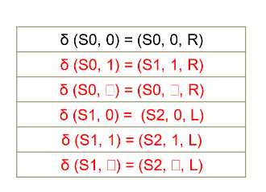A statetable is a set of transition rules (instructions) that define the program for a Turing Machine. A statetable can be defined in many ways, in A level theory, we define a statetable using a table of state transitions:

These display five-tuples which each define an instruction for our Turing machine, where we lookup our current state of the Turing Machine and the value we are currently reading from the tape, to get the three values to perform our Turing Machines’ loop, of changing new state, the new state, the new value that should appear on the tape, and the direction the R/w head should move in.

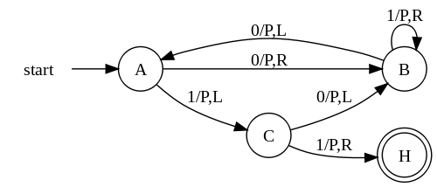Looking wider, there are numerous other methods of representing statetables for Turing Machines, for example through finite state machine graphs:

As such, we need to create a structure in our data model that allows these multiple representations to all compile to one consistent statetable representation that our Turing Machine can finally interpret.

To solve this, we will create a Statetable Source object in our data model, this object will provide a common interface, that compiles whatever statetable representation it stores, into a standardised stateable, which our black box Turing Machine algorithm will be implemented to understand. Since we need an alphabet to be able to define any kind of statetable, and the Turing Machine will itself require the alphabet, we will package the defining alphabet of the statetable representation alongside it, as part of our Stateable Source object:

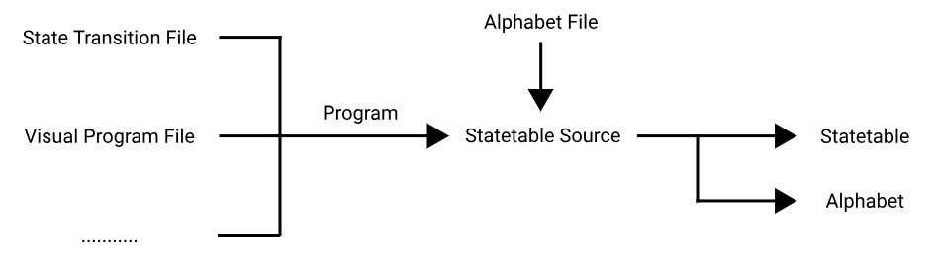

Our front end is currently planned to provide two methods of defining a statetable, one using the A-Level spec method, using state transitions, and another method using graphs and nodes, which allow the user greater control (by being able to define non-classical statetables). These source can be seen as the “program” inputs on the above graph.

**The Tape**

The tape is the final vital component to a Turing Machine. It serves both as the input and the memory for a Turing Machine, it is where all data is written to and read from.

It spans infinitely and is split into single cells, with each cell containing a symbol written on it, this could include letters, words, numbers, Unicode characters or blank cells, where an empty space on them is itself a symbol.

From an implementation perspective, it is impossible for us to store the entire infinite tape on disk, as such in our model, we will only store the non-empty cells of a tape, and then fill in the remaining cells on the go, using a default empty symbol, which we will add as an additional property of an alphabet in our model.

Going back, the user should be able to run their Turing machines with a variety of inputs, to allow this, our Turing Machine model must be able to take in a custom, user defined tape, known as a preset tape.

For ease of use, we will also define a default tape, this tape will be automatically loaded into a Turing Machine to use if a user doesn’t load in their own preset tape, the default tape will simply be an infinitely long span of empty symbols.

As such we have two input sources for our Turing Machines, a default tape or a preset tape; fitting these possible input sources into our diagram looks like this:

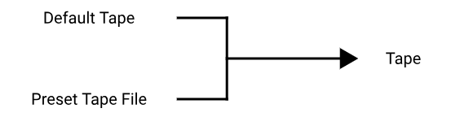

**Final Input/Output Design**

Having considered all of our data required for our Turing Machine simulation algorithm, we can create a final data model using our design:

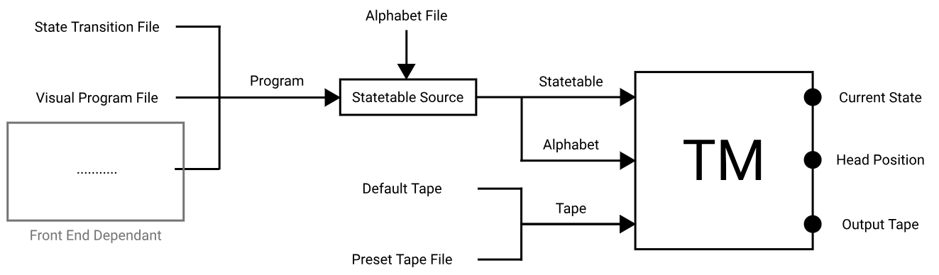

**Controlling The Model**

Now that we have considered how to appropriately create our Turing Machine’s data model, we must consider the other component required to finalise the Turing Machine simulation model, the control methods for our simulation algorithm.

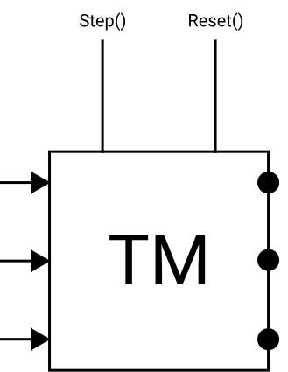We must provide some way to interact with the Turing Machine, for example to allow the user to change inputs they put into the Turing Machine or actually make the Machine start/stop its simulation loop:

Here we can see two control methods having been added to the TM black box, the Step() function and the Reset() function. The step function makes the TM algorithm perform a loop once, stepping the TM forward one instruction, while the Reset() method clears all inputs supplied to the Turing Machine.

Just these two controls allow us great control and flexibility over interaction with the Turing Machine model, this is as these two control can be built up on by the front end user interface, meaning implementing additional controls that work purely by utilising these two base functions:

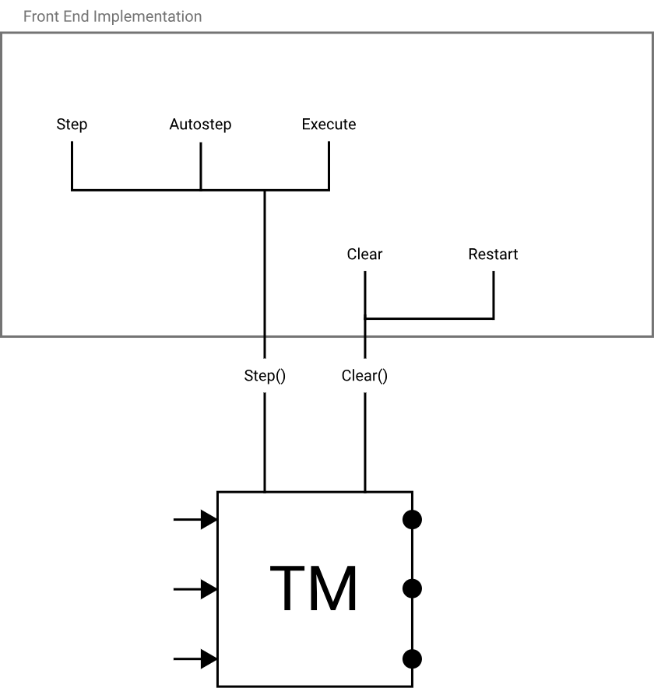

Above is complete list of controls we will later offer the user in our front end. In detail these are:

* **Stepping**

Moves the turing machine forward one instruction.

* **Auto stepping**

Automatically moves the turing machine forward an instruction at a time, animating it for the user.

* **Executing**

Loops the Turing Machine until it reaches a halt state or some limiting number of instructions, allowing the user to immediately see the output of his program with a given input.

* **Clearing**

Clears all data supplied to the Turing Machine, allowing user to change inputs.

* **Restart**

Clears all data in the Turing Machine and inputs previously inputted data, setting the Machine back to its start state, allowing user to rerun their program again.

All of these are implemented simply using the two core controls. This alongside our TM inputs gives front ends great flexibility on implementing our overall core model for the user, be it how it can be displayed, altered through parameters or controlled

**Final Design**

Combining our core data model with all our control methods, we can represent the entire Turing machine model like this:

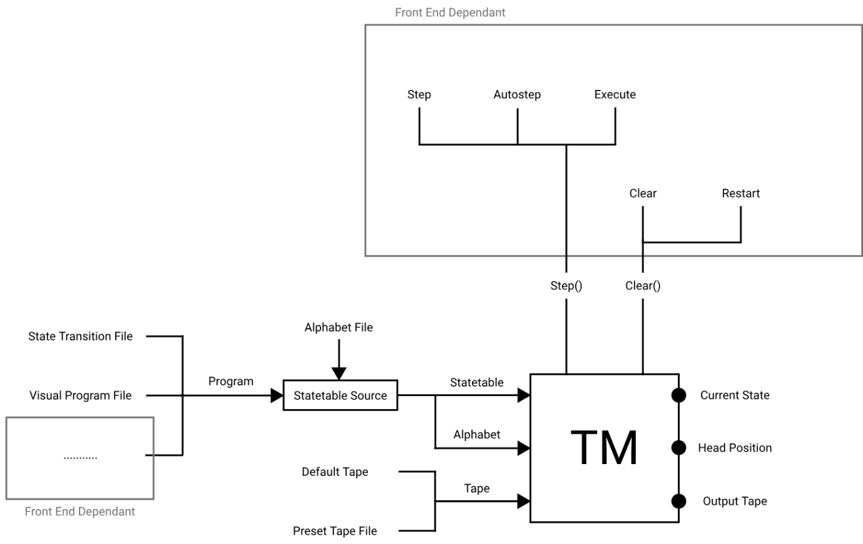

## Backend Design

The backend will be responsible for all resource management, be it managing the user projects state, manging files within a project, or managing clients and their respective connections.

The backend will be implemented as previously mentioned as a standalone library, this can then be implemented by any interface, for example a console or as part of a visual front end (which will be the case in our front end).

The library will consist of the main server and helper classes for it, e.g., specifically for managing files or generating response packets.

**The Server Main Loop**

The server must process requests in real time, with high speed as to ensure a smooth experience for clients using the software. As such the proposed design is that the part of the server that is responsible for processing requests and sending back responses will run on its own dedicated thread while the networking aspect of receiving requests will be handled separately from the server thread, as will be expanded upon in the networking section.

As the server thread that does all the processing will run on its own thread, this opens a few issues we must consider; first is how will the server receive requests from the separate networking threads, and how will we be able to shut down the server from a UI thread?

The solution is simple, the server will contain two variables that can be modified by any thread, a boolean signifying whether the server should shut down, and a queue of requests the server is to process. The server will run an infinite loop, checking if it has been told to shut down by checking the shutdown boolean value, while within the loop, the server will copy the contents of the request queue, (which will store requests oldest first) and then process all these requests, repeating the process.

A flowchart for this algorithm can be found on the next page.

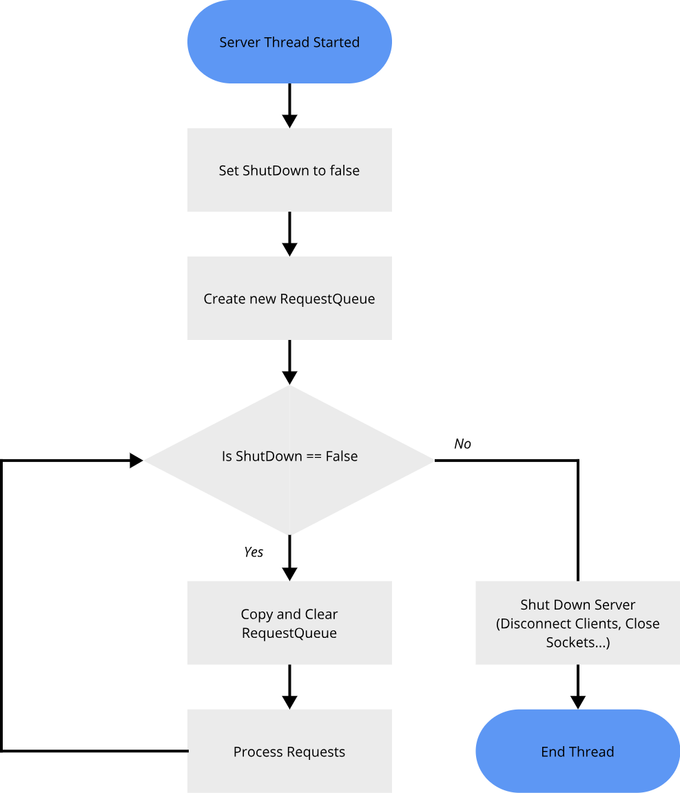

### Networking Design

In the technical analysis a basic outline of the networking system to be used in the backend was described. This consisted of using a REST style architecture to communicate with the front-end using TCP sockets to send the requests/response between devices.

Looking at the networking more exactly, we first must establish a proper protocol for communication so that every device understands the data/bytes sent to it.

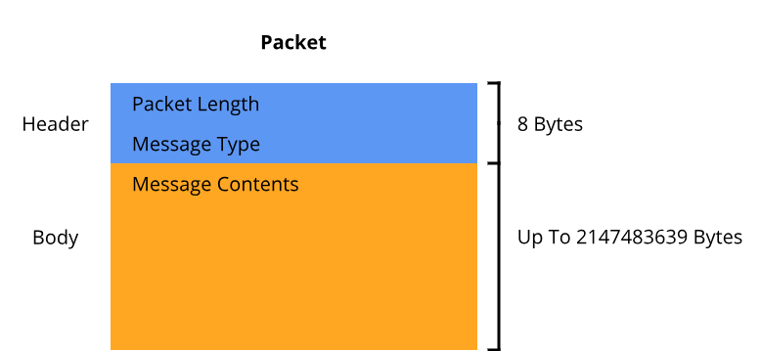Each message will first consist of an 8-byte header. The first 4 bytes of every message sent between clients will be allocated for an integer that tells the receiver how many bytes the whole message is in size, following this will be another 4-byte integer identifying what type of request/response this message is, following the header be the payload, also known as the body of the message, which is the actual useful contents of the message:

The next consideration is how we will be structuring our payload within the packets/messages we send between the server and client.

As agreed by our REST architecture, the payload from our server to the client will consist of an array of bytes that represent a JSON object, this object will contain all information related to the message, this being what type of response this is, indicated by a unique integer, and the associated response data, i.e. the contents of a file if a file request was sent.

The core library contains C# class/JSON templates that describe these JSON responses, allowing the client to easily serialize the byte stream into the appropriate object, these templates alongside the assumption that any message coming from the server is always valid and contains all appropriate data allows any front end implementation to easily translate the incoming data into useful messages/objects, without having to perform unnecessary validity checks or implementing its own parser, saving on code in the front end.

On the other hand, messages sent to the server will not use JSON objects as a payload, but will instead use structured binary data, for example a file update request packet will have this structure:

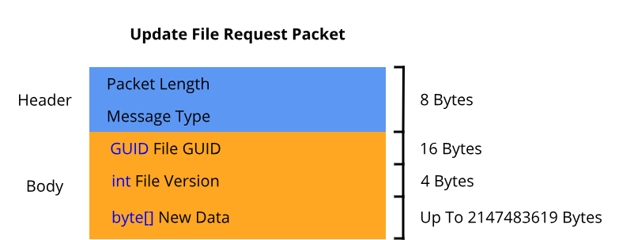

These binary structed requests while seeming counterintuitive are actually beneficial, performance is a huge factor with servers, the server must be able to process packets quickly as to keep clients feeling like they are working with the project in real time, part of this is optimizing communication, by having a specific binary structure like this, the server don’t need to use processing time to serialize the received data into a JSON object to then read, instead it can directly read in binary as the required data types, this alongside the fact the binary packets will themselves be smaller in size (in terms of bytes) as values aren’t encoded as long text, but as their actual binary representation, means the incoming requests to the server will be received and read and as such processed quicker.

On the next page you can find a table showing every possible request and a mapping to its binary structure.

|  |  |
| --- | --- |
| **Request Type** | **Structure** |
| Load Project | string Location |
| Request Project Data | *Empty* |
| Receive Log Receiver Status | *Empty* |
| Request File | Guid File ID  bool Subscribe To Updates |
| Request File Metadata | Guid File ID |
| Unsubscribe from File Updates | Guid File ID |
| Create File | int Parent Folder ID  string File Name  int File Type |
| Move File | Guid File ID  int Destination Folder ID |
| Rename File | Guid File ID  string New File Name |
| Update File | Guid File ID  int File Version  byte[] New Data |
| Delete File | Guid File ID |
| Request Folder Data | int Folder ID  bool Subscribe To Updates |
| Unsubscribe from Folder Updates | int Folder ID |
| Create Folder | int Parent Folder ID  string Folder Name |
| Move Folder | int Folder ID  int Destination Folder ID |
| Rename Folder | int Folder ID  string New Folder Name |
| Delete Folder | int Folder ID |

**TCP Sockets & Packet Rebuilding**

Now that we understand how these packets/messages that will be sent between devices look like and how they will be processed, we must consider how we will actually send these packets over a network to other devices.

As previously stated, we will use a network protocol called TCP to send messages between devices. TCP is a networking protocol which allows us to treat a connection like a file and stream bytes to another device over a socket (active connection) for it to receive, TCP specifically provides us a few specific benefits over alternatives like UDP. TCP specifically guarantees that the data sent arrives to the receiver in the exact order sent and that the data does indeed arrive intact (missed/corrupt data is automatically reset). This simplifies our algorithm for reading in messages received as we have a guarantee the message is recieved exactly as originally sent.

A TCP socket provides a way of receiving or sending a stream of bytes as previously stated, as such sending data is easy, treating the socket like a file we simply call the write function with the message we want to send and the OS does the rest for us, but there appears a small difficulty with receiving data, there is no guarantee that an entire packet worth of data is going to be received in a single TCP transmission aka. a Read function call, that’s why we need to implement an algorithm to rebuild data being recieved over the socket, until a full request packet is received by the server.

C# Allows us to use asynchronous sockets – this means that the server won’t have to listen constantly for incoming data but instead can have the operating system notify our program whenever there is new data incoming to the server and launch a separate thread that will handle this data, and eventually provide us with a valid request from a client that the server thread can handle.

This requires an algorithm that correctly handles the server receiving incoming TCP data, collecting it until a valid request is fully received and then adding the request to a queue using which the server can finally process the request.

A flowchart algorithm for this can be seen on the next page.

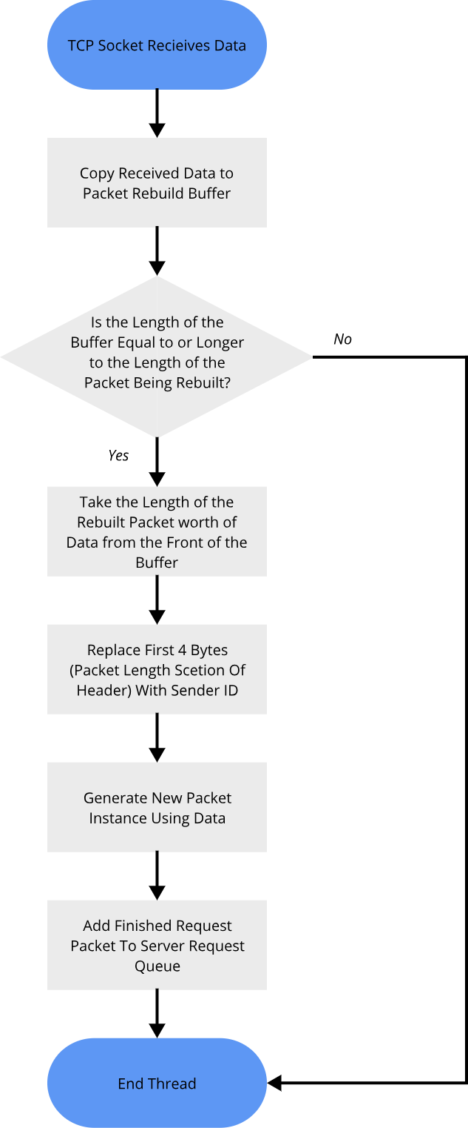

### File Persistence & Management

Part of our goals for the project is to allow users to be able to work together collaboratively on a set of files and to be able to intuitively manage the resources they generate and use.

As such the software will use a project-based file management system, akin to that found in other software like Visual Studio or Unity. When a user wants to start working with the application, they will first have to create a project. A project is a space where a user will store all related files they create and use when working with Turing Machines, projects also bound all files within them to settings that have been set up on the project, for example whether non-classical Turing Programs are allowed to be programmed within the given project.

From a technical standpoint a freshly created project is stored on the disk as a main folder, within which there is a project settings file and a data folder.

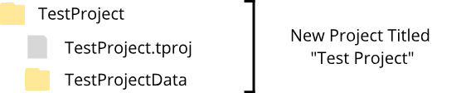

The project settings file stores both technical information, such as the path of the data folder, and settings/details about a given project.

The role of the data folder is that it is where all user generated content is stored and modified by the backend. meaning when a user creates folder, or files, they all are placed inside the data folder.

As per our core model design there are 4 core objects we want to user to be able to use and store:

* Alphabet Definitions
* Tape Pre-sets
* State Transition Programs
* Custom Graph Programs

To store these objects on disk alongside the previously mentioned project settings file, each of these will need their own file type:

|  |
| --- |
| **Project Settings File** |
| Stores a variety of settings and technical information about a project.  ***File Extension: .tproj*** |

|  |
| --- |
| **Alphabet Definition File** |
| An alphabet definition file stores an Alphabet object as defined in the Core Model section.  This means storing a list of strings (symbols).  ***File Extension: .alph*** |

|  |
| --- |
| **Tape Pre-set File** |
| A tape pre-set file stores a tape (an input as defined in the Core Model section) the user can quickly load in to use by a Turing Machine instance.  This means storing a list of strings (symbols).  ***File Extension: .tape*** |

|  |
| --- |
| **State Transition File** |
| A state transition file stores a state transition based program source as defined in the Core Model section.  This means storing a list of transition objects and a list of halt states.  ***File Extension: .trt*** |

|  |
| --- |
| **Custom Graph File** |
| A custom graph file stores a node based program source as defined in the Core Model section.  This means storing a list of nodes, connections between nodes, possible states and halt states.  ***File Extension: .cgr*** |

We want to store the data in these files in an easy-to-read format, both for people and the computer, this is for two reasons:

* We want to encourage users to be able to read through the files and be able to alter them themselves.
* We want to computer to be able to easily deserialize the data for performance reasons.

As such we will encode the objects represented by these files using a format called JSON. JSON is a standard file format for translating objects in memory into a text string format that is both easy for a human and computer to read, or in technical terms deserialize, and easy for the computer to write, or in technical terms serialize. As stated, when we serialize our objects, we will get a specifically encoded string of text that we will store, there are a variety of ways to encode strings for storage, in our use case we will encode the JSON strings for our objects using the UTF8 format.

The UTF 8 format has been specifically chosen due to performance, the C# UTF8 JSON serializer/deserializer is about 15-20% faster in performance compared to other formats such as Unicode and provides better error detection within the serializer itself, according to Microsoft’s own documentation:

<https://learn.microsoft.com/en-us/dotnet/standard/base-types/character-encoding>

All while still allowing our backend to encode a large set of characters.

Performance and the ability to encode a large variety of symbols/characters are both key requirements for our backend, making UTF8 the optimal choice.

Our files are for all intents and purposes equivalent to simple text files that store JSON encoded objects, but they have been elected to have their own file formats for safety reasons, specifically, since we have our own proprietary file formats (extensions) for these files, whenever a file is requested to be opened we can have the backend ensure the file is one of these known formats, to ensure we are not opening any objects/files the backend would not be able to deserialize, and to ensure that we aren’t loading in any non-project, private files we don’t want clients to access.

An important note about these files is that some files need to be able to reference other files, i.e., the program files need to reference an alphabet definition file, to determine the alphabet they are written in. This means we will need to have some sort of information regarding each file to provide us a way for files to address each other, this coupled with us having to store a few pieces of metadata, for example files names, means that we need to figure out a system to store and reference this data to their respective files.

The solution to storing this metadata is to use a two-file system, meaning that every one of our designed files will be in fact stored as two files, a metadata-file and an object-file, where the object files are the ones as described previously, storing our JSON objects, and the metadata-files are additional files stored in the same folder area, storing pure metadata about our object files.

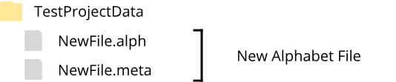

These metadata-files will have an extension of “.meta” also contain be text files that store UTF8 JSON objects, where we will now have a fifth object to save called a metadata object. Each metadata object will have to store these pieces of metadata:

* File Name
* File Type
* File Unique Identifier

The question arises of what is a unique file identifier? As mentioned, we will need a way for files to be able to reference each other, this can be done though assigning each file a unique ID, and then storing that unique ID to refer to that file. As for how our unique file ID system will work, we will use something called GUIDs. A GUID is a Global Unique Identifier, it is a 128-bit identifier that can be generated independently by any computer and practically speaking is guaranteed to be globally unique, a GUID will be generated for every file created and will allow files to reference each other as required. Some additional benefits of this system include that since each GUID is guaranteed to be unique globally, files generated by other devices in other projects can be added to a project and referenced without a problem, which is important since students are likely to share files together and we also don’t have to create our own ID issuing system, as the GUID system is implemented by C# for us.

Additional notes about the file management system, is that whenever the backend loads in a project, it will verify each file for corruption.

The first check that will be implemented is checking a files metadata, this means making sure it has an issued GUID, that the object file the metadata references does indeed exist and that the file type and extension match up, if a problem is found the server will automatically be able to perform certain fixes or skip loading the corrupted file, for example a missing GUID can be reissued with a new one, or a metadata pointing to a non-existent object file can be simply deleted and object files with corrupted JSON data can be skipped during loading and the backend can write a log saying which files were found to be corrupted and skipped allowing some sort of admin or server owner to manually fix the files, which is possible thanks to the human readable format of JSON.

Since we have established what files we will be using, and how we will format and store data in them, we can now establish data schemas for each core-model/file-management-system JSON objects that are required by our backend:

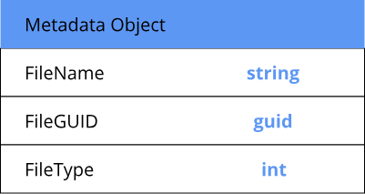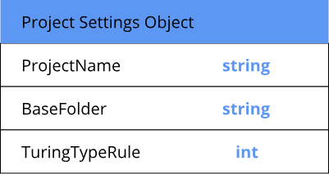

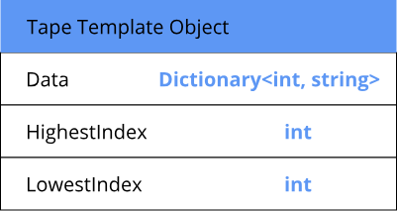

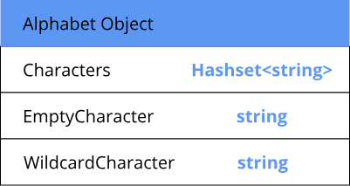

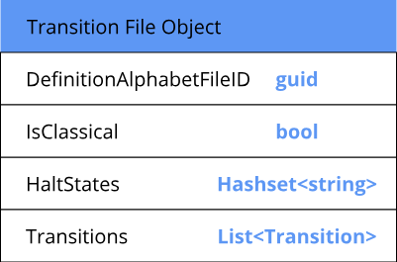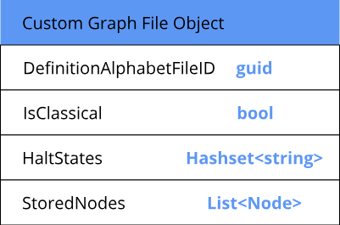

### Networking and File Security

As this project uses networking, there is a variety of security risks that we as developers must consider and balance.

The backend of the application directly interacts with files on the server’s device. This is a huge, namely biggest of all this projects, security vulnerability. This opens the host device to a variety of problems, be it having clients attempt to read non-project host files, edit, overwrite, move, or delete these files, and through extension try to gain access to the host OS in some capacity.

Another problem is that clients may try to send in corrupted requests or files in an attempt to crash the host server or client or maliciously overwrite project files.

Another issue we must consider is understanding where our requests come from. TCP sockets provide no guarantee that the device they are officially being received from, is actually the device sending the data and whether the data has been unaltered during transport. This is as TCP sockets do not provide encryption and only work on a combination of sender IP and socket to determine who the sender device is, and sender IP’s can easily be spoofed, this opens the requests being sent to risks of man-in-the-middle attacks and sender spoofing, consideration whether additional measures such as signing requests to determine the true sender must be taken.

Since as a rule of thumb, clients can never be trusted, these risks must be correctly accounted for.

For our first and second security vulnerabilities we take a measure of steps to secure the backend from being able to perform malicious actions in any capacity.

* The first measure we take is to weed out malicious/corrupt requests, the networking algorithm once it rebuilds a packet, checks if the request type encoded in the request is valid, if not, the request is skipped, otherwise the next security measure is within the processing stage itself, when the packet is being read for parameters, if a parameter is invalid the server again skips the request and moves onto the next one. This protects us against malicious file overwrite and attempts to crash the server from client devices.
* The next security measure stems from our file management system. All data users can create, read or edit is saved within the currently opened projects data folder, the server is incapable of accessing or altering files in any capacity that are outside of this directory, and has access to no files when no project is loaded. This protects the server device from attempts by clients to read or alter any non-project, private files.

For our third security problem, there are a number of solutions we could take.

* Signing of messages with a key could be implemented to ensure the sender is who they claim they are.
* Encryption could be used on requests/responses to stop man-in-the-middle attacks from both altering our data being sent and to stop capture of the unique signing key.

But an important consideration with these features is their usefulness and necessity compared to their downsides and the work required to implement them. So far, we do not handle any actually sensitive data between requests and responses, only sending back and forth either simple messages from the client to the server for the server to perform a certain action, or JSON objects from the server to the client. Implementing a public-private key encryption system, as symmetric would not prevent man-in-the-middle attacks due to risk of initial key capture, would be very time consuming, require learning an additional subsection of computer science and would, once implemented, cost a lot of performance both on the server and the client, as each communication would need to be decrypted first, costing precious processing time which may worsen the user experience. Furthermore, malicious files which could be introduced by man-in-the-middle attacks are already handled as part of our solution to our first and second security problems. Balancing these pros and cons, no steps are required to tackle this third vulnerability, as its main risks are already tackled and its remaining risk of knowing who the true sender of requests to the server is, is irrelevant to the scope of the project.

Now we must consider the client-side vulnerabilities.

* For the client side, the front end does not alter the devices files in any way using data from responses, only using those to supplement the frontend UI elements, as such the client does not to consider the issue of preventing improper files accesses from the sever or man-in the-middle attacks.
* Tackling the second vulnerability, invalid responses, which could only be caused by a malicious server or man-in-the-middle-attacks, are handled similarly to as on the server side, where these invalid responses are simply ignored if the JSON object returned fails to be successfully serialized.
* In terms of the need to ensure the client knows the responses are truly from the server, seeing our earlier considerations of this issue, it is again irrelevant, meaning the client side, like the server, does also not need to take any additional steps in this regard.

In conclusion, we have taken considered and implemented the appropriate steps to mitigate security vulnerabilities in our project and can ensure that the server and client devices are safe from attackers to the best of our knowledge.

## Front End Design

To the end user, the front end is what the application is. It is exclusively what dictates the users experience, how they interact with the application, their quality of life and how engaging it is to them. As such a lot of consideration must be taken into making the front end interface be responsive and intuitive.

From a technical standpoint, our front end will be responsible for communicating to the server any actions/requests made by the user, and then processing and displaying the responses generated by the server for the user in an interactive and again intuitive way.

The front end I will be making is a cross-OS desktop GUI interface. It is developed on the MonoGame engine which is what allows the final executable to be exported in such a way that it can run on Windows 10, 11, Mac OS and Linux devices as long as they have Mono installed.

**Main Client Loop**

As mentioned our front end uses Monogame as a base platform to work on. This is as MonoGame provides a single set of multi-platform interfaces that allow us to start, update, manage and close our application.

MonoGame provides us with a base MainWindow class with a variety of functions that we can use, for example the LoadContent() function is a function that gets called immediately when the application is opened, allowing us to load up and prepare any required resources and setup our application before it starts running.

The main function the class provides us is the Draw() function, this function gets called every frame of the application until it gets closed, meaning this is where we can put our main update loop for our application.

Some additional functions that we will use that are provided are the OnResize and OnExiting functions. These functions are both events that get called after the draw function is finished for the current frame. If the user resizes the OS window in which the application is running, the OnResize function will get called and allow us to handle resizing our UI appropriately, finally the OnExiting function gets called after the application has been told to close, this allows us to have a place where we can safely shut down our application, meaning saving changes made to a project, disconnecting from a server and shutting down our server if we were hosting the open project.

The main update loop will be responsible for managing the entire application. This means a variety of tasks will need to be done by it:

* **Process User Input**

This means processing all interaction between the user and UI, for example clicking a button and firing off appropriate events, checking if a user has dragged and dropped a piece of data onto a UI element, and as such updating the element appropriately.

* **Process Responses from the Server**

Once we receive our responses from the server, the main thread must take the responses and update the UI elements appropriately, so that the user can now see and interact with the data received from the server.

* **Managing Special Events**

Certain events cannot be executed immediately/sequentially, for example when waiting for a response when connecting to a server, we cannot freeze the entire update loop until a response is heard back as to the user it would look like the program crashed. As such a special events system needs to be setup, where when some task is ready to be processed further, it notifies the update loop, allowing the main thread to pick the task back up. An example would be the earlier mentioned application resizing, we get notified of the application window being resized through the OnResize function, but we don’t know the dimension of the new window until one frame later, as such a resize read event must be created, letting the main thread resize the UI appropriately later, once we know the new dimension for the application window.

* **Draw UI**

This is one of the most important tasks, we must finally display the entire state of the application to the user, this means drawing all of our UI elements into a final bitmap that is displayed to the user on the application window.

The order of performing these operations is important, drawing the UI before dealing with user inputs may result in the UI lagging behind user actions, and updating the UI with responses from the sever and then processing user input may result in the user clicking an element that may have not existed there before.

As such the order specified above is optimal, first dealing with the users inputs, performing what the user would expect to happen, then processing any new response from the server, such as creating a new view for a received file, next dealing with special events such as resizing the screen, which is now fine to do as all elements the screen will contain now have been processed, and then finally drawing the screen, displaying all that has happened to the user.

A flowchart displaying an algorithm for out frontend based on the above design can be found on the next page.

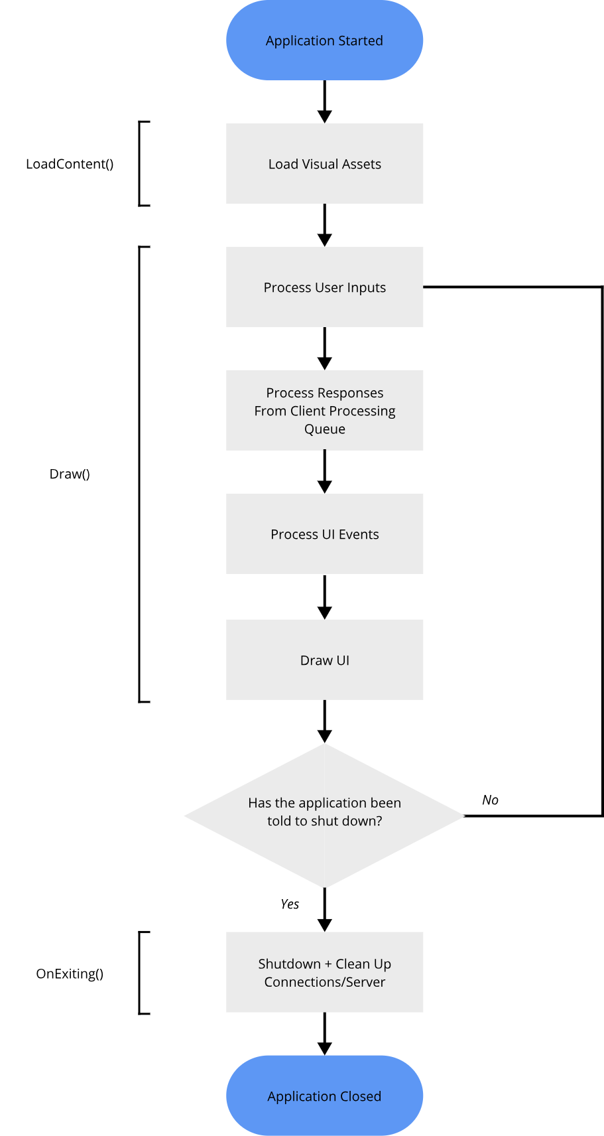

**Integrating The Backend**

Our backend implementation as specified before is only a library, meaning that it needs to be implemented by some front end to become part of an executable the user can run.

Our frontend will need to implement the server library as whenever we want to locally open or host a project, we will need to launch a server that will load in the project so we can interact with it.

The server library has been designed to primarily operate by itself, but we still need a way to control the backend, be it telling it when to launch a server or close it down, when for example the user shuts down the application. We can interact with our backend through an API. In our case the backend has a BackendInterface class which acts as the interface for our front end to interact with the backend, there we can find functions with appropriate to control our backend, fully integrating our front end and backend.

### Networking

The core protocol for how messages are structured and sent between devices, an explanation about sending/receiving data over TCP alongside resulting security considerations can be found in the Backend Design Networking and Networking & File Security sections.

**Receiving Data**

Since our front end is being implemented from scratch, we will not be provided with a networking system built in, as opposed to something like in web browsers where HTML messaging is provided for you, and as such will have to write our own networking system here similarly as was done on the backend.

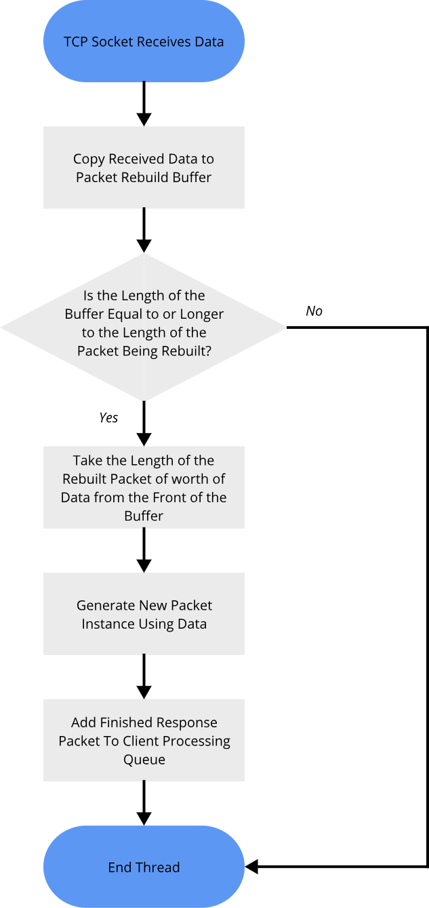As we are developing this front-end using C#, we can use an almost identical algorithm for receiving and processing responses from the server as we did when designing the server:

**Sending Data**

As for sending data, we will first generate request packets using a helper class that will come as part of the core data library, it will implement functions that return the appropriately setup packets that match the binary structures as specified in the Backend Design Networking sections’ table.

Like in our backend, C# lets us treat the TCP socket like a file and call the Write() function to write our request packets to the TCP socket to send to the server.

**Joining Projects**

When attempting to join a server, this attempt may not always be successful, this may be due to the server being full, network problems or a host of other reasons, as such creating a safe system that allows the application to attempt to join but can handle both successes and failures is important.

This problem can be handled through a timeout system, where a connection attempt will be made, and will be given only a select amount time to succeed before it is considered a failed attempt.

The drawback to a timeout system is that the machine must somehow track this attempt, the time it is taken and await for a response should a successful one arrive, doing this timeout-based connection attempt on the main update loop would be problem, as it would cause the entire loop to freeze up, and stop the user form being able to use the application.

As such connection attempt s will be made by calling a function that starts another thread, which itself handles the connection attempt, this separate thread will open the TCP connection, attempt to connect to the target device and await the timeout period. It will either receive a successful call back and finalise the connection, utilise our event system and mark the connected event as ready to be executed and then finish; or if the time period runs out, the separate thread will instead close the TCP connection and then end, marking the connected event a failure. This system means the main loop can execute separately from the connection attempt, and only process as successful connection when one is ready.

### File Management

The front end will need to store certain user settings/information, for example recently accessed files.

This will be saved as a JSON object representing the data, in a UTF8 text file. The reasoning for UTF8 usage can be found in the Backend Design File Management section.

OS’s provide special save areas for each user, called Application Data folders, where applications can store such setting/data files specific to each user, as they are always able to know this area exists and as such can access it no matter the device. We will also use this are to store our text file.

The schema for this file currently is:

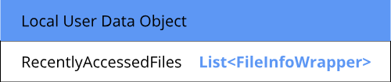

### UI Designs

#### Inspiration & Development Method

In the requirements for this project, it was established that one of the most important requirements of the application is that it must offer an intuitive yet effective visual interface that give the user the ability to create, interact with and view the step-by-step workings of Turing Machines as dictated by objectives 3 & 4:

*3. User interface should be intuitive, interactive, and engaging.*

*4. User should be able to visually and/or textually program Turing Machines.*

Similarly agreed on previously, users of this program will for majority of cases either have had or will have experience with IDE’s, with one of the most widely used, including by the sponsor, being Visual Studio, this meant Visual Studio was one of the core design inspirations for how the front-end UI would look and work, this including certain functionalities like windowed views or the core layout of the UI:

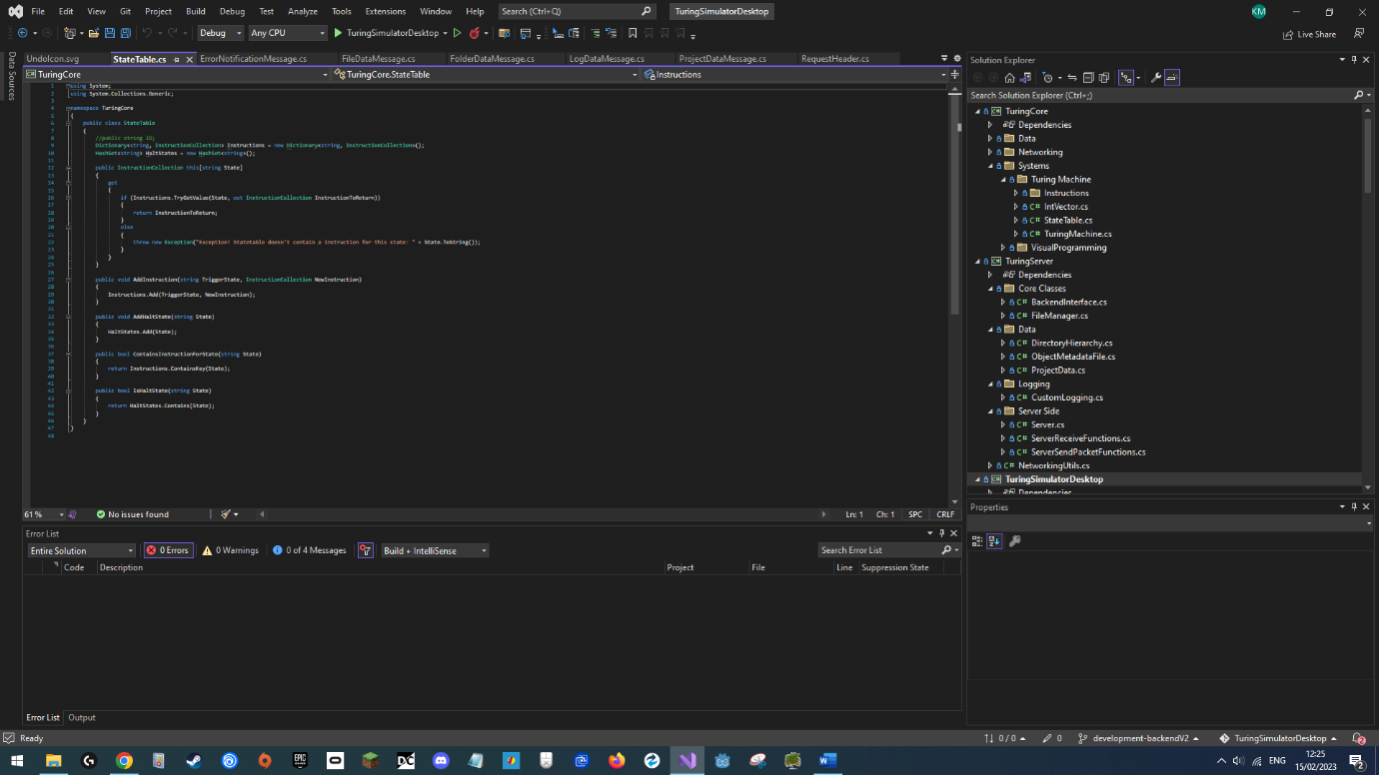

Fortunately, this Turing simulation tool doesn’t require the same complexity in terms of interface features as VS, so certain parts of the UI were to be simplified from VS, this mixed together with not wanting to make an exact carbon copy of Visual Studio, for most user control elements inspiration was taken from generic modern UI designs, for example the File browser design was initially inspired by the Unity file browser design:

//unity pic

Colour wise, the UI was planned to support two colour palettes, a dark mode, and a light mode palette, with initial designs focusing on using the dark palette first, where the second palette (light mode in this case) would be created once the entire UI was completely designed.

The original colour palette was designed based on Visual Studios palette and another simulation tool called CRUMB, images can be seen on the next page.

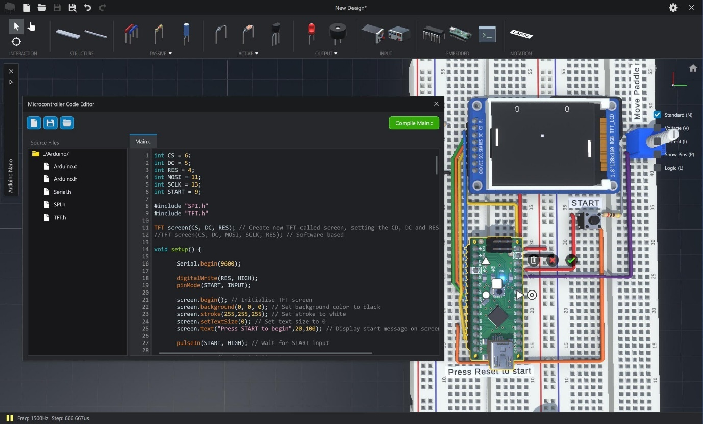

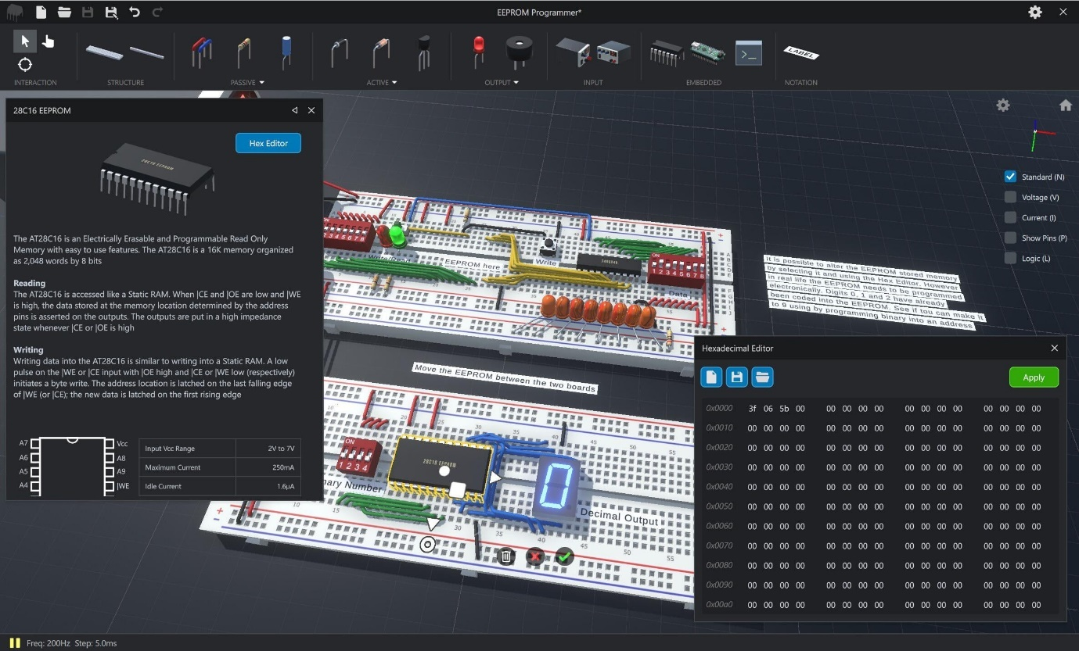

These images were sampled for core colours, and accent colours were selected using a colour palette generator online:

* https://coolors.co/

The first design sketch was drawn by hand and details 2 views and 9 windows:

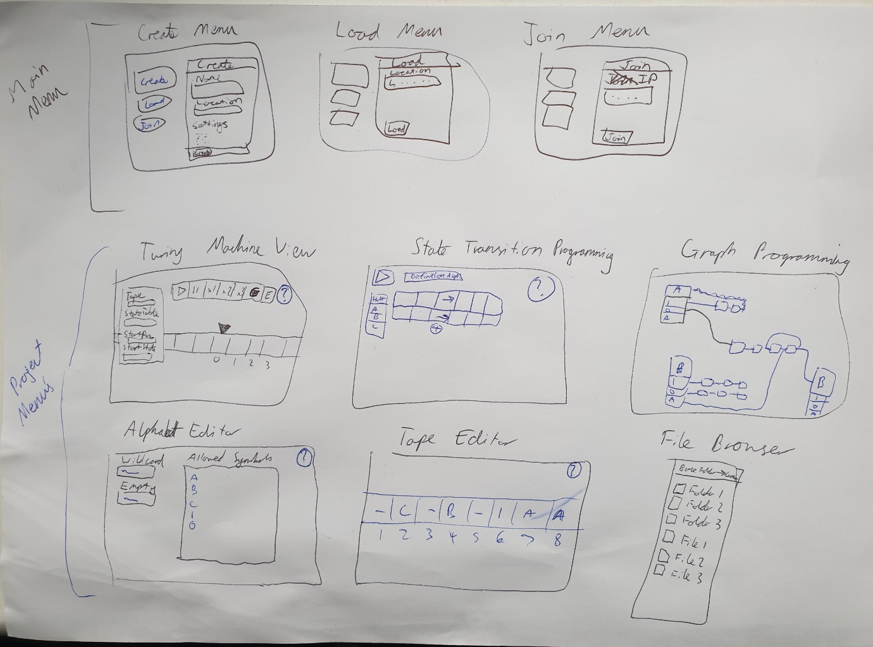

These are:

* A Main Menu View
  + Create Menu
  + Load Menu
  + Join Menu
* A Project View
  + Turing Machine Execution Window
  + State Transition Programming Window
  + Custom Graph Programming Window
  + Alphabet Editor Window
  + Tape Pre-set Editor Window
  + File Browser Window

This rough sketch served as the base design/guide for creating digital mock ups of the UI, it shows us the rough layout and some of the user controls contained within these views/windows.

We can see two methods of programming TM’s, both are visual methods matching objective 3, where the “User should be able to visually and/or textually program Turing Machines.”, one uses a method as described in theory, that being state transitions, and one that uses visual nodes/graphs give an easier alternative for the user to program with and allows for complex non-classical Turing Programs, helping us meet our extension objective (Objective 9).

We can also see certain elements with question marks on them, these indicate help menus that the user can select, matching the objective 4; “Interface should contain optional educational guides/information on functioning and usage of TM”.

The development cycle of the UI worked in an agile methodology, certain requirements would be set for a certain UI screen/element, a design would be created, reviewed by clients, and based of the feedback new requirements/changes would be given and the process would as such repeat. There were 4 core iterations (including the final one) of the design.

#### Design 1

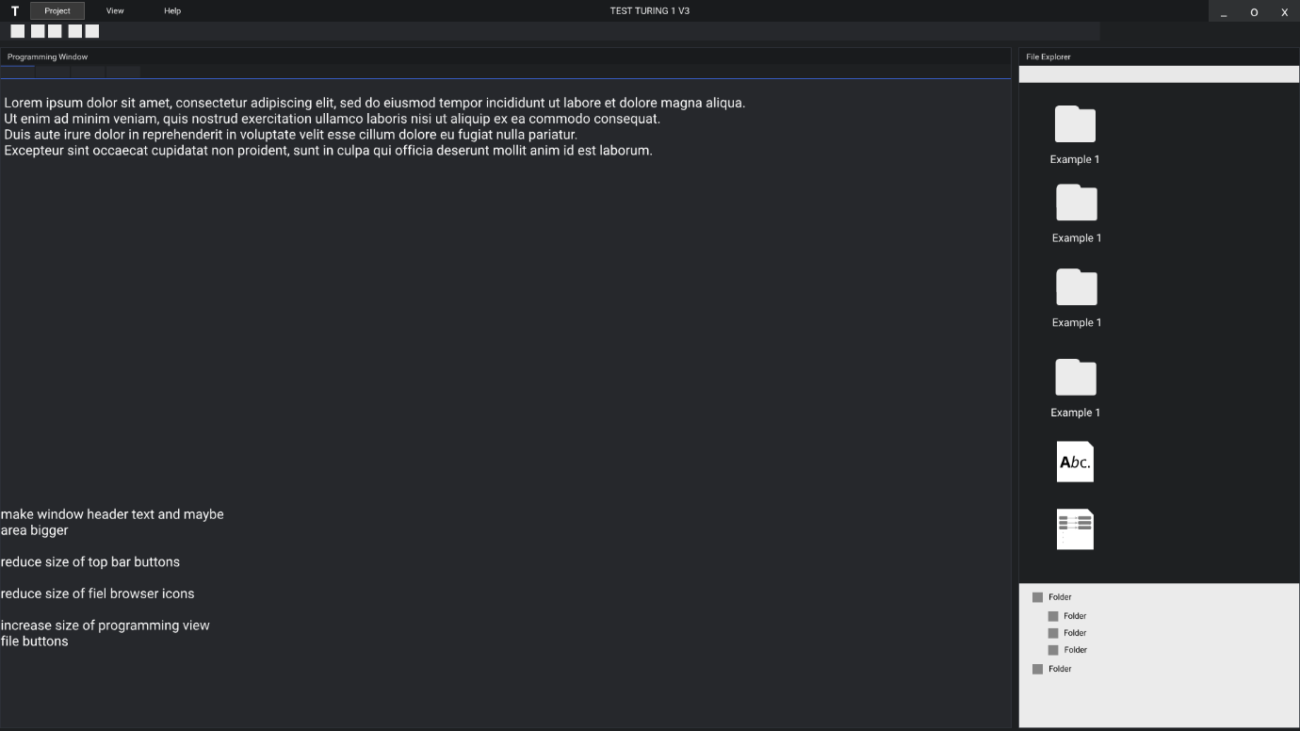

This was the first digital design of the project view interface, here we can see a drop down bar, a toolbar and two windows, a programming view window and file browser window, only the file browser window is complete in terms of its user controls, as you can see this first draft meets our initial design goals of a window-based UI system, the file browser is well adapted from the Unity inspiration one, and follows the designed dark colour scheme.

This first draft was used to ask two of the interviewed end users (Alex and Luke) on whether the UI was heading in the right direction, after being shown on their own devices, the responses were as follows:

**Alex**

“The layout seems right and slightly reminds me of editor/development programs I use such as Unity and Visual Studio, btu I can’t give any review to the actual user controls of this design as there is none shown.”

**Luke**

“The colour scheme could use more contrast as some of the colours are very similar and could be hard to discern without giving them a proper look, the file explorer seems like a good start, looking ease to use and clean so far, but I would like to see more detail in the programming window.”

As we can see the general design is heading in the right direction, but naturally the end users want to see a closer to final version to give a full review and propose slightly giving more contrast to the colour palette.

#### Design 2

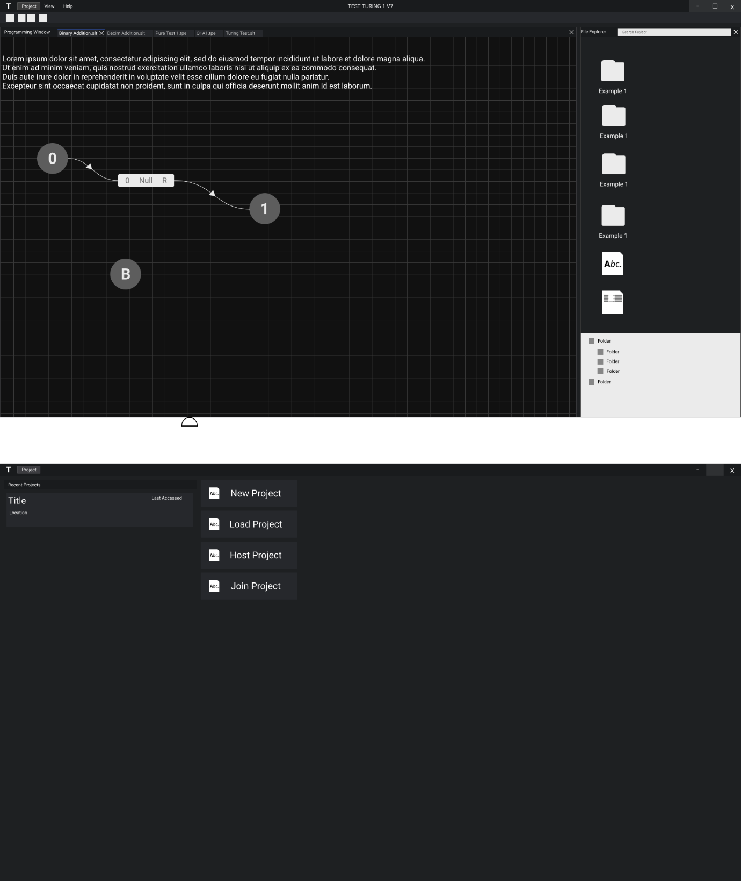

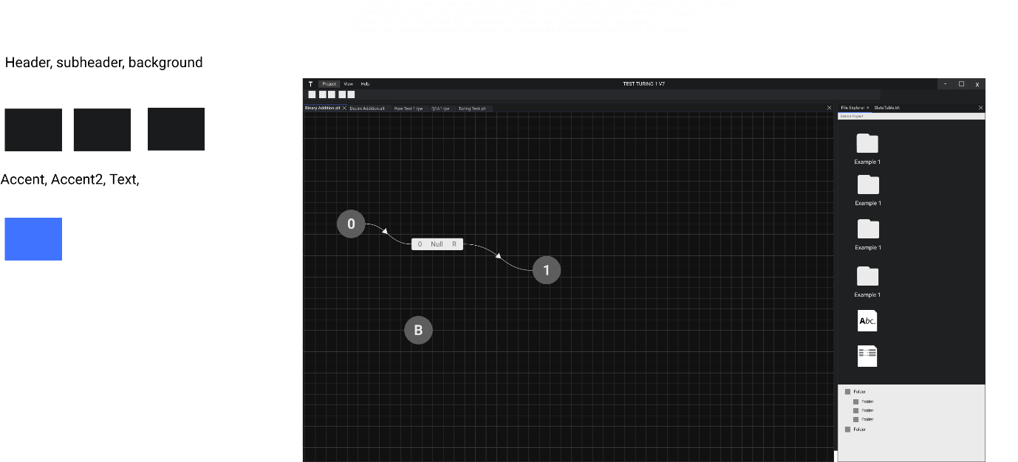

In the second design cycle of the UI, the custom graph programming window was further developed and a main menu interface was developed next, matching the original design sketches, the main menu also has some additional features such as the recently opened projects view as to improve the user experience by allowing users to quickly open recent projects, this further matches this design to that of visual studio, which is one of the goals of this design, where it has a similarly laid out main menu.

This second draft was then again used to ask of the end users (Alex and Luke) on whether the UI was heading in the right direction, after being shown on a school computer this time, the responses were as follows:

**Alex**

“The general design of the visual programming window is starting to look good but lacks button controls for things such as adding node, where I wouldn’t know that I’d have to right click with my mouse to add/edit nodes, the colour scheme also definitely needs brightening as it is hard to see on these screens compared to earlier on my computer.”

**Luke**

“The main screen does somewhat remind me of the one from Visual Studio and the visual programming window is starting to look usable, but it’s very difficult to tell on these screens with this dark colour scheme.”

As we can see from their responses, while the dark colour scheme was for the most part fine on their own devices, which have very bright screens, the dark colour scheme was unusable on the school devices, which are the main target of this software, which have dark screens, which meant the design didn’t meet objectives 8 of being portable among any desktop devices,

This problem along repeated request for better contrast in colour, resulted in me asking the two end users on whether they would prefer a light colour scheme first to be designed, which was met with a positive response, as such for future designs, I would switch to a light colour scheme.

In terms of layout/user controls, the end users responded positively to the first draft on how the custom graph programming window looks like, but want more explicit user controls, such as buttons being placed on the screen, which will need to be incorporated in the next designs, meaning meeting the objective of an intuitive design was on the right tracks.

#### Design 3

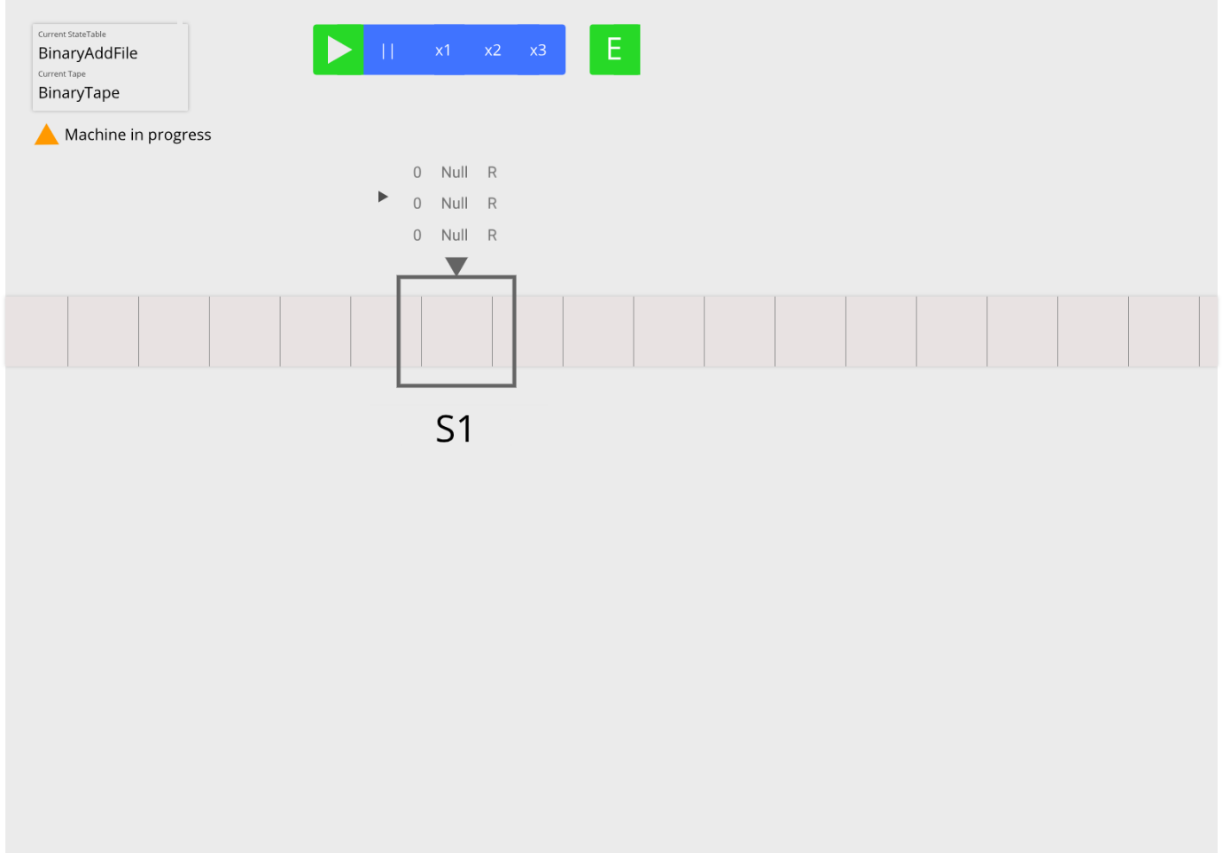

For this design cycle, since upon request by the end users the colour scheme was drastically changed, only one of the original design sketch views was made in this updated colour/layout scheme as to gauge whether applying this new design would be the correct way to head forward regarding the previous designs shown.

Here we can see the first implementation of the Turing Machine view, the user can drag across an infinite canvas to view an infinite tape, on which is placed a read/write head with the current state of the machine written under it. The top left serves as an anchored spot where the user can always find information regarding the state of the Turing Machine, i.e., what tape present and stateable are currently loaded into it or whether the machine is currently running (as shown in above picture) or other states of the machine, such as it reaching a halt state or running into a problem.

This third draft was then again used to ask of the end users (Alex and Luke) on whether the UI was heading in the right direction, after being shown on a school computer again, the responses were as follows:

**Alex**

“The new light colour scheme is looking a lot better on these monitors, and the addition of more button controls, which are colour coded to show their functionality is very useful, but I would like to see more contrast in colours.”

**Luke**

“The new colour scheme looks a lot more useable than before but needs more contrast, but other than that I consider this design very simple and easy to use for myself.”

As we can see from their responses, this new colour scheme is a generally positive change in the development of the interface but still has some details to fix, and the users consider the layout of the Turing machine view intuitive and simple to use, matching our initially set out objectives of an intuitive and engaging interface.

#### Final Design

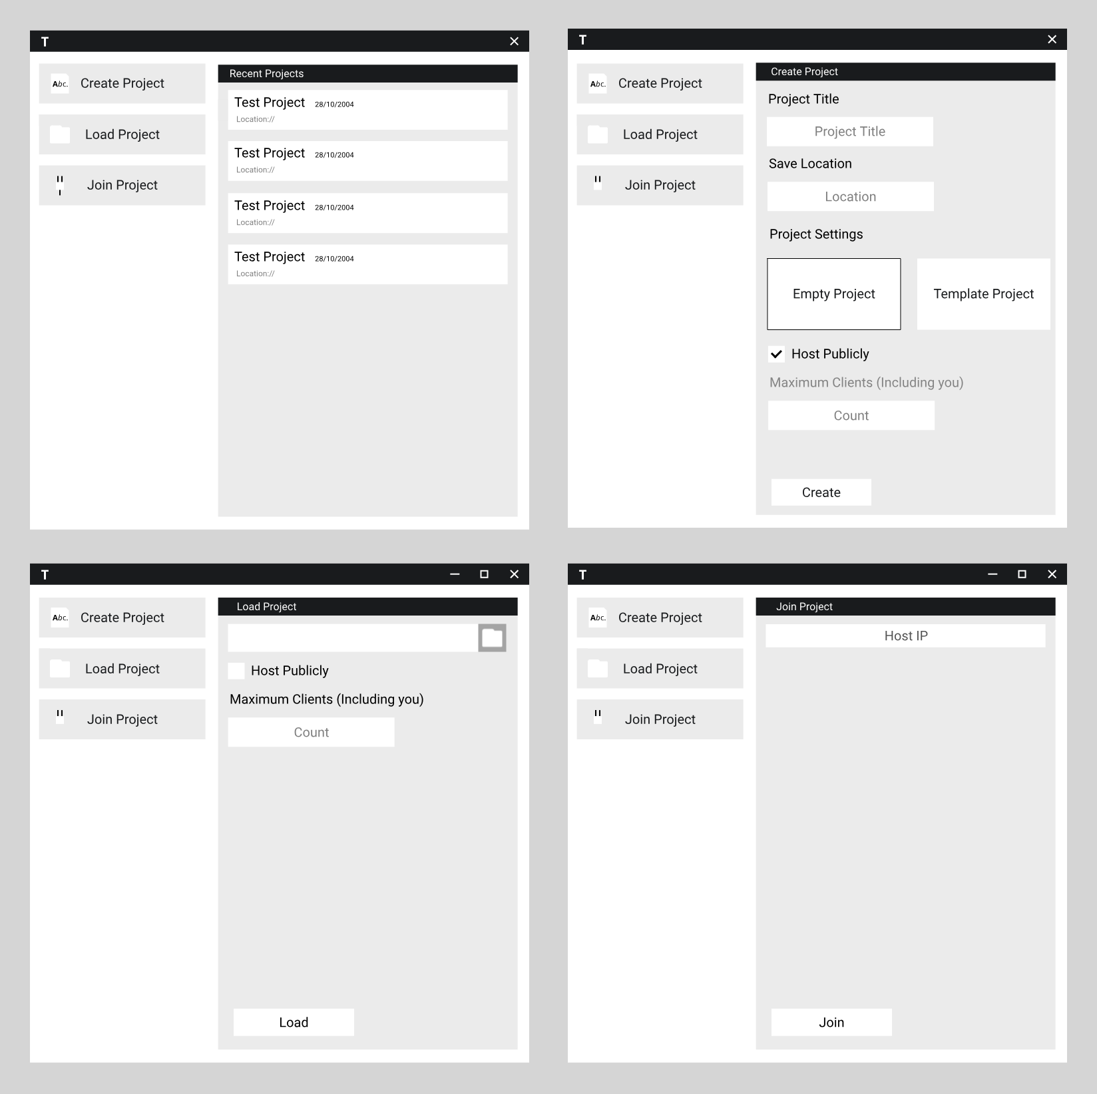

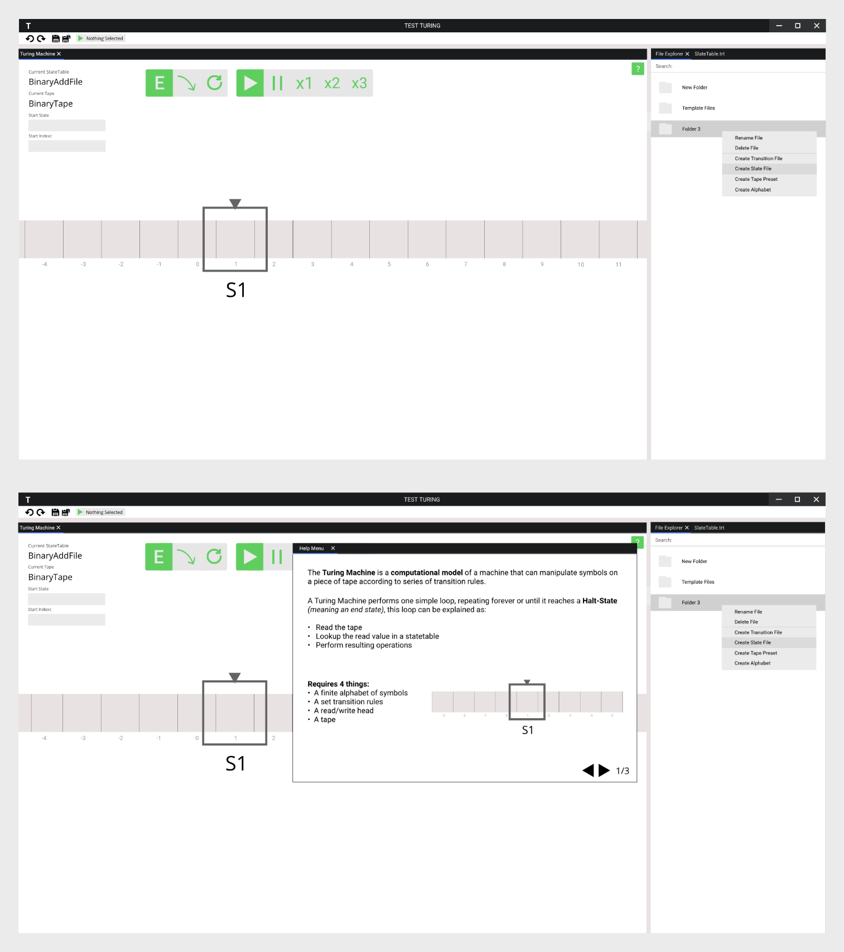

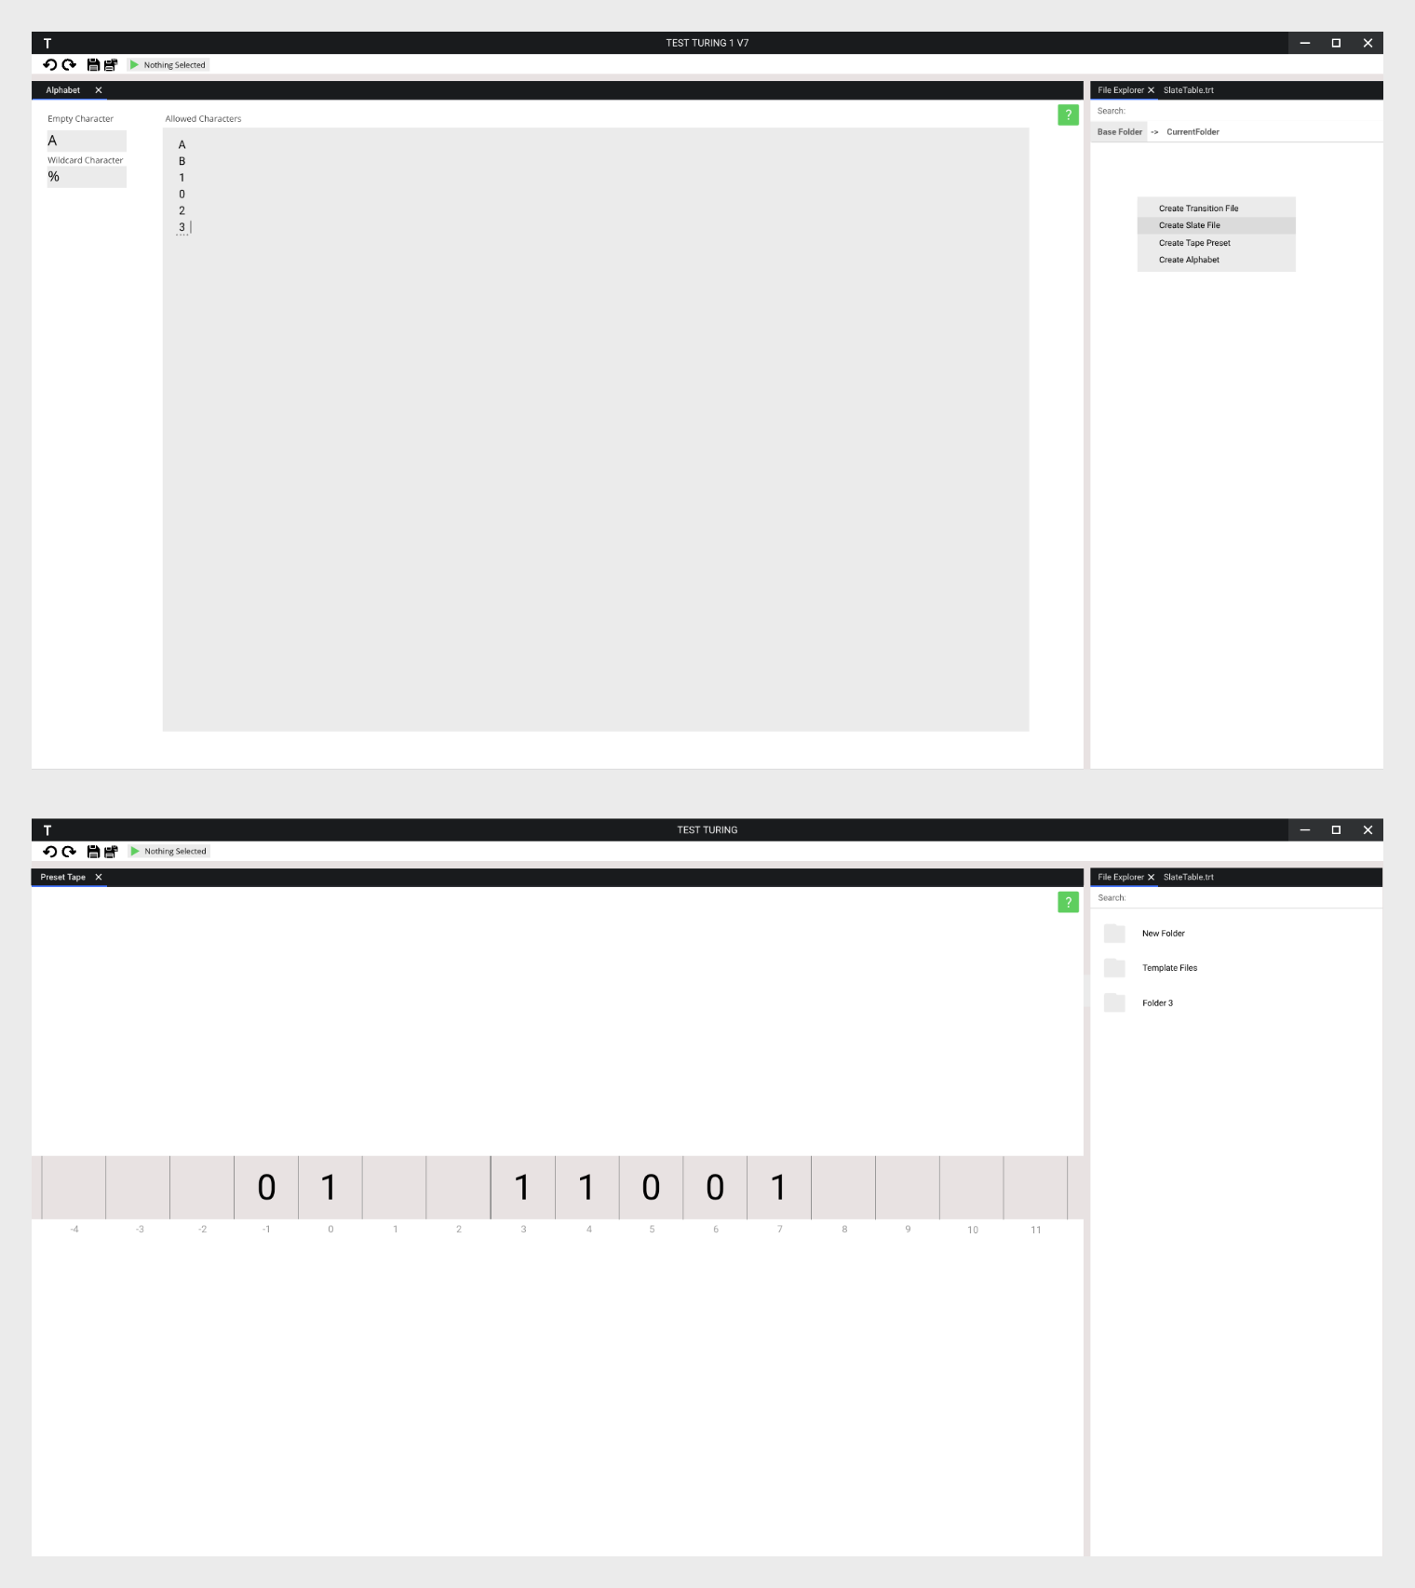

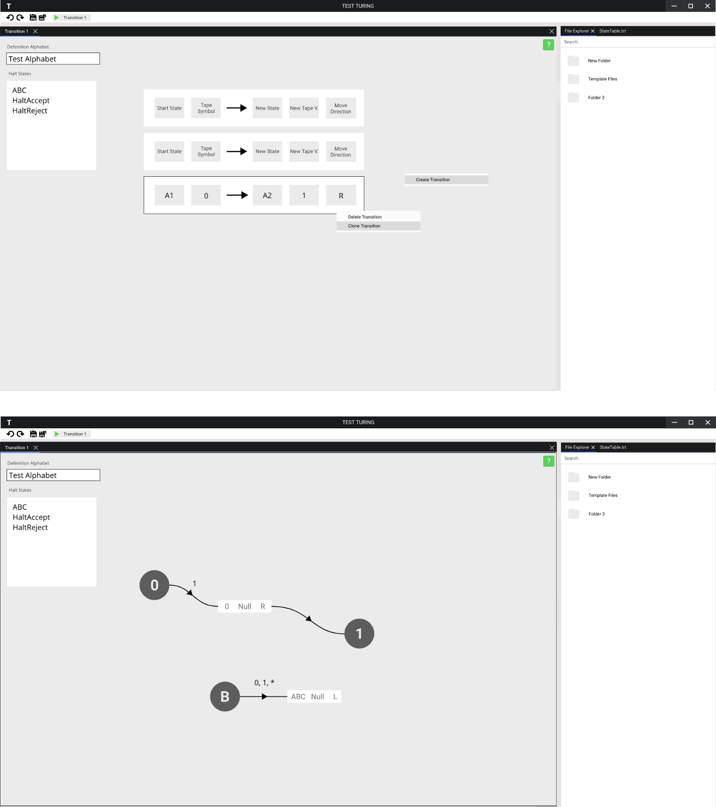

Having aggregated all the previous feedback and designs, we were now able to design a fourth, and as decided from reviews – final, UI mock-up for our entire interface, one that will serve as our guide/target when programming our front end.

Every original design on the initial hand drawn sketch has been preserved and refined into their final form, with an additional main menu design appearing, showing the user recently access files for quick project loading, following our objective of an intuitive interface.

Seeing the favouring of the new, light colour scheme, a new final consistent colour scheme was generated. Using whites, greys and blacks for background and header colours, while using blues and greens for interactive/highlighted elements to draw the users attention to them.

Here we will evaluate the exact features and design decisions of every view presented in the final design.

***Main Menu Screens***

The main menu screen has 4 views:

Viewing recently open projects, which will be the first screen when the application opens, allowing the user to immediately click and open a project to work on locally, making this an intuitive addition, which also follows a similar structure to the Visual Studio main menu, which has a recent project menu at start up too. This implementation means we are successfully following our initial project goals of an intuitive design and our UI goals of the design being similar to existing ones, such as VS.

Creating project view, this view is very simple and shows appropriate visual feedback to the user regarding their inputs using highlighting and elements such as tick boxes, making it intuitive understand, and quick to develop, following our objectives.

Join project view, this again is very simple and uses visual feedback to inputs, making it follow our design objectives.

Load project view, this menu is also simple in design and provides a button to open the integrated OS file browser to select files, making it again intuitive and adhering to our design objectives.

***Project Screens***

There are 5 project interaction related views:

Turing Execution Window, this window places all user control regarding the TM at the top in a two categorised button strips, which use a bright colourful (comparatively to the rest of the interface) colour scheme, which makes them stand out alongside symbols that are common indicators for each buttons use. Too this screens help menus are to be akin to a PowerPoint presentation, which users should feel at home with, making the help menu system very easy to use, overall making this interface design intuitive, and helpful, adhering to our original objectives regarding providing educational information and intuitiveness.

Alphabet Definition Window, this view is very easy to use and shows appropriate visual feedback to the user regarding their inputs, using the mouse cursor and underlining the input box, making it intuitive understand, and quick to develop, following our objectives of a short development time requirement and intuitive design.

Tape Preset Editor Window, this view uses the same tape system as the Turing machine Execution Window, making the design consistent and very minimal, large font and high contrast makes the tape very readable and ready for users to see and edit, the tape system also is placed on the canvas (the white area behind the tape) allowing for dragging and zooming around to see more of the tape, making it very simple to use, following our intuitive design objective.

State Transition Programming Window, this window uses visual nodes to present each state transition, where each node contains input boxes the user can enter symbols into to define the transition itself, this alongside the implementation of a context menu (which is opened by left/right clicking on nodes), makes it very simple to structure large collections of state transitions, by allowing custom grouping on the graph, and easy control over the nodes, following our design objectives of providing a text and/or visual programming method and intuitive design.

Custom Graph Programming Window, this window uses a graph system somewhat similar to finite state machines, which makes it familiar to CS students who are going to be the main users of this program, this graph system provides another visual programming method for TM’s and is a visually easier method to understand a Turing Program, the nodes on the graph can be edited through a context menu like in the state transition editor, making the UI constant, and alongside the previous functions, intuitive.

File Browser, the final view, uses a system similar to the Unity File Browser, of displaying one folder area at a time, sorting the items by showing folders then files, one after the other, where each file/folder icon can be clicked, and then have a context men accessed to alter the file/folder. Too these file/folders will support drag & drop, for example to drop a tape file on a Turing Execution Window, to load that tape into the TM system. This design is again consistent as it uses context menus like previous windows/views, draws similarity to existing systems and is easy to use, making it intuitive and quick to develop as the infrastructure will already exist for certain features, such as context menus, from the previous views, following our time and visual design objectives.

**Final Review**

This fourth design was then run by our sponsor and by end users that we had interviewed when beginning this project (Alex and Luke) to ensure that it fit in with their expectations as to what a final design would look like, and how well did it stand up to our objectives according to their points of view.

**Sponsor**

“The final design for the project is very compact and minimal, but looks like it will get the job done more than adequately, the finite state machine alternative programming method is a neat addition, as is the help menu, which I see contains information from the mark scheme for a mock recently done in my class. The window based design allowing for the user to control the amount of information on their screen and with what files they interact, alongside the topside toolbar, is similar to that of Visal Studio, which makes this design play well into the experience of my current student class, which all use VS. Overall I think this matches my demands as given in my first interview, and am happy for you to continue with implementing this.”

**Alex**

“The final UI is clean, simple to use, and brings attention to itself through colour or layout where required. The large emphasis on drag & drop control and context menus is intuitive and fun to use. The colour scheme is a heavy improvement over the initial ones . The help menu example also looks good, giving me some important information that I can recognise from revision, in a compact form.”

**Luke**

“The window based system for working with multiple files/views looks very intuitive and matches to functionality found in other editing/development software like VS, which is very handy for a cs student like me. The graph programming method looks identical to finite stat machine diagrams, which makes it intuitive for me to use. The help menu having information taken of the mark scheme very helpful, especially as a student taking my computer science exams this year.”

**Interview Summary**

According to the interviews the final design has been a resounding success, it matches all our visual design related objectives, namely objectives number 2, 3 and 4. Too it fulfils our initial goals when designing the UI, of being similar to some currently used IDE’s namely Visual Studio, and has recognisable features for Computer Science students, for whom this design is mostly intended for, this being a finite state machine like alternate programming interface, and mark scheme based help information available for the user to see.

Seeing this response to the design, I am happy to carry it forward, into the implementation phase.

### UI System

Since we are designing our own UI system from ground, we must consider how we will structure building, editing and changing views.

Using the UI Design section we can first design an application overview, which will help us group together in technical terms, the different UI elements we see in the designs.

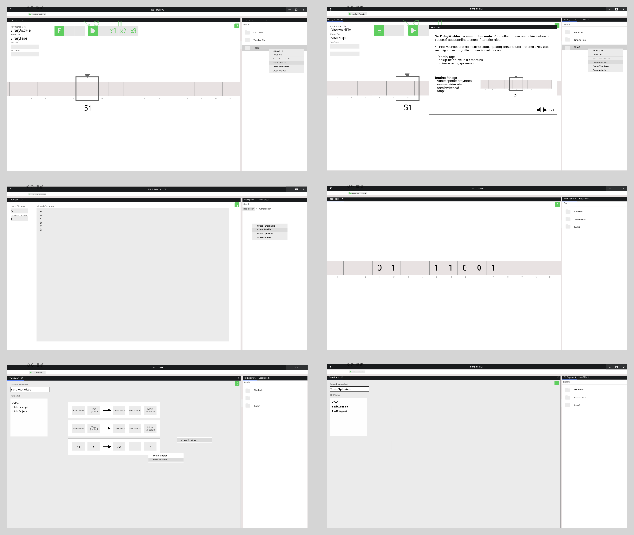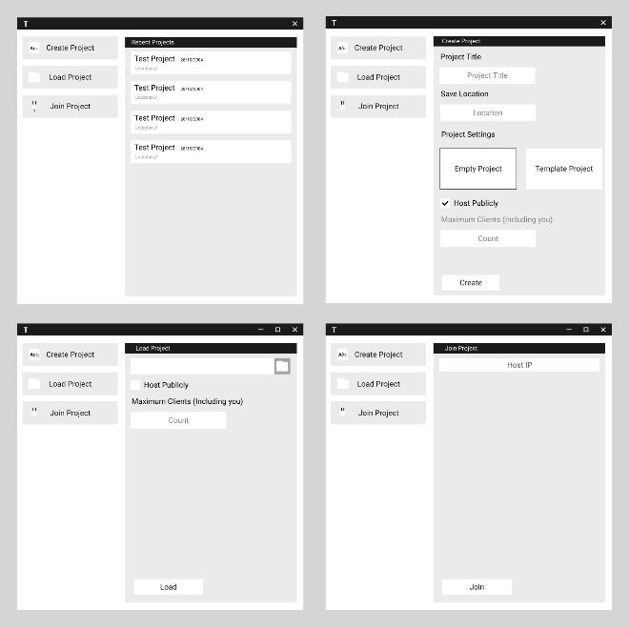

First, looking back at our final UI designs, we can see the designs group into two categories, a series of main menu related views, and a series of project interaction views.

This gives us a first idea how we will structure our UI; we can split it up into dedicated screens, namely into a main menu screen and project screen, from which we will then continue to develop our interface:

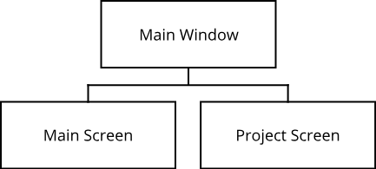

The main menu as we can see has 4 different collections of submenus. Comparing this to the Project screens, they do not use submenus like the main menu screen, they instead use windows, which then contain views, which are equivalent to the submenus. This seems perfect for our next stage of separation, the project screen would have windows, which contain submenus, which are then also implemented by the main menu screen. We will term these submenus “Views” for now.

Now the final stage of separation is considering the fact that all these views are themselves composed of induvial component, from our design we can immediately see a few components:

* Buttons
* Labels
* Input Boxes
* Checkboxes
* Icons

Additional ones we may want to have and use in the future include:

* Drop downs
* Sliders
* Layout Controllers (Automatically group components on top of each other/next to each other)

When we consider some of these components, for example the drop down, we realise they are not that different from our views. The dropdown when clicked brings up a list of options, which themselves are buttons, meaning it stores a collection of components, just like a view. As such we can in fact consider everything below a screen a component.

Treating everything as a common component object gives us great flexibility in terms of being able to place, interchange and interact these objects inside or together with other objects. A more appropriate name for these components as such, as they can in reality be anything from menus to single components, will be Visual Elements.

We can create a toolbox of generic, ready to use, visual elements, from the earlier component list, similar to what WPF provides, and then can also create custom visual elements as we need on the go, for example when generating one of the project screens windows.

While having this flexibility, have some enforced order is important in quality design, we want to have some limited set of views the application window has to switch between, limiting unexpected interactions made by the user, as such we will still employ the use of screens.

As such our final UI System hierarchy looks like this:

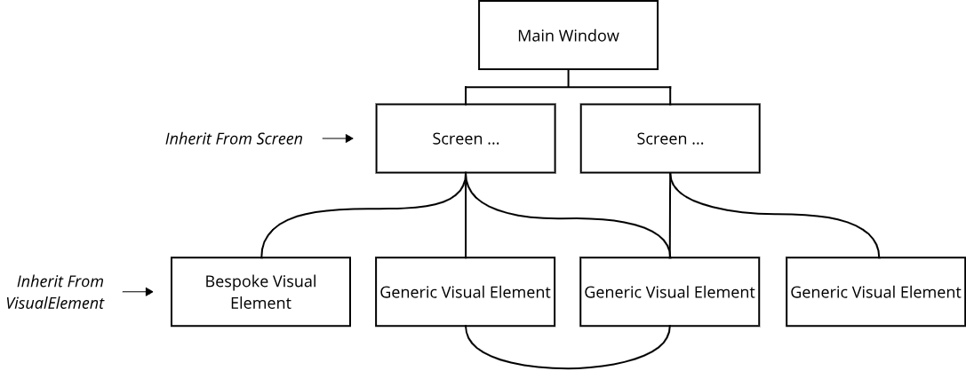

**Processing User Input**

MonoGame again provides a single interface for processing user inputs. We are given access to a Mouse and Keyboard class from which we can poll the state of mouse buttons and keys.

Our frontend is meant to build around the idea of events, executing things only once they are meant to be, such as only opening and displaying a window to a user once we get a response with data from the server.

This alongside the fact it would be near impossible, and very performance demanding, for every visual element to track whether it is the intended recipient of an input, for example when windows overlap and each would have to determine which is on top, means we need to create a centralised input management system.

The central input management system will be responsible for polling the state of the keyboard and mouse, tracking changes in the input and then based of these changes setting off appropriate interaction events.

These events can be a variety of things:

* Element Clicked
* Element Clicked Away
* Element Receiving Keyboard Input

Visual elements will be processed in groups to determine whether their events should be set off. These groups will be called Action Groups, this allows for the previously mentioned UI design system, where visual elements can be children to other visual elements, these groups allow a whole series of visual elements to be ordered together (in terms of top to back order on screen), disabled/enabled for processing and allows us to implement scissor tests.

A scissor test refers to the assigning a given area where the elements in the action group are allowed to receive input in and then only testing those elements for receiving input when and only when the input has been calculated to have occurred in the allowed area, this prevents issue where for example you have a button on a canvas and after dragging the canvas the button moves offscreen, but can still be pressed as it has no limit on where it can be pressed on the screen.

The possibility for visual elements to poll input instead of only be event based will still exist, for example when an element is being animated or wants to track the mouses movement to somehow change (e.g. highlight itself), it will still need to poll user input every frame, the central input management system will update all elements that have subscribed for polling every frame.

**Rendering**

Each visual element will contain a Draw() function and then itself implement how it will be drawn, each will as such also store their own graphical data, this can range from a collection of child visual elements to draw, or at the most basic, a 3D mesh, which in application of UI will virtually always be a rectangle the size of the visual element, and any additional rendering data they require, be it their current texture, or current mesh colour.

This allows us to implement the designed UI system where visual elements can be children to other visual elements, as we can call the Draw() function on all children in our Draw() function.

In terms of drawing the meshes themselves, MonoGame provides us with access to the GPU, allowing us to render 3D meshes. A 3D mesh is simply a collection of vertices (or points), and a list of connections between these vertices, where we repeatedly define triangle shaped faces using three points. We will create our own global mesh drawing class, which will have a variety of functions, each will take in a mesh and some series of arguments, such as the texture for the mesh, then each function will appropriately setup the GPU’s 3D shader, and then instruct the GPU to finally rasterise the mesh, resulting in it being drawn to the screen.

# Technical Design

## Overview

In this section new will go through the exact design for each class in each library, and the next few pages will provide a complete overview of the execution and interaction systems of the final application.

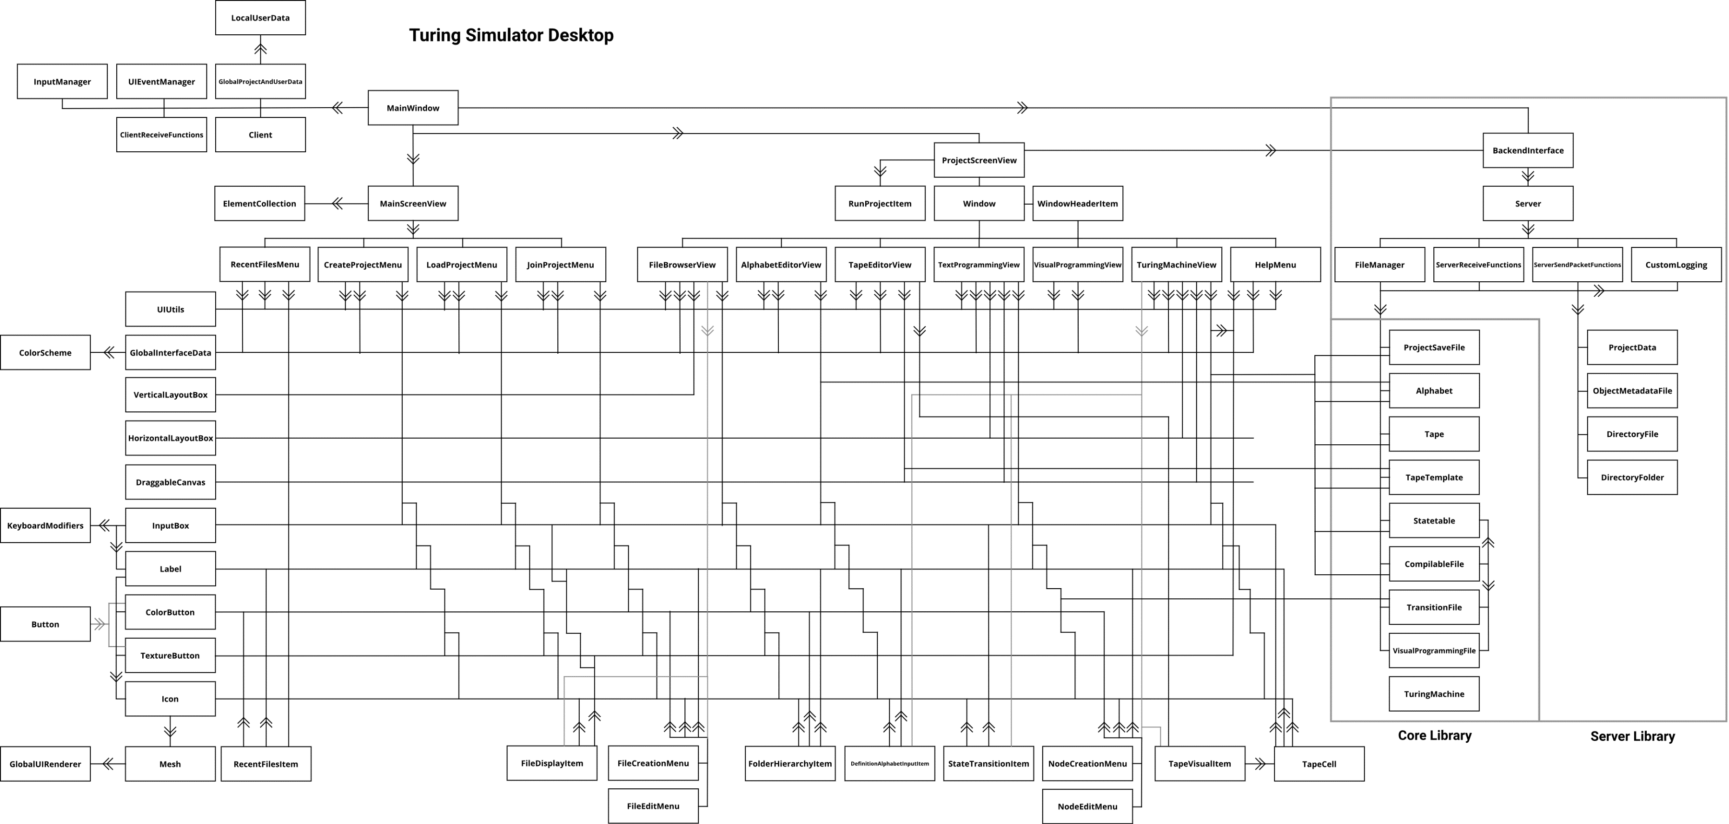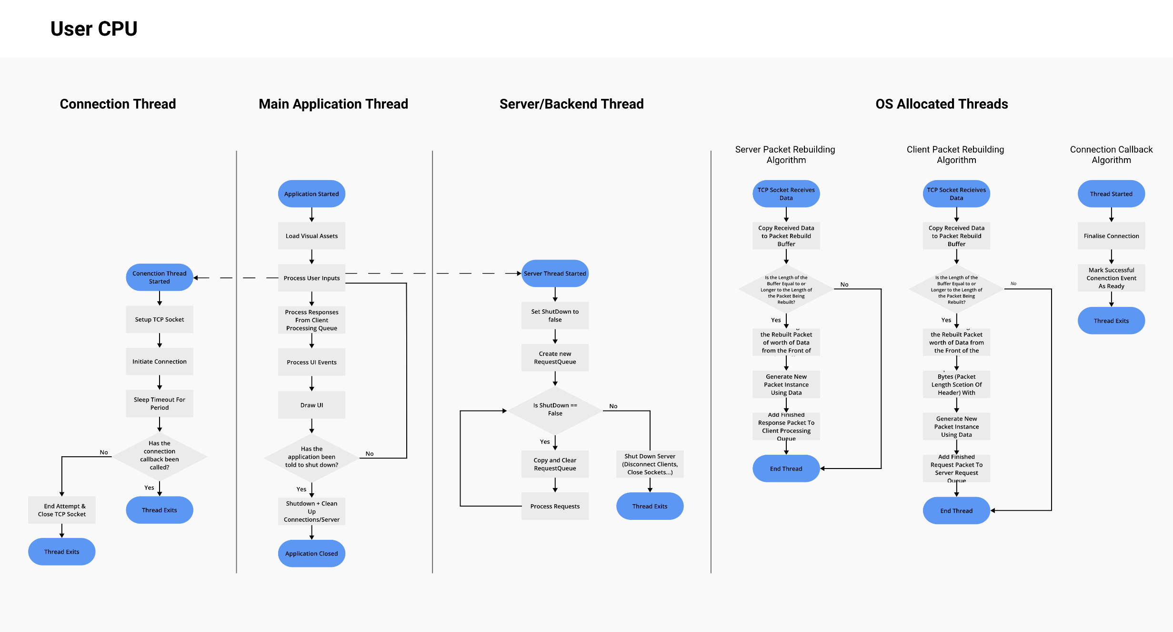

**Implementation UML**

This UML diagram displays an overview of how classes join, reference or interact with the rest of the classes within the entire project.

An arrow on a connection means a one way relation – the class from which the arrow is coming from has a reference to an and interacts with the class the arrow points to.

If an arrow is not present – this means the relationship is bilateral.

Certain minor classes that only have very specific functions and are only referred to by one other class (for example instruction and instruction collection) have been omitted for clarity.

**Thread Usage Diagram**

This diagram displays an overview of how the final application will run on the users device

We can see how the separation between the backend and frontend, both running independently, but the front end still controls when the backend starts and ends.

We can also see a large number of threads will not be manged by us, but by the OS.

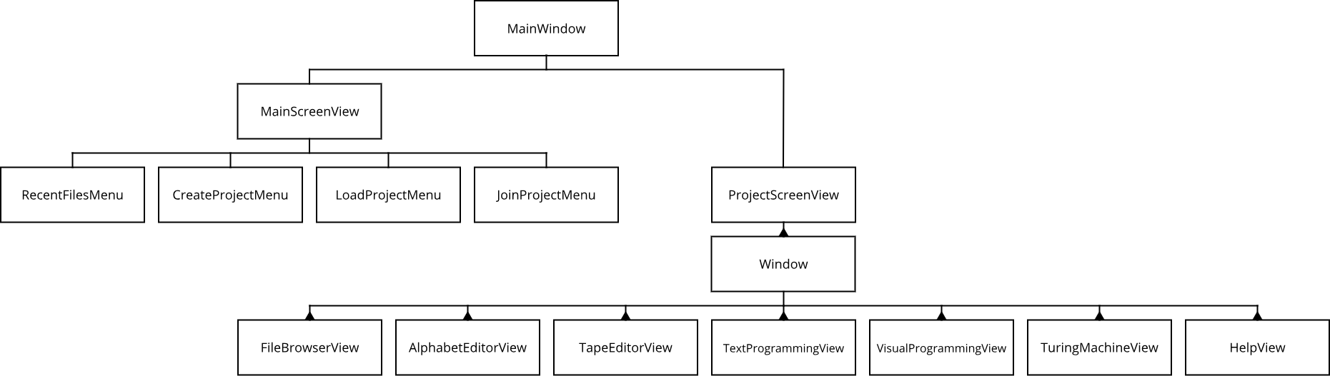

**Application Hierarchy**

**Application Hierarchy**

This diagram displays an overview of the final application’s core elements, showing their respective ownership and how they may appear.

***A cone indicates that the owner object can point to multiple such child objects.***

## Class Design

Each library has been separated into a separate section, each will have a short introduction detailing the library’s exact function, its requirements and will provide inheritance diagrams of the entire library before providing exact UML diagram and description for each class in the library.

### Core Library

The core library is the first of the three solutions. Its goal is to provide the core model implementation (Statetables, Turing Machines, etc.) and description (through C# Classes in this case) of the JSON objects that will be used to communicate between the backend and front-end. This library is to be used by front ends, allowing any of them to have the appropriate business logic to work with the backend, without having to reimplement it themselves.

This is the UML inheritance diagram for this library:



**Class ProjectSaveFile**

|  |  |  |
| --- | --- | --- |
| **UML** | | **Description** |
|  | | Defines a Project Save File. Used as JSON template for saving to disk and as a class instance containing all relevant data for the backend. |
| **Attributes** | | |
| string ProjectName | Stores the title of the project. | |
| string BaseFolder | Stores the name of the folder which stores all the data for a project. | |
| TuringProjectType TuringTypeRule | Stores whether the project can have non-classical Turing Machine programs. | |
| **Functions** | | |
| FUNCTION ProjectSaveFile (string SetProjectName, string SetBaseFolder, TuringProjectType SetTuringTypeRule)  ProjectName ← SetProjectName  BaseFolder ← SetBaseFolder  TuringTypeRule ← SetTuringTypeRule  END FUNCTION | | |

**Class Alphabet**

|  |  |  |
| --- | --- | --- |
| **UML** | | **Description** |
|  | | Defines a Turing Alphabet. Used as JSON template for saving to disk and as a class instance containing all relevant data for frontends. |
| **Attributes** | | |
| Hashset<string> Characters | Stores all symbols allowed by the alphabet. | |
| string EmptyCharacter | Stores the special “Empty” character. | |
| string WildcardCharacter | Stores the special “Wildcard“ character. | |
| **Functions** | | |
| FUNCTION Alphabet()  Characters ← new HashSet<string>()  EmptyCharacter ← ""  WildcardCharacter ← "*"  END FUNCTION | | |

**Class TapeTemplate**

|  |  |  |
| --- | --- | --- |
| **UML** | | **Description** |
|  | | Defines a tape with pre-set values from which instances of tapes can then be created from. Used as JSON template for saving to disk and as a class instance containing all relevant data for frontends. |
| **Attributes** | | |
| Dictionary<int, string> Data | Stores values written on cells on the tape. | |
| int HighestIndex | Stores the index of the furthest positive cell. | |
| int LowestIndex | Stores the index of the furthest negative cell. | |
| **Functions** | | |
| FUNCTION TapeTemplate(Tape Source)  Data ← new Dictionary<int, string>(Source.Data)  HighestIndex ← Source.HighestIndex  LowestIndex ← Source.LowestIndex  END FUNCTION | | |
| FUNCTION TapeTemplate()  Data ← new Dictionary<int, string>()  HighestIndex ← 0  LowestIndex ← 0  END FUNCTION | | |
| FUNCTION Tape Clone(Alphabet Alphabet)  Tape CloneTape ← new Tape()  CloneTape.DefinitionAlphabet ← Alphabet  CloneTape.Data ← new Dictionary<int, string>(Data)  CloneTape.HighestIndex ← HighestIndex  CloneTape.LowestIndex ← LowestIndex  RETURN CloneTape  END FUNCTION | | |
| FUNCTION int Count()  RETURN Data.Count  END FUNCTION | | |
| FUNCTION SetData(string[] Input)  Data.Clear()  FOR i ← 0 to Input.Length - 1  Data.Add(i, Input[i])  END FOR  LowestIndex ← 0  HighestIndex ← Input.Length - 1  END FUNCTION | | |

**Class Tape**

|  |  |  |
| --- | --- | --- |
| **UML** | | **Description** |
|  | | Defines a tape instance which is used by the Turing Machine. In contrast to a tape template stores what alphabet the tape is defined in. |
| **Attributes** | | |
| Dictionary<int, string> Data | Stores values written on cells on the tape. | |
| int HightestIndex | Stores the index of the furthest positive cell. | |
| int LowestIndex | Stores the index of the furthest negative cell. | |
| Alphabet DefinitionAlphabet | Reference to the alphabet that defines this tape. | |
| **Functions** | | |
| FUNCTION this[int Position]  GET  IF Data.TryGetValue(Position, out string Value)  return Value  ELSE  Data.Add(Position, DefinitionAlphabet.EmptyCharacter)  return Data[Position]  END IF  END GET  SET  IF Data.ContainsKey(Position)  Data[Position] ← value  ELSE  IF Position < LowestIndex) LowestIndex ← Position  IF Position > HighestIndex) HighestIndex ← Position  Data.Add(Position, value)  END IF  END SET  END FUNCTION | | |
| FUNCTION int Count()  RETURN Data.Count  END FUNCTION | | |
| FUNCTION SetData(string[] Input)  Data.Clear()  FOR int i ← 0 to Input.Length - 1  Data.Add(i, Input[i])  END FOR  LowestIndex ← 0  HighestIndex ← Input.Length - 1  END FUNCTION | | |

**Abstract Class CompilableFile**

|  |  |  |
| --- | --- | --- |
| **UML** | | **Description** |
|  | | Abstract class to be implemented by each StateTable Source as specified in the core model explanation. Makes classes implement appropriate properties and a compile function that returns a fully compiled StateTable. |
| **Attributes** | | |
| Guid DefinitionAlphabetFIleID | Stores a GUID for the alphabet that defines this StateTable source (Compilable File). | |
| bool IsClassical | Indicates if this program is a classical TM. | |
| **Functions** | | |
| ABSTRACT FUNCTION Compile(Alphabet DefinitionAlphabet)  END FUNCTION | | |

**Class TransitionFile Inherits CompilableFile**

|  |  |  |
| --- | --- | --- |
| **UML** | | **Description** |
|  | | Defines a transition table file. It is one of two base statetable sources. Stores transition-based program made by user and implements function that compiles relevant data into a StateTable. |
| **Attributes** | | |
| Hashset<string> HaltStates | Stores all states that will cause the Turing Machine to halt. | |
| List<Transition> Transitions | Stores all transitions made by user that then get compiled. | |
| **Functions** | | |
| FUNCTION TransitionFile()  HaltStates ← new HashSet<string>()  Transitions ← new List<Transition>()  END FUNCTION | | |
| FUNCTION StateTable Compile(Alphabet DefinitionAlphabet)  StateTable Table ← new StateTable()    FOREACH string HaltState in HaltStates  Table.AddHaltState(HaltState)  END FOREACH  FOR int i ← 0 to Transitions.Count - 1  IF !Table.ContainsInstructionForState(Transitions[i].CurrentState) THEN  Table.AddInstruction(Transitions[i].CurrentState, new InstructionCollection())  END IF  END FOR  FOR int i ← 0 to Transitions.Count - 1  IF !DefinitionAlphabet.Characters.Contains(Transitions[i].TapeValue) OR Table[Transitions[i].CurrentState].ContainsVariant(Transitions[i].TapeValue) THEN  RETURN null  END IF  InstructionVariant Variant ← new InstructionVariant()  IF Transitions[i].NewState != DefinitionAlphabet.WildcardCharacte) THEN  Variant.Actions.Add(new ChangeStateAction(Transitions[i].NewState))  END IF  IF Transitions[i].NewTapeValue != DefinitionAlphabet.WildcardCharacter THEN  Variant.Actions.Add(new WriteAction(Transitions[i].NewTapeValue))  END IF    IF Transitions[i].MoveDirection == MoveHeadDirection.Left THEN  Variant.Actions.Add(new MoveHeadAction(-1))  ELSE  Variant.Actions.Add(new MoveHeadAction(1))  END IF  Table[Transitions[i].CurrentState].AddVariant(Transitions[i].TapeValue, Variant)  END FOR  RETURN Table    END FUNCTION | | |

**Class Transition**

|  |  |  |
| --- | --- | --- |
| **UML** | | **Description** |
|  | | Represents a Turing Transition, meaning a current state, current tape value, and instruction on what the machine should then do (write to tape, move, change state). these are used in the TransitionFile to compile a StateTable. |
| **Attributes** | | |
| string CurrentState | Stores the state the TM must be in for this transition to take place. | |
| string TapeValue | Stores the tape value the TM must have read for this transition to take place. | |
| MoveHeadDirection MoveDirection | Stores which way the TM will move. | |
| string NewState | Stores the new state the TM will change to. | |
| string NewTapeValue | Stores the value the TM will write to its active tape. | |
| float X | Stores where this transition node is placed on the save files’ canvas. | |
| float Y | Stores where this transition node is placed on the save files’ canvas. | |
| **Functions** | | |
| FUNCTION Transition(float x, float y, string currentState, string tapeValue, string newState, string newTapeValue, MoveHeadDirection moveDirection)  X ← x  Y ← y  CurrentState ← currentState  TapeValue ← tapeValue  NewState ← newState  NewTapeValue ← newTapeValue  MoveDirection ← moveDirection  END FUNCTION | | |
| FUNCTION Transition()  END FUNCTION | | |

**Class VisualProgrammingFile Inherits CompilableFile**

|  |  |  |
| --- | --- | --- |
| **UML** | | **Description** |
|  | | Defines a graph program file. It is one of two base statetable sources. Stores placed nodes, their type, arguments, and connections between nodes and implements function that compiles relevant data into a StateTable. |
| **Attributes** | | |
| List<Node> StoredNodes | Stores all nodes placed on the graph by the user. | |
| **Functions** | | |
| FUNCTION InsertStateNode(string State)  StateNode Node ← new StateNode(State)  StoredNodes.Add(Node)  END FUNCTION | | |
| FUNCTION StateTable Compile(Alphabet DefinitionAlphabet)  RETURN null  END FUNCTION | | |

**Abstract Class Node**

|  |  |  |
| --- | --- | --- |
| **UML** | | **Description** |
|  | | Is the base class from which all node types inherit from. Stores a nodes position on the graph. |
| **Attributes** | | |
| float X | Stores the position of the node on the graph. | |
| float Y | Stores the position of the node on the graph. | |

**Class ActionNode Inherits Node**

|  |  |  |
| --- | --- | --- |
| **UML** | | **Description** |
|  | | Type of node which when executed makes the Turing Machine perform an Action. |
| **Attributes** | | |
| TuringAction Action | Stores an action to be executed. | |

**Class StateNode Inherits Node**

|  |  |  |
| --- | --- | --- |
| **UML** | | **Description** |
|  | | Type of node from which the user can create actions from. Equivalent to the current state field in state transitions. |
| **Attributes** | | |
| string CurrentState | Stores the state the current node represents. | |
| **Functions** | | |
| FUNCTION StateNode(string SetCurrentState)  CurrentState ← SetCurrentState  END FUNCTION | | |

**Class TuringMachine**

|  |  |  |
| --- | --- | --- |
| **UML** | | **Description** |
|  | | Implements the core Turing Machine model logic. (See Core Model Design Section for details) |
| **Attributes** | | |
| Alphabet ActiveAlphabet | Reference to currently loaded alphabet. | |
| StateTable ActiveStateTable | Reference to currently loaded statetable. | |
| Tape ActiveTape | Refence to currently active tape. | |
| string CurrentState | Stores the current state of the TM. | |
| int HeadPosition | Stores the index of the cell over which the read head of the TM is currently over. | |
| bool IsActive | Returns whether the TM has been started and is currently working (hasn’t yet reached error or halt state) | |
| InstructionVariant NextInstruction | Stores reference to the next instruction to be executed by the TM. | |
| TapeTemplate OriginalTape | Stores reference to the source tape which is used to reset the active tape to its original state when the TM is restarted. | |
| bool ReachedHaltState | Returns whether the TM has reached a successful halt state. | |
| **Functions** | | |
| FUNCTION SetActiveStateTable(StateTable Table, Alphabet Alphabet)  ActiveAlphabet ← Alphabet  ActiveStateTable ← Table  END FUNCTION | | |
| FUNCTION SetActiveTape(TapeTemplate NewTape)  OriginalTape ← NewTape  ENF FUNCTION | | |
| FUNCTION ShallowClear()  ReachedHaltState ← false  IsActive ← false  CurrentState ← "Null"  HeadPosition ← 0  NextInstruction ← null  ActiveTape ← null  END FUNCTION | | |
| FUNCTION int Start(string StartState, int StartHeadPosition)  IF ActiveStateTable == null THEN  RETURN 2  END IF  IF ActiveAlphabet == null THEN  RETURN 3  END IF  IF OriginalTape == null THEN  RETURN 4  END IF    ShallowClear()  IsActive ← true  CurrentState ← StartState  HeadPosition ← StartHeadPosition  ActiveTape ← OriginalTape.Clone(ActiveAlphabet)  IF ActiveStateTable.IsHaltState(CurrentState) THEN  NextInstruction ← null  ELSE IF ActiveStateTable.ContainsInstructionForState(CurrentState) THEN    IF ActiveStateTable[CurrentState].ContainsVariant(ActiveTape[HeadPosition]) THEN  NextInstruction ← ActiveStateTable[CurrentState][ActiveTape[HeadPosition]]  ELSE IF ActiveStateTable[CurrentState].ContainsVariant(ActiveAlphabet.WildcardCharacter) THEN  NextInstruction ← ActiveStateTable[CurrentState][ActiveAlphabet.WildcardCharacter]  ELSE  IsActive ← false  ReachedHaltState ← true  CurrentState ← HaltError  END IF    ELSE  IsActive ← false  ReachedHaltState ← true  CurrentState ← HaltError  END IF  RETURN 0  END FUNCTION | | |
| FUNCTION StepProgram()  IF !IsActive RETURN  IF CurrentState == HaltError OR ActiveStateTable.IsHaltState(CurrentState) THEN  ReachedHaltState ← true  IsActive ← false  RETURN  END IF  FOR int i ← 0 TO NextInstruction.Actions.Count - 1  NextInstruction.Actions[i].Execute(this)  END FOR  IF ActiveStateTable.IsHaltState(CurrentState) THEN  NextInstruction ← null  ELSE IF ActiveStateTable.ContainsInstructionForState(CurrentState) THEN    IF ActiveStateTable[CurrentState].ContainsVariant(ActiveTape[HeadPosition]) THEN  NextInstruction ← ActiveStateTable[CurrentState][ActiveTape[HeadPosition]]  ELSE IF ActiveStateTable[CurrentState].ContainsVariant(ActiveAlphabet.WildcardCharacter) THEN  NextInstruction ← ActiveStateTable[CurrentState][ActiveAlphabet.WildcardCharacter]  ELSE  ReachedHaltState ← true  CurrentState ← HaltError  END IF  ELSE  ReachedHaltState ← true  CurrentState ← HaltError  END IF  END FUNCTION | | |

**Class StateTable**

|  |  |  |
| --- | --- | --- |
| **UML** | | **Description** |
|  | | Implements the State Table core model logic. (See Core Model Design Section for details).  Stores a definition alphabet and maps the current Turing Machine to a list of Instruction Collections. |
| **Attributes** | | |
| Dictionary<string, InstructionCollection> Instructions | Maps the current TM state to a InstructionCollection object. | |
| HashSet<string> HaltStates | Stores all halt accept states. | |
| **Functions** | | |
| FUNCTION InstructionCollection this[string State]  GET  IF Instructions.TryGetValue(State, out InstructionCollection InstructionToReturn) THEN  RETURN InstructionToReturn  ELSE  new Exception("Exception! Statetable doesn't contain an instruction for this state: " + State.ToString())  END IF  END GET  END FUNCTION | | | |
| FUNCTION AddHaltState(string State)  HaltStates.Add(State)  END FUNCTION | | | |
| FUNCTION AddInstruction(string TriggerState, InstructionCollection NewInstruction)  Instructions.Add(TriggerState, NewInstruction)  END FUNCTION | | | |
| FUNCTION ContainsInstructionForState(string State)  RETURN Instructions.ContainsKey(State)  END FUNCTION | | | |
| FUNCTION IsHaltState(string State)  RETURN HaltStates.Contains(State)  END FUNCTION | | | |

**Class InstructionCollection**

|  |  |  |
| --- | --- | --- |
| **UML** | | **Description** |
|  | | Maps symbols that can be read by a Turing Machine to appropriate InstructionVariant Objects. |
| **Attributes** | | |
| Dictionary<string, InstructionVariant> InstructionVariants | Maps a symbol (that is read by the TM from a tape) to a InstructionVariant. | |
| **Functions** | | |
| FUNCTION InstructionVariant this[string ReadAlphabetCharacter]  GET  IF InstructionVariants.TryGetValue(ReadAlphabetCharacter, out InstructionVariant Variant) THEN  RETURN Variant  ELSE  new Exception("Exception! No variant implentation for current character! Index: " + ReadAlphabetCharacter)  END IF  END GET  END FUNCTION | | | |
| FUNCTION AddVariant(string TriggerState, InstructionVariant NewVariant)  InstructionVariants.Add(TriggerState, NewVariant)  END FUNCTION | | | |
| FUNCTION bool ContainsVariant(string ReadAlphabetCharacter)  RETURN InstructionVariants.ContainsKey(ReadAlphabetCharacter)  END FUNCTION | | | |

**Class InstructionVariant**

|  |  |  |
| --- | --- | --- |
| **UML** | | **Description** |
|  | | Stores a list of instructions for the Turing Machine to execute. |
| **Attributes** | | |
| List<TuringAction> Actions | Stores a list of actions to be performed by the TM. | |

**Abstract Class TuringAction**

|  |  |
| --- | --- |
| **UML** | **Description** |
|  | Base class for all actions that can be executed by a Turing Machine. Provides a base Execute function for all children to inherit. |
| **Functions** | |
| ABSTRACT FUNCTION Execute()  END FUNCTION | | |

**Class ChangeStateAction Inherits TuringAction**

|  |  |  |
| --- | --- | --- |
| **UML** | | **Description** |
|  | | Stores a new state value. When executed makes the Turing Machine change state to the stored state. |
| **Attributes** | | |
| string NewState | Stores new state value. | |
| **Functions** | | |
| FUNCTION ChangeStateAction(string newState)  NewState ← newState  END FUNCTION | | | |
| FUNCTION Execute(TuringMachine Machine)  Machine.CurrentState ← NewState  END FUNCTION | | | |

**Class MoveHeadAction Inherits TuringAction**

|  |  |  |
| --- | --- | --- |
| **UML** | | **Description** |
|  | | When executed makes the Turing Machine move along the tape by the stored number of spaces. |
| **Attributes** | | |
| int MoveValue | Stores the number of spaces the Turing Machine should move along the tape. Negative number indicates moving left, positive moving right. | |
| **Functions** | | |
| FUNCTION MoveHeadAction(int moveValue)  MoveValue ← moveValue  END FUNCTION | | | |
| FUNCTION Execute(TuringMachine Machine)  Machine.HeadPosition += MoveValue  END FUNCTION | | | |

**Class WriteAction Inherits Action**

|  |  |  |
| --- | --- | --- |
| **UML** | | **Description** |
|  | | Stores a new value. When executed makes the Turing Machine write the stored value to the currently highlighted cell on the tape. |
| **Attributes** | | |
| string WriteValue | Stores the new value to be written to the tape. | |
| **Functions** | | |
| FUNCTION Execute(TuringMachine Machine)  Machine.ActiveTape[Machine.HeadPosition] ← WriteValue  END FUNCTION | | |
| FUNCTION WriteAction(string writeValue)  WriteValue ← writeValue  END FUNCTION | | |

**Abstract Class RequestHeader**

|  |  |  |
| --- | --- | --- |
| **UML** | | **Description** |
|  | | Request files are used to define the JSON requests/responses to/from the server. All request files inherit from this class. Stores the requests type. |
| **Attributes** | | |
| int RequestHeader | Value which represents the type of request/response this is. | |

**Class ErrorNotificationMessage Inherits RequestHeader**

|  |  |  |
| --- | --- | --- |
| **UML** | | **Description** |
|  | | Describes the JSON data for an error message type response from the server. Inherits data from RequestHeader. |
| **Attributes** | | |
| string ErrorMessage | Stores the error message sent back by the server. | |

**Class FileDataMessage Inherits RequestHeader**

|  |  |  |
| --- | --- | --- |
| **UML** | | **Description** |
|  | | Describes the JSON data for a file request type response from the server. Inherits data from RequestHeader. |
| **Attributes** | | |
| byte[] Data | Stores the bytes representing the data of the file requested. | |
| CoreFileType FileType | Stores the type of file requested. | |
| Guid GUID | Stores the GUID of the request file. | |
| string Name | Stores the Name of the requested file. | |
| int Version | Stores the version of the requested file, this is used to track whether the client has the most up to date version of the file, to make sure they are not overwriting a new version with an old one should they try to update the file. | |

**Class FolderDataMessage Inherits RequestHeader**

|  |  |  |
| --- | --- | --- |
| **UML** | | **Description** |
|  | | Describes the JSON data for a folder data request type response from the server. Inherits data from RequestHeader. |
| **Attributes** | | |
| List<FileDataMessage> Files | List of all files contained within the requested folder. | |
| int ID | Stores the ID of the requested folder. | |
| string Name | Stores the name of the requested folder. | |
| List<FolderDataMessage> ParentFolders | List of parent folders that eventually lead up to the base folder of the project. | |
| List<FolderDataMessage> SubFolders | List of all folders contained within the requested folder. | |

**Class LogDataMessage Inherits RequestHeader**

|  |  |  |
| --- | --- | --- |
| **UML** | | **Description** |
|  | | Describes the JSON data for a log copy response from the server. Inherits data from RequestHeader. |
| **Attributes** | | |
| string LogMessage | Stores the message sent by the server. | |

**Class ProjectDataMessage Inherits RequestHeader**

|  |  |  |
| --- | --- | --- |
| **UML** | | **Description** |
|  | | Describes the JSON data for a project save file data type response from the server. Inherits data from RequestHeader. |
| **Attributes** | | |
| string ProjectName | Stores the name of the project sent by the server. | |
| TuringProjectType ProjectType | Stores the turing-strictness rule of the project sent by the server. | |

**Class Packet**

|  |  |  |
| --- | --- | --- |
| **UML** | | **Description** |
|  | | Object used to store binary data to be sent to server/client, with additional helper functions to encode data types to appropriate binary representation. |
| **Attributes** | | |
| byte[] ReadBuffer | Byte buffer from which data is read using the read functions. | |
| int ReadBufferPosition | Stores index from where the next read function call will read bytes from. | |
| List<byte> TemporaryWriteBuffer | Byte buffer where data being currently written to the packet using the write functions is stored. | |
| **Functions** | | |
| FUNCTION InsertPacketLength()  TemporaryWriteBuffer.InsertRange(0, BitConverter.GetBytes(TemporaryWriteBuffer.Count + 4))  END FUNCTION | | |
| FUNCTION InsertPacketSenderIDUnsafe(int SenderID)  byte[] IDToBytes ← BitConverter.GetBytes(SenderID)  ReadBuffer[0] ← IDToBytes[0]  ReadBuffer[1] ← IDToBytes[1]  ReadBuffer[2] ← IDToBytes[2]  ReadBuffer[3] ← IDToBytes[3]  END IF | | |
| FUNCTION Length()  RETURN ReadBuffer.Length  END FUNCTION | | |
| FUNCTION Packet()  TemporaryWriteBuffer ← new List<byte>(0)  ReadPointerPosition ← 0  END FUNCTION | | |
| FUNCTION Packet(byte[] Data)  TemporaryWriteBuffer ← new List<byte>(0)  ReadPointerPosition ← 0  ReadBuffer ← Data  END FUNCTION | | |
| FUNCTION ReadBool(bool MovePointer ← true)  IF ReadPointerPosition + 1 > ReadBuffer.Length) THEN  new Exception("ReadBool Length out of bounds!")  END IF  bool Result ← BitConverter.ToBoolean(ReadBuffer, ReadPointerPosition)  IF MovePointer THEN  ReadPointerPosition += 1  END IF  RETURN Result  END FUNCTION | | |
| FUNCTION ReadByteArray(bool MovePointer ← true)  int Length ← ReadInt()  IF ReadPointerPosition + Length > ReadBuffer.Length THEN  new Exception("ReadBytes Length out of bounds!")  END IF  byte[] Result ← new byte[Length]  Array.Copy(ReadBuffer, ReadPointerPosition, Result, 0, Length)  IF MovePointer  ReadPointerPosition += Length  ELSE  ReadPointerPosition -= 4  END IF  RETURN Result  END FUNCTION | | |
| FUNCTION byte[] ReadBytes(int Length, bool MovePointer ← true)  IF ReadPointerPosition + Length > ReadBuffer.Length  new Exception("ReadBytes Length out of bounds!")  END IF  byte[] Result ← new byte[Length]  Array.Copy(ReadBuffer, ReadPointerPosition, Result, 0, Length)  IF MovePointer  ReadPointerPosition += Length  END IF  RETURN Result  END FUNCTION | | |
| FUNCTION ReadGuid(bool MovePointer ← true)  IF ReadPointerPosition + 16 > ReadBuffer.Length THEN  new Exception("ReadGuid Length out of bounds!")  END IF  RETURN new Guid(ReadBytes(16, MovePointer))  END FUNCTION | | |
| FUNCTION int ReadInt(bool MovePointer ← true)  IF ReadPointerPosition + 4 > ReadBuffer.Length THEN  new Exception("ReadInt Length out of bounds!")  END IF  int Result ← BitConverter.ToInt32(ReadBuffer, ReadPointerPosition)  IF MovePointer  ReadPointerPosition += 4  END IF  RETURN Result  END FUNCTION | | |
| FUNCTION short ReadShort(bool MovePointer ← true)  IF ReadPointerPosition + 2 > ReadBuffer.Length THEN  new Exception("ReadShort Length out of bounds!")  END IF  short Result ← BitConverter.ToInt16(ReadBuffer, ReadPointerPosition)  IF MovePointer  ReadPointerPosition += 2  END IF  RETURN Result  END FUNCTION | | |
| FUNCTION string ReadString(bool MovePointer ← true)  int Length ← ReadInt()  IF ReadPointerPosition + Length > ReadBuffer.Length THEN  new Exception("ReadString Length out of bounds!")  END IF  string Result ← Encoding.ASCII.GetString(ReadBuffer, ReadPointerPosition, Length)  IF MovePointer  ReadPointerPosition += Length  ELSE  ReadPointerPosition -= 4  END IF  RETURN Result  END FUNCTION | | |
| FUNCTION Reset()  ReadBuffer ← null  TemporaryWriteBuffer ← new List<byte>()  ReadPointerPosition ← 0  END FUNCTION | | |
| FUNCTION byte[] SaveTemporaryBufferToPernamentReadBuffer()  ReadBuffer ← TemporaryWriteBuffer.ToArray()  RETURN ReadBuffer  END FUNCTION | | |
| FUNCTION int UnreadLength()  RETURN ReadBuffer.Length - ReadPointerPosition  END FUNCTION | | |
| FUNCTION Write(byte[] Data, bool AddLength ← true)  IF AddLength THEN  Write(Data.Length)  END IF  TemporaryWriteBuffer.AddRange(Data)  END FUNCTION | | |
| FUNCTION Write(float Data)  TemporaryWriteBuffer.AddRange(BitConverter.GetBytes(Data))  END FUNCTION | | |
| FUNCTION Write(int Data)  TemporaryWriteBuffer.AddRange(BitConverter.GetBytes(Data))  END FUNCTION | | |
| FUNCTION Write(Guid Data)  TemporaryWriteBuffer.AddRange(Data.ToByteArray())  END FUNCTION | | |
| FUNCTION Write(short Data)  TemporaryWriteBuffer.AddRange(BitConverter.GetBytes(Data))  END FUNCTION | | |
| FUNCTION Write(bool Data)  TemporaryWriteBuffer.AddRange(BitConverter.GetBytes(Data))  END FUNCTION | | |
| FUNCTION Write(string Data)  Write(Data.Length)  TemporaryWriteBuffer.AddRange(Encoding.ASCII.GetBytes(Data))  END FUNCTION | | |

**Class ClientSendPacketFunctions**

|  |  |
| --- | --- |
| **UML** | **Description** |
|  | A helper class which helps the frontend appropriately setup packets that are to be sent to the server. |
| **Functions** | |
| STATIC FUNCTION Packet CreateFile(int Folder, string NewName, CoreFileType FileType)  Packet Data ← new Packet()  Data.Write((int)ClientSendPackets.CreateFile)  Data.Write(Folder)  Data.Write(NewName)  Data.Write((int)FileType)  RETURN Data  END FUNCTION | |
| STATIC FUNCTION Packet CreateFolder(int BaseFolder, string NewName)  Packet Data ← new Packet()  Data.Write((int)ClientSendPackets.CreateFolder)  Data.Write(BaseFolder)  Data.Write(NewName)  RETURN Data  END FUNCTION | |
| STATIC FUNCTION Packet DeleteFile(Guid FileID)  Packet Data ← new Packet()  Data.Write((int)ClientSendPackets.DeleteFile)  Data.Write(FileID)  RETURN Data  END FUNCTION | |
| STATIC FUNCTION Packet DeleteFolder(int Folder)  Packet Data ← new Packet()  Data.Write((int)ClientSendPackets.DeleteFolder)  Data.Write(Folder)  RETURN Data  END FUNCTION | |
| STATIC FUNCTION Packet LoadProject(string Location)  Packet Data ← new Packet()  Data.Write((int)ClientSendPackets.LoadProject)  Data.Write(Location)  RETURN Data  END FUNCTION | |
| STATIC FUNCTION Packet MoveFile(Guid FileID, int NewFolderID)  Packet Data ← new Packet()  Data.Write((int)ClientSendPackets.MoveFile)  Data.Write(FileID)  Data.Write(NewFolderID)  RETURN Data  END FUNCTION | |
| STATIC FUNCTION Packet RenameFile(Guid FileID, string NewFileName)  Packet Data ← new Packet()  Data.Write((int)ClientSendPackets.RenameFile)  Data.Write(FileID)  Data.Write(NewFileName)  RETURN Data  END FUNCTION | |
| STATIC FUNCTION Packet RenameFolder(int Folder, string NewName)  Packet Data ← new Packet()  Data.Write((int)ClientSendPackets.RenameFolder)  Data.Write(Folder)  Data.Write(NewName)  RETURN Data  END FUNCTION | |
| STATIC FUNCTION Packet RequestFile(Guid FileID, bool RecieveUpdates)  Packet Data ← new Packet()  Data.Write((int)ClientSendPackets.RequestFile)  Data.Write(FileID)  Data.Write(RecieveUpdates)  RETURN Data  END FUNCTION | |
| STATIC FUNCTION Packet RequestFileMetadata(Guid FileID)  Packet Data ← new Packet()  Data.Write((int)ClientSendPackets.RequestFileMetadata)  Data.Write(FileID)  RETURN Data  END FUNCTION | |
| STATIC FUNCTION Packet RequestFolderData(int FolderID, bool RecieveUpdates)  Packet Data ← new Packet()  Data.Write((int)ClientSendPackets.RequestFolderData)  Data.Write(FolderID)  Data.Write(RecieveUpdates)  RETURN Data  END FUNCTION | |
| STATIC FUNCTION Packet RequestLogReceiverStatus()  Packet Data ← new Packet()  Data.Write((int)ClientSendPackets.RequestLogReceieverStatus)  RETURN Data  END FUNCTION | |
| STATIC FUNCTION Packet RequestProjectData()  Packet Data ← new Packet()  Data.Write((int)ClientSendPackets.RequestProjectData)  RETURN Data  END FUNCTION | |
| STATIC FUNCTION Packet UnsubscribeFromFileUpdates(Guid FileID)  Packet Data ← new Packet()  Data.Write((int)ClientSendPackets.UnsubscribeFromUpdatesForFile)  Data.Write(FileID)  RETURN Data  END FUNCTION | |
| STATIC FUNCTION Packet UnsubscribeFromFolderUpdates(int FileID)  Packet Data ← new Packet()  Data.Write((int)ClientSendPackets.UnsubscribeFromUpdatesForFolder)  Data.Write(FileID)  RETURN Data  END FUNCTION | |
| STATIC FUNCTION Packet UpdateFile(Guid FileID, int Version, string NewContents)  Packet Data ← new Packet()  Data.Write((int)ClientSendPackets.UpdateFile)  Data.Write(FileID)  Data.Write(Version)  Data.Write(Encoding.ASCII.GetBytes(NewContents))  RETURN Data  END FUNCTION | |
| STATIC FUNCTION Packet UpdateFile(Guid FileID, int Version, byte[] NewContents)  Packet Data ← new Packet()  Data.Write((int)ClientSendPackets.UpdateFile)  Data.Write(FileID)  Data.Write(Version)  Data.Write(NewContents)  RETURN Data  END FUNCTION | |

Enum CoreFileType

|  |
| --- |
| **UML** |
|  |
| **Description** |
| Used to indicate what type of file a file is. |

Enum TuringProjectType

|  |
| --- |
| **UML** |
|  |
| **Description** |
| Used to indicate if a project is allowed to contain nonclassical Turing Machine programs. |

Enum MoveHeadDirection

|  |
| --- |
| **UML** |
|  |
| **Description** |
| Used by Transition to indicate which direction the TM should move. |

Enum ClientSendPackets

|  |
| --- |
| **UML** |
|  |
| **Description** |
| Used to indicate what type of request a packet sent by the client is. |

Enum ServerSendPackets

|  |
| --- |
| **UML** |
|  |
| **Description** |
| Used to indicate what type of response a packet sent by the server to the client is. |

### Turing Server Library

The server library is the second of the three solutions. Its goal is to provide the backend implementation (Networking, File management) and description (through C# Classes) of the JSON objects that will be used to as part of the file management system, all detailed in the Backend Design Section. This library still needs to be implemented by some front end, be it a console or visual front end, and then can be simply controlled through a BackendInterface class, allowing any front end to then start hosting a project server.

This is the UML inheritance diagram for this library:



**Class BackendInterface**

|  |  |  |
| --- | --- | --- |
| **UML** | | **Description** |
|  | | Provides an interface for programs to interact with the backend. |
| **Attributes** | | |
| ProjectData LoadedProject | Reference to the currently loaded project object instance. | |
| **Functions** | | |
| FUNCTION CloseProject()  Server.CloseServer()  END FUNCTION | | |
| FUNCTION StartProjectServer(int SetMaxClients, int SetPort)  IF NetworkingUtils.PortInUse(SetPort) THEN  CustomLogging.Log("SERVER: Can't start, port already in use!")  RETURN false  END IF  Thread ServerThread ← new Thread(() => Server.StartServer(SetMaxClients, SetPort))  ServerThread.Start()  RETURN true  END FUNCTION | | |

**Class Server**

|  |  |
| --- | --- |
| **UML** | **Description** |
|  | Implements the backend server responsible for managing clients/connections, requests, and shutdown/startup. |
| **Attributes** | |
| bool IsServerOn | Represents whether the server is currently on. |
| long LastTick | Stores the timestamp of when the last update loop was finished. |
| ProjectData LoadedProject | Reference to the currently loaded projects data. |
| bool MarkForClosing | Marks whether the thread that runs the server should shut down the server once it completes its current update loop. |
| Queue<Packet> PacketProcessingQueue | Queue that stores all packets that have been fully received from clients since the last update loop. |
| Queue<Packet> PacketsBeingProcessed | Stores a copy of PacketProcessingQueue, allowing the server thread to process those packets and then new packets to be added to the PacketProcessingQueue. |
| TCPListener ServerTcpListener | Reference to the TCP Listener instance – class provided by C# responsible for managing open TCP Socket. |
| **Functions** | |
| FUNCTION AddPacketToProcessOnServerThread(int SenderID, Packet PacketToAdd)  LOCK PacketProcessingQueue  PacketToAdd.InsertPacketSenderIDUnsafe(SenderID)  PacketProcessingQueue.Enqueue(PacketToAdd)  END LOCK  END FUNCTION | |
| FUNCTION CloseServer()  MarkForClosing ← true  END FUNCTION | |
| FUNCTION NewTCPClientConnectedCallback(IAsyncResult Result)  IF !IsServerOn THEN  return  END IF    CustomLogging.Log("SERVER: Server dealing with new connection on thread " + Thread.CurrentThread.ManagedThreadId.ToString())  TcpClient NewClient ← ServerTcpListener.EndAcceptTcpClient(Result)  ServerTcpListener.BeginAcceptTcpClient(new AsyncCallback(NewTCPClientConnectedCallback), null)  FOR int i ← 0 TO MaxClients - 1  IF Clients[i].TCP.ConnectionSocket == null THEN  Clients[i].TCP.ConnectClientToServer(NewClient)  IF LoadedProject != null THEN  Packet MockPacket ← ClientSendPacketFunctions.RequestProjectData()  MockPacket.InsertPacketLength()  MockPacket.SaveTemporaryBufferToPernamentReadBuffer()  AddPacketToProcessOnServerThread(i, MockPacket)  END IF  RETURN  END IF  END FOR  CustomLogging.Log("SERVER: " + NewClient.Client.RemoteEndPoint.ToString() + " failed to connect: Server Full!")  NewClient.Close()  END FUNCTION | |
| FUNCTION RunServer()  WHILE !MarkForClosing  IF PacketProcessingQueue.Count > 0 THEN    LOCK PacketProcessingQueue  PacketsBeingProcessed ← new Queue<Packet>(PacketProcessingQueue)  PacketProcessingQueue.Clear()  END LOCK  int Length ← PacketsBeingProcessed.Count  FOR int i ← 0 to Length - 1  Packet Data ← PacketsBeingProcessed.Dequeue()  int SenderID ← Data.ReadInt()  int PacketType ← Data.ReadInt()    IF Enum.IsDefined(typeof(ClientSendPackets) THEN PacketType)  ServerReceiveFunctions.PacketToFunction[PacketType](SenderID, Data)  ELSE  CustomLogging.Log("SERVER: Invalid Packet recieved")  END IF    END FOR  END IF  long CurrentTime ← DateTime.UtcNow.Ticks  IF LoadedProject != null THEN  FOREACH KeyValuePair<int, CacheFileData> CachedFile in LoadedProject.CacheDataLookup  CachedFile.Value.ExpiryTimer += CurrentTime - LastTick  IF CachedFile.Value.ExpiryTimer > CacheExpiryTime THEN  LoadedProject.CacheDataLookup.Remove(CachedFile.Key)  END IF  END FOREACH  END IF  LastTick ← CurrentTime  END WHILE  ShutDown()  END FUNCTION | |
| FUNCTION SendTCPData(int ClientID, Packet Data)  Data.InsertPacketLength()  Clients[ClientID].TCP.SendDataToClient(Data.SaveTemporaryBufferToPernamentReadBuffer())  END FUNCTION | |
| FUNCTION SendTCPToAllClients(Packet Data)  Data.InsertPacketLength()  byte[] FinalData ← Data.SaveTemporaryBufferToPernamentReadBuffer()  FOR int i ← 0 to MaxClients - 1  IF Clients[i].TCP.ConnectionSocket != null  Clients[i].TCP.SendDataToClient(FinalData)  END IF  END FOR  END FUNCTION | |
| FUNCTION ShutDown()  IsServerOn ← false  ServerTcpListener.Stop()  ServerTcpListener ← null  Clients ← null  PacketProcessingQueue.Clear()  PacketsBeingProcessed ← null  LoadedProject ← null    CustomLogging.LogClientID ← -1  CustomLogging.Log("SERVER: Server Closed")  END FUNCTION | |
| FUNCTION StartServer(int SetMaxPlayers, int SetPort)  MaxClients ← SetMaxPlayers  Port ← SetPort  CustomLogging.Log("THREAD NOTIF SERVER: SERVER INIT ON THREAD " + Thread.CurrentThread.ManagedThreadId.ToString())  IsServerOn ← true  MarkForClosing ← false  LastTick ← DateTime.UtcNow.Ticks  Clients ← new Dictionary<int, ServerClientSlot>()  FOR int i ← 0 to MaxClients - 1  Clients.Add(i, new ServerClientSlot(i))  END FOR  ServerTcpListener ← new TcpListener(IPAddress.Any, Port)  ServerTcpListener.Start()  CustomLogging.Log("SERVER: Server Started on port: " + Port.ToString())  ServerTcpListener.BeginAcceptTcpClient(new AsyncCallback(NewTCPClientConnectedCallback), null)    RunServer()  END FUNCTION | |

**Class ServerClientSlot**

|  |  |  |
| --- | --- | --- |
| **UML** | | **Description** |
|  | | Stores helper functions and information relevant to a connection with a client. |
| **Attributes** | | |
| int ClientId | Stores the unique ID to this client. | |
| int DefaultDataBufferSize | Size of the default TCP data buffer for new clients. | |
| TCPInterface TCP | Reference to relevant TCPInterface helper class. | |
| **Functions** | | |
| FUNCTION DisconnectClientFromServer()  CustomLogging.Log("SERVER: " + TCP.ConnectionSocket.Client.RemoteEndPoint.ToString() + " aka. Client N:" + ClientId.ToString() + " has been disconnected from the server!")  TCP.TCPInternalDisconnect()  END FUNCTION | | |
| FUNCTION ServerClientSlot(int SetClientID)  ClientId ← SetClientID  TCP ← new TCPInterface(ClientId)  END FUNCTION | | |

**Class TCPInterface**

|  |  |  |
| --- | --- | --- |
| **UML** | | **Description** |
|  | | Class that provides helper function for the TCP connection with the client, manages sending data and receiving plus asynchronous rebuilding of packets from a client. |
| **Attributes** | | |
| TCPClient ConnectionSocket | Reference to the currently loaded project object instance. | |
| int DataBufferSize | Size of the TCP data buffer with this client. | |
| NetworkStream DataStream | Reference to the provided NetworkStream from the network connection with the client. | |
| int ID | The unique ID of this clients’ connection (same as client ID) | |
| Packet PacketCurrentlyBeingRebuilt | The packet instance currently storing recieved request that is being rebuilt from the client. | |
| byte[] ReceiveDataBuffer | The buffer used to temporarily store data received from the NetworkStream before it is copied into the currently rebuilt packet. | |
| **Functions** | | |
| FUNCTION ConnectClientToServer(TcpClient SetConnectionSocket)  ConnectionSocket ← SetConnectionSocket  ConnectionSocket.ReceiveBufferSize ← DataBufferSize  ConnectionSocket.SendBufferSize ← DataBufferSize  DataStream ← ConnectionSocket.GetStream()  ReceiveDataBuffer ← new byte[DataBufferSize]  PacketCurrentlyBeingRebuilt ← new Packet()  DataStream.BeginRead(ReceiveDataBuffer, 0, DataBufferSize, OnReceiveDataFromClient, null)  CustomLogging.Log("SERVER: Client at " + ConnectionSocket.Client.RemoteEndPoint.ToString() + " has been connected to server!")  END FUNCTION | | |
| FUNCTION OnReceiveDataFromClient(IAsyncResult Result)  CustomLogging.Log("SERVER: Server dealing with incoming data on thread " + Thread.CurrentThread.ManagedThreadId.ToString()+ ". From client: " + ID.ToString())  IF !ConnectionSocket.Connected THEN  TCPInternalDisconnect()  CustomLogging.Log("SERVER: Client " + ID.ToString() + " has disconnected!")  IF CustomLogging.LogClientID == ID THEN  CustomLogging.LogClientID ← -1  END IF    RETURN  END IF  int IncomingDataLength ← DataStream.EndRead(Result)  byte[] UsefuldataBuffer ← new byte[IncomingDataLength]  Array.Copy(ReceiveDataBuffer, UsefuldataBuffer, IncomingDataLength)  PacketCurrentlyBeingRebuilt.Write(UsefuldataBuffer, false)  PacketCurrentlyBeingRebuilt.SaveTemporaryBufferToPernamentReadBuffer()  IF PacketCurrentlyBeingRebuilt.UnreadLength() >= 4 THEN  int PacketLength ← PacketCurrentlyBeingRebuilt.ReadInt(false)  WHILE PacketCurrentlyBeingRebuilt.UnreadLength() >= PacketLength AND PacketCurrentlyBeingRebuilt.UnreadLength() >= 4  Packet ProcessedPacket ← new Packet(PacketCurrentlyBeingRebuilt.ReadBytes(PacketLength))  Server.AddPacketToProcessOnServerThread(ID, ProcessedPacket)  IF PacketCurrentlyBeingRebuilt.UnreadLength() >= 4 THEN  PacketLength ← PacketCurrentlyBeingRebuilt.ReadInt(false)  END IF  END WHILE  IF PacketCurrentlyBeingRebuilt.UnreadLength() == 0 THEN  PacketCurrentlyBeingRebuilt.Reset()  END IF  END IF  IF ConnectionSocket != null THEN  DataStream.BeginRead(ReceiveDataBuffer, 0, DataBufferSize, OnReceiveDataFromClient, null)  END IF  END FUNCTION | | |
| FUNCTION SendDataToClient(byte[] Data)  IF ConnectionSocket == null THEN  RETURN  END IF  TRY  DataStream.BeginWrite(Data, 0, Data.Length, null, null)  CATCH Exception E  CustomLogging.Log("SERVER: Error Sending Data To Client " + ID.ToString() + ": " + E.ToString())  END TRY    END FUNCTION | | |
| FUNCTION TCPInterface(int SetID)  ID ← SetID  END FUNCTION | | |
| FUNCTION TCPInternalDisconnect()  ConnectionSocket?.Close()  ConnectionSocket ← null  DataStream ← null  ReceiveDataBuffer ← null  PacketCurrentlyBeingRebuilt ← null  END FUNCTION | | |

**Class ServerReceiveFunctions**

|  |  |  |
| --- | --- | --- |
| **UML** | | **Description** |
|  | | Class that stores all functions the server can perform do respond to requests. |
| **Attributes** | | |
| Dictionary<int, PacketFunctionPointer> LoadedProject | Stores a lookup of a requests ID to a function pointer, which points to the corresponding function the server must perform to reply to the received request. | |
| **Functions** | | |
| FUNCTION UserCreatedFolder(int SenderClientID, Packet Data)  CustomLogging.Log("SERVER INSTRUCTION: User created folder.")  int ParentFolderID  string NewFolderName  TRY  ParentFolderID ← Data.ReadInt()  NewFolderName ← Data.ReadString()  CATCH  CustomLogging.Log("ServerReceive Error: Invalid create folder packet recieved from client: " + SenderClientID.ToString())  RETURN  END CATCH  IF !FileManager.IsValidFileName(NewFolderName) THEN  Server.SendTCPData(SenderClientID, ServerSendPacketFunctions.ErrorNotification("Failed to create folder - New folder name invalid."))  RETURN  END IF  IF !Server.LoadedProject.FolderDataLookup.ContainsKey(ParentFolderID) THEN  Server.SendTCPData(SenderClientID, ServerSendPacketFunctions.ErrorNotification("Failed to create folder - Root folder doesn't exist."))  RETURN  END IF  DirectoryFolder ParentFolderData ← Server.LoadedProject.FolderDataLookup[ParentFolderID]  string NewFolderDirectory ← Server.LoadedProject.BasePath + ParentFolderData.LocalPath + NewFolderName + Path.DirectorySeparatorChar  string FinalFolderName ← NewFolderName  string BaseDirectoryName ← Server.LoadedProject.BasePath + ParentFolderData.LocalPath  IF Directory.Exists(NewFolderDirectory) THEN  bool Failed ← true  int CopyVersion ← 1  WHILE CopyVersion < int.MaxValue - 1 AND Failed  FinalFolderName ← NewFolderName + " (" + CopyVersion.ToString() + ")"  NewFolderDirectory ← BaseDirectoryName + FinalFolderName + Path.DirectorySeparatorChar  Failed ← Directory.Exists(NewFolderDirectory)  CopyVersion++  END WHILE  IF Failed THEN  Server.SendTCPData(SenderClientID, ServerSendPacketFunctions.ErrorNotification("Failed to create folder - Folder already exists/too many default name folders currently exist."))  RETURN  END IF  END IF    TRY  Directory.CreateDirectory(NewFolderDirectory)  CATCH Exception E  CustomLogging.Log("ServerRecieve Error: UserCreatedFolder - " + E.ToString())  Server.SendTCPData(SenderClientID, ServerSendPacketFunctions.ErrorNotification("Failed to create folder - Server failed to create the folder locally."))  RETURN  END CATCH  int NewID ← FileManager.GetNewFileID()  DirectoryFolder NewFolderData ← new DirectoryFolder(NewID, FinalFolderName, ParentFolderData)  ParentFolderData.SubFolders.Add(NewFolderData)  Server.LoadedProject.FolderDataLookup.Add(NewID, NewFolderData)  Packet SendPacket ← ServerSendPacketFunctions.FolderData(ParentFolderData.ID)  FOREACH int SubscriberID in Server.LoadedProject.FolderDataLookup[ParentFolderData.ID].SubscriberIDs  Server.SendTCPData(SubscriberID, SendPacket)  END FOREACH  END FUNCTION | | |
| FUNCTION UserCreatedNewFile(int SenderClientID, Packet Data)  CustomLogging.Log("SERVER INSTRUCTION: User created file.")  int FolderID  string FileName  CoreFileType FileType  TRY  FolderID ← Data.ReadInt()  FileName ← Data.ReadString()  FileType ← (CoreFileType)Data.ReadInt()  CATCH  CustomLogging.Log("ServerReceive Error: Invalid create file packet recieved from client: " + SenderClientID.ToString())  RETURN  END CATCH  IF FileType == CoreFileType.Other THEN  Server.SendTCPData(SenderClientID, ServerSendPacketFunctions.ErrorNotification("Failed to create file - Cannot create file with unknown extension."))  RETURN  END IF  IF !FileManager.IsValidFileName(FileName) THEN  Server.SendTCPData(SenderClientID, ServerSendPacketFunctions.ErrorNotification("Failed to create file - File name uses invalid characters."))  RETURN  END IF  IF !Server.LoadedProject.FolderDataLookup.ContainsKey(FolderID) THEN  Server.SendTCPData(SenderClientID, ServerSendPacketFunctions.ErrorNotification("Failed to create file - Folder doesnt exist."))  RETURN  END IF  DirectoryFolder ParentFolder ← Server.LoadedProject.FolderDataLookup[FolderID]  string NewFileLocation ← Server.LoadedProject.BasePath + ParentFolder.LocalPath + FileName + FileManager.FileTypeToExtension(FileType)  string FinalFileName ← FileName  IF File.Exists(NewFileLocation) THEN  bool Failed ← true  int CopyVersion ← 1  WHILE CopyVersion < int.MaxValue-1 AND Failed  FinalFileName ← FileName + " (" + CopyVersion.ToString() + ")"  NewFileLocation ← Server.LoadedProject.BasePath + ParentFolder.LocalPath + FinalFileName + FileManager.FileTypeToExtension(FileType)  Failed ← File.Exists(NewFileLocation)  CopyVersion++  END WHILE  IF Failed THEN  Server.SendTCPData(SenderClientID, ServerSendPacketFunctions.ErrorNotification("Failed to create file - File already exists/too many default name files currently exist."))  RETURN  END IF  END IF  Guid FileGUID ← Guid.NewGuid()  TRY  FileStream MetadataFilestream ← File.Create(Server.LoadedProject.BasePath + ParentFolder.LocalPath + FinalFileName + ".tmeta")  MetadataFilestream.Write(JsonSerializer.SerializeToUtf8Bytes(new ObjectMetadataFile() ( FileGUID ← FileGUID, FileName ← FinalFileName, FileType ← FileType )))  MetadataFilestream.Close()  FileStream DataFileStream ← File.Create(NewFileLocation)  SWITCH FileType  CASE CoreFileType.Alphabet  DataFileStream.Write(JsonSerializer.SerializeToUtf8Bytes(new Alphabet()))  CASE CoreFileType.Tape  DataFileStream.Write(JsonSerializer.SerializeToUtf8Bytes(new TapeTemplate()))  CASE CoreFileType.TransitionFile  DataFileStream.Write(JsonSerializer.SerializeToUtf8Bytes(new TransitionFile()))  CASE CoreFileType.CustomGraphFile  DataFileStream.Write(JsonSerializer.SerializeToUtf8Bytes(new VisualProgrammingFile()))  END SWITCH    DataFileStream.Close()  CATCH Exception E  CustomLogging.Log("ServerRecieve Error: UserCreatedNewFile - " + E.ToString())  Server.SendTCPData(SenderClientID, ServerSendPacketFunctions.ErrorNotification("Failed to create file - Server failed to create it."))  RETURN  END CATCH  int NewID ← FileManager.GetNewFileID()  Server.LoadedProject.GuidFileLookup.Add(FileGUID, NewID)  DirectoryFile NewFileData ← new DirectoryFile(NewID, FileGUID, FinalFileName, FileType, Server.LoadedProject.FolderDataLookup[FolderID])  Server.LoadedProject.FileDataLookup.Add(NewID, NewFileData)  ParentFolder.SubFiles.Add(NewFileData)  FileManager.LoadFileIntoCache(NewID)  Packet SendPacket ← ServerSendPacketFunctions.FolderData(FolderID)  FOREACH int SubscriberID in Server.LoadedProject.FolderDataLookup[FolderID].SubscriberIDs  Server.SendTCPData(SubscriberID, SendPacket)  END FOREACH  END FUNCTION | | |
| FUNCTION UserCreatedNewFileWithData(int SenderClientID, Packet Data)  CustomLogging.Log("SERVER INSTRUCTION: User created file with initial data.")  int FolderID  string FileName  CoreFileType FileType  byte[] InitialData  TRY  FolderID ← Data.ReadInt()  FileName ← Data.ReadString()  FileType ← (CoreFileType)Data.ReadInt()  InitialData ← Data.ReadByteArray()  CATCH  CustomLogging.Log("ServerReceive Error: Invalid create file packet recieved from client: " + SenderClientID.ToString())  RETURN  END CATCH  IF FileType == CoreFileType.Other THEN  Server.SendTCPData(SenderClientID, ServerSendPacketFunctions.ErrorNotification("Failed to create file - Cannot create file with unknown extension."))  RETURN  END IF  IF !FileManager.IsValidFileName(FileName) THEN  Server.SendTCPData(SenderClientID, ServerSendPacketFunctions.ErrorNotification("Failed to create file - File name uses invalid characters."))  RETURN  END IF  IF !Server.LoadedProject.FolderDataLookup.ContainsKey(FolderID) THEN  Server.SendTCPData(SenderClientID, ServerSendPacketFunctions.ErrorNotification("Failed to create file - Folder doesnt exist."))  RETURN  END IF  DirectoryFolder ParentFolder ← Server.LoadedProject.FolderDataLookup[FolderID]  string NewFileLocation ← Server.LoadedProject.BasePath + ParentFolder.LocalPath + FileName + FileManager.FileTypeToExtension(FileType)  string FinalFileName ← FileName  IF File.Exists(NewFileLocation) THEN  bool Failed ← true  int CopyVersion ← 1  WHILE CopyVersion < int.MaxValue - 1 AND Failed  FinalFileName ← FileName + " (" + CopyVersion.ToString() + ")"  NewFileLocation ← Server.LoadedProject.BasePath + ParentFolder.LocalPath + FinalFileName + FileManager.FileTypeToExtension(FileType)  Failed ← File.Exists(NewFileLocation)  CopyVersion++  END WHILE  IF Failed THEN  Server.SendTCPData(SenderClientID, ServerSendPacketFunctions.ErrorNotification("Failed to create file - File already exists/too many default name files currently exist."))  RETURN  END IF  END IF  Guid FileGUID ← Guid.NewGuid()  TRY  FileStream MetadataFilestream ← File.Create(Server.LoadedProject.BasePath + ParentFolder.LocalPath + FinalFileName + ".tmeta")  MetadataFilestream.Write(JsonSerializer.SerializeToUtf8Bytes(new ObjectMetadataFile() ( FileGUID ← FileGUID, FileName ← FinalFileName, FileType ← FileType )))  MetadataFilestream.Close()  FileStream DataFileStream ← File.Create(NewFileLocation)  TRY  SWITCH FileType  CASE CoreFileType.Alphabet  Alphabet A ← JsonSerializer.Deserialize<Alphabet>(InitialData)  CASE CoreFileType.Tape  TapeTemplate T ← JsonSerializer.Deserialize<TapeTemplate>(InitialData)  CASE CoreFileType.TransitionFile  TransitionFile Ta ← JsonSerializer.Deserialize<TransitionFile>(InitialData)  CASE CoreFileType.CustomGraphFile  VisualProgrammingFile S ← JsonSerializer.Deserialize<VisualProgrammingFile>(InitialData)  END SWITCH    DataFileStream.Write(InitialData)  CATCH Exception E  CustomLogging.Log("ServerRecieve Error: UserCreatedNewFile - " + E.ToString())  Server.SendTCPData(SenderClientID, ServerSendPacketFunctions.ErrorNotification("Failed to create file - Invalid inital data sent."))  RETURN  END CATCH    DataFileStream.Close()  CATCH Exception E  CustomLogging.Log("ServerRecieve Error: UserCreatedNewFile - " + E.ToString())  Server.SendTCPData(SenderClientID, ServerSendPacketFunctions.ErrorNotification("Failed to create file - Server failed to create it."))  RETURN  END CATCH  int NewID ← FileManager.GetNewFileID()  Server.LoadedProject.GuidFileLookup.Add(FileGUID, NewID)  DirectoryFile NewFileData ← new DirectoryFile(NewID, FileGUID, FinalFileName, FileType, Server.LoadedProject.FolderDataLookup[FolderID])  Server.LoadedProject.FileDataLookup.Add(NewID, NewFileData)  ParentFolder.SubFiles.Add(NewFileData)  FileManager.LoadFileIntoCache(NewID)  Packet SendPacket ← ServerSendPacketFunctions.FolderData(FolderID)  FOREACH int SubscriberID in Server.LoadedProject.FolderDataLookup[FolderID].SubscriberIDs  Server.SendTCPData(SubscriberID, SendPacket)  END FOREACH  END FUNCTION | | |
| FUNCTION UserDeletedFile(int SenderClientID, Packet Data)  CustomLogging.Log("SERVER INSTRUCTION: User deleted file.")  Guid FileGUID  TRY  FileGUID ← Data.ReadGuid()  CATCH  CustomLogging.Log("ServerReceive Error: Invalid delete file packet recieved from client: " + SenderClientID.ToString())  RETURN  END CATCH  IF !Server.LoadedProject.GuidFileLookup.ContainsKey(FileGUID) THEN  Server.SendTCPData(SenderClientID, ServerSendPacketFunctions.ErrorNotification("Failed to delete file - File doesn't exist."))  RETURN  END IF  int FileID ← Server.LoadedProject.GuidFileLookup[FileGUID]  DirectoryFile FileData ← Server.LoadedProject.FileDataLookup[FileID]  FileManager.DeleteFileByPath(Server.LoadedProject.BasePath + FileData.GetLocalPath())  FileManager.DeleteFileByPath(Server.LoadedProject.BasePath + FileData.GetMetadataLocalPath())  FileData.ParentFolder.SubFiles.Remove(FileData)  Server.LoadedProject.CacheDataLookup.Remove(FileID)  Server.LoadedProject.FileDataLookup.Remove(FileID)  Packet SendPacket ← ServerSendPacketFunctions.FolderData(FileData.ParentFolder.ID)  FOREACH int SubscriberID in Server.LoadedProject.FolderDataLookup[FileData.ParentFolder.ID].SubscriberIDs  Server.SendTCPData(SubscriberID, SendPacket)  END FOREACH  SendPacket ← ServerSendPacketFunctions.FileDeleted(FileData.GUID)  FOREACH int SubscriberID in FileData.SubscriberIDs  Server.SendTCPData(SubscriberID, SendPacket)  END FOREACH  END FUNCTION | | |
| FUNCTION UserDeletedFolder(int SenderClientID, Packet Data)  CustomLogging.Log("SERVER INSTRUCTION: User deleted folder.")  int FolderID  TRY  FolderID ← Data.ReadInt()  CATCH  CustomLogging.Log("ServerReceive Error: Invalid delete folder packet recieved from client: " + SenderClientID.ToString())  RETURN  END CATCH  IF FolderID == 0 THEN  Server.SendTCPData(SenderClientID, ServerSendPacketFunctions.ErrorNotification("Failed to delete folder - Cannot delete base project folder."))  RETURN  END IF  IF !Server.LoadedProject.FolderDataLookup.ContainsKey(FolderID) THEN  Server.SendTCPData(SenderClientID, ServerSendPacketFunctions.ErrorNotification("Failed to delete folder - Folder doesn't exist."))  RETURN  END IF  DirectoryFolder FolderData ← Server.LoadedProject.FolderDataLookup[FolderID]  TRY  Directory.Delete(Server.LoadedProject.BasePath + FolderData.LocalPath, true)  CATCH Exception E  CustomLogging.Log("ServerRecieve Error: UserDeletedFolder - " + E.ToString())  END CATCH  FolderData.ParentFolder.SubFolders.Remove(FolderData)  Queue<DirectoryFolder> FoldersToClean ← new Queue<DirectoryFolder>()  FoldersToClean.Enqueue(FolderData)  WHILE FoldersToClean.Count != 0  DirectoryFolder SearchFolderData ← FoldersToClean.Dequeue()  Server.LoadedProject.FolderDataLookup.Remove(SearchFolderData.ID)  FOR int i ← 0 to SearchFolderData.SubFiles.Count - 1  Server.LoadedProject.FileDataLookup.Remove(SearchFolderData.SubFiles[i].ID)  Server.LoadedProject.CacheDataLookup.Remove(SearchFolderData.SubFiles[i].ID)  END FOR  FOR int i ← 0 to SearchFolderData.SubFolders.Count - 1  FoldersToClean.Enqueue(SearchFolderData.SubFolders[i])  END FOR  END WHILE  Packet SendPacket ← ServerSendPacketFunctions.FolderData(FolderData.ParentFolder.ID)  FOREACH int SubscriberID in Server.LoadedProject.FolderDataLookup[FolderData.ParentFolder.ID].SubscriberIDs  Server.SendTCPData(SubscriberID, SendPacket)  END FOREACH  END FUNCTION | | |
| FUNCTION UserMovedFile(int SenderClientID, Packet Data)  CustomLogging.Log("SERVER INSTRUCTION: User moved file.")  Guid FileGUID  int NewFolderID  TRY  FileGUID ← Data.ReadGuid()  NewFolderID ← Data.ReadInt()  CATCH  CustomLogging.Log("ServerReceive Error: Invalid move file packet recieved from client: " + SenderClientID.ToString())  RETURN  END CATCH  IF !Server.LoadedProject.GuidFileLookup.ContainsKey(FileGUID) THEN  Server.SendTCPData(SenderClientID, ServerSendPacketFunctions.ErrorNotification("Failed to move file - File doesn't exist."))  RETURN  END IF  int FileID ← Server.LoadedProject.GuidFileLookup[FileGUID]  IF !Server.LoadedProject.FolderDataLookup.ContainsKey(NewFolderID) THEN  Server.SendTCPData(SenderClientID, ServerSendPacketFunctions.ErrorNotification("Failed to move file - Target folder doesn't exist."))  RETURN  END IF  IF !Server.LoadedProject.CacheDataLookup.ContainsKey(FileID) THEN  IF !FileManager.LoadFileIntoCache(FileID) THEN  Server.SendTCPData(SenderClientID, ServerSendPacketFunctions.ErrorNotification("Failed to move file - Server failed to load it."))  RETURN  END IF  END IF  DirectoryFile FileData ← Server.LoadedProject.FileDataLookup[FileID]  DirectoryFolder FolderData ← Server.LoadedProject.FolderDataLookup[NewFolderID]  string NewFileLocation ← Server.LoadedProject.BasePath + FolderData.LocalPath + FileData.Name + FileData.Extension  string NewMetadataLocation ← Server.LoadedProject.BasePath + FolderData.LocalPath + FileData.Name + ".tmeta"  string OldFileLocation ← Server.LoadedProject.BasePath + FileData.GetLocalPath()  string OldMetadataFileLocation ← Server.LoadedProject.BasePath + FileData.GetMetadataLocalPath()  IF File.Exists(NewFileLocation) OR File.Exists(NewMetadataLocation) THEN  Server.SendTCPData(SenderClientID, ServerSendPacketFunctions.ErrorNotification("Failed to move file - File/metadata file with this name already exists."))  RETURN  END IF  TRY  File.WriteAllBytes(NewFileLocation, Server.LoadedProject.CacheDataLookup[FileID].FileData)  File.WriteAllBytes(NewMetadataLocation, JsonSerializer.SerializeToUtf8Bytes(FileData.ToMetaDataFile()))  CATCH Exception E  CustomLogging.Log("ServerRecieveError: UserMoveFile - " + E.ToString())  Server.SendTCPData(SenderClientID, ServerSendPacketFunctions.ErrorNotification("Failed to move file - Server failed to save the renamed/moved file."))  RETURN  END CATCH  IF !FileManager.DeleteFileByPath(OldFileLocation) OR !FileManager.DeleteFileByPath(OldMetadataFileLocation) THEN  Server.SendTCPData(SenderClientID, ServerSendPacketFunctions.ErrorNotification("Failed to move file - Server failed to clean old file. Please manually delete old file."))  RETURN  END IF  int PreviousFolderID ← FileData.ParentFolder.ID  FileData.ParentFolder.SubFiles.Remove(FileData)  FileData.ParentFolder ← FolderData  FileData.ParentFolder.SubFiles.Add(FileData)  Packet SendPacket ← ServerSendPacketFunctions.FolderData(PreviousFolderID)  FOREACH int SubscriberID in Server.LoadedProject.FolderDataLookup[PreviousFolderID].SubscriberIDs  Server.SendTCPData(SubscriberID, SendPacket)  END FOREACH  SendPacket ← ServerSendPacketFunctions.FolderData(NewFolderID)  FOREACH int SubscriberID in Server.LoadedProject.FolderDataLookup[NewFolderID].SubscriberIDs  Server.SendTCPData(SubscriberID, SendPacket)  END FOREACH  END FUNCTION | | |
| FUNCTION UserMovedFolder(int SenderClientID, Packet Data)  CustomLogging.Log("SERVER INSTRUCTION: User moved folder.")  int FolderID  int TargetFolderID  TRY  FolderID ← Data.ReadInt()  TargetFolderID ← Data.ReadInt()  CATCH  CustomLogging.Log("ServerReceive Error: Invalid move folder packet recieved from client: " + SenderClientID.ToString())  RETURN  END CATCH  IF FolderID == 0 THEN  Server.SendTCPData(SenderClientID, ServerSendPacketFunctions.ErrorNotification("Failed to move folder - Cannot move base project folder."))  RETURN  END IF  IF !Server.LoadedProject.FolderDataLookup.ContainsKey(FolderID) THEN  Server.SendTCPData(SenderClientID, ServerSendPacketFunctions.ErrorNotification("Failed to move folder - Folder doesn't exist."))  RETURN  END IF  IF !Server.LoadedProject.FolderDataLookup.ContainsKey(TargetFolderID) THEN  Server.SendTCPData(SenderClientID, ServerSendPacketFunctions.ErrorNotification("Failed to move folder - Target folder doesn't exist."))  RETURN  END IF  DirectoryFolder FolderData ← Server.LoadedProject.FolderDataLookup[FolderID]  DirectoryFolder TargetFolderData ← Server.LoadedProject.FolderDataLookup[TargetFolderID]  string NewDirectory ← Server.LoadedProject.BasePath + TargetFolderData.LocalPath + FolderData.Name + Path.DirectorySeparatorChar  IF Directory.Exists(NewDirectory) THEN  Server.SendTCPData(SenderClientID, ServerSendPacketFunctions.ErrorNotification("Failed to move folder - Folder with this name already exists."))  RETURN  END IF  TRY  Directory.Move(Server.LoadedProject.BasePath + FolderData.LocalPath, NewDirectory)  CATCH Exception E  CustomLogging.Log("ServerRecieve Error: UserMovedFolder - " + E.ToString())  Server.SendTCPData(SenderClientID, ServerSendPacketFunctions.ErrorNotification("Failed to move folder - Server failed to move the folder locally."))  RETURN  END CATCH  DirectoryFolder PreviousParentFolder ← FolderData.ParentFolder  FolderData.ParentFolder.SubFolders.Remove(FolderData)  FolderData.ParentFolder ← TargetFolderData  TargetFolderData.SubFolders.Add(FolderData)  Queue<DirectoryFolder> FoldersToReworkPath ← new Queue<DirectoryFolder>()  FoldersToReworkPath.Enqueue(FolderData)  WHILE FoldersToReworkPath.Count != 0  DirectoryFolder RenameFolderData ← FoldersToReworkPath.Dequeue()  RenameFolderData.UpdatePath()  FOR int i ← 0 to RenameFolderData.SubFolders.Count - 1  FoldersToReworkPath.Enqueue(RenameFolderData.SubFolders[i])  END FOR  END WHILE  Packet SendPacket ← ServerSendPacketFunctions.FolderData(TargetFolderID)  FOREACH int SubscriberID in Server.LoadedProject.FolderDataLookup[TargetFolderID].SubscriberIDs  Server.SendTCPData(SubscriberID, SendPacket)  END FOREACH  SendPacket ← ServerSendPacketFunctions.FolderData(PreviousParentFolder.ID)  FOREACH int SubscriberID in Server.LoadedProject.FolderDataLookup[PreviousParentFolder.ID].SubscriberIDs  Server.SendTCPData(SubscriberID, SendPacket)  END FOREACH  END FUNCTION | | |
| FUNCTION UserRenamedFile(int SenderClientID, Packet Data)  CustomLogging.Log("SERVER INSTRUCTION: User renamed file.")  Guid FileGUID  string NewFileName  TRY  FileGUID ← Data.ReadGuid()  NewFileName ← Data.ReadString()  CATCH  CustomLogging.Log("ServerReceive Error: Invalid rename file packet recieved from client: " + SenderClientID.ToString())  RETURN  END CATCH  IF !Server.LoadedProject.GuidFileLookup.ContainsKey(FileGUID) THEN  Server.SendTCPData(SenderClientID, ServerSendPacketFunctions.ErrorNotification("Failed to rename file - File doesn't exist."))  RETURN  END IF  int FileID ← Server.LoadedProject.GuidFileLookup[FileGUID]  IF !FileManager.IsValidFileName(NewFileName) THEN  Server.SendTCPData(SenderClientID, ServerSendPacketFunctions.ErrorNotification("Failed to rename file - File name uses invalid characters."))  RETURN  END IF  IF !Server.LoadedProject.CacheDataLookup.ContainsKey(FileID) THEN  IF !FileManager.LoadFileIntoCache(FileID) THEN  Server.SendTCPData(SenderClientID, ServerSendPacketFunctions.ErrorNotification("Failed to rename file - Server failed to load it."))  RETURN  END IF  END IF  DirectoryFile FileData ← Server.LoadedProject.FileDataLookup[FileID]  string NewFileLocation ← Server.LoadedProject.BasePath + FileData.ParentFolder.LocalPath + Path.DirectorySeparatorChar + NewFileName + FileManager.FileTypeToExtension(FileData.FileType)  string NewMetafileLocation ← Server.LoadedProject.BasePath + FileData.ParentFolder.LocalPath + Path.DirectorySeparatorChar + NewFileName + ".tmeta"  IF File.Exists(NewFileLocation) THEN  Server.SendTCPData(SenderClientID, ServerSendPacketFunctions.ErrorNotification("Failed to rename file - File with this name already exists."))  RETURN  END IF  TRY  File.WriteAllBytes(NewMetafileLocation, JsonSerializer.SerializeToUtf8Bytes(new ObjectMetadataFile() ( FileName ← NewFileName, FileGUID ← FileGUID, FileType ← FileData.FileType )))  File.WriteAllBytes(NewFileLocation, Server.LoadedProject.CacheDataLookup[FileID].FileData)  CATCH Exception E  CustomLogging.Log("ServerRecieveError: UserRenameFile - " + E.ToString())  Server.SendTCPData(SenderClientID, ServerSendPacketFunctions.ErrorNotification("Failed to rename file - Server failed to save the renamed/moved file."))  RETURN  END CATCH  IF !FileManager.DeleteFileByPath(Server.LoadedProject.BasePath + FileData.GetLocalPath()) OR !FileManager.DeleteFileByPath(Server.LoadedProject.BasePath + FileData.GetMetadataLocalPath()) THEN  Server.SendTCPData(SenderClientID, ServerSendPacketFunctions.ErrorNotification("Failed to rename file - Server failed to clean old file."))  FileManager.DeleteFileByPath(NewFileLocation)  FileManager.DeleteFileByPath(NewMetafileLocation)  RETURN  END IF    FileData.Name ← NewFileName  Packet SendPacket ← ServerSendPacketFunctions.FolderData(FileData.ParentFolder.ID)  FOREACH int SubscriberID in Server.LoadedProject.FolderDataLookup[FileData.ParentFolder.ID].SubscriberIDs  Server.SendTCPData(SubscriberID, SendPacket)  END FOREACH  SendPacket ← ServerSendPacketFunctions.FileData(FileData.GUID)  FOREACH int SubscriberID in Server.LoadedProject.FileDataLookup[FileData.ID].SubscriberIDs  Server.SendTCPData(SubscriberID, SendPacket)  END FOREACH  END FUNCTION | | |
| FUNCTION UserRenamedFolder(int SenderClientID, Packet Data)  CustomLogging.Log("SERVER INSTRUCTION: User renamed folder.")  int FolderID  string NewFolderName  TRY  FolderID ← Data.ReadInt()  NewFolderName ← Data.ReadString()  CATCH  CustomLogging.Log("ServerReceive Error: Invalid rename folder packet recieved from client: " + SenderClientID.ToString())  RETURN  END CATCH  IF FolderID == 0 THEN  Server.SendTCPData(SenderClientID, ServerSendPacketFunctions.ErrorNotification("Failed to rename folder - Cannot rename base project folder."))  RETURN  END IF  IF !FileManager.IsValidFileName(NewFolderName) THEN  Server.SendTCPData(SenderClientID, ServerSendPacketFunctions.ErrorNotification("Failed to rename folder - New folder name invalid."))  RETURN  END IF  IF !Server.LoadedProject.FolderDataLookup.ContainsKey(FolderID) THEN  Server.SendTCPData(SenderClientID, ServerSendPacketFunctions.ErrorNotification("Failed to rename folder - Folder doesn't exist."))  RETURN  END IF  DirectoryFolder BaseFolder ← Server.LoadedProject.FolderDataLookup[FolderID]  string NewDirectory ← Server.LoadedProject.BasePath + BaseFolder.ParentFolder.LocalPath + NewFolderName + Path.DirectorySeparatorChar  IF Directory.Exists(NewDirectory) THEN  Server.SendTCPData(SenderClientID, ServerSendPacketFunctions.ErrorNotification("Failed to rename folder - Folder with this name already exists."))  RETURN  END IF  TRY  Directory.Move(Server.LoadedProject.BasePath + BaseFolder.LocalPath, NewDirectory)  CATCH Exception E  CustomLogging.Log("ServerRecieve Error: UserRenamedFolder - " + E.ToString())  Server.SendTCPData(SenderClientID, ServerSendPacketFunctions.ErrorNotification("Failed to rename folder - Server failed to rename the folder locally."))  RETURN  END CATCH  BaseFolder.Name ← NewFolderName  Queue<DirectoryFolder> FoldersToReworkPath ← new Queue<DirectoryFolder>()  FoldersToReworkPath.Enqueue(BaseFolder)  WHILE FoldersToReworkPath.Count != 0  DirectoryFolder RenameFolderData ← FoldersToReworkPath.Dequeue()  RenameFolderData.UpdatePath()  FOR int i ← 0 to RenameFolderData.SubFolders.Count - 1  FoldersToReworkPath.Enqueue(RenameFolderData.SubFolders[i])  END FOR  END WHILE  Packet SendPacket ← ServerSendPacketFunctions.FolderData(BaseFolder.ParentFolder.ID)  FOREACH int SubscriberID in Server.LoadedProject.FolderDataLookup[BaseFolder.ParentFolder.ID].SubscriberIDs  Server.SendTCPData(SubscriberID, SendPacket)  END FOREACH  END FUNCTION | | |
| FUNCTION UserRequestedFile(int SenderClientID, Packet Data)  CustomLogging.Log("SERVER INSTRUCTION: User requested GUID file.")  Guid FileGUID  bool SubscribeToUpdates  TRY  FileGUID ← Data.ReadGuid()  SubscribeToUpdates ← Data.ReadBool()  CATCH  CustomLogging.Log("ServerReceive Error: Invalid request file packet recieved from client: " + SenderClientID.ToString())  RETURN  END CATCH  IF !Server.LoadedProject.GuidFileLookup.ContainsKey(FileGUID) THEN  Server.SendTCPData(SenderClientID, ServerSendPacketFunctions.ErrorNotification("Failed to retreive file - File doesn't exist."))  RETURN  END IF  int FileID ← Server.LoadedProject.GuidFileLookup[FileGUID]  IF !FileManager.LoadFileIntoCache(FileID) THEN  Server.SendTCPData(SenderClientID, ServerSendPacketFunctions.ErrorNotification("Failed to retreive file - Server failed to load it."))  RETURN  END IF  IF SubscribeToUpdates THEN  Server.LoadedProject.FileDataLookup[FileID].SubscriberIDs.Add(SenderClientID)  END IF    Server.LoadedProject.CacheDataLookup[FileID].ResetExpiryTimer()  Server.SendTCPData(SenderClientID, ServerSendPacketFunctions.FileData(FileGUID))  END FUNCTION | | |
| FUNCTION UserRequestedFileMetadata(int SenderClientID, Packet Data)  CustomLogging.Log("SERVER INSTRUCTION: User requested GUID Metadata file.")  Guid FileGUID  TRY  FileGUID ← Data.ReadGuid()  CATCH  CustomLogging.Log("ServerReceive Error: Invalid request file packet recieved from client: " + SenderClientID.ToString())  RETURN  END CATCH  IF !Server.LoadedProject.GuidFileLookup.ContainsKey(FileGUID) THEN  Server.SendTCPData(SenderClientID, ServerSendPacketFunctions.ErrorNotification("Failed to retreive file metadata - File doesn't exist."))  RETURN  END IF  Server.SendTCPData(SenderClientID, ServerSendPacketFunctions.FileMetadata(FileGUID))  END FUNCTION | | |
| FUNCTION UserRequestedFolderData(int SenderClientID, Packet Data)  int FolderID  bool SubscribeToFolderChanges    TRY  FolderID ← Data.ReadInt()  SubscribeToFolderChanges ← Data.ReadBool()  CATCH  CustomLogging.Log("ServerReceive Error: Invalid request folder packet recieved from client: " + SenderClientID.ToString())  RETURN  END CATCH  IF !Server.LoadedProject.FolderDataLookup.ContainsKey(FolderID) THEN  Server.SendTCPData(SenderClientID, ServerSendPacketFunctions.ErrorNotification("Failed to request folder - Folder doesn't exist."))  RETURN  END IF  IF SubscribeToFolderChanges THEN  Server.LoadedProject.FolderDataLookup[FolderID].SubscriberIDs.Add(SenderClientID)  END IF    Server.SendTCPData(SenderClientID, ServerSendPacketFunctions.FolderData(FolderID))  END FUNCTION | | |
| FUNCTION UserRequestedLoadProject(int SenderClientID, Packet Data)  string Location  TRY  Location ← Data.ReadString()  CATCH  CustomLogging.Log("ServerReceive Error: Invalid request Load Project packet recieved from client: " + SenderClientID.ToString())  RETURN  END CATCH    ProjectData NewProjectData ← FileManager.LoadProjectFile(Location)  IF NewProjectData == null THEN  Server.SendTCPData(SenderClientID, ServerSendPacketFunctions.ErrorNotification("Failed to load project - Project doesn't exist."))  RETURN  END IF    Server.LoadedProject ← NewProjectData  Server.SendTCPToAllClients(ServerSendPacketFunctions.ProjectData())  END FUNCTION | | |
| FUNCTION UserRequestedLogReceieverStatus(int SenderClientID, Packet Data)  CustomLogging.LogClientID ← SenderClientID  END FUNCTION | | |
| FUNCTION UserRequestedProjectData(int SenderClientID, Packet Data)  IF Server.LoadedProject == null THEN  Server.SendTCPData(SenderClientID, ServerSendPacketFunctions.ErrorNotification("No project currently loaded!"))  RETURN  END IF  Server.SendTCPData(SenderClientID, ServerSendPacketFunctions.ProjectData())  END FUNCTION | | |
| FUNCTION UserUnsubscribedFromFileUpdates(int SenderClientID, Packet Data)  CustomLogging.Log("SERVER INSTRUCTION: User unsubbed from file.")  Guid FileGUID  TRY  FileGUID ← Data.ReadGuid()  CATCH  CustomLogging.Log("ServerReceive Error: Invalid unsubscribe file packet recieved from client: " + SenderClientID.ToString())  RETURN  END CATCH  IF !Server.LoadedProject.GuidFileLookup.ContainsKey(FileGUID) THEN  Server.SendTCPData(SenderClientID, ServerSendPacketFunctions.ErrorNotification("Failed to unsubscribe from file - File doesn't exist."))  RETURN  END IF  int FileID ← Server.LoadedProject.GuidFileLookup[FileGUID]  IF !Server.LoadedProject.GuidFileLookup.ContainsKey(FileGUID) THEN  Server.SendTCPData(SenderClientID, ServerSendPacketFunctions.ErrorNotification("Failed to unsubscribe from file - File doesn't exist."))  RETURN  END IF  CustomLogging.Log("SERVER INSTRUCTION: User "+SenderClientID.ToString()+" no longer recieiving updates to file "+ FileID.ToString()+".")  Server.LoadedProject.FileDataLookup[FileID].SubscriberIDs.Remove(SenderClientID)  END FUNCTION | | |
| FUNCTION UserUnsubscribedFromFolderUpdates(int SenderClientID, Packet Data)  CustomLogging.Log("SERVER INSTRUCTION: User unsubbed from folder.")  int FolderID  TRY  FolderID ← Data.ReadInt()  CATCH  CustomLogging.Log("ServerReceive Error: Invalid unsubscribe folder packet recieved from client: " + SenderClientID.ToString())  RETURN  END CATCH  IF !Server.LoadedProject.FolderDataLookup.ContainsKey(FolderID) THEN  Server.SendTCPData(SenderClientID, ServerSendPacketFunctions.ErrorNotification("Failed to unsubscribe from folder - Folder doesn't exist."))  RETURN  END IF  CustomLogging.Log("SERVER INSTRUCTION: User " + SenderClientID.ToString() + " no longer recieiving updates to folder " + FolderID.ToString() + ".")  Server.LoadedProject.FolderDataLookup[FolderID].SubscriberIDs.Remove(SenderClientID)  END FUNCTION | | |
| FUNCTION UserUpdatedFile(int SenderClientID, Packet Data)  CustomLogging.Log("SERVER INSTRUCTION: User updated file.")  Guid FileGUID  int FileVersion  byte[] NewData  TRY  FileGUID ← Data.ReadGuid()  FileVersion ← Data.ReadInt()  NewData ← Data.ReadByteArray()  CATCH  CustomLogging.Log("ServerReceive Error: Invalid update file packet recieved from client: " + SenderClientID.ToString())  RETURN  END CATCH    IF !Server.LoadedProject.GuidFileLookup.ContainsKey(FileGUID) THEN  Server.SendTCPData(SenderClientID, ServerSendPacketFunctions.ErrorNotification("Failed to update file - File doesn't exist."))  RETURN  END IF  int FileID ← Server.LoadedProject.GuidFileLookup[FileGUID]  IF !Server.LoadedProject.FileDataLookup.ContainsKey(FileID) THEN  Server.SendTCPData(SenderClientID, ServerSendPacketFunctions.ErrorNotification("Failed to update file - File doesn't exist."))  RETURN  END IF  DirectoryFile FileData ← Server.LoadedProject.FileDataLookup[FileID]  IF FileData.Version != FileVersion THEN  Server.SendTCPData(SenderClientID, ServerSendPacketFunctions.ErrorNotification("Failed to update file - You updated an older version of the file."))  RETURN  END IF  TRY  File.WriteAllBytes(Server.LoadedProject.BasePath + FileData.GetLocalPath(), NewData)  CATCH Exception E  CustomLogging.Log("ServerRecieve Error: UserUpdatedFile - " + E.ToString())  Server.SendTCPData(SenderClientID, ServerSendPacketFunctions.ErrorNotification("Failed to update file - Server failed to write to file."))  RETURN  END CATCH  IF !Server.LoadedProject.CacheDataLookup.ContainsKey(FileID) THEN  IF !FileManager.LoadFileIntoCache(FileID) THEN  Server.SendTCPData(SenderClientID, ServerSendPacketFunctions.ErrorNotification("Failed to update file - Server failed to load it."))  RETURN  END IF  ELSE  Server.LoadedProject.CacheDataLookup[FileID].FileData ← NewData  END IF  FileData.Version++  Server.LoadedProject.CacheDataLookup[FileID].ResetExpiryTimer()  Packet SendPacket ← ServerSendPacketFunctions.FileData(FileGUID)  FOREACH int Client in FileData.SubscriberIDs  Server.SendTCPData(Client, SendPacket)  END FOREACH  END FUNCTION | | |

**Class ServerSendPacketFunctions**

|  |  |
| --- | --- |
| **UML** | **Description** |
|  | Helper class that provides functions that fill in response packets. |
| **Functions** | |
| FUNCTION Packet ErrorNotification(string ErrorString)  Packet Data ← new Packet()  CustomLogging.Log("SERVER: Error Notif Copy - " + ErrorString)  ErrorNotificationMessage Payload ← new ErrorNotificationMessage()  Payload.RequestType ← (int)ServerSendPackets.ErrorNotification  Payload.ErrorMessgae ← ErrorString  Data.Write((int)ServerSendPackets.ErrorNotification)  Data.Write(JsonSerializer.SerializeToUtf8Bytes(Payload))  RETURN Data  END FUNCTION | |
| FUNCTION Packet FileData(Guid FileGUID)  Packet Data ← new Packet()  int FileID ← Server.LoadedProject.GuidFileLookup[FileGUID]  FileDataMessage Payload ← new FileDataMessage()  Payload.RequestType ← (int)ServerSendPackets.SentOrUpdatedFile  Payload.GUID ← FileGUID  Payload.FileType ← Server.LoadedProject.FileDataLookup[FileID].FileType  Payload.Name ← Server.LoadedProject.FileDataLookup[FileID].Name  Payload.Version ← Server.LoadedProject.FileDataLookup[FileID].Version  Payload.Data ← Server.LoadedProject.CacheDataLookup[FileID].FileData  Data.Write((int)ServerSendPackets.SentOrUpdatedFile)  Data.Write(JsonSerializer.SerializeToUtf8Bytes(Payload))  RETURN Data  END FUNCTION | |
| FUNCTION Packet FileDeleted(Guid FileGUID)  Packet Data ← new Packet()  Data.Write((int)ServerSendPackets.DeletedFile)  Data.Write(FileGUID)  RETURN Data  END FUNCTION | |
| FUNCTION Packet FileMetadata(Guid FileGUID)  Packet Data ← new Packet()  int FileID ← Server.LoadedProject.GuidFileLookup[FileGUID]  FileDataMessage Payload ← new FileDataMessage()  Payload.RequestType ← (int)ServerSendPackets.SentFileMetadata  Payload.GUID ← FileGUID  Payload.FileType ← Server.LoadedProject.FileDataLookup[FileID].FileType  Payload.Name ← Server.LoadedProject.FileDataLookup[FileID].Name  Payload.Version ← Server.LoadedProject.FileDataLookup[FileID].Version  Data.Write((int)ServerSendPackets.SentFileMetadata)  Data.Write(JsonSerializer.SerializeToUtf8Bytes(Payload))  RETURN Data  END FUNCTION | |
| FUNCTION Packet FolderData(int FolderID)  Packet Data ← new Packet()  DirectoryFolder SendFolder ← Server.LoadedProject.FolderDataLookup[FolderID]  FolderDataMessage Payload ← new FolderDataMessage()  Payload.RequestType ← (int)ServerSendPackets.SentFolderData  Payload.ID ← FolderID  Payload.Name ← SendFolder.Name  DirectoryFolder CurrentFolder ← SendFolder  List<FolderDataMessage> ParentFolders ← new List<FolderDataMessage>()  WHILE CurrentFolder.ParentFolder != null  ParentFolders.Add(new FolderDataMessage() ( ID ← CurrentFolder.ParentFolder.ID, Name ← CurrentFolder.ParentFolder.Name ))  CurrentFolder ← CurrentFolder.ParentFolder  END WHILE    Payload.ParentFolders ← ParentFolders  List<FolderDataMessage> SubFolders ← new List<FolderDataMessage>()  FOREACH DirectoryFolder Folder in SendFolder.SubFolders  SubFolders.Add(new FolderDataMessage()( ID ← Folder.ID, Name ← Folder.Name ))  END FOREACH  Payload.SubFolders ← SubFolders  List<FileDataMessage> Files ← new List<FileDataMessage>()  FOREACH DirectoryFile File in SendFolder.SubFiles  Files.Add(new FileDataMessage() ( GUID ← File.GUID, FileType ← File.FileType, Name ← File.Name, Version ← File.Version))  END FOREACH  Payload.Files ← Files  Data.Write((int)ServerSendPackets.SentFolderData)  Data.Write(JsonSerializer.SerializeToUtf8Bytes(Payload))  RETURN Data  END FUNCTION | |
| FUNCTION Packet FolderDeleted(int FolderID)  Packet Data ← new Packet()  Data.Write((int)ServerSendPackets.DeletedFolder)  Data.Write(FolderID)  RETURN Data  END FUNCTION | |
| FUNCTION Packet LogData(string LogData)  Packet Data ← new Packet()  LogDataMessage Payload ← new LogDataMessage()  Payload.RequestType ← (int)ServerSendPackets.LogData  Payload.LogMessgae ← LogData  Data.Write((int)ServerSendPackets.LogData)  Data.Write(JsonSerializer.SerializeToUtf8Bytes(Payload))  RETURN Data  END FUNCTION | |
| FUNCTION Packet ProjectData()  Packet Data ← new Packet()  ProjectDataMessage Payload ← new ProjectDataMessage()  Payload.RequestType ← (int)ServerSendPackets.SentProjectData  Payload.ProjectName ← Server.LoadedProject.ProjectName  Payload.ProjectType ← Server.LoadedProject.TuringTypeRule  Data.Write((int)ServerSendPackets.SentProjectData)  Data.Write(JsonSerializer.SerializeToUtf8Bytes(Payload))  RETURN Data  END FUNCTION | |

**Class FileManager**

|  |  |  |
| --- | --- | --- |
| **UML** | | **Description** |
|  | | Helper class for managing files and folder, be it creating/deleting files/folders., issuing new ID’s, and dealing with file extensions. |
| **Attributes** | | |
| int NextID | Stores the next ID that is to be issued to a new folder or file. | |
| JsonSerializerOptions Options | Stores options object which contains settings for the JSON serialize used by the backend to save project files. | |
| **Functions** | | |
| FUNCTION CreateProjectReturnData CreateProject(string Name, string ProjectDirectory, TuringProjectType RuleType)  string BaseFolder ← ProjectDirectory + Path.DirectorySeparatorChar + Name  string ProjectPath ← BaseFolder + Path.DirectorySeparatorChar + Name + ".tproj"    TRY  Directory.CreateDirectory(BaseFolder)  File.WriteAllBytes(ProjectPath, JsonSerializer.SerializeToUtf8Bytes(new ProjectSaveFile(Name, Name + "Data", RuleType), Options))  Directory.CreateDirectory(BaseFolder + Path.DirectorySeparatorChar + Name + "Data")  CATCH Exception E  IF File.Exists(ProjectPath) THEN  DeleteFileByPath(ProjectPath)  END IF  CustomLogging.Log("File Manager Error: CreateProject - " + E.ToString())  RETURN new CreateProjectReturnData(false, "")  END CATCH    RETURN new CreateProjectReturnData(true, ProjectPath)  END FUNCTION | | |
| FUNCTION bool DeleteFileByPath(string FilePath)  TRY  File.Delete(FilePath)  CATCH Exception E  CustomLogging.Log("File Manager Error: DeleteFile - " + E.ToString())  RETURN false  END CATCH  RETURN true  END FUNCTION | | |
| FUNCTION CoreFileType ExtensionToFileType(string Extension)  SWITCH Extension  CASE ".alph"  RETURN CoreFileType.Alphabet  CASE ".tape"  RETURN CoreFileType.Tape  CASE ".trt"  RETURN CoreFileType.TransitionFile  CASE ".cgr"  RETURN CoreFileType.CustomGraphFile  DEFAULT  RETURN CoreFileType.Other  END SWITCH  END FUNCTION | | |
| FUNCTION string FileTypeToExtension(CoreFileType FileType)  SWITCH FileType  CASE CoreFileType.Alphabet  RETURN ".alph"  CASE CoreFileType.Tape  RETURN ".tape"  CASE CoreFileType.TransitionFile  RETURN ".trt"  CASE CoreFileType.CustomGraphFile  RETURN ".cgr"  DEFAULT  RETURN ""  END SWITCH  END FUNCTION | | |
| FUNCTION string GetFileExtensionFromPath(string FilePath)  RETURN FilePath.Substring(FilePath.LastIndexOf('.'))  END FUNCTION | | |
| FUNCTION string GetFileNameFromPath(string FilePath)  int Index ← FilePath.LastIndexOf(Path.DirectorySeparatorChar) + 1  int HasType ← FilePath.LastIndexOf('.')  IF HasType != -1 THEN  RETURN FilePath.Substring(Index, FilePath.LastIndexOf('.') - Index)  ELSE  RETURN FilePath.Substring(Index)  END IF  END FUNCTION | | |
| FUNCTION int GetNewFileID()  RETURN NextID++  END FUNCTION | | |
| FUNCTION bool IsValidFileName(string FileName)  FOR int i ← 0 to FileName.Length - 1  IF !char.IsAscii(FileName[i])  RETURN false  END IF  END FOR  IF FileName.Contains("<") OR FileName.Contains(">") OR FileName.Contains(":") OR FileName.Contains("\"") OR FileName.Contains("/") OR FileName.Contains("\\") OR FileName.Contains("|") OR FileName.Contains("?") OR FileName.Contains("*") THEN  RETURN false  END IF  RETURN true  END FUNCTION | | |
| FUNCTION bool LoadFileIntoCache(int FileID)  IF Server.LoadedProject.FileDataLookup.ContainsKey(FileID) THEN  IF Server.LoadedProject.CacheDataLookup.ContainsKey(FileID) THEN  Server.LoadedProject.CacheDataLookup[FileID].ResetExpiryTimer()  RETURN true  ELSE  TRY  Server.LoadedProject.CacheDataLookup.Add(FileID, new CacheFileData(  File.ReadAllBytes(Server.LoadedProject.BasePath + Server.LoadedProject.FileDataLookup[FileID].GetLocalPath())  ))  RETURN true  CATCH Exception E  CustomLogging.Log("File Manager Error: LoadFileIntoCache - " + E.ToString())  END CATCH  END IF  END IF  RETURN false  END FUNCTION | | |
| FUNCTION ProjectData LoadProjectFile(string FilePath)  string CorrectPath ← ""  IF FilePath.Substring(FilePath.Length-6) == ".tproj" THEN  CorrectPath ← FilePath  ELSE  string[] AllFiles ← Directory.GetFiles(FilePath)  FOR int i ← 0 to AllFiles.Length -1  IF AllFiles[i].Substring(AllFiles[i].Length - 6) == ".tproj" THEN  CorrectPath ← AllFiles[i]  i ← AllFiles.Length  END IF  END FOR  END IF  IF CorrectPath == "") THEN  RETURN null  END IF  ProjectSaveFile SaveFile  TRY  SaveFile ← JsonSerializer.Deserialize<ProjectSaveFile>(File.ReadAllBytes(CorrectPath))  CATCH Exception E  CustomLogging.Log("File Manager Error - Load Project - " + E.ToString())  RETURN null  END CATCH  string ProjectBasePath ← Directory.GetParent(CorrectPath).ToString() + Path.DirectorySeparatorChar  Dictionary<int, CacheFileData> NewCacheDataLookup ← new Dictionary<int, CacheFileData>()  Dictionary<int, DirectoryFile> NewFileDataLookup ← new Dictionary<int, DirectoryFile>()  DirectoryFolder BaseFolder ← new DirectoryFolder(0, SaveFile.BaseFolder, null)  Dictionary<int, DirectoryFolder> NewFolderDataLookup ← new Dictionary<int, DirectoryFolder>() ( ( 0, BaseFolder ) )  Dictionary<Guid, int> NewGuidFileLookup ← new Dictionary<Guid, int>()  Queue<(string, DirectoryFolder)> FolderQueue ← new Queue<(string, DirectoryFolder)>()  FolderQueue.Enqueue((ProjectBasePath + SaveFile.BaseFolder, null))    WHILE FolderQueue.Count != 0  (string, DirectoryFolder) FolderInfo ← FolderQueue.Dequeue()  DirectoryFolder NewFolder  IF FolderInfo.Item2 == null THEN  NewFolder ← BaseFolder  ELSE  NewFolder ← new DirectoryFolder(GetNewFileID(), GetFileNameFromPath(FolderInfo.Item1), FolderInfo.Item2)  NewFolderDataLookup.Add(NewFolder.ID, NewFolder)  FolderInfo.Item2.SubFolders.Add(NewFolder)  END IF  string[] Files ← Directory.GetFiles(FolderInfo.Item1)  FOR int i ← 0 to Files.Length - 1  ObjectMetadataFile MetadataFile ← null  IF Files[i].EndsWith("tmeta") THEN  bool Failed  byte[] Data ← File.ReadAllBytes(Files[i])  TRY  MetadataFile ← JsonSerializer.Deserialize<ObjectMetadataFile>(Data)  Failed ← !File.Exists(FolderInfo.Item1 + Path.DirectorySeparatorChar + MetadataFile.FileName + FileManager.FileTypeToExtension(MetadataFile.FileType))  CATCH  Failed ← true  END CATCH  IF !Failed THEN  int ID ← GetNewFileID()  NewGuidFileLookup.Add(MetadataFile.FileGUID, ID)  DirectoryFile NewFileData ← new DirectoryFile(ID, MetadataFile.FileGUID, MetadataFile.FileName, MetadataFile.FileType, NewFolder)  NewFileDataLookup.Add(NewFileData.ID, NewFileData)  NewFolder.SubFiles.Add(NewFileData)  END IF  END IF  END FOR  string[] Folders ← Directory.GetDirectories(FolderInfo.Item1)  FOR int i ← 0 to Folders.Length - 1  FolderQueue.Enqueue((Folders[i], NewFolder))  END FOR  END WHILE  RETURN new ProjectData()  (  ProjectName ← SaveFile.ProjectName,  TuringTypeRule ← SaveFile.TuringTypeRule,  BaseDirectoryFolder ← BaseFolder,  BasePath ← ProjectBasePath,  ProjectFilePath ← CorrectPath,  CacheDataLookup ← NewCacheDataLookup,  FileDataLookup ← NewFileDataLookup,  FolderDataLookup ← NewFolderDataLookup,  GuidFileLookup ← NewGuidFileLookup  )  END FUNCTION | | |
| FUNCTION bool SaveProject()  TRY  File.WriteAllBytes(Server.LoadedProject.ProjectFilePath, JsonSerializer.SerializeToUtf8Bytes(new ProjectSaveFile(Server.LoadedProject.ProjectName, Server.LoadedProject.BaseDirectoryFolder.Name, Server.LoadedProject.TuringTypeRule), Options))  CATCH Exception E  CustomLogging.Log("File Manager Error: SaveProject - " + E.ToString())  RETURN false  END CATCH  RETURN true  END FUNCTION | | |

**Struct CreateProjectReturnData**

|  |  |  |
| --- | --- | --- |
| **UML** | | **Description** |
|  | | Returned by the CreateProject function and provides information about the functions success and other details. |
| **Attributes** | | |
| bool Succes | Stores whether the project was successfully created. | |
| string SolutionPath | Stores the path on disk of the projects solution file (if the function executed successfully). | |
| **Functions** | | |
| FUNCTION CreateProjectReturnData(bool success, string solutionPath)  Success ← success  SolutionPath ← solutionPath  END FUNCTION | | |

**Class NetworkingUtils**

|  |  |
| --- | --- |
| **UML** | **Description** |
|  | Provides helper functions related to networking. |
| **Functions** | |
| FUNCTION bool PortInUse(int Port)  IPGlobalProperties IpProperties ← IPGlobalProperties.GetIPGlobalProperties()  IPEndPoint[] IpEndPoints ← IpProperties.GetActiveTcpListeners()  FOREACH IPEndPoint EndPoint in IpEndPoints  IF EndPoint.Port == Port THEN  RETURN true  END IF  END FOREACH  RETURN false  END FUNCTION | |

**Class CustomLogging**

|  |  |  |
| --- | --- | --- |
| **UML** | | **Description** |
|  | | Class responsible for managing logs created by the server library. |
| **Attributes** | | |
| int LogClientID | Stores the ID of the client of whop is to receive log copies. | |
| string LogFilePath | Path on disk of file where local log copies are to be stored. | |
| LogMethod LogPointer | Function pointer for when the Log function is called. | |
| FileStream LogStream | FileStream that allows for writing to the local file containing local log copies. | |
| LogMethod WritePointer | Function pointer for when the Write function is called. | |
| **Functions** | | |
| FUNCTION CustomLogging()  LogPointer ← delegate (string Message)  (  IF LogClientID != -1 THEN  Server.SendTCPData(LogClientID, ServerSendPacketFunctions.LogData(Message))  END IF  Debug.WriteLine(Message)  )  WritePointer ← delegate (string Message)  (  IF LogClientID != -1 THEN  Server.SendTCPData(LogClientID, ServerSendPacketFunctions.LogData(Message))  END IF  Debug.Write(Message)  )  Directory.CreateDirectory(Environment.GetFolderPath(Environment.SpecialFolder.ApplicationData) + Path.DirectorySeparatorChar + "Turing Machine - Desktop")  LogFilePath ← Environment.GetFolderPath(Environment.SpecialFolder.ApplicationData) + Path.DirectorySeparatorChar + "Turing Machine - Desktop" + Path.DirectorySeparatorChar + "Log--" + DateTime.Now.ToString("yyyy-MM-dd--HH-mm") + ".txt"    TRY  LogStream ← File.Create(LogFilePath)  CATCH Exception E  LogPointer(E.ToString())  ENC CATCH  END FUNCTION | | |
| FUNCTION Log(string Message)  IF LogPointer != null THEN  LogPointer(Message)  END IF  byte[] Data ← Encoding.ASCII.GetBytes(Message + "\n")  LogStream?.Write(Data, 0, Data.Length)  LogStream?.Flush()  END FUNCTION | | |
| FUNCTION Write(string Message)  IF WritePointer != null THEN  WritePointer(Message)  END IF  byte[] Data ← Encoding.ASCII.GetBytes(Message)  LogStream?.Write(Data, 0, Data.Length)  LogStream?.Flush()  END FUNCTION | | |

**Class ProjectData**

|  |  |  |
| --- | --- | --- |
| **UML** | | **Description** |
|  | | Class representing a loaded project. |
| **Attributes** | | |
| DirectoryFolder BaseDirectoryFolder | Stores reference to the root data folder of the project, where all files and folders are placed in. | |
| string BasePath | Path on disk to the base folder. | |
| Dictionary<int, CacheFileData> CacheDataLookup | Maps a files ID to a its cached data on disk. | |
| Dictionary<int, DirectoryFile> FileDataLookup; | Maps a files ID to a DirectoryFile which holds all related information to the file. | |
| Dictionary<int, DirectoryFolder> FolderDataLookup; | Maps a folders ID to a DirectoryFolder which holds all related information to the folder. | |
| Dictionary<Guid, int> GuidFileLookup; | Maps a files Guid to its equivalent int ID which is used for lookups. | |
| string ProjectFilePath; | Path on disk to the solution file of the project. | |
| string ProjectName; | Name of the project. | |
| TuringProjectType TuringTypeRule; | Rule whether this project allows for non-classical TM’s. | |

**Class CacheFileData**

|  |  |  |
| --- | --- | --- |
| **UML** | | **Description** |
|  | | Stores a cached copy of a file that is on disk. |
| **Attributes** | | |
| long ExpiryTimer | Stores how long this cache has been up for, once it is high enough the cache is unloaded from memory. | |
| byte[] FileData | Stores the contents/copy of the file. | |
| **Functions** | | |
| FUNCTION CacheFileData(byte[] SetFileData)  FileData ← SetFileData  ExpiryTimer ← 0  END FUNCTION | | |
| FUNCTION ResetExpiryTimer()  ExpiryTimer ← 0  END FUNCTION | | |

**Class DirectoryFile**

|  |  |  |
| --- | --- | --- |
| **UML** | | **Description** |
|  | | Stores all information related to a loaded file and provides some helper functions related to it. |
| **Attributes** | | |
| string Extension | Stores the string extension of a file. | |
| CoreFileType FileType | Stores the file type (extension) of the file. | |
| Guid GUID | Stores the unique ID of the file. | |
| int ID | Stores the allocated ID for the file (which used by backend for lookups). | |
| string Name | Stores the name of the file. | |
| DirectoryFolder ParentFolder | Stores a reference to the parent folder of the file. | |
| HashSet<int> SubscriberIDs | Stores ID’s of all the clients who want to be notified when this file is updated. | |
| int Version | Stores the version of the file, gets incremented with each update of the file. | |
| **Functions** | | |
| FUNCTION DirectoryFile(int SetID, Guid SetGUID, string SetName, string SetExtension, DirectoryFolder SetParentFolder)  ID ← SetID  GUID ← SetGUID  Name ← SetName  Extension ← SetExtension  FileType ← FileManager.ExtensionToFileType(Extension)  Version ← 1  ParentFolder ← SetParentFolder  SubscriberIDs ← new HashSet<int>()  END FUNCTION | | |
| FUNCTION DirectoryFile(int SetID, Guid SetGUID, string SetName, CoreFileType SetType, DirectoryFolder SetParentFolder)  ID ← SetID  GUID ← SetGUID  Name ← SetName  FileType ← SetType  Extension ← FileManager.FileTypeToExtension(FileType)  Version ← 1  ParentFolder ← SetParentFolder  SubscriberIDs ← new HashSet<int>()  END FUNCTION | | |
| FUNCTION string GetLocalPath()  RETURN ParentFolder.LocalPath + Name + Extension  END FUNCTION | | |
| FUNCTION string GetMetadataLocalPath()  RETURN ParentFolder.LocalPath + Name + ".tmeta"  END FUNCTION | | |
| FUNCTION ObjectMetadataFile ToMetaDataFile()  RETURN new ObjectMetadataFile() ( FileGUID ← GUID, FileName ← Name, FileType ← FileType )  END FUNCTION | | |

**Class DirectoryFolder**

|  |  |  |
| --- | --- | --- |
| **UML** | | **Description** |
|  | | Stores all information related to a loaded folder and provides some helper functions related to it. |
| **Attributes** | | |
| int ID | Stores the allocated ID for this folder (which used by backend for lookups). | |
| string LocalPath | Stores the path on disk of the folder. | |
| string Name | Stores the name of the folder. | |
| DirectoryFolder ParentFolder | Stores a reference to the parent folder of the folder. | |
| List<DirectoryFile> SubFiles | List of all child files of the folder. | |
| List<DirectoryFolder> SubFolders | List of all child folders of the folder. | |
| HashSet<int> SubscriberIDs | Stores ID’s of all the clients who want to be notified when this folder is updated. | |
| **Functions** | | |
| FUNCTION DirectoryFolder(int SetID, string SetName, DirectoryFolder SetParentFolder)  ID ← SetID  SubscriberIDs ← new HashSet<int>()  Name ← SetName  ParentFolder ← SetParentFolder  UpdatePath()  SubFolders ← new List<DirectoryFolder>()  SubFiles ← new List<DirectoryFile>()  END FUNCTION | | |
| FUNCTION UpdatePath()  IF ParentFolder == null THEN  LocalPath ← Name + Path.DirectorySeparatorChar  ELSE  LocalPath ← ParentFolder.LocalPath + Name + Path.DirectorySeparatorChar  END IF  END FUNCTION | | |

**Class ObjectMetadataFile**

|  |  |  |
| --- | --- | --- |
| **UML** | | **Description** |
|  | | Stores metadata related to a loaded file in a project. |
| **Attributes** | | |
| Guid FileGUID | Stores the files unique ID. | |
| string FileName | Stores the files name. | |
| CoreFileType FileType | Stores the files extension type. | |

**Delegate LogMethod**

|  |  |  |
| --- | --- | --- |
| **UML** | | **Description** |
|  | | Function pointer that takes in a string. |
| **Attributes** | | |
| string Message | String representing the log message. | |

### Desktop Front End Implementation

The desktop MonoGame implementation is the last of the three solutions. Its goal is to implement the entire front end as specified in the Front End Design Section and incorporate the core and server libraries to be able to be used.

This is the inheritance diagram for this library:

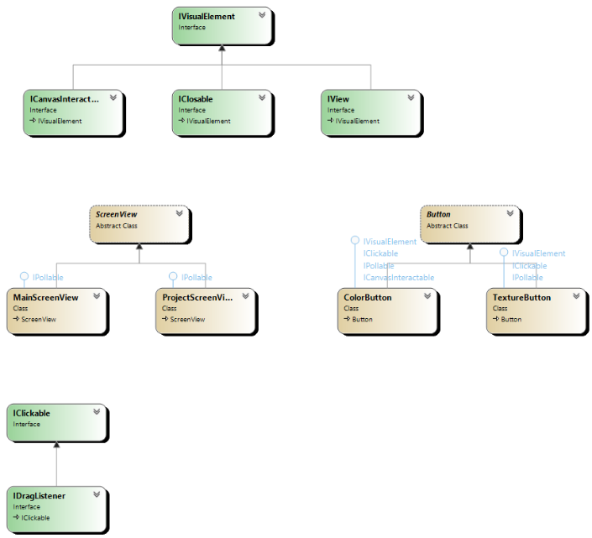

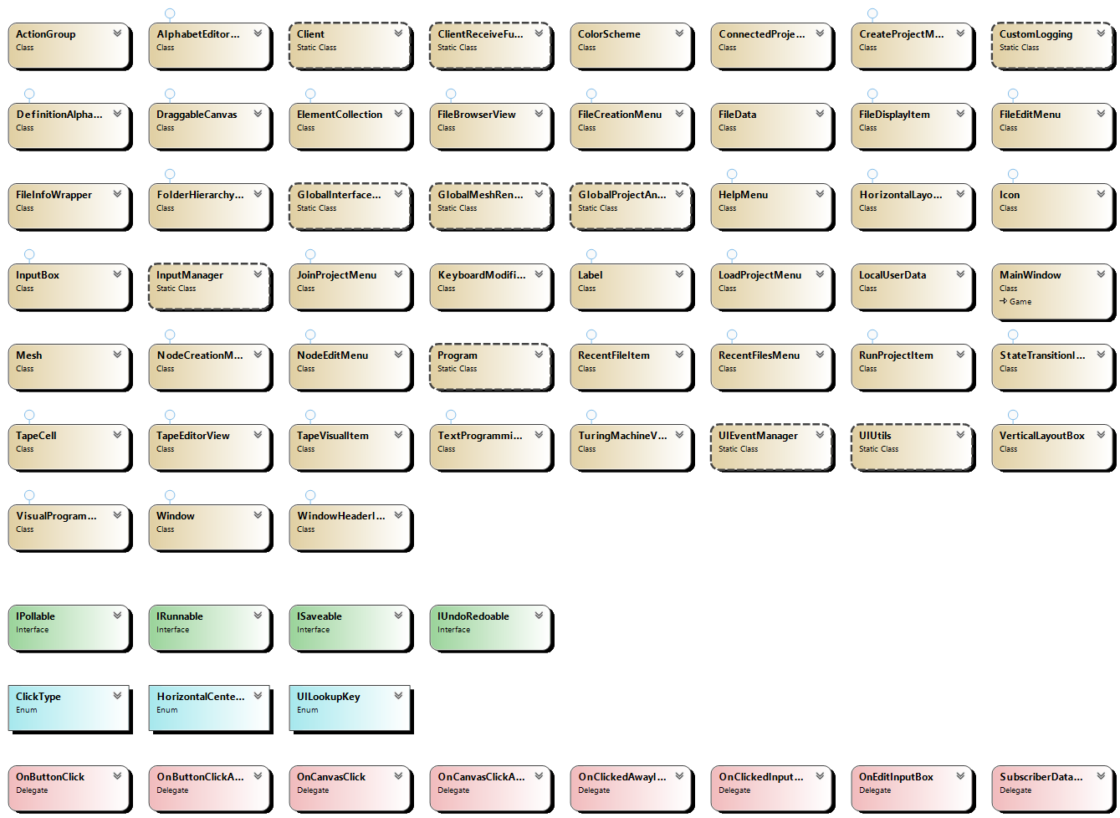

**Class MainWindow Inherits Game**

|  |  |  |
| --- | --- | --- |
| **UML** | | **Description** |
|  | | The MainWindow is how we interface with MonoGame, provides base functio0ns like Draw(), LoadContent(), OnExiting(), etc. |
| **Attributes** | | |
| ScreenView CurrentView | Reference to the currently open view, namely main menu or project view. | |
| GraphicsDeviceManager GraphicsManager | Reference to class provided by MonoGame, allows us to control the application window. | |
| **Functions** | | |
| FUNCTION Draw(GameTime gameTime)  IF GamePad.GetState(PlayerIndex.One).Buttons.Back == ButtonState.Pressed OR Keyboard.GetState().IsKeyDown(Keys.Escape) THEN  Exit()  END IF  UIEventManager.WindowRequiresNextFrameResizeStep ← UIEventManager.WindowRequiresNextFrameResize  GlobalInterfaceData.Time ← gameTime  InputManager.Update()  Client.ProcessPackets()  IF UIEventManager.ClientSuccessConnecting THEN  UIEventManager.ClientSuccessConnectingDelegate?.Invoke(this, new EventArgs())  END IF  IF UIEventManager.ClientFailedConnecting THEN  UIEventManager.ClientFailedConnectingDelegate?.Invoke(this, new EventArgs())  END IF    GraphicsDevice.SetRenderTarget(null)  GraphicsDevice.Clear(Color.CornflowerBlue)  CurrentView.Draw()  GraphicsDevice.Viewport ← GlobalInterfaceData.FullscreenViewport  IF InputManager.DragData != null THEN  MouseIcon.Bounds ← new Point(13, 22)  MouseIcon.Position ← new Vector2(InputManager.MouseData.X, InputManager.MouseData.Y)  MouseIcon.DrawTexture ← GlobalInterfaceData.TextureLookup[UILookupKey.MouseDragIcon]  ELSE IF InputManager.IsMouseOverTypingArea THEN  MouseIcon.Bounds ← new Point(10, 19)  MouseIcon.Position ← new Vector2(InputManager.MouseData.X - MouseIcon.Bounds.X * 0.5f, InputManager.MouseData.Y - MouseIcon.Bounds.Y * 0.5f)  MouseIcon.DrawTexture ← GlobalInterfaceData.TextureLookup[UILookupKey.TypingIcon]  ELSE THEN  MouseIcon.Bounds ← new Point(13, 22)  MouseIcon.Position ← new Vector2(InputManager.MouseData.X, InputManager.MouseData.Y)  MouseIcon.DrawTexture ← GlobalInterfaceData.TextureLookup[UILookupKey.MouseIcon]  END IF    MouseIcon.Draw()  InputManager.IsMouseOverTypingArea ← false    IF UIEventManager.WindowRequiresNextFrameResizeStep THEN  GraphicsManager.PreferredBackBufferWidth ← GraphicsDevice.PresentationParameters.BackBufferWidth  GraphicsManager.PreferredBackBufferHeight ← GraphicsDevice.PresentationParameters.BackBufferHeight + BoundTop  GraphicsManager.ApplyChanges()  UIEventManager.WindowRequiresNextFrameResize ← false  UIEventManager.WindowRequiresNextFrameResizeStep ← false  OnResize(this, null)  END IF  base.Draw(gameTime)  END FUNCTION | | |
| FUNCTION Initialize()  base.Initialize()  END FUNCTION | | |
| FUNCTION LeaveMainMenu()  SDL_SetWindowResizable(Window.Handle, (byte)1U)  MaximiseWindow()  END FUNCTION | | |
| FUNCTION LoadContent()  GraphicsManager.PreferredBackBufferWidth ← GlobalInterfaceData.MainMenuWidth  GraphicsManager.PreferredBackBufferHeight ← GlobalInterfaceData.MainMenuHeight  GraphicsManager.ApplyChanges()  GraphicsDevice.BlendState ← BlendState.AlphaBlend  GlobalInterfaceData.OSWindow ← Window  GlobalInterfaceData.MainWindow ← this  GlobalInterfaceData.FullscreenViewport ← GraphicsDevice.Viewport  GlobalInterfaceData.Device ← GraphicsDevice  GlobalInterfaceData.UIEffect ← Content.Load<Effect>("UIShader")  FontSystemDefaults.FontResolutionFactor ← 1.0f  FontSystemDefaults.KernelWidth ← 1  FontSystemDefaults.KernelHeight ← 1  FontSystemDefaults.PremultiplyAlpha ← true  FontSystemDefaults.FontLoader ← new FreeTypeLoader()  GlobalInterfaceData.TextBatch ← new SpriteBatch(GraphicsDevice)  GlobalInterfaceData.StandardRegularFont ← new FontSystem()  GlobalInterfaceData.StandardRegularFont.AddFont(File.ReadAllBytes(@"Assets/Fonts/Roboto-Regular.ttf"))  GlobalInterfaceData.StandardBoldFont ← new FontSystem()  GlobalInterfaceData.StandardBoldFont.AddFont(File.ReadAllBytes(@"Assets/Fonts/Roboto-Bold.ttf"))  GlobalInterfaceData.MediumRegularFont ← new FontSystem()  GlobalInterfaceData.MediumRegularFont.AddFont(File.ReadAllBytes(@"Assets/Fonts/Roboto-Medium.ttf"))  DateTime Start ← DateTime.UtcNow  GlobalInterfaceData.BakeTextures()  GlobalMeshRenderer.Setup()  DirectoryInfo Info ← Directory.CreateDirectory(Environment.GetFolderPath(Environment.SpecialFolder.ApplicationData) + Path.DirectorySeparatorChar + "Turing Machine - Desktop")  string DataPath ← Info.FullName + Path.DirectorySeparatorChar + "LocalUserData.txt"  IF !File.Exists(DataPath) THEN  TRY  File.Create(DataPath).Close()  GlobalProjectAndUserData.UserData ← new LocalUserData()  GlobalProjectAndUserData.UserDataPath ← DataPath  GlobalProjectAndUserData.SaveUserData()  CATCH Exception E  CustomLogging.Log("UI Error: Failed to generate fresh LocalUserData File - " + E.ToString())  END CATCH  END IF  GlobalProjectAndUserData.LoadUserData(DataPath)  CustomLogging.Log("Load Time: " + (DateTime.UtcNow-Start).TotalSeconds.ToString())  CurrentView ← new MainScreenView()  END FUNCTION | | |
| FUNCTION MainWindow()  GraphicsManager ← new GraphicsDeviceManager(this)  GraphicsManager.PreparingDeviceSettings += NEW LAMBDA FUNCTION (object s, PreparingDeviceSettingsEventArgs args)  (  args.GraphicsDeviceInformation.PresentationParameters.RenderTargetUsage ← RenderTargetUsage.PreserveContents  )  Content.RootDirectory ← "Content"  Window.IsBorderless ← true  Window.AllowUserResizing ← false  Window.ClientSizeChanged += OnResize  Window.AllowAltF4 ← true  IsMouseVisible ← false  IsFixedTimeStep ← false  MouseIcon ← new Icon()  END FUNCTION | | |
| FUNCTION MaximiseWindow()  SDL_SetWindowBordered(Window.Handle, (byte)1U)  SDL_MaximizeWindow(Window.Handle)  BoundTop ← Window.ClientBounds.Top  int Y ← Window.Position.Y - BoundTop  SDL_SetWindowBordered(Window.Handle, (byte)0U)  Window.Position ← new Point(Window.Position.X, Y)  UIEventManager.WindowRequiresNextFrameResize ← true  END FUNCTION | | |
| FUNCTION MinimiseWindow()  SDL_SetWindowBordered(Window.Handle, (byte)1U)  SDL_MinimizeWindow(Window.Handle)  END FUNCTION | | |
| FUNCTION OnExiting(Object sender, EventArgs args)  base.OnExiting(sender, args)  Client.Disconnect()  BackendInterface.CloseProject()  END FUNCTION | | |
| FUNCTION OnResize(object Sender, EventArgs Args)  IF GraphicsDevice.PresentationParameters.BackBufferWidth < GlobalInterfaceData.MinimumApplicationWindowWidth THEN  GraphicsManager.PreferredBackBufferWidth ← GlobalInterfaceData.MinimumApplicationWindowWidth  END IF    IF GraphicsDevice.PresentationParameters.BackBufferHeight < GlobalInterfaceData.MinimumApplicationWindowHeight THEN  GraphicsManager.PreferredBackBufferHeight ← GlobalInterfaceData.MinimumApplicationWindowHeight  END IF    GraphicsManager.ApplyChanges()  GlobalInterfaceData.FullscreenViewport ← new Viewport(0, 0, GraphicsManager.PreferredBackBufferWidth, GraphicsManager.PreferredBackBufferHeight)  CurrentView.ScreenResize()  END FUNCTION | | |

**Class GlobalProjectAndUserData**

|  |  |  |
| --- | --- | --- |
| **UML** | | **Description** |
|  | | Single store of information about user and project data. |
| **Attributes** | | |
| ConnectedProjectData ProjectData | Reference to object with data regarding project. | |
| LocalUserData UserData | Reference to object storing data about local user. | |
| string UserDataPath | Path on disk to file storing local user data. | |
| **Functions** | | |
| FUNCTION LoadUserData(string Path)  TRY  UserData ← JsonSerializer.Deserialize<LocalUserData>(File.ReadAllBytes(Path))  UserDataPath ← Path  CATCH Exception E  CustomLogging.Log("UI Error: Failed to deserialize LocalUserData File" + E.ToString())  END CATCH  END FUNCTION | | |
| FUNCTION SaveUserData()  TRY  File.WriteAllBytes(UserDataPath, JsonSerializer.SerializeToUtf8Bytes(UserData, JsonOptions))  CATCH Exception E  CustomLogging.Log("UI Error: Failed to write LocalUserData File - " + E.ToString())  END CATCH  END FUNCTION | | |
| FUNCTION UpdateRecentlyOpenedFile(string FileDirectory)  FOR int i ← 0 to UserData.RecentlyAccessedFiles.Count - 1  IF UserData.RecentlyAccessedFiles[i].FullPath == FileDirectory THEN  UserData.RecentlyAccessedFiles[i].LastAccessed ← DateTime.Now  SaveUserData()  RETURN  END IF  END FOR  UserData.RecentlyAccessedFiles.Add(new FileInfoWrapper(ProjectData.ProjectName, FileDirectory, DateTime.Now))  SaveUserData()  END FUNCTION | | |

**Class ConnectedProjectData**

|  |  |  |
| --- | --- | --- |
| **UML** | | **Description** |
|  | | Stores information about the currently connected project. |
| **Attributes** | | |
| string ProjectName | Reference to object with data regarding project. | |
| **Functions** | | |
| FUNCTION ConnectedProjectData(string projectName)  ProjectName ← projectName;  END FUNCTION | | |

**Class FileData**

|  |  |  |
| --- | --- | --- |
| **UML** | | **Description** |
|  | | Contains information about a received file or folder (we will refer to it as a resource). Used by the file browser view and other elements to interact with the resource. |
| **Attributes** | | |
| Guid GUID | Stores resources’ GUID (Only used by files). | |
| int ID | Stores resources’ unique ID 9only used by folders). | |
| bool IsFolder | Stores whether the resource is a folder. | |
| string Name | Stores resource name. | |
| CoreFileType Type | Stores type of file the resource is (If it is a file). | |
| **Functions** | | |
| FUNCTION FileData(string SetName, Guid SetGUID, CoreFileType SetType)  Name ← SetName  GUID ← SetGUID  Type ← SetType  IsFolder ← false  END FUNCTION | | |
| FUNCTION FileData(string SetName, int SetID)  Name ← SetName  ID ← SetID  Type ← CoreFileType.Other  IsFolder ← true  END FUNCTION | | |

**Class LocalUserData**

|  |  |  |
| --- | --- | --- |
| **UML** | | **Description** |
|  | | C# JSON template. Used as class containing all data and settings the local user may have. |
| **Attributes** | | |
| List<FileInfoWrapper> RecentlyAccessedFiles | Stores all files recently opened by the user. | |

**Class FileInfoWrapper**

|  |  |  |
| --- | --- | --- |
| **UML** | | **Description** |
|  | | Contains information about a file on disk. Used to represent project files the user recently opened. |
| **Attributes** | | |
| string FileName | Stores the name of the file it represents. | |
| string FullPath | Stores the path on disk of the file it represents. | |
| DateTime LastAccessed | Stores the date of when the file was last opened by the application. | |
| **Functions** | | |
| FUNCTION FileInfoWrapper(string fileName, string fullPath, DateTime lastAccessed)  FileName ← fileName  FullPath ← fullPath  LastAccessed ← lastAccessed  END FUNCTION | | |

**Class CustomLogging**

|  |  |
| --- | --- |
| **UML** | **Description** |
|  | Provides custom debugging system, allowing us to save/display application made logs in a variety of ways. |
| **Functions** | |
| FUNCTION CustomLogging()  Directory.CreateDirectory(Environment.GetFolderPath(Environment.SpecialFolder.ApplicationData) + Path.DirectorySeparatorChar + "Turing Machine - Desktop")  LogFilePath ← Environment.GetFolderPath(Environment.SpecialFolder.ApplicationData) + Path.DirectorySeparatorChar + "Turing Machine - Desktop" + Path.DirectorySeparatorChar + "Log--" + DateTime.Now.ToString("yyyy-MM-dd--HH-mm") + ".txt"  TRY  LogStream ← File.Create(LogFilePath)  CATCH  END CATCH    END FUNCTION | |
| FUNCTION Log(string Message)  Debug.WriteLine(Message)  byte[] Data ← Encoding.ASCII.GetBytes(Message + "\n")  LogStream?.Write(Data, 0, Data.Length)  LogStream?.Flush()  END FUNCTION | |
| FUNCTION Write(string Message)  Debug.Write(Message);  byte[] Data ← Encoding.ASCII.GetBytes(Message)  LogStream?.Write(Data, 0, Data.Length)  LogStream?.Flush()  END FUNCTION | |

**Class Client**

|  |  |  |
| --- | --- | --- |
| **UML** | | **Description** |
|  | | Responsible for networking and processing responses for front end. |
| **Attributes** | | |
| bool IsConnecting | Whether the client is currently attempting to connect to a server. | |
| bool IsConnected | Whether the client is connected to a server. | |
| **Functions** | | |
| FUNCTION AddPacketToProcessOnMainThread(Packet PacketToAdd)  LOCK PacketProcessingQueue  PacketProcessingQueue.Enqueue(PacketToAdd)  END LOCK  END FUNCTION | | |
| FUNCTION ConnectToServer(IPAddress IP, int Port)  IF IsConnecting OR IsConnected THEN  RETURN  END IF  IsConnecting ← true  Thread ConnectThread ← new Thread(NEW LAMBDA FUNCTION () (TCP.Connect(IP, Port, 1000)))  ConnectThread.Start()  END FUNCTION | | |
| FUNCTION Disconnect()  CustomLogging.Log("CLIENT: DISCONNECTING FROM SERVER!")  TCP.TCPInternalDisconnect()  END FUNCTION | | |
| FUNCTION ProcessPackets()  IF PacketProcessingQueue.Count > 0 THEN    LOCK PacketProcessingQueue  PacketsBeingProcessed ← new Queue<Packet>(PacketProcessingQueue)  PacketProcessingQueue.Clear()  END LOCK  int Length ← PacketsBeingProcessed.Count  FOR int i ← 0 to Length - 1  Packet Data ← PacketsBeingProcessed.Dequeue()  IF Data.Length() >= 8 THEN  Data.ReadInt()  int PacketType ← Data.ReadInt()  IF ClientReceiveFunctions.PacketToFunction.ContainsKey(PacketType) THEN  ClientReceiveFunctions.PacketToFunction[PacketType](Data)  END IF  END IF  END FOR  END IF  END FUNCTION | | |
| FUNCTION SendTCPData(Packet Data)  TCP.SendDataToServer(Data)  END FUNCTION | | |

**Class TCPInterface**

|  |  |
| --- | --- |
| **UML** | **Description** |
|  | Helper class that stores the TCP socket connection/socket data and implements the data reconstruction and sending algorithms. |
| **Functions** | |
| FUNCTION Connect(IPAddress TargetIP, int Port, int Timeout)  TRY  ConnectionSocket ← new TcpClient()  ConnectionSocket.ReceiveBufferSize ← DataBufferSize  ConnectionSocket.SendBufferSize ← DataBufferSize  ReceiveDataBuffer ← new byte[DataBufferSize]  ConnectionSocket.BeginConnect(TargetIP, Port, OnConnectCallBack, ConnectionSocket)  Thread.Sleep(Timeout)  IsConnecting ← false  IF !IsConnected THEN  CustomLogging.Log("CLIENT: Connection timed out.")  TCPInternalDisconnect()  UIEventManager.ClientFailedConnecting ← true  END IF  CATCH Exception E  CustomLogging.Log("CLIENT: Connection attempt failure! " + E.ToString())  UIEventManager.ClientFailedConnecting ← true  TCPInternalDisconnect()  END CATCH  END FUNCTION | |
| FUNCTION OnConnectCallBack(IAsyncResult Result)  TRY  IF ConnectionSocket == null THEN  RETURN  END IF    CustomLogging.Log("CLIENT: Connect callback called.")  ConnectionSocket.EndConnect(Result)  DataStream ← ConnectionSocket.GetStream()  PacketCurrentlyBeingRebuilt ← new Packet()  UIEventManager.ClientSuccessConnecting ← true  DataStream.BeginRead(ReceiveDataBuffer, 0, DataBufferSize, OnReceiveDataFromServer, null)  CATCH Exception E  CustomLogging.Log(E.ToString())  TCPInternalDisconnect()  END CATCH  END FUNCTION | |
| FUNCTION OnReceiveDataFromServer(IAsyncResult Result)  TRY  IF ConnectionSocket == null OR !ConnectionSocket.Connected THEN  CustomLogging.Log("CLIENT: Server disconnected me!")  TCPInternalDisconnect()  RETURN  END IF    int IncomingDataLength ← DataStream.EndRead(Result)  byte[] UsefuldataBuffer ← new byte[IncomingDataLength]  Array.Copy(ReceiveDataBuffer, UsefuldataBuffer, IncomingDataLength)  PacketCurrentlyBeingRebuilt.Write(UsefuldataBuffer, false)  PacketCurrentlyBeingRebuilt.SaveTemporaryBufferToPernamentReadBuffer()  IF PacketCurrentlyBeingRebuilt.UnreadLength() >= 4 THEN  int PacketLength ← PacketCurrentlyBeingRebuilt.ReadInt(false)  WHILE PacketCurrentlyBeingRebuilt.UnreadLength() >= PacketLength AND PacketCurrentlyBeingRebuilt.UnreadLength() >= 4  Packet ProcessedPacket ← new Packet(PacketCurrentlyBeingRebuilt.ReadBytes(PacketLength))  AddPacketToProcessOnMainThread(ProcessedPacket)  IF PacketCurrentlyBeingRebuilt.UnreadLength() >= 4  PacketLength ← PacketCurrentlyBeingRebuilt.ReadInt(false)  END IF  END WHILE  IF PacketCurrentlyBeingRebuilt.UnreadLength() == 0  PacketCurrentlyBeingRebuilt.Reset()  END IF  END IF  IF ConnectionSocket != null  DataStream.BeginRead(ReceiveDataBuffer, 0, DataBufferSize, OnReceiveDataFromServer, null)  END IF  CATCH Exception E  CustomLogging.Log(E.ToString())  END CATCH  END FUNCTION | |
| FUNCTION SendDataToServer(Packet Data)  TRY  CustomLogging.Log("CLIENT: Client is writing data to server")  Data.InsertPacketLength()  DataStream.BeginWrite(Data.SaveTemporaryBufferToPernamentReadBuffer(), 0, Data.Length(), null, null)  CATCH Exception E  CustomLogging.Log("CLIENT: Error Sending Data To Server! " + E.ToString())  END CATCH  END FUNCTION | |
| FUNCTION TCPInternalDisconnect()  ConnectionSocket?.Close()  ConnectionSocket ← null  DataStream ← null  ReceiveDataBuffer ← null  PacketCurrentlyBeingRebuilt ← null  END FUNCTION | |

**Class ClientReceiveFunctions**

|  |  |  |
| --- | --- | --- |
| **UML** | | **Description** |
|  | | Contains information about a file on disk. Used to represent project files the user recently opened. |
| **Attributes** | | |
| Dictionary<int, PacketFunctionPointer> PacketToFunction | Stores lookup of packet type (as int) to appropriate function that processes said packet type. | |
| **Functions** | | |
| FUNCTION ReceivedFileFromServer(Packet Data)  CustomLogging.Log("CLIENT: Received FILE Data")  FileDataMessage Message ← JsonSerializer.Deserialize<FileDataMessage>(Data.ReadByteArray(false))  UIEventManager.PushFileToListeners(Message.GUID, Message)  END FUNCTION | | |
| FUNCTION ReceivedFileMetadataFromServer(Packet Data)  CustomLogging.Log("CLIENT: Received METADATA")  FileDataMessage Message ← JsonSerializer.Deserialize<FileDataMessage>(Data.ReadByteArray(false))  UIEventManager.PushFileToListeners(Message.GUID, Message)  END FUNCTION | | |
| FUNCTION ReceivedFolderDataFromServer(Packet Data)  CustomLogging.Log("CLIENT: Received FOLDER Data")  FolderDataMessage Message ← JsonSerializer.Deserialize<FolderDataMessage>(Data.ReadByteArray(false))  UIEventManager.PushFolderToListeners(Message.ID, Message)  END FUNCTION | | |
| FUNCTION ReceivedProjectData(Packet Data)  ProjectDataMessage Message ← JsonSerializer.Deserialize<ProjectDataMessage>(Data.ReadByteArray())  GlobalProjectAndUserData.ProjectData ← new ConnectedProjectData(Message.ProjectName)  UIEventManager.RecievedProjectDataFromServerDelegate?.Invoke(null, null)  END FUNCTION | | |
| FUNCTION ReceiveErrorNotification(Packet Data)  ErrorNotificationMessage Message ← JsonSerializer.Deserialize<ErrorNotificationMessage>(Data.ReadByteArray())  CustomLogging.Log("CLIENT: Received Error Notification: " + Message.ErrorMessage)  END FUNCTION | | |
| FUNCTION ReceiveLogData(Packet Data)  LogDataMessage Message ← JsonSerializer.Deserialize<LogDataMessage>(Data.ReadByteArray())  CustomLogging.Log("CLIENT: LOG DATA FROM SERVER: " + Message.LogMessage)  END FUNCTION | | |

**Class ActionGroup**

|  |  |  |
| --- | --- | --- |
| **UML** | | **Description** |
|  | | An action group stores a list of visual elements that listen to actions from the InputManager. Action groups also provide scissor testing, explanation found in Front End UI System Design section. |
| **Attributes** | | |
| List<IClickable> ClickableObjects | All objects that support a clicked event in the action group. | |
| int Height | Height of the action groups area. | |
| bool IsActive | Whether the action group is to be processed. | |
| bool IsDirtyClickable | Whether an element that is clickable is ready to be removed from this action group. | |
| bool IsDirtyPollable | Whether an element that is pollable is ready to be removed from this action group. | |
| bool IsMarkedForDeletion | Whether this action group is to be deleted. | |
| bool IsPersistant | Whether this action group should remain when screens are switched. | |
| List<IPollable> PollableObjects | All objects that want to be polled/updated by the action group. | |
| int Width | Width of the action groups area. | |
| int X | X position of the action group. | |
| int Y | Y position of the action group. | |
| **Functions** | | |
| FUNCTION ActionGroup()  END FUNCTION | | |
| FUNCTION ActionGroup(int SetX, int SetY, int SetWidth, int SetHeight)  X ← SetX  Y ← SetY  Width ← SetWidth  Height ← SetHeight  END FUNCTION | | |
| FUNCTION bool IsMouseInBounds()  RETURN (InputManager.MouseData.X > X AND InputManager.MouseData.X < X + Width AND InputManager.MouseData.Y > Y AND InputManager.MouseData.Y < Y + Height)  END FUNCTION | | |

**Class InputManager**

|  |  |  |
| --- | --- | --- |
| **UML** | | **Description** |
|  | | Central input management class. Responsible for determining which UI events are fired and providing input data for UI. |
| **Attributes** | | |
| object DragData | Data currently in clipboard when dragging & dropping. | |
| bool IsDragging | Returns whether there is an active drag & drop currently. | |
| bool IsMouseOverTypingArea | Returns whether the mouse is currently over a typing area, such an input box. | |
| bool LeftMousePressed | Returns whether the left mouse button was pressed down this frame. | |
| bool LeftMouseReleased | Returns whether the left mouse button was released this frame. | |
| MouseState MouseData | Reference to object provide by MonoGame, that returns all data about the mouse state for this frame. | |
| int MouseDeltaX | The change in X coordinate of the mouse this frame. | |
| int MouseDeltaY | The change in Y coordinate of the mouse this frame. | |
| Matrix MousePositionMatrix | Matrix representing the current mouse position. | |
| int PreviousMouseX | The X coordinate of the mouse in the previous frame. | |
| int PreviousMouseY | The Y coordinate of the mouse in the previous frame. | |
| int PreviousScrollWheel | The value of the scroll wheel in the previous frame. | |
| bool RightMousePressed | Returns whether the right mouse button was pressed down this frame. | |
| bool RightMouseReleased | Returns whether the right mouse button was released this frame. | |
| int ScrollWheelDelta | Change in the value of the scroll wheel between the last frame and the current one. | |
| **Functions** | | |
| FUNCTION ActionGroup CreateActionGroup()  ActionGroup NewGroup ← new ActionGroup()  ActionGroups.Add(NewGroup)  RETURN NewGroup  END FUNCTION | | |
| FUNCTION ActionGroup CreateActionGroup(int X, int Y, int Width, int Height)  ActionGroup NewGroup ← new ActionGroup(X, Y, Width, Height)  ActionGroups.Add(NewGroup)  RETURN NewGroup  END FUNCTION | | |
| FUNCTION DeleteAllActionGroups()  FOR int i ← 0 to ActionGroups.Count - 1  ActionGroups[i].IsMarkedForDeletion ← true  END FOR  PreviouslyClickedObject ← null  END FUNCTION | | |
| FUNCTION DrawActionGroups()  FOR int i ← 0 to ActionGroups.Count - 1  Icon debug ← new Icon()  IF i % 3 == 0 THEN  debug.DrawColor ← new Color(new Color(GlobalInterfaceData.Scheme.UIOverlayDebugColor4.ToVector3()), 20)  ELSE IF i % 2 == 0 THEN  debug.DrawColor ← new Color(new Color(GlobalInterfaceData.Scheme.UIOverlayDebugColor1.ToVector3()), 20)  ELSE  debug.DrawColor ← new Color(new Color(GlobalInterfaceData.Scheme.UIOverlayDebugColor3.ToVector3()), 20)  END IF  debug.Bounds ← new Point(ActionGroups[i].Width, ActionGroups[i].Height)  debug.Position ← new Vector2(ActionGroups[i].X, ActionGroups[i].Y)  debug.Draw()  END FOR  END FUNCTION | | |
| FUNCTION ManuallyClickElement(IClickable Element)  IF PreviouslyClickedObject != null AND Element != PreviouslyClickedObject THEN  PreviouslyClickedObject.ClickedAway()  END IF  PreviouslyClickedObject ← Element  Element.Clicked()  END FUNCTION | | |
| FUNCTION SendActionGroupToFront(ActionGroup Group)  int Index ← ActionGroups.IndexOf(Group)  ActionGroups.Add(ActionGroups[Index])  ActionGroups.RemoveAt(Index)  END FUNCTION | | |
| FUNCTION StartDragging(object Data)  DragData ← Data  IsDragging ← true  END FUNCTION | | |
| FUNCTION Update()  MouseData ← Mouse.GetState()  MousePositionMatrix ← Matrix.CreateTranslation(MouseData.X, MouseData.Y, 0)  LeftMousePressed ← false  LeftMouseReleased ← false    IF MouseData.LeftButton == ButtonState.Pressed AND PreviousLeftClickState == ButtonState.Released THEN  LeftMousePressed ← true  END IF  IF MouseData.LeftButton == ButtonState.Released AND PreviousLeftClickState == ButtonState.Pressed THEN  LeftMouseReleased ← true  END IF    PreviousLeftClickState ← MouseData.LeftButton  RightMousePressed ← false  RightMouseReleased ← false    IF MouseData.RightButton == ButtonState.Pressed AND PreviousRightClickState == ButtonState.Released THEN  RightMousePressed ← true  END IF  IF MouseData.RightButton == ButtonState.Released AND PreviousRightClickState == ButtonState.Pressed THEN  RightMouseReleased ← true  END IF    PreviousRightClickState ← MouseData.RightButton  MouseDeltaX ← MouseData.X - PreviousMouseX  MouseDeltaY ← MouseData.Y - PreviousMouseY  PreviousMouseX ← MouseData.X  PreviousMouseY ← MouseData.Y  ScrollWheelDelta ← MouseData.ScrollWheelValue - PreviousScrollWheel  PreviousScrollWheel ← MouseData.ScrollWheelValue  IF GlobalInterfaceData.MainWindow.IsActive AND (LeftMousePressed OR RightMousePressed OR LeftMouseReleased) THEN  int i ← ActionGroups.Count-1  bool RecepientFound ← false  WHILE i > -1 AND !RecepientFound  IF ActionGroups[i].IsActive AND ActionGroups[i].IsMouseInBounds() THEN  int j ← ActionGroups[i].ClickableObjects.Count - 1  WHILE j > -1 AND !RecepientFound  IF ActionGroups[i].ClickableObjects[j].IsMouseOver() THEN  CustomLogging.Log(ActionGroups[i].ClickableObjects[j].ToString()+" was clicked")  IF LeftMousePressed OR RightMousePressed THEN  IF PreviouslyClickedObject != null AND ActionGroups[i].ClickableObjects[j] != PreviouslyClickedObject THEN  PreviouslyClickedObject.ClickedAway()  END IF  PreviouslyClickedObject ← ActionGroups[i].ClickableObjects[j]  ActionGroups[i].ClickableObjects[j].Clicked()  ELSE  IDragListener Listener ← ActionGroups[i].ClickableObjects[j] as IDragListener  IF Listener != null THEN  Listener.RecieveDragData()  END IF  END IF  RecepientFound ← true  END IF  j--  END WHILE  END IF  i--  END WHILE  IF PreviouslyClickedObject != null AND RecepientFound == false THEN  PreviouslyClickedObject.ClickedAway()  END IF  END IF  IF LeftMouseReleased THEN  IsDragging ← false  DragData ← null  END IF  FOR int i ← 0 to ActionGroups.Count - 1  IF ActionGroups[i].IsActive THEN  IF ActionGroups[i].IsMouseInBounds()  FOR int j ← 0 to ActionGroups[i].PollableObjects.Count - 1  ActionGroups[i].PollableObjects[j].PollInput(true)  END FOR  ELSE  FOR int j ← 0 to ActionGroups[i].PollableObjects.Count - 1  ActionGroups[i].PollableObjects[j].PollInput(false)  END FOR  END IF  END IF  END FOR  FOR int i ← ActionGroups.Count - 1 to 0  IF ActionGroups[i].IsMarkedForDeletion AND !ActionGroups[i].IsPersistant THEN  ActionGroups.RemoveAt(i)  ELSE  IF ActionGroups[i].IsDirtyClickable THEN  FOR int j ← ActionGroups[i].ClickableObjects.Count - 1 to 0  IF ActionGroups[i].ClickableObjects[j].IsMarkedForDeletion) ActionGroups[i].ClickableObjects.RemoveAt(j)  END FOR  ActionGroups[i].IsDirtyClickable ← false  END IF  IF ActionGroups[i].IsDirtyPollable THEN  FOR int j ← ActionGroups[i].PollableObjects.Count - 1 to 0  IF ActionGroups[i].PollableObjects[j].IsMarkedForDeletion) ActionGroups[i].PollableObjects.RemoveAt(j)  END FOR  ActionGroups[i].IsDirtyPollable ← false  END IF  END IF  END FOR  END FUNCTION | | |

**Class KeyboardModifiers**

|  |  |  |
| --- | --- | --- |
| **UML** | | **Description** |
|  | | Provides restrictions for an input box on what typing input it can accept. |
| **Attributes** | | |
| bool AllowsCharacters | Whether the input box can accept alphabet characters. | |
| bool AllowsNewLine | Whether the input box can accept the enter key. | |
| bool AllowsNumbers | Whether the input box can accept number characters. | |
| bool AllowsShift | Whether the input box can accept capital/alternate characters. | |
| bool AllowsSymbols | Whether the input box can accept special characters (not numbers/alphabet). | |

**Class UIEventManager**

|  |  |  |
| --- | --- | --- |
| **UML** | | **Description** |
|  | | Responsible for manging and implementing special UI events. |
| **Attributes** | | |
| bool ClientFailedConnecting | Whether the client failed to connect to a server. | |
| EventHandler ClientFailedConnectingDelegate | Event called when client fails to connect to a server. | |
| bool ClientSuccessConnecting | Whether the client succeeds to connect to a server. | |
| EventHandler ClientSuccessConnectingDelegate | Event called when client succeeds in connecting to a server. | |
| EventHandler RecievedProjectDataFromServerDelegate | Event called when the client receives a project data response | |
| bool WindowRequiresNextFrameResize | Marks that the application window needs to be resized the next frame. | |
| bool WindowRequiresNextFrameResize | Required due to the window resize event check taking place in at the end of the update loop, as such this ensures the window is updated the next frame not the current one. | |
| **Functions** | | |
| FUNCTION PushFileToListeners(Guid FileID, FileDataMessage Data)  List<SubscriberDataCallback> Subscribers ← GUIDFileUpdateSubscribers[FileID]  FOR int i ← Subscribers.Count - 1 to 0  Subscribers[i](Data)  END FOR  END FUNCTION | | |
| FUNCTION PushFolderToListeners(int FolderID, FolderDataMessage Data)  List<SubscriberDataCallback> Subscribers ← FileUpdateSubscribers[FolderID]    FOR int i ← Subscribers.Count - 1 to 0  Subscribers[i](Data)  END FOR  END FUNCTION | | |
| FUNCTION Subscribe(int FileID, SubscriberDataCallback Function)  IF !FileUpdateSubscribers.ContainsKey(FileID) THEN  FileUpdateSubscribers.Add(FileID, new List<SubscriberDataCallback>())  END IF  FileUpdateSubscribers[FileID].Add(Function)  END FUNCTION | | |
| FUNCTION Subscribe(Guid FileID, SubscriberDataCallback Function)  IF !GUIDFileUpdateSubscribers.ContainsKey(FileID) THEN  GUIDFileUpdateSubscribers.Add(FileID, new List<SubscriberDataCallback>())  END IF  GUIDFileUpdateSubscribers[FileID].Add(Function)  END FUNCTION | | |
| FUNCTION Unsubscribe(int FileID, SubscriberDataCallback Function)  IF FileUpdateSubscribers.ContainsKey(FileID) AND FileUpdateSubscribers[FileID].Contains(Function) THEN  FileUpdateSubscribers[FileID].Remove(Function)  END IF  END FUNCTION | | |
| FUNCTION Unsubscribe(Guid FileID, SubscriberDataCallback Function)  IF GUIDFileUpdateSubscribers.ContainsKey(FileID) AND GUIDFileUpdateSubscribers[FileID].Contains(Function)  GUIDFileUpdateSubscribers[FileID].Remove(Function)  END IF  END FUNCTION | | |

**Class GlobalInterfaceData**

|  |  |  |
| --- | --- | --- |
| **UML** | | **Description** |
|  | | Single access point for all UI classes to have access to all UI related information, be it colour schemes, fonts, UI scaling data, rendering object references. |
| **Attributes** | | |
| GraphicsDevice Device | Reference to GPU control object. | |
| Viewport FullscreenViewport | Viewport used for rendering the entire application window. | |
| int MainMenuHeight | Reference height for the main menu screen. | |
| int MainMenuWidth | Reference width for the main menu screen. | |
| MainWindow MainWindow | Reference to the main application class. | |
| FontSystem MediumRegularFont | Reference to font object. | |
| int MinimumApplicationWindowHeight | Minimum size for the application window (in pixels). | |
| int MinimumApplicationWindowWidth | Minimum size for the application window (in pixels). | |
| GameWindow OSWindow | Reference to application window object. | |
| ColorScheme Scheme | Currently loaded colour scheme. | |
| FontSystem StandardBoldFont | Reference to font object. | |
| FontSystem StandardRegularFont | Reference to font object. | |
| SpriteBatch TextBatch | Rendering batch used for rendering text. | |
| Dictionary<UILookupKey, Texture2D> TextureLookup | Lookup for all loaded texture assets. | |
| GameTime Time | Time taken for the last frame to be fully processed. | |
| Effect UIEffect | GPU shader used for rendering UI. | |
| **Functions** | | |
| FUNCTION BakeTextures()  FOR int i ← 0 to ManuallyGeneratedMaxEnum  UILookupKey Key ← (UILookupKey)i  TextureLookup.Add(Key, SVGToTexture(Environment.CurrentDirectory + @"\Assets\SVG\" + Key.ToString() + @".svg"))  END FOR  TextureLookup.Add(UILookupKey.Execute, PNGToTexture(Environment.CurrentDirectory + @"\Assets\PNG\" + "Execute" + @".png"))  TextureLookup.Add(UILookupKey.ExecuteHighlight, PNGToTexture(Environment.CurrentDirectory + @"\Assets\PNG\" + "ExecuteHighlight" + @".png"))  TextureLookup.Add(UILookupKey.Restart, PNGToTexture(Environment.CurrentDirectory + @"\Assets\PNG\" + "Restart" + @".png"))  TextureLookup.Add(UILookupKey.RestartHighlight, PNGToTexture(Environment.CurrentDirectory + @"\Assets\PNG\" + "RestartHighlight" + @".png"))  TextureLookup.Add(UILookupKey.Step, PNGToTexture(Environment.CurrentDirectory + @"\Assets\PNG\" + "Step" + @".png"))  TextureLookup.Add(UILookupKey.StepHighlight, PNGToTexture(Environment.CurrentDirectory + @"\Assets\PNG\" + "StepHighlight" + @".png"))  TextureLookup.Add(UILookupKey.AutoStep, PNGToTexture(Environment.CurrentDirectory + @"\Assets\PNG\" + "AutoStep" + @".png"))  TextureLookup.Add(UILookupKey.AutoStepHighlight, PNGToTexture(Environment.CurrentDirectory + @"\Assets\PNG\" + "AutoStepHighlight" + @".png"))  TextureLookup.Add(UILookupKey.Pause, PNGToTexture(Environment.CurrentDirectory + @"\Assets\PNG\" + "Pause" + @".png"))  TextureLookup.Add(UILookupKey.PauseHighlight, PNGToTexture(Environment.CurrentDirectory + @"\Assets\PNG\" + "PauseHighlight" + @".png"))  TextureLookup.Add(UILookupKey.SpeedOne, PNGToTexture(Environment.CurrentDirectory + @"\Assets\PNG\" + "SpeedOne" + @".png"))  TextureLookup.Add(UILookupKey.SpeedOneHighlight, PNGToTexture(Environment.CurrentDirectory + @"\Assets\PNG\" + "SpeedOneHighlight" + @".png"))  TextureLookup.Add(UILookupKey.SpeedTwo, PNGToTexture(Environment.CurrentDirectory + @"\Assets\PNG\" + "SpeedTwo" + @".png"))  TextureLookup.Add(UILookupKey.SpeedTwoHighlight, PNGToTexture(Environment.CurrentDirectory + @"\Assets\PNG\" + "SpeedTwoHighlight" + @".png"))  TextureLookup.Add(UILookupKey.SpeedThree, PNGToTexture(Environment.CurrentDirectory + @"\Assets\PNG\" + "SpeedThree" + @".png"))  TextureLookup.Add(UILookupKey.SpeedThreeHighlight, PNGToTexture(Environment.CurrentDirectory + @"\Assets\PNG\" + "SpeedThreeHighlight" + @".png"))  TextureLookup.Add(UILookupKey.HelpMenuTuringExecution1, PNGToTexture(Environment.CurrentDirectory + @"\Assets\PNG\" + "HelpMenuTuringExecution1" + @".png"))  TextureLookup.Add(UILookupKey.HelpMenuTuringExecution2, PNGToTexture(Environment.CurrentDirectory + @"\Assets\PNG\" + "HelpMenuTuringExecution2" + @".png"))  TextureLookup.Add(UILookupKey.DebugTexture, GenerateFilledTexture(1,1, Scheme.UIOverlayDebugColor1))  END FUNCTION | | |
| FUNCTION Texture2D GenerateFilledTexture(int Width, int Height, Color Fill)  Texture2D Texture ← new Texture2D(Device, Width, Height)  Color[] Values ← new Color[Width*Height]  FOR int i ← 0 to Values.Length - 1  Values[i] ← Fill  END FOR  Texture.SetData(Values)  RETURN Texture  END FUNCTION | | |
| FUNCTION Texture2D PNGToTexture(string Path)  Bitmap image ← new Bitmap(Image.FromFile(Path))  int bufferSize ← image.Height * image.Width * 4  System.IO.MemoryStream memoryStream ← new MemoryStream(bufferSize)  image.Save(memoryStream, System.Drawing.Imaging.ImageFormat.Png)  Texture2D Texture ← Texture2D.FromStream(Device, memoryStream)  RETURN Texture  END FUNCTION | | |
| FUNCTION float Scale(float Value)  RETURN (float)(Value * UIScale)  END FUNCTION | | |
| FUNCTION Vector2 Scale(Vector2 Value)  RETURN new Vector2((float)(Value.X * UIScale), (float)(Value.Y * UIScale))  END FUNCTION | | |
| FUNCTION Point ScaleMin(Point Value, double Min)  RETURN new Point(Convert.ToInt32(Math.Clamp((double)Value.X * UIScale, Min, double.PositiveInfinity)), Convert.ToInt32(Math.Clamp((double)Value.Y * UIScale, Min, double.PositiveInfinity)))  END FUNCTION | | |
| FUNCTION Texture2D SVGToTexture(string Path)  SvgDocument svgDoc ← SvgDocument.Open<SvgDocument>(Path, null)  Bitmap Image ← svgDoc.Draw(Convert.ToInt32(MathF.Ceiling(svgDoc.Width.Value)) * 2, Convert.ToInt32(MathF.Ceiling(svgDoc.Height.Value)) * 2) int bufferSize ← Image.Height * Image.Width * 4  System.IO.MemoryStream memoryStream ← new MemoryStream(bufferSize)  Image.Save(memoryStream, System.Drawing.Imaging.ImageFormat.Bmp)  Texture2D Texture ← Texture2D.FromStream(Device, memoryStream)  RETURN Texture  END FUNCTION | | |
| FUNCTION UpdateScaleAuto()  UIScale ← Device.PresentationParameters.BackBufferHeight / ReferenceHeight;  END FUNCTION | | |
| FUNCTION UpdateScaleManual(double NewScale)  UIScale ← NewScale  END FUNCTION | | |

**Class GlobalUIRenderer**

|  |  |
| --- | --- |
| **UML** | **Description** |
|  | Responsible for drawing meshes. |
| **Functions** | |
| FUNCTION Draw(Mesh DrawMesh, Matrix Transformations, Texture2D DrawTexture, Viewport? Port ← null)  Viewport port  IF Port == null THEN  port ← GlobalInterfaceData.FullscreenViewport  ELSE  port ← Port.Value  END IF  Device.Viewport ← port  RecalculateProjection(port.X, port.Y, port.Width, port.Height)  Effect.Parameters["HasBaseTexture"].SetValue(true)  Effect.Parameters["BaseTextureSampler+BaseTexture"].SetValue(DrawTexture)  Effect.Parameters["OverlayColor"].SetValue(Vector4.Zero)  Effect.Parameters["Projection"].SetValue(Transformations * Projection)  FOREACH EffectPass Pass in Effect.CurrentTechnique.Passes  Pass.Apply()  Device.DrawUserIndexedPrimitives(PrimitiveType.TriangleList, DrawMesh.Vertices, 0, DrawMesh.Vertices.Length, DrawMesh.Indices, 0, DrawMesh.Indices.Length / 3)  END FOREACH  END FUNCTION | |
| FUNCTION Draw(Mesh DrawMesh, Matrix Transformations, Color DrawColor, Viewport? Port ← null)  Viewport port  IF Port == null THEN  port ← GlobalInterfaceData.FullscreenViewport  ELSE  port ← Port.Value  END IF  Device.Viewport ← port  RecalculateProjection(port.X, port.Y, port.Width, port.Height)  Effect.Parameters["HasBaseTexture"].SetValue(false)  Effect.Parameters["OverlayColor"].SetValue(DrawColor.ToVector4())  Effect.Parameters["Projection"].SetValue(Transformations * Projection)  FOREACH EffectPass Pass in Effect.CurrentTechnique.Passes  Pass.Apply()  Device.DrawUserIndexedPrimitives(PrimitiveType.TriangleList, DrawMesh.Vertices, 0, DrawMesh.Vertices.Length, DrawMesh.Indices, 0, DrawMesh.Indices.Length / 3)  END FOREACH  END FUNCTION | |
| FUNCTION RecalculateProjection(int X, int Y, int Width, int Height)  Projection ← Matrix.CreateOrthographicOffCenter(X, X + Width, Y + Height, Y, 0f, 1f)  END FUNCTION | |
| FUNCTION Setup()  Device ← GlobalInterfaceData.Device  Effect ← GlobalInterfaceData.UIEffect  END FUNCTION | |

**Class Mesh**

|  |  |  |
| --- | --- | --- |
| **UML** | | **Description** |
|  | | Stores a mesh and relevant data, also provides helper functions for creating meshes. |
| **Attributes** | | |
| int[] Indices | All indices in the mesh. | |
| VertexPositionTexture[] Vertices | All vertices in the mesh. | |
| **Functions** | | |
| FUNCTION Mesh CreateRectangle(Vector2 Offset, float Width, float Height)  RETURN new Mesh  (  new VertexPositionTexture[]  {  new VertexPositionTexture(new Vector3(Offset.X, Offset.Y + Height, 0f), Vector2.UnitY),  new VertexPositionTexture(new Vector3(Offset.X, Offset.Y, 0f), Vector2.Zero),  new VertexPositionTexture(new Vector3(Offset.X + Width, Offset.Y, 0f), Vector2.UnitX),  new VertexPositionTexture(new Vector3(Offset.X + Width, Offset.Y + Height, 0f), Vector2.One),  },  new int[]  {  0, 1, 2, 0, 2, 3  }  )  END FUNCTION | | |
| FUNCTION Mesh CreateRectangle(Vector2 Offset, Point Bounds)  RETURN new Mesh  (  new VertexPositionTexture[]  {  new VertexPositionTexture(new Vector3(Offset.X, Offset.Y + Bounds.Y, 0f), Vector2.UnitY),  new VertexPositionTexture(new Vector3(Offset.X, Offset.Y, 0f), Vector2.Zero),  new VertexPositionTexture(new Vector3(Offset.X + Bounds.X, Offset.Y, 0f), Vector2.UnitX),  new VertexPositionTexture(new Vector3(Offset.X + Bounds.X, Offset.Y + Bounds.Y, 0f), Vector2.One),  },  new int[]  {  0, 1, 2, 0, 2, 3  }  )  END FUNCTION | | |
| FUNCTION Mesh()  END FUNCTION | | |
| FUNCTION Mesh(VertexPositionTexture[] vertices, int[] indices)  Vertices ← vertices  Indices ← indices  END FUNCTION | | |

**Class UIUtils**

|  |  |
| --- | --- |
| **UML** | **Description** |
|  | Provides helper functions relevant to UI elements. |
| **Functions** | |
| FUNCTION Viewport CalculateOverlapPort(Viewport Left, Viewport Right)  int LeftLeft ← Left.X  int LeftRight ← Left.X + Left.Width  int RightLeft ← Right.X  int RightRight ← Right.X + Right.Width  IF LeftRight < RightLeft OR RightRight < LeftLeft THEN  RETURN new Viewport(0, 0, 0, 0)  END IF  Viewport Port ← new Viewport()    Port.X ← Math.Max(LeftLeft, RightLeft)  IF LeftRight > RightRight THEN  Port.Width ← RightRight - Port.X  ELSE  Port.Width ← LeftRight - Port.X  END IF  LeftLeft ← Left.Y  LeftRight ← Left.Y + Left.Height  RightLeft ← Right.Y  RightRight ← Right.Y + Right.Height  Port.Y ← Math.Max(LeftLeft, RightLeft)  IF LeftRight > RightRight THEN  Port.Height ← RightRight - Port.Y  ELSE  Port.Height ← LeftRight - Port.Y  END IF  RETURN Port  END FUNCTION | |
| FUNCTION int ConvertFloatToInt(float Value)  RETURN Convert.ToInt32(Value)  END FUNCTION | |
| FUNCTION int ConvertFloatToMinInt(float Value, float Min)  RETURN Convert.ToInt32(Math.Clamp(MathF.Round(Value), Min, float.PositiveInfinity))  END FUNCTION | |
| FUNCTION Matrix CreateTranslation(Vector2 Position)  RETURN Matrix.CreateTranslation(new Vector3(Position, 0))  END FUNCTION | |
| FUNCTION bool IsDefaultViewport(Viewport Port)  RETURN (Port.X == 0 AND Port.Y == 0 AND Port.Width == 0 AND Port.Height == 0)  END FUNCTION | |

**Abstract Class Button**

|  |  |
| --- | --- |
| **UML** | **Description** |
|  | Base class for button visual elements. |

**Class ColorButton Inherits Button Implements IVisualElement, IClickable, IPollable, ICanvasInteractable**

|  |  |  |
| --- | --- | --- |
| **UML** | | **Description** |
|  | | Implements a button that renders as a flat colour. |
| **Attributes** | | |
| Color BaseColor | Base colour for rendering the button. | |
| ClickType ClickListenType | What type of click the button listens for (left, right, middle, etc.) | |
| Color HighlightColor | Highlight colour for rendering the button. | |
| bool HighlightOnMouseOver | Whether the button should render a different colour when hovered over by the mouse button. | |
| Point Bounds | The size of the button (width/height). | |
| ActionGroup Group | Action group the button belongs to currently. | |
| bool IsActive | Whether the button is currently on. | |
| bool IsMarkedForDeletion | Whether the button is to be deleted from its action group. | |
| Vector2 Position | The current position of the button on the screen. | |
| **Functions** | | |
| FUNCTION Close()  Group.IsDirtyClickable ← true  Group.IsDirtyPollable ← true  IsMarkedForDeletion ← true  END FUNCTION | | |
| FUNCTION ColorButton(ActionGroup group)  Group ← group  group.ClickableObjects.Add(this)  group.PollableObjects.Add(this)  Background ← new Icon()  Bounds ← Point.Zero  Position ← Vector2.Zero  END FUNCTION | | |
| FUNCTION ColorButton(int width, int height, ActionGroup group)  Group ← group  group.ClickableObjects.Add(this)  group.PollableObjects.Add(this)  Background ← new Icon()  Bounds ← new Point(width, height)  Position ← Vector2.Zero  END FUNCTION | | |
| FUNCTION Draw(Viewport? BoundPort ← null)  IF IsActive THEN  Background.Draw(BoundPort)  END IF  END FUNCTION | | |
| FUNCTION IClickable.Clicked()  IF ClickListenType == ClickType.Both OR (ClickListenType == ClickType.Left AND InputManager.LeftMousePressed) OR (ClickListenType == ClickType.Right AND InputManager.RightMousePressed) THEN  OnClickedEvent?.Invoke(this)  END IF  END FUNCTION | | |
| FUNCTION IClickable.ClickedAway()  OnClickedAwayEvent?.Invoke(this)  END FUNCTION | | |
| FUNCTION bool IsMouseOver()  Vector3 MousePosition ← (InputManager.MousePositionMatrix * InverseProjectionMatrix).Translation  RETURN (IsActive AND MousePosition.X >= Position.X AND MousePosition.X <= Position.X + bounds.X AND MousePosition.Y >= Position.Y AND MousePosition.Y <= Position.Y + bounds.Y)  END FUNCTION | | |
| FUNCTION PollInput(bool IsInActionGroupFrame)  IF IsInActionGroupFrame AND HighlightOnMouseOver AND IsMouseOver() THEN  Background.DrawColor ← HighlightColor  ELSE  Background.DrawColor ← BaseColor  END IF  END FUNCTION | | |
| FUNCTION SetProjectionMatrix(Matrix projectionMatrix, Matrix inverseProjectionMatrix)  ProjectionMatrix ← projectionMatrix  InverseProjectionMatrix ← inverseProjectionMatrix  Background.SetProjectionMatrix(projectionMatrix, InverseProjectionMatrix)  END FUNCTION | | |

**Class DraggableCanvas Implements IVisualElement, IClickable, IPollable**

|  |  |  |
| --- | --- | --- |
| **UML** | | **Description** |
|  | | Implements an interactable canvas that supports child visual elements. |
| **Attributes** | | |
| bool ActiveDuringDataDragDrop | Whether the canvas can be dragged/interacted with I any way while the user is drag and dropping something. | |
| float DragFactor | Multiplies the dragging movement of a user. | |
| bool Draggable | Whether the canvas can be dragged across. | |
| bool DrawBounded | Whether the canvas clips elements to only draw within the canvases’ area. | |
| List<ICanvasInteractable> Elements | All child elements of the canvas. | |
| float ZoomFactor | Multiplies the zoom input of a user. | |
| Point Bounds | The size of the element (width/height). | |
| ActionGroup Group | Action group the element belongs to currently. | |
| bool IsActive | Whether the element is currently on. | |
| bool IsMarkedForDeletion | Whether the element is to be deleted from its action group. | |
| Vector2 Position | The current position of the element on the screen. | |
| **Functions** | | |
| FUNCTION ApplyMatrices()  ResultMatrix ← PositionMatrix * OffsetMatrix * ZoomMatrix  InverseMatrix ← Matrix.Invert(ResultMatrix)  FOREACH ICanvasInteractable InteractableItem in Elements  InteractableItem.SetProjectionMatrix(ResultMatrix, InverseMatrix)  END FOREACH  END FUNCTION | | |
| FUNCTION Clear()  Group.IsDirtyClickable ← true  Group.IsDirtyPollable ← true  FOR int i ← 0 to Group.ClickableObjects.Count - 1  IF Group.ClickableObjects[i] != this THEN  Group.ClickableObjects[i].IsMarkedForDeletion ← true  END IF  END FOR  FOR int i ← 0 to Group.PollableObjects.Count - 1  IF Group.PollableObjects[i] != this THEN  Group.PollableObjects[i].IsMarkedForDeletion ← true  END IF  END FOR  Elements.Clear()  END FUNCTION | | |
| FUNCTION Clicked()  OnClickedEvent?.Invoke(this)  END FUNCTION | | |

|  |
| --- |
| FUNCTION ClickedAway()  OnClickedAwayEvent?.Invoke(this)  END FUNCTION |
| FUNCTION Close()  Group.IsMarkedForDeletion ← true  IsMarkedForDeletion ← true  END FUNCTION |
| FUNCTION DraggableCanvas()  Group ← InputManager.CreateActionGroup()  Group.PollableObjects.Add(this)  Group.ClickableObjects.Add(this)  Elements ← new List<ICanvasInteractable>()  Port ← new Viewport()  InverseMatrix ← Matrix.Identity  OffsetMatrix ← Matrix.Identity  ZoomMatrix ← Matrix.Identity  IsActive ← true  Bounds ← new Point(0, 0)  Position ← Vector2.Zero  END FUNCTION |
| FUNCTION Draw(Viewport? BoundPort ← null)  IF IsActive THEN  IF DrawBounded THEN  IF BoundPort != null THEN  Port ← UIUtils.CalculateOverlapPort(Port, BoundPort.Value)  END IF  FOR int i ← 0 to Elements.Count - 1  Elements[i].Draw(Port)  END FOR  ELSE  FOR int i ← 0 to Elements.Count - 1  Elements[i].Draw(BoundPort)  END FOR  END IF  END IF  END FUNCTION |
| FUNCTION bool IsMouseOver()  RETURN (IsActive AND InputManager.MouseData.X >= Position.X AND InputManager.MouseData.X <= Position.X + bounds.X AND InputManager.MouseData.Y >= Position.Y AND InputManager.MouseData.Y <= Position.Y + bounds.Y)  END FUNCTION |
| FUNCTION MoveLayout()  Group.X ← UIUtils.ConvertFloatToInt(position.X)  Group.Y ← UIUtils.ConvertFloatToInt(position.Y)  Port.X ← UIUtils.ConvertFloatToInt(Position.X)  Port.Y ← UIUtils.ConvertFloatToInt(Position.Y)  PositionMatrix ← Matrix.CreateTranslation(Position.X, Position.Y, 0)  ApplyMatrices()  END FUNCTION |
| FUNCTION PollInput(bool IsInActionGroupFrame)  IF IsInActionGroupFrame AND Draggable AND IsMouseOver() THEN  IF !ActiveDuringDataDragDrop AND InputManager.DragData != null THEN  RETURN  END IF    IF InputManager.MouseData.LeftButton == Microsoft.Xna.Framework.Input.ButtonState.Pressed THEN  Offset.X += (float)InputManager.MouseDeltaX * DragFactor  Offset.Y += (float)InputManager.MouseDeltaY * DragFactor  OffsetMatrix ← Matrix.CreateTranslation(Offset)  END IF  Zoom += (InputManager.ScrollWheelDelta/120)*ZoomFactor  ZoomMatrix ← Matrix.CreateScale(Zoom)  ApplyMatrices()  END IF  END FUNCTION |
| FUNCTION ResizeLayout()  Group.Width ← bounds.X  Group.Height ← bounds.Y  Port.Width ← bounds.X  Port.Height ← bounds.Y  END FUNCTION |

**Class ElementCollection Implements IVisualElement**

|  |  |  |
| --- | --- | --- |
| **UML** | | **Description** |
|  | | Allows grouping of visual elements under one visual element. |
| **Attributes** | | |
| List<IVisualElement> Elements | All child elements of the collection. | |
| List<Vector2> Offsets | Position offset of each child element relative to the element collection. | |
| Point Bounds | The size of the element (width/height). | |
| bool IsActive | Whether the element is currently on. | |
| Vector2 Position | The current position of the element on the screen. | |
| **Functions** | | |
| FUNCTION AddElement(IVisualElement Element)  Elements.Add(Element)  Offsets.Add(new Vector2())  END FUNCTION | | |
| FUNCTION Draw(Viewport? BoundPort ← null)  IF IsActive THEN  FOR int i ← 0 to Elements.Count - 1  Elements[i].Draw(BoundPort)  END FOR  END IF  END FUNCTION | | |
| FUNCTION ElementCollection()  Elements ← new List<IVisualElement>()  Offsets ← new List<Vector2>()  Bounds ← Point.Zero  Position ← Vector2.Zero  END FUNCTION | | |
| FUNCTION MoveLayout()  FOR int i ← 0 to Elements.Count - 1  Elements[i].Position ← position + Offsets[i]  END FOR  END FUNCTION | | |

**Class HorizontalLayoutBox Implements IVisualElement, IPollable**

|  |  |  |
| --- | --- | --- |
| **UML** | | **Description** |
|  | | Automatically places elements in a horizontal line. |
| **Attributes** | | |
| HorizontalCentering Centering | Whether the elements are placed vertically from the top, centred, or from the bottom. | |
| bool DrawBounded | Whether the layout box clips elements to only draw within its area. | |
| bool Scrollable | Whether the layout box can be scrolled across. | |
| float ScrollFactor | Multiplies scroll input buy this value. | |
| float Spacing | The space between each element being placed. | |
| bool UniformAreaAutoSize | Whether the equal area for each element should be calculated automatically. | |
| bool UniformAreas | Whether the layout box should allocates an equal area for each child, no matter their size. | |
| float UniformAreaSize | Manual uniform area size value. | |
| Vector2 ViewOffset | Current offset for each element that gets placed (based on scroll input and ViewOffsetBoundsMin). | |
| Vector2 ViewOffsetBoundsMin | The minimum offset value the elements must have (used or limiting scrolling). | |
| Point Bounds | The size of the element (width/height). | |
| ActionGroup Group | Action group the element belongs to currently. | |
| bool IsActive | Whether the element is currently on. | |
| bool IsMarkedForDeletion | Whether the element is to be deleted from its action group. | |
| Vector2 Position | The current position of the element on the screen. | |
| **Functions** | | |
| FUNCTION AddElement(IVisualElement Element)  Elements.Add(Element)  END FUNCTION | | |
| FUNCTION Clear()  Group.IsDirtyClickable ← true  FOREACH IClickable Clickable in Group.ClickableObjects  Clickable.IsMarkedForDeletion ← true  END FOR  Group.IsDirtyPollable ← true  FOREACH IPollable Pollable in Group.PollableObjects  Pollable.IsMarkedForDeletion ← true  END FOR  Elements.Clear()  UpdateLayout()  END FUNCTION | | |
| FUNCTION Draw(Viewport? BoundPort ← null)  IF IsActive THEN  IF DrawBounded THEN  IF BoundPort != null THEN  Port ← UIUtils.CalculateOverlapPort(Port, BoundPort.Value)  END IF  FOR int i ← 0 to Elements.Count - 1  Elements[i].Draw(Port)  END FOR  ELSE  FOR int i ← 0 to Elements.Count - 1  Elements[i].Draw(BoundPort)  END FOR  END IF  END IF  END FUNCTION | | |
| FUNCTION HorizontalLayoutBox()  Group ← InputManager.CreateActionGroup()  Group.PollableObjects.Add(this)  Elements ← new List<IVisualElement>()  Port ← new Viewport()  Bounds ← new Point(0, 0)  Position ← Vector2.Zero  END FUNCTION | | |
| FUNCTION HorizontalLayoutBox(int width, int height)  Group ← InputManager.CreateActionGroup()  Group.PollableObjects.Add(this)  Elements ← new List<IVisualElement>()  Port ← new Viewport()  Bounds ← new Point(width, height)  Position ← Vector2.Zero  END FUNCTION | | |
| FUNCTION HorizontalLayoutBox(int width, int height, Vector2 position)  Group ← InputManager.CreateActionGroup()  Group.PollableObjects.Add(this)  Elements ← new List<IVisualElement>()  Port ← new Viewport()  Bounds ← new Point(width, height)  Position ← position  END FUNCTION | | |
| FUNCTION bool IsMouseOver()  RETURN (IsActive AND InputManager.MouseData.X >= Position.X AND InputManager.MouseData.X <= Position.X + bounds.X AND InputManager.MouseData.Y >= Position.Y AND InputManager.MouseData.Y <= Position.Y + bounds.Y)  END FUNCTION | | |
| FUNCTION PollInput(bool IsInActionGroupFrame)  IF IsInActionGroupFrame AND Scrollable AND IsMouseOver() AND InputManager.ScrollWheelDelta != 0 THEN  ViewOffset.X += (float)InputManager.ScrollWheelDelta * ScrollFactor  ViewOffset.X ← Math.Clamp(ViewOffset.X, Math.Clamp(-LayoutEndBound.X + bounds.X - Spacing, float.MinValue, ViewOffsetBoundsMin.X), ViewOffsetBoundsMin.X)  UpdateLayout()  END IF  END FUNCTION | | |
| FUNCTION RemoveElement(IVisualElement Element)  Elements.Remove(Element)  UpdateLayout()  END FUNCTION | | |
| FUNCTION UpdateLayout()  Vector2 PlacementPosition ← Position + ViewOffset  IF !UniformAreas THEN  FOR int i ← 0 to Elements.Count - 1  IF Elements[i].IsActive THEN  float Y ← PlacementPosition.Y  IF Centering == HorizontalCentering.Middle THEN  IF Elements[i] is Label THEN  Y += bounds.Y / 2f  ELSE  Y += bounds.Y / 2f - Elements[i].Bounds.Y / 2f  END IF  ELSE IF Centering == HorizontalCentering.Bottom THEN  Y += bounds.Y - Elements[i].Bounds.Y  END IF  Elements[i].Position ← new Vector2(PlacementPosition.X, Y)  PlacementPosition ← new Vector2(PlacementPosition.X + Elements[i].Bounds.X + Spacing, PlacementPosition.Y)  END IF  END FOR  ELSE    IF UniformAreaAutoSize THEN  float UniformAreaSize ← 0  FOR int i ← 0 to Elements.Count - 1  IF Elements[i].Bounds.X > UniformAreaSize THEN  UniformAreaSize ← Elements[i].Bounds.X  END IF  END FOR  END IF  FOR int i ← 0 to Elements.Count - 1  IF Elements[i].IsActive THEN  float Y ← PlacementPosition.Y  IF Centering == HorizontalCentering.Middle THEN  IF Elements[i] is Label THEN  Y += bounds.Y / 2f  ELSE  Y += bounds.Y / 2f - Elements[i].Bounds.Y / 2f  END IF  ELSE IF Centering == HorizontalCentering.Bottom THEN  Y += bounds.Y - Elements[i].Bounds.Y  END IF  Elements[i].Position ← new Vector2(PlacementPosition.X, Y)  PlacementPosition ← new Vector2(PlacementPosition.X + UniformAreaSize + Spacing, Y)  END IF  END FOR  END IF  LayoutEndBound ← PlacementPosition - ViewOffset - Position - ViewOffsetBoundsMin - new Vector2(Spacing, 0)  END FUNCTION | | |

**Class Icon Implements IVisualElement, ICanvasInteractable**

|  |  |  |
| --- | --- | --- |
| **UML** | | **Description** |
|  | | Stores a mesh with either a colour or texture. |
| **Attributes** | | |
| Color DrawColor | Whether the elements are placed vertically from the top, centred, or from the bottom. | |
| Texture2D DrawTexture | Whether the layout box clips elements to only draw within its area. | |
| Mesh MeshData | Whether the layout box can be scrolled across. | |
| Point Bounds | The size of the element (width/height). | |
| bool IsActive | Whether the element is currently on. | |
| Vector2 Position | The current position of the element on the screen. | |
| **Functions** | | |
| FUNCTION Draw(Viewport? BoundPort ← null)  IF IsActive THEN  IF DrawTexture != null THEN  GlobalMeshRenderer.Draw(MeshData, WorldSpaceMatrix * ProjectionMatrix, DrawTexture, BoundPort)  ELSE  GlobalMeshRenderer.Draw(MeshData, WorldSpaceMatrix * ProjectionMatrix, DrawColor, BoundPort)  END IF  END IF  END FUNCTION | | |
| FUNCTION Icon()  END FUNCTION | | |
| FUNCTION Icon(Texture2D texture)  DrawTexture ← texture  END FUNCTION | | |
| FUNCTION Icon(Color color)  DrawColor ← color  END FUNCTION | | |
| FUNCTION Icon(int width, int height)  Bounds ← new Point(width, height)  END FUNCTION | | |
| FUNCTION Icon(int width, int height, Texture2D texture) : this(width, height)  DrawTexture ← texture  Position ← Vector2.Zero  END FUNCTION | | |
| FUNCTION Icon(int width, int height, Color color) : this(width, height)  DrawColor ← color  Position ← Vector2.Zero  END FUNCTION | | |
| FUNCTION Icon(int width, int height, Vector2 position, Texture2D texture) : this(width, height)  DrawTexture ← texture  Position ← position  END FUNCTION | | |
| FUNCTION Icon(int width, int height, Vector2 position, Color color) : this(width, height)  DrawColor ← color  Position ← position  END FUNCTION | | |
| FUNCTION SetProjectionMatrix(Matrix projectionMatrix, Matrix inverseProjectionMatrix)  ProjectionMatrix ← projectionMatrix  END FUNCTION | | |

**Class InputBox Implements IVisualElement, ICanvasInteractable, IClickable**

|  |  |  |
| --- | --- | --- |
| **UML** | | **Description** |
|  | | Represents a visual element into which the user can type in. |
| **Attributes** | | |
| Color BackgroundColor | Color of the Input Box’s Background | |
| bool IsFocused | Whether the element is currently being typed in. | |
| Vector2 LabelOffset | The offset of the label that draws the text stored in the InputBox relative to the Input Box. | |
| KeyboardModifiers Modifiers | Stores what characters the Input Box can allow being typed in. | |
| Label OutputLabel | The label used to render the text stored in the Input Box. | |
| Point Bounds | The size of the element (width/height). | |
| bool IsActive | Whether the element is currently on. | |
| bool IsMarkedForDeletion | Whether the element is to be deleted from its action group. | |
| Vector2 Position | The current position of the element on the screen. | |
| string Text | The currently stored text in the Input Box. | |
| **Functions** | | |
| FUNCTION Clicked()  IsFocused ← true  ClickEvent?.Invoke(this)  END FUNCTION | | |
| FUNCTION ClickedAway()  IsFocused ← false  ClickAwayEvent?.Invoke(this)  END FUNCTION | | |
| FUNCTION Close()  Group.IsDirtyClickable ← true  IsMarkedForDeletion ← true  END FUNCTION | | |
| FUNCTION Draw(Viewport? BoundPort ← null)  IF IsActive THEN  IF IsMouseOver() THEN  InputManager.IsMouseOverTypingArea ← true  END IF  GlobalMeshRenderer.Draw(BackgroundMesh, WorldSpaceMatrix * ProjectionMatrix, BackgroundColor, BoundPort)  OutputLabel.Draw(BoundPort)  END IF  END FUNCTION | | |
| FUNCTION InputBox(ActionGroup group)  Group ← group  group.ClickableObjects.Add(this)  GlobalInterfaceData.OSWindow.TextInput += TextInput  OutputLabel ← new Label(0, 0)  Bounds ← new Point(20, 20)  Position ← Vector2.Zero  END FUNCTION | | |
| FUNCTION InputBox(int width, int height, ActionGroup group)  Group ← group  group.ClickableObjects.Add(this)  GlobalInterfaceData.OSWindow.TextInput += TextInput  OutputLabel ← new Label(0, 0)  Bounds ← new Point(width, height)  Position ← Vector2.Zero  END FUNCTION | | |
| FUNCTION bool IsMouseOver()  Vector3 MousePosition ← (InputManager.MousePositionMatrix * InverseProjectionMatrix).Translation  RETURN (IsActive AND MousePosition.X >= Position.X AND MousePosition.X <= Position.X + bounds.X AND MousePosition.Y >= Position.Y AND MousePosition.Y <= Position.Y + bounds.Y)  END FUNCTION | | |
| FUNCTION SetProjectionMatrix(Matrix projectionMatrix, Matrix inverseProjectionMatrix)  ProjectionMatrix ← projectionMatrix  InverseProjectionMatrix ← inverseProjectionMatrix  OutputLabel.SetProjectionMatrix(projectionMatrix, inverseProjectionMatrix)  END FUNCTION | | |
| FUNCTION TextInput(object Sender, TextInputEventArgs Args)  bool IllegalInput ← false  IF IsActive AND IsFocused THEN  SWITCH Args.Key  CASE Keys.Tab  Builder.Append(" ")  CASE Keys.Enter  IF Modifiers.AllowsNewLine THEN  Builder.Append("/n")  ELSE  IllegalInput ← true  END IF  CASE Keys.Back  IF Builder.Length > 0 THEN  IF Builder.Length > 1 AND Builder[Builder.Length - 1] == 'n' AND Builder[Builder.Length - 2] == '/' THEN  Builder.Remove(Builder.Length - 2, 2)  ELSE  Builder.Remove(Builder.Length - 1, 1)  END IF  END IF  DEFAULT  IF (char.IsNumber(Args.Character) AND Modifiers.AllowsNumbers) OR ((char.IsLetter(Args.Character) OR char.IsPunctuation(Args.Character)) AND Modifiers.AllowsCharacters) OR (char.IsSymbol(Args.Character) AND Modifiers.AllowsSymbols) THEN  Builder.Append(Args.Character)  END IF  END SWITCH  OutputLabel.Text ← Builder.ToString()  IF !IllegalInput THEN  EditEvent?.Invoke(this)  END IF  END IF  END FUNCTION | | |

**Class Label Implements IVisualElement, ICanvasInteractable**

|  |  |  |
| --- | --- | --- |
| **UML** | | **Description** |
|  | | Represents a visual element which contains, formats and draws text to the screen. |
| **Attributes** | | |
| bool AutoSizeMesh | Whether the Label should anatomically resize based on amount of text. | |
| bool DrawCentered | Whether to draw the text centred in the Labels bounds. | |
| FontSystem Font | The font of the text. | |
| Color FontColor | Color of the text. | |
| float FontSize | Size of the text. | |
| Point Bounds | The size of the element (width/height). | |
| bool IsActive | Whether the element is currently on. | |
| Vector2 Position | The current position of the element on the screen. | |
| string Text | The currently stored text in the Label. | |
| **Functions** | | |
| FUNCTION Draw(Viewport? BoundPort ← null)  IF IsActive THEN  IF DrawFrame THEN  Background.DrawTexture ← null  ELSE  Background.DrawTexture ← RenderTexture  END IF  Background.Draw(BoundPort)  END IF  END FUNCTION | | |
| FUNCTION DrawTextToTexture()  Background.Position ← new Vector2(MathF.Round(position.X), MathF.Round(position.Y - RichText.Size.Y * 0.5f))  GlobalInterfaceData.Device.SetRenderTarget(RenderTexture)  GlobalInterfaceData.Device.Clear(Color.Transparent)  GlobalInterfaceData.TextBatch.Begin()  IF DrawCentered THEN  RichText.Draw(GlobalInterfaceData.TextBatch, new Vector2(MathF.Round(bounds.X/2f - RichText.Size.X/2f), 0), FontColor)  ELSE  RichText.Draw(GlobalInterfaceData.TextBatch, new Vector2(0, 0), FontColor)  END IF  GlobalInterfaceData.TextBatch.End()  GlobalInterfaceData.Device.SetRenderTarget(null)  Background.DrawTexture ← RenderTexture  END FUNCTION | | |
| FUNCTION Label(int width, int height)  Background ← new Icon()  RichText.VerticalSpacing ← 0  Bounds ← new Point(width, height)  Position ← Vector2.Zero  END FUNCTION | | |
| FUNCTION Label(int width, int height, FontSystem font)  Background ← new Icon()  RichText.VerticalSpacing ← 0  Font ← font  Bounds ← new Point(width, height)  Position ← Vector2.Zero  END FUNCTION | | |
| FUNCTION Label(int width, int height, Vector2 position, FontSystem font)  Background ← new Icon()  RichText.VerticalSpacing ← 0  Font ← font  Bounds ← new Point(width, height)  Position ← position  END FUNCTION | | |
| FUNCTION Label(int width, int height, Vector2 position)  Background ← new Icon()  RichText.VerticalSpacing ← 0  Bounds ← new Point(width, height)  Position ← position  END FUNCTION | | |
| FUNCTION Label() : this(0, 0)  AutoSizeMesh ← true  END FUNCTION | | |
| FUNCTION Label(FontSystem font) : this(0, 0, font)  AutoSizeMesh ← true  END FUNCTION | | |
| FUNCTION Label(Vector2 position) : this(0, 0, position)  AutoSizeMesh ← true  END FUNCTION | | |
| FUNCTION Label(Vector2 position, FontSystem font) : this(0, 0, position, font)  AutoSizeMesh ← true  END FUNCTION | | |
| FUNCTION SetProjectionMatrix(Matrix projectionMatrix, Matrix inverseProjectionMatrix)  Background.SetProjectionMatrix(projectionMatrix, inverseProjectionMatrix)  END FUNCTION | | |
| FUNCTION UpdateLabel()  RichText.Font ← Font.GetFont(FontSize)  IF AutoSizeMesh THEN  Bounds ← new Point(UIUtils.ConvertFloatToInt(RichText.Size.X), UIUtils.ConvertFloatToInt(RichText.Size.Y))  IF !UpdateRenderTexture() THEN  RETURN  END IF  END IF  DrawTextToTexture()  END FUNCTION | | |
| FUNCTION bool UpdateRenderTexture()  RenderTexture?.Dispose()  IF bounds.X == 0 OR bounds.Y == 0 THEN  RETURN false  ELSE  RenderTexture ← new RenderTarget2D(GlobalInterfaceData.Device, bounds.X, bounds.Y)  RETURN true  END IF  END FUNCTION | | |

**Class TextureButton Inherits Button Implements IVisualElement, IClickable, IPollable, ICanvasInteractable**

|  |  |  |
| --- | --- | --- |
| **UML** | | **Description** |
|  | | Implements a button that renders a texture. |
| **Attributes** | | |
| Texture2D BaseTexture | Base texture for rendering the button. | |
| ClickType ClickListenType | What type of click the button listens for (left, right, middle, etc.) | |
| bool HighlightOnMouseOver | Whether the button should render a different colour when hovered over by the mouse button. | |
| Texture2D HighlightTexture | Texture used for rendering the button when highlighted. | |
| Point Bounds | The size of the button (width/height). | |
| ActionGroup Group | Action group the button belongs to currently. | |
| bool IsActive | Whether the button is currently on. | |
| bool IsMarkedForDeletion | Whether the button is to be deleted from its action group. | |
| Vector2 Position | The current position of the button on the screen. | |
| **Functions** | | |
| FUNCTION Close()  Group.IsDirtyClickable ← true  Group.IsDirtyPollable ← true  IsMarkedForDeletion ← true  END FUNCTION | | |
| FUNCTION Draw(Viewport? BoundPort ← null)  IF IsActive THEN  Background.Draw(BoundPort)  END IF  END FUNCTION | | |
| FUNCTION IClickable.Clicked()  IF ClickListenType == ClickType.Both OR (ClickListenType == ClickType.Left AND InputManager.LeftMousePressed) OR (ClickListenType == ClickType.Right AND InputManager.RightMousePressed) THEN  OnClickedEvent?.Invoke(this)  END IF  END FUNCTION | | |
| FUNCTION IClickable.ClickedAway()  OnClickedAwayEvent?.Invoke(this)  END FUNCTION | | |
| FUNCTION bool IsMouseOver()  Vector3 MousePosition ← (InputManager.MousePositionMatrix * InverseProjectionMatrix).Translation  RETURN (IsActive AND MousePosition.X >= Position.X AND MousePosition.X <= Position.X + bounds.X AND MousePosition.Y >= Position.Y AND MousePosition.Y <= Position.Y + bounds.Y)  END FUNCTION | | |
| FUNCTION PollInput(bool IsInActionGroupFrame)  IF IsInActionGroupFrame AND HighlightOnMouseOver AND IsMouseOver() THEN  Background.DrawColor ← HighlightColor  ELSE  Background.DrawColor ← BaseColor  END IF  END FUNCTION | | |
| FUNCTION TextureButton(ActionGroup group)  Background ← new Icon()  Group ← group  group.ClickableObjects.Add(this)  group.PollableObjects.Add(this)  Bounds ← new Point(10, 10)  Position ← Vector2.Zero  END FUNCTION | | |
| FUNCTION TextureButton(int width, int height, ActionGroup group)  Background ← new Icon()  Bounds ← new Point(width, height)  Position ← Vector2.Zero  Group ← group  group.ClickableObjects.Add(this)  group.PollableObjects.Add(this)  END FUNCTION | | |
| FUNCTION TextureButton(int width, int height, Vector2 position, ActionGroup group)  Background ← new Icon()  Bounds ← new Point(width, height)  Position ← position  Group ← group  group.ClickableObjects.Add(this)  group.PollableObjects.Add(this)  END FUNCTION | | |

**Class VerticalLayoutBox Implements IVisualElement, IPollable**

|  |  |  |
| --- | --- | --- |
| **UML** | | **Description** |
|  | | Automatically places elements in a vertical line. |
| **Attributes** | | |
| bool DrawBounded | Whether the layout box clips elements to only draw within its area. | |
| bool Scrollable | Whether the layout box can be scrolled across. | |
| float ScrollFactor | Multiplies scroll input buy this value. | |
| float Spacing | The space between each element being placed. | |
| bool UniformAreaAutoSize | Whether the equal area for each element should be calculated automatically. | |
| bool UniformAreas | Whether the layout box should allocates an equal area for each child, no matter their size. | |
| float UniformAreaSize | Manual uniform area size value. | |
| Vector2 ViewOffset | Current offset for each element that gets placed (based on scroll input and ViewOffsetBoundsMin). | |
| Vector2 ViewOffsetBoundsMin | The minimum offset value the elements must have (used or limiting scrolling). | |
| Point Bounds | The size of the element (width/height). | |
| ActionGroup Group | Action group the element belongs to currently. | |
| bool IsActive | Whether the element is currently on. | |
| bool IsMarkedForDeletion | Whether the element is to be deleted from its action group. | |
| Vector2 Position | The current position of the element on the screen. | |
| **Functions** | | |
| FUNCTION AddElement(IVisualElement Element)  Elements.Add(Element)  END FUNCTION | | |
| FUNCTION Clear()  Group.IsDirtyClickable ← true  FOREACH IClickable Clickable in Group.ClickableObjects  Clickable.IsMarkedForDeletion ← true  END FOR  Group.IsDirtyPollable ← true  FOREACH IPollable Pollable in Group.PollableObjects  Pollable.IsMarkedForDeletion ← true  END FOR  Elements.Clear()  UpdateLayout()  END FUNCTION | | |
| FUNCTION Draw(Viewport? BoundPort ← null)  IF IsActive THEN  IF DrawBounded THEN  IF BoundPort != null THEN  Port ← UIUtils.CalculateOverlapPort(Port, BoundPort.Value)  END IF  FOR int i ← 0 to Elements.Count - 1  Elements[i].Draw(Port)  END FOR  ELSE  FOR int i ← 0 to Elements.Count - 1  Elements[i].Draw(BoundPort)  END FOR  END IF  END IF  END FUNCTION | | |
| FUNCTION bool IsMouseOver()  RETURN (IsActive AND InputManager.MouseData.X >= Position.X AND InputManager.MouseData.X <= Position.X + bounds.X AND InputManager.MouseData.Y >= Position.Y AND InputManager.MouseData.Y <= Position.Y + bounds.Y)  END FUNCTION | | |
| FUNCTION PollInput(bool IsInActionGroupFrame)  IF IsInActionGroupFrame AND Scrollable AND IsMouseOver() AND InputManager.ScrollWheelDelta != 0 THEN  ViewOffset.X += (float)InputManager.ScrollWheelDelta * ScrollFactor  ViewOffset.X ← Math.Clamp(ViewOffset.X, Math.Clamp(-LayoutEndBound.X + bounds.X - Spacing, float.MinValue, ViewOffsetBoundsMin.X), ViewOffsetBoundsMin.X)  UpdateLayout()  END IF  END FUNCTION | | |
| FUNCTION RemoveElement(IVisualElement Element)  Elements.Remove(Element)  UpdateLayout()  END FUNCTION | | |
| FUNCTION UpdateLayout()  Vector2 PlacementPosition ← Position + ViewOffset  IF !UniformAreas THEN  FOR int i ← 0 to Elements.Count - 1  IF Elements[i].IsActive THEN  Elements[i].Position ← PlacementPosition  PlacementPosition ← new Vector2(PlacementPosition.X, PlacementPosition.Y + Elements[i].Bounds.Y + Spacing)  END IF  END FOR  ELSE  IF UniformAreaAutoSize THEN  float UniformAreaSize ← 0  FOR int i ← 0 to Elements.Count - 1  IF Elements[i].Bounds.Y > UniformAreaSize THEN  UniformAreaSize ← Elements[i].Bounds.Y  END IF  END FOR  END IF    FOR int i ← 0 to Elements.Count - 1  IF Elements[i].IsActive THEN  Elements[i].Position ← PlacementPosition  PlacementPosition ← new Vector2(PlacementPosition.X, PlacementPosition.Y + UniformAreaSize + Spacing)  END IF  END FOR  END IF  LayoutEndBound ← PlacementPosition - ViewOffset - Position - ViewOffsetBoundsMin - new Vector2(0, Spacing)  END FUNCTION | | |
| FUNCTION VerticalLayoutBox()  Group ← InputManager.CreateActionGroup()  Group.PollableObjects.Add(this)  Elements ← new List<IVisualElement>()  Port ← new Viewport()  Bounds ← new Point(0, 0)  Position ← Vector2.Zero  END FUNCTION | | |
| FUNCTION VerticalLayoutBox(int width, int height)  Group ← InputManager.CreateActionGroup()  Group.PollableObjects.Add(this)  Elements ← new List<IVisualElement>()  Port ← new Viewport()  Bounds ← new Point(width, height)  Position ← Vector2.Zero  END FUNCTION | | |
| FUNCTION VerticalLayoutBox(int width, int height, Vector2 position)  Group ← InputManager.CreateActionGroup()  Group.PollableObjects.Add(this)  Elements ← new List<IVisualElement>()  Port ← new Viewport()  Bounds ← new Point(width, height)  Position ← position  END FUNCTION | | |

**Abstract Class ScreenView**

|  |  |
| --- | --- |
| **UML** | **Description** |
|  | Used as base class for screens, project so far will contain two screens, a main menu screen and a project screen. |
| **Functions** | |
| ABSTRACT FUNCTION Draw()  END FUNCTION | |
| ABSTRACT FUNCTION ScreenResize()  END FUNCTION | |

**Class MainScreenView Inherits ScreenView Implements IPollable**

|  |  |  |
| --- | --- | --- |
| **UML** | | **Description** |
|  | | The screen responsible for managing the main menu. |
| **Attributes** | | |
| bool IsMarkedForDeletion | Whether the screen is to be deleted from its action group. | |
| **Functions** | | |
| FUNCTION Close(Button Sender)  GlobalInterfaceData.MainWindow.Exit()  END FUNCTION | | |
| FUNCTION ConnectedToLocalServer(object sender, EventArgs e)  UIEventManager.ClientSuccessConnecting ← false  UIEventManager.ClientSuccessConnectingDelegate ← null  UIEventManager.RecievedProjectDataFromServerDelegate ← ServerSentProjectData  Client.SendTCPData(ClientSendPacketFunctions.LoadProject(Location))  END FUNCTION | | |
| FUNCTION ConnectToOtherDevice(IPAddress IP)  UIEventManager.RecievedProjectDataFromServerDelegate ← FullyConnectedToServer  UIEventManager.ClientFailedConnectingDelegate ← ResetConnection  Client.ConnectToServer(IP, 28104)  END FUNCTION | | |
| FUNCTION CreateNewProject(Button Sender)  OpenMenu.Close()  CreateProjectMenu Menu ← new CreateProjectMenu(this)  Menu.Bounds ← new Point(450, GlobalInterfaceData.MainMenuHeight - 36 - 32)  Menu.Position ← new Vector2(282, 50)  OpenMenu ← Menu  END FUNCTION | | |
| FUNCTION Draw()  Background.Draw()  Header.Draw()  Title.Draw()  CloseButton.Draw()  NewProjectButton.Draw()  LoadProjectButton.Draw()  JoinProjectButton.Draw()  OpenMenu.Draw()  END FUNCTION | | |
| FUNCTION FullyConnectedToServer(object sender, EventArgs e)  ResetConnection(null, null)  InputManager.DeleteAllActionGroups()  GlobalInterfaceData.MainWindow.LeaveMainMenu()  ProjectScreenView ProjectView ← new ProjectScreenView()  UIEventManager.RecievedProjectDataFromServerDelegate ← ProjectView.UpdatedProject  GlobalInterfaceData.MainWindow.CurrentView ← ProjectView  ProjectView.UpdatedProject(null, null)  END FUNCTION | | |
| FUNCTION bool IsMouseOver()  RETURN (InputManager.MouseData.X >= 0 AND InputManager.MouseData.X <= Width AND InputManager.MouseData.Y >= 0 AND InputManager.MouseData.Y <= Header.Bounds.Y)  END FUNCTION | | |
| FUNCTION JoinProject(Button Sender)  OpenMenu.Close()  JoinProjectMenu Menu ← new JoinProjectMenu(this)  Menu.Bounds ← new Point(450, GlobalInterfaceData.MainMenuHeight - 36 - 32)  Menu.Position ← new Vector2(282, 50)  OpenMenu ← Menu  END FUNCTION | | |
| FUNCTION LoadProject(Button Sender)  OpenMenu.Close()  LoadProjectMenu Menu ← new LoadProjectMenu(this)  Menu.Bounds ← new Point(450, GlobalInterfaceData.MainMenuHeight - 36 - 32)  Menu.Position ← new Vector2(282, 50)  OpenMenu ← Menu  END FUNCTION | | |
| FUNCTION MainScreenView()  Group ← InputManager.CreateActionGroup()  Group.PollableObjects.Add(this)  CloseButton ← new TextureButton(45, 32, new Vector2(705, 0), Group)  CloseButton.OnClickedEvent += Close  CloseButton.HighlightOnMouseOver ← true  CloseButton.BaseTexture ← GlobalInterfaceData.TextureLookup[UILookupKey.CloseApplicationIcon]  CloseButton.HighlightTexture ← GlobalInterfaceData.TextureLookup[UILookupKey.CloseApplicationHighlightIcon]    NewProjectButton ← new ElementCollection()  ColorButton CreateButton ← new ColorButton(Group)  CreateButton.Bounds ← new Point(250, 60)    CreateButton.BaseColor ← GlobalInterfaceData.Scheme.InteractableAccent  CreateButton.HighlightColor ← GlobalInterfaceData.Scheme.DarkInteractableAccent  CreateButton.HighlightOnMouseOver ← true  CreateButton.OnClickedEvent += CreateNewProject  Icon CreateIcon ← new Icon()  CreateIcon.Bounds ← new Point(26, 29)  CreateIcon.DrawTexture ← GlobalInterfaceData.TextureLookup[UILookupKey.AlphabetIcon]  Label CreateLabel ← new Label()  CreateLabel.DrawCentered ← true  CreateLabel.AutoSizeMesh ← false  CreateLabel.Bounds ← new Point(250, 60)  CreateLabel.FontSize ← 20  CreateLabel.Text ← "Create Project"  NewProjectButton.AddElement(CreateButton)  NewProjectButton.AddElement(CreateIcon)  NewProjectButton.AddElement(CreateLabel)  NewProjectButton.Offsets[1] ← new Vector2(18, 15)  NewProjectButton.Offsets[2] ← new Vector2(0, CreateButton.Bounds.Y * 0.5f)  NewProjectButton.Position ← new Vector2(14, 50)  LoadProjectButton ← new ElementCollection()  ColorButton LoadButton ← new ColorButton(Group)  LoadButton.Bounds ← new Point(250, 60)  LoadButton.BaseColor ← GlobalInterfaceData.Scheme.InteractableAccent  LoadButton.HighlightColor ← GlobalInterfaceData.Scheme.DarkInteractableAccent  LoadButton.HighlightOnMouseOver ← true  LoadButton.OnClickedEvent += LoadProject  Icon LoadIcon ← new Icon()  LoadIcon.Bounds ← new Point(30, 27)  LoadIcon.DrawTexture ← GlobalInterfaceData.TextureLookup[UILookupKey.LoadIcon]  LoadIcon.Position ← new Vector2()  Label LoadLabel ← new Label()  LoadLabel.DrawCentered ← true  LoadLabel.AutoSizeMesh ← false  LoadLabel.Bounds ← new Point(250, 60)  LoadLabel.FontSize ← 20  LoadLabel.Text ← "Load Project"  LoadProjectButton.AddElement(LoadButton)  LoadProjectButton.AddElement(LoadIcon)  LoadProjectButton.AddElement(LoadLabel)  LoadProjectButton.Offsets[1] ← new Vector2(16, 17)  LoadProjectButton.Offsets[2] ← new Vector2(0, LoadButton.Bounds.Y * 0.5f)  LoadProjectButton.Position ← new Vector2(14, 126)  JoinProjectButton ← new ElementCollection()  ColorButton JoinButton ← new ColorButton(Group)  JoinButton.Bounds ← new Point(250, 60)  JoinButton.BaseColor ← GlobalInterfaceData.Scheme.InteractableAccent  JoinButton.HighlightColor ← GlobalInterfaceData.Scheme.DarkInteractableAccent  JoinButton.HighlightOnMouseOver ← true  JoinButton.OnClickedEvent += JoinProject  Icon JoinIcon ← new Icon()  JoinIcon.DrawTexture ← GlobalInterfaceData.TextureLookup[UILookupKey.ConnectIcon]  JoinIcon.Bounds ← new Point(12, 28)  Label JoinLabel ← new Label()  JoinLabel.DrawCentered ← true  JoinLabel.AutoSizeMesh ← false  JoinLabel.Bounds ← new Point(250, 60)  JoinLabel.FontSize ← 20  JoinLabel.Text ← "Join Project"  JoinProjectButton.AddElement(JoinButton)  JoinProjectButton.AddElement(JoinIcon)  JoinProjectButton.AddElement(JoinLabel)  JoinProjectButton.Offsets[1] ← new Vector2(25, 16)  JoinProjectButton.Offsets[2] ← new Vector2(0, JoinButton.Bounds.Y * 0.5f)  JoinProjectButton.Position ← new Vector2(14, 202)  Title ← new Label(GlobalInterfaceData.MediumRegularFont)  Title.FontSize ← 20  Title.FontColor ← GlobalInterfaceData.Scheme.FontColorBright  Title.Text ← "T"  Title.Position ← new Vector2(16, 16)  RecentFilesMenu Viewer ← new RecentFilesMenu(this)  Viewer.Bounds ← new Point(450, GlobalInterfaceData.MainMenuHeight - 36 - 32)  Viewer.Position ← new Vector2(282, 50)  IF GlobalProjectAndUserData.UserData != null THEN  Viewer.DisplayRecentFiles()  END IF  OpenMenu ← Viewer  ScreenResize()  END FUNCTION | | |
| FUNCTION Minimise(Button Sender)  GlobalInterfaceData.MainWindow.MinimiseWindow()  END FUNCTION | | |
| FUNCTION PollInput(bool IsInActionGroupFrame)  IF IsDragging THEN  Point Difference ← new Point(GlobalInterfaceData.OSWindow.Position.X + InputManager.MouseData.Position.X, GlobalInterfaceData.OSWindow.Position.Y + InputManager.MouseData.Position.Y) - GlobalStartPosition  GlobalInterfaceData.OSWindow.Position ← new Point(GlobalStartPosition.X + Difference.X - Offset.X, GlobalStartPosition.Y + Difference.Y - Offset.Y)  END IF  IF InputManager.LeftMouseReleased THEN  IsDragging ← false  END IF  IF InputManager.LeftMousePressed AND IsMouseOver() THEN  IsDragging ← true  Offset ← new Point(InputManager.MouseData.X, InputManager.MouseData.Y)  GlobalStartPosition ← GlobalInterfaceData.OSWindow.Position + Offset  END IF  END FUNCTION | | |
|  | | |
| FUNCTION ScreenResize()  Width ← GlobalInterfaceData.Device.PresentationParameters.BackBufferWidth  Height ← GlobalInterfaceData.Device.PresentationParameters.BackBufferHeight  Group.Width ← Width  Group.Height ← Height  Background ← new Icon(Width, Height, Vector2.Zero, GlobalInterfaceData.Scheme.Background)  Header ← new Icon(Width, 32, Vector2.Zero, GlobalInterfaceData.Scheme.Header)  END FUNCTION | | |
| FUNCTION ResetConnection(object sender, EventArgs e)  UIEventManager.ClientSuccessConnecting ← false  UIEventManager.ClientSuccessConnectingDelegate ← null  UIEventManager.ClientFailedConnecting ← false  UIEventManager.ClientFailedConnectingDelegate ← null  END FUNCTION | | |
| FUNCTION SelectedProject(string location, int MaxClientCount)  BackendInterface.StartProjectServer(MaxClientCount, 28104)  Location ← location  UIEventManager.ClientSuccessConnectingDelegate ← ConnectedToLocalServer  UIEventManager.ClientFailedConnectingDelegate ← ResetConnection  Client.ConnectToServer(IPAddress.Parse("127.0.0.1"), 28104)  END FUNCTION | | |
| FUNCTION ServerSentProjectData(object sender, EventArgs e)  GlobalProjectAndUserData.UpdateRecentlyOpenedFile(Location)  FullyConnectedToServer(this, null)  END FUNCTION | | |
| FUNCTION Window(Button Sender)  GlobalInterfaceData.MainWindow.MaximiseWindow()  END FUNCTION | | |

**Class ProjectScreenView Inherits ScreenView**

|  |  |  |
| --- | --- | --- |
| **UML** | | **Description** |
|  | | The screen responsible for managing the project interaction menu. |
| **Attributes** | | |
| Window LastActiveWindow | The last window that was interacted with by the user. | |
| IRunnable ActiveEditorView | The current window that has a runnable turing program. | |
| bool IsMarkedForDeletion | Whether the screen is to be deleted from its action group. | |
| **Functions** | | |
| FUNCTION Close(Button Sender)  GlobalInterfaceData.MainWindow.Exit()  END FUNCTION | | |
| FUNCTION Window CreateWindow(int X, int Y, int Width, int Height)  Window NewWindow ← new Window(new Vector2(X, Y), new Point(Width, Height), this)  Windows.Add(NewWindow)  RETURN NewWindow  END FUNCTION | | |
| FUNCTION DeleteWindow(Window DeleteWindow)  Windows.Remove(DeleteWindow)  DeleteWindow.Close()  END FUNCTION | | |
| FUNCTION Draw()  Background.Draw()  Header.Draw()  Subheader.Draw()  ProjectTitle.Draw()  AppTitle.Draw()  CloseButton.Draw()  FullscreenIcon.Draw()  MinimiseIcon.Draw()  UndoButton.Draw()  RedoButton.Draw()  SaveButton.Draw()  SaveAllButton.Draw()  RunProjectButton.Draw()    FOR int i ← 0 to Windows.Count - 1  Windows[i].Draw()  END FOR  END FUNCTION | | |
| FUNCTION Maximise(Button Sender)  GlobalInterfaceData.MainWindow.MaximiseWindow()  END FUNCTION | | |
| FUNCTION Minimise(Button Sender)  GlobalInterfaceData.MainWindow.MinimiseWindow()  END FUNCTION | | |
| FUNCTION PollInput(bool IsInActionFrameGroup)  FOR int i ← Windows.Count - 1 to 0  IF Windows[i].IsMarkedForDeletion THEN  Windows.RemoveAt(i)  END IF  END FOR  int j ← Windows.Count - 1  bool AssignedFocus ← false  IF !IsDragging THEN  WHILE !AssignedFocus AND j > -1  IF Windows[j].IsMouseOverWindow() THEN  AssignedFocus ← true  CurrentlyFocusedWindow ← Windows[j]  IF InputManager.LeftMousePressed THEN  Windows.RemoveAt(j)  Windows.Add(CurrentlyFocusedWindow)  END IF  END IF  j--  END WHILE  END IF  IF IsDragging THEN  CurrentlyFocusedWindow.Position += new Vector2(InputManager.MouseDeltaX, InputManager.MouseDeltaY)  IF InputManager.LeftMouseReleased THEN  IsDragging ← false  END IF  END IF  IF !IsDragging AND InputManager.LeftMousePressed AND CurrentlyFocusedWindow != null AND CurrentlyFocusedWindow.IsMouseOverHeader() THEN  IsDragging ← true  END IF  END FUNCTION | | |
| FUNCTION ProjectScreenView()  Group ← InputManager.CreateActionGroup()  Group.PollableObjects.Add(this)  CloseButton ← new TextureButton(45, 32, new Vector2(GlobalInterfaceData.Device.PresentationParameters.BackBufferWidth - 45, 0), Group)  CloseButton.OnClickedEvent += Close  CloseButton.HighlightOnMouseOver ← true  CloseButton.BaseTexture ← GlobalInterfaceData.TextureLookup[UILookupKey.CloseApplicationIcon]  CloseButton.HighlightTexture ← GlobalInterfaceData.TextureLookup[UILookupKey.CloseApplicationHighlightIcon]  FullscreenIcon ← new TextureButton(45, 32, new Vector2(GlobalInterfaceData.Device.PresentationParameters.BackBufferWidth - 90, 0), Group)  FullscreenIcon.OnClickedEvent += Maximise  FullscreenIcon.HighlightOnMouseOver ← true  FullscreenIcon.BaseTexture ← GlobalInterfaceData.TextureLookup[UILookupKey.FullscreenIcon]  FullscreenIcon.HighlightTexture ← GlobalInterfaceData.TextureLookup[UILookupKey.FullscreenHighlightIcon]  MinimiseIcon ← new TextureButton(45, 32, new Vector2(GlobalInterfaceData.Device.PresentationParameters.BackBufferWidth - 135, 0), Group)  MinimiseIcon.OnClickedEvent += Minimise  MinimiseIcon.HighlightOnMouseOver ← true  MinimiseIcon.BaseTexture ← GlobalInterfaceData.TextureLookup[UILookupKey.MinimiseIcon]  MinimiseIcon.HighlightTexture ← GlobalInterfaceData.TextureLookup[UILookupKey.MinimiseHighlightIcon]  Windows ← new List<Window>()  Window Temp ← new Window(new Vector2(0, 70), new Point(GraphicsAdapter.DefaultAdapter.CurrentDisplayMode.Width - 410, GraphicsAdapter.DefaultAdapter.CurrentDisplayMode.Height - 70), this)  Windows.Add(Temp)  LastActiveWindow ← Temp  Temp ← new Window(new Vector2(Temp.Bounds.X + 10, 70), new Point(400, GraphicsAdapter.DefaultAdapter.CurrentDisplayMode.Height - 70), this)  Temp.AddView(new FileBrowserView())  Windows.Add(Temp)  Background ← new Icon(GlobalInterfaceData.Scheme.InteractableAccent)  Subheader ← new Icon(GlobalInterfaceData.Scheme.Background)  Header ← new Icon(GlobalInterfaceData.Scheme.Header)  AppTitle ← new Label()  AppTitle.FontColor ← Color.White  AppTitle.Font ← GlobalInterfaceData.StandardBoldFont  AppTitle.FontSize ← GlobalInterfaceData.Scale(20)  AppTitle.Text ← "T"  AppTitle.DrawCentered ← true  ToolbarLayout ← new HorizontalLayoutBox()  ToolbarLayout.Spacing ← 5  UndoButton ← new TextureButton(Group)  UndoButton.BaseTexture ← GlobalInterfaceData.TextureLookup[UILookupKey.UndoIcon]  UndoButton.HighlightOnMouseOver ← true  UndoButton.OnClickedEvent += Undo  RedoButton ← new TextureButton(Group)  RedoButton.BaseTexture ← GlobalInterfaceData.TextureLookup[UILookupKey.RedoIcon]  RedoButton.HighlightOnMouseOver ← true  RedoButton.OnClickedEvent += Redo  SaveButton ← new TextureButton(Group)  SaveButton.BaseTexture ← GlobalInterfaceData.TextureLookup[UILookupKey.Save]  SaveButton.HighlightTexture ← GlobalInterfaceData.TextureLookup[UILookupKey.SaveHighlight]  SaveButton.HighlightOnMouseOver ← true  SaveButton.OnClickedEvent += Save  SaveAllButton ← new TextureButton(Group)  SaveAllButton.BaseTexture ← GlobalInterfaceData.TextureLookup[UILookupKey.SaveAll]  SaveAllButton.HighlightTexture ← GlobalInterfaceData.TextureLookup[UILookupKey.SaveAllHighlight]  SaveAllButton.HighlightOnMouseOver ← true  SaveAllButton.OnClickedEvent += SaveAll  RunProjectButton ← new RunProjectItem(this, Group)  ToolbarLayout.AddElement(UndoButton)  ToolbarLayout.AddElement(RedoButton)  ToolbarLayout.AddElement(SaveButton)  ToolbarLayout.AddElement(SaveAllButton)  ToolbarLayout.AddElement(RunProjectButton)  ProjectTitle ← new Label()  ProjectTitle.AutoSizeMesh ← false  ProjectTitle.DrawCentered ← true  ProjectTitle.FontSize ← GlobalInterfaceData.Scale(14)  ProjectTitle.FontColor ← GlobalInterfaceData.Scheme.FontColorBright  ProjectTitle.Font ← GlobalInterfaceData.StandardRegularFont  ScreenResize()  END FUNCTION | | |
| FUNCTION Redo(Button Sender)  IUndoRedoable Target ← (IUndoRedoable)CurrentlyFocusedWindow.CurrentView  IF Target != null THEN  Target.Redo()  END IF  END FUNCTION | | |
| FUNCTION Run(Button Sender)  IF ActiveEditorView != null THEN  LastActiveWindow.AddView(new TuringMachineView(ActiveEditorView.OpenFileID))  END IF  END FUNCTION | | |
| FUNCTION Save(Button Sender)  IF LastActiveWindow.CurrentView is ISaveable THEN  ((ISaveable)LastActiveWindow.CurrentView).Save()  END IF  END FUNCTION | | |
| FUNCTION SaveAll(Button Sender)  FOR int i ← 0 to Windows.Count - 1  FOR int j ← 0 to Windows[i].Headers.Count - 1  IF Windows[i].Headers[j].View is ISaveable) ((ISaveable)Windows[i].Headers[j].View).Save()  END FOR  END FOR  END FUNCTION | | |
| FUNCTION ScreenResize()  int Width ← GlobalInterfaceData.Device.PresentationParameters.BackBufferWidth  int Height ← GlobalInterfaceData.Device.PresentationParameters.BackBufferHeight  Group.Width ← Width  Group.Height ← Height  Background.Bounds ← new Point(10000, 10000)  Background.Position ← Vector2.Zero  Subheader.Bounds ← new Point(Width, UIUtils.ConvertFloatToMinInt(GlobalInterfaceData.Scale(28), 1))  Subheader.Position ← new Vector2(0, GlobalInterfaceData.Scale(32))  Header.Bounds ← new Point(Width, UIUtils.ConvertFloatToMinInt(GlobalInterfaceData.Scale(32), 1))  Header.Position ← Vector2.Zero  CloseButton.Position ← new Vector2(GlobalInterfaceData.Device.PresentationParameters.BackBufferWidth - 45, 0)  FullscreenIcon.Position ← new Vector2(GlobalInterfaceData.Device.PresentationParameters.BackBufferWidth - 90, 0)  MinimiseIcon.Position ← new Vector2(GlobalInterfaceData.Device.PresentationParameters.BackBufferWidth - 135, 0)  UndoButton.Bounds ← GlobalInterfaceData.Scale(new Point(20, 20))  RedoButton.Bounds ← GlobalInterfaceData.Scale(new Point(20, 20))  SaveButton.Bounds ← GlobalInterfaceData.Scale(new Point(20, 20))  SaveAllButton.Bounds ← GlobalInterfaceData.Scale(new Point(20, 20))  ToolbarLayout.Position ← GlobalInterfaceData.Scale(new Vector2(16, 36))  ToolbarLayout.UpdateLayout()  RunProjectButton.ResizeLayout()  AppTitle.Bounds ← GlobalInterfaceData.Scale(new Point(45, 32))  AppTitle.Position ← new Vector2(0, AppTitle.Bounds.Y / 2f)  ProjectTitle.Bounds ← GlobalInterfaceData.Scale(new Point(Width, 32))  ProjectTitle.Position ← GlobalInterfaceData.Scale(new Vector2(0, 16))  END FUNCTION | | |
| FUNCTION SetActiveEditorWindow(IRunnable RunnableView)  RunProjectButton.UpdateTarget(RunnableView.Title)  ActiveEditorView ← RunnableView  END FUNCTION | | |
| FUNCTION Undo(Button Sender)  IUndoRedoable Target ← (IUndoRedoable)CurrentlyFocusedWindow.CurrentView  IF Target != null THEN  Target.Undo()  END IF  END FUNCTION | | |
| FUNCTION UpdatedProject(object sender, EventArgs e)  ProjectTitle.Text ← GlobalProjectAndUserData.ProjectData.ProjectName  END FUNCTION | | |

**Class CreateProjectMenu Implements IVisualElement, IClosable**

|  |  |  |
| --- | --- | --- |
| **UML** | | **Description** |
|  | | Menu that allows the user to create a new project. |
| **Attributes** | | |
| Point Bounds | The size of the element (width/height). | |
| bool IsActive | Whether the element is currently on. | |
| Vector2 Position | The current position of the element on the screen. | |
| **Functions** | | |
| FUNCTION Close()  Group.IsMarkedForDeletion ← true  END FUNCTION | | |
| FUNCTION CreateProject(Button Sender)  int ClientCount ← 1  IF IsHosting AND !int.TryParse(ClientsInputBox.Text, out ClientCount) THEN  RETURN  END IF    CreateProjectReturnData Result ← FileManager.CreateProject(ProjectTitleInputBox.Text, ProjectLocationInputBox.Text, TuringCore.TuringProjectType.NonClassical)    IF !Result.Success THEN  throw new Exception("Failed To create new project!")  END IF  IF !IsEmptyProject THEN  string Dir ← ProjectLocationInputBox.Text + Path.DirectorySeparatorChar + ProjectTitleInputBox.Text + Path.DirectorySeparatorChar + ProjectTitleInputBox.Text + "Data" + Path.DirectorySeparatorChar + "Templates"  Directory.CreateDirectory(Dir)    string[] Templates ← Directory.GetFiles(Environment.CurrentDirectory + @"\Assets\Templates\")    FOREACH string TemplatePath in Templates  string FileName ← TemplatePath.Substring(TemplatePath.LastIndexOf("\\"))  FileStream Stream ← File.Create(Dir + FileName)  Stream.Write(File.ReadAllBytes(TemplatePath))  Stream.Close()  END FOREACH  END IF  IF IsHosting THEN  MainScreen.SelectedProject(Result.SolutionPath, ClientCount)  ELSE  MainScreen.SelectedProject(Result.SolutionPath, 1)  END IF  END FUNCTION | | |
| FUNCTION CreateProjectMenu(MainScreenView Screen)  Group ← InputManager.CreateActionGroup()  MainScreen ← Screen  Header ← new Icon(GlobalInterfaceData.Scheme.Header)  Background ← new Icon(GlobalInterfaceData.Scheme.InteractableAccent)  Title ← new Label()  Title.FontSize ← 16f  Title.Font ← GlobalInterfaceData.StandardRegularFont  Title.FontColor ← GlobalInterfaceData.Scheme.FontColorBright  Title.Text ← "Create New Project"  ProjectTitle ← new Label()  ProjectTitle.AutoSizeMesh ← true  ProjectTitle.FontSize ← 20f  ProjectTitle.FontColor ← GlobalInterfaceData.Scheme.FontColor  ProjectTitle.Text ← "Project Title"  ProjectTitleInputBox ← new InputBox(Group)  ProjectTitleInputBox.BackgroundColor ← GlobalInterfaceData.Scheme.Background  ProjectTitleInputBox.OutputLabel.DrawCentered ← true  ProjectTitleInputBox.OutputLabel.FontSize ← 20f  ProjectTitleInputBox.OutputLabel.FontColor ← GlobalInterfaceData.Scheme.FontGrayedOutColor  ProjectLocationTitle ← new Label()  ProjectLocationTitle.AutoSizeMesh ← true  ProjectLocationTitle.FontSize ← 20f  ProjectLocationTitle.FontColor ← GlobalInterfaceData.Scheme.FontColor  ProjectLocationTitle.Text ← "Save Location"  ProjectLocationInputBox ← new InputBox(Group)  ProjectLocationInputBox.BackgroundColor ← GlobalInterfaceData.Scheme.Background  ProjectLocationInputBox.OutputLabel.DrawCentered ← true  ProjectLocationInputBox.OutputLabel.FontSize ← 20f  ProjectLocationInputBox.OutputLabel.FontColor ← GlobalInterfaceData.Scheme.FontGrayedOutColor  ProjectLocationSelectionButton ← new TextureButton(Group)  ProjectLocationSelectionButton.BaseTexture ← GlobalInterfaceData.TextureLookup[UILookupKey.LoadFile]  ProjectLocationSelectionButton.HighlightOnMouseOver ← false  ProjectLocationSelectionButton.OnClickedEvent += SelectLocation  ProjectSettingsTitle ← new Label()  ProjectSettingsTitle.AutoSizeMesh ← true  ProjectSettingsTitle.FontSize ← 20f  ProjectSettingsTitle.FontColor ← GlobalInterfaceData.Scheme.FontColor  ProjectSettingsTitle.Text ← "Project Settings"  EmptyOption ← new TextureButton(Group)  EmptyOption.BaseTexture ← GlobalInterfaceData.TextureLookup[UILookupKey.EmptyProjectSelected]  EmptyOption.OnClickedEvent += SelectEmptyProject  TemplateOption ← new TextureButton(Group)  TemplateOption.BaseTexture ← GlobalInterfaceData.TextureLookup[UILookupKey.TemplateProject]  TemplateOption.OnClickedEvent += SelectTemplateProject  HostOption ← new TextureButton(Group)  HostOption.BaseTexture ← GlobalInterfaceData.TextureLookup[UILookupKey.TickboxUnticked]  HostOption.OnClickedEvent += ToggleHost  HostLabel ← new Label()  HostLabel.AutoSizeMesh ← true  HostLabel.FontSize ← 20f  HostLabel.FontColor ← GlobalInterfaceData.Scheme.FontColor  HostLabel.Text ← "Host Publicly"  ClientsTitle ← new Label()  ClientsTitle.AutoSizeMesh ← true  ClientsTitle.FontSize ← 20f  ClientsTitle.FontColor ← GlobalInterfaceData.Scheme.FontGrayedOutColor  ClientsTitle.Text ← "Maximum Clients"  ClientsTitle.IsActive ← false  ClientsInputBox ← new InputBox(Group)  ClientsInputBox.Modifiers.AllowsCharacters ← false  ClientsInputBox.Modifiers.AllowsSymbols ← false  ClientsInputBox.BackgroundColor ← GlobalInterfaceData.Scheme.Background  ClientsInputBox.OutputLabel.DrawCentered ← true  ClientsInputBox.OutputLabel.FontSize ← 20f  ClientsInputBox.OutputLabel.FontColor ← GlobalInterfaceData.Scheme.FontColor  ClientsInputBox.Text ← "Count"  ClientsInputBox.IsActive ← false  ClientsInputBox.ClickAwayEvent += FinaliseCount  CreateButton ← new TextureButton(Group)  CreateButton.BaseTexture ← GlobalInterfaceData.TextureLookup[UILookupKey.CreateButton]  CreateButton.HighlightTexture ← GlobalInterfaceData.TextureLookup[UILookupKey.CreateButtonHighlight]  CreateButton.HighlightOnMouseOver ← true  CreateButton.OnClickedEvent += CreateProject  END FUNCTION | | |
| FUNCTION Draw(Viewport? BoundPort ← null)  Background.Draw()  Header.Draw()  Title.Draw()  ProjectTitle.Draw()  ProjectTitleInputBox.Draw()  ProjectLocationTitle.Draw()  ProjectLocationInputBox.Draw()  ProjectLocationSelectionButton.Draw()  ProjectSettingsTitle.Draw()  EmptyOption.Draw()  TemplateOption.Draw()  HostOption.Draw()  HostLabel.Draw()  ClientsTitle.Draw()  ClientsInputBox.Draw()  CreateButton.Draw()  END FUNCTION | | |
| FUNCTION FinaliseCount(InputBox Sender)  IF ClientsInputBox.Text == "" THEN  ClientsInputBox.Text ← "Count"  ELSE IF !int.TryParse(ClientsInputBox.Text, out int Result) OR Result < 1 THEN  ClientsInputBox.Text ← "1"  END IF  END FUNCTION | | |
| FUNCTION MoveLayout()  Group.X ← UIUtils.ConvertFloatToInt(Position.X)  Group.Y ← UIUtils.ConvertFloatToInt(Position.Y)  Background.Position ← position  Header.Position ← position  Title.Position ← new Vector2(position.X + 17, position.Y + Header.Bounds.Y * 0.5f)  ProjectTitle.Position ← Position + new Vector2(17, 54)  ProjectTitleInputBox.Position ← Position + new Vector2(16, 80)  ProjectLocationTitle.Position ← Position + new Vector2(17, 150)  ProjectLocationInputBox.Position ← Position + new Vector2(16, 176)  ProjectLocationSelectionButton.Position ← Position + new Vector2(392, 176)  ProjectSettingsTitle.Position ← position + new Vector2(17, 246)  EmptyOption.Position ← Position + new Vector2(16, 272)  TemplateOption.Position ← Position + new Vector2(232, 272)  HostOption.Position ← Position + new Vector2(16, 410)  HostLabel.Position ← Position + new Vector2(54, 423)  ClientsTitle.Position ← Position + new Vector2(17, 460)  ClientsInputBox.Position ← Position + new Vector2(16, 486)  CreateButton.Position ← Position + new Vector2(16, 630)  END FUNCTION | | |
| FUNCTION ResizeLayout()  Group.Width ← bounds.X  Group.Height ← bounds.Y  Background.Bounds ← bounds  Header.Bounds ← new Point(bounds.X, 28)  ProjectTitleInputBox.Bounds ← new Point(300, 42)    ProjectLocationInputBox.Bounds ← new Point(376, 42)  ProjectLocationSelectionButton.Bounds ← new Point(42, 42)  EmptyOption.Bounds ← new Point(200, 105)  TemplateOption.Bounds ← new Point(200, 105)  HostOption.Bounds ← new Point(25, 25)  CreateButton.Bounds ← new Point(150, 40)  ClientsInputBox.Bounds ← new Point(300, 42)  END FUNCTION | | |
| FUNCTION SelectEmptyProject(Button Sender)  IsEmptyProject ← true  EmptyOption.BaseTexture ← GlobalInterfaceData.TextureLookup[UILookupKey.EmptyProjectSelected]  TemplateOption.BaseTexture ← GlobalInterfaceData.TextureLookup[UILookupKey.TemplateProject]  END FUNCTION | | |
| FUNCTION SelectLocation(Button Sender)  IF OperatingSystem.IsWindows() THEN  FolderBrowserDialog Dialog ← new FolderBrowserDialog  (  InitialDirectory ← @"C:\",  )  IF Dialog.ShowDialog() == DialogResult.OK THEN  ProjectLocationInputBox.Text ← Dialog.SelectedPath  END IF  END IF  END FUNCTION | | |
| FUNCTION SelectTemplateProject(Button Sender)  IsEmptyProject ← false  EmptyOption.BaseTexture ← GlobalInterfaceData.TextureLookup[UILookupKey.EmptyProject]  TemplateOption.BaseTexture ← GlobalInterfaceData.TextureLookup[UILookupKey.TemplateProjectSelected]  END FUNCTION | | |
| FUNCTION ToggleHost(Button Sender)  IsHosting ← !IsHosting  IF IsHosting THEN  HostOption.BaseTexture ← GlobalInterfaceData.TextureLookup[UILookupKey.TickboxTicked]  ClientsTitle.IsActive ← true  ClientsInputBox.IsActive ← true  ELSE  HostOption.BaseTexture ← GlobalInterfaceData.TextureLookup[UILookupKey.TickboxUnticked]  ClientsTitle.IsActive ← false  ClientsInputBox.IsActive ← false  END IF  END FUNCTION | | |

**Class JoinProjectMenu Implements IVisualElement, IClosable**

|  |  |  |
| --- | --- | --- |
| **UML** | | **Description** |
|  | | Menu that allows the user to join to a server with a project. |
| **Attributes** | | |
| Point Bounds | The size of the element (width/height). | |
| bool IsActive | Whether the element is currently on. | |
| Vector2 Position | The current position of the element on the screen. | |
| **Functions** | | |
| FUNCTION Close()  Group.IsMarkedForDeletion ← true  END FUNCTION | | |
| FUNCTION Draw(Viewport? BoundPort ← null)  Background.Draw()  Header.Draw()  Title.Draw()  HostIPLabel.Draw()  HostIPInputBox.Draw()  JoinButton.Draw()  END FUNCTION | | |
| FUNCTION Join(Button Sender)  IF System.Net.IPAddress.TryParse(HostIPInputBox.Text, out System.Net.IPAddress IP) THEN  MainScreen.ConnectToOtherDevice(IP)  ELSE  HostIPInputBox.Text ← "Invalid IP!"  END IF  END FUNCTION | | |
| FUNCTION JoinProjectMenu(MainScreenView Screen)  Group ← InputManager.CreateActionGroup()  MainScreen ← Screen  Header ← new Icon(GlobalInterfaceData.Scheme.Header)  Background ← new Icon(GlobalInterfaceData.Scheme.InteractableAccent)  Title ← new Label()  Title.FontSize ← 16f  Title.Font ← GlobalInterfaceData.StandardRegularFont  Title.FontColor ← GlobalInterfaceData.Scheme.FontColorBright  Title.Text ← "Join Project"  HostIPLabel ← new Label()  HostIPLabel.AutoSizeMesh ← true  HostIPLabel.FontSize ← 20f  HostIPLabel.FontColor ← GlobalInterfaceData.Scheme.FontColor  HostIPLabel.Text ← "Host IP"  HostIPInputBox ← new InputBox(Group)  HostIPInputBox.BackgroundColor ← GlobalInterfaceData.Scheme.Background  HostIPInputBox.OutputLabel.DrawCentered ← true  HostIPInputBox.OutputLabel.FontSize ← 20f  HostIPInputBox.OutputLabel.FontColor ← GlobalInterfaceData.Scheme.FontGrayedOutColor  JoinButton ← new TextureButton(Group)  JoinButton.BaseTexture ← GlobalInterfaceData.TextureLookup[UILookupKey.JoinButton]  JoinButton.HighlightTexture ← GlobalInterfaceData.TextureLookup[UILookupKey.JoinButtonHighlight]  JoinButton.HighlightOnMouseOver ← true  JoinButton.OnClickedEvent += Join  END FUNCTION | | |
| FUNCTION MoveLayout()  Group.X ← UIUtils.ConvertFloatToInt(Position.X)  Group.Y ← UIUtils.ConvertFloatToInt(Position.Y)  Background.Position ← position  Header.Position ← position  Title.Position ← new Vector2(position.X + 17, position.Y + Header.Bounds.Y * 0.5f)  HostIPLabel.Position ← Position + new Vector2(17, 54)  HostIPInputBox.Position ← Position + new Vector2(16, 80)  JoinButton.Position ← Position + new Vector2(16, 630)  END FUNCTION | | |
| FUNCTION ResizeLayout()  Group.Width ← bounds.X  Group.Height ← bounds.Y  Background.Bounds ← bounds  Header.Bounds ← new Point(bounds.X, 28)  HostIPInputBox.Bounds ← new Point(418, 42)  JoinButton.Bounds ← new Point(150, 40)  END FUNCTION | | |

**Class LoadProjectMenu Implements IVisualElement, IClosable**

|  |  |  |
| --- | --- | --- |
| **UML** | | **Description** |
|  | | Menu that allows the user to load a project on disk. |
| **Attributes** | | |
| Point Bounds | The size of the element (width/height). | |
| bool IsActive | Whether the element is currently on. | |
| Vector2 Position | The current position of the element on the screen. | |
| **Functions** | | |
| FUNCTION Close()  Group.IsMarkedForDeletion ← true  END FUNCTION | | |
| FUNCTION Draw(Viewport? BoundPort ← null)  Background.Draw()  Header.Draw()  Title.Draw()  ProjectLocationTitle.Draw()  ProjectLocationInputBox.Draw()  ProjectLocationSelectionButton.Draw()  HostOption.Draw()  HostLabel.Draw()  ClientsTitle.Draw()  ClientsInputBox.Draw()  LoadButton.Draw()  END FUNCTION | | |
| FUNCTION FinaliseClientCount(InputBox Sender)  IF ClientsInputBox.Text == "" THEN  ClientsInputBox.Text ← "Count"  ELSE IF !int.TryParse(ClientsInputBox.Text, out int Result) OR Result < 1 THEN  ClientsInputBox.Text ← "1"  END IF  END FUNCTION | | |
| FUNCTION LoadProject(Button Sender)  IF ProjectLocationInputBox.Text.Length < 6 THEN  RETURN  END IF    int ClientCount ← 1  IF IsHosting AND !int.TryParse(ClientsInputBox.Text, out ClientCount) THEN  RETURN  END IF  IF IsHosting THEN  MainScreen.SelectedProject(ProjectLocationInputBox.Text, ClientCount)  ELSE  MainScreen.SelectedProject(ProjectLocationInputBox.Text, 1)  END IF  END FUNCTION | | |
| FUNCTION LoadProjectMenu(MainScreenView Screen)  Group ← InputManager.CreateActionGroup()  MainScreen ← Screen  Header ← new Icon(GlobalInterfaceData.Scheme.Header)  Background ← new Icon(GlobalInterfaceData.Scheme.InteractableAccent)  Title ← new Label()  Title.FontSize ← 16f  Title.Font ← GlobalInterfaceData.StandardRegularFont  Title.FontColor ← GlobalInterfaceData.Scheme.FontColorBright  Title.Text ← "Load Project"  ProjectLocationTitle ← new Label()  ProjectLocationTitle.AutoSizeMesh ← true  ProjectLocationTitle.FontSize ← 20f  ProjectLocationTitle.FontColor ← GlobalInterfaceData.Scheme.FontColor  ProjectLocationTitle.Text ← "Project Location"  ProjectLocationInputBox ← new InputBox(Group)  ProjectLocationInputBox.Modifiers.AllowsNewLine ← false  ProjectLocationInputBox.BackgroundColor ← GlobalInterfaceData.Scheme.Background  ProjectLocationInputBox.OutputLabel.FontSize ← 20f  ProjectLocationInputBox.OutputLabel.FontColor ← GlobalInterfaceData.Scheme.FontGrayedOutColor  ProjectLocationSelectionButton ← new TextureButton(Group)  ProjectLocationSelectionButton.BaseTexture ← GlobalInterfaceData.TextureLookup[UILookupKey.LoadFile]  ProjectLocationSelectionButton.OnClickedEvent += SelectLocation  HostOption ← new TextureButton(Group)  HostOption.BaseTexture ← GlobalInterfaceData.TextureLookup[UILookupKey.TickboxUnticked]  HostOption.OnClickedEvent += ToggleHost  HostLabel ← new Label()  HostLabel.AutoSizeMesh ← true  HostLabel.FontSize ← 20f  HostLabel.FontColor ← GlobalInterfaceData.Scheme.FontColor  HostLabel.Text ← "Host Publicly"  ClientsTitle ← new Label()  ClientsTitle.AutoSizeMesh ← true  ClientsTitle.FontSize ← 20f  ClientsTitle.FontColor ← GlobalInterfaceData.Scheme.FontGrayedOutColor  ClientsTitle.Text ← "Maximum Clients"  ClientsTitle.IsActive ← false  ClientsInputBox ← new InputBox(Group)  ClientsInputBox.Modifiers.AllowsCharacters ← false  ClientsInputBox.Modifiers.AllowsSymbols ← false  ClientsInputBox.Modifiers.AllowsNewLine ← false  ClientsInputBox.BackgroundColor ← GlobalInterfaceData.Scheme.Background  ClientsInputBox.OutputLabel.DrawCentered ← true  ClientsInputBox.OutputLabel.FontSize ← 20f  ClientsInputBox.OutputLabel.FontColor ← GlobalInterfaceData.Scheme.FontGrayedOutColor  ClientsInputBox.ClickAwayEvent += FinaliseClientCount  ClientsInputBox.IsActive ← false  LoadButton ← new TextureButton(Group)  LoadButton.BaseTexture ← GlobalInterfaceData.TextureLookup[UILookupKey.LoadButton]  LoadButton.HighlightTexture ← GlobalInterfaceData.TextureLookup[UILookupKey.LoadButtonHighlight]  LoadButton.HighlightOnMouseOver ← true  LoadButton.OnClickedEvent += LoadProject  END FUNCTION | | |
| FUNCTION MoveLayout()  Group.X ← UIUtils.ConvertFloatToInt(Position.X)  Group.Y ← UIUtils.ConvertFloatToInt(Position.Y)  Background.Position ← position  Header.Position ← position  Title.Position ← new Vector2(position.X + 17, position.Y + Header.Bounds.Y * 0.5f)  ProjectLocationTitle.Position ← Position + new Vector2(17, 54)  ProjectLocationInputBox.Position ← Position + new Vector2(16, 80)  ProjectLocationSelectionButton.Position ← Position + new Vector2(392, 80)  HostOption.Position ← Position + new Vector2(16, 150)  HostLabel.Position ← Position + new Vector2(54, 163)  ClientsTitle.Position ← Position + new Vector2(17, 200)  ClientsInputBox.Position ← Position + new Vector2(16, 226)  LoadButton.Position ← Position + new Vector2(16, 630)  END FUNCTION | | |
| FUNCTION ResizeLayout()  Group.Width ← bounds.X  Group.Height ← bounds.Y  Background.Bounds ← bounds  Header.Bounds ← new Point(bounds.X, 28)  ProjectLocationInputBox.Bounds ← new Point(376, 42)  ProjectLocationSelectionButton.Bounds ← new Point(42, 42)  HostOption.Bounds ← new Point(25, 25)  LoadButton.Bounds ← new Point(150, 40)  ClientsInputBox.Bounds ← new Point(300, 42)  END FUNCTION | | |
| FUNCTION SelectLocation(Button Sender)  IF OperatingSystem.IsWindows() THEN  OpenFileDialog Dialog ← new OpenFileDialog  (  InitialDirectory ← @"C:\",  Title ← "Browse tproj Files",  CheckFileExists ← true,  CheckPathExists ← true,  DefaultExt ← "tproj",  Filter ← "tproj files (*.tproj)|*.tproj",  FilterIndex ← 2,  RestoreDirectory ← true,  ReadOnlyChecked ← true,  ShowReadOnly ← true  )  IF Dialog.ShowDialog() == DialogResult.OK THEN  ProjectLocationInputBox.Text ← Dialog.FileName  END IF  END IF  END FUNCTION | | |
| FUNCTION ToggleHost(Button Sender)  IsHosting ← !IsHosting  IF IsHosting THEN  HostOption.BaseTexture ← GlobalInterfaceData.TextureLookup[UILookupKey.TickboxTicked]  ClientsTitle.IsActive ← true  ClientsInputBox.IsActive ← true  ELSE  HostOption.BaseTexture ← GlobalInterfaceData.TextureLookup[UILookupKey.TickboxUnticked]  ClientsTitle.IsActive ← false  ClientsInputBox.IsActive ← false  END IF  END FUNCTION | | |

**Class RecentFilesMenu Implements IVisualElement, IClosable**

|  |  |  |
| --- | --- | --- |
| **UML** | | **Description** |
|  | | Menu that allows the user to quickly load a project on disk that was recently opened. |
| **Attributes** | | |
| Point Bounds | The size of the element (width/height). | |
| bool IsActive | Whether the element is currently on. | |
| Vector2 Position | The current position of the element on the screen. | |
| **Functions** | | |
| FUNCTION Close()  LayoutBox.Close()  END FUNCTION | | |
| FUNCTION DisplayRecentFiles()  FOR int i ← 0 to GlobalProjectAndUserData.UserData.RecentlyAccessedFiles.Count - 1  LayoutBox.AddElement(new RecentFileItem(GlobalProjectAndUserData.UserData.RecentlyAccessedFiles[i], MainScreen, LayoutBox.Group))  END FOR  LayoutBox.UpdateLayout()  END FUNCTION | | |
| FUNCTION Draw(Viewport? BoundPort ← null)  Background.Draw()  Header.Draw()  Title.Draw()  LayoutBox.Draw()  END FUNCTION | | |
| FUNCTION MoveLayout()  Background.Position ← position  Header.Position ← position  Title.Position ← new Vector2(position.X + 17, position.Y + Header.Bounds.Y * 0.5f)  LayoutBox.Position ← new Vector2(position.X, position.Y + 28)  END FUNCTION | | |
| FUNCTION RecentFilesMenu(MainScreenView Screen)  MainScreen ← Screen  Header ← new Icon(GlobalInterfaceData.Scheme.Header)  Background ← new Icon(GlobalInterfaceData.Scheme.InteractableAccent)  Title ← new Label()  Title.FontSize ← 16f  Title.Font ← GlobalInterfaceData.StandardRegularFont  Title.FontColor ← GlobalInterfaceData.Scheme.FontColorBright  Title.Text ← "Recently Opened Projects"  LayoutBox ← new VerticalLayoutBox()  LayoutBox.Spacing ← 10  LayoutBox.Scrollable ← true  LayoutBox.ScrollFactor ← 0.2f  LayoutBox.ViewOffsetBoundsMin ← new Vector2(15f, 5f)  LayoutBox.ViewOffset ← new Vector2(15f, 5f)  END FUNCTION | | |
| FUNCTION ResizeLayout()  Background.Bounds ← bounds  Header.Bounds ← new Point(bounds.X, 28)  LayoutBox.Bounds ← new Point(bounds.X, bounds.Y - 28)  END FUNCTION | | |

**Class RecentFileItem Implements IVisualElement**

|  |  |  |
| --- | --- | --- |
| **UML** | | **Description** |
|  | | Visual element that display the data relevant to a recently opened project. |
| **Attributes** | | |
| int ReferenceHeight | Height of the visual element that the element was designed for in refence to a 1080p screen. | |
| int ReferenceWidth | Width of the visual element that the element was designed for in refence to a 1080p screen. | |
| Point Bounds | The size of the element (width/height). | |
| bool IsActive | Whether the element is currently on. | |
| Vector2 Position | The current position of the element on the screen. | |
| **Functions** | | |
| FUNCTION Draw(Viewport? BoundPort ← null)  Background.Draw(BoundPort)  FileName.Draw(BoundPort)  FileLocation.Draw(BoundPort)  FileLastAccessed.Draw(BoundPort)  END FUNCTION | | |
| FUNCTION LoadRecentProject(Button Sender)  MainScreen.SelectedProject(FileInfo.FullPath, 1)  END FUNCTION | | |
| FUNCTION MoveLayout()  Background.Position ← Position  FileName.Position ← new Vector2(Position.X + 8, Position.Y + 19)  FileLocation.Position ← new Vector2(Position.X + 8, Position.Y + 45)  FileLastAccessed.Position ← new Vector2(Position.X + ReferenceWidth - FileLastAccessed.Bounds.X - 10, Position.Y + 19)  END FUNCTION | | |
| FUNCTION RecentFileItem(FileInfoWrapper Info, MainScreenView Screen, ActionGroup group)  FileInfo ← Info  MainScreen ← Screen  Background ← new ColorButton(ReferenceWidth, ReferenceHeight, group)  Background.BaseColor ← GlobalInterfaceData.Scheme.Background  Background.HighlightColor ← GlobalInterfaceData.Scheme.DarkInteractableAccent  Background.HighlightOnMouseOver ← true  Background.OnClickedEvent += LoadRecentProject  FileName ← new Label()  FileName.FontSize ← 20  FileLocation ← new Label()  FileLastAccessed ← new Label()  FileName.Text ← FileInfo.FileName  IF FileInfo.FullPath.Length > 65 THEN  FileLocation.Text ← FileInfo.FullPath.Substring(0, 65) + "..."  ELSE  FileLocation.Text ← FileInfo.FullPath  END IF  FileLastAccessed.Text ← FileInfo.LastAccessed.ToString("g")  bounds ← new Point(ReferenceWidth, ReferenceHeight)  Position ← Vector2.Zero  END FUNCTION | | |

**Class AlphabetEditorView Implements IView, ISaveable**

|  |  |  |
| --- | --- | --- |
| **UML** | | **Description** |
|  | | View for editing an alphabet definition file. Displayed inside windows. |
| **Attributes** | | |
| Point Bounds | The size of the element (width/height). | |
| bool IsActive | Whether the element is currently on. | |
| bool IsMarkedForDeletion | Whether the view is to be deleted from its action group. | |
| Guid OpenFileID | The GUID of the file currently open by this view. | |
| Window OwnerWindow | The window this view is a child of. | |
| Vector2 Position | The current position of the element on the screen. | |
| string Title | The title of this view – usually the name of the open file. Used by window tab headers to display the name of the view. | |
| **Functions** | | |
| FUNCTION AlphabetEditorView(Guid FileToDisplay)  Group ← InputManager.CreateActionGroup()  Background ← new Icon(GlobalInterfaceData.Scheme.Background)  HelpMenuButton ← new TextureButton(Group)  HelpMenuButton.BaseTexture ← GlobalInterfaceData.TextureLookup[UILookupKey.HelpButton]  EmptyCharacterTitle ← new Label()  EmptyCharacterTitle.FontSize ← GlobalInterfaceData.Scale(12)  EmptyCharacterTitle.FontColor ← GlobalInterfaceData.Scheme.FontGrayedOutColor  EmptyCharacterTitle.Text ← "Empty Character"  EmptyCharacterInputBox ← new InputBox(Group)  EmptyCharacterInputBox.BackgroundColor ← GlobalInterfaceData.Scheme.InteractableAccent  EmptyCharacterInputBox.OutputLabel.FontSize ← GlobalInterfaceData.Scale(20)  EmptyCharacterInputBox.OutputLabel.FontColor ← GlobalInterfaceData.Scheme.FontColor  EmptyCharacterInputBox.OutputLabel.Text ← ""  EmptyCharacterInputBox.Modifiers.AllowsNewLine ← false  WildcardCharacterTitle ← new Label()  WildcardCharacterTitle.FontSize ← GlobalInterfaceData.Scale(12)  WildcardCharacterTitle.FontColor ← GlobalInterfaceData.Scheme.FontGrayedOutColor  WildcardCharacterTitle.Text ← "Wildcard Character"  WildcardCharacterInputBox ← new InputBox(Group)  WildcardCharacterInputBox.BackgroundColor ← GlobalInterfaceData.Scheme.InteractableAccent  WildcardCharacterInputBox.OutputLabel.FontSize ← GlobalInterfaceData.Scale(20)  WildcardCharacterInputBox.OutputLabel.FontColor ← GlobalInterfaceData.Scheme.FontColor  WildcardCharacterInputBox.OutputLabel.Text ← "*"  WildcardCharacterInputBox.Modifiers.AllowsNewLine ← false  AllowedCharactersTitle ← new Label()  AllowedCharactersTitle.FontSize ← GlobalInterfaceData.Scale(12)  AllowedCharactersTitle.FontColor ← GlobalInterfaceData.Scheme.FontGrayedOutColor  AllowedCharactersTitle.Text ← "Allowed Characters"  CharacterInputItem ← new InputBox(Group)  CharacterInputItem.BackgroundColor ← GlobalInterfaceData.Scheme.InteractableAccent  IsActive ← false  IF FileToDisplay != Guid.Empty THEN  SwitchOpenedAlphabet(FileToDisplay)  END IF  END FUNCTION | | |
| FUNCTION Close()  Group.IsMarkedForDeletion ← true  END FUNCTION | | |
| FUNCTION Draw(Viewport? BoundPort ← null)  IF IsActive THEN  Background.Draw(BoundPort)  EmptyCharacterTitle.Draw(BoundPort)  EmptyCharacterInputBox.Draw(BoundPort)  WildcardCharacterTitle.Draw(BoundPort)  WildcardCharacterInputBox.Draw(BoundPort)  AllowedCharactersTitle.Draw(BoundPort)  CharacterInputItem.Draw(BoundPort)  HelpMenuButton.Draw(BoundPort)  END IF  END FUNCTION | | |
| FUNCTION MoveLayout()  Group.X ← UIUtils.ConvertFloatToInt(position.X)  Group.Y ← UIUtils.ConvertFloatToInt(position.Y)  Background.Position ← position  HelpMenuButton.Position ← Position + new Vector2(bounds.X - 37, 7)  EmptyCharacterTitle.Position ← position + GlobalInterfaceData.Scale(new Vector2(22, 18))  EmptyCharacterInputBox.Position ← position + GlobalInterfaceData.Scale(new Vector2(20, 30))  WildcardCharacterTitle.Position ← position + GlobalInterfaceData.Scale(new Vector2(22, 82))  WildcardCharacterInputBox.Position ← position + GlobalInterfaceData.Scale(new Vector2(20, 94))  AllowedCharactersTitle.Position ← position + GlobalInterfaceData.Scale(new Vector2(185, 18))  CharacterInputItem.Position ← position + GlobalInterfaceData.Scale(new Vector2(183, 30))  END FUNCTION | | |
| FUNCTION ReceivedAlphabetData(object Data)  CustomLogging.Log("CLIENT: Window received Alphabet Data")  FileDataMessage Message ← (FileDataMessage)Data  IF (ServerSendPackets)Message.RequestType == ServerSendPackets.SentFileMetadata THEN  RETURN  END IF    IF Message.GUID != CurrentlyOpenedFileID THEN  CustomLogging.Log("CLIENT: Alphabet Editor Window Fatal Error, received unwanted file data!")  RETURN  END IF  TRY  OpenedFile ← JsonSerializer.Deserialize<Alphabet>(Message.Data)  CATCH  Client.SendTCPData(ClientSendPacketFunctions.RequestFile(CurrentlyOpenedFileID, true))  CustomLogging.Log("CLIENT: Window - Invalid Alphabet received")  RETURN  END CATCH  title ← Message.Name  FileVersion ← Message.Version  EmptyCharacterInputBox.Text ← OpenedFile.EmptyCharacter  WildcardCharacterInputBox.Text ← OpenedFile.WildcardCharacter  StringBuilder Builder ← new StringBuilder()  FOREACH string Character in OpenedFile.Characters  Builder.Append(Character)  Builder.Append("/n")  END FOREACH  IF Builder.Length > 0 THEN  Builder.Remove(Builder.Length - 2, 2)  END IF  CharacterInputItem.Text ← Builder.ToString()  FullyLoadedFile ← true  END FUNCTION | | |
| FUNCTION ResizeLayout()  Group.Width ← bounds.X  Group.Height ← bounds.Y  Background.Bounds ← bounds  HelpMenuButton.Bounds ← new Point(30, 30)  EmptyCharacterInputBox.Bounds ← GlobalInterfaceData.Scale(new Point(120, 30))  WildcardCharacterInputBox.Bounds ← GlobalInterfaceData.Scale(new Point(120, 30))  CharacterInputItem.Bounds ← GlobalInterfaceData.Scale(new Point(300, 500))  END FUNCTION | | |
| FUNCTION Save()  IF !FullyLoadedFile THEN  RETURN  END IF  Alphabet NewAlphabet ← new Alphabet()  NewAlphabet.EmptyCharacter ← EmptyCharacterInputBox.Text  NewAlphabet.WildcardCharacter ← WildcardCharacterInputBox.Text  HashSet<string> AllowedCharacters ← new HashSet<string>()  string[] Symbols ← CharacterInputItem.Text.Split("/n")  FOR int i ← 0 to Symbols.Length - 1  AllowedCharacters.Add(Symbols[i])  END FOR    AllowedCharacters.Add(EmptyCharacterInputBox.Text)  AllowedCharacters.Add(WildcardCharacterInputBox.Text)  NewAlphabet.Characters ← AllowedCharacters  Client.SendTCPData(ClientSendPacketFunctions.UpdateFile(CurrentlyOpenedFileID, FileVersion, JsonSerializer.SerializeToUtf8Bytes(NewAlphabet, GlobalProjectAndUserData.JsonOptions)))  END FUNCTION | | |
| FUNCTION SwitchOpenedAlphabet(Guid ID)  FullyLoadedFile ← false  UIEventManager.Unsubscribe(CurrentlyOpenedFileID, ReceivedAlphabetData)  Client.SendTCPData(ClientSendPacketFunctions.UnsubscribeFromFileUpdates(CurrentlyOpenedFileID))  CurrentlyOpenedFileID ← ID  UIEventManager.Subscribe(CurrentlyOpenedFileID, ReceivedAlphabetData)  Client.SendTCPData(ClientSendPacketFunctions.RequestFile(ID, true))  END FUNCTION | | |

**Class FileBrowserView Implements IView, IClickable**

|  |  |  |
| --- | --- | --- |
| **UML** | | **Description** |
|  | | View for browsing and managing files in a project. |
| **Attributes** | | |
| Point Bounds | The size of the element (width/height). | |
| bool IsActive | Whether the element is currently on. | |
| bool IsMarkedForDeletion | Whether the view is to be deleted from its action group. | |
| Guid OpenFileID | The GUID of the file currently open by this view. (Always none in this view) | |
| Window OwnerWindow | The window this view is a child of. | |
| Vector2 Position | The current position of the element on the screen. | |
| string Title | The title of this view – constant name for file browsers. Used by window tab headers to display the name of the view. | |
| **Functions** | | |
| FUNCTION ClearSearchbar(InputBox Sender)  Searchbar.Text ← ""  FilterFiles(null)  END FUNCTION | | |
| FUNCTION Clicked()  IF InputManager.RightMousePressed THEN  OpenMenu?.Close()  OpenMenu ← new FileCreationMenu(this)  OpenMenu.Position ← new Vector2(InputManager.MouseData.X, InputManager.MouseData.Y)  END IF  END FUNCTION | | |
| FUNCTION ClickedAway()  END FUNCTION | | |
| FUNCTION Close()  OpenMenu?.Close()  FileLayout.Close()  Group.IsMarkedForDeletion ← true  END FUNCTION | | |
| FUNCTION CreateAlphabetFile(Button Sender)  OpenMenu?.Close()  Client.SendTCPData(ClientSendPacketFunctions.CreateFile(CurrentlyOpenedFolderID, "Empty Alphabet", CoreFileType.Alphabet))  END FUNCTION | | |
| FUNCTION CreateFolder(Button Sender)  OpenMenu?.Close()  Client.SendTCPData(ClientSendPacketFunctions.CreateFolder(CurrentlyOpenedFolderID, "Empty Folder"))  END FUNCTION | | |
| FUNCTION CreateSlateFile(Button Sender)  OpenMenu?.Close()  Client.SendTCPData(ClientSendPacketFunctions.CreateFile(CurrentlyOpenedFolderID, "Empty Slate File", CoreFileType.CustomGraphFile))  END FUNCTION | | |
| FUNCTION CreateTapeFile(Button Sender)  OpenMenu?.Close()  Client.SendTCPData(ClientSendPacketFunctions.CreateFile(CurrentlyOpenedFolderID, "Empty Tape Preset", CoreFileType.Tape))  END FUNCTION | | |
| FUNCTION CreateTransitionFile(Button Sender)  OpenMenu?.Close()  Client.SendTCPData(ClientSendPacketFunctions.CreateFile(CurrentlyOpenedFolderID, "Empty Transition File", CoreFileType.TransitionFile))  END FUNCTION | | |
| FUNCTION Delete(FileData Data)  IF Data.IsFolder THEN  Client.SendTCPData(ClientSendPacketFunctions.DeleteFolder(Data.ID))  ELSE  Client.SendTCPData(ClientSendPacketFunctions.DeleteFile(Data.GUID))  END IF  END FUNCTION | | |
| FUNCTION Draw(Viewport? BoundPort ← null)  IF IsActive THEN  Background.Draw(BoundPort)  Searchbar.Draw(BoundPort)  Divider1.Draw(BoundPort)  HierarchyLayout.Draw(BoundPort)  Divider2.Draw(BoundPort)  FileLayout.Draw(BoundPort)  OpenMenu?.Draw()  END IF  END FUNCTION | | |
| FUNCTION FileBrowserView()  Group ← InputManager.CreateActionGroup()  Group.ClickableObjects.Add(this)  Background ← new Icon(GlobalInterfaceData.Scheme.Background)  Searchbar ← new InputBox(Group)  Searchbar.Labeloffset ← GlobalInterfaceData.Scale(new Vector2(FolderHierarchyItem.ReferencePadding/2f, 0))  Searchbar.BackgroundColor ← GlobalInterfaceData.Scheme.Background  Searchbar.OutputLabel.FontSize ← GlobalInterfaceData.Scale(12)  Searchbar.OutputLabel.FontColor ← GlobalInterfaceData.Scheme.FontGrayedOutColor  Searchbar.Text ← DefaultText  Searchbar.ClickEvent += ClearSearchbar  Searchbar.ClickAwayEvent += ResetSearchbar  Searchbar.EditEvent += FilterFiles  Searchbar.Modifiers.AllowsNewLine ← false  Divider1 ← new Icon(GlobalInterfaceData.Scheme.NonInteractableAccent)  HierarchyLayout ← new HorizontalLayoutBox()  HierarchyLayout.Scrollable ← false  HierarchyLayout.Centering ← HorizontalCentering.Middle  HierarchyLayout.Spacing ← GlobalInterfaceData.Scale(-1)  Divider2 ← new Icon(GlobalInterfaceData.Scheme.NonInteractableAccent)  FileLayout ← new VerticalLayoutBox()  FileLayout.Scrollable ← true  FileLayout.Spacing ← GlobalInterfaceData.Scale(11f)  FileLayout.ViewOffset ← GlobalInterfaceData.Scale(new Vector2(0, 13f))  FileLayout.ViewOffsetBoundsMin ← GlobalInterfaceData.Scale(new Vector2(0, 13f))  IsActive ← false  SwitchOpenedFolder(0)  END FUNCTION | | |
| FUNCTION FilterFiles(InputBox Sender)  FOR int i ← 0 to Files.Count - 1  Files[i].IsActive ← false  END FOR  IF Searchbar.Text == "" OR Searchbar.Text == DefaultText THEN  FOR int i ← 0 to Files.Count - 1  Files[i].IsActive ← true  END FOR  ELSE  FOR int i ← 0 to Files.Count - 1  IF Files[i].Data.Name.Contains(Searchbar.Text, StringComparison.OrdinalIgnoreCase) THEN  Files[i].IsActive ← true  END IF  END FOR  END IF  FileLayout.UpdateLayout()  END FUNCTION | | |
| FUNCTION FolderUpdated(object Data)  CustomLogging.Log("CLIENT: Window received Folder Data")  FolderDataMessage Message ← (FolderDataMessage)Data    IF Message.ID != CurrentlyOpenedFolderID THEN  CustomLogging.Log("Client: File Browser Window Fatal Error, received unwanted folder data!")  RETURN  END IF  FileLayout.Clear()  Files.Clear()  HierarchyLayout.Clear()  string FolderName ← Message.Name  List<IVisualElement> Items ← new List<IVisualElement>()    int Max ← Message.ParentFolders.Count  FOR int i ← 0 to Max - 1  Label TransitionLabel ← new Label()  TransitionLabel.FontSize ← GlobalInterfaceData.Scale(12)  TransitionLabel.Font ← GlobalInterfaceData.StandardBoldFont  TransitionLabel.FontColor ← GlobalInterfaceData.Scheme.FontGrayedOutColor  TransitionLabel.Text ← " > "  TransitionLabel.DrawCentered ← true  TransitionLabel.Bounds ← TransitionLabel.Bounds + GlobalInterfaceData.Scale(new Point(FolderHierarchyItem.ReferencePadding, 0))  Items.Add(TransitionLabel)  Items.Add(new FolderHierarchyItem(new FileData(Message.ParentFolders[i].Name, Message.ParentFolders[i].ID), this, HierarchyLayout.Group))  END FOR  FOR int i ← Items.Count - 1 to 0  HierarchyLayout.AddElement(Items[i])  END FOR  Label CurrentFolderLabel ← new Label()  CurrentFolderLabel.FontSize ← GlobalInterfaceData.Scale(12)  CurrentFolderLabel.FontColor ← GlobalInterfaceData.Scheme.FontGrayedOutColor  CurrentFolderLabel.Font ← GlobalInterfaceData.StandardBoldFont  CurrentFolderLabel.Text ← FolderName  CurrentFolderLabel.DrawCentered ← true  CurrentFolderLabel.Bounds ← CurrentFolderLabel.Bounds + GlobalInterfaceData.Scale(new Point(FolderHierarchyItem.ReferencePadding, 0))  HierarchyLayout.AddElement(CurrentFolderLabel)  HierarchyLayout.UpdateLayout()  int FolderCount ← Message.SubFolders.Count  FOR int i ← 0 to FolderCount - 1  FileDisplayItem Item ← new FileDisplayItem(new FileData(Message.SubFolders[i].Name, Message.SubFolders[i].ID), this, FileLayout.Group)  Item.Bounds ← new Point(FileLayout.Bounds.X, 0)  Files.Add(Item)  FileLayout.AddElement(Item)  END FOR  int FileCount ← Message.Files.Count  FOR int i ← 0 to FileCount - 1  FileDisplayItem Item ← new FileDisplayItem(new FileData(Message.Files[i].Name, Message.Files[i].GUID, Message.Files[i].FileType), this, FileLayout.Group)  Item.Bounds ← new Point(FileLayout.Bounds.X, 0)  Files.Add(Item)  FileLayout.AddElement(Item)  END FOR  FilterFiles(null)  END FUNCTION | | |
| FUNCTION bool IsMouseOver()  RETURN (IsActive AND InputManager.MouseData.X >= Position.X AND InputManager.MouseData.X <= Position.X + bounds.X AND InputManager.MouseData.Y >= Position.Y AND InputManager.MouseData.Y <= Position.Y + bounds.Y)  END FUNCTION | | |
| FUNCTION MoveLayout()  Group.X ← UIUtils.ConvertFloatToInt(position.X)  Group.Y ← UIUtils.ConvertFloatToInt(position.Y)  Background.Position ← Position  Searchbar.Position ← Position  Divider1.Position ← Position + new Vector2(0, Searchbar.Bounds.Y)  HierarchyLayout.Position ← Divider1.Position + new Vector2(0, Divider1.Bounds.Y)  Divider2.Position ← HierarchyLayout.Position + new Vector2(0, HierarchyLayout.Bounds.Y)  FileLayout.Position ← Divider2.Position + new Vector2(0, Divider2.Bounds.Y)  END FUNCTION | | |
| FUNCTION OpenFile(FileData Data)  IView ViewToAdd ← null  SWITCH Data.Type  CASE CoreFileType.Alphabet  ViewToAdd ← new AlphabetEditorView(Data.GUID)  CASE CoreFileType.Tape  ViewToAdd ← new TapeEditorView(Data.GUID)  CASE CoreFileType.TransitionFile  ViewToAdd ← new TextProgrammingView(Data.GUID)  OwnerWindow.OwnerScreen.SetActiveEditorWindow((IRunnable)ViewToAdd)  CASE CoreFileType.CustomGraphFile  ViewToAdd ← new VisualProgrammingView(Data.GUID)  OwnerWindow.OwnerScreen.SetActiveEditorWindow((IRunnable)ViewToAdd)  CASE CoreFileType.Other  RETURN  END SWITCH  IF ownerWindow.OwnerScreen.LastActiveWindow == null THEN  ownerWindow.AddView(ViewToAdd)  ownerWindow.OwnerScreen.LastActiveWindow ← ownerWindow  ELSE  ownerWindow.OwnerScreen.LastActiveWindow.AddView(ViewToAdd)  END IF  END FUNCTION | | |
| FUNCTION Rename(FileData Data, string NewName)  IF Data.IsFolder THEN  Client.SendTCPData(ClientSendPacketFunctions.RenameFolder(Data.ID, NewName))  ELSE  Client.SendTCPData(ClientSendPacketFunctions.RenameFile(Data.GUID, NewName))  END IF  END FUNCTION | | |
| FUNCTION ResetSearchbar(InputBox Sender)  IF Searchbar.Text == "" THEN  Searchbar.Text ← DefaultText  END IF  FilterFiles(null)  END FUNCTION | | |
| FUNCTION ResizeLayout()  Group.Width ← bounds.X  Group.Height ← bounds.Y  Background.Bounds ← bounds  Divider1.Bounds ← new Point(bounds.X, UIUtils.ConvertFloatToMinInt(GlobalInterfaceData.Scale(1), 1))  Divider2.Bounds ← new Point(bounds.X, UIUtils.ConvertFloatToMinInt(GlobalInterfaceData.Scale(1), 1))  Searchbar.Bounds ← new Point(bounds.X, UIUtils.ConvertFloatToInt(GlobalInterfaceData.Scale(28)))  HierarchyLayout.Bounds ← new Point(bounds.X, UIUtils.ConvertFloatToInt(GlobalInterfaceData.Scale(28)))  FileLayout.Bounds ← new Point(bounds.X, bounds.Y - Searchbar.Bounds.Y - HierarchyLayout.Bounds.Y - Divider1.Bounds.Y - Divider2.Bounds.Y)  FOREACH FileDisplayItem Item in Files  Item.Bounds ← new Point(FileLayout.Bounds.X, 0)  END FOREACH  END FUNCTION | | |
| FUNCTION SwitchOpenedFolder(int ID)  UIEventManager.Unsubscribe(CurrentlyOpenedFolderID, FolderUpdated)  Client.SendTCPData(ClientSendPacketFunctions.UnsubscribeFromFolderUpdates(CurrentlyOpenedFolderID))  CurrentlyOpenedFolderID ← ID  UIEventManager.Subscribe(CurrentlyOpenedFolderID, FolderUpdated)  Client.SendTCPData(ClientSendPacketFunctions.RequestFolderData(ID,true))  END FUNCTION | | |

**Class FileCreationMenu Implements IVisualElement, IClosable**

|  |  |  |
| --- | --- | --- |
| **UML** | | **Description** |
|  | | Context menu for creating files in the file browser. |
| **Attributes** | | |
| Point Bounds | The size of the element (width/height). | |
| bool IsActive | Whether the element is currently on. | |
| Vector2 Position | The current position of the element on the screen. | |
| **Functions** | | |
| FUNCTION Close()  IsActive ← false  Group.IsMarkedForDeletion ← true  END FUNCTION | | |
| FUNCTION Draw(Viewport? BoundPort ← null)  IF IsActive THEN  Background.Draw()  CreateFolderButton.Draw()  Divider1.Draw()  CreateTransitionFileButton.Draw()  CreateSlateFileButton.Draw()  CreateTapeFileButton.Draw()  CreateAlphabetFileButton.Draw()  CreateFolderLabel.Draw()  CreateTransitionFileLabel.Draw()  CreateSlateFileLabel.Draw()  CreateTapeFileLabel.Draw()  CreateAlphabetFileLabel.Draw()  END IF  END FUNCTION | | |
| FUNCTION FileCreationMenu(FileBrowserView browser)  Group ← InputManager.CreateActionGroup()  Background ← new Icon(GlobalInterfaceData.Scheme.InteractableAccent)  CreateFolderButton ← new ColorButton(Group)  CreateFolderButton.BaseColor ← GlobalInterfaceData.Scheme.ContextMenuBackground  CreateFolderButton.HighlightColor ← GlobalInterfaceData.Scheme.ContextMenuSelected  CreateFolderButton.HighlightOnMouseOver ← true  CreateFolderButton.OnClickedEvent += browser.CreateFolder  Divider1 ← new Icon(GlobalInterfaceData.Scheme.NonInteractableAccent)  CreateTransitionFileButton ← new ColorButton(Group)  CreateTransitionFileButton.BaseColor ← GlobalInterfaceData.Scheme.ContextMenuBackground  CreateTransitionFileButton.HighlightColor ← GlobalInterfaceData.Scheme.ContextMenuSelected  CreateTransitionFileButton.HighlightOnMouseOver ← true  CreateTransitionFileButton.OnClickedEvent += browser.CreateTransitionFile  CreateSlateFileButton ← new ColorButton(Group)  CreateSlateFileButton.BaseColor ← GlobalInterfaceData.Scheme.ContextMenuBackground  CreateSlateFileButton.HighlightColor ← GlobalInterfaceData.Scheme.ContextMenuSelected  CreateSlateFileButton.HighlightOnMouseOver ← true  CreateSlateFileButton.OnClickedEvent += browser.CreateSlateFile  CreateTapeFileButton ← new ColorButton(Group)  CreateTapeFileButton.BaseColor ← GlobalInterfaceData.Scheme.ContextMenuBackground  CreateTapeFileButton.HighlightColor ← GlobalInterfaceData.Scheme.ContextMenuSelected  CreateTapeFileButton.HighlightOnMouseOver ← true  CreateTapeFileButton.OnClickedEvent += browser.CreateTapeFile  CreateAlphabetFileButton ← new ColorButton(Group)  CreateAlphabetFileButton.BaseColor ← GlobalInterfaceData.Scheme.ContextMenuBackground  CreateAlphabetFileButton.HighlightColor ← GlobalInterfaceData.Scheme.ContextMenuSelected  CreateAlphabetFileButton.HighlightOnMouseOver ← true  CreateAlphabetFileButton.OnClickedEvent += browser.CreateAlphabetFile  CreateFolderLabel ← new Label()  CreateFolderLabel.FontSize ← 12  CreateFolderLabel.FontColor ← GlobalInterfaceData.Scheme.FontColor  CreateFolderLabel.Text ← "Create Folder"  CreateTransitionFileLabel ← new Label()  CreateTransitionFileLabel.FontSize ← 12  CreateTransitionFileLabel.FontColor ← GlobalInterfaceData.Scheme.FontColor  CreateTransitionFileLabel.Text ← "Create Transition File"  CreateSlateFileLabel ← new Label()  CreateSlateFileLabel.FontSize ← 12  CreateSlateFileLabel.FontColor ← GlobalInterfaceData.Scheme.FontColor  CreateSlateFileLabel.Text ← "Create Slate File"  CreateTapeFileLabel ← new Label()  CreateTapeFileLabel.FontSize ← 12  CreateTapeFileLabel.FontColor ← GlobalInterfaceData.Scheme.FontColor  CreateTapeFileLabel.Text ← "Create Tape Preset"  CreateAlphabetFileLabel ← new Label()  CreateAlphabetFileLabel.FontSize ← 12  CreateAlphabetFileLabel.FontColor ← GlobalInterfaceData.Scheme.FontColor  CreateAlphabetFileLabel.Text ← "Create Alphabet"  bounds ← GlobalInterfaceData.Scale(new Point(225, 132))  ResizeLayout()  Position ← Vector2.Zero  END FUNCTION | | |
| FUNCTION MoveLayout()  Group.X ← UIUtils.ConvertFloatToInt(position.X)  Group.Y ← UIUtils.ConvertFloatToInt(position.Y)  Background.Position ← Position  CreateFolderButton.Position ← Position + GlobalInterfaceData.Scale(new Vector2(0, 5))  Divider1.Position ← Position + GlobalInterfaceData.Scale(new Vector2(0, 29))  CreateTransitionFileButton.Position ← Position + GlobalInterfaceData.Scale(new Vector2(0, 30))  CreateSlateFileButton.Position ← Position + GlobalInterfaceData.Scale(new Vector2(0, 54))  CreateTapeFileButton.Position ← Position + GlobalInterfaceData.Scale(new Vector2(0, 78))  CreateAlphabetFileButton.Position ← Position + GlobalInterfaceData.Scale(new Vector2(0, 102))  CreateFolderLabel.Position ← Position + new Vector2(30, 16)  CreateTransitionFileLabel.Position ← Position + GlobalInterfaceData.Scale(new Vector2(30, 41))  CreateSlateFileLabel.Position ← Position + GlobalInterfaceData.Scale(new Vector2(30, 65))  CreateTapeFileLabel.Position ← Position + GlobalInterfaceData.Scale(new Vector2(30, 89))  CreateAlphabetFileLabel.Position ← Position + GlobalInterfaceData.Scale(new Vector2(30, 113))  END FUNCTION | | |
| FUNCTION ResizeLayout()  Group.Width ← bounds.X  Group.Height ← bounds.Y  Background.Bounds ← bounds  Divider1.Bounds ← GlobalInterfaceData.Scale(new Point(225, 1))  CreateFolderButton.Bounds ← GlobalInterfaceData.Scale(new Point(225, 24))  CreateTransitionFileButton.Bounds ← GlobalInterfaceData.Scale(new Point(225, 24))  CreateSlateFileButton.Bounds ← GlobalInterfaceData.Scale(new Point(225, 24))  CreateTapeFileButton.Bounds ← GlobalInterfaceData.Scale(new Point(225, 24))  CreateAlphabetFileButton.Bounds ← GlobalInterfaceData.Scale(new Point(225, 24))  float FontSize ← GlobalInterfaceData.Scale(12)  CreateFolderLabel.FontSize ← FontSize  CreateTransitionFileLabel.FontSize ← FontSize  CreateSlateFileLabel.FontSize ← FontSize  CreateTapeFileLabel.FontSize ← FontSize  CreateAlphabetFileLabel.FontSize ← FontSize  END FUNCTION | | |

**Class FileDisplayItem Implements IVisualElement, IClosable, IPollable, IDragListener**

|  |  |  |
| --- | --- | --- |
| **UML** | | **Description** |
|  | | Displays and allows interaction between a file or folder in the file browser. |
| **Attributes** | | |
| FileData Data | Data about the file/folder this element represents. | |
| int ReferenceHeight | Height of the visual element that the element was designed for in refence to a 1080p screen. | |
| Point Bounds | The size of the element (width/height). | |
| bool IsActive | Whether the element is currently on. | |
| bool IsMarkedForDeletion | Whether the element is to be deleted from its action group. | |
| Vector2 Position | The current position of the element on the screen. | |
| **Functions** | | |
| FUNCTION Clicked()  Background.DrawColor ← GlobalInterfaceData.Scheme.FileBrowserSelected  IF InputManager.RightMousePressed THEN  Browser.OpenMenu?.Close()  Browser.OpenMenu ← new FileEditMenu(Browser, this)  Browser.OpenMenu.Position ← new Vector2(InputManager.MouseData.X, InputManager.MouseData.Y)  RETURN  END IF  IF ClickedOnce AND InputManager.LeftMousePressed THEN  ClickedOnce ← false  IF Data.IsFolder THEN  Browser.SwitchOpenedFolder(Data.ID)  ELSE  Browser.OpenFile(Data)  END IF  RETURN  END IF    ClickedOnce ← true  END FUNCTION | | |
| FUNCTION ClickedAway()  Browser.OpenMenu?.Close()  ClickedOnce ← false  Background.DrawColor ← GlobalInterfaceData.Scheme.Background  END FUNCTION | | |
| FUNCTION Draw(Viewport? BoundPort ← null)  IF IsActive THEN  Background.Draw(BoundPort)  FileIcon.Draw(BoundPort)  FileLabel.Draw(BoundPort)  IF RenameBox.IsActive THEN  RenameBox.Draw()  END IF  END IF  END FUNCTION | | |
| FUNCTION EndRename()  RenameBox.IsActive ← false  Browser.Rename(Data, RenameBox.Text)  END FUNCTION | | |
| FUNCTION EndRenameEvent(InputBox Sender)  EndRename()  END FUNCTION | | |
| FUNCTION FileDisplayItem(FileData data, FileBrowserView browser, ActionGroup group)  Data ← data  Browser ← browser  group.ClickableObjects.Add(this)  group.PollableObjects.Add(this)  RenameBox ← new InputBox(group)  RenameBox.Modifiers.AllowsNewLine ← false  RenameBox.IsActive ← false  RenameBox.ClickAwayEvent += EndRenameEvent  RenameBox.BackgroundColor ← GlobalInterfaceData.Scheme.DarkInteractableAccent  Background ← new Icon(GlobalInterfaceData.Scheme.Background)  FileIcon ← new Icon()  IF data.IsFolder THEN  FileIcon.DrawTexture ← GlobalInterfaceData.TextureLookup[UILookupKey.FolderIcon]  ELSE  SWITCH Data.Type  CASE CoreFileType.Alphabet  FileIcon.DrawTexture ← GlobalInterfaceData.TextureLookup[UILookupKey.AlphabetIcon]  CASE CoreFileType.Tape  FileIcon.DrawTexture ← GlobalInterfaceData.TextureLookup[UILookupKey.TapeIcon]  CASE CoreFileType.TransitionFile  FileIcon.DrawTexture ← GlobalInterfaceData.TextureLookup[UILookupKey.TransitionTableIcon]  CASE CoreFileType.CustomGraphFile  FileIcon.DrawTexture ← GlobalInterfaceData.TextureLookup[UILookupKey.SlateFileTCIcon]  CASE CoreFileType.Other  FileIcon.DrawTexture ← GlobalInterfaceData.TextureLookup[UILookupKey.DebugTexture]  END SWITCH  END IF  FileLabel ← new Label()  FileLabel.FontColor ← GlobalInterfaceData.Scheme.FontColor  FileLabel.Font ← GlobalInterfaceData.StandardRegularFont  FileLabel.FontSize ← GlobalInterfaceData.Scale(12)  FileLabel.Text ← data.Name  END FUNCTION | | |
| FUNCTION bool IsMouseOver()  RETURN (IsActive AND InputManager.MouseData.X >= Position.X AND InputManager.MouseData.X <= Position.X + bounds.X AND InputManager.MouseData.Y >= Position.Y AND InputManager.MouseData.Y <= Position.Y + bounds.Y)  END FUNCTION | | |
| FUNCTION MoveLayout()  Background.Position ← Position  FileIcon.Position ← Position + GlobalInterfaceData.Scale(new Vector2(18, bounds.Y/2f - FileIcon.Bounds.Y/2f))  FileLabel.Position ← Position + GlobalInterfaceData.Scale(new Vector2(68, bounds.Y/2f))  RenameBox.Position ← Position + new Vector2(68, 3)  END FUNCTION | | |
| FUNCTION PollInput(bool IsInActionGroupFrame)  IF ClickedOnce AND InputManager.MouseData.LeftButton == ButtonState.Pressed AND !IsMouseOver() THEN  InputManager.StartDragging(Data)  ClickedOnce ← false  END IF  IF RenameBox.IsActive AND Keyboard.GetState().IsKeyDown(Keys.Enter) THEN  EndRename()  END IF  END FUNCTION | | |
| FUNCTION RecieveDragData()  FileData ReceivedData ← InputManager.DragData as FileData  IF ReceivedData != null AND Data.IsFolder THEN  IF ReceivedData.IsFolder THEN  Client.SendTCPData(ClientSendPacketFunctions.MoveFolder(ReceivedData.ID, Data.ID))  ELSE  Client.SendTCPData(ClientSendPacketFunctions.MoveFile(ReceivedData.GUID, Data.ID))  END IF  END IF  END FUNCTION | | |
| FUNCTION RenameFile()  RenameBox.IsActive ← true  InputManager.ManuallyClickElement(RenameBox)  RenameBox.Text ← ""  END FUNCTION | | |
| FUNCTION ResizeLayout()  Background.Bounds ← bounds  FileIcon.Bounds ← GlobalInterfaceData.Scale(new Point(30, 30))  RenameBox.Bounds ← new Point(bounds.X - 74, ReferenceHeight - 6)  END FUNCTION | | |

**Class FileEditMenu Implements IVisualElement, IClosable**

|  |  |  |
| --- | --- | --- |
| **UML** | | **Description** |
|  | | Context menu for editing a file in the file browser. |
| **Attributes** | | |
| Point Bounds | The size of the element (width/height). | |
| bool IsActive | Whether the element is currently on. | |
| Vector2 Position | The current position of the element on the screen. | |
| **Functions** | | |
| FUNCTION Close()  IsActive ← false  Group.IsMarkedForDeletion ← true  END FUNCTION | | |
| FUNCTION Delete(Button Sender)  Browser.Delete(Item.Data)  Close()  END FUNCTION | | |
| FUNCTION Draw(Viewport? BoundPort ← null)  IF IsActive THEN  Background.Draw()  RenameFileButton.Draw()  DeleteFileButton.Draw()  Divider1.Draw()  CreateFolderButton.Draw()  Divider2.Draw()  CreateTransitionFileButton.Draw()  CreateSlateFileButton.Draw()  CreateTapeFileButton.Draw()  CreateAlphabetFileButton.Draw()  RenameFileLabel.Draw()  DeleteFileLabel.Draw()  CreateFolderLabel.Draw()  CreateTransitionFileLabel.Draw()  CreateSlateFileLabel.Draw()  CreateTapeFileLabel.Draw()  CreateAlphabetFileLabel.Draw()  END IF  END FUNCTION | | |
| FUNCTION FileEditMenu(FileBrowserView browser, FileDisplayItem item)  Browser ← browser  Item ← item  Group ← InputManager.CreateActionGroup()  Background ← new Icon(GlobalInterfaceData.Scheme.InteractableAccent)    CreateFolderButton ← new ColorButton(Group)  CreateFolderButton.BaseColor ← GlobalInterfaceData.Scheme.ContextMenuBackground  CreateFolderButton.HighlightColor ← GlobalInterfaceData.Scheme.ContextMenuSelected  CreateFolderButton.HighlightOnMouseOver ← true  CreateFolderButton.OnClickedEvent += browser.CreateFolder  RenameFileButton ← new ColorButton(Group)  RenameFileButton.BaseColor ← GlobalInterfaceData.Scheme.ContextMenuBackground  RenameFileButton.HighlightColor ← GlobalInterfaceData.Scheme.ContextMenuSelected  RenameFileButton.HighlightOnMouseOver ← true  RenameFileButton.OnClickedEvent += Rename  DeleteFileButton ← new ColorButton(Group)  DeleteFileButton.BaseColor ← GlobalInterfaceData.Scheme.ContextMenuBackground  DeleteFileButton.HighlightColor ← GlobalInterfaceData.Scheme.ContextMenuSelected  DeleteFileButton.HighlightOnMouseOver ← true  DeleteFileButton.OnClickedEvent += Delete  Divider1 ← new Icon(GlobalInterfaceData.Scheme.NonInteractableAccent)  Divider2 ← new Icon(GlobalInterfaceData.Scheme.NonInteractableAccent)  CreateTransitionFileButton ← new ColorButton(Group)  CreateTransitionFileButton.BaseColor ← GlobalInterfaceData.Scheme.ContextMenuBackground  CreateTransitionFileButton.HighlightColor ← GlobalInterfaceData.Scheme.ContextMenuSelected  CreateTransitionFileButton.HighlightOnMouseOver ← true  CreateTransitionFileButton.OnClickedEvent += browser.CreateTransitionFile  CreateSlateFileButton ← new ColorButton(Group)  CreateSlateFileButton.BaseColor ← GlobalInterfaceData.Scheme.ContextMenuBackground  CreateSlateFileButton.HighlightColor ← GlobalInterfaceData.Scheme.ContextMenuSelected  CreateSlateFileButton.HighlightOnMouseOver ← true  CreateSlateFileButton.OnClickedEvent += browser.CreateSlateFile  CreateTapeFileButton ← new ColorButton(Group)  CreateTapeFileButton.BaseColor ← GlobalInterfaceData.Scheme.ContextMenuBackground  CreateTapeFileButton.HighlightColor ← GlobalInterfaceData.Scheme.ContextMenuSelected  CreateTapeFileButton.HighlightOnMouseOver ← true  CreateTapeFileButton.OnClickedEvent += browser.CreateTapeFile  CreateAlphabetFileButton ← new ColorButton(Group)  CreateAlphabetFileButton.BaseColor ← GlobalInterfaceData.Scheme.ContextMenuBackground  CreateAlphabetFileButton.HighlightColor ← GlobalInterfaceData.Scheme.ContextMenuSelected  CreateAlphabetFileButton.HighlightOnMouseOver ← true  CreateAlphabetFileButton.OnClickedEvent += browser.CreateAlphabetFile  RenameFileLabel ← new Label()  RenameFileLabel.FontSize ← 12  RenameFileLabel.FontColor ← GlobalInterfaceData.Scheme.FontColor  RenameFileLabel.Text ← "Rename"  DeleteFileLabel ← new Label()  DeleteFileLabel.FontSize ← 12  DeleteFileLabel.FontColor ← GlobalInterfaceData.Scheme.FontColor  DeleteFileLabel.Text ← "Delete"  CreateFolderLabel ← new Label()  CreateFolderLabel.FontSize ← 12  CreateFolderLabel.FontColor ← GlobalInterfaceData.Scheme.FontColor  CreateFolderLabel.Text ← "Create Folder"  CreateTransitionFileLabel ← new Label()  CreateTransitionFileLabel.FontSize ← 12  CreateTransitionFileLabel.FontColor ← GlobalInterfaceData.Scheme.FontColor  CreateTransitionFileLabel.Text ← "Create Transition File"  CreateSlateFileLabel ← new Label()  CreateSlateFileLabel.FontSize ← 12  CreateSlateFileLabel.FontColor ← GlobalInterfaceData.Scheme.FontColor  CreateSlateFileLabel.Text ← "Create Slate File"  CreateTapeFileLabel ← new Label()  CreateTapeFileLabel.FontSize ← 12  CreateTapeFileLabel.FontColor ← GlobalInterfaceData.Scheme.FontColor  CreateTapeFileLabel.Text ← "Create Tape Preset"  CreateAlphabetFileLabel ← new Label()  CreateAlphabetFileLabel.FontSize ← 12  CreateAlphabetFileLabel.FontColor ← GlobalInterfaceData.Scheme.FontColor  CreateAlphabetFileLabel.Text ← "Create Alphabet"  bounds ← GlobalInterfaceData.Scale(new Point(225, 181))  ResizeLayout()  Position ← Vector2.Zero  END FUNCTION | | |
| FUNCTION MoveLayout()  Group.X ← UIUtils.ConvertFloatToInt(position.X)  Group.Y ← UIUtils.ConvertFloatToInt(position.Y)  Background.Position ← Position  RenameFileButton.Position ← Position + GlobalInterfaceData.Scale(new Vector2(0, 5))  DeleteFileButton.Position ← Position + GlobalInterfaceData.Scale(new Vector2(0, 29))  Divider1.Position ← Position + GlobalInterfaceData.Scale(new Vector2(0, 54))  CreateFolderButton.Position ← Position + GlobalInterfaceData.Scale(new Vector2(0, 55))  Divider2.Position ← Position + GlobalInterfaceData.Scale(new Vector2(0, 79))  CreateTransitionFileButton.Position ← Position + GlobalInterfaceData.Scale(new Vector2(0, 80))  CreateSlateFileButton.Position ← Position + GlobalInterfaceData.Scale(new Vector2(0, 104))  CreateTapeFileButton.Position ← Position + GlobalInterfaceData.Scale(new Vector2(0, 128))  CreateAlphabetFileButton.Position ← Position + GlobalInterfaceData.Scale(new Vector2(0, 152))  RenameFileLabel.Position ← Position + new Vector2(30, 16)  DeleteFileLabel.Position ← Position + new Vector2(30, 40)  CreateFolderLabel.Position ← Position + new Vector2(30, 66)  CreateTransitionFileLabel.Position ← Position + GlobalInterfaceData.Scale(new Vector2(30, 91))  CreateSlateFileLabel.Position ← Position + GlobalInterfaceData.Scale(new Vector2(30, 115))  CreateTapeFileLabel.Position ← Position + GlobalInterfaceData.Scale(new Vector2(30, 139))  CreateAlphabetFileLabel.Position ← Position + GlobalInterfaceData.Scale(new Vector2(30, 163))  END FUNCTION | | |
| FUNCTION Rename(Button Sender)  Item.RenameFile()  Close()  END FUNCTION | | |
| FUNCTION ResizeLayout()  Group.Width ← bounds.X  Group.Height ← bounds.Y  Background.Bounds ← bounds  Divider1.Bounds ← GlobalInterfaceData.Scale(new Point(225, 1))  Divider2.Bounds ← GlobalInterfaceData.Scale(new Point(225, 1))  RenameFileButton.Bounds ← GlobalInterfaceData.Scale(new Point(225, 24))  DeleteFileButton.Bounds ← GlobalInterfaceData.Scale(new Point(225, 24))  CreateFolderButton.Bounds ← GlobalInterfaceData.Scale(new Point(225, 24))  CreateTransitionFileButton.Bounds ← GlobalInterfaceData.Scale(new Point(225, 24))  CreateSlateFileButton.Bounds ← GlobalInterfaceData.Scale(new Point(225, 24))  CreateTapeFileButton.Bounds ← GlobalInterfaceData.Scale(new Point(225, 24))  CreateAlphabetFileButton.Bounds ← GlobalInterfaceData.Scale(new Point(225, 24))  float FontSize ← GlobalInterfaceData.Scale(12)  RenameFileLabel.FontSize ← FontSize  DeleteFileLabel.FontSize ← FontSize  CreateFolderLabel.FontSize ← FontSize  CreateTransitionFileLabel.FontSize ← FontSize  CreateSlateFileLabel.FontSize ← FontSize  CreateTapeFileLabel.FontSize ← FontSize  CreateAlphabetFileLabel.FontSize ← FontSize  END FUNCTION | | |

**Class FolderHierarchyItem Implements IVisualElement, IClickable, IPollable, IDragListener**

|  |  |  |
| --- | --- | --- |
| **UML** | | **Description** |
|  | | Used in the top area of a file browser to display the parent folders of the current open folder. |
| **Attributes** | | |
| Point Bounds | The size of the element (width/height). | |
| bool IsActive | Whether the element is currently on. | |
| bool IsMarkedForDeletion | Whether the element is to be deleted from its action group. | |
| Vector2 Position | The current position of the element on the screen. | |
| **Functions** | | |
| FUNCTION Clicked()  Browser.SwitchOpenedFolder(Data.ID)  END FUNCTION | | |
| FUNCTION ClickedAway()  END FUNCTION | | |
| FUNCTION Close()  IsActive ← false  Group.IsDirtyClickable ← true  Group.IsDirtyPollable ← true  IsMarkedForDeletion ← true  END FUNCTION | | |
| FUNCTION Draw(Viewport? BoundPort ← null)  IF IsActive THIS  SelectFolderButton.Draw(BoundPort)  FolderLabel.Draw(BoundPort)  END IF  END FUNCTION | | |
| FUNCTION FolderHierarchyItem(FileData data, FileBrowserView browser, ActionGroup group)  Group ← group  Browser ← browser  Data ← data  Group.ClickableObjects.Add(this)  Group.PollableObjects.Add(this)  SelectFolderButton ← new Icon(GlobalInterfaceData.Scheme.Background)  FolderLabel ← new Label()  FolderLabel.Font ← GlobalInterfaceData.StandardBoldFont  FolderLabel.FontColor ← GlobalInterfaceData.Scheme.FontGrayedOutColor  FolderLabel.FontSize ← GlobalInterfaceData.Scale(12)  FolderLabel.Text ← Data.Name  bounds ← GlobalInterfaceData.Scale(new Point(FolderLabel.Bounds.X + ReferencePadding, browser.HierarchyLayout.Bounds.Y))  ResizeLayout()  Position ← new Vector2(0, 0)  END FUNCTION | | |
| FUNCTION bool IsMouseOver()  RETURN (IsActive AND InputManager.MouseData.X >= Position.X AND InputManager.MouseData.X <= Position.X + bounds.X AND InputManager.MouseData.Y >= Position.Y AND InputManager.MouseData.Y <= Position.Y + bounds.Y)  END FUNCTION | | |
| FUNCTION MoveLayout()  SelectFolderButton.Position ← Position  FolderLabel.Position ← Position + new Vector2(GlobalInterfaceData.Scale(ReferencePadding / 2f), bounds.Y / 2f)  END FUNCTION | | |
| FUNCTION PollInput(bool IsInActionGroupFrame)  IF IsInActionGroupFrame AND IsMouseOver() THEN  SelectFolderButton.DrawColor ← GlobalInterfaceData.Scheme.DarkInteractableAccent  ELSE  SelectFolderButton.DrawColor ← GlobalInterfaceData.Scheme.Background  END IF  END FUNCTION | | |
| FUNCTION RecieveDragData()  FileData ReceivedData ← InputManager.DragData as FileData  IF ReceivedData != null THEN  IF ReceivedData.IsFolder THEN  Client.SendTCPData(ClientSendPacketFunctions.MoveFolder(ReceivedData.ID, Data.ID))  ELSE  Client.SendTCPData(ClientSendPacketFunctions.MoveFile(ReceivedData.GUID, Data.ID))  END IF  END IF  END FUNCTION | | |
| FUNCTION ResizeLayout()  SelectFolderButton.Bounds ← bounds  float FontSize ← GlobalInterfaceData.Scale(12)  FolderLabel.FontSize ← FontSize  END FUNCTION | | |

**Class HelpMenu Implements IView**

|  |  |  |
| --- | --- | --- |
| **UML** | | **Description** |
|  | | View used to display series of help screens/informational layouts. |
| **Attributes** | | |
| Point Bounds | The size of the element (width/height). | |
| bool IsActive | Whether the element is currently on. | |
| bool IsMarkedForDeletion | Whether the view is to be deleted from its action group. | |
| Guid OpenFileID | The GUID of the file currently open by this view. (Always none in this view) | |
| Window OwnerWindow | The window this view is a child of. | |
| Vector2 Position | The current position of the element on the screen. | |
| string Title | The title of this view – constant name for file browsers. Used by window tab headers to display the name of the view. | |
| **Functions** | | |
| FUNCTION ChangeMenuLeft(Button Sender)  IF CurrentView > 0 THEN  CurrentView--  END IF  MenuIcon.DrawTexture ← Views[CurrentView]  CurrentMenuLabel.Text ← (CurrentView + 1).ToString() + "/" + Views.Count  END FUNCTION | | |
| FUNCTION ChangeMenuRight(Button Sender)  IF CurrentView < Views.Count - 1 THEN  CurrentView++  END IF  MenuIcon.DrawTexture ← Views[CurrentView]  CurrentMenuLabel.Text ← (CurrentView + 1).ToString() + "/" + Views.Count  END FUNCTION | | |
| FUNCTION Close()  IsActive ← false  END FUNCTION | | |
| FUNCTION Draw(Viewport? BoundPort ← null)  IF IsActive THEN  MenuIcon.Draw(BoundPort)  CurrentMenuLabel.Draw(BoundPort)  LeftButton.Draw(BoundPort)  RightButton.Draw(BoundPort)  END IF  END FUNCTION | | |
| FUNCTION HelpMenu(List<Texture2D> Textures)  IF Textures.Count == 0 THEN  throw new Exception("Cannot supply 0 slides to a Help Menu")  END IF  Views ← Textures  Group ← InputManager.CreateActionGroup()  MenuIcon ← new Icon()  MenuIcon.DrawTexture ← Views[0]  CurrentMenuLabel ← new Label()  CurrentMenuLabel.FontSize ← 24  CurrentMenuLabel.FontColor ← GlobalInterfaceData.Scheme.FontColor  CurrentMenuLabel.Text ← (CurrentView + 1).ToString() + "/" + Views.Count  LeftButton ← new TextureButton(Group)  LeftButton.BaseTexture ← GlobalInterfaceData.TextureLookup[UILookupKey.ButtonLeft]  LeftButton.OnClickedEvent += ChangeMenuLeft  RightButton ← new TextureButton(Group)  RightButton.BaseTexture ← GlobalInterfaceData.TextureLookup[UILookupKey.ButtonRight]  RightButton.OnClickedEvent += ChangeMenuRight  IsActive ← false  END FUNCTION | | |
| FUNCTION MoveLayout()  Group.X ← UIUtils.ConvertFloatToInt(position.X)  Group.Y ← UIUtils.ConvertFloatToInt(position.Y)  MenuIcon.Position ← position  LeftButton.Position ← position + new Vector2(bounds.X, bounds.Y) - new Vector2(136.5f, 52.5f)  RightButton.Position ← position + new Vector2(bounds.X, bounds.Y) - new Vector2(97.5f, 52.5f)  CurrentMenuLabel.Position ← position + new Vector2(bounds.X, bounds.Y) - new Vector2(58.9f, 37f)  END FUNCTION | | |
| FUNCTION ResizeLayout()  Group.Width ← bounds.X  Group.Height ← bounds.Y  MenuIcon.Bounds ← bounds  LeftButton.Bounds ← new Point(26, 31)  RightButton.Bounds ← new Point(26, 31)  END FUNCTION | | |

**Class DefinitionAlphabetInputItem Implements IVisualElement, IClickable, IDragListener**

|  |  |  |
| --- | --- | --- |
| **UML** | | **Description** |
|  | | Element that displays/allows user to drag and drop an alphabet definition file onto, to set that file as the defining alphabet for a Turing Program. |
| **Attributes** | | |
| FileData ReferenceFileData | File data about the definition file that was last dragged and dropped (as such is currently set as) to be the defining alphabet. | |
| Point Bounds | The size of the element (width/height). | |
| bool IsActive | Whether the element is currently on. | |
| bool IsMarkedForDeletion | Whether the view is to be deleted from its action group. | |
| Vector2 Position | The current position of the element on the screen. | |
| **Functions** | | |
| FUNCTION ChangeAlphabet(FileData AlphabetFile)  ReferenceFileData ← AlphabetFile  FileLabel.Text ← AlphabetFile.Name  Background.Bounds ← new Point(FileLabel.Bounds.X + 4, 16)  END FUNCTION | | |
| FUNCTION Clicked()  END FUNCTION | | |
| FUNCTION ClickedAway()  END FUNCTION | | |
| FUNCTION DefinitionAlphabetInputItem(ActionGroup group)  group.ClickableObjects.Add(this)  Background ← new Icon(GlobalInterfaceData.Scheme.Background)  FileLabel ← new Label()  FileLabel.FontColor ← GlobalInterfaceData.Scheme.FontColor  FileLabel.Font ← GlobalInterfaceData.StandardRegularFont  FileLabel.FontSize ← GlobalInterfaceData.Scale(12)  FileLabel.Text ← "No Referenced Alphabet"  Bounds ← new Point(FileLabel.Bounds.X + 4, 16)  END FUNCTION | | |
| FUNCTION Draw(Viewport? BoundPort ← null)  IF IsActive THEN  Background.Draw(BoundPort)  FileLabel.Draw(BoundPort)  END IF  END FUNCTION | | |
| FUNCTION bool IsMouseOver()  RETURN (IsActive AND InputManager.MouseData.X >= Position.X AND InputManager.MouseData.X <= Position.X + bounds.X AND InputManager.MouseData.Y >= Position.Y AND InputManager.MouseData.Y <= Position.Y + bounds.Y)  END FUNCTION | | |
| FUNCTION MoveLayout()  Background.Position ← Position  FileLabel.Position ← Position + GlobalInterfaceData.Scale(new Vector2(2, bounds.Y * 0.5f))  END FUNCTION | | |
| FUNCTION RecieveDragData()  FileData Data ← InputManager.DragData as FileData  IF Data != null AND Data.Type == TuringCore.CoreFileType.Alphabet THEN  ChangeAlphabet(Data)  END IF  END FUNCTION | | |
| FUNCTION ResizeLayout()  Background.Bounds ← bounds  END FUNCTION | | |

**Class NodeCreationMenu Implements IVisualElement, IClosable**

|  |  |  |
| --- | --- | --- |
| **UML** | | **Description** |
|  | | Context menu for creating state transition nodes in the text/state transition programming view. |
| **Attributes** | | |
| Point Bounds | The size of the element (width/height). | |
| bool IsActive | Whether the element is currently on. | |
| Vector2 Position | The current position of the element on the screen. | |
| **Functions** | | |
| FUNCTION Close()  IsActive ← false  Group.IsMarkedForDeletion ← true  END FUNCTION | | |
| FUNCTION Draw(Viewport? BoundPort ← null)  IF IsActive THEN  Background.Draw()  CreateTransitionButton.Draw()  CreateTransitionLabel.Draw()  END IF  END FUNCTION | | |
| FUNCTION MoveLayout()  Group.X ← UIUtils.ConvertFloatToInt(position.X)  Group.Y ← UIUtils.ConvertFloatToInt(position.Y)  Background.Position ← Position  CreateTransitionButton.Position ← Position + GlobalInterfaceData.Scale(new Vector2(0, 5))  CreateTransitionLabel.Position ← Position + GlobalInterfaceData.Scale(new Vector2(30, 16))  END FUNCTION | | |
| FUNCTION NodeCreationMenu(TextProgrammingView editor)  Editor ← editor  Group ← InputManager.CreateActionGroup()  Background ← new Icon(GlobalInterfaceData.Scheme.CanvasContextMenu)  CreateTransitionButton ← new ColorButton(Group)  CreateTransitionButton.BaseColor ← GlobalInterfaceData.Scheme.CanvasContextMenu  CreateTransitionButton.HighlightColor ← GlobalInterfaceData.Scheme.CanvasContextMenuSelected  CreateTransitionButton.HighlightOnMouseOver ← true  CreateTransitionButton.OnClickedEvent += Editor.AddNewTransition  CreateTransitionLabel ← new Label()  CreateTransitionLabel.FontSize ← 12  CreateTransitionLabel.FontColor ← GlobalInterfaceData.Scheme.FontColor  CreateTransitionLabel.Text ← "Create Transition"  bounds ← GlobalInterfaceData.Scale(new Point(225, 34))  ResizeLayout()  Position ← Vector2.Zero  END FUNCTION | | |
| FUNCTION ResizeLayout()  Group.Width ← bounds.X  Group.Height ← bounds.Y  Background.Bounds ← bounds  CreateTransitionButton.Bounds ← GlobalInterfaceData.Scale(new Point(225, 24))  float FontSize ← GlobalInterfaceData.Scale(12)  CreateTransitionLabel.FontSize ← FontSize  END FUNCTION | | |

**Class NodeEditMenu Implements IVisualElement, IClosable**

|  |  |  |
| --- | --- | --- |
| **UML** | | **Description** |
|  | | Context menu for editing state transition nodes in the text/state transition programming view. |
| **Attributes** | | |
| Point Bounds | The size of the element (width/height). | |
| bool IsActive | Whether the element is currently on. | |
| Vector2 Position | The current position of the element on the screen. | |
| **Functions** | | |
| FUNCTION Clone(Button Sender)  Editor.CloneTransition(CurrentNode)  END FUNCTION | | |
| FUNCTION Close()  IsActive ← false  Group.IsMarkedForDeletion ← true  END FUNCTION | | |
| FUNCTION Delete(Button Sender)  Editor.DeleteTransition(CurrentNode)  END FUNCTION | | |
| FUNCTION Draw(Viewport? BoundPort ← null)  IF IsActive THEN  Background.Draw()  DeleteNodeButton.Draw()  CloneNodeButton.Draw()  Divider1.Draw()  CreateTransitionButton.Draw()  DeleteNodeLabel.Draw()  CloneNodeLabel.Draw()  CreateTransitionLabel.Draw()  END IF  END FUNCTION | | |
| FUNCTION MoveLayout()  Group.X ← UIUtils.ConvertFloatToInt(position.X)  Group.Y ← UIUtils.ConvertFloatToInt(position.Y)  Background.Position ← Position  DeleteNodeButton.Position ← Position + GlobalInterfaceData.Scale(new Vector2(0, 5))  DeleteNodeLabel.Position ← Position + new Vector2(30, 16)  CloneNodeButton.Position ← Position + GlobalInterfaceData.Scale(new Vector2(0, 29))  CloneNodeLabel.Position ← Position + new Vector2(30, 40)  Divider1.Position ← Position + GlobalInterfaceData.Scale(new Vector2(0, 54))  CreateTransitionButton.Position ← Position + GlobalInterfaceData.Scale(new Vector2(0, 55))  CreateTransitionLabel.Position ← Position + GlobalInterfaceData.Scale(new Vector2(30, 66))  END FUNCTION | | |
| FUNCTION NodeEditMenu(TextProgrammingView editor, StateTransitionItem Node)  CurrentNode ← Node  Editor ← editor  Group ← InputManager.CreateActionGroup()  Background ← new Icon(GlobalInterfaceData.Scheme.CanvasContextMenu)  DeleteNodeButton ← new ColorButton(Group)  DeleteNodeButton.BaseColor ← GlobalInterfaceData.Scheme.CanvasContextMenu  DeleteNodeButton.HighlightColor ← GlobalInterfaceData.Scheme.CanvasContextMenuSelected  DeleteNodeButton.HighlightOnMouseOver ← true  DeleteNodeButton.OnClickedEvent += Delete  CloneNodeButton ← new ColorButton(Group)  CloneNodeButton.BaseColor ← GlobalInterfaceData.Scheme.CanvasContextMenu  CloneNodeButton.HighlightColor ← GlobalInterfaceData.Scheme.CanvasContextMenuSelected  CloneNodeButton.HighlightOnMouseOver ← true  CloneNodeButton.OnClickedEvent += Clone  DeleteNodeLabel ← new Label()  DeleteNodeLabel.FontSize ← 12  DeleteNodeLabel.FontColor ← GlobalInterfaceData.Scheme.FontColor  DeleteNodeLabel.Text ← "Delete Transition"  CloneNodeLabel ← new Label()  CloneNodeLabel.FontSize ← 12  CloneNodeLabel.FontColor ← GlobalInterfaceData.Scheme.FontColor  CloneNodeLabel.Text ← "Clone Transition"  Divider1 ← new Icon(GlobalInterfaceData.Scheme.NonInteractableAccent)  CreateTransitionButton ← new ColorButton(Group)  CreateTransitionButton.BaseColor ← GlobalInterfaceData.Scheme.CanvasContextMenu  CreateTransitionButton.HighlightColor ← GlobalInterfaceData.Scheme.CanvasContextMenuSelected  CreateTransitionButton.HighlightOnMouseOver ← true  CreateTransitionButton.OnClickedEvent += Editor.AddNewTransition  CreateTransitionLabel ← new Label()  CreateTransitionLabel.FontSize ← 12  CreateTransitionLabel.FontColor ← GlobalInterfaceData.Scheme.FontColor  CreateTransitionLabel.Text ← "Create Transition"  bounds ← GlobalInterfaceData.Scale(new Point(225, 83))  ResizeLayout()  Position ← Vector2.Zero  END FUNCTION | | |
| FUNCTION ResizeLayout()  Group.Width ← bounds.X  Group.Height ← bounds.Y  Background.Bounds ← bounds  Divider1.Bounds ← GlobalInterfaceData.Scale(new Point(225, 1))  CloneNodeButton.Bounds ← GlobalInterfaceData.Scale(new Point(225, 24))  DeleteNodeButton.Bounds ← GlobalInterfaceData.Scale(new Point(225, 24))  CreateTransitionButton.Bounds ← GlobalInterfaceData.Scale(new Point(225, 24))  float FontSize ← GlobalInterfaceData.Scale(12)  DeleteNodeLabel.FontSize ← FontSize  CloneNodeLabel.FontSize ← FontSize  CreateTransitionLabel.FontSize ← FontSize  END FUNCTION | | |

**Class StateTransitionItem Implements IVisualElement, ICanvasInteractable, IPollable**

|  |  |  |
| --- | --- | --- |
| **UML** | | **Description** |
|  | | Node element that is used to define a state transition in the text/state transition programming view. |
| **Attributes** | | |
| InputBox CurrentStateTextBox | Input field containing the current state argument for a state transition. | |
| InputBox MoveDirectionTextBox | Input field containing the move direction argument for a state transition. | |
| InputBox NewStateTextBox | Input field containing the new state argument for a state transition. | |
| InputBox NewTapeValueTextBox | Input field containing the write tape value argument for a state transition. | |
| InputBox TapeValueTextBox | Input field containing the read tape value argument for a state transition. | |
| Point Bounds | The size of the element (width/height). | |
| bool IsActive | Whether the element is currently on. | |
| bool IsMarkedForDeletion | Whether the view is to be deleted from its action group. | |
| Vector2 Position | The current position of the element on the screen. | |
| **Functions** | | |
| FUNCTION Clicked(Button Sender)  IF LeftClickedOnce THEN  ClickedAway(null)  RETURN  END IF  Offset ← Matrix.CreateTranslation(position.X, position.Y, 0) - ProgrammingView.TransitionCanvas.InverseMatrix * Matrix.CreateTranslation(InputManager.MouseData.X, InputManager.MouseData.Y, 0)  Background.BaseColor ← GlobalInterfaceData.Scheme.DarkInteractableAccent  ProgrammingView.TransitionCanvas.Draggable ← false  IF InputManager.RightMousePressed THEN  ProgrammingView.OpenNodeEditMenu(this)  ELSE  LeftClickedOnce ← true  END IF  END FUNCTION | | |
| FUNCTION ClickedAway(Button Sender)  LeftClickedOnce ← false  Offset ← Matrix.CreateTranslation(0, 0, 0)  Background.BaseColor ← GlobalInterfaceData.Scheme.Background  ProgrammingView.TransitionCanvas.Draggable ← true  END FUNCTION | | |
| FUNCTION Close()  IsMarkedForDeletion ← true  IsActive ← false  Background.Close()  CurrentStateTextBox.Close()  TapeValueTextBox.Close()  NewTapeValueTextBox.Close()  NewStateTextBox.Close()  MoveDirectionTextBox.Close()  END FUNCTION | | |
| FUNCTION Draw(Viewport? BoundPort ← null)  Background.Draw(BoundPort)  Arrow.Draw(BoundPort)  CurrentStateTextBox.Draw(BoundPort)  TapeValueTextBox.Draw(BoundPort)  NewStateTextBox.Draw(BoundPort)  NewTapeValueTextBox.Draw(BoundPort)  MoveDirectionTextBox.Draw(BoundPort)  END FUNCTION | | |
| FUNCTION EditBoxResize(InputBox Sender)  IF Sender.OutputLabel.RichText.Size.X > Sender.Bounds.X THEN  Sender.Bounds ← new Point(Sender.OutputLabel.RichText.Size.X + 4, Sender.Bounds.Y)  END IF  MoveLayout()  END FUNCTION | | |
| FUNCTION MoveLayout()  Background.Position ← position  CurrentStateTextBox.Position ← position + new Vector2(12, 12)  TapeValueTextBox.Position ← CurrentStateTextBox.Position + new Vector2(CurrentStateTextBox.Bounds.X + 12, 0)  Arrow.Position ← new Vector2(TapeValueTextBox.Position.X + TapeValueTextBox.Bounds.X + 9, position.Y + 23)  NewStateTextBox.Position ← new Vector2(Arrow.Position.X + Arrow.Bounds.X + 9, TapeValueTextBox.Position.Y)  NewTapeValueTextBox.Position ← NewStateTextBox.Position + new Vector2(NewStateTextBox.Bounds.X + 12, 0)  MoveDirectionTextBox.Position ← NewTapeValueTextBox.Position + new Vector2(NewTapeValueTextBox.Bounds.X + 12, 0)  bounds ← new Point(115 + CurrentStateTextBox.Bounds.X + TapeValueTextBox.Bounds.X + NewStateTextBox.Bounds.X + NewTapeValueTextBox.Bounds.X + MoveDirectionTextBox.Bounds.X, 56)  Background.Bounds ← bounds  END FUNCTION | | |
| FUNCTION PollInput(bool IsInActionGroupFrame)  IF IsInActionGroupFrame AND LeftClickedOnce THEN  ProgrammingView.MoveTansition(this, Offset)  END IF  END FUNCTION | | |
| FUNCTION SetProjectionMatrix(Matrix projectionMatrix, Matrix inverseProjectionMatrix)  Background.SetProjectionMatrix(projectionMatrix, inverseProjectionMatrix)  Arrow.SetProjectionMatrix(projectionMatrix, inverseProjectionMatrix)  CurrentStateTextBox.SetProjectionMatrix(projectionMatrix, inverseProjectionMatrix)  TapeValueTextBox.SetProjectionMatrix(projectionMatrix, inverseProjectionMatrix)  NewStateTextBox.SetProjectionMatrix(projectionMatrix, inverseProjectionMatrix)  NewTapeValueTextBox.SetProjectionMatrix(projectionMatrix, inverseProjectionMatrix)  MoveDirectionTextBox.SetProjectionMatrix(projectionMatrix, inverseProjectionMatrix)  END FUNCTION | | |
| FUNCTION StateTransitionItem(ActionGroup group, TextProgrammingView view)  Group ← group  group.PollableObjects.Add(this)  ProgrammingView ← view  Background ← new ColorButton(group)  Background.BaseColor ← GlobalInterfaceData.Scheme.Background  Background.OnClickedEvent += Clicked  Background.OnClickedAwayEvent += ClickedAway  Background.ClickListenType ← ClickType.Both  Arrow ← new Icon()  Arrow.Bounds ← new Point(37, 10)  Arrow.DrawTexture ← GlobalInterfaceData.TextureLookup[UILookupKey.Arrow]  CurrentStateTextBox ← new InputBox(54, 34, group)  CurrentStateTextBox.OutputLabel.FontSize ← 16  CurrentStateTextBox.OutputLabel.DrawCentered ← true  CurrentStateTextBox.BackgroundColor ← GlobalInterfaceData.Scheme.InteractableAccent  CurrentStateTextBox.ClickEvent += (InputBox Sender) => { ProgrammingView.AddUndo(CurrentStateTextBox) }  TapeValueTextBox ← new InputBox(54, 34, group)  TapeValueTextBox.OutputLabel.FontSize ← 16  TapeValueTextBox.OutputLabel.DrawCentered ← true  TapeValueTextBox.BackgroundColor ← GlobalInterfaceData.Scheme.InteractableAccent  TapeValueTextBox.ClickEvent += (InputBox Sender) => { ProgrammingView.AddUndo(TapeValueTextBox) }  NewStateTextBox ← new InputBox(54, 34, group)  NewStateTextBox.OutputLabel.FontSize ← 16  NewStateTextBox.OutputLabel.DrawCentered ← true  NewStateTextBox.BackgroundColor ← GlobalInterfaceData.Scheme.InteractableAccent  NewStateTextBox.ClickEvent += (InputBox Sender) => { ProgrammingView.AddUndo(NewStateTextBox) }  NewTapeValueTextBox ← new InputBox(54, 34, group)  NewTapeValueTextBox.OutputLabel.FontSize ← 16  NewTapeValueTextBox.OutputLabel.DrawCentered ← true  NewTapeValueTextBox.BackgroundColor ← GlobalInterfaceData.Scheme.InteractableAccent  NewTapeValueTextBox.ClickEvent += (InputBox Sender) => { ProgrammingView.AddUndo(NewTapeValueTextBox) }  MoveDirectionTextBox ← new InputBox(54, 34, group)  MoveDirectionTextBox.OutputLabel.FontSize ← 16  MoveDirectionTextBox.OutputLabel.DrawCentered ← true  MoveDirectionTextBox.BackgroundColor ← GlobalInterfaceData.Scheme.InteractableAccent  MoveDirectionTextBox.ClickEvent += (InputBox Sender) => { ProgrammingView.AddUndo(MoveDirectionTextBox) }  CurrentStateTextBox.EditEvent += EditBoxResize  TapeValueTextBox.EditEvent += EditBoxResize  NewStateTextBox.EditEvent += EditBoxResize  NewTapeValueTextBox.EditEvent += EditBoxResize  MoveDirectionTextBox.EditEvent += EditBoxResize  END FUNCTION | | |

**Class TextProgrammingView Implements IView, IPollable, IRunnable, ISaveable, IUndoRedoable**

|  |  |  |
| --- | --- | --- |
| **UML** | | **Description** |
|  | | View for creating state transition based Turing Programs. |
| **Attributes** | | |
| Point Bounds | The size of the element (width/height). | |
| bool IsActive | Whether the element is currently on. | |
| bool IsMarkedForDeletion | Whether the view is to be deleted from its action group. | |
| Guid OpenFileID | The GUID of the file currently open by this view. | |
| Window OwnerWindow | The window this view is a child of. | |
| Vector2 Position | The current position of the element on the screen. | |
| string Title | The title of this view – usually name of currently open file. Used by window tab headers to display the name of the view. | |
| **Functions** | | |
| FUNCTION AddNewTransition(Button Sender)  Matrix CanvasPos ← TransitionCanvas.InverseMatrix * Matrix.CreateTranslation(OpenMenu.Position.X, OpenMenu.Position.Y, 0)  StateTransitionItem NewTransition ← new StateTransitionItem(TransitionCanvas.Group, this)  NewTransition.Position ← new Vector2(CanvasPos.Translation.X, CanvasPos.Translation.Y)  TransitionCanvas.Elements.Add(NewTransition)  OpenMenu?.Close()  END FUNCTION | | |
| FUNCTION AddUndo(InputBox Box)  StateTransitionChangeRedoStack.Clear()  StateTransitionChangeUndoStack.Push((Box, Box.Text))  END FUNCTION | | |
| FUNCTION Clicked(DraggableCanvas Sender)  IF InputManager.RightMousePressed THEN  OpenMenu?.Close()  OpenMenu ← new NodeCreationMenu(this)  OpenMenu.Position ← new Vector2(InputManager.MouseData.X, InputManager.MouseData.Y)  END IF  END FUNCTION | | |
| FUNCTION ClickedAway(DraggableCanvas Sender)  OpenMenu?.Close()  END FUNCTION | | |
| FUNCTION CloneTransition(StateTransitionItem Item)  Matrix CanvasPos ← TransitionCanvas.InverseMatrix * Matrix.CreateTranslation(OpenMenu.Position.X, OpenMenu.Position.Y, 0)  StateTransitionItem NewTransition ← new StateTransitionItem(TransitionCanvas.Group, this)  NewTransition.CurrentStateTextBox.Text ← Item.CurrentStateTextBox.Text  NewTransition.TapeValueTextBox.Text ← Item.TapeValueTextBox.Text  NewTransition.NewTapeValueTextBox.Text ← Item.NewTapeValueTextBox.Text  NewTransition.NewStateTextBox.Text ← Item.NewStateTextBox.Text  NewTransition.MoveDirectionTextBox.Text ← Item.MoveDirectionTextBox.Text  NewTransition.Position ← new Vector2(CanvasPos.Translation.X, CanvasPos.Translation.Y)  TransitionCanvas.Elements.Add(NewTransition)  OpenMenu?.Close()  END FUNCTION | | |
| FUNCTION Close()  TransitionCanvas.Close()  IsActive ← false  END FUNCTION | | |
| FUNCTION DeleteTransition(StateTransitionItem Item)  TransitionCanvas.Elements.Remove(Item)  Item.Close()  TransitionCanvas.Group.IsDirtyPollable ← true  TransitionCanvas.Group.IsDirtyClickable ← true  OpenMenu?.Close()  END FUNCTION | | |
| FUNCTION Draw(Viewport? BoundPort ← null)  IF IsActive THEN  Background.Draw(BoundPort)  TransitionCanvas.Draw(BoundPort)  DefenitionAlphabetTitle.Draw(BoundPort)  DefenitionAlphabetBox.Draw(BoundPort)  HaltStatesTitle.Draw(BoundPort)  HaltStateInputBox.Draw(BoundPort)  HelpMenuButton.Draw(BoundPort)  OpenMenu?.Draw()  END IF  END FUNCTION | | |
| FUNCTION bool IsMouseOver()  RETURN (IsActive AND InputManager.MouseData.X >= Position.X AND InputManager.MouseData.X <= Position.X + bounds.X AND InputManager.MouseData.Y >= Position.Y AND InputManager.MouseData.Y <= Position.Y + bounds.Y)  END FUNCTION | | |
| FUNCTION MoveLayout()  Group.X ← UIUtils.ConvertFloatToInt(position.X)  Group.Y ← UIUtils.ConvertFloatToInt(position.Y)  Background.Position ← position  HelpMenuButton.Position ← Position + new Vector2(bounds.X - 37, 7)  DefenitionAlphabetTitle.Position ← new Vector2(position.X + 10, position.Y + 10)  DefenitionAlphabetBox.Position ← new Vector2(position.X + 10, position.Y + 30)  HaltStatesTitle.Position ← new Vector2(position.X + 10, position.Y + 60)  HaltStateInputBox.Position ← new Vector2(position.X + 10, position.Y + 80)    TransitionCanvas.Position ← position  END FUNCTION | | |
| FUNCTION MoveTansition(StateTransitionItem Item, Matrix Offset)  Matrix CanvasPos ← TransitionCanvas.InverseMatrix * Matrix.CreateTranslation(InputManager.MouseData.X, InputManager.MouseData.Y, 0)  Item.Position ← new Vector2(CanvasPos.Translation.X + Offset.Translation.X, CanvasPos.Translation.Y + Offset.Translation.Y)  END FUNCTION | | |
| FUNCTION OpenNodeEditMenu(StateTransitionItem Node)  OpenMenu?.Close()  OpenMenu ← new NodeEditMenu(this, Node)  OpenMenu.Position ← new Vector2(InputManager.MouseData.X, InputManager.MouseData.Y)  END FUNCTION | | |
| FUNCTION PollInput(bool IsInActionGroupFrame)  IF (InputManager.LeftMousePressed OR InputManager.RightMousePressed) AND OwnerWindow.OwnerScreen.ActiveEditorView != this AND IsMouseOver() THEN  OwnerWindow.OwnerScreen.SetActiveEditorWindow(this)  END IF  END FUNCTION | | |
| FUNCTION ReceiveAlphabetMetaData(object Data)  CustomLogging.Log("CLIENT: Window received State Alphabet Data")  FileDataMessage Message ← (FileDataMessage)Data    IF (ServerSendPackets)Message.RequestType == ServerSendPackets.SentOrUpdatedFile THEN  RETURN  END IF    IF Message.GUID != OpenedFile.DefinitionAlphabetFileID THEN  CustomLogging.Log("CLIENT: State Transition Editor Fatal Error, received unwanted alphabet file data!")  RETURN  END IF    Guid AlphabetID ← Message.GUID  string AlphabetFileName ← Message.Name  int AlphabetFileVersion ← Message.Version  DefenitionAlphabetBox.ChangeAlphabet(new FileData(AlphabetFileName, AlphabetID, CoreFileType.Alphabet))    FullyLoadedFile ← true  END FUNCTION | | |
| FUNCTION ReceivedStateTransitionFile(object Data)  CustomLogging.Log("CLIENT: Window received State Transition Data")  FileDataMessage Message ← (FileDataMessage)Data  IF (ServerSendPackets)Message.RequestType == ServerSendPackets.SentFileMetadata THEN  title ← Message.Name  FileVersion ← Message.Version  RETURN  END IF  IF Message.GUID != CurrentlyOpenedFileID THEN  CustomLogging.Log("CLIENT: State Transition Editor Fatal Error, received unwanted file data!")  RETURN  END IF  title ← Message.Name  FileVersion ← Message.Version  TRY  OpenedFile ← JsonSerializer.Deserialize<TransitionFile>(Message.Data)  CATCH  CustomLogging.Log("CLIENT: Window - Invalid Transition table received")  RETURN  END CATCH  DefenitionAlphabetBox.ReferenceFileData ← null  DefenitionAlphabetBox.FileLabel.Text ← ""  IF OpenedFile.DefinitionAlphabetFileID != Guid.Empty THEN  UIEventManager.Subscribe(OpenedFile.DefinitionAlphabetFileID, ReceiveAlphabetMetaData)  Client.SendTCPData(ClientSendPacketFunctions.RequestFileMetadata(OpenedFile.DefinitionAlphabetFileID))  ELSE  DefenitionAlphabetBox.ReferenceFileData ← null  DefenitionAlphabetBox.FileLabel.Text ← "No Referenced Alphabet"  FullyLoadedFile ← true  END IF    TransitionCanvas.Clear()  FOR int i ← 0 to OpenedFile.Transitions.Count - 1  StateTransitionItem Item ← new StateTransitionItem(TransitionCanvas.Group, this)  Item.Position ← new Vector2(OpenedFile.Transitions[i].X, OpenedFile.Transitions[i].Y)  Item.CurrentStateTextBox.Text ← OpenedFile.Transitions[i].CurrentState  Item.EditBoxResize(Item.CurrentStateTextBox)  Item.TapeValueTextBox.Text ← OpenedFile.Transitions[i].TapeValue  Item.EditBoxResize(Item.TapeValueTextBox)  Item.NewStateTextBox.Text ← OpenedFile.Transitions[i].NewState  Item.EditBoxResize(Item.NewStateTextBox)  Item.NewTapeValueTextBox.Text ← OpenedFile.Transitions[i].NewTapeValue  Item.EditBoxResize(Item.NewTapeValueTextBox)  IF OpenedFile.Transitions[i].MoveDirection == MoveHeadDirection.Left THEN  Item.MoveDirectionTextBox.Text ← "L"  ELSE IF OpenedFile.Transitions[i].MoveDirection == MoveHeadDirection.Right THEN  Item.MoveDirectionTextBox.Text ← "R"  ELSE  Item.MoveDirectionTextBox.Text ← ""  END IF    TransitionCanvas.Elements.Add(Item)  END FOR  StringBuilder Builder ← new StringBuilder()  FOREACH string HaltState in OpenedFile.HaltStates  Builder.Append(HaltState)  Builder.Append("/n")  END FOREACH  IF Builder.Length > 0 THEN  Builder.Remove(Builder.Length - 2, 2)  END IF  HaltStateInputBox.Text ← Builder.ToString()  TransitionCanvas.ApplyMatrices()  END FUNCTION | | |
| FUNCTION Redo()  IF StateTransitionChangeRedoStack.Count == 0 THEN  RETURN  END IF    (InputBox, string) Pair ← StateTransitionChangeRedoStack.Pop()  StateTransitionChangeUndoStack.Push((Pair.Item1, Pair.Item1.Text))  Pair.Item1.Text ← Pair.Item2  END FUNCTION | | |
| FUNCTION ResizeLayout()  Group.Width ← bounds.X  Group.Height ← bounds.Y  Background.Bounds ← bounds  HelpMenuButton.Bounds ← new Point(30, 30)  TransitionCanvas.Bounds ← bounds  HaltStateInputBox.Bounds ← new Point(120, 90)  END FUNCTION | | |
| FUNCTION Save()  IF !FullyLoadedFile THEN  RETURN  END IF  TransitionFile NewFile ← new TransitionFile()  IF DefenitionAlphabetBox.ReferenceFileData != null THEN  NewFile.DefinitionAlphabetFileID ← DefenitionAlphabetBox.ReferenceFileData.GUID  ELSE  NewFile.DefinitionAlphabetFileID ← Guid.Empty  END IF  string[] HaltStates ← HaltStateInputBox.Text.Split("/n")  FOR int i ← 0 to HaltStates.Length - 1  NewFile.HaltStates.Add(HaltStates[i])  END FOR  FOR int i ← 0 to TransitionCanvas.Elements.Count - 1  Transition NewTransition ← new Transition()  StateTransitionItem TransitionSource ← (StateTransitionItem)TransitionCanvas.Elements[i]  NewTransition.X ← TransitionSource.Position.X  NewTransition.Y ← TransitionSource.Position.Y  NewTransition.CurrentState ← TransitionSource.CurrentStateTextBox.Text  NewTransition.TapeValue ← TransitionSource.TapeValueTextBox.Text  NewTransition.NewState ← TransitionSource.NewStateTextBox.Text  NewTransition.NewTapeValue ← TransitionSource.NewTapeValueTextBox.Text  IF TransitionSource.MoveDirectionTextBox.Text.ToUpper() == "L" THEN  NewTransition.MoveDirection ← MoveHeadDirection.Left  ELSE IF TransitionSource.MoveDirectionTextBox.Text.ToUpper() == "R" THEN  NewTransition.MoveDirection ← MoveHeadDirection.Right  ELSE  NewTransition.MoveDirection ← MoveHeadDirection.Empty  END IF  NewFile.Transitions.Add(NewTransition)  END FOR  Client.SendTCPData(ClientSendPacketFunctions.UpdateFile(CurrentlyOpenedFileID, FileVersion, JsonSerializer.SerializeToUtf8Bytes(NewFile, GlobalProjectAndUserData.JsonOptions)))  END FUNCTION | | |
| FUNCTION TextProgrammingView(Guid FileToDisplay)  TransitionCanvas ← new DraggableCanvas()  TransitionCanvas.OnClickedEvent += Clicked  TransitionCanvas.OnClickedAwayEvent += ClickedAway  Group ← InputManager.CreateActionGroup()  Group.PollableObjects.Add(this)  Background ← new Icon(GlobalInterfaceData.Scheme.CanvasProgrammingBackground)  HelpMenuButton ← new TextureButton(Group)  HelpMenuButton.BaseTexture ← GlobalInterfaceData.TextureLookup[UILookupKey.HelpButton]  DefenitionAlphabetTitle ← new Label()  DefenitionAlphabetTitle.Text ← "Definition Alphabet ID:"  DefenitionAlphabetBox ← new DefinitionAlphabetInputItem(Group)    HaltStatesTitle ← new Label()  HaltStatesTitle.Text ← "Halt States:"  HaltStateInputBox ← new InputBox(Group)  HaltStateInputBox.BackgroundColor ← GlobalInterfaceData.Scheme.Background  IsActive ← false  CurrentlyOpenedFileID ← FileToDisplay  SwitchOpenedFile(FileToDisplay)  END FUNCTION | | |
| FUNCTION SwitchOpenedFile(Guid ID)  FullyLoadedFile ← false  UIEventManager.Unsubscribe(CurrentlyOpenedFileID, ReceivedStateTransitionFile)  Client.SendTCPData(ClientSendPacketFunctions.UnsubscribeFromFileUpdates(CurrentlyOpenedFileID))  CurrentlyOpenedFileID ← ID  UIEventManager.Subscribe(CurrentlyOpenedFileID, ReceivedStateTransitionFile)  Client.SendTCPData(ClientSendPacketFunctions.RequestFile(ID, true))  END FUNCTION | | |
| FUNCTION Undo()  IF StateTransitionChangeUndoStack.Count == 0 THEN  RETURN  END IF  (InputBox, string) Pair ← StateTransitionChangeUndoStack.Pop()  StateTransitionChangeRedoStack.Push((Pair.Item1, Pair.Item1.Text))  Pair.Item1.Text ← Pair.Item2    END FUNCTION | | |

**Class TapeEditorView Implements IView, ISaveable**

|  |  |  |
| --- | --- | --- |
| **UML** | | **Description** |
|  | | View for editing preset tape files. |
| **Attributes** | | |
| Point Bounds | The size of the element (width/height). | |
| bool IsActive | Whether the element is currently on. | |
| bool IsMarkedForDeletion | Whether the view is to be deleted from its action group. | |
| Guid OpenFileID | The GUID of the file currently open by this view. | |
| Window OwnerWindow | The window this view is a child of. | |
| Vector2 Position | The current position of the element on the screen. | |
| string Title | The title of this view – usually name of currently open file. Used by window tab headers to display the name of the view. | |
| **Functions** | | |
| FUNCTION Close()  Canvas.Close()  IsActive ← false  END FUNCTION | | |
| FUNCTION Draw(Viewport? BoundPort ← null)  IF IsActive THEN  Background.Draw(BoundPort)  VisualTape.CameraMin ← (Matrix.CreateTranslation(Canvas.Position.X, 0, 0) * Canvas.InverseMatrix).Translation.X  VisualTape.CameraMax ← (Matrix.CreateTranslation(Canvas.Position.X + Canvas.Bounds.X, 0, 0) * Canvas.InverseMatrix).Translation.X  VisualTape.UpdateLayout()  Canvas.Draw(BoundPort)  HelpMenuButton.Draw(BoundPort)  END IF  END FUNCTION | | |
| FUNCTION MoveLayout()  Background.Position ← position  Canvas.Position ← position  HelpMenuButton.Position ← Position + new Vector2(bounds.X - 37, 7)  END FUNCTION | | |
| FUNCTION ReceivedTapeData(object Data)  CustomLogging.Log("CLIENT: Window received Tape Template Data")  FileDataMessage Message ← (FileDataMessage)Data  IF (ServerSendPackets)Message.RequestType == ServerSendPackets.SentFileMetadata THEN  RETURN  END IF    IF Message.GUID != CurrentlyOpenedFileID THEN  CustomLogging.Log("CLIENT: Tape Editor Window Fatal Error, received unwanted file data!")  RETURN  END IF  TRY  OpenedFile ← JsonSerializer.Deserialize<TapeTemplate>(Message.Data)  CATCH  CustomLogging.Log("CLIENT: Window - Invalid Tape Template recieved")  RETURN  END CATCH  title ← Message.Name  FileVersion ← Message.Version  ActivelyEditedTape ← OpenedFile.Clone(EditorAlphabet)  VisualTape.SetSourceTape(ActivelyEditedTape)  FullyLoadedFile ← true  END FUNCTION | | |
| FUNCTION ResizeLayout()  Background.Bounds ← bounds  Canvas.Bounds ← bounds  HelpMenuButton.Bounds ← new Point(30, 30)  END FUNCTION | | |
| FUNCTION Save()  IF !FullyLoadedFile THEN  RETURN  END IF  TapeTemplate NewTemplate ← new TapeTemplate()  FOREACH KeyValuePair<int, string> Pair in ActivelyEditedTape.Data  IF Pair.Value == "" THEN  ActivelyEditedTape.Data.Remove(Pair.Key)  END IF  END FOREACH  NewTemplate.Data ← ActivelyEditedTape.Data  NewTemplate.HighestIndex ← ActivelyEditedTape.HighestIndex  NewTemplate.LowestIndex ← ActivelyEditedTape.LowestIndex  Client.SendTCPData(ClientSendPacketFunctions.UpdateFile(CurrentlyOpenedFileID, FileVersion, JsonSerializer.SerializeToUtf8Bytes(NewTemplate, GlobalProjectAndUserData.JsonOptions)))  END FUNCTION | | |
| FUNCTION SwitchOpenedTape(Guid ID)  FullyLoadedFile ← false  UIEventManager.Unsubscribe(CurrentlyOpenedFileID, ReceivedTapeData)  Client.SendTCPData(ClientSendPacketFunctions.UnsubscribeFromFileUpdates(CurrentlyOpenedFileID))  CurrentlyOpenedFileID ← ID  UIEventManager.Subscribe(CurrentlyOpenedFileID, ReceivedTapeData)  Client.SendTCPData(ClientSendPacketFunctions.RequestFile(ID, true))  END FUNCTION | | |
| FUNCTION TapeEditorView(Guid FileToDisplay)  Background ← new Icon(GlobalInterfaceData.Scheme.CanvasBackground)  Canvas ← new DraggableCanvas()  HelpMenuButton ← new TextureButton(Canvas.Group)  HelpMenuButton.BaseTexture ← GlobalInterfaceData.TextureLookup[UILookupKey.HelpButton]  VisualTape ← new TapeVisualItem(Canvas.Group)  Canvas.Elements.Add(VisualTape)  IsActive ← false  IF FileToDisplay != Guid.Empty THEN  SwitchOpenedTape(FileToDisplay)  END IF  END FUNCTION | | |

**Class TapeCell Implements IVisualElement, ICanvasInteractable**

|  |  |  |
| --- | --- | --- |
| **UML** | | **Description** |
|  | | Element representing individual cell on a tape used by TapeVisualItem |
| **Attributes** | | |
| int Index | The index on the cell this TapeCell represents. | |
| Label IndexLabel | Label used to render the index. | |
| InputBox InputOutputLabel | Input Box used to display the value of the cell and allow the user to edit the cells value. | |
| int ReferenceCellHeight | The reference height of a TapeCell on a canvas (excluding index label). | |
| int ReferenceCellWidth | The reference width of a TapeCell on a canvas (excluding index label). | |
| int ReferenceTotalHeight | The reference height of a TapeCell on a canvas (including index label). | |
| int ReferenceTotalWidth | The reference width of a TapeCell on a canvas (including index label). | |
| Point Bounds | The size of the element (width/height). | |
| bool IsActive | Whether the element is currently on. | |
| Vector2 Position | The current position of the element on the screen. | |
| **Functions** | | |
| FUNCTION Close()  InputOutputLabel.IsMarkedForDeletion ← true  IsActive ← false  END FUNCTION | | |
| FUNCTION Draw(Viewport? BoundPort ← null)  IF IsActive THEN  InputOutputLabel.Draw(BoundPort)  Seperator.Draw(BoundPort)  IndexLabel.Draw(BoundPort)  END IF  END FUNCTION | | |
| FUNCTION MoveLayout()  InputOutputLabel.Position ← position  Seperator.Position ← InputOutputLabel.Position + new Vector2(InputOutputLabel.Bounds.X, 0)  IndexLabel.Position ← Position + new Vector2((ReferenceCellWidth - IndexLabel.Bounds.X)*0.5f, 110)  END FUNCTION | | |
| FUNCTION ResizeLayout()  InputOutputLabel.Bounds ← new Point(ReferenceCellWidth, ReferenceCellHeight)  Seperator.Bounds ← new Point(1, ReferenceCellHeight)  END FUNCTION | | |
| FUNCTION SetProjectionMatrix(Matrix projectionMatrix, Matrix inverseProjectionMatrix)  Seperator.SetProjectionMatrix(projectionMatrix, inverseProjectionMatrix)  InputOutputLabel.SetProjectionMatrix(projectionMatrix, inverseProjectionMatrix)  IndexLabel.SetProjectionMatrix(projectionMatrix, inverseProjectionMatrix)  END FUNCTION | | |
| FUNCTION TapeCell(TapeVisualItem ownerTape, ActionGroup Group)  Seperator ← new Icon(GlobalInterfaceData.Scheme.NonInteractableAccent)  InputOutputLabel ← new InputBox(Group)  InputOutputLabel.OutputLabel.DrawCentered ← true  InputOutputLabel.BackgroundColor ← GlobalInterfaceData.Scheme.DarkInteractableAccent  InputOutputLabel.EditEvent += UpdatedCell  IndexLabel ← new Label()  IndexLabel.AutoSizeMesh ← true  IndexLabel.FontSize ← 14f  IndexLabel.FontColor ← GlobalInterfaceData.Scheme.FontGrayedOutColor  IndexLabel.Text ← ""  Bounds ← new Point(ReferenceTotalWidth, ReferenceTotalHeight)  OwnerTape ← ownerTape  END FUNCTION | | |
| FUNCTION UpdatedCell(InputBox Sender)  OwnerTape.UpdateTapeContents(Index, InputOutputLabel)  END FUNCTION | | |

**Class TapeVisualItem Implements IVisualElement, ICanvasInteractable**

|  |  |  |
| --- | --- | --- |
| **UML** | | **Description** |
|  | | Element representing visually a tape used by Turing Machines. |
| **Attributes** | | |
| float CameraMax | The position of the cameras’ right most field of view on the tape. | |
| float CameraMin | The position of the cameras’ left most field of view on the tape. | |
| Tape SourceTape | Core model object that stores data about a tape. | |
| Point Bounds | The size of the element (width/height). | |
| bool IsActive | Whether the element is currently on. | |
| Vector2 Position | The current position of the element on the screen. | |
| **Functions** | | |
| FUNCTION Draw(Viewport? BoundPort ← null)  IF IsActive THEN  FOR int i ← 0 to Cells.Count - 1  Cells[i].Draw(BoundPort)  END FOR  END IF  END FUNCTION | | |
| FUNCTION Vector2 GetIndexWorldPosition(int Index)  RETURN Position + new Vector2(TapeCell.ReferenceTotalWidth * Index + TapeCell.ReferenceTotalWidth * 0.5f, Position.Y + TapeCell.ReferenceCellHeight * 0.5f)  END FUNCTION | | |
| FUNCTION MoveLayout()  UpdateLayout()  END FUNCTION | | |
| FUNCTION SetProjectionMatrix(Matrix projectionMatrix, Matrix inverseProjectionMatrix)  ProjectionMatrix ← projectionMatrix  InverseProjectionMatrix ← inverseProjectionMatrix  FOR int i ← 0 to Cells.Count - 1  Cells[i].SetProjectionMatrix(projectionMatrix, inverseProjectionMatrix)  END FOR  END FUNCTION | | |
| FUNCTION SetSourceTape(Tape Data)  SourceTape ← Data  UpdateLayout()  END FUNCTION | | |
| FUNCTION TapeVisualItem(ActionGroup group)  Group ← group  Cells ← new List<TapeCell>()  IsActive ← true  END FUNCTION | | |
| FUNCTION UpdateLayout()  int TargetCellCount ← Convert.ToInt32(MathF.Ceiling((CameraMax - CameraMin) / TapeCell.ReferenceTotalWidth)) + 1  IF Cells.Count < TargetCellCount THEN  WHILE Cells.Count < TargetCellCount  TapeCell NewCell ← new TapeCell(this, Group)  NewCell.IsActive ← true  NewCell.SetProjectionMatrix(ProjectionMatrix, InverseProjectionMatrix)  Cells.Add(NewCell)  END WHILE  ELSE IF Cells.Count > TargetCellCount THEN  WHILE Cells.Count > TargetCellCount  Cells[Cells.Count - 1].Close()  Cells.RemoveAt(Cells.Count - 1)  END WHILE  END IF  float Difference ← CameraMin - position.X  int StartCellIndex  IF Difference > 0 THEN  StartCellIndex ← Convert.ToInt32(MathF.Ceiling(Difference / TapeCell.ReferenceTotalWidth)) - 1  ELSE  StartCellIndex ← Convert.ToInt32(MathF.Floor(Difference / TapeCell.ReferenceTotalWidth))  END IF  FOR int i ← 0 to Cells.Count - 1  Cells[i].Position ← new Vector2(position.X + StartCellIndex * TapeCell.ReferenceTotalWidth, position.Y)  Cells[i].Index ← StartCellIndex  Cells[i].IndexLabel.Text ← StartCellIndex.ToString()  StartCellIndex++  END FOR  IF SourceTape != null THEN  FOR int i ← 0 to Cells.Count - 1  IF Cells[i].Index > SourceTape.HighestIndex OR Cells[i].Index < SourceTape.LowestIndex THEN  Cells[i].InputOutputLabel.Text ← SourceTape.DefinitionAlphabet.EmptyCharacter  ELSE  Cells[i].InputOutputLabel.Text ← SourceTape[Cells[i].Index]  END IF  END FOR  END IF  END FUNCTION | | |
| FUNCTION UpdateTapeContents(int Index, InputBox Sender)  IF SourceTape != null THEN  SourceTape[Index] ← Sender.Text  ELSE  Sender.Text ← ""  END IF  END FUNCTION | | |

**Class TuringMachineView Implements IView, IPollable, IDragListener**

|  |  |  |
| --- | --- | --- |
| **UML** | | **Description** |
|  | | View for executing/interacting with Turing Programs. |
| **Attributes** | | |
| Point Bounds | The size of the element (width/height). | |
| bool IsActive | Whether the element is currently on. | |
| bool IsMarkedForDeletion | Whether the view is to be deleted from its action group. | |
| Guid OpenFileID | The GUID of the file currently open by this view. | |
| Window OwnerWindow | The window this view is a child of. | |
| Vector2 Position | The current position of the element on the screen. | |
| string Title | The title of this view – usually name of currently open file. Used by window tab headers to display the name of the view. | |
| **Functions** | | |
| FUNCTION AutoStep(Button Sender)  IF !Machine.IsActive THEN  IF StartMachine() != 0 THEN  RETURN  END IF  END IF  TimeLeftToNextStep ← TimeBetweenStepsMS  IsAutoStepActive ← true  END FUNCTION | | |
| FUNCTION Clicked()  END FUNCTION | | |
| FUNCTION ClickedAway()  END FUNCTION | | |
| FUNCTION Close()  Canvas.Close()  Group.IsMarkedForDeletion ← true  END FUNCTION | | |
| FUNCTION CompileSourceFile()  TempStateTable ← TempFile.Compile(TempAlphabet)  IF TempStateTable == null THEN  NotificationLabel.Text ← "Failed to compile state table: Check it programmed correctly!"  CustomLogging.Log("Client: Failed to compile file, invalid transition/slate file!")  RETURN  END IF  IsStateTableOutdated ← true  END FUNCTION | | |
| FUNCTION Draw(Viewport? BoundPort ← null)  IF IsActive THEN  Background.Draw(BoundPort)  VisualTape.CameraMin ← (Matrix.CreateTranslation(Canvas.Position.X, 0, 0) * Canvas.InverseMatrix).Translation.X  VisualTape.CameraMax ← (Matrix.CreateTranslation(Canvas.Position.X + Canvas.Bounds.X, 0, 0) * Canvas.InverseMatrix).Translation.X  VisualTape.UpdateLayout()  Canvas.Draw(BoundPort)  CurrentStateTableTitle.Draw(BoundPort)  CurrentStateTableLabel.Draw(BoundPort)  CurrentTapeTitle.Draw(BoundPort)  CurrentTapeLabel.Draw(BoundPort)  StartStateTitle.Draw(BoundPort)  StartStateInputBox.Draw(BoundPort)  StartIndexTitle.Draw(BoundPort)  StartIndexInputBox.Draw(BoundPort)  NotificationLabel.Draw(BoundPort)  ControlBox1.Draw(BoundPort)  ControlBox2.Draw(BoundPort)  HelpMenuButton.Draw(BoundPort)  END IF  END FUNCTION | | |
| FUNCTION Execute(Button Sender)  IF Machine.ReachedHaltState  RETURN  END IF    IF StartMachine() != 0 THEN  RETURN  END IF  WHILE Machine.IsActive  Machine.StepProgram()  END WHILE  UpdateUI()  END FUNCTION | | |
| FUNCTION bool IsMouseOver()  RETURN (IsActive AND InputManager.MouseData.X >= Position.X AND InputManager.MouseData.X <= Position.X + bounds.X AND InputManager.MouseData.Y >= Position.Y AND InputManager.MouseData.Y <= Position.Y + bounds.Y)  END FUNCTION | | |
| FUNCTION LoadStateTableSource(Guid FileID)  IF CurrentlyOpenedAlphabetID != Guid.Empty THEN  UIEventManager.Unsubscribe(CurrentlyOpenedAlphabetID, ReceivedAlphabetData)  Client.SendTCPData(ClientSendPacketFunctions.UnsubscribeFromFileUpdates(CurrentlyOpenedAlphabetID))  CurrentlyOpenedAlphabetID ← Guid.Empty  TempAlphabet ← null  END IF  IF CurrentlyOpenedFileID != Guid.Empty THEN  UIEventManager.Unsubscribe(CurrentlyOpenedFileID, ReceivedStateTableSourceData)  Client.SendTCPData(ClientSendPacketFunctions.UnsubscribeFromFileUpdates(CurrentlyOpenedFileID))  TempFile ← null  END IF  CurrentlyOpenedFileID ← FileID  UIEventManager.Subscribe(CurrentlyOpenedFileID, ReceivedStateTableSourceData)  Client.SendTCPData(ClientSendPacketFunctions.RequestFile(CurrentlyOpenedFileID, true))  END FUNCTION | | |
| FUNCTION LoadTape(Guid FileID)  IF CurrentlyOpenedTapeID != Guid.Empty THEN  UIEventManager.Unsubscribe(CurrentlyOpenedTapeID, ReceivedTapeData)  Client.SendTCPData(ClientSendPacketFunctions.UnsubscribeFromFileUpdates(CurrentlyOpenedTapeID))  END IF  CurrentlyOpenedTapeID ← FileID  UIEventManager.Subscribe(CurrentlyOpenedTapeID, ReceivedTapeData)  Client.SendTCPData(ClientSendPacketFunctions.RequestFile(CurrentlyOpenedTapeID, false))  END FUNCTION | | |
| FUNCTION MoveLayout()  Group.X ← UIUtils.ConvertFloatToInt(position.X)  Group.Y ← UIUtils.ConvertFloatToInt(position.Y)  Background.Position ← Position  HelpMenuButton.Position ← Position + new Vector2(bounds.X - 37, 7)  Canvas.Position ← Position  CurrentStateTableTitle.Position ← Position + new Vector2(22, 27)  CurrentStateTableLabel.Position ← Position + new Vector2(22, 52)  CurrentTapeTitle.Position ← Position + new Vector2(22, 80)  CurrentTapeLabel.Position ← Position + new Vector2(22, 105)  StartStateTitle.Position ← Position + new Vector2(22, 133)  StartStateInputBox.Position ← Position + new Vector2(22, 145)  StartIndexTitle.Position ← Position + new Vector2(22, 186)  StartIndexInputBox.Position ← Position + new Vector2(22, 198)  ControlBox1.Position ← Position + new Vector2(520, 20)  ControlBox1.UpdateLayout()  ControlBox2.Position ← Position + new Vector2(300, 20)  ControlBox2.UpdateLayout()  END FUNCTION | | |
| FUNCTION OpenHelpMenu(Button Sender)  Window Win ← OwnerWindow.OwnerScreen.CreateWindow(InputManager.MouseData.X - HelpMenus[0].Width, InputManager.MouseData.Y, HelpMenus[0].Width, HelpMenus[0].Height)  Win.AddView(new HelpMenu(HelpMenus))  END FUNCTION | | |
| FUNCTION Pause(Button Sender)  IsAutoStepActive ← false  END FUNCTION | | |
| FUNCTION PollInput(bool IsInActionGroupFrame)  IF IsAutoStepActive THEN  IF TimeLeftToNextStep < -1 THEN  TimeLeftToNextStep ← -1  END IF  TimeLeftToNextStep -= GlobalInterfaceData.Time.ElapsedGameTime.TotalMilliseconds  IF TimeLeftToNextStep < 0 THEN  Step(null)  TimeLeftToNextStep ← TimeBetweenStepsMS  END IF  UpdateUI()  END IF  END FUNCTION | | |
| FUNCTION ReceivedAlphabetData(object Data)  FileDataMessage Message ← (FileDataMessage)Data  IF (ServerSendPackets)Message.RequestType == ServerSendPackets.SentFileMetadata THEN  RETURN  END IF    IF Message.GUID != CurrentlyOpenedAlphabetID THEN  RETURN  END IF  IF Message.FileType != CoreFileType.Alphabet THEN  CustomLogging.Log("Client: Turing Machine Window Fatal Error, received an unexpected non alphabet!")  RETURN  END IF  TRY  TempAlphabet ← JsonSerializer.Deserialize<Alphabet>(Message.Data)  CATCH  Client.SendTCPData(ClientSendPacketFunctions.RequestFile(CurrentlyOpenedAlphabetID, true))  CustomLogging.Log("Client: Turing Machine Window error, received corrupted alphabet file")  RETURN  END CATCH  TempTape ← Machine.OriginalTape.Clone(TempAlphabet)  VisualTape.SetSourceTape(TempTape)  CompileSourceFile()  END IF | | |
| FUNCTION ReceivedStateTableSourceData(object Data)  FileDataMessage Message ← (FileDataMessage)Data  IF (ServerSendPackets)Message.RequestType == ServerSendPackets.SentFileMetadata THEN  RETURN  END IF  IF Message.GUID != CurrentlyOpenedFileID THEN  RETURN  END IF  TRY  IF Message.FileType == CoreFileType.TransitionFile THEN  TempFile ← JsonSerializer.Deserialize<TransitionFile>(Message.Data)  ELSE  TempFile ← JsonSerializer.Deserialize<VisualProgrammingFile>(Message.Data)  END IF  CATCH  Client.SendTCPData(ClientSendPacketFunctions.RequestFile(CurrentlyOpenedFileID, true))  CustomLogging.Log("Client: Turing Machine Window error, received corrupted transition/slate file")  RETURN  END CATCH  CurrentStateTableLabel.Text ← Message.Name  CurrentlyOpenedAlphabetID ← TempFile.DefinitionAlphabetFileID  UIEventManager.Subscribe(CurrentlyOpenedAlphabetID, ReceivedAlphabetData)  Client.SendTCPData(ClientSendPacketFunctions.RequestFile(CurrentlyOpenedAlphabetID, true))  END FUNCTION | | |
| FUNCTION ReceivedTapeData(object Data)  FileDataMessage Message ← (FileDataMessage)Data  IF (ServerSendPackets)Message.RequestType == ServerSendPackets.SentFileMetadata  RETURN  END IF    IF Message.GUID != CurrentlyOpenedTapeID THEN  RETURN  END IF  IF Message.FileType != CoreFileType.Tape THEN  CustomLogging.Log("Client: Turing Machine Window Fatal Error, received an unexpected non tape!")  RETURN  END IF  TapeTemplate Tape  TRY  Tape ← JsonSerializer.Deserialize<TapeTemplate>(Message.Data)  CATCH  Client.SendTCPData(ClientSendPacketFunctions.RequestFile(CurrentlyOpenedTapeID, true))  CustomLogging.Log("Client: Turing Machine Window error, received corrupted tape file")  RETURN  END TRY  Machine.SetActiveTape(Tape)  IF TempAlphabet != null THEN  TempTape ← Machine.OriginalTape.Clone(TempAlphabet)  ELSE  TempTape ← Machine.OriginalTape.Clone(EmptyAlphabet)  END IF    VisualTape.SetSourceTape(TempTape)  CurrentTapeLabel.Text ← Message.Name  Restart(null)  END FUNCTION | | |
| FUNCTION RecieveDragData()  FileData Data ← InputManager.DragData as FileData  IF Data != null AND Data.Type == CoreFileType.Tape THEN  LoadTape(Data.GUID)  END IF  END FUNCTION | | |
| FUNCTION ResizeInputBox(InputBox Sender)  IF Sender.OutputLabel.RichText.Size.X > Sender.Bounds.X - 4 THEN  Sender.Bounds ← new Point(Sender.OutputLabel.RichText.Size.X + 4, 26)  END IF  IF Sender.Bounds.X > 200 AND Sender.OutputLabel.RichText.Size.X + 4 < Sender.Bounds.X THEN  Sender.Bounds ← new Point(200, 26)  END IF  END FUNCTION | | |
| FUNCTION ResizeLayout()  Group.Width ← bounds.X  Group.Height ← bounds.Y  Background.Bounds ← bounds  HelpMenuButton.Bounds ← new Point(30, 30)  ExecuteButton.Bounds ← new Point(65, 65)  RestartButton.Bounds ← new Point(65, 65)  StepButton.Bounds ← new Point(65, 65)  AutoStepButton.Bounds ← new Point(65, 65)  PauseButton.Bounds ← new Point(65, 65)  Speed1Button.Bounds ← new Point(65, 65)  Speed2Button.Bounds ← new Point(65, 65)  Speed3Button.Bounds ← new Point(65, 65)  ReadHead.Bounds ← new Point(155, 177)  UpdateUI()  Canvas.Bounds ← bounds  END FUNCTION | | |
| FUNCTION Restart(Button Sender)  IsAutoStepActive ← false  StartMachine()  UpdateUI()  END FUNCTION | | |
| FUNCTION SetSpeed1(Button Sender)  TimeBetweenStepsMS ← BaseTimeBetweenSteps  END FUNCTION | | |
| FUNCTION SetSpeed2(Button Sender)  TimeBetweenStepsMS ← BaseTimeBetweenSteps / 2  END FUNCTION | | |
| FUNCTION SetSpeed3(Button Sender)  TimeBetweenStepsMS ← BaseTimeBetweenSteps / 4  END FUNCTION | | |
| FUNCTION int StartMachine()  IF IsStateTableOutdated THEN  Machine.SetActiveStateTable(TempStateTable, TempAlphabet)  IsStateTableOutdated ← false  END IF    int Code ← Machine.Start(StartStateInputBox.Text, Convert.ToInt32(StartIndexInputBox.Text))    IF Code == 0 THEN  VisualTape.SetSourceTape(Machine.ActiveTape)  END IF    IF Code == 1 THEN  CustomLogging.Log("Error Code 1 Running TM")  END IF  IF Code == 2 THEN  CustomLogging.Log("Error Code 2 Running TM")  END IF  IF Code == 3 THEN  CustomLogging.Log("Error Code 3 Running TM")  END IF  IF Code == 4 THEN  CustomLogging.Log("Error Code 4 Running TM")  END IF  RETURN Code  END FUNCTION | | |
| FUNCTION Step(Button Sender)  IF Machine.ReachedHaltState THEN  IsAutoStepActive ← false  RETURN  END IF  IF Machine.IsActive THEN  Machine.StepProgram()  ELSE  IF StartMachine() != 0) RETURN  END IF  UpdateUI()  END FUNCTION | | |
| FUNCTION TuringMachineView(Guid FileToDisplay)  Canvas ← new DraggableCanvas()  VisualTape ← new TapeVisualItem(Canvas.Group)  Background ← new Icon(GlobalInterfaceData.Scheme.Background)  Group ← InputManager.CreateActionGroup()  Group.ClickableObjects.Add(this)  Group.PollableObjects.Add(this)  HelpMenus ← new List<Texture2D>() { GlobalInterfaceData.TextureLookup[UILookupKey.HelpMenuTuringExecution1], GlobalInterfaceData.TextureLookup[UILookupKey.HelpMenuTuringExecution2] }  CurrentStateTableTitle ← new Label()  CurrentStateTableTitle.FontSize ← 11  CurrentStateTableTitle.FontColor ← GlobalInterfaceData.Scheme.FontGrayedOutColor  CurrentStateTableTitle.Text ← "Current State Table"  CurrentStateTableLabel ← new Label()  CurrentStateTableLabel.FontSize ← 20  CurrentStateTableLabel.FontColor ← GlobalInterfaceData.Scheme.FontColor  CurrentStateTableLabel.Text ← "NONE"  CurrentTapeTitle ← new Label()  CurrentTapeTitle.FontSize ← 11  CurrentTapeTitle.FontColor ← GlobalInterfaceData.Scheme.FontGrayedOutColor  CurrentTapeTitle.Text ← "Current Tape"  CurrentTapeLabel ← new Label()  CurrentTapeLabel.FontSize ← 20  CurrentTapeLabel.FontColor ← GlobalInterfaceData.Scheme.FontColor  CurrentTapeLabel.Text ← "DEFAULT"  StartStateTitle ← new Label()  StartStateTitle.FontSize ← 11  StartStateTitle.FontColor ← GlobalInterfaceData.Scheme.FontGrayedOutColor  StartStateTitle.Text ← "Start State"  StartStateInputBox ← new InputBox(Group)  StartStateInputBox.OutputLabel.FontSize ← 20  StartStateInputBox.OutputLabel.FontColor ← GlobalInterfaceData.Scheme.FontColor  StartStateInputBox.Text ← ""  StartStateInputBox.EditEvent += ResizeInputBox  StartStateInputBox.BackgroundColor ← GlobalInterfaceData.Scheme.InteractableAccent  StartIndexTitle ← new Label()  StartIndexTitle.FontSize ← 11  StartIndexTitle.FontColor ← GlobalInterfaceData.Scheme.FontGrayedOutColor  StartIndexTitle.Text ← "Start Tape Index"  StartIndexInputBox ← new InputBox(Group)  StartIndexInputBox.OutputLabel.FontSize ← 20  StartIndexInputBox.OutputLabel.FontColor ← GlobalInterfaceData.Scheme.FontColor  StartIndexInputBox.Text ← "0"  StartIndexInputBox.EditEvent += ResizeInputBox  StartIndexInputBox.BackgroundColor ← GlobalInterfaceData.Scheme.InteractableAccent  StartIndexInputBox.Bounds ← new Point(200, 26)  StartStateInputBox.Bounds ← new Point(200, 26)  NotificationLabel ← new Label()  ControlBox1 ← new HorizontalLayoutBox()  ControlBox1.DrawBounded ← false  ControlBox1.Scrollable ← false  HelpMenuButton ← new TextureButton(Group)  HelpMenuButton.BaseTexture ← GlobalInterfaceData.TextureLookup[UILookupKey.HelpButton]  HelpMenuButton.OnClickedEvent += OpenHelpMenu  AutoStepButton ← new TextureButton(Group)  AutoStepButton.BaseTexture ← GlobalInterfaceData.TextureLookup[UILookupKey.AutoStep]  AutoStepButton.HighlightTexture ← GlobalInterfaceData.TextureLookup[UILookupKey.AutoStepHighlight]  AutoStepButton.HighlightOnMouseOver ← true  AutoStepButton.OnClickedEvent += AutoStep  PauseButton ← new TextureButton(Group)  PauseButton.BaseTexture ← GlobalInterfaceData.TextureLookup[UILookupKey.Pause]  PauseButton.HighlightTexture ← GlobalInterfaceData.TextureLookup[UILookupKey.PauseHighlight]  PauseButton.HighlightOnMouseOver ← true  PauseButton.OnClickedEvent += Pause  StepButton ← new TextureButton(Group)  StepButton.BaseTexture ← GlobalInterfaceData.TextureLookup[UILookupKey.Step]  StepButton.HighlightTexture ← GlobalInterfaceData.TextureLookup[UILookupKey.StepHighlight]  StepButton.HighlightOnMouseOver ← true  StepButton.OnClickedEvent += Step  Speed1Button ← new TextureButton(Group)  Speed1Button.BaseTexture ← GlobalInterfaceData.TextureLookup[UILookupKey.SpeedOne]  Speed1Button.HighlightTexture ← GlobalInterfaceData.TextureLookup[UILookupKey.SpeedOneHighlight]  Speed1Button.HighlightOnMouseOver ← true  Speed1Button.OnClickedEvent += SetSpeed1  Speed2Button ← new TextureButton(Group)  Speed2Button.BaseTexture ← GlobalInterfaceData.TextureLookup[UILookupKey.SpeedTwo]  Speed2Button.HighlightTexture ← GlobalInterfaceData.TextureLookup[UILookupKey.SpeedTwoHighlight]  Speed2Button.HighlightOnMouseOver ← true  Speed2Button.OnClickedEvent += SetSpeed2  Speed3Button ← new TextureButton(Group)  Speed3Button.BaseTexture ← GlobalInterfaceData.TextureLookup[UILookupKey.SpeedThree]  Speed3Button.HighlightTexture ← GlobalInterfaceData.TextureLookup[UILookupKey.SpeedThreeHighlight]  Speed3Button.HighlightOnMouseOver ← true  Speed3Button.OnClickedEvent += SetSpeed3  ControlBox1.AddElement(AutoStepButton)  ControlBox1.AddElement(PauseButton)  ControlBox1.AddElement(Speed1Button)  ControlBox1.AddElement(Speed2Button)  ControlBox1.AddElement(Speed3Button)  ControlBox2 ← new HorizontalLayoutBox()  ControlBox2.DrawBounded ← false  ControlBox2.Scrollable ← false  ExecuteButton ← new TextureButton(Group)  ExecuteButton.BaseTexture ← GlobalInterfaceData.TextureLookup[UILookupKey.Execute]  ExecuteButton.HighlightTexture ← GlobalInterfaceData.TextureLookup[UILookupKey.ExecuteHighlight]  ExecuteButton.HighlightOnMouseOver ← true  ExecuteButton.OnClickedEvent += Execute  RestartButton ← new TextureButton(Group)  RestartButton.BaseTexture ← GlobalInterfaceData.TextureLookup[UILookupKey.Restart]  RestartButton.HighlightTexture ← GlobalInterfaceData.TextureLookup[UILookupKey.RestartHighlight]  RestartButton.HighlightOnMouseOver ← true  RestartButton.OnClickedEvent += Restart  ControlBox2.AddElement(ExecuteButton)  ControlBox2.AddElement(RestartButton)  ControlBox2.AddElement(StepButton)  CurrentStateLabel ← new Label()  CurrentStateLabel.FontSize ← 48  CurrentStateLabel.FontColor ← GlobalInterfaceData.Scheme.FontColor  CurrentStateLabel.Text ← "-"  ReadHead ← new Icon()  ReadHead.DrawTexture ← GlobalInterfaceData.TextureLookup[UILookupKey.Header]  ReadHead.Position ← VisualTape.GetIndexWorldPosition(0)  Canvas.Elements.Add(CurrentStateLabel)  Canvas.Elements.Add(VisualTape)  Canvas.Elements.Add(ReadHead)  Machine ← new TuringMachine()  TimeBetweenStepsMS ← BaseTimeBetweenSteps    Machine.SetActiveTape(new TapeTemplate())  IsActive ← false  IF FileToDisplay != Guid.Empty THEN  LoadStateTableSource(FileToDisplay)  END IF  END FUNCTION | | |
| FUNCTION UpdateUI()  IF Machine.CurrentState != "Null" THEN  CurrentStateLabel.Text ← Machine.CurrentState  ELSE  CurrentStateLabel.Text ← "-"  END IF  Vector2 NewHeadPos ← VisualTape.GetIndexWorldPosition(Machine.HeadPosition)  CurrentStateLabel.Position ← NewHeadPos + new Vector2(-CurrentStateLabel.Bounds.X * 0.5f, 115)  ReadHead.Position ← VisualTape.GetIndexWorldPosition(Machine.HeadPosition) - new Vector2(ReadHead.Bounds.X * 0.5f, 100.5f)  END FUNCTION | | |

**Class VisualProgrammingView Implements IView**

|  |  |  |
| --- | --- | --- |
| **UML** | | **Description** |
|  | | View for creating finite state machine graph like Turing Programs. |
| **Attributes** | | |
| Point Bounds | The size of the element (width/height). | |
| bool IsActive | Whether the element is currently on. | |
| bool IsMarkedForDeletion | Whether the view is to be deleted from its action group. | |
| Guid OpenFileID | The GUID of the file currently open by this view. | |
| Window OwnerWindow | The window this view is a child of. | |
| Vector2 Position | The current position of the element on the screen. | |
| string Title | The title of this view – usually name of currently open file. Used by window tab headers to display the name of the view. | |
| **Functions** | | |
| FUNCTION Close()  END FUNCTION | | |
| FUNCTION Draw(Viewport? BoundPort ← null)  IF IsActive THEN  END IF  END FUNCTION | | |
| FUNCTION MoveLayout()  END FUNCTION | | |
| FUNCTION ResizeLayout()  END FUNCTION | | |
| FUNCTION VisualProgrammingView(Guid FileToDisplay)  IsActive ← false  CurrentlyOpenedFileID ← FileToDisplay  END FUNCTION | | |

**Class Window Implements IVisualElement**

|  |  |  |
| --- | --- | --- |
| **UML** | | **Description** |
|  | | Base window – stores a collection of views the user can switch between. |
| **Attributes** | | |
| IView CurrentView | Currently opened view within this window. | |
| ProjectScreenView OwnerScreen | Points to the screen that this window is a child of. | |
| IView Bounds | The size of the element (width/height). | |
| bool IsActive | Whether the element is currently on. | |
| Vector2 Position | The current position of the element on the screen. | |
| **Functions** | | |
| FUNCTION AddView(IView View)  FOREACH WindowHeaderItem Header in Headers  IF View.OpenFileID != Guid.Empty AND Header.View.OpenFileID == View.OpenFileID THEN  SetView(Header)  RETURN  END IF  END FOREACH  WindowHeaderItem HB ← new WindowHeaderItem(View, this, ButtonLayout.Group)  View.OwnerWindow ← this  Headers.Add(HB)  ButtonLayout.AddElement(HB)  ButtonLayout.UpdateLayout()  SetView(HB)  END FUNCTION | | |
| FUNCTION Close()  FOREACH WindowHeaderItem CurrentHeader in Headers  CurrentHeader.Close()  END FOREACH  Headers.Clear()  ButtonLayout.Clear()  ButtonLayout.Close()  IsActive ← false  END FUNCTION | | |
| FUNCTION Draw(Viewport? BoundPort ← null)  IF IsActive THEN  Background.Draw()  Header.Draw()  ButtonLayout.Draw()  IF CurrentView != null THEN  CurrentView.Draw(MainPort)  END IF  END IF  END FUNCTION | | |
| FUNCTION bool IsMouseOverHeader()  RETURN (IsActive AND InputManager.MouseData.X >= Position.X AND InputManager.MouseData.X <= Position.X + bounds.X AND InputManager.MouseData.Y >= Position.Y AND InputManager.MouseData.Y <= Position.Y + 24)  END FUNCTION | | |
| FUNCTION bool IsMouseOverWindow()  RETURN (IsActive AND InputManager.MouseData.X >= Position.X AND InputManager.MouseData.X <= Position.X + bounds.X AND InputManager.MouseData.Y >= Position.Y AND InputManager.MouseData.Y <= Position.Y + 24)  END FUNCTION | | |
| FUNCTION RemoveView(WindowHeaderItem ViewButton)  IF ViewButton.View == CurrentView THEN  int Index ← Headers.IndexOf(ViewButton)  IF Index < Headers.Count - 1 THEN  SetView(Headers[Index + 1])  ELSE IF Index > 0 THEN  SetView(Headers[Index - 1])  ELSE  CurrentView ← null  OwnerScreen.DeleteWindow(this)  END IF  END IF  ViewButton.Close()  Headers.Remove(ViewButton)  ButtonLayout.RemoveElement(ViewButton)  ButtonLayout.UpdateLayout()  END FUNCTION | | |
| FUNCTION SetView(WindowHeaderItem ViewButton)  IF CurrentHeader != null THEN  CurrentHeader.Deselect()  END IF  CurrentHeader ← ViewButton  CurrentHeader.Select()  IF CurrentView != null THEN  CurrentView.IsActive ← false  END IF  CurrentView ← ViewButton.View  CurrentView.IsActive ← true  CurrentView.Bounds ← new Point(bounds.X, bounds.Y - 26)  CurrentView.Position ← new Vector2(position.X, position.Y + 26)  END FUNCTION | | |
| FUNCTION UpdateHeader()  ButtonLayout.UpdateLayout()  END FUNCTION | | |
| FUNCTION Window(Vector2 position, Point bounds, ProjectScreenView ownerScreen)  MainPort ← new Viewport()  OwnerScreen ← ownerScreen  Background ← new Icon(GlobalInterfaceData.Scheme.Background)  Header ← new Icon(GlobalInterfaceData.Scheme.Header)  ButtonLayout ← new HorizontalLayoutBox()  ButtonLayout.Spacing ← 0  ButtonLayout.ViewOffset ← new Vector2(0, 0)  ButtonLayout.Centering ← HorizontalCentering.Bottom  Position ← position  Bounds ← bounds  END FUNCTION | | |

**Class WindowHeaderItem Implements IVisualElement, IPollable, IClickable**

|  |  |  |
| --- | --- | --- |
| **UML** | | **Description** |
|  | | Window header – used for tabbing views in a window. |
| **Attributes** | | |
| IView View | The view represented by this header. | |
| IView Bounds | The size of the element (width/height). | |
| bool IsActive | Whether the element is currently on. | |
| bool IsMarkedForDeletion | Whether the element is to be deleted from its action group. | |
| Vector2 Position | The current position of the element on the screen. | |
| **Functions** | | |
| FUNCTION Clicked()  OwnerWindow.SetView(this)  END FUNCTION | | |
| FUNCTION ClickedAway()  END FUNCTION | | |
| FUNCTION Close()  Group.IsDirtyClickable ← true  Group.IsDirtyPollable ← true  IsMarkedForDeletion ← true  END FUNCTION | | |
| FUNCTION Deselect()  Selected ← false  SelectionStrip.IsActive ← false  Title.Font ← GlobalInterfaceData.StandardRegularFont  Title.UpdateLabel()  END FUNCTION | | |
| FUNCTION Draw(Viewport? BoundPort ← null)  Background.Draw(BoundPort)  Title.Draw(BoundPort)  SelectionStrip.Draw(BoundPort)  CloseButton.Draw(BoundPort)  END FUNCTION | | |
| FUNCTION bool IsMouseOver()  RETURN (InputManager.MouseData.X >= Position.X AND InputManager.MouseData.X <= Position.X + bounds.X AND InputManager.MouseData.Y >= Position.Y AND InputManager.MouseData.Y <= Position.Y + bounds.Y)  END FUNCTION | | |
| FUNCTION PollInput(bool IsInActionGroupFrame)  IF View.Title != Title.Text THEN  Title.Text ← View.Title  Bounds ← new Point(42 + Title.Bounds.X, 26)  OwnerWindow.UpdateHeader()  END IF  IF Selected OR (IsInActionGroupFrame AND IsMouseOver()) THEN  CloseButton.IsActive ← true  ELSE  CloseButton.IsActive ← false  END IF  END FUNCTION | | |
| FUNCTION Remove(Button Sender)  OwnerWindow.RemoveView(this)  END FUNCTION | | |
| FUNCTION Select()  Selected ← true  SelectionStrip.IsActive ← true  Title.Font ← GlobalInterfaceData.MediumRegularFont  Title.UpdateLabel()  END FUNCTION | | |
| FUNCTION WindowHeaderItem(IView view, Window window, ActionGroup group)  View ← view  OwnerWindow ← window  group.ClickableObjects.Add(this)  group.PollableObjects.Add(this)  Group ← group  Background ← new Icon(GlobalInterfaceData.Scheme.Header)  SelectionStrip ← new Icon(GlobalInterfaceData.Scheme.BrightAccent)  SelectionStrip.IsActive ← false  Title ← new Label()  Title.Font ← GlobalInterfaceData.StandardRegularFont  Title.FontColor ← GlobalInterfaceData.Scheme.FontColorBright  Title.Text ← view.Title  CloseButton ← new TextureButton(group)  CloseButton.BaseTexture ← GlobalInterfaceData.TextureLookup[UILookupKey.CloseIcon]  CloseButton.HighlightTexture ← GlobalInterfaceData.TextureLookup[UILookupKey.CloseIconHighlight]  CloseButton.HighlightOnMouseOver ← true  CloseButton.Bounds ← new Point(16, 16)  CloseButton.OnClickedEvent += Remove  CloseButton.IsActive ← false  Bounds ← new Point(42 + Title.Bounds.X, 26)  END FUNCTION | | |

**Class RunProjectItem Implements IVisualElement**

|  |  |  |
| --- | --- | --- |
| **UML** | | **Description** |
|  | | Part of toolbar – used to indicate currently selected Turing Program – and runs it on click. |
| **Attributes** | | |
| IView Bounds | The size of the element (width/height). | |
| bool IsActive | Whether the element is currently on. | |
| Vector2 Position | The current position of the element on the screen. | |
| **Functions** | | |
| FUNCTION Close()  IsActive ← false  END FUNCTION | | |
| FUNCTION Draw(Viewport? BoundPort ← null)  IF IsActive THEN  BackgroundButton.Draw()  RunIcon.Draw()  CurrentFileTitle.Draw()  END IF  END FUNCTION | | |
| FUNCTION MoveLayout()  BackgroundButton.Position ← Position  RunIcon.Position ← Position + GlobalInterfaceData.Scale(new Vector2(4, 3.5f))  CurrentFileTitle.Position ← Position + GlobalInterfaceData.Scale(new Vector2(20, 10))  END FUNCTION | | |
| FUNCTION ResizeLayout()  BackgroundButton.Bounds ← bounds  RunIcon.Bounds ← GlobalInterfaceData.Scale(new Point(13, 13))  float FontSize ← GlobalInterfaceData.Scale(12)  CurrentFileTitle.FontSize ← FontSize  CurrentFileTitle.UpdateLabel()  END FUNCTION | | |
| FUNCTION RunProjectItem(ProjectScreenView view, ActionGroup group)  BackgroundButton ← new ColorButton(group)  BackgroundButton.BaseColor ← GlobalInterfaceData.Scheme.InteractableAccent  BackgroundButton.HighlightColor ← GlobalInterfaceData.Scheme.DarkInteractableAccent  BackgroundButton.HighlightOnMouseOver ← true  BackgroundButton.OnClickedEvent += view.Run  RunIcon ← new Icon(GlobalInterfaceData.TextureLookup[UILookupKey.Run])  CurrentFileTitle ← new Label()  CurrentFileTitle.FontSize ← 12  CurrentFileTitle.FontColor ← GlobalInterfaceData.Scheme.FontColor  CurrentFileTitle.Text ← "Nothing Selected"  bounds ← GlobalInterfaceData.Scale(new Point(25 + CurrentFileTitle.Bounds.X + 8, 20))  ResizeLayout()  Position ← Vector2.Zero  END FUNCTION | | |
| FUNCTION UpdateTarget(string title)  CurrentFileTitle.Text ← title  bounds ← GlobalInterfaceData.Scale(new Point(25 + CurrentFileTitle.Bounds.X + 8, 20))  ResizeLayout()  END FUNCTION | | |

**Interface IVisualElement**

|  |  |  |
| --- | --- | --- |
| **UML** | | **Description** |
|  | | Base interface for any object that wants to be a UI element, meaning drawn on screen. |
| **Attributes** | | |
| Point Bounds | Returns an integer 2d vector (MonoGame calls Point) showing the width and height (in pixels) of the element. | |
| bool IsActive | Returns whether the element is currently on or off. | |
| Vector2 Position | Returns a float 2d vector showing the position (in pixels) of the element on the screen. | |
| **Functions** | | |
| FUNCTION Draw(Viewport? BoundPort = null)  END FUNCTION | | |

**Interface IView Inherits IVisualElement**

|  |  |  |
| --- | --- | --- |
| **UML** | | **Description** |
|  | | Interface required for all visual elements that want to be stackable/addable to a window. |
| **Attributes** | | |
| Guid OpenFileID | GUID of file this view is representing/has loaded in. | |
| Window OwnerWindow | Window this view is contained by/a child of. | |
| string Title | Title of this view. | |

**Interface IClosable Inherits IVisualElement**

|  |  |
| --- | --- |
| **UML** | **Description** |
|  | Indicates this visual element has a close function. |
| **Functions** | |
| FUNCTION Close()  END FUNCTION | |

**Interface ICanvasInteractable Inherits IVisualElement**

|  |  |
| --- | --- |
| **UML** | **Description** |
|  | Provides functions required for this visual element to be able to be placed as a child of a Canvas. |
| **Functions** | |
| FUNCTION SetProjectionMatrix(Matrix projectionMatrix, Matrix inverseProjectionMatrix)  END FUNCTION | |

**Interface IRunnable**

|  |  |  |
| --- | --- | --- |
| **UML** | | **Description** |
|  | | Indicates this object has a Turing Program that can be ran. |
| **Attributes** | | |
| Guid OpenFileID | GUID of file this visual element is representing. | |
| string Title | Title of the Turing Program. | |

**Interface ISaveable**

|  |  |
| --- | --- |
| **UML** | **Description** |
|  | Indicates this object has a save function that can be run when the save toolbar buttons are clicked. |
| **Functions** | |
| FUNCTION Save()  END FUNCTION | |

**Interface IUndoRedoable**

|  |  |
| --- | --- |
| **UML** | **Description** |
|  | Indicates this object has support for redo and undo functions for when the undo and redo buttons are pressed in the toolbar. |
| **Functions** | |
| FUNCTION Redo()  END FUNCTION | |
| FUNCTION Undo()  END FUNCTION | |

**Interface IClickable**

|  |  |  |
| --- | --- | --- |
| **UML** | | **Description** |
|  | | Provides functions and properties required for an object to be able to receive Clicked() events. |
| **Attributes** | | |
| bool IsMarkedForDeletion | Whether this object is meant to be deleted from the action group it is currently member off. | |
| **Functions** | | |
| FUNCTION Clicked()  END FUNCTION | | |
| FUNCTION ClickedAway()  END FUNCTION | | |
| FUNCTION bool IsMouseOver()  END FUNCTION | | |

**Interface IDragListener Inherits IClickable**

|  |  |
| --- | --- |
| **UML** | **Description** |
|  | Provides functions required for an object to be able to receive drag and drop events. |
| **Functions** | |
| FUNCTION ReceiveDragData()  END FUNCTION | |

**Interface IPollable**

|  |  |  |
| --- | --- | --- |
| **UML** | | **Description** |
|  | | Provides functions and properties required for an object to be able to receive PollInput() events. |
| **Attributes** | | |
| bool IsMarkedForDeletion | Whether this object is meant to be deleted from the action group it is currently member off. | |
| **Functions** | | |
| FUNCTION PollInput()  END FUNCTION | | |

**Delegate PacketFunctionPointer**

|  |  |
| --- | --- |
| **UML** | **Description** |
|  | Function pointer for converting packet type to function to execute to process said packet. |

**Delegate OnButtonClick**

|  |  |  |
| --- | --- | --- |
| **UML** | | **Description** |
|  | | Function pointer that passes a Button object, used for button press events. |
| **Attributes** | | |
| Button Sender | Reference to the button object that was clicked and triggered the function. | |

**Delegate OnButtonClickAway**

|  |  |  |
| --- | --- | --- |
| **UML** | | **Description** |
|  | | Function pointer that passes a Button object, used for button pressed away events. |
| **Attributes** | | |
| Button Sender | Reference to the button object that was clicked away from and triggered the function. | |

**Delegate OnCanvasClick**

|  |  |  |
| --- | --- | --- |
| **UML** | | **Description** |
|  | | Function pointer that passes a DraggableCanvas object, used for canvas press events. |
| **Attributes** | | |
| DraggableCanvas Sender | Reference to the canvas object that was clicked and triggered the function. | |

**Delegate OnCanvasClickAway**

|  |  |  |
| --- | --- | --- |
| **UML** | | **Description** |
|  | | Function pointer that passes a DraggableCanvas object, used for canvas pressed away events. |
| **Attributes** | | |
| DraggableCanvas Sender | Reference to the canvas object that was clicked away from and triggered the function. | |

**Delegate OnClickedInputBox**

|  |  |  |
| --- | --- | --- |
| **UML** | | **Description** |
|  | | Function pointer that passes a InputBox object, used for input box press events. |
| **Attributes** | | |
| InputBox Sender | Reference to the input box object that was clicked and triggered the function. | |

**Delegate OnClickedAwayInputBox**

|  |  |  |
| --- | --- | --- |
| **UML** | | **Description** |
|  | | Function pointer that passes a InputBox object, used for input box pressed away events. |
| **Attributes** | | |
| InputBox Sender | Reference to the input box object that was clicked away from and triggered the function. | |

**Delegate OnEditInputBox**

|  |  |  |
| --- | --- | --- |
| **UML** | | **Description** |
|  | | Function pointer that passes a InputBox object, used for input box edited events. |
| **Attributes** | | |
| InputBox Sender | Reference to the input box object that was edited (typed in) and triggered the function. | |

**Delegate SubscriberDataCallback**

|  |  |  |
| --- | --- | --- |
| **UML** | | **Description** |
|  | | Function pointer that passes an object, used for passing UI elements response data. |
| **Attributes** | | |
| object Data | Data received from the server, that is going to be received by the UI response processing function. | |

Enum ClickType

|  |
| --- |
| **UML** |
|  |
| **Description** |
| Used by IClickable elements to indicate which mouse click they want to be triggered. |

Enum HorizontalCentering

|  |
| --- |
| **UML** |
|  |
| **Description** |
| Used by HorizontalLayoutBox element to indicate whether the elements should be vertically placed on their centre, top, or their bottom point. |

Enum UILookupKey

|  |
| --- |
| **UML** |
|  |
| **Description** |
| Used to access the loaded visual assets (textures) in GlobalInterfaceData. |

## File Storage Format

To use the C# JSON Serializer as planned, class templates describing the files to be used are required, thankfully, we can use the classes designed in UML previously to describe the JSON files, where on code implementation, special C# attributes/keywords can be used to indicate to the compiler that these classes double as JSON templates. This means additional class designs are not required.

Previously it has been mentioned that these save files would be required by the project:

* **Project File**

File describing the projects settings and related technical information.

* **Metadata File**

File used by backend to store technical information about a user made file.

* **Transition File**

User made TM program.

* **Visual Programming File**

User made TM program.

* **Tape File**

User made tape pre-set.

* **Alphabet File**

User made Turing alphabet.

* **Local User Data**

Stores user settings/data, for example recently accessed files.

Here is a table matching each save file to the appropriate class design that will double as the JSON descriptor/schema for that save file:

|  |  |
| --- | --- |
| **Save File** | **Corresponding Design Class** |
| Project File | TuringCore.Files.ProjectSaveFile |
| Transition File | TuringCore.Files.TransitionFile |
| Visual Programming File | TuringCore.Files.VisualProgrammingFile |
| Tape File | TuringCore.Files.TapeTemplate |
| Alphabet File | TuringCore.Files.Alphabet |
| Metadata File | TuringServer.Data.ObjectMetadataFile |
| Local User Data File | TuringSimulatorDesktop.Files.LocalUserData |

## Additional Libraries

During design, additional 3rd party libraries that were not planned on within the technical analysis had to be utilised to fulfil certain required features, here is an exact list of libraries used in the design of the project:

**FontStashSharp.MonoGame + FontStashSharp.Rasterisers.FreeType**

An integral part of any UI is text, as this UI was being developed for a large part from the ground up, this meant rendering of text had to be developed manually, within the prototyping stage, the clarity of the built in Monogame text renderer was found to be lacking, as such during planning an alternative text rendering library was sought after, the final library that has been settled on is the FontStashSharp library, specially integrated for MonoGame alongside an extension library for it that provides a specific font renderer.

The usage of this library will allow for high clarity font to be displayed in the interface, which is required as part of one the projects core objectives:

* User interface should be intuitive, interactive, and engaging.

**Svg**

One of the core objectives of the project is that:

* Project must be portable and capable of running on a low power Windows 10/11, Linux, or Mac OS machine.

One of the components of portability is screen compatibility, meaning that the project should be able to scale to screens of any size and resolution.

To meet this requirement all elements of the UI that need to scale with monitor resolution must do so while maintaining visual clarity, this requires all textures that are used by the UI to scale with resolution, a solution to this problem is to develop all manually made graphics as SVG files, which means that the graphics can be rasterised to the appropriate resolution on demand and maintain full visual clarity at all times as the users monitor varies. To rasterise SVG files, a SVG Rasterization library titled “Svg” has been utilised to simplify and speed up the process. All SVG files were generated myself using an application called Gravit Designer.

# Technical Solution

A complete copy of the project source code can be accessed on the GitHub Repository for my project at:

https://github.com/Kacper-M-Michalik/TuringSimulatorDesktop

The Repository contains an additional readme with guidance on installation and usage of the software.

## Core Library

### TuringCore.Files.ProjectSaveFile

using System.Text.Json.Serialization;

namespace TuringCore.Files

{

//Class + JSON Template

public class ProjectSaveFile

{

//The JsonIncludeAttribute Marks that this variable can be serialized by the JSON serializer

[JsonInclude]

public string ProjectName;

[JsonInclude]

public string BaseFolder;

[JsonInclude]

public TuringProjectType TuringTypeRule;

//Marks that the JSON serializer should use this constructor

[JsonConstructor]

public ProjectSaveFile(string ProjectName, string BaseFolder, TuringProjectType TuringTypeRule)

{

this.ProjectName = ProjectName;

this.BaseFolder = BaseFolder;

this.TuringTypeRule = TuringTypeRule;

}

}

}

### TuringCore.Files.Alphabet

using System;

using System.Collections.Generic;

using System.Text.Json.Serialization;

namespace TuringCore.Files

{

//Class + JSON Template

public class Alphabet

{

[JsonInclude]

public HashSet<string> Characters;

[JsonInclude]

public string EmptyCharacter;

[JsonInclude]

public string WildcardCharacter;

//Construct a new alphabet

public Alphabet()

{

Characters = new HashSet<string>();

EmptyCharacter = "";

WildcardCharacter = "*";

}

}

}

### TuringCore.Files.TapeTemplate

using System;

using System.Collections.Generic;

using System.Text.Json.Serialization;

namespace TuringCore.Files

{

//Class + JSON Template

public class TapeTemplate

{

[JsonInclude]

public Dictionary<int, string> Data = new Dictionary<int, string>();

[JsonInclude]

public int HighestIndex;

[JsonInclude]

public int LowestIndex;

//Construct a new TapeTemplate

public TapeTemplate()

{

Data = new Dictionary<int, string>();

HighestIndex = 0;

LowestIndex = 0;

}

//Construct a new TapeTemplate using data from an existing Tape

public TapeTemplate(Tape Source)

{

Data = new Dictionary<int, string>(Source.Data);

HighestIndex = Source.HighestIndex;

LowestIndex = Source.LowestIndex;

}

//Set data on the TapeTemplate in bulk

public void SetData(string[] Input)

{

Data.Clear();

for (int i = 0; i < Input.Length; i++)

{

Data.Add(i, Input[i]);

}

LowestIndex = 0;

HighestIndex = Input.Length - 1;

}

//Get the length of the Tape

public int Count()

{

return Data.Count;

}

//Create a new Tape using the TapeTemplates data

public Tape Clone(Alphabet Alphabet)

{

Tape CloneTape = new Tape();

CloneTape.DefinitionAlphabet = Alphabet;

CloneTape.Data = new Dictionary<int, string>(Data);

CloneTape.HighestIndex = HighestIndex;

CloneTape.LowestIndex = LowestIndex;

return CloneTape;

}

}

}

### TuringCore.Files.Tape

using System;

using System.Collections.Generic;

using System.Text.Json.Serialization;

namespace TuringCore.Files

{

public class Tape

{

public Alphabet DefinitionAlphabet;

public Dictionary<int, string> Data = new Dictionary<int, string>();

public int HighestIndex;

public int LowestIndex;

//[] Allows tape to be accessed like an array -> Neater code

public string this[int Position]

{

get

{

//As the tape is meant to be infinite, it would have to have an infinite amount of empty symbol values on it, which is impossible to store, as such we only store cells that have been read from/written to, then adding empty symbols as required

//Here we check if we have a symbol written on the tape at this index

if (Data.TryGetValue(Position, out string Value))

{

return Value;

}

else

{

//If not, write an empty character and return it

Data.Add(Position, DefinitionAlphabet.EmptyCharacter);

return Data[Position];

}

}

set

{

if (Data.ContainsKey(Position))

{

Data[Position] = value;

}

else

{

//We store the highest and lowest index of the tape as optimisation so the UI can know when to stop reading the tape and instead just print empty symbols on the UI tape

//Check if the index exceeds the highest/lowest bound

if (Position < LowestIndex) LowestIndex = Position;

if (Position > HighestIndex) HighestIndex = Position;

Data.Add(Position, value);

}

}

}

//Set data to an array

public void SetData(string[] Input)

{

Data.Clear();

for (int i = 0; i < Input.Length; i++)

{

Data.Add(i, Input[i]);

}

LowestIndex = 0;

HighestIndex = Input.Length - 1;

}

public int Count()

{

return Data.Count;

}

}

}

### TuringCore.Files.CompilableFile

using System;

using System.Text.Json.Serialization;

using TuringCore.Systems;

namespace TuringCore.Files

{

//Class + JSON Template

public abstract class CompilableFile

{

//The JsonIncludeAttribute Marks that this variable can be serialized by the JSON serializer

[JsonInclude]

public Guid DefinitionAlphabetFileID = Guid.Empty;

[JsonInclude]

public bool IsClassical = true;

//Abstract function means every child will have to implement this function in some way

public abstract StateTable Compile(Alphabet DefinitionAlphabet);

}

}

### TuringCore.Files.TransitionFile

using System;

using System.Collections.Generic;

using System.Text.Json.Serialization;

using TuringCore.Systems;

using TuringCore.TextProgramming;

namespace TuringCore.Files

{

public class TransitionFile : CompilableFile

{

[JsonInclude]

public HashSet<string> HaltStates;

[JsonInclude]

public List<Transition> Transitions;

public TransitionFile()

{

HaltStates = new HashSet<string>();

Transitions = new List<Transition>();

}

//Implementation of the Compile parent function

public override StateTable Compile(Alphabet DefinitionAlphabet)

{

StateTable Table = new StateTable();

//Copy all halt states to the statetable

foreach (string HaltState in HaltStates)

{

Table.AddHaltState(HaltState);

}

//Generate an instruction collection for every state in transitions

for (int i = 0; i < Transitions.Count; i++)

{

if (!Table.ContainsInstructionForState(Transitions[i].CurrentState))

{

Table.AddInstruction(Transitions[i].CurrentState, new InstructionCollection());

}

}

//Generate Instructions

for (int i = 0; i < Transitions.Count; i++)

{

//If a transition has a read tape value that is not part of the definition alphabet, an empty statetable is returned, signifying an error

if (!DefinitionAlphabet.Characters.Contains(Transitions[i].TapeValue) || Table[Transitions[i].CurrentState].ContainsVariant(Transitions[i].TapeValue))

{

return null;

}

//Every classical transition has these three instructions: Chang State, Write to Tape, Move Left/Right

InstructionVariant Variant = new InstructionVariant();

//In a non-classical TM we can use a Wildcard Character to indicate no change on function

if (IsClassical || Transitions[i].NewState != DefinitionAlphabet.WildcardCharacter) Variant.Actions.Add(new ChangeStateAction(Transitions[i].NewState));

if (IsClassical || Transitions[i].NewTapeValue != DefinitionAlphabet.WildcardCharacter) Variant.Actions.Add(new WriteAction(Transitions[i].NewTapeValue));

//Directions are defined as negative being to the left of the tape and positive as being to the right of the tape

if (Transitions[i].MoveDirection == MoveHeadDirection.Left)

{

Variant.Actions.Add(new MoveHeadAction(-1));

}

else

{

Variant.Actions.Add(new MoveHeadAction(1));

}

//Add the variant to the Instruction Collection

Table[Transitions[i].CurrentState].AddVariant(Transitions[i].TapeValue, Variant);

}

//Return successfully compiled StateTable

return Table;

}

}

}

### TuringCore.Files.Transition

using System.Text.Json.Serialization;

namespace TuringCore.TextProgramming

{

public class Transition

{

[JsonInclude]

public float X;

[JsonInclude]

public float Y;

[JsonInclude]

public string CurrentState;

[JsonInclude]

public string TapeValue;

[JsonInclude]

public string NewState;

[JsonInclude]

public string NewTapeValue;

[JsonInclude]

public MoveHeadDirection MoveDirection;

public Transition()

{

}

public Transition(float x, float y, string currentState, string tapeValue, string newState, string newTapeValue, MoveHeadDirection moveDirection)

{

X = x;

Y = y;

CurrentState = currentState;

TapeValue = tapeValue;

NewState = newState;

NewTapeValue = newTapeValue;

MoveDirection = moveDirection;

}

}

}

### TuringCore.Files.VisualProgrammingFile

using System.Collections.Generic;

using System.Text.Json.Serialization;

using TuringCore.Systems;

using TuringCore.VisualProgramming;

namespace TuringCore.Files

{

public class VisualProgrammingFile : CompilableFile

{

[JsonInclude]

public HashSet<string> HaltStates;

[JsonInclude]

public List<Node> StoredNodes = new List<Node>();

public void InsertStateNode(string State)

{

StateNode Node = new StateNode(State);

StoredNodes.Add(Node);

}

//Did not have time to complete the Extension Objective of a node based TM programming method

public override StateTable Compile(Alphabet DefinitionAlphabet)

{

return null;

}

}

}

### TurignCore.Files.Node

namespace TuringCore.VisualProgramming

{

public abstract class Node

{

//Stores the position of the node on the graph

public float X;

public float Y;

}

}

### TuringCore.Files.ActionNode

using TuringCore.Systems;

namespace TuringCore.VisualProgramming

{

class ActionNode : Node

{

TuringAction Action;

}

}

### TuringCore.Files.StateNode

namespace TuringCore.VisualProgramming

{

public class StateNode : Node

{

public string CurrentState;

public StateNode(string SetCurrentState)

{

CurrentState = SetCurrentState;

}

}

}

### TuringCore.Systems.TuringMachine

using System;

using System.Collections.Generic;

using System.Text;

using System.Threading.Tasks;

using TuringCore.Files;

namespace TuringCore.Systems

{

public class TuringMachine

{

//Arbitrarily decided error state -> Shown when there is a problem while executing TM program

const string HaltError = "HALT-ERROR";

public bool IsActive { get; private set; } = false;

public bool ReachedHaltState { get; private set; } = false;

public string CurrentState { get; set; } = "Null";

public int HeadPosition { get; set; } = 0;

public InstructionVariant NextInstruction { get; private set; } = null;

public TapeTemplate OriginalTape { get; private set; }

public Alphabet ActiveAlphabet { get; private set; }

public StateTable ActiveStateTable { get; private set; }

public Tape ActiveTape { get; private set; }

//Starts the TM

public int Start(string StartState, int StartHeadPosition)

{

//Error codes returned depending on error type

if (ActiveStateTable == null) return 2;

if (ActiveAlphabet == null) return 3;

if (OriginalTape == null) return 4;

//Clears the machine in case it was active before

ShallowClear();

IsActive = true;

CurrentState = StartState;

HeadPosition = StartHeadPosition;

//Clone source tape to one that will be edited by the TM

ActiveTape = OriginalTape.Clone(ActiveAlphabet);

//If the current state is a halt state as programmed by the user, there will no longer be a next instruction

if (ActiveStateTable.IsHaltState(CurrentState))

{

NextInstruction = null;

}

else if (ActiveStateTable.ContainsInstructionForState(CurrentState))

{

//Check if the state table has a valid instruction set for the current state/tape value combination, if not then we check if there is a valid wildcard instruction

if (ActiveStateTable[CurrentState].ContainsVariant(ActiveTape[HeadPosition]))

{

NextInstruction = ActiveStateTable[CurrentState][ActiveTape[HeadPosition]];

}

else if (ActiveStateTable[CurrentState].ContainsVariant(ActiveAlphabet.WildcardCharacter))

{

NextInstruction = ActiveStateTable[CurrentState][ActiveAlphabet.WildcardCharacter];

}

else

{

//If no valid instructions found, enter error state

IsActive = false;

ReachedHaltState = true;

CurrentState = HaltError;

}

}

else

{

//If no valid instructions found, enter error state

IsActive = false;

ReachedHaltState = true;

CurrentState = HaltError;

}

//Successful return code

return 0;

}

public void StepProgram()

{

if (!IsActive) return;

//Finish program once halt state or error state are reached

if (CurrentState == HaltError || ActiveStateTable.IsHaltState(CurrentState))

{

ReachedHaltState = true;

IsActive = false;

return;

}

//Execute all next instructions

for (int i = 0; i < NextInstruction.Actions.Count; i++)

{

NextInstruction.Actions[i].Execute(this);

}

//Similar code as in the Start function, checks for the next valid instructions or sets the TM into an error state if none found

if (ActiveStateTable.IsHaltState(CurrentState))

{

NextInstruction = null;

}

else if (ActiveStateTable.ContainsInstructionForState(CurrentState))

{

if (ActiveStateTable[CurrentState].ContainsVariant(ActiveTape[HeadPosition]))

{

NextInstruction = ActiveStateTable[CurrentState][ActiveTape[HeadPosition]];

}

else if (ActiveStateTable[CurrentState].ContainsVariant(ActiveAlphabet.WildcardCharacter))

{

NextInstruction = ActiveStateTable[CurrentState][ActiveAlphabet.WildcardCharacter];

}

else

{

ReachedHaltState = true;

CurrentState = HaltError;

}

}

else

{

ReachedHaltState = true;

CurrentState = HaltError;

}

}

public void SetActiveTape(TapeTemplate NewTape)

{

OriginalTape = NewTape;

}

public void SetActiveStateTable(StateTable Table, Alphabet Alphabet)

{

ActiveAlphabet = Alphabet;

ActiveStateTable = Table;

}

public void ShallowClear()

{

//Resets all variables on the TM

ReachedHaltState = false;

IsActive = false;

CurrentState = "Null";

HeadPosition = 0;

NextInstruction = null;

ActiveTape = null;

}

}

}

### TuringCore.Systems.StateTable

using System;

using System.Collections.Generic;

namespace TuringCore.Systems

{

public class StateTable

{

Dictionary<string, InstructionCollection> Instructions = new Dictionary<string, InstructionCollection>();

HashSet<string> HaltStates = new HashSet<string>();

//Allows the statetable to be accessed like an array -> Neater Code

public InstructionCollection this[string State]

{

get

{

//Check if we have a valid collection of instructions for this state

if (Instructions.TryGetValue(State, out InstructionCollection InstructionToReturn))

{

return InstructionToReturn;

}

else

{

throw new Exception("Exception! Statetable doesn't contain an instruction for this state: " + State.ToString());

}

}

}

public void AddInstruction(string TriggerState, InstructionCollection NewInstruction)

{

Instructions.Add(TriggerState, NewInstruction);

}

public void AddHaltState(string State)

{

HaltStates.Add(State);

}

public bool ContainsInstructionForState(string State)

{

return Instructions.ContainsKey(State);

}

public bool IsHaltState(string State)

{

return HaltStates.Contains(State);

}

}

}

### TuringCore.Systems.InstructionCollection

using System;

using System.Collections.Generic;

namespace TuringCore.Systems

{

public class InstructionCollection

{

Dictionary<string, InstructionVariant> InstructionVariants = new Dictionary<string, InstructionVariant>();

//Allows the InstructionCollection to be accessed like an array -> Neater Code

public InstructionVariant this[string ReadAlphabetCharacter]

{

get

{

//Check if we have valid instructions for this read tape value

if (InstructionVariants.TryGetValue(ReadAlphabetCharacter, out InstructionVariant Variant))

{

return Variant;

}

else

{

throw new Exception("Exception! No variant implentation for current character! Index: " + ReadAlphabetCharacter);

}

}

}

public void AddVariant(string TriggerState, InstructionVariant NewVariant)

{

InstructionVariants.Add(TriggerState, NewVariant);

}

public bool ContainsVariant(string ReadAlphabetCharacter)

{

return InstructionVariants.ContainsKey(ReadAlphabetCharacter);

}

}

}

### TuringCore.Systems.InstructionVariant

using System.Collections.Generic;

namespace TuringCore.Systems

{

public class InstructionVariant

{

public List<TuringAction> Actions = new List<TuringAction>();

}

}

### TuringCore.Systems.TuringAction

namespace TuringCore.Systems

{

public abstract class TuringAction

{

public abstract void Execute(TuringMachine Machine);

}

}

### TuringCore.Systems. ChangeStateAction

namespace TuringCore.Systems

{

public class ChangeStateAction : TuringAction

{

public string NewState;

public ChangeStateAction(string newState)

{

NewState = newState;

}

public override void Execute(TuringMachine Machine)

{

Machine.CurrentState = NewState;

}

}

}

### TuringCore.Systems. MoveHeadAction

namespace TuringCore.Systems

{

public class MoveHeadAction : TuringAction

{

public int MoveValue;

public MoveHeadAction(int moveValue)

{

MoveValue = moveValue;

}

public override void Execute(TuringMachine Machine)

{

Machine.HeadPosition += MoveValue;

}

}

}

### TuringCore.Systems. WriteAction

namespace TuringCore.Systems

{

public class WriteAction : TuringAction

{

public string WriteValue;

public WriteAction(string writeValue)

{

WriteValue = writeValue;

}

public override void Execute(TuringMachine Machine)

{

Machine.ActiveTape[Machine.HeadPosition] = WriteValue;

}

}

}

### TuringCore.Networking.RequestHeader

using System.Text.Json.Serialization;

namespace TuringCore.Networking

{

public abstract class RequestHeader

{

[JsonInclude]

public int RequestType;

}

}

### TuringCore.Networking.ErrorNotificationMessage

using System.Text.Json.Serialization;

namespace TuringCore.Networking

{

public class ErrorNotificationMessage : RequestHeader

{

[JsonInclude]

public string ErrorMessage;

}

}

### TuringCore.Networking.FileDataMessage

using System

using System.Text.Json.Serialization;

namespace TuringCore.Networking

{

public class FileDataMessage : RequestHeader

{

[JsonInclude]

public Guid GUID;

[JsonInclude]

public CoreFileType FileType;

[JsonInclude]

public string Name;

[JsonInclude]

public int Version;

[JsonInclude]

public byte[] Data;

}

}

### TuringCore.Networking.FolderDataMessage

using System.Collections.Generic;

using System.Text.Json.Serialization;

namespace TuringCore.Networking

{

public class FolderDataMessage : RequestHeader

{

[JsonInclude]

public int ID;

[JsonInclude]

public string Name;

[JsonInclude]

public List<FolderDataMessage> ParentFolders;

[JsonInclude]

public List<FolderDataMessage> SubFolders;

[JsonInclude]

public List<FileDataMessage> Files;

}

}

### TuringCore.Networking.LogDataMessage

using System.Text.Json.Serialization;

namespace TuringCore.Networking

{

public class LogDataMessage : RequestHeader

{

[JsonInclude]

public string LogMessage;

}

}

### TuringCore.Networking.ProjectDataMessage

using System.Text.Json.Serialization;

namespace TuringCore.Networking

{

public class ProjectDataMessage : RequestHeader

{

[JsonInclude]

public string ProjectName;

[JsonInclude]

public TuringProjectType ProjectType;

}

}

### TuringCore.Networking.Packet

using System;

using System.Collections.Generic;

using System.Text;

namespace TuringCore.Networking

{

//Request types the client can send

public enum ClientSendPackets

{

LoadProject,

RequestLogReceieverStatus,

RequestProjectData,

RequestFolderData,

RequestFileMetadata,

RequestFile,

UnsubscribeFromUpdatesForFile,

UnsubscribeFromUpdatesForFolder,

CreateFile,

UpdateFile,

RenameFile,

MoveFile,

DeleteFile,

CreateFolder,

RenameFolder,

MoveFolder,

DeleteFolder

}

//Response types the server can send

public enum ServerSendPackets

{

LogData,

ErrorNotification,

SentProjectData,

SentFolderData,

SentOrUpdatedFile,

SentFileMetadata,

DeletedFile,

CreatedFolder,

RenamedFolder,

MovedFolder,

DeletedFolder

}

public class Packet

{

byte[] ReadBuffer;

public List<byte> TemporaryWriteBuffer;

public int ReadPointerPosition;

public Packet()

{

TemporaryWriteBuffer = new List<byte>(0);

ReadPointerPosition = 0;

}

//Create Packet with existing binary data

public Packet(byte[] Data)

{

TemporaryWriteBuffer = new List<byte>(0);

ReadPointerPosition = 0;

ReadBuffer = Data;

}

//Each write function writes to the temporary write buffer, this is as to allow dynamically increasing the size of the packet as more data is written to it

//AddLength controls whether the length of the byte[] is inserted before the byte[], it might not always be required if the size is known beforehand and saves us memory

public void Write(byte[] Data, bool AddLength = true)

{

if (AddLength) Write(Data.Length);

TemporaryWriteBuffer.AddRange(Data);

}

public void Write(float Data)

{

TemporaryWriteBuffer.AddRange(BitConverter.GetBytes(Data));

}

public void Write(int Data)

{

TemporaryWriteBuffer.AddRange(BitConverter.GetBytes(Data));

}

public void Write(Guid Data)

{

TemporaryWriteBuffer.AddRange(Data.ToByteArray());

}

public void Write(short Data)

{

TemporaryWriteBuffer.AddRange(BitConverter.GetBytes(Data));

}

public void Write(bool Data)

{

TemporaryWriteBuffer.AddRange(BitConverter.GetBytes(Data));

}

public void Write(string Data)

{

Write(Data.Length);

TemporaryWriteBuffer.AddRange(Encoding.ASCII.GetBytes(Data));

}

//We read from the final ReadBuffer

//MovePointer indicates whether we want the pointer to have moved the amount of data we have read after the read is complete

public byte[] ReadBytes(int Length, bool MovePointer = true)

{

if (ReadPointerPosition + Length > ReadBuffer.Length) throw new Exception("ReadBytes Length out of bounds!");

byte[] Result = new byte[Length];

Array.Copy(ReadBuffer, ReadPointerPosition, Result, 0, Length);

if (MovePointer) ReadPointerPosition += Length;

return Result;

}

public byte[] ReadByteArray(bool MovePointer = true)

{

int Length = ReadInt();

if (ReadPointerPosition + Length > ReadBuffer.Length) throw new Exception("ReadBytes Length out of bounds!");

byte[] Result = new byte[Length];

Array.Copy(ReadBuffer, ReadPointerPosition, Result, 0, Length);

if (MovePointer) ReadPointerPosition += Length;

else ReadPointerPosition -= 4;

return Result;

}

public int ReadInt(bool MovePointer = true)

{

if (ReadPointerPosition + 4 > ReadBuffer.Length) throw new Exception("ReadInt Length out of bounds!");

int Result = BitConverter.ToInt32(ReadBuffer, ReadPointerPosition);

if (MovePointer) ReadPointerPosition += 4;

return Result;

}

public Guid ReadGuid(bool MovePointer = true)

{

if (ReadPointerPosition + 16 > ReadBuffer.Length) throw new Exception("ReadGuid Length out of bounds!");

return new Guid(ReadBytes(16, MovePointer));

}

public short ReadShort(bool MovePointer = true)

{

if (ReadPointerPosition + 2 > ReadBuffer.Length) throw new Exception("ReadShort Length out of bounds!");

short Result = BitConverter.ToInt16(ReadBuffer, ReadPointerPosition);

if (MovePointer) ReadPointerPosition += 2;

return Result;

}

public bool ReadBool(bool MovePointer = true)

{

if (ReadPointerPosition + 1 > ReadBuffer.Length) throw new Exception("ReadBool Length out of bounds!");

bool Result = BitConverter.ToBoolean(ReadBuffer, ReadPointerPosition);

if (MovePointer) ReadPointerPosition += 1;

return Result;

}

public string ReadString(bool MovePointer = true)

{

int Length = ReadInt();

if (ReadPointerPosition + Length > ReadBuffer.Length) throw new Exception("ReadString Length out of bounds!");

string Result = Encoding.ASCII.GetString(ReadBuffer, ReadPointerPosition, Length);

if (MovePointer) ReadPointerPosition += Length;

else ReadPointerPosition -= 4;

return Result;

}

public int Length()

{

return ReadBuffer.Length;

}

//Unread number of bytes of the packet

public int UnreadLength()

{

return ReadBuffer.Length - ReadPointerPosition;

}

//Inserts the size of the packet in bytes in the front of the TemporaryWriteBuffer

public void InsertPacketLength()

{

TemporaryWriteBuffer.InsertRange(0, BitConverter.GetBytes(TemporaryWriteBuffer.Count + 4));

}

//This is used by the server to overwrite the length of the packet (which will be no longer necessary when the packet is fully received) with the ID of the client who sent the packet to the server, which is important for further processing, this method of simply overwriting the beginning of the packet means we don't need to pass around multiple parameter in the server functions other than this packet and makes it quick to insert the sender ID

public void InsertPacketSenderIDUnsafe(int SenderID)

{

byte[] IDToBytes = BitConverter.GetBytes(SenderID);

ReadBuffer[0] = IDToBytes[0];

ReadBuffer[1] = IDToBytes[1];

ReadBuffer[2] = IDToBytes[2];

ReadBuffer[3] = IDToBytes[3];

}

//Saves the write buffer to the final read buffer (which is used for sending/reading packet)

public byte[] SaveTemporaryBufferToPernamentReadBuffer()

{

ReadBuffer = TemporaryWriteBuffer.ToArray();

return ReadBuffer;

}

//Clear the packet to be empty

public void Reset()

{

ReadBuffer = null;

TemporaryWriteBuffer = new List<byte>();

ReadPointerPosition = 0;

}

}

}

### TuringCore.Networking.ClientSendPacketFunctions

using System;

using System.Text;

namespace TuringCore.Networking

{

//This class simplifies the process of creating a request packet for clients by having them have to simply call a function with the appropriate parameters, and the request packet is generated automatically.

public static class ClientSendPacketFunctions

{

//Generates Load Project Request Packet

public static Packet LoadProject(string Location)

{

Packet Data = new Packet();

Data.Write((int)ClientSendPackets.LoadProject);

Data.Write(Location);

return Data;

}

//Generates Request Packet that asks for data about the currently loaded project

public static Packet RequestProjectData()

{

Packet Data = new Packet();

Data.Write((int)ClientSendPackets.RequestProjectData);

return Data;

}

//Generates Request Packet for this client to become the debug client that receives all copies of debugs logs made by the server

public static Packet RequestLogReceiverStatus()

{

Packet Data = new Packet();

Data.Write((int)ClientSendPackets.RequestLogReceieverStatus);

return Data;

}

//Generates Request Packet that asks for a file

public static Packet RequestFile(Guid FileID, bool RecieveUpdates)

{

Packet Data = new Packet();

Data.Write((int)ClientSendPackets.RequestFile);

Data.Write(FileID);

Data.Write(RecieveUpdates);

return Data;

}

//Generates Request Packet that asks for a files metadata

public static Packet RequestFileMetadata(Guid FileID)

{

Packet Data = new Packet();

Data.Write((int)ClientSendPackets.RequestFileMetadata);

Data.Write(FileID);

return Data;

}

//Generates Request Packet that asks for a folder and its related data

public static Packet RequestFolderData(int FolderID, bool RecieveUpdates)

{

Packet Data = new Packet();

Data.Write((int)ClientSendPackets.RequestFolderData);

Data.Write(FolderID);

Data.Write(RecieveUpdates);

return Data;

}

//Generates Request Packet that asks to create a new file

public static Packet CreateFile(int Folder, string NewName, CoreFileType FileType)

{

Packet Data = new Packet();

Data.Write((int)ClientSendPackets.CreateFile);

Data.Write(Folder);

Data.Write(NewName);

Data.Write((int)FileType);

return Data;

}

//Generates Request Packet that asks edit an existing files contents

public static Packet UpdateFile(Guid FileID, int Version, string NewContents)

{

Packet Data = new Packet();

Data.Write((int)ClientSendPackets.UpdateFile);

Data.Write(FileID);

Data.Write(Version);

Data.Write(Encoding.ASCII.GetBytes(NewContents));

return Data;

}

//Generates Request Packet that asks edit an existing files contents

public static Packet UpdateFile(Guid FileID, int Version, byte[] NewContents)

{

Packet Data = new Packet();

Data.Write((int)ClientSendPackets.UpdateFile);

Data.Write(FileID);

Data.Write(Version);

Data.Write(NewContents);

return Data;

}

//Generates Request Packet that asks rename an existing file

public static Packet RenameFile(Guid FileID, string NewFileName)

{

Packet Data = new Packet();

Data.Write((int)ClientSendPackets.RenameFile);

Data.Write(FileID);

Data.Write(NewFileName);

return Data;

}

//Generates Request Packet that asks file to be moved to a new folder

public static Packet MoveFile(Guid FileID, int NewFolderID)

{

Packet Data = new Packet();

Data.Write((int)ClientSendPackets.MoveFile);

Data.Write(FileID);

Data.Write(NewFolderID);

return Data;

}

//Generates Request Packet that asks for a file to be deleted

public static Packet DeleteFile(Guid FileID)

{

Packet Data = new Packet();

Data.Write((int)ClientSendPackets.DeleteFile);

Data.Write(FileID);

return Data;

}

//Generates Request Packet that asks the server to stop sending updates about this file to the client

public static Packet UnsubscribeFromFileUpdates(Guid FileID)

{

Packet Data = new Packet();

Data.Write((int)ClientSendPackets.UnsubscribeFromUpdatesForFile);

Data.Write(FileID);

return Data;

}

//Generates Request Packet that asks the server to stop sending updates about this folder to the client

public static Packet UnsubscribeFromFolderUpdates(int FileID)

{

Packet Data = new Packet();

Data.Write((int)ClientSendPackets.UnsubscribeFromUpdatesForFolder);

Data.Write(FileID);

return Data;

}

//Generates Request Packet that asks to create a new folder

public static Packet CreateFolder(int BaseFolder, string NewName)

{

Packet Data = new Packet();

Data.Write((int)ClientSendPackets.CreateFolder);

Data.Write(BaseFolder);

Data.Write(NewName);

return Data;

}

//Generates Request Packet that asks rename an existing folder

public static Packet RenameFolder(int Folder, string NewName)

{

Packet Data = new Packet();

Data.Write((int)ClientSendPackets.RenameFolder);

Data.Write(Folder);

Data.Write(NewName);

return Data;

}

//Generates Request Packet that asks folder to be moved to a new folder

public static Packet MoveFolder(int Folder, int TargetFolder)

{

Packet Data = new Packet();

Data.Write((int)ClientSendPackets.MoveFolder);

Data.Write(Folder);

Data.Write(TargetFolder);

return Data;

}

//Generates Request Packet that asks for a folder to be deleted

public static Packet DeleteFolder(int Folder)

{

Packet Data = new Packet();

Data.Write((int)ClientSendPackets.DeleteFolder);

Data.Write(Folder);

return Data;

}

}

}

## Server Library

### TuringServer.BackendInterface

using TuringServer.Logging;

using TuringServer.Data;

using TuringServer.ServerSide;

namespace TuringServer

{

//Provides an API for front ends to use this library

public static class BackendInterface

{

//Reference to currently loaded project by server

public static ProjectData LoadedProject { get { return Server.LoadedProject; } }

//Start Server

public static bool StartProjectServer(int SetMaxClients, int SetPort)

{

if (NetworkingUtils.PortInUse(SetPort))

{

CustomLogging.Log("SERVER: Can't start, port already in use!");

return false;

}

Thread ServerThread = new Thread(() => Server.StartServer(SetMaxClients, SetPort));

ServerThread.Start();

return true;

}

//Close Server

public static void CloseProject()

{

Server.CloseServer();

}

}

}

### TuringServer.FileManager

using System;

using System.Collections.Generic;

using System.Text;

using System.IO;

using System.Text.Json;

using TuringCore.Files;

using TuringCore;

using TuringServer.Logging;

using TuringServer.Data;

using TuringServer.ServerSide;

namespace TuringServer

{

public static class FileManager

{

static readonly JsonSerializerOptions Options = new JsonSerializerOptions() { WriteIndented = true };

public static bool IsValidFileName(string FileName)

{

for (int i = 0; i < FileName.Length; i++)

{

if (!char.IsAscii(FileName[i])) return false;

}

//https://docs.microsoft.com/en-gb/windows/win32/fileio/naming-a-file?redirectedfrom=MSDN for seeing banned characters

if (FileName.Contains("<") || FileName.Contains(">") || FileName.Contains(":") || FileName.Contains("\"") || FileName.Contains("/") || FileName.Contains("\\") || FileName.Contains("|") || FileName.Contains("?") || FileName.Contains("*") || FileName.Length > 255)

{

return false;

}

return true;

}

public static string GetFileNameFromPath(string FilePath)

{

int Index = FilePath.LastIndexOf(Path.DirectorySeparatorChar) + 1;

int HasType = FilePath.LastIndexOf('.');

if (HasType != -1) return FilePath.Substring(Index, FilePath.LastIndexOf('.') - Index);

else return FilePath.Substring(Index);

}

public static string GetFileExtensionFromPath(string FilePath)

{

return FilePath.Substring(FilePath.LastIndexOf('.'));

}

public static CoreFileType ExtensionToFileType(string Extension)

{

switch (Extension)

{

case ".alph":

return CoreFileType.Alphabet;

case ".tape":

return CoreFileType.Tape;

case ".trt":

return CoreFileType.TransitionFile;

case ".cgr":

return CoreFileType.CustomGraphFile;

default:

return CoreFileType.Other;

}

}

public static string FileTypeToExtension(CoreFileType FileType)

{

switch (FileType)

{

case CoreFileType.Alphabet:

return ".alph";

case CoreFileType.Tape:

return ".tape";

case CoreFileType.TransitionFile:

return ".trt";

case CoreFileType.CustomGraphFile:

return ".cgr";

default:

return "";

}

}

//ID 0 reserved for BaseFolder

//These ID's are different than GUIS used for files, they are reallocated each boot up of a project, and used to assign ID's to folders, they are also given to files for backwards compatibility, as during prototyping files used int ID's

static int NextID = 1;

public static int GetNewFileID()

{

return NextID++;

}

public static ProjectData LoadProjectFile(string FilePath)

{

string CorrectPath = "";

if (FilePath.Substring(FilePath.Length-6) == ".tproj")

{

CorrectPath = FilePath;

}

else

{

//Search for tproj file

string[] AllFiles = Directory.GetFiles(FilePath);

for (int i = 0; i < AllFiles.Length; i++)

{

if (AllFiles[i].Substring(AllFiles[i].Length - 6) == ".tproj")

{

CorrectPath = AllFiles[i];

i = AllFiles.Length;

}

}

}

if (CorrectPath == "") return null;

ProjectSaveFile SaveFile;

//Try to read Project Data File

try

{

SaveFile = JsonSerializer.Deserialize<ProjectSaveFile>(File.ReadAllBytes(CorrectPath));

}

catch (Exception E)

{

CustomLogging.Log("File Manager Error - Load Project - " + E.ToString());

return null;

}

//Get the parent path of the entire project

string ProjectBasePath = Directory.GetParent(CorrectPath).ToString() + Path.DirectorySeparatorChar;

//Generate our lookups

Dictionary<int, CacheFileData> NewCacheDataLookup = new Dictionary<int, CacheFileData>();

Dictionary<int, DirectoryFile> NewFileDataLookup = new Dictionary<int, DirectoryFile>();

DirectoryFolder BaseFolder = new DirectoryFolder(0, SaveFile.BaseFolder, null);

Dictionary<int, DirectoryFolder> NewFolderDataLookup = new Dictionary<int, DirectoryFolder>() { { 0, BaseFolder } };

Dictionary<Guid, int> NewGuidFileLookup = new Dictionary<Guid, int>();

Queue<(string, DirectoryFolder)> FolderQueue = new Queue<(string, DirectoryFolder)>();

FolderQueue.Enqueue((ProjectBasePath + SaveFile.BaseFolder, null));

//Generate file/folder hierarchy from files/folders on disk

while (FolderQueue.Count != 0)

{

(string, DirectoryFolder) FolderInfo = FolderQueue.Dequeue();

DirectoryFolder NewFolder;

if (FolderInfo.Item2 == null)

{

NewFolder = BaseFolder;

}

else

{

NewFolder = new DirectoryFolder(GetNewFileID(), GetFileNameFromPath(FolderInfo.Item1), FolderInfo.Item2);

NewFolderDataLookup.Add(NewFolder.ID, NewFolder);

FolderInfo.Item2.SubFolders.Add(NewFolder);

}

string[] Files = Directory.GetFiles(FolderInfo.Item1);

for (int i = 0; i < Files.Length; i++)

{

ObjectMetadataFile MetadataFile = null;

//Check if a file is a metadata file

if (Files[i].EndsWith("tmeta"))

{

bool Failed;

byte[] Data = File.ReadAllBytes(Files[i]);

try

{

MetadataFile = JsonSerializer.Deserialize<ObjectMetadataFile>(Data);

//Check if equivalent object file exists, if it doesn't there is an error, and so we fail to load it in

Failed = !File.Exists(FolderInfo.Item1 + Path.DirectorySeparatorChar + MetadataFile.FileName + FileManager.FileTypeToExtension(MetadataFile.FileType));

//Verify JSON objects are valid

if (!Failed)

{

switch (MetadataFile.FileType)

{

case CoreFileType.Alphabet:

JsonSerializer.Deserialize<Alphabet>(File.ReadAllBytes(FolderInfo.Item1 + Path.DirectorySeparatorChar + MetadataFile.FileName + FileManager.FileTypeToExtension(MetadataFile.FileType)));

break;

case CoreFileType.Tape:

JsonSerializer.Deserialize<TapeTemplate>(File.ReadAllBytes(FolderInfo.Item1 + Path.DirectorySeparatorChar + MetadataFile.FileName + FileManager.FileTypeToExtension(MetadataFile.FileType)));

break;

case CoreFileType.TransitionFile:

JsonSerializer.Deserialize<TransitionFile>(File.ReadAllBytes(FolderInfo.Item1 + Path.DirectorySeparatorChar + MetadataFile.FileName + FileManager.FileTypeToExtension(MetadataFile.FileType)));

break;

case CoreFileType.CustomGraphFile:

JsonSerializer.Deserialize<VisualProgrammingFile>(File.ReadAllBytes(FolderInfo.Item1 + Path.DirectorySeparatorChar + MetadataFile.FileName + FileManager.FileTypeToExtension(MetadataFile.FileType)));

break;

default:

Failed = true;

break;

}

}

}

catch

{

Failed = true;

}

if (!Failed)

{

int ID = GetNewFileID();

NewGuidFileLookup.Add(MetadataFile.FileGUID, ID);

DirectoryFile NewFileData = new DirectoryFile(ID, MetadataFile.FileGUID, MetadataFile.FileName, MetadataFile.FileType, NewFolder);

NewFileDataLookup.Add(NewFileData.ID, NewFileData);

NewFolder.SubFiles.Add(NewFileData);

}

else

{

CustomLogging.Log("Failed to load in file: " + Files[i]);

}

}

}

string[] Folders = Directory.GetDirectories(FolderInfo.Item1);

for (int i = 0; i < Folders.Length; i++)

{

FolderQueue.Enqueue((Folders[i], NewFolder));

}

}

//Return ProjectData Object

return new ProjectData()

{

ProjectName = SaveFile.ProjectName,

TuringTypeRule = SaveFile.TuringTypeRule,

BaseDirectoryFolder = BaseFolder,

BasePath = ProjectBasePath,

ProjectFilePath = CorrectPath,

CacheDataLookup = NewCacheDataLookup,

FileDataLookup = NewFileDataLookup,

FolderDataLookup = NewFolderDataLookup,

GuidFileLookup = NewGuidFileLookup

};

}

public static bool LoadFileIntoCache(int FileID)

{

//Check file exists

if (Server.LoadedProject.FileDataLookup.ContainsKey(FileID))

{

//Check if file isn't already cached

if (Server.LoadedProject.CacheDataLookup.ContainsKey(FileID))

{

Server.LoadedProject.CacheDataLookup[FileID].ResetExpiryTimer();

return true;

}

else

{

//Load file and add to cache

try

{

Server.LoadedProject.CacheDataLookup.Add(FileID, new CacheFileData(

File.ReadAllBytes(Server.LoadedProject.BasePath + Server.LoadedProject.FileDataLookup[FileID].GetLocalPath())

));

return true;

}

catch (Exception E)

{

CustomLogging.Log("File Manager Error: LoadFileIntoCache - " + E.ToString());

}

}

}

return false;

}

//Wrapper functions that handles errors when deleting a file

public static bool DeleteFileByPath(string FilePath)

{

try

{

File.Delete(FilePath);

}

catch (Exception E)

{

CustomLogging.Log("File Manager Error: DeleteFile - " + E.ToString());

return false;

}

return true;

}

//Create appropriate folder structure and generates Project Data File in specified location

public static CreateProjectReturnData CreateProject(string Name, string ProjectDirectory, TuringProjectType RuleType)

{

string BaseFolder = ProjectDirectory + Path.DirectorySeparatorChar + Name;

string ProjectPath = BaseFolder + Path.DirectorySeparatorChar + Name + ".tproj";

try

{

Directory.CreateDirectory(BaseFolder);

File.WriteAllBytes(ProjectPath, JsonSerializer.SerializeToUtf8Bytes(new ProjectSaveFile(Name, Name + "Data", RuleType), Options));

Directory.CreateDirectory(BaseFolder + Path.DirectorySeparatorChar + Name + "Data");

}

catch (Exception E)

{

if (File.Exists(ProjectPath)) DeleteFileByPath(ProjectPath);

CustomLogging.Log("File Manager Error: CreateProject - " + E.ToString());

return new CreateProjectReturnData(false, "");

}

return new CreateProjectReturnData(true, ProjectPath);

}

//Saves changes made to a Project Data File

public static bool SaveProject()

{

try

{

File.WriteAllBytes(Server.LoadedProject.ProjectFilePath, JsonSerializer.SerializeToUtf8Bytes(new ProjectSaveFile(Server.LoadedProject.ProjectName, Server.LoadedProject.BaseDirectoryFolder.Name, Server.LoadedProject.TuringTypeRule), Options));

}

catch (Exception E)

{

CustomLogging.Log("File Manager Error: SaveProject - " + E.ToString());

return false;

}

return true;

}

}

}

### TuringServer.CreateProjectReturnData

using System;

using System.Collections.Generic;

using System.Linq;

using System.Text;

using System.Threading.Tasks;

namespace TuringServer

{

public struct CreateProjectReturnData

{

public bool Success;

public string SolutionPath;

//Constructor

public CreateProjectReturnData(bool success, string solutionPath)

{

Success = success;

SolutionPath = solutionPath;

}

}

}

### TuringServer.ServerSide.Server

using System;

using System.Collections.Generic;

using System.Net;

using System.Net.Sockets;

using System.Threading;

using TuringCore;

using TuringCore.Networking;

using TuringServer.Data;

using TuringServer.Logging;

namespace TuringServer.ServerSide

{

public static class Server

{

public static bool IsServerOn;

public static int MaxClients { get; private set; }

public static int Port { get; private set; }

public static long CacheExpiryTime { get; private set; } = TimeSpan.FromMinutes(5).Ticks;

public static Thread ServerThread { get; private set; }

static TcpListener ServerTcpListener;

public static Dictionary<int, ServerClientSlot> Clients { get; private set; }

static Queue<Packet> PacketProcessingQueue = new Queue<Packet>();

static Queue<Packet> PacketsBeingProcessed;

static bool MarkForClosing;

static long LastTick;

public static ProjectData LoadedProject;

//Sets up server

public static void StartServer(int SetMaxPlayers, int SetPort)

{

MaxClients = SetMaxPlayers;

Port = SetPort;

CustomLogging.Log("THREAD NOTIF SERVER: SERVER INITIATED ON THREAD " + Thread.CurrentThread.ManagedThreadId.ToString());

IsServerOn = true;

MarkForClosing = false;

LastTick = DateTime.UtcNow.Ticks;

//Create slot for every possible client

Clients = new Dictionary<int, ServerClientSlot>();

for (int i = 0; i < MaxClients; i++)

{

Clients.Add(i, new ServerClientSlot(i));

}

//Start listening for any incoming TCP connections

ServerTcpListener = new TcpListener(IPAddress.Any, Port);

ServerTcpListener.Start();

CustomLogging.Log("SERVER: Server Started on port: " + Port.ToString());

//When a TCP connection is found, call this function

ServerTcpListener.BeginAcceptTcpClient(new AsyncCallback(NewTCPClientConnectedCallback), null);

RunServer();

}

#region Helper Functions

//Sends a packet to specific client

public static void SendTCPData(int ClientID, Packet Data)

{

Data.InsertPacketLength();

Clients[ClientID].TCP.SendDataToClient(Data.SaveTemporaryBufferToPernamentReadBuffer());

}

//Sends a packet to all connected clients

public static void SendTCPToAllClients(Packet Data)

{

Data.InsertPacketLength();

byte[] FinalData = Data.SaveTemporaryBufferToPernamentReadBuffer();

for (int i = 0; i < MaxClients; i++)

{

if (Clients[i].TCP.ConnectionSocket != null)

{

Clients[i].TCP.SendDataToClient(FinalData);

}

}

//Data.Dispose();

}

#endregion

//Server main loop as described by the Backend Design Section

static void RunServer()

{

//Continue while not told to close

while (!MarkForClosing)

{

if (PacketProcessingQueue.Count > 0)

{

//Copy queued packets

lock (PacketProcessingQueue)

{

PacketsBeingProcessed = new Queue<Packet>(PacketProcessingQueue);

PacketProcessingQueue.Clear();

}

int Length = PacketsBeingProcessed.Count;

for (int i = 0; i < Length; i++)

{

Packet Data = PacketsBeingProcessed.Dequeue();

//Check packet has valid header

if (Data.Length() >= 8)

{

//Packet Length has been replaced with sender ID

int SenderID = Data.ReadInt();

//Get Packet Type

int PacketType = Data.ReadInt();

//Check if Packet Type Valid + Process Packet

if (Enum.IsDefined(typeof(ClientSendPackets), PacketType))

{

ServerReceiveFunctions.PacketToFunction[PacketType](SenderID, Data);

}

else

{

CustomLogging.Log("SERVER: Invalid Packet recieved");

}

}

}

}

long CurrentTime = DateTime.UtcNow.Ticks;

//Here we add the time passed to each cached file, when the time alive is larger than the maximum time alive, the cached file is unloaded

if (LoadedProject != null)

{

foreach (KeyValuePair<int, CacheFileData> CachedFile in LoadedProject.CacheDataLookup)

{

CachedFile.Value.ExpiryTimer += CurrentTime - LastTick;

if (CachedFile.Value.ExpiryTimer > CacheExpiryTime)

{

LoadedProject.CacheDataLookup.Remove(CachedFile.Key);

}

}

}

LastTick = CurrentTime;

}

//Once the server has finished processing packets and was told turn off, we shut it down

ShutDown();

}

public static void CloseServer()

{

MarkForClosing = true;

}

//Allows another thread to add a packet to the processing queue for the main server thread

public static void AddPacketToProcessOnServerThread(int SenderID, Packet PacketToAdd)

{

//Locking the queue means that the main server loop has to wait until the queue is unlocked to use it, guaranteeing that the server thread doesn't copy the processing queue while more packets are being added to it

lock (PacketProcessingQueue)

{

PacketToAdd.InsertPacketSenderIDUnsafe(SenderID);

PacketProcessingQueue.Enqueue(PacketToAdd);

}

}

//This gets called when a new TCP connection is incoming

static void NewTCPClientConnectedCallback(IAsyncResult Result)

{

if (!IsServerOn) return;

CustomLogging.Log("SERVER: Server dealing with new connection on thread " + Thread.CurrentThread.ManagedThreadId.ToString());

//Accept the connection

TcpClient NewClient = ServerTcpListener.EndAcceptTcpClient(Result);

//Listen for any more incoming connections

ServerTcpListener.BeginAcceptTcpClient(new AsyncCallback(NewTCPClientConnectedCallback), null);

//Find next available slot for client to connect to, if none found, we reach the NewClient.Close() function at the end, closing the connection

for (int i = 0; i < MaxClients; i++)

{

if (Clients[i].TCP.ConnectionSocket == null)

{

Clients[i].TCP.ConnectClientToServer(NewClient);

if (LoadedProject != null)

{

//When a new client join successfully, we send a fake request to the server, making it automatically send the user data about the currently loaded project

Packet MockPacket = ClientSendPacketFunctions.RequestProjectData();

MockPacket.InsertPacketLength();

MockPacket.SaveTemporaryBufferToPernamentReadBuffer();

AddPacketToProcessOnServerThread(i, MockPacket);

}

return;

}

}

CustomLogging.Log("SERVER: " + NewClient.Client.RemoteEndPoint.ToString() + " failed to connect: Server Full!");

NewClient.Close();

}

//Shuts down all TCP connections and cleans up server

static void ShutDown()

{

IsServerOn = false;

ServerTcpListener.Stop();

ServerTcpListener = null;

Clients = null;

PacketProcessingQueue.Clear();

PacketsBeingProcessed = null;

LoadedProject = null;

CustomLogging.LogClientID = -1;

CustomLogging.Log("SERVER: Server Closed");

}

}

}

### TuringServer.ServerSide.ServerClientSlot

using System;

using System.Collections.Generic;

using System.Net;

using System.Net.Sockets;

using System.Threading;

using TuringCore;

using TuringCore.Networking;

using TuringServer.Data;

using TuringServer.Logging;

namespace TuringServer.ServerSide

{

public class ServerClientSlot

{

private int ClientId;

public TCPInterface TCP;

public static int DefaultDataBufferSize = 4096;

//Constructor

public ServerClientSlot(int SetClientID)

{

ClientId = SetClientID;

TCP = new TCPInterface(ClientId);

}

//Shuts down TCP connection with this client

public void DisconnectClientFromServer()

{

CustomLogging.Log("SERVER: " + TCP.ConnectionSocket.Client.RemoteEndPoint.ToString() + " aka. Client N:" + ClientId.ToString() + " has been disconnected from the server!");

TCP.TCPInternalDisconnect();

}

}

}

### TuringServer.ServerSide.TCPInterface

using System;

using System.Collections.Generic;

using System.Net;

using System.Net.Sockets;

using System.Threading;

using TuringCore;

using TuringCore.Networking;

using TuringServer.Data;

using TuringServer.Logging;

namespace TuringServer.ServerSide

{

public class TCPInterface

{

public TcpClient ConnectionSocket;

NetworkStream DataStream;

readonly int ID;

byte[] ReceiveDataBuffer;

int DataBufferSize = DefaultDataBufferSize;

Packet PacketCurrentlyBeingRebuilt;

public TCPInterface(int SetID)

{

ID = SetID;

}

//Setups up socket information and data stream once a connection is completed

public void ConnectClientToServer(TcpClient SetConnectionSocket)

{

ConnectionSocket = SetConnectionSocket;

ConnectionSocket.ReceiveBufferSize = DataBufferSize;

ConnectionSocket.SendBufferSize = DataBufferSize;

DataStream = ConnectionSocket.GetStream();

ReceiveDataBuffer = new byte[DataBufferSize];

PacketCurrentlyBeingRebuilt = new Packet();

DataStream.BeginRead(ReceiveDataBuffer, 0, DataBufferSize, OnReceiveDataFromClient, null);

CustomLogging.Log("SERVER: Client at " + ConnectionSocket.Client.RemoteEndPoint.ToString() + " has been connected to server!");

}

//Writes data to the data stream, sending it to the client

public void SendDataToClient(byte[] Data)

{

if (ConnectionSocket == null) return;

try

{

DataStream.BeginWrite(Data, 0, Data.Length, null, null);

}

catch (Exception E)

{

CustomLogging.Log("SERVER: Error Sending Data To Client " + ID.ToString() + ": " + E.ToString());

}

}

// Packet rebuilding algorithm as detailed in the Backend Networking Section

private void OnReceiveDataFromClient(IAsyncResult Result)

{

CustomLogging.Log("SERVER: Server dealing with incoming data on thread " + Thread.CurrentThread.ManagedThreadId.ToString()+ ". From client: " + ID.ToString());

//Check if the socket is still active (this function may get called on a disconnect according to Microsoft Docs)

if (!ConnectionSocket.Connected)

{

TCPInternalDisconnect();

CustomLogging.Log("SERVER: Client " + ID.ToString() + " has disconnected!");

if (CustomLogging.LogClientID == ID) CustomLogging.LogClientID = -1;

return;

}

//Read incoming data

int IncomingDataLength = DataStream.EndRead(Result);

//0 length data also means disconnect

if (IncomingDataLength == 0)

{

TCPInternalDisconnect();

CustomLogging.Log("SERVER: Client " + ID.ToString() + " has disconnected!");

if (CustomLogging.LogClientID == ID) CustomLogging.LogClientID = -1;

return;

}

//Copy into temp buffer

byte[] UsefuldataBuffer = new byte[IncomingDataLength];

Array.Copy(ReceiveDataBuffer, UsefuldataBuffer, IncomingDataLength);

//Copy into Packet

PacketCurrentlyBeingRebuilt.Write(UsefuldataBuffer, false);

PacketCurrentlyBeingRebuilt.SaveTemporaryBufferToPernamentReadBuffer();

//Check if a full packet has been received, if so, add to packet processing queue

if (PacketCurrentlyBeingRebuilt.UnreadLength() >= 4)

{

int PacketLength = PacketCurrentlyBeingRebuilt.ReadInt(false);

while (PacketCurrentlyBeingRebuilt.UnreadLength() >= PacketLength && PacketCurrentlyBeingRebuilt.UnreadLength() >= 4)

{

Packet ProcessedPacket = new Packet(PacketCurrentlyBeingRebuilt.ReadBytes(PacketLength));

Server.AddPacketToProcessOnServerThread(ID, ProcessedPacket);

if (PacketCurrentlyBeingRebuilt.UnreadLength() >= 4)

{

PacketLength = PacketCurrentlyBeingRebuilt.ReadInt(false);

}

}

if (PacketCurrentlyBeingRebuilt.UnreadLength() == 0)

{

PacketCurrentlyBeingRebuilt.Reset();

}

}

//Start reading the incoming data again

if (ConnectionSocket != null) DataStream.BeginRead(ReceiveDataBuffer, 0, DataBufferSize, OnReceiveDataFromClient, null);

}

}

### TuringServer.ServerSide.ServerRecieveFunctions

using System;

using System.Collections.Generic;

using System.IO;

using TuringServer.Logging;

using TuringCore;

using System.Text.Json;

using System.Text.Json.Serialization;

using TuringCore.Files;

using TuringCore.Networking;

using TuringServer.Data;

namespace TuringServer.ServerSide

{

static class ServerReceiveFunctions

{

//Since every request has a request type ID, we can use this ID to create a function lookup dictionary, where we get returned a function pointer to the appropriate function to call to process this request, allowing us to skip a large case/if block of code, making it cleaner, and easy to modify, as new functions to process requests only have to be added to this dictionary to be used to the server

public delegate void PacketFunctionPointer(int SenderClientID, Packet Data);

//Here we map the request ID's to the appropriate functions

public static Dictionary<int, PacketFunctionPointer> PacketToFunction = new Dictionary<int, PacketFunctionPointer>()

{

{(int)ClientSendPackets.LoadProject, UserRequestedLoadProject},

{(int)ClientSendPackets.RequestLogReceieverStatus, UserRequestedLogReceieverStatus},

{(int)ClientSendPackets.RequestProjectData, UserRequestedProjectData},

{(int)ClientSendPackets.RequestFolderData, UserRequestedFolderData},

{(int)ClientSendPackets.RequestFile, UserRequestedFile},

{(int)ClientSendPackets.RequestFileMetadata, UserRequestedFileMetadata},

{(int)ClientSendPackets.UnsubscribeFromUpdatesForFile, UserUnsubscribedFromFileUpdates},

{(int)ClientSendPackets.UnsubscribeFromUpdatesForFolder, UserUnsubscribedFromFolderUpdates},

{(int)ClientSendPackets.UpdateFile, UserUpdatedFile},

{(int)ClientSendPackets.CreateFile, UserCreatedNewFile},

{(int)ClientSendPackets.RenameFile, UserRenamedFile},

{(int)ClientSendPackets.MoveFile, UserMovedFile},

{(int)ClientSendPackets.DeleteFile, UserDeletedFile},

{(int)ClientSendPackets.CreateFolder, UserCreatedFolder},

{(int)ClientSendPackets.RenameFolder, UserRenamedFolder},

{(int)ClientSendPackets.MoveFolder, UserMovedFolder},

{(int)ClientSendPackets.DeleteFolder, UserDeletedFolder}

};

#region Main

/* -PACKET LAYOUT-

* string Location

*/

public static void UserRequestedLoadProject(int SenderClientID, Packet Data)

{

string Location;

//Check packet validity

try

{

Location = Data.ReadString();

}

catch

{

//Log error if an invalid packet was received

CustomLogging.Log("ServerReceive Error: Invalid request Load Project packet received from client: " + SenderClientID.ToString());

return;

}

ProjectData NewProjectData = FileManager.LoadProjectFile(Location);

//Send back the client an error response

if (NewProjectData == null)

{

Server.SendTCPData(SenderClientID, ServerSendPacketFunctions.ErrorNotification("Failed to load project - Project doesn't exist."));

return;

}

Server.LoadedProject = NewProjectData;

//Notify all clients that a new project has been loaded

Server.SendTCPToAllClients(ServerSendPacketFunctions.ProjectData());

}

/* -PACKET LAYOUT-

*/

public static void UserRequestedLogReceieverStatus(int SenderClientID, Packet Data)

{

CustomLogging.LogClientID = SenderClientID;

}

/* -PACKET LAYOUT-

*/

public static void UserRequestedProjectData(int SenderClientID, Packet Data)

{

if (Server.LoadedProject == null)

{

Server.SendTCPData(SenderClientID, ServerSendPacketFunctions.ErrorNotification("No project currently loaded!"));

return;

}

Server.SendTCPData(SenderClientID, ServerSendPacketFunctions.ProjectData());

}

/* -PACKET LAYOUT-

* int Folder ID

* bool Subscribe To Folder Changes

*/

public static void UserRequestedFolderData(int SenderClientID, Packet Data)

{

int FolderID;

bool SubscribeToFolderChanges;

try

{

FolderID = Data.ReadInt();

SubscribeToFolderChanges = Data.ReadBool();

}

catch

{

CustomLogging.Log("ServerReceive Error: Invalid request folder packet recieved from client: " + SenderClientID.ToString());

return;

}

if (!Server.LoadedProject.FolderDataLookup.ContainsKey(FolderID))

{

Server.SendTCPData(SenderClientID, ServerSendPacketFunctions.ErrorNotification("Failed to request folder - Folder doesn't exist."));

return;

}

//If the client subscribed to updates, we add them to the subscriber list for the folder

if (SubscribeToFolderChanges) Server.LoadedProject.FolderDataLookup[FolderID].SubscriberIDs.Add(SenderClientID);

//Send back a response to the client

Server.SendTCPData(SenderClientID, ServerSendPacketFunctions.FolderData(FolderID));

}

/* -PACKET LAYOUT-

* GUID File ID

* bool Subscribe To Updates (Whether or not client wants to receive new version of file when it is updated)

*/

public static void UserRequestedFile(int SenderClientID, Packet Data)

{

CustomLogging.Log("SERVER INSTRUCTION: User requested GUID file.");

Guid FileGUID;

bool SubscribeToUpdates;

try

{

FileGUID = Data.ReadGuid();

SubscribeToUpdates = Data.ReadBool();

}

catch

{

CustomLogging.Log("ServerReceive Error: Invalid request file packet received from client: " + SenderClientID.ToString());

return;

}

if (!Server.LoadedProject.GuidFileLookup.ContainsKey(FileGUID))

{

Server.SendTCPData(SenderClientID, ServerSendPacketFunctions.ErrorNotification("Failed to retrieve file - File doesn't exist."));

return;

}

int FileID = Server.LoadedProject.GuidFileLookup[FileGUID];

//Check if the file requested exists in cache, if not it is automatically loaded in, if there is an error while loading it in we send back the client an Error Notification response

if (!FileManager.LoadFileIntoCache(FileID))

{

Server.SendTCPData(SenderClientID, ServerSendPacketFunctions.ErrorNotification("Failed to retrieve file - Server failed to load it."));

return;

}

//If the client subscribed to updates, we add them to the subscriber list for the file

if (SubscribeToUpdates) Server.LoadedProject.FileDataLookup[FileID].SubscriberIDs.Add(SenderClientID);

//The cache was accessed recently so we reset its timer

Server.LoadedProject.CacheDataLookup[FileID].ResetExpiryTimer();

Server.SendTCPData(SenderClientID, ServerSendPacketFunctions.FileData(FileGUID));

}

/* -PACKET LAYOUT-

* GUID File ID

*/

public static void UserRequestedFileMetadata(int SenderClientID, Packet Data)

{

CustomLogging.Log("SERVER INSTRUCTION: User requested GUID Metadata file.");

Guid FileGUID;

try

{

FileGUID = Data.ReadGuid();

}

catch

{

CustomLogging.Log("ServerReceive Error: Invalid request file packet received from client: " + SenderClientID.ToString());

return;

}

if (!Server.LoadedProject.GuidFileLookup.ContainsKey(FileGUID))

{

Server.SendTCPData(SenderClientID, ServerSendPacketFunctions.ErrorNotification("Failed to retrieve file metadata - File doesn't exist."));

return;

}

Server.SendTCPData(SenderClientID, ServerSendPacketFunctions.FileMetadata(FileGUID));

}

/* -PACKET LAYOUT-

* int Folder ID

* string File Name

* int FileType (This int is the equivalent encoding of an enum)

*/

public static void UserCreatedNewFile(int SenderClientID, Packet Data)

{

CustomLogging.Log("SERVER INSTRUCTION: User created file.");

int FolderID;

string FileName;

CoreFileType FileType;

try

{

FolderID = Data.ReadInt();

FileName = Data.ReadString();

FileType = (CoreFileType)Data.ReadInt();

}

catch

{

CustomLogging.Log("ServerReceive Error: Invalid create file packet recieved from client: " + SenderClientID.ToString());

return;

}

//Ensure clients can’t create files with untrusted extensions

if (FileType == CoreFileType.Other)

{

Server.SendTCPData(SenderClientID, ServerSendPacketFunctions.ErrorNotification("Failed to create file - Cannot create file with unknown extension."));

return;

}

//Check validity of new name -> Cant contain certain characters or be too long

if (!FileManager.IsValidFileName(FileName))

{

Server.SendTCPData(SenderClientID, ServerSendPacketFunctions.ErrorNotification("Failed to create file - File name uses invalid characters."));

return;

}

//Check the parent folder exists

if (!Server.LoadedProject.FolderDataLookup.ContainsKey(FolderID))

{

Server.SendTCPData(SenderClientID, ServerSendPacketFunctions.ErrorNotification("Failed to create file - Folder doesn't exist."));

return;

}

DirectoryFolder ParentFolder = Server.LoadedProject.FolderDataLookup[FolderID];

string NewFileLocation = Server.LoadedProject.BasePath + ParentFolder.LocalPath + FileName + FileManager.FileTypeToExtension(FileType);

//If there is a file with an identical name already existing, here we loop and add a copy version to the name (as in "NewFile" may become "NewFile (1)") until we hit the loop limit or until a valid name is found

string FinalFileName = FileName;

if (File.Exists(NewFileLocation))

{

bool Failed = true;

int CopyVersion = 1;

while (CopyVersion < int.MaxValue-1 && Failed)

{

FinalFileName = FileName + " (" + CopyVersion.ToString() + ")";

NewFileLocation = Server.LoadedProject.BasePath + ParentFolder.LocalPath + FinalFileName + FileManager.FileTypeToExtension(FileType);

Failed = File.Exists(NewFileLocation);

CopyVersion++;

}

//If we couldn't find a valid name within a certain limit, we send back the client an ErrorNotification

if (Failed)

{

Server.SendTCPData(SenderClientID, ServerSendPacketFunctions.ErrorNotification("Failed to create file - File already exists/too many default name files currently exist."));

return;

}

}

//Generate new GUID for the file

Guid FileGUID = Guid.NewGuid();

//Create Metadata + Object Files

try

{

FileStream MetadataFilestream = File.Create(Server.LoadedProject.BasePath + ParentFolder.LocalPath + FinalFileName + ".tmeta");

MetadataFilestream.Write(JsonSerializer.SerializeToUtf8Bytes(new ObjectMetadataFile() { FileGUID = FileGUID, FileName = FinalFileName, FileType = FileType }));

MetadataFilestream.Close();

FileStream DataFileStream = File.Create(NewFileLocation);

switch (FileType)

{

case CoreFileType.Alphabet:

DataFileStream.Write(JsonSerializer.SerializeToUtf8Bytes(new Alphabet()));

break;

case CoreFileType.Tape:

DataFileStream.Write(JsonSerializer.SerializeToUtf8Bytes(new TapeTemplate()));

break;

case CoreFileType.TransitionFile:

DataFileStream.Write(JsonSerializer.SerializeToUtf8Bytes(new TransitionFile()));

break;

case CoreFileType.CustomGraphFile:

DataFileStream.Write(JsonSerializer.SerializeToUtf8Bytes(new VisualProgrammingFile()));

break;

}

DataFileStream.Close();

}

catch (Exception E)

{

CustomLogging.Log("ServerRecieve Error: UserCreatedNewFile - " + E.ToString());

Server.SendTCPData(SenderClientID, ServerSendPacketFunctions.ErrorNotification("Failed to create file - Server failed to create it."));

return;

}

int NewID = FileManager.GetNewFileID();

//Add file to folder hierarchy and lookups

Server.LoadedProject.GuidFileLookup.Add(FileGUID, NewID);

DirectoryFile NewFileData = new DirectoryFile(NewID, FileGUID, FinalFileName, FileType, Server.LoadedProject.FolderDataLookup[FolderID]);

Server.LoadedProject.FileDataLookup.Add(NewID, NewFileData);

ParentFolder.SubFiles.Add(NewFileData);

//Load file int cache as usually a new file will be accessed soon

FileManager.LoadFileIntoCache(NewID);

//Notify all clients who are listening to updates for the parent folder that the folder has been updated

Packet SendPacket = ServerSendPacketFunctions.FolderData(FolderID);

foreach (int SubscriberID in Server.LoadedProject.FolderDataLookup[FolderID].SubscriberIDs)

{

Server.SendTCPData(SubscriberID, SendPacket);

}

}

//Identical to above except we add data as well to the new file

/* -PACKET LAYOUT-

* int Folder ID

* string File Name

* int FileType (This int is the equivalent encoding of an enum)

* byte[] Data (this is the initial file data)

*/

public static void UserCreatedNewFileWithData(int SenderClientID, Packet Data)

{

CustomLogging.Log("SERVER INSTRUCTION: User created file with inital data.");

int FolderID;

string FileName;

CoreFileType FileType;

byte[] InitialData;

try

{

FolderID = Data.ReadInt();

FileName = Data.ReadString();

FileType = (CoreFileType)Data.ReadInt();

InitialData = Data.ReadByteArray();

}

catch

{

CustomLogging.Log("ServerReceive Error: Invalid create file packet recieved from client: " + SenderClientID.ToString());

return;

}

if (FileType == CoreFileType.Other)

{

Server.SendTCPData(SenderClientID, ServerSendPacketFunctions.ErrorNotification("Failed to create file - Cannot create file with unknown extension."));

return;

}

if (!FileManager.IsValidFileName(FileName))

{

Server.SendTCPData(SenderClientID, ServerSendPacketFunctions.ErrorNotification("Failed to create file - File name uses invalid characters."));

return;

}

if (!Server.LoadedProject.FolderDataLookup.ContainsKey(FolderID))

{

Server.SendTCPData(SenderClientID, ServerSendPacketFunctions.ErrorNotification("Failed to create file - Folder doesnt exist."));

return;

}

DirectoryFolder ParentFolder = Server.LoadedProject.FolderDataLookup[FolderID];

string NewFileLocation = Server.LoadedProject.BasePath + ParentFolder.LocalPath + FileName + FileManager.FileTypeToExtension(FileType);

string FinalFileName = FileName;

if (File.Exists(NewFileLocation))

{

bool Failed = true;

int CopyVersion = 1;

while (CopyVersion < int.MaxValue - 1 && Failed)

{

FinalFileName = FileName + " (" + CopyVersion.ToString() + ")";

NewFileLocation = Server.LoadedProject.BasePath + ParentFolder.LocalPath + FinalFileName + FileManager.FileTypeToExtension(FileType);

Failed = File.Exists(NewFileLocation);

CopyVersion++;

}

if (Failed)

{

Server.SendTCPData(SenderClientID, ServerSendPacketFunctions.ErrorNotification("Failed to create file - File already exists/too many default name files currently exist."));

return;

}

}

Guid FileGUID = Guid.NewGuid();

try

{

FileStream MetadataFilestream = File.Create(Server.LoadedProject.BasePath + ParentFolder.LocalPath + FinalFileName + ".tmeta");

MetadataFilestream.Write(JsonSerializer.SerializeToUtf8Bytes(new ObjectMetadataFile() { FileGUID = FileGUID, FileName = FinalFileName, FileType = FileType }));

MetadataFilestream.Close();

FileStream DataFileStream = File.Create(NewFileLocation);

try

{

//Check if the initial data is a valid JSON Object -> prevent malicious data being sent, such as an executable which the attacker may try to alter the extension of and then run later

switch (FileType)

{

case CoreFileType.Alphabet:

Alphabet A = JsonSerializer.Deserialize<Alphabet>(InitialData);

break;

case CoreFileType.Tape:

TapeTemplate T = JsonSerializer.Deserialize<TapeTemplate>(InitialData);

break;

case CoreFileType.TransitionFile:

TransitionFile Ta = JsonSerializer.Deserialize<TransitionFile>(InitialData);

break;

case CoreFileType.CustomGraphFile:

VisualProgrammingFile S = JsonSerializer.Deserialize<VisualProgrammingFile>(InitialData);

break;

}

DataFileStream.Write(InitialData);

}

catch (Exception E)

{

CustomLogging.Log("ServerRecieve Error: UserCreatedNewFile - " + E.ToString());

Server.SendTCPData(SenderClientID, ServerSendPacketFunctions.ErrorNotification("Failed to create file - Invalid inital data sent."));

return;

}

DataFileStream.Close();

}

catch (Exception E)

{

CustomLogging.Log("ServerRecieve Error: UserCreatedNewFile - " + E.ToString());

Server.SendTCPData(SenderClientID, ServerSendPacketFunctions.ErrorNotification("Failed to create file - Server failed to create it."));

return;

}

int NewID = FileManager.GetNewFileID();

Server.LoadedProject.GuidFileLookup.Add(FileGUID, NewID);

DirectoryFile NewFileData = new DirectoryFile(NewID, FileGUID, FinalFileName, FileType, Server.LoadedProject.FolderDataLookup[FolderID]);

Server.LoadedProject.FileDataLookup.Add(NewID, NewFileData);

ParentFolder.SubFiles.Add(NewFileData);

FileManager.LoadFileIntoCache(NewID);

Packet SendPacket = ServerSendPacketFunctions.FolderData(FolderID);

foreach (int SubscriberID in Server.LoadedProject.FolderDataLookup[FolderID].SubscriberIDs)

{

Server.SendTCPData(SubscriberID, SendPacket);

}

}

/* -PACKET LAYOUT-

* GUID File ID

* int File Version

* byte[] New Data

*/

public static void UserUpdatedFile(int SenderClientID, Packet Data)

{

CustomLogging.Log("SERVER INSTRUCTION: User updated file.");

Guid FileGUID;

int FileVersion;

byte[] NewData;

try

{

FileGUID = Data.ReadGuid();

FileVersion = Data.ReadInt();

NewData = Data.ReadByteArray();

}

catch

{

CustomLogging.Log("ServerReceive Error: Invalid update file packet recieved from client: " + SenderClientID.ToString());

return;

}

if (!Server.LoadedProject.GuidFileLookup.ContainsKey(FileGUID))

{

Server.SendTCPData(SenderClientID, ServerSendPacketFunctions.ErrorNotification("Failed to update file - File doesn't exist."));

return;

}

int FileID = Server.LoadedProject.GuidFileLookup[FileGUID];

if (!Server.LoadedProject.FileDataLookup.ContainsKey(FileID))

{

Server.SendTCPData(SenderClientID, ServerSendPacketFunctions.ErrorNotification("Failed to update file - File doesn't exist."));

return;

}

DirectoryFile FileData = Server.LoadedProject.FileDataLookup[FileID];

if (FileData.Version != FileVersion)

{

Server.SendTCPData(SenderClientID, ServerSendPacketFunctions.ErrorNotification("Failed to update file - You updated an older version of the file."));

return;

}

try

{

//Check if the initial data is a valid JSON Object

switch (FileData.FileType)

{

case CoreFileType.Alphabet:

Alphabet A = JsonSerializer.Deserialize<Alphabet>(NewData);

break;

case CoreFileType.Tape:

TapeTemplate T = JsonSerializer.Deserialize<TapeTemplate>(NewData);

break;

case CoreFileType.TransitionFile:

TransitionFile Ta = JsonSerializer.Deserialize<TransitionFile>(NewData);

break;

case CoreFileType.CustomGraphFile:

VisualProgrammingFile S = JsonSerializer.Deserialize<VisualProgrammingFile>(NewData);

break;

}

File.WriteAllBytes(Server.LoadedProject.BasePath + FileData.GetLocalPath(), NewData);

}

catch (Exception E)

{

CustomLogging.Log("ServerRecieve Error: UserUpdatedFile - " + E.ToString());

Server.SendTCPData(SenderClientID, ServerSendPacketFunctions.ErrorNotification("Failed to update file - Invalid update object sent or failed to write data."));

return;

}

if (!Server.LoadedProject.CacheDataLookup.ContainsKey(FileID))

{

if (!FileManager.LoadFileIntoCache(FileID))

{

Server.SendTCPData(SenderClientID, ServerSendPacketFunctions.ErrorNotification("Failed to update file - Server failed to load it."));

return;

}

}

else

{

Server.LoadedProject.CacheDataLookup[FileID].FileData = NewData;

}

//Increment file version on successful update

FileData.Version++;

Server.LoadedProject.CacheDataLookup[FileID].ResetExpiryTimer();

//Notify users who are subscribed to this file of an update

Packet SendPacket = ServerSendPacketFunctions.FileData(FileGUID);

foreach (int Client in FileData.SubscriberIDs)

{

Server.SendTCPData(Client, SendPacket);

}

}

/* -PACKET LAYOUT-

* GUID File ID

* string New File Name

*/

public static void UserRenamedFile(int SenderClientID, Packet Data)

{

CustomLogging.Log("SERVER INSTRUCTION: User renamed file.");

Guid FileGUID;

string NewFileName;

try

{

FileGUID = Data.ReadGuid();

NewFileName = Data.ReadString();

}

catch

{

CustomLogging.Log("ServerReceive Error: Invalid rename file packet recieved from client: " + SenderClientID.ToString());

return;

}

if (!Server.LoadedProject.GuidFileLookup.ContainsKey(FileGUID))

{

Server.SendTCPData(SenderClientID, ServerSendPacketFunctions.ErrorNotification("Failed to rename file - File doesn't exist."));

return;

}

int FileID = Server.LoadedProject.GuidFileLookup[FileGUID];

if (!FileManager.IsValidFileName(NewFileName))

{

Server.SendTCPData(SenderClientID, ServerSendPacketFunctions.ErrorNotification("Failed to rename file - File name uses invalid characters."));

return;

}

if (!Server.LoadedProject.CacheDataLookup.ContainsKey(FileID))

{

if (!FileManager.LoadFileIntoCache(FileID))

{

Server.SendTCPData(SenderClientID, ServerSendPacketFunctions.ErrorNotification("Failed to rename file - Server failed to load it."));

return;

}

}

DirectoryFile FileData = Server.LoadedProject.FileDataLookup[FileID];

string NewFileLocation = Server.LoadedProject.BasePath + FileData.ParentFolder.LocalPath + Path.DirectorySeparatorChar + NewFileName + FileManager.FileTypeToExtension(FileData.FileType);

string NewMetafileLocation = Server.LoadedProject.BasePath + FileData.ParentFolder.LocalPath + Path.DirectorySeparatorChar + NewFileName + ".tmeta";

//Make sure file with such name doesn't exist already

if (File.Exists(NewFileLocation))

{

Server.SendTCPData(SenderClientID, ServerSendPacketFunctions.ErrorNotification("Failed to rename file - File with this name already exists."));

return;

}

try

{

File.WriteAllBytes(NewMetafileLocation, JsonSerializer.SerializeToUtf8Bytes(new ObjectMetadataFile() { FileName = NewFileName, FileGUID = FileGUID, FileType = FileData.FileType }));

File.WriteAllBytes(NewFileLocation, Server.LoadedProject.CacheDataLookup[FileID].FileData);

}

catch (Exception E)

{

CustomLogging.Log("ServerRecieveError: UserRenameFile - " + E.ToString());

Server.SendTCPData(SenderClientID, ServerSendPacketFunctions.ErrorNotification("Failed to rename file - Server failed to save the renamed/moved file."));

return;

}

//Delete files with old name

if (!FileManager.DeleteFileByPath(Server.LoadedProject.BasePath + FileData.GetLocalPath()) || !FileManager.DeleteFileByPath(Server.LoadedProject.BasePath + FileData.GetMetadataLocalPath()))

{

//If deleting the old files fails, we notify the client

Server.SendTCPData(SenderClientID, ServerSendPacketFunctions.ErrorNotification("Failed to rename file - Server failed to clean old file. Please manually delete old file."));

return;

}

FileData.Name = NewFileName;

//Notify about folder update

Packet SendPacket = ServerSendPacketFunctions.FolderData(FileData.ParentFolder.ID);

foreach (int SubscriberID in Server.LoadedProject.FolderDataLookup[FileData.ParentFolder.ID].SubscriberIDs)

{

Server.SendTCPData(SubscriberID, SendPacket);

}

//Notify file subscribers about rename

SendPacket = ServerSendPacketFunctions.FileData(FileData.GUID);

foreach (int SubscriberID in Server.LoadedProject.FileDataLookup[FileData.ID].SubscriberIDs)

{

Server.SendTCPData(SubscriberID, SendPacket);

}

}

/* -PACKET LAYOUT-

* GUID File ID

* int New Folder ID

*/

public static void UserMovedFile(int SenderClientID, Packet Data)

{

CustomLogging.Log("SERVER INSTRUCTION: User moved file.");

Guid FileGUID;

int NewFolderID;

try

{

FileGUID = Data.ReadGuid();

NewFolderID = Data.ReadInt();

}

catch

{

CustomLogging.Log("ServerReceive Error: Invalid move file packet recieved from client: " + SenderClientID.ToString());

return;

}

if (!Server.LoadedProject.GuidFileLookup.ContainsKey(FileGUID))

{

Server.SendTCPData(SenderClientID, ServerSendPacketFunctions.ErrorNotification("Failed to move file - File doesn't exist."));

return;

}

int FileID = Server.LoadedProject.GuidFileLookup[FileGUID];

if (!Server.LoadedProject.FolderDataLookup.ContainsKey(NewFolderID))

{

Server.SendTCPData(SenderClientID, ServerSendPacketFunctions.ErrorNotification("Failed to move file - Target folder doesn't exist."));

return;

}

if (!Server.LoadedProject.CacheDataLookup.ContainsKey(FileID))

{

if (!FileManager.LoadFileIntoCache(FileID))

{

Server.SendTCPData(SenderClientID, ServerSendPacketFunctions.ErrorNotification("Failed to move file - Server failed to load it."));

return;

}

}

DirectoryFile FileData = Server.LoadedProject.FileDataLookup[FileID];

DirectoryFolder FolderData = Server.LoadedProject.FolderDataLookup[NewFolderID];

string NewFileLocation = Server.LoadedProject.BasePath + FolderData.LocalPath + FileData.Name + FileData.Extension;

string NewMetadataLocation = Server.LoadedProject.BasePath + FolderData.LocalPath + FileData.Name + ".tmeta";

string OldFileLocation = Server.LoadedProject.BasePath + FileData.GetLocalPath();

string OldMetadataFileLocation = Server.LoadedProject.BasePath + FileData.GetMetadataLocalPath();

//Check such file doesn't already exist in the new folder

if (File.Exists(NewFileLocation) || File.Exists(NewMetadataLocation))

{

Server.SendTCPData(SenderClientID, ServerSendPacketFunctions.ErrorNotification("Failed to move file - File/metadata file with this name already exists."));

return;

}

try

{

File.WriteAllBytes(NewFileLocation, Server.LoadedProject.CacheDataLookup[FileID].FileData);

File.WriteAllBytes(NewMetadataLocation, JsonSerializer.SerializeToUtf8Bytes(FileData.ToMetaDataFile()));

}

catch (Exception E)

{

CustomLogging.Log("ServerRecieveError: UserMoveFile - " + E.ToString());

Server.SendTCPData(SenderClientID, ServerSendPacketFunctions.ErrorNotification("Failed to move file - Server failed to save the renamed/moved file."));

return;

}

if (!FileManager.DeleteFileByPath(OldFileLocation) || !FileManager.DeleteFileByPath(OldMetadataFileLocation))

{

Server.SendTCPData(SenderClientID, ServerSendPacketFunctions.ErrorNotification("Failed to move file - Server failed to clean old file. Please manually delete old file."));

return;

}

int PreviousFolderID = FileData.ParentFolder.ID;

FileData.ParentFolder.SubFiles.Remove(FileData);

FileData.ParentFolder = FolderData;

FileData.ParentFolder.SubFiles.Add(FileData);

Packet SendPacket = ServerSendPacketFunctions.FolderData(PreviousFolderID);

foreach (int SubscriberID in Server.LoadedProject.FolderDataLookup[PreviousFolderID].SubscriberIDs)

{

Server.SendTCPData(SubscriberID, SendPacket);

}

SendPacket = ServerSendPacketFunctions.FolderData(NewFolderID);

foreach (int SubscriberID in Server.LoadedProject.FolderDataLookup[NewFolderID].SubscriberIDs)

{

Server.SendTCPData(SubscriberID, SendPacket);

}

}

/* -PACKET LAYOUT-

* GUID File ID

*/

public static void UserDeletedFile(int SenderClientID, Packet Data)

{

CustomLogging.Log("SERVER INSTRUCTION: User deleted file.");

Guid FileGUID;

try

{

FileGUID = Data.ReadGuid();

}

catch

{

CustomLogging.Log("ServerReceive Error: Invalid delete file packet recieved from client: " + SenderClientID.ToString());

return;

}

if (!Server.LoadedProject.GuidFileLookup.ContainsKey(FileGUID))

{

Server.SendTCPData(SenderClientID, ServerSendPacketFunctions.ErrorNotification("Failed to delete file - File doesn't exist."));

return;

}

int FileID = Server.LoadedProject.GuidFileLookup[FileGUID];

DirectoryFile FileData = Server.LoadedProject.FileDataLookup[FileID];

//Delete object + Metadata Files

FileManager.DeleteFileByPath(Server.LoadedProject.BasePath + FileData.GetLocalPath());

FileManager.DeleteFileByPath(Server.LoadedProject.BasePath + FileData.GetMetadataLocalPath());

//Clean up folder hierarchy and lookups

FileData.ParentFolder.SubFiles.Remove(FileData);

Server.LoadedProject.CacheDataLookup.Remove(FileID);

Server.LoadedProject.FileDataLookup.Remove(FileID);

Packet SendPacket = ServerSendPacketFunctions.FolderData(FileData.ParentFolder.ID);

foreach (int SubscriberID in Server.LoadedProject.FolderDataLookup[FileData.ParentFolder.ID].SubscriberIDs)

{

Server.SendTCPData(SubscriberID, SendPacket);

}

SendPacket = ServerSendPacketFunctions.FileDeleted(FileData.GUID);

foreach (int SubscriberID in FileData.SubscriberIDs)

{

Server.SendTCPData(SubscriberID, SendPacket);

}

}

/* -PACKET LAYOUT-

* GUID File ID

*/

public static void UserUnsubscribedFromFileUpdates(int SenderClientID, Packet Data)

{

CustomLogging.Log("SERVER INSTRUCTION: User unsubbed from file.");

Guid FileGUID;

try

{

FileGUID = Data.ReadGuid();

}

catch

{

CustomLogging.Log("ServerReceive Error: Invalid unsubscribe file packet received from client: " + SenderClientID.ToString());

return;

}

//Ensure file exists

if (!Server.LoadedProject.GuidFileLookup.ContainsKey(FileGUID))

{

Server.SendTCPData(SenderClientID, ServerSendPacketFunctions.ErrorNotification("Failed to unsubscribe from file - File doesn't exist."));

return;

}

int FileID = Server.LoadedProject.GuidFileLookup[FileGUID];

if (!Server.LoadedProject.GuidFileLookup.ContainsKey(FileGUID))

{

Server.SendTCPData(SenderClientID, ServerSendPacketFunctions.ErrorNotification("Failed to unsubscribe from file - File doesn't exist."));

return;

}

CustomLogging.Log("SERVER INSTRUCTION: User "+SenderClientID.ToString()+" no longer receiving updates to file "+ FileID.ToString()+".");

//Remove sender from subscriber list

Server.LoadedProject.FileDataLookup[FileID].SubscriberIDs.Remove(SenderClientID);

}

/* -PACKET LAYOUT-

* int Folder ID

*/

public static void UserUnsubscribedFromFolderUpdates(int SenderClientID, Packet Data)

{

CustomLogging.Log("SERVER INSTRUCTION: User unsubbed from folder.");

int FolderID;

try

{

FolderID = Data.ReadInt();

}

catch

{

CustomLogging.Log("ServerReceive Error: Invalid unsubscribe folder packet received from client: " + SenderClientID.ToString());

return;

}

if (!Server.LoadedProject.FolderDataLookup.ContainsKey(FolderID))

{

Server.SendTCPData(SenderClientID, ServerSendPacketFunctions.ErrorNotification("Failed to unsubscribe from folder - Folder doesn't exist."));

return;

}

CustomLogging.Log("SERVER INSTRUCTION: User " + SenderClientID.ToString() + " no longer recieiving updates to folder " + FolderID.ToString() + ".");

//Remove sender from subscriber list

Server.LoadedProject.FolderDataLookup[FolderID].SubscriberIDs.Remove(SenderClientID);

}

/* -PACKET LAYOUT-

* int ParentFolderID

* string New Folder Name

*/

public static void UserCreatedFolder(int SenderClientID, Packet Data)

{

CustomLogging.Log("SERVER INSTRUCTION: User created folder.");

int ParentFolderID;

string NewFolderName;

try

{

ParentFolderID = Data.ReadInt();

NewFolderName = Data.ReadString();

}

catch

{

CustomLogging.Log("ServerReceive Error: Invalid create folder packet recieved from client: " + SenderClientID.ToString());

return;

}

if (!FileManager.IsValidFileName(NewFolderName))

{

Server.SendTCPData(SenderClientID, ServerSendPacketFunctions.ErrorNotification("Failed to create folder - New folder name invalid."));

return;

}

if (!Server.LoadedProject.FolderDataLookup.ContainsKey(ParentFolderID))

{

Server.SendTCPData(SenderClientID, ServerSendPacketFunctions.ErrorNotification("Failed to create folder - Root folder doesn't exist."));

return;

}

DirectoryFolder ParentFolderData = Server.LoadedProject.FolderDataLookup[ParentFolderID];

string NewFolderDirectory = Server.LoadedProject.BasePath + ParentFolderData.LocalPath + NewFolderName + Path.DirectorySeparatorChar;

string FinalFolderName = NewFolderName;

string BaseDirectoryName = Server.LoadedProject.BasePath + ParentFolderData.LocalPath;

if (Directory.Exists(NewFolderDirectory))

{

bool Failed = true;

int CopyVersion = 1;

while (CopyVersion < int.MaxValue - 1 && Failed)

{

FinalFolderName = NewFolderName + " (" + CopyVersion.ToString() + ")";

NewFolderDirectory = BaseDirectoryName + FinalFolderName + Path.DirectorySeparatorChar;

Failed = Directory.Exists(NewFolderDirectory);

CopyVersion++;

}

if (Failed)

{

Server.SendTCPData(SenderClientID, ServerSendPacketFunctions.ErrorNotification("Failed to create folder - Folder already exists/too many default name folders currently exist."));

return;

}

}

//Create folder on disk

try

{

Directory.CreateDirectory(NewFolderDirectory);

}

catch (Exception E)

{

CustomLogging.Log("ServerRecieve Error: UserCreatedFolder - " + E.ToString());

Server.SendTCPData(SenderClientID, ServerSendPacketFunctions.ErrorNotification("Failed to create folder - Server failed to create the folder locally."));

return;

}

//Update folder hierarchy

int NewID = FileManager.GetNewFileID();

DirectoryFolder NewFolderData = new DirectoryFolder(NewID, FinalFolderName, ParentFolderData);

ParentFolderData.SubFolders.Add(NewFolderData);

Server.LoadedProject.FolderDataLookup.Add(NewID, NewFolderData);

//Notify about folder update

Packet SendPacket = ServerSendPacketFunctions.FolderData(ParentFolderData.ID);

foreach (int SubscriberID in Server.LoadedProject.FolderDataLookup[ParentFolderData.ID].SubscriberIDs)

{

Server.SendTCPData(SubscriberID, SendPacket);

}

}

/* -PACKET LAYOUT-

* int Folder ID

* string New Folder Name

*/

public static void UserRenamedFolder(int SenderClientID, Packet Data)

{

CustomLogging.Log("SERVER INSTRUCTION: User renamed folder.");

int FolderID;

string NewFolderName;

try

{

FolderID = Data.ReadInt();

NewFolderName = Data.ReadString();

}

catch

{

CustomLogging.Log("ServerReceive Error: Invalid rename folder packet recieved from client: " + SenderClientID.ToString());

return;

}

if (FolderID == 0)

{

Server.SendTCPData(SenderClientID, ServerSendPacketFunctions.ErrorNotification("Failed to rename folder - Cannot rename base project folder."));

return;

}

if (!FileManager.IsValidFileName(NewFolderName))

{

Server.SendTCPData(SenderClientID, ServerSendPacketFunctions.ErrorNotification("Failed to rename folder - New folder name invalid."));

return;

}

if (!Server.LoadedProject.FolderDataLookup.ContainsKey(FolderID))

{

Server.SendTCPData(SenderClientID, ServerSendPacketFunctions.ErrorNotification("Failed to rename folder - Folder doesn't exist."));

return;

}

DirectoryFolder BaseFolder = Server.LoadedProject.FolderDataLookup[FolderID];

string NewDirectory = Server.LoadedProject.BasePath + BaseFolder.ParentFolder.LocalPath + NewFolderName + Path.DirectorySeparatorChar;

//Make sure such a folder doesn't already exist

if (Directory.Exists(NewDirectory))

{

Server.SendTCPData(SenderClientID, ServerSendPacketFunctions.ErrorNotification("Failed to rename folder - Folder with this name already exists."));

return;

}

try

{

Directory.Move(Server.LoadedProject.BasePath + BaseFolder.LocalPath, NewDirectory);

}

catch (Exception E)

{

CustomLogging.Log("ServerRecieve Error: UserRenamedFolder - " + E.ToString());

Server.SendTCPData(SenderClientID, ServerSendPacketFunctions.ErrorNotification("Failed to rename folder - Server failed to rename the folder locally."));

return;

}

//We have to update every subfolders path, as their paths on disk have changed

BaseFolder.Name = NewFolderName;

Queue<DirectoryFolder> FoldersToReworkPath = new Queue<DirectoryFolder>();

FoldersToReworkPath.Enqueue(BaseFolder);

while (FoldersToReworkPath.Count != 0)

{

DirectoryFolder RenameFolderData = FoldersToReworkPath.Dequeue();

RenameFolderData.UpdatePath();

for (int i = 0; i < RenameFolderData.SubFolders.Count; i++)

{

FoldersToReworkPath.Enqueue(RenameFolderData.SubFolders[i]);

}

}

Packet SendPacket = ServerSendPacketFunctions.FolderData(BaseFolder.ParentFolder.ID);

foreach (int SubscriberID in Server.LoadedProject.FolderDataLookup[BaseFolder.ParentFolder.ID].SubscriberIDs)

{

Server.SendTCPData(SubscriberID, SendPacket);

}

}

/* -PACKET LAYOUT-

* int Folder ID

* int TargetFolderID

*/

public static void UserMovedFolder(int SenderClientID, Packet Data)

{

CustomLogging.Log("SERVER INSTRUCTION: User moved folder.");

int FolderID;

int TargetFolderID;

try

{

FolderID = Data.ReadInt();

TargetFolderID = Data.ReadInt();

}

catch

{

CustomLogging.Log("ServerReceive Error: Invalid move folder packet recieved from client: " + SenderClientID.ToString());

return;

}

if (FolderID == 0)

{

Server.SendTCPData(SenderClientID, ServerSendPacketFunctions.ErrorNotification("Failed to move folder - Cannot move base project folder."));

return;

}

if (!Server.LoadedProject.FolderDataLookup.ContainsKey(FolderID))

{

Server.SendTCPData(SenderClientID, ServerSendPacketFunctions.ErrorNotification("Failed to move folder - Folder doesn't exist."));

return;

}

if (!Server.LoadedProject.FolderDataLookup.ContainsKey(TargetFolderID))

{

Server.SendTCPData(SenderClientID, ServerSendPacketFunctions.ErrorNotification("Failed to move folder - Target folder doesn't exist."));

return;

}

DirectoryFolder FolderData = Server.LoadedProject.FolderDataLookup[FolderID];

DirectoryFolder TargetFolderData = Server.LoadedProject.FolderDataLookup[TargetFolderID];

string NewDirectory = Server.LoadedProject.BasePath + TargetFolderData.LocalPath + FolderData.Name + Path.DirectorySeparatorChar;

if (Directory.Exists(NewDirectory))

{

Server.SendTCPData(SenderClientID, ServerSendPacketFunctions.ErrorNotification("Failed to move folder - Folder with this name already exists."));

return;

}

try

{

Directory.Move(Server.LoadedProject.BasePath + FolderData.LocalPath, NewDirectory);

}

catch (Exception E)

{

CustomLogging.Log("ServerRecieve Error: UserMovedFolder - " + E.ToString());

Server.SendTCPData(SenderClientID, ServerSendPacketFunctions.ErrorNotification("Failed to move folder - Server failed to move the folder locally."));

return;

}

//Update all subfolders and folder hierarchy

DirectoryFolder PreviousParentFolder = FolderData.ParentFolder;

FolderData.ParentFolder.SubFolders.Remove(FolderData);

FolderData.ParentFolder = TargetFolderData;

TargetFolderData.SubFolders.Add(FolderData);

Queue<DirectoryFolder> FoldersToReworkPath = new Queue<DirectoryFolder>();

FoldersToReworkPath.Enqueue(FolderData);

while (FoldersToReworkPath.Count != 0)

{

DirectoryFolder RenameFolderData = FoldersToReworkPath.Dequeue();

RenameFolderData.UpdatePath();

for (int i = 0; i < RenameFolderData.SubFolders.Count; i++)

{

FoldersToReworkPath.Enqueue(RenameFolderData.SubFolders[i]);

}

}

//Notify previous folder and new folder subscribers about respective folder updates

Packet SendPacket = ServerSendPacketFunctions.FolderData(TargetFolderID);

foreach (int SubscriberID in Server.LoadedProject.FolderDataLookup[TargetFolderID].SubscriberIDs)

{

Server.SendTCPData(SubscriberID, SendPacket);

}

SendPacket = ServerSendPacketFunctions.FolderData(PreviousParentFolder.ID);

foreach (int SubscriberID in Server.LoadedProject.FolderDataLookup[PreviousParentFolder.ID].SubscriberIDs)

{

Server.SendTCPData(SubscriberID, SendPacket);

}

}

/* -PACKET LAYOUT-

* int Folder ID

*/

public static void UserDeletedFolder(int SenderClientID, Packet Data)

{

CustomLogging.Log("SERVER INSTRUCTION: User deleted folder.");

int FolderID;

try

{

FolderID = Data.ReadInt();

}

catch

{

CustomLogging.Log("ServerReceive Error: Invalid delete folder packet recieved from client: " + SenderClientID.ToString());

return;

}

if (FolderID == 0)

{

Server.SendTCPData(SenderClientID, ServerSendPacketFunctions.ErrorNotification("Failed to delete folder - Cannot delete base project folder."));

return;

}

if (!Server.LoadedProject.FolderDataLookup.ContainsKey(FolderID))

{

Server.SendTCPData(SenderClientID, ServerSendPacketFunctions.ErrorNotification("Failed to delete folder - Folder doesn't exist."));

return;

}

DirectoryFolder FolderData = Server.LoadedProject.FolderDataLookup[FolderID];

//Delete folder

try

{

Directory.Delete(Server.LoadedProject.BasePath + FolderData.LocalPath, true);

}

catch (Exception E)

{

CustomLogging.Log("ServerRecieve Error: UserDeletedFolder - " + E.ToString());

}

//We have to go and update our folder hierarchy and remove/unload any files that no longer exist

FolderData.ParentFolder.SubFolders.Remove(FolderData);

Queue<DirectoryFolder> FoldersToClean = new Queue<DirectoryFolder>();

FoldersToClean.Enqueue(FolderData);

while (FoldersToClean.Count != 0)

{

DirectoryFolder SearchFolderData = FoldersToClean.Dequeue();

Server.LoadedProject.FolderDataLookup.Remove(SearchFolderData.ID);

for (int i = 0; i < SearchFolderData.SubFiles.Count; i++)

{

Server.LoadedProject.FileDataLookup.Remove(SearchFolderData.SubFiles[i].ID);

Server.LoadedProject.CacheDataLookup.Remove(SearchFolderData.SubFiles[i].ID);

}

for (int i = 0; i < SearchFolderData.SubFolders.Count; i++)

{

FoldersToClean.Enqueue(SearchFolderData.SubFolders[i]);

}

}

Packet SendPacket = ServerSendPacketFunctions.FolderData(FolderData.ParentFolder.ID);

foreach (int SubscriberID in Server.LoadedProject.FolderDataLookup[FolderData.ParentFolder.ID].SubscriberIDs)

{

Server.SendTCPData(SubscriberID, SendPacket);

}

}

#endregion

}

}

### TurignServer.ServerSide.ServerSendPacketFunctions

using System;

using System.Collections.Generic;

using TuringCore;

using TuringServer.Logging;

using System.Text.Json.Serialization;

using System.Text.Json;

using TuringCore.Networking;

using TuringServer.Data;

namespace TuringServer.ServerSide

{

static class ServerSendPacketFunctions

{

#region Main

//Generates a specific packet

public static Packet LogData(string LogData)

{

Packet Data = new Packet();

//Generating our contents/payload

LogDataMessage Payload = new LogDataMessage();

Payload.RequestType = (int)ServerSendPackets.LogData;

Payload.LogMessage = LogData;

//Writing our Header information

Data.Write((int)ServerSendPackets.LogData);

//Writing our Payload

Data.Write(JsonSerializer.SerializeToUtf8Bytes(Payload));

return Data;

}

public static Packet ErrorNotification(string ErrorString)

{

Packet Data = new Packet();

CustomLogging.Log("SERVER: Error Notification Copy - " + ErrorString);

ErrorNotificationMessage Payload = new ErrorNotificationMessage();

Payload.RequestType = (int)ServerSendPackets.ErrorNotification;

Payload.ErrorMessage = ErrorString;

Data.Write((int)ServerSendPackets.ErrorNotification);

Data.Write(JsonSerializer.SerializeToUtf8Bytes(Payload));

return Data;

}

public static Packet ProjectData()

{

Packet Data = new Packet();

ProjectDataMessage Payload = new ProjectDataMessage();

Payload.RequestType = (int)ServerSendPackets.SentProjectData;

Payload.ProjectName = Server.LoadedProject.ProjectName;

Payload.ProjectType = Server.LoadedProject.TuringTypeRule;

Data.Write((int)ServerSendPackets.SentProjectData);

Data.Write(JsonSerializer.SerializeToUtf8Bytes(Payload));

return Data;

}

public static Packet FileData(Guid FileGUID)

{

Packet Data = new Packet();

int FileID = Server.LoadedProject.GuidFileLookup[FileGUID];

FileDataMessage Payload = new FileDataMessage();

Payload.RequestType = (int)ServerSendPackets.SentOrUpdatedFile;

Payload.GUID = FileGUID;

Payload.FileType = Server.LoadedProject.FileDataLookup[FileID].FileType;

Payload.Name = Server.LoadedProject.FileDataLookup[FileID].Name;

Payload.Version = Server.LoadedProject.FileDataLookup[FileID].Version;

Payload.Data = Server.LoadedProject.CacheDataLookup[FileID].FileData;

Data.Write((int)ServerSendPackets.SentOrUpdatedFile);

Data.Write(JsonSerializer.SerializeToUtf8Bytes(Payload));

return Data;

}

public static Packet FileMetadata(Guid FileGUID)

{

Packet Data = new Packet();

int FileID = Server.LoadedProject.GuidFileLookup[FileGUID];

FileDataMessage Payload = new FileDataMessage();

Payload.RequestType = (int)ServerSendPackets.SentFileMetadata;

Payload.GUID = FileGUID;

Payload.FileType = Server.LoadedProject.FileDataLookup[FileID].FileType;

Payload.Name = Server.LoadedProject.FileDataLookup[FileID].Name;

Payload.Version = Server.LoadedProject.FileDataLookup[FileID].Version;

Data.Write((int)ServerSendPackets.SentFileMetadata);

Data.Write(JsonSerializer.SerializeToUtf8Bytes(Payload));

return Data;

}

public static Packet FolderData(int FolderID)

{

Packet Data = new Packet();

DirectoryFolder SendFolder = Server.LoadedProject.FolderDataLookup[FolderID];

FolderDataMessage Payload = new FolderDataMessage();

Payload.RequestType = (int)ServerSendPackets.SentFolderData;

Payload.ID = FolderID;

Payload.Name = SendFolder.Name;

//Add a list of parent folders

DirectoryFolder CurrentFolder = SendFolder;

List<FolderDataMessage> ParentFolders = new List<FolderDataMessage>();

while (CurrentFolder.ParentFolder != null)

{

ParentFolders.Add(new FolderDataMessage() { ID = CurrentFolder.ParentFolder.ID, Name = CurrentFolder.ParentFolder.Name });

CurrentFolder = CurrentFolder.ParentFolder;

}

Payload.ParentFolders = ParentFolders;

//Add our list of subfolders

List<FolderDataMessage> SubFolders = new List<FolderDataMessage>();

foreach (DirectoryFolder Folder in SendFolder.SubFolders)

{

SubFolders.Add(new FolderDataMessage() { ID = Folder.ID, Name = Folder.Name });

}

Payload.SubFolders = SubFolders;

//Add our list of subfiles

List<FileDataMessage> Files = new List<FileDataMessage>();

foreach (DirectoryFile File in SendFolder.SubFiles)

{

Files.Add(new FileDataMessage() { GUID = File.GUID, FileType = File.FileType, Name = File.Name, Version = File.Version});

}

Payload.Files = Files;

//Header

Data.Write((int)ServerSendPackets.SentFolderData);

//Payload

Data.Write(JsonSerializer.SerializeToUtf8Bytes(Payload));

return Data;

}

public static Packet FileDeleted(Guid FileGUID)

{

Packet Data = new Packet();

Data.Write((int)ServerSendPackets.DeletedFile);

Data.Write(FileGUID);

return Data;

}

public static Packet FolderDeleted(int FolderID)

{

Packet Data = new Packet();

Data.Write((int)ServerSendPackets.DeletedFolder);

Data.Write(FolderID);

return Data;

}

#endregion

}

}

### TuringServer.ServerSide.NetworkingUtils

using System;

using System.Collections.Generic;

using System.Text;

using System.Net;

using System.Net.NetworkInformation;

namespace TuringServer.ServerSide

{

public static class NetworkingUtils

{

public static bool PortInUse(int Port)

{

//Get all active TCP connections

IPGlobalProperties IpProperties = IPGlobalProperties.GetIPGlobalProperties();

IPEndPoint[] IpEndPoints = IpProperties.GetActiveTcpListeners();

//Check if any of them match our port ID

foreach (IPEndPoint EndPoint in IpEndPoints)

{

if (EndPoint.Port == Port)

{

return true;

}

}

return false;

}

}

}

### TuringServer.Logging.CustomLogging

using System;

using System.Collections.Generic;

using System.Text;

using System.Diagnostics;

using System.IO;

using TuringServer;

using TuringServer.ServerSide;

namespace TuringServer.Logging

{

public delegate void LogMethod(string Message);

public static class CustomLogging

{

public static int LogClientID = -1;

public static LogMethod LogPointer;

public static LogMethod WritePointer;

static string LogFilePath = "";

static FileStream? LogStream;

static CustomLogging()

{

//Bug where if error happens and log is done again, infinite log loop!

//We use function pointers for our logging as to allow the front end that implements this backend to be able to override the logging with its own version

LogPointer = delegate (string Message) { if (LogClientID != -1) { Server.SendTCPData(LogClientID, ServerSendPacketFunctions.LogData(Message)); } Debug.WriteLine(Message); };

WritePointer = delegate (string Message) { if (LogClientID != -1) { Server.SendTCPData(LogClientID, ServerSendPacketFunctions.LogData(Message)); } Debug.Write(Message); };

//Create local logging file with current date and time

Directory.CreateDirectory(Environment.GetFolderPath(Environment.SpecialFolder.ApplicationData) + Path.DirectorySeparatorChar + "Turing Machine - Desktop");

LogFilePath = Environment.GetFolderPath(Environment.SpecialFolder.ApplicationData) + Path.DirectorySeparatorChar + "Turing Machine - Desktop" + Path.DirectorySeparatorChar + "Log--" + DateTime.Now.ToString("yyyy-MM-dd--HH-mm") + ".txt";

try

{

LogStream = File.Create(LogFilePath);

}

catch (Exception E)

{

LogPointer(E.ToString());

}

}

//Write to a new line

public static void Log(string Message)

{

//Check if we have a function pointer

if (LogPointer != null) LogPointer(Message);

byte[] Data = Encoding.ASCII.GetBytes(Message + "\n");

//Write copy of log to log/debug file

LogStream?.Write(Data, 0, Data.Length);

LogStream?.Flush();

}

//Appends to a line

public static void Write(string Message)

{

if (WritePointer != null) WritePointer(Message);

byte[] Data = Encoding.ASCII.GetBytes(Message);

LogStream?.Write(Data, 0, Data.Length);

LogStream?.Flush();

}

}

}

### TuringServer.Data.ProjectData

using System;

using System.Collections.Generic;

using TuringCore;

namespace TuringServer.Data

{

public class ProjectData

{

//Cache System

public Dictionary<int, CacheFileData> CacheDataLookup;

public Dictionary<int, DirectoryFile> FileDataLookup;

public Dictionary<int, DirectoryFolder> FolderDataLookup;

//Data

public string ProjectName;

public string BasePath;

public string ProjectFilePath;

public TuringProjectType TuringTypeRule;

public DirectoryFolder BaseDirectoryFolder;

public Dictionary<Guid, int> GuidFileLookup;

}

}

### TuringServer.Data.CacheFileData

using System;

using System.Collections.Generic;

using TuringCore;

namespace TuringServer.Data

{

public class CacheFileData

{

public byte[] FileData;

public long ExpiryTimer;

public CacheFileData(byte[] SetFileData)

{

FileData = SetFileData;

ExpiryTimer = 0;

}

public void ResetExpiryTimer()

{

ExpiryTimer = 0;

}

}

}

### TuringServer.Data.DirectoryFile

using System;

using System.Collections.Generic;

using System.IO;

using TuringCore;

using TuringServer.ServerSide;

namespace TuringServer.Data

{

public class DirectoryFile

{

public int ID;

public Guid GUID;

public int Version;

public HashSet<int> SubscriberIDs;

public string Name;

public string Extension;

public CoreFileType FileType;

public DirectoryFolder ParentFolder;

//Constructors

public DirectoryFile(int SetID, Guid SetGUID, string SetName, string SetExtension, DirectoryFolder SetParentFolder)

{

ID = SetID;

GUID = SetGUID;

Name = SetName;

Extension = SetExtension;

FileType = FileManager.ExtensionToFileType(Extension);

Version = 1;

ParentFolder = SetParentFolder;

SubscriberIDs = new HashSet<int>();

}

public DirectoryFile(int SetID, Guid SetGUID, string SetName, CoreFileType SetType, DirectoryFolder SetParentFolder)

{

ID = SetID;

GUID = SetGUID;

Name = SetName;

FileType = SetType;

Extension = FileManager.FileTypeToExtension(FileType);

Version = 1;

ParentFolder = SetParentFolder;

SubscriberIDs = new HashSet<int>();

}

//Gets path on disk to object file

public string GetLocalPath()

{

return ParentFolder.LocalPath + Name + Extension;

}

//Gets path on disk to metadata file

public string GetMetadataLocalPath()

{

return ParentFolder.LocalPath + Name + ".tmeta";

}

//Returns a metadata object based on this file

public ObjectMetadataFile ToMetaDataFile()

{

return new ObjectMetadataFile() { FileGUID = GUID, FileName = Name, FileType = FileType };

}

}

}

### TuringServer.Data.DirectoryFolder

using System;

using System.Collections.Generic;

using System.IO;

using TuringCore;

using TuringServer.ServerSide;

namespace TuringServer.Data

{

public class DirectoryFolder

{

public int ID;

public HashSet<int> SubscriberIDs;

public string Name;

public DirectoryFolder ParentFolder;

public string LocalPath;

public List<DirectoryFolder> SubFolders;

public List<DirectoryFile> SubFiles;

public DirectoryFolder(int SetID, string SetName, DirectoryFolder SetParentFolder)

{

ID = SetID;

SubscriberIDs = new HashSet<int>();

Name = SetName;

ParentFolder = SetParentFolder;

UpdatePath();

SubFolders = new List<DirectoryFolder>();

SubFiles = new List<DirectoryFile>();

}

//Path on disk of this folder, having a cached version of it saves on computation time of having to regenerate the string each time we want to access something in this folder on disk

public void UpdatePath()

{

LocalPath = ParentFolder == null ? Name + Path.DirectorySeparatorChar : ParentFolder.LocalPath + Name + Path.DirectorySeparatorChar;

}

}

}

### TuringServer.Data.ObjectMetadataFile

using System;

using System.Text;

using System.Text.Json.Serialization;

using TuringCore;

namespace TuringServer.Data

{

//Class + JSON Template

public class ObjectMetadataFile

{

[JsonInclude]

public string FileName;

[JsonInclude]

public Guid FileGUID;

[JsonInclude]

public CoreFileType FileType;

}

}

## Desktop Front End Implementation

### TuringSimulatorDesktop.MainWindow

using System;

using System.Collections.Generic;

using Microsoft.Xna.Framework;

using Microsoft.Xna.Framework.Graphics;

using Microsoft.Xna.Framework.Input;

using TuringSimulatorDesktop.Input;

using TuringSimulatorDesktop.UI;

using FontStashSharp;

using System.IO;

using FontStashSharp.Rasterizers.FreeType;

using System.Text.Json;

using System.Text.Json.Serialization;

using System.Runtime.InteropServices;

using System.Text;

using TuringServer;

using TuringSimulatorDesktop.Networking;

using TuringSimulatorDesktop.Debugging;

using TuringSimulatorDesktop.Files;

namespace TuringSimulatorDesktop

{

public static class Program

{

//Entry point for our application

static void Main()

{

using var game = new MainWindow();

game.Run();

}

}

public class MainWindow : Game

{

public GraphicsDeviceManager GraphicsManager;

public ScreenView CurrentView;

int BoundTop;

//Gives us access to specific MonoGame functions not exposed directly by the Game Class

[DllImport("SDL2.dll", CallingConvention = CallingConvention.Cdecl)]

public static extern void SDL_MaximizeWindow(IntPtr window);

[DllImport("SDL2.dll", CallingConvention = CallingConvention.Cdecl)]

public static extern void SDL_MinimizeWindow(IntPtr window);

[DllImport("SDL2.dll", CallingConvention = CallingConvention.Cdecl)]

public static extern void SDL_SetWindowFullscreen(IntPtr window, UInt32 flags);

[DllImport("SDL2.dll", CallingConvention = CallingConvention.Cdecl)]

public static extern void SDL_SetWindowBordered(IntPtr window, byte Bool);

[DllImport("SDL2.dll", CallingConvention = CallingConvention.Cdecl)]

public static extern void SDL_GetWindowBordersSize(IntPtr window, out int top, out int left, out int bottom, out int right);

[DllImport("SDL2.dll", CallingConvention = CallingConvention.Cdecl)]

public static extern void SDL_SetWindowResizable(IntPtr window, byte Bool);

//Used in above functions

UInt32 Flags = 0x00000001U | 0x00001000U;

Icon MouseIcon;

//Constructor

public MainWindow()

{

//Setup graphics correctly -> Want to preserve the contents of a texture when the GPU switches to a different one

GraphicsManager = new GraphicsDeviceManager(this);

GraphicsManager.PreparingDeviceSettings += (object s, PreparingDeviceSettingsEventArgs args) =>

{

args.GraphicsDeviceInformation.PresentationParameters.RenderTargetUsage = RenderTargetUsage.PreserveContents;

};

Content.RootDirectory = "Content";

//Setup application window correctly

Window.IsBorderless = true;

Window.AllowUserResizing = false;

Window.ClientSizeChanged += OnResize;

Window.AllowAltF4 = true;

IsMouseVisible = false;

IsFixedTimeStep = false;

MouseIcon = new Icon();

}

//Default MonoGame class, not in use

protected override void Initialize()

{

base.Initialize();

}

//Load our assets here

protected override void LoadContent()

{

GraphicsManager.PreferredBackBufferWidth = GlobalInterfaceData.MainMenuWidth;

GraphicsManager.PreferredBackBufferHeight = GlobalInterfaceData.MainMenuHeight;

GraphicsManager.ApplyChanges();

GraphicsDevice.BlendState = BlendState.AlphaBlend;

GlobalInterfaceData.OSWindow = Window;

GlobalInterfaceData.MainWindow = this;

GlobalInterfaceData.FullscreenViewport = GraphicsDevice.Viewport;

GlobalInterfaceData.Device = GraphicsDevice;

GlobalInterfaceData.UIEffect = Content.Load<Effect>("UIShader");

//Setup font renderer correctly

FontSystemDefaults.FontResolutionFactor = 1.0f;

FontSystemDefaults.KernelWidth = 1;

FontSystemDefaults.KernelHeight = 1;

FontSystemDefaults.PremultiplyAlpha = true;

FontSystemDefaults.FontLoader = new FreeTypeLoader();

//Load fonts

GlobalInterfaceData.TextBatch = new SpriteBatch(GraphicsDevice);

GlobalInterfaceData.StandardRegularFont = new FontSystem();

GlobalInterfaceData.StandardRegularFont.AddFont(File.ReadAllBytes(@"Assets/Fonts/Roboto-Regular.ttf"));

GlobalInterfaceData.StandardBoldFont = new FontSystem();

GlobalInterfaceData.StandardBoldFont.AddFont(File.ReadAllBytes(@"Assets/Fonts/Roboto-Bold.ttf"));

GlobalInterfaceData.MediumRegularFont = new FontSystem();

GlobalInterfaceData.MediumRegularFont.AddFont(File.ReadAllBytes(@"Assets/Fonts/Roboto-Medium.ttf"));

//Setup rendering classes + load SVG/PNG Assets

DateTime Start = DateTime.UtcNow;

GlobalInterfaceData.BakeTextures();

GlobalMeshRenderer.Setup();

//Load local user data

DirectoryInfo Info = Directory.CreateDirectory(Environment.GetFolderPath(Environment.SpecialFolder.ApplicationData) + Path.DirectorySeparatorChar + "Turing Machine - Desktop");

string DataPath = Info.FullName + Path.DirectorySeparatorChar + "LocalUserData.txt";

if (!File.Exists(DataPath) || !GlobalProjectAndUserData.LoadUserData(DataPath))

{

try

{

File.Create(DataPath).Close();

GlobalProjectAndUserData.UserData = new LocalUserData();

GlobalProjectAndUserData.UserDataPath = DataPath;

GlobalProjectAndUserData.SaveUserData();

}

catch (Exception E)

{

CustomLogging.Log("UI Error: Failed to generate fresh LocalUserData File - " + E.ToString());

}

}

CustomLogging.Log("Load Time: " + (DateTime.UtcNow-Start).TotalSeconds.ToString());

//Set current view to be of main menu

CurrentView = new MainScreenView();

}

//Our main update loop

protected override void Draw(GameTime gameTime)

{

//Marks next step in event to be true, meaning it is ready to be performed next frame

UIEventManager.WindowRequiresNextFrameResizeStep = UIEventManager.WindowRequiresNextFrameResize;

GlobalInterfaceData.Time = gameTime;

//Process inputs

InputManager.Update();

//Process Responses

Client.ProcessPackets();

//Process special events

if (UIEventManager.ClientSuccessConnecting) UIEventManager.ClientSuccessConnectingDelegate?.Invoke(this, new EventArgs());

if (UIEventManager.ClientFailedConnecting) UIEventManager.ClientFailedConnectingDelegate?.Invoke(this, new EventArgs());

GraphicsDevice.SetRenderTarget(null);

GraphicsDevice.Clear(Color.CornflowerBlue);

//Draw Current View

CurrentView.Draw();

//Draw appropriate cursor

GraphicsDevice.Viewport = GlobalInterfaceData.FullscreenViewport;

if (InputManager.DragData != null)

{

MouseIcon.Bounds = new Point(13, 22);

MouseIcon.Position = new Vector2(InputManager.MouseData.X, InputManager.MouseData.Y);

MouseIcon.DrawTexture = GlobalInterfaceData.TextureLookup[UILookupKey.MouseDragIcon];

}

else if (InputManager.IsMouseOverTypingArea)

{

MouseIcon.Bounds = new Point(10, 19);

MouseIcon.Position = new Vector2(InputManager.MouseData.X - MouseIcon.Bounds.X * 0.5f, InputManager.MouseData.Y - MouseIcon.Bounds.Y * 0.5f);

MouseIcon.DrawTexture = GlobalInterfaceData.TextureLookup[UILookupKey.TypingIcon];

}

else

{

MouseIcon.Bounds = new Point(13, 22);

MouseIcon.Position = new Vector2(InputManager.MouseData.X, InputManager.MouseData.Y);

MouseIcon.DrawTexture = GlobalInterfaceData.TextureLookup[UILookupKey.MouseIcon];

}

MouseIcon.Draw();

InputManager.IsMouseOverTypingArea = false;

//Apply window resize changes when ready

if (UIEventManager.WindowRequiresNextFrameResizeStep)

{

GraphicsManager.PreferredBackBufferWidth = GraphicsDevice.PresentationParameters.BackBufferWidth;

GraphicsManager.PreferredBackBufferHeight = GraphicsDevice.PresentationParameters.BackBufferHeight + BoundTop;

GraphicsManager.ApplyChanges();

UIEventManager.WindowRequiresNextFrameResize = false;

UIEventManager.WindowRequiresNextFrameResizeStep = false;

OnResize(this, null);

}

base.Draw(gameTime);

}

//Maximise screen from small main menu version to fullscreen one

public void LeaveMainMenu()

{

SDL_SetWindowResizable(Window.Handle, (byte)1U);

MaximiseWindow();

}

//Minimise application window to taskbar

public void MinimiseWindow()

{

SDL_SetWindowBordered(Window.Handle, (byte)1U);

SDL_MinimizeWindow(Window.Handle);

}

//Fullscreen the application window

public void MaximiseWindow()

{

//Hack - As we have no border and implement top border ourselves, we need the window to maximise and position itself correctly with this hack

SDL_SetWindowBordered(Window.Handle, (byte)1U);

SDL_MaximizeWindow(Window.Handle);

BoundTop = Window.ClientBounds.Top;

int Y = Window.Position.Y - BoundTop;

SDL_SetWindowBordered(Window.Handle, (byte)0U);

Window.Position = new Point(Window.Position.X, Y);

UIEventManager.WindowRequiresNextFrameResize = true;

}

//Called whenever application window is resized

public void OnResize(object Sender, EventArgs Args)

{

if (GraphicsDevice.PresentationParameters.BackBufferWidth < GlobalInterfaceData.MinimumApplicationWindowWidth) GraphicsManager.PreferredBackBufferWidth = GlobalInterfaceData.MinimumApplicationWindowWidth;

if (GraphicsDevice.PresentationParameters.BackBufferHeight < GlobalInterfaceData.MinimumApplicationWindowHeight) GraphicsManager.PreferredBackBufferHeight = GlobalInterfaceData.MinimumApplicationWindowHeight;

GraphicsManager.ApplyChanges();

GlobalInterfaceData.FullscreenViewport = new Viewport(0, 0, GraphicsManager.PreferredBackBufferWidth, GraphicsManager.PreferredBackBufferHeight);

CurrentView.ScreenResize();

}

//Called whenever application is attempted to be closed

protected override void OnExiting(Object sender, EventArgs args)

{

base.OnExiting(sender, args);

Client.Disconnect();

BackendInterface.CloseProject();

}

}

}

### TuringSimulatorDesktop.GlobalProjectAndUserData

using System;

using System.Collections.Generic;

using System.IO;

using System.Linq;

using System.Text;

using System.Text.Json;

using System.Text.Encodings.Web;

using System.Threading.Tasks;

using TuringCore;

using TuringSimulatorDesktop.Debugging;

using TuringSimulatorDesktop.Files;

namespace TuringSimulatorDesktop

{

public static class GlobalProjectAndUserData

{

public static readonly JsonSerializerOptions JsonOptions = new JsonSerializerOptions() { WriteIndented = true };

public static string UserDataPath;

public static LocalUserData UserData;

public static ConnectedProjectData ProjectData;

//Add newly opened file to list

public static void UpdateRecentlyOpenedFile(string FileDirectory)

{

for (int i = 0; i < UserData.RecentlyAccessedFiles.Count; i++)

{

if (UserData.RecentlyAccessedFiles[i].FullPath == FileDirectory)

{

UserData.RecentlyAccessedFiles[i].LastAccessed = DateTime.Now;

SaveUserData();

return;

}

}

UserData.RecentlyAccessedFiles.Add(new FileInfoWrapper(ProjectData.ProjectName, FileDirectory, DateTime.Now));

SaveUserData();

}

//Save local user data

public static void SaveUserData()

{

try

{

File.WriteAllBytes(UserDataPath, JsonSerializer.SerializeToUtf8Bytes(UserData, JsonOptions));

}

catch (Exception E)

{

CustomLogging.Log("UI Error: Failed to write LocalUserData File - " + E.ToString());

//add something here to notify user and stop program

}

}

//Load local user data

public static bool LoadUserData(string Path)

{

try

{

UserData = JsonSerializer.Deserialize<LocalUserData>(File.ReadAllBytes(Path));

UserDataPath = Path;

return true;

}

catch (Exception E)

{

CustomLogging.Log("UI Error: Failed to deserialize LocalUserData File" + E.ToString());

return false;

}

}

}

}

### TuringSimulatorDesktop.ConnectedProjectData

using System;

using System.Collections.Generic;

namespace TuringSimulatorDesktop

{

public class ConnectedProjectData

{

public string ProjectName;

public ConnectedProjectData(string projectName)

{

ProjectName = projectName;

}

}

}

### TuringSimulatorDesktop.FileData

using System;

using System.Collections.Generic;

using System.Text;

using TuringCore;

namespace TuringSimulatorDesktop

{

public class FileData

{

public string Name;

public int ID;

public Guid GUID;

public CoreFileType Type;

public bool IsFolder;

public FileData(string SetName, Guid SetGUID, CoreFileType SetType)

{

Name = SetName;

GUID = SetGUID;

Type = SetType;

IsFolder = false;

}

public FileData(string SetName, int SetID)

{

Name = SetName;

ID = SetID;

Type = CoreFileType.Other;

IsFolder = true;

}

}

}

### TuringSimulatorDesktop.Files.LocalUserData

using System;

using System.Collections.Generic;

using System.Linq;

using System.Text;

using System.Threading.Tasks;

using System.IO;

using System.Text.Json;

using System.Text.Json.Serialization;

namespace TuringSimulatorDesktop.Files

{

//C# Class + JSON Template

public class LocalUserData

{

[JsonInclude]

public List<FileInfoWrapper> RecentlyAccessedFiles = new List<FileInfoWrapper>();

}

}

### TuringSimulatorDesktop.Files.FileInfoWrapper

using System;

using System.Collections.Generic;

using System.Linq;

using System.Text;

using System.Threading.Tasks;

using System.Text.Json;

using System.Text.Json.Serialization;

namespace TuringSimulatorDesktop.Files

{

//C# Class + JSON Template

public class FileInfoWrapper

{

[JsonInclude]

public string FileName;

[JsonInclude]

public string FullPath;

[JsonInclude]

public DateTime LastAccessed;

public FileInfoWrapper(string fileName, string fullPath, DateTime lastAccessed)

{

FileName = fileName;

FullPath = fullPath;

LastAccessed = lastAccessed;

}

}

}

### TuringSimulatorDesktop.Debugging.CustomLogging

using System;

using System.Collections.Generic;

using System.Diagnostics;

using System.IO;

using System.Linq;

using System.Text;

using System.Threading.Tasks;

namespace TuringSimulatorDesktop.Debugging

{

public static class CustomLogging

{

static string LogFilePath = "";

static FileStream? LogStream;

static CustomLogging()

{

//Create log file in ApplicationData area

Directory.CreateDirectory(Environment.GetFolderPath(Environment.SpecialFolder.ApplicationData) + Path.DirectorySeparatorChar + "Turing Machine - Desktop");

LogFilePath = Environment.GetFolderPath(Environment.SpecialFolder.ApplicationData) + Path.DirectorySeparatorChar + "Turing Machine - Desktop" + Path.DirectorySeparatorChar + "Log--" + DateTime.Now.ToString("yyyy-MM-dd--HH-mm") + ".txt";

try

{

LogStream = File.Create(LogFilePath);

}

catch { }

}

public static void Log(string Message)

{

//Only full logs (not writes) get written to the log file

Debug.WriteLine(Message);

byte[] Data = Encoding.ASCII.GetBytes(Message + "\n");

LogStream?.Write(Data, 0, Data.Length);

LogStream?.Flush();

}

public static void Write(string Message)

{

Debug.Write(Message);

byte[] Data = Encoding.ASCII.GetBytes(Message);

LogStream?.Write(Data, 0, Data.Length);

LogStream?.Flush();

}

}

}

### TuringSimulatorDesktop.Networking.Client

using System;

using System.Collections.Generic;

using System.Net;

using System.Net.Sockets;

using System.Threading;

using TuringCore;

using TuringServer;

using System.Text.Json;

using System.Text.Json.Serialization;

using TuringCore.Networking;

using TuringSimulatorDesktop.Debugging;

using TuringSimulatorDesktop.UI;

namespace TuringSimulatorDesktop.Networking

{

public static class Client

{

public static bool IsConnected

{

get

{

return TCP.ConnectionSocket != null ? TCP.ConnectionSocket.Connected : false;

}

}

public static bool IsConnecting;

static TCPInterface TCP = new TCPInterface();

static int DataBufferSize = 4096;

//TCP Helper Class

class TCPInterface

{

public TcpClient ConnectionSocket;

private NetworkStream DataStream;

private byte[] ReceiveDataBuffer;

private Packet PacketCurrentlyBeingRebuilt;

//Timeout based connection system

public void Connect(IPAddress TargetIP, int Port, int Timeout)

{

try

{

ConnectionSocket = new TcpClient();

ConnectionSocket.ReceiveBufferSize = DataBufferSize;

ConnectionSocket.SendBufferSize = DataBufferSize;

ReceiveDataBuffer = new byte[DataBufferSize];

ConnectionSocket.BeginConnect(TargetIP, Port, OnConnectCallBack, ConnectionSocket);

Thread.Sleep(Timeout);

IsConnecting = false;

if (!IsConnected)

{

CustomLogging.Log("CLIENT: Connection timed out.");

TCPInternalDisconnect();

UIEventManager.ClientFailedConnecting = true;

}

}

catch (Exception E)

{

CustomLogging.Log("CLIENT: Connection attempt failure! " + E.ToString());

UIEventManager.ClientFailedConnecting = true;

TCPInternalDisconnect();

}

}

//If successfully connected, this is called

public void OnConnectCallBack(IAsyncResult Result)

{

try

{

//Check connection is successful, if TCP socket is shut down while waiting for callback, this function gets called despite no connection according to Microsoft Docs

if (ConnectionSocket == null) return;

CustomLogging.Log("CLIENT: Connect callback called.");

ConnectionSocket.EndConnect(Result);

DataStream = ConnectionSocket.GetStream();

PacketCurrentlyBeingRebuilt = new Packet();

UIEventManager.ClientSuccessConnecting = true;

//Start reading incoming data from server

DataStream.BeginRead(ReceiveDataBuffer, 0, DataBufferSize, OnReceiveDataFromServer, null);

}

catch (Exception E)

{

CustomLogging.Log(E.ToString());

TCPInternalDisconnect();

}

}

//Processes and sends packet to server

public void SendDataToServer(Packet Data)

{

try

{

CustomLogging.Log("CLIENT: Client is writing data to server");

Data.InsertPacketLength();

DataStream.BeginWrite(Data.SaveTemporaryBufferToPernamentReadBuffer(), 0, Data.Length(), null, null);

}

catch (Exception E)

{

CustomLogging.Log("CLIENT: Error Sending Data To Server! " + E.ToString());

}

}

//Packet reconstruction algorithm as detailed in Front End Networking

private void OnReceiveDataFromServer(IAsyncResult Result)

{

try

{

//Check connection is still valid, when a TCP connection is terminated and we were waiting to read data, this function gets called according to Microsoft Docs

if (ConnectionSocket == null || !ConnectionSocket.Connected)

{

CustomLogging.Log("CLIENT: Server disconnected me!");

TCPInternalDisconnect();

return;

}

int IncomingDataLength = DataStream.EndRead(Result);

//0 length data also means disconnect

if (IncomingDataLength == 0)

{

CustomLogging.Log("CLIENT: Server disconnected me!");

TCPInternalDisconnect();

return;

}

byte[] UsefuldataBuffer = new byte[IncomingDataLength];

Array.Copy(ReceiveDataBuffer, UsefuldataBuffer, IncomingDataLength);

PacketCurrentlyBeingRebuilt.Write(UsefuldataBuffer, false);

PacketCurrentlyBeingRebuilt.SaveTemporaryBufferToPernamentReadBuffer();

if (PacketCurrentlyBeingRebuilt.UnreadLength() >= 4)

{

int PacketLength = PacketCurrentlyBeingRebuilt.ReadInt(false);

while (PacketCurrentlyBeingRebuilt.UnreadLength() >= PacketLength && PacketCurrentlyBeingRebuilt.UnreadLength() >= 4)

{

//Packet successfully reconstructed, add to queue to process on main UI thread

Packet ProcessedPacket = new Packet(PacketCurrentlyBeingRebuilt.ReadBytes(PacketLength));

AddPacketToProcessOnMainThread(ProcessedPacket);

if (PacketCurrentlyBeingRebuilt.UnreadLength() >= 4)

{

PacketLength = PacketCurrentlyBeingRebuilt.ReadInt(false);

}

}

if (PacketCurrentlyBeingRebuilt.UnreadLength() == 0)

{

PacketCurrentlyBeingRebuilt.Reset();

}

}

if (ConnectionSocket != null) DataStream.BeginRead(ReceiveDataBuffer, 0, DataBufferSize, OnReceiveDataFromServer, null);

}

catch (Exception E)

{

CustomLogging.Log(E.ToString());

}

}

//Closes and cleans up TCP connection/socket

public void TCPInternalDisconnect()

{

ConnectionSocket?.Close();

ConnectionSocket = null;

DataStream = null;

ReceiveDataBuffer = null;

PacketCurrentlyBeingRebuilt = null;

}

}

static Queue<Packet> PacketProcessingQueue = new Queue<Packet>();

static Queue<Packet> PacketsBeingProcessed;

static void AddPacketToProcessOnMainThread(Packet PacketToAdd)

{

lock (PacketProcessingQueue)

{

PacketProcessingQueue.Enqueue(PacketToAdd);

}

}

//Process Responses

public static void ProcessPackets()

{

if (PacketProcessingQueue.Count > 0)

{

//Copy reconstructed packets

lock (PacketProcessingQueue)

{

PacketsBeingProcessed = new Queue<Packet>(PacketProcessingQueue);

PacketProcessingQueue.Clear();

}

int Length = PacketsBeingProcessed.Count;

for (int i = 0; i < Length; i++)

{

Packet Data = PacketsBeingProcessed.Dequeue();

if (Data.Length() >= 8)

{

//Get rid of packet size

Data.ReadInt();

int PacketType = Data.ReadInt();

//Execute function

if (ClientReceiveFunctions.PacketToFunction.ContainsKey(PacketType))

ClientReceiveFunctions.PacketToFunction[PacketType](Data);

}

}

}

}

//Starts the join server thread

public static void ConnectToServer(IPAddress IP, int Port)

{

if (IsConnecting || IsConnected) return;

IsConnecting = true;

Thread ConnectThread = new Thread(() => TCP.Connect(IP, Port, 1000));

ConnectThread.Start();

}

//Writes data to server

public static void SendTCPData(Packet Data)

{

TCP.SendDataToServer(Data);

}

//Disconnects the TCP connection

public static void Disconnect()

{

CustomLogging.Log("CLIENT: DISCONNECTING FROM SERVER!");

TCP.TCPInternalDisconnect();

}

}

}

### TuringSimulatorDesktop.Networking.ClientReceiveFunctions

using System;

using System.Collections.Generic;

using System.Linq;

using System.Text;

using System.Threading.Tasks;

using TuringCore;

using TuringServer;

using TuringSimulatorDesktop.UI;

using System.Text.Json;

using TuringCore.Networking;

using TuringSimulatorDesktop.Debugging;

namespace TuringSimulatorDesktop.Networking

{

static class ClientReceiveFunctions

{

//We use response type ID as a lookup to the appropriate function pointer to execute -> Allows cleaner code

public delegate void PacketFunctionPointer(Packet Data);

public static Dictionary<int, PacketFunctionPointer> PacketToFunction = new Dictionary<int, PacketFunctionPointer>()

{

{(int)ServerSendPackets.SentProjectData, ReceivedProjectData},

{(int)ServerSendPackets.ErrorNotification, ReceiveErrorNotification},

{(int)ServerSendPackets.SentOrUpdatedFile, ReceivedFileFromServer},

{(int)ServerSendPackets.SentFileMetadata, ReceivedFileMetadataFromServer},

{(int)ServerSendPackets.SentFolderData, ReceivedFolderDataFromServer},

{(int)ServerSendPackets.LogData, ReceiveLogData},

};

public static void ReceivedProjectData(Packet Data)

{

ProjectDataMessage Message = JsonSerializer.Deserialize<ProjectDataMessage>(Data.ReadByteArray());

//Create new project data object

GlobalProjectAndUserData.ProjectData = new ConnectedProjectData(Message.ProjectName);

//Fire received project data event

UIEventManager.RecievedProjectDataFromServerDelegate?.Invoke(null, null);// = true;

}

public static void ReceiveErrorNotification(Packet Data)

{

ErrorNotificationMessage Message = JsonSerializer.Deserialize<ErrorNotificationMessage>(Data.ReadByteArray());

CustomLogging.Log("CLIENT: Received Error Notification: " + Message.ErrorMessage);

}

public static void ReceiveLogData(Packet Data)

{

LogDataMessage Message = JsonSerializer.Deserialize<LogDataMessage>(Data.ReadByteArray());

CustomLogging.Log("CLIENT: LOG DATA FROM SERVER: " + Message.LogMessage);

}

public static void ReceivedFileFromServer(Packet Data)

{

CustomLogging.Log("CLIENT: Received FILE Data");

FileDataMessage Message = JsonSerializer.Deserialize<FileDataMessage>(Data.ReadByteArray(false));

//Push payload to UI elements waiting for response

UIEventManager.PushFileToListeners(Message.GUID, Message);

}

//deprecate?

public static void ReceivedFileMetadataFromServer(Packet Data)

{

CustomLogging.Log("CLIENT: Received METADATA");

//Push payload to UI elements waiting for response

FileDataMessage Message = JsonSerializer.Deserialize<FileDataMessage>(Data.ReadByteArray(false));

//Push payload to UI elements waiting for response

UIEventManager.PushFileToListeners(Message.GUID, Message);

}

public static void ReceivedFolderDataFromServer(Packet Data)

{

CustomLogging.Log("CLIENT: Received FOLDER Data");

FolderDataMessage Message = JsonSerializer.Deserialize<FolderDataMessage>(Data.ReadByteArray(false));

//Push payload to UI elements waiting for response

UIEventManager.PushFolderToListeners(Message.ID, Message);

}

}

}

### TuringSimulatorDesktop.Input.ActionGroup

using Microsoft.Xna.Framework.Content;

using System;

using System.Collections.Generic;

using System.Linq;

using System.Text;

using System.Threading.Tasks;

using TuringSimulatorDesktop.UI;

namespace TuringSimulatorDesktop.Input

{

public class ActionGroup

{

//Dirty variables mark if the InputManager needs to actually evaluate the elements contained in this group -> Optimisation

public bool IsActive = true;

public bool IsDirtyClickable;

public bool IsDirtyPollable;

public bool IsMarkedForDeletion;

//Marks whether this group stays when a view is switched

public bool IsPersistant;

public int X, Y, Width, Height;

public List<IClickable> ClickableObjects = new List<IClickable>();

public List<IPollable> PollableObjects = new List<IPollable>();

public ActionGroup()

{

}

public ActionGroup(int SetX, int SetY, int SetWidth, int SetHeight)

{

X = SetX;

Y = SetY;

Width = SetWidth;

Height = SetHeight;

}

//Returns if the mouse is currently within the area of the input group

public bool IsMouseInBounds()

{

return (InputManager.MouseData.X > X && InputManager.MouseData.X < X + Width && InputManager.MouseData.Y > Y && InputManager.MouseData.Y < Y + Height);

}

}

}

### TuringSimulatorDesktop.Input.IClickable

using System;

using System.Collections.Generic;

using System.Linq;

using System.Text;

using System.Threading.Tasks;

namespace TuringSimulatorDesktop.Input

{

public interface IClickable

{

public bool IsMarkedForDeletion { get; set; }

public void Clicked();

public void ClickedAway();

public bool IsMouseOver();

}

}

### TuringSimulatorDesktop.Input.IDragListener

using System;

using System.Collections.Generic;

using System.Linq;

using System.Text;

using System.Threading.Tasks;

namespace TuringSimulatorDesktop.Input

{

public interface IDragListener : IClickable

{

public void RecieveDragData();

}

}

### TuringSimulatorDesktop.Input.InputManager

using Microsoft.Xna.Framework;

using Microsoft.Xna.Framework.Input;

using System;

using System.Collections.Generic;

using System.Text;

using System.Threading.Tasks;

using TuringSimulatorDesktop.Debugging;

using TuringSimulatorDesktop.UI;

namespace TuringSimulatorDesktop.Input

{

public static class InputManager

{

static List<ActionGroup> ActionGroups = new List<ActionGroup>();

static IClickable PreviouslyClickedObject;

public static bool IsMouseOverTypingArea;

public static MouseState MouseData;

public static Matrix MousePositionMatrix;

public static int MouseDeltaX;

public static int MouseDeltaY;

public static int PreviousMouseX;

public static int PreviousMouseY;

public static bool LeftMousePressed;

public static bool LeftMouseReleased;

static ButtonState PreviousLeftClickState;

public static bool RightMousePressed;

public static bool RightMouseReleased;

static ButtonState PreviousRightClickState;

public static int PreviousScrollWheel;

public static int ScrollWheelDelta;

public static object DragData;

public static bool IsDragging;

//Processes User Inputs

public static void Update()

{

MouseData = Mouse.GetState();

MousePositionMatrix = Matrix.CreateTranslation(MouseData.X, MouseData.Y, 0);

//Update values

LeftMousePressed = false;

LeftMouseReleased = false;

if (MouseData.LeftButton == ButtonState.Pressed && PreviousLeftClickState == ButtonState.Released) LeftMousePressed = true;

if (MouseData.LeftButton == ButtonState.Released && PreviousLeftClickState == ButtonState.Pressed) LeftMouseReleased = true;

PreviousLeftClickState = MouseData.LeftButton;

RightMousePressed = false;

RightMouseReleased = false;

if (MouseData.RightButton == ButtonState.Pressed && PreviousRightClickState == ButtonState.Released) RightMousePressed = true;

if (MouseData.RightButton == ButtonState.Released && PreviousRightClickState == ButtonState.Pressed) RightMouseReleased = true;

PreviousRightClickState = MouseData.RightButton;

MouseDeltaX = MouseData.X - PreviousMouseX;

MouseDeltaY = MouseData.Y - PreviousMouseY;

PreviousMouseX = MouseData.X;

PreviousMouseY = MouseData.Y;

ScrollWheelDelta = MouseData.ScrollWheelValue - PreviousScrollWheel;

PreviousScrollWheel = MouseData.ScrollWheelValue;

//Checks if application window is focused and whether mouse input exists

if (GlobalInterfaceData.MainWindow.IsActive && (LeftMousePressed || RightMousePressed || LeftMouseReleased))

{

int i = ActionGroups.Count-1;

bool RecepientFound = false;

while (i > -1 && !RecepientFound)

{

//Only process this action group if it is active and the mouse is within it

if (ActionGroups[i].IsActive && ActionGroups[i].IsMouseInBounds())

{

//Go through every clickable item and check if the mouse is over the item

int j = ActionGroups[i].ClickableObjects.Count - 1;

while (j > -1 && !RecepientFound)

{

if (ActionGroups[i].ClickableObjects[j].IsMouseOver())

{

CustomLogging.Log(ActionGroups[i].ClickableObjects[j].ToString()+" was clicked");

//If left or right click occurred, fire off the elements clicked event and notify the previously clicked item it has been clicked away by firing its ClickedAway event

if (LeftMousePressed || RightMousePressed)

{

if (PreviouslyClickedObject != null && ActionGroups[i].ClickableObjects[j] != PreviouslyClickedObject) PreviouslyClickedObject.ClickedAway();

PreviouslyClickedObject = ActionGroups[i].ClickableObjects[j];

ActionGroups[i].ClickableObjects[j].Clicked();

}

else

{

//If the mouse buttons weren't pressed, the left mouse button must have been released

//Check if the receiving item is actually listening for drag data and if so, make it process the data

IDragListener Listener = ActionGroups[i].ClickableObjects[j] as IDragListener;

if (Listener != null)

{

Listener.RecieveDragData();

}

}

RecepientFound = true;

}

j--;

}

}

i--;

}

if (PreviouslyClickedObject != null && RecepientFound == false) PreviouslyClickedObject.ClickedAway();

}

//End dragging on mouse release

if (LeftMouseReleased)

{

IsDragging = false;

DragData = null;

}

//Poll all IPollable objects, argument indicates if the mouse is within the elements action group

for (int i = 0; i < ActionGroups.Count; i++)

{

if (ActionGroups[i].IsActive)

{

if (ActionGroups[i].IsMouseInBounds())

{

for (int j = 0; j < ActionGroups[i].PollableObjects.Count; j++)

{

ActionGroups[i].PollableObjects[j].PollInput(true);

}

}

else

{

for (int j = 0; j < ActionGroups[i].PollableObjects.Count; j++)

{

ActionGroups[i].PollableObjects[j].PollInput(false);

}

}

}

}

//Clean up any elements that have been marked to be deleted

for (int i = ActionGroups.Count - 1; i > -1; i--)

{

if (ActionGroups[i].IsMarkedForDeletion && !ActionGroups[i].IsPersistant) ActionGroups.RemoveAt(i);

else

{

if (ActionGroups[i].IsDirtyClickable)

{

for (int j = ActionGroups[i].ClickableObjects.Count - 1; j > -1; j--)

{

if (ActionGroups[i].ClickableObjects[j].IsMarkedForDeletion) ActionGroups[i].ClickableObjects.RemoveAt(j);

}

ActionGroups[i].IsDirtyClickable = false;

}

if (ActionGroups[i].IsDirtyPollable)

{

for (int j = ActionGroups[i].PollableObjects.Count - 1; j > -1; j--)

{

if (ActionGroups[i].PollableObjects[j].IsMarkedForDeletion) ActionGroups[i].PollableObjects.RemoveAt(j);

}

ActionGroups[i].IsDirtyPollable = false;

}

}

}

}

//Debug feature, draws action groups brightly coloured

public static void DrawActionGroups()

{

for (int i = 0; i < ActionGroups.Count; i++)

{

Icon debug = new Icon();

if (i % 3 == 0)

{

debug.DrawColor = new Color(new Color(GlobalInterfaceData.Scheme.UIOverlayDebugColor4.ToVector3()), 20);

}

else if (i % 2 == 0)

{

debug.DrawColor = new Color(new Color(GlobalInterfaceData.Scheme.UIOverlayDebugColor1.ToVector3()), 20);

}

else

{

debug.DrawColor = new Color(new Color(GlobalInterfaceData.Scheme.UIOverlayDebugColor3.ToVector3()), 20);

}

debug.Bounds = new Point(ActionGroups[i].Width, ActionGroups[i].Height);

debug.Position = new Vector2(ActionGroups[i].X, ActionGroups[i].Y);

debug.Draw();

}

}

//Manually tell an element to be ClickedAway from

public static void ManuallyClickElement(IClickable Element)

{

if (PreviouslyClickedObject != null && Element != PreviouslyClickedObject) PreviouslyClickedObject.ClickedAway();

PreviouslyClickedObject = Element;

Element.Clicked();

}

//Creates action groups

public static ActionGroup CreateActionGroup(int X, int Y, int Width, int Height)

{

ActionGroup NewGroup = new ActionGroup(X, Y, Width, Height);

ActionGroups.Add(NewGroup);

return NewGroup;

}

public static ActionGroup CreateActionGroup()

{

ActionGroup NewGroup = new ActionGroup();

ActionGroups.Add(NewGroup);

return NewGroup;

}

//Make action group be first to be checked for receiving input

public static void SendActionGroupToFront(ActionGroup Group)

{

int Index = ActionGroups.IndexOf(Group);

ActionGroups.Add(ActionGroups[Index]);

ActionGroups.RemoveAt(Index);

}

public static void DeleteAllActionGroups()

{

for (int i = 0; i < ActionGroups.Count; i++) ActionGroups[i].IsMarkedForDeletion = true;

PreviouslyClickedObject = null;

}

//Start mouse dragging data

public static void StartDragging(object Data)

{

DragData = Data;

IsDragging = true;

}

}

}

### TuringSimulatorDesktop.Input.IPollable

using System;

using System.Collections.Generic;

using System.Linq;

using System.Text;

using System.Threading.Tasks;

using TuringSimulatorDesktop.Input;

namespace TuringSimulatorDesktop.Input

{

public interface IPollable

{

public bool IsMarkedForDeletion { get; set; }

public void PollInput(bool IsInActionGroupFrame);

}

}

### TuringSimulatorDesktop.Input.KeyboardModifiers

using System;

using System.Collections.Generic;

using System.Linq;

using System.Text;

using System.Threading.Tasks;

namespace TuringSimulatorDesktop.Input

{

//Used to limit text box inputs

public class KeyboardModifiers

{

public bool AllowsShift = true;

public bool AllowsNewLine = true;

public bool AllowsNumbers = true;

public bool AllowsCharacters = true;

public bool AllowsSymbols = true;

}

}

### TuringSimulatorDesktop.UI.UIEventManager

using System;

using System.Collections.Generic;

using TuringCore;

using TuringCore.Networking;

using TuringServer;

namespace TuringSimulatorDesktop.UI

{

public delegate void SubscriberDataCallback(object Data);

public static class UIEventManager

{

static Dictionary<int, List<SubscriberDataCallback>> FileUpdateSubscribers = new Dictionary<int, List<SubscriberDataCallback>>();

static Dictionary<Guid, List<SubscriberDataCallback>> GUIDFileUpdateSubscribers = new Dictionary<Guid, List<SubscriberDataCallback>>();

//UI Elements subscribe for a response for a specific File/Folder by supplying the File/Folder ID they want to wait for, and a function pointer to the function that should be executed with the response data when the response arrives

public static void Subscribe(int FileID, SubscriberDataCallback Function)

{

if (!FileUpdateSubscribers.ContainsKey(FileID)) FileUpdateSubscribers.Add(FileID, new List<SubscriberDataCallback>());

FileUpdateSubscribers[FileID].Add(Function);

}

public static void Subscribe(Guid FileID, SubscriberDataCallback Function)

{

if (!GUIDFileUpdateSubscribers.ContainsKey(FileID)) GUIDFileUpdateSubscribers.Add(FileID, new List<SubscriberDataCallback>());

GUIDFileUpdateSubscribers[FileID].Add(Function);

}

public static void Unsubscribe(int FileID, SubscriberDataCallback Function)

{

if (FileUpdateSubscribers.ContainsKey(FileID) && FileUpdateSubscribers[FileID].Contains(Function)) FileUpdateSubscribers[FileID].Remove(Function);

}

public static void Unsubscribe(Guid FileID, SubscriberDataCallback Function)

{

if (GUIDFileUpdateSubscribers.ContainsKey(FileID) && GUIDFileUpdateSubscribers[FileID].Contains(Function)) GUIDFileUpdateSubscribers[FileID].Remove(Function);

}

//Push folder data responses to subscribers

public static void PushFolderToListeners(int FolderID, FolderDataMessage Data)

{

List<SubscriberDataCallback> Subscribers = FileUpdateSubscribers[FolderID];

for (int i = Subscribers.Count - 1; i > -1; i--)

{

Subscribers[i](Data);

}

}

//Push file data responses to subscribers

public static void PushFileToListeners(Guid FileID, FileDataMessage Data)

{

List<SubscriberDataCallback> Subscribers = GUIDFileUpdateSubscribers[FileID];

for (int i = Subscribers.Count - 1; i > -1; i--)

{

Subscribers[i](Data);

}

}

//All Special Events we have so far

public static bool WindowRequiresNextFrameResize;

public static bool WindowRequiresNextFrameResizeStep;

public static bool ClientSuccessConnecting;

public static EventHandler ClientSuccessConnectingDelegate;

public static bool ClientFailedConnecting;

public static EventHandler ClientFailedConnectingDelegate;

public static EventHandler RecievedProjectDataFromServerDelegate;

}

}

### TuringSimulatorDesktop.UI.GlobalInterfaceData

using Microsoft.Xna.Framework;

using Microsoft.Xna.Framework.Graphics;

using System;

using System.Collections.Generic;

using System.Linq;

using System.Text;

using System.Threading.Tasks;

using TuringSimulatorDesktop.UI;

using FontStashSharp;

using Svg;

using Bitmap = System.Drawing.Bitmap;

using Image = System.Drawing.Image;

using System.IO;

using TuringSimulatorDesktop.UI;

namespace TuringSimulatorDesktop.UI

{

public static class GlobalInterfaceData

{

public static int MainMenuWidth = 750;

public static int MainMenuHeight = 750;

public static int MinimumApplicationWindowWidth = 750;

public static int MinimumApplicationWindowHeight = 370;

public static GameWindow OSWindow;

public static MainWindow MainWindow;

public static Viewport FullscreenViewport;

public static GameTime Time;

public static GraphicsDevice Device;

public static Effect UIEffect;

public static SpriteBatch TextBatch;

public static FontSystem StandardRegularFont;

public static FontSystem StandardBoldFont;

public static FontSystem MediumRegularFont;

public static ColorScheme Scheme = new ColorScheme();

public static Dictionary<UILookupKey, Texture2D> TextureLookup = new Dictionary<UILookupKey, Texture2D>();

//Rasterizes a SVG to a usable Texture object using 3rd party library

public static Texture2D SVGToTexture(string Path)

{

SvgDocument svgDoc = SvgDocument.Open<SvgDocument>(Path, null);

Bitmap Image = svgDoc.Draw(Convert.ToInt32(MathF.Ceiling(svgDoc.Width.Value)) * 2, Convert.ToInt32(MathF.Ceiling(svgDoc.Height.Value)) * 2);

int bufferSize = Image.Height * Image.Width * 4;

System.IO.MemoryStream memoryStream = new MemoryStream(bufferSize);

Image.Save(memoryStream, System.Drawing.Imaging.ImageFormat.Bmp);

Texture2D Texture = Texture2D.FromStream(Device, memoryStream);

return Texture;

}

//Converts a PNG to a usable Texture object using 3rd party library

public static Texture2D PNGToTexture(string Path)

{

Bitmap image = new Bitmap(Image.FromFile(Path));

int bufferSize = image.Height * image.Width * 4;

System.IO.MemoryStream memoryStream = new MemoryStream(bufferSize);

image.Save(memoryStream, System.Drawing.Imaging.ImageFormat.Png);

Texture2D Texture = Texture2D.FromStream(Device, memoryStream);

return Texture;

}

//Here we load in the textures, the enums in the UIKeyLookup are 1:1 with the file names of the SVG asset, as such we can automatically load them in based on the enum names, PNG assets are loaded in manually though due to being in a different folder location

const int ManuallyGeneratedMaxEnum = (int)UILookupKey.TransitionTableIcon + 1;

public static void BakeTextures()

{

for (int i = 0; i < ManuallyGeneratedMaxEnum; i++)

{

UILookupKey Key = (UILookupKey)i;

TextureLookup.Add(Key, SVGToTexture(Environment.CurrentDirectory + @"\Assets\SVG\" + Key.ToString() + @".svg"));

}

TextureLookup.Add(UILookupKey.Execute, PNGToTexture(Environment.CurrentDirectory + @"\Assets\PNG\" + "Execute" + @".png"));

TextureLookup.Add(UILookupKey.ExecuteHighlight, PNGToTexture(Environment.CurrentDirectory + @"\Assets\PNG\" + "ExecuteHighlight" + @".png"));

TextureLookup.Add(UILookupKey.Restart, PNGToTexture(Environment.CurrentDirectory + @"\Assets\PNG\" + "Restart" + @".png"));

TextureLookup.Add(UILookupKey.RestartHighlight, PNGToTexture(Environment.CurrentDirectory + @"\Assets\PNG\" + "RestartHighlight" + @".png"));

TextureLookup.Add(UILookupKey.Step, PNGToTexture(Environment.CurrentDirectory + @"\Assets\PNG\" + "Step" + @".png"));

TextureLookup.Add(UILookupKey.StepHighlight, PNGToTexture(Environment.CurrentDirectory + @"\Assets\PNG\" + "StepHighlight" + @".png"));

TextureLookup.Add(UILookupKey.AutoStep, PNGToTexture(Environment.CurrentDirectory + @"\Assets\PNG\" + "AutoStep" + @".png"));

TextureLookup.Add(UILookupKey.AutoStepHighlight, PNGToTexture(Environment.CurrentDirectory + @"\Assets\PNG\" + "AutoStepHighlight" + @".png"));

TextureLookup.Add(UILookupKey.Pause, PNGToTexture(Environment.CurrentDirectory + @"\Assets\PNG\" + "Pause" + @".png"));

TextureLookup.Add(UILookupKey.PauseHighlight, PNGToTexture(Environment.CurrentDirectory + @"\Assets\PNG\" + "PauseHighlight" + @".png"));

TextureLookup.Add(UILookupKey.SpeedOne, PNGToTexture(Environment.CurrentDirectory + @"\Assets\PNG\" + "SpeedOne" + @".png"));

TextureLookup.Add(UILookupKey.SpeedOneHighlight, PNGToTexture(Environment.CurrentDirectory + @"\Assets\PNG\" + "SpeedOneHighlight" + @".png"));

TextureLookup.Add(UILookupKey.SpeedTwo, PNGToTexture(Environment.CurrentDirectory + @"\Assets\PNG\" + "SpeedTwo" + @".png"));

TextureLookup.Add(UILookupKey.SpeedTwoHighlight, PNGToTexture(Environment.CurrentDirectory + @"\Assets\PNG\" + "SpeedTwoHighlight" + @".png"));

TextureLookup.Add(UILookupKey.SpeedThree, PNGToTexture(Environment.CurrentDirectory + @"\Assets\PNG\" + "SpeedThree" + @".png"));

TextureLookup.Add(UILookupKey.SpeedThreeHighlight, PNGToTexture(Environment.CurrentDirectory + @"\Assets\PNG\" + "SpeedThreeHighlight" + @".png"));

TextureLookup.Add(UILookupKey.HelpMenuTuringExecution1, PNGToTexture(Environment.CurrentDirectory + @"\Assets\PNG\" + "HelpMenuTuringExecution1" + @".png"));

TextureLookup.Add(UILookupKey.HelpMenuTuringExecution2, PNGToTexture(Environment.CurrentDirectory + @"\Assets\PNG\" + "HelpMenuTuringExecution2" + @".png"));

TextureLookup.Add(UILookupKey.DebugTexture, GenerateFilledTexture(1,1, Scheme.UIOverlayDebugColor1));

}

//Generate a texture at runtime, this one makes it filled with a single colour

static Texture2D GenerateFilledTexture(int Width, int Height, Color Fill)

{

Texture2D Texture = new Texture2D(Device, Width, Height);

Color[] Values = new Color[Width*Height];

for (int i = 0; i < Values.Length; i++)

{

Values[i] = Fill;

}

Texture.SetData(Values);

return Texture;

}

//Used for scaling UI based on monitor resolution

const int ReferenceHeight = 1080;

static double UIScale = 1f;

public static void UpdateScaleManual(double NewScale)

{

UIScale = NewScale;

}

public static void UpdateScaleAuto()

{

//UIScale = main;

}

public static Point Scale(Point Value)

{

return new Point(Convert.ToInt32((double)Value.X * UIScale), Convert.ToInt32((double)Value.Y * UIScale));

}

public static Point ScaleMin(Point Value, double Min)

{

return new Point(Convert.ToInt32(Math.Clamp((double)Value.X * UIScale, Min, double.PositiveInfinity)), Convert.ToInt32(Math.Clamp((double)Value.Y * UIScale, Min, double.PositiveInfinity)));

}

public static Vector2 Scale(Vector2 Value)

{

return new Vector2((float)(Value.X * UIScale), (float)(Value.Y * UIScale));

}

public static float Scale(float Value)

{

return (float)(Value * UIScale);

}

}

//Color scheme, represented as class allows for multiple colour scheme to exist and be interchangeable

public class ColorScheme

{

public Color Header = new Color(25, 27, 29);

public Color SubHeader = new Color(38, 40, 44);

public Color Background = new Color(255, 255, 255);

// these are to be changed

public Color BrightAccent = new Color(64, 115, 255);

public Color DarkAccent = new Color(60, 60, 64);

public Color HighlightEdgeColorChange = new Color(30, 30, 30);

//

public Color DarkInteractableAccent = new Color(219, 219, 219);

public Color InteractableAccent = new Color(235, 235, 235);

public Color NonInteractableAccent = new Color(208, 208, 208);

public Color CanvasBackground = new Color(255, 255, 255);

public Color CanvasProgrammingBackground = new Color(235, 235, 235);

public Color CanvasContextMenu = new Color(255, 255, 255);

public Color CanvasContextMenuSelected = new Color(219, 219, 219);

public Color FontColor = Color.Black;

public Color FontColorBright = Color.White;

public Color FontGrayedOutColor = new Color(94, 94, 94);

public Color FileBrowserSelected = new Color(208, 208, 208);

public Color ContextMenuBackground = new Color(235, 235, 235);

public Color ContextMenuSelected = new Color(219, 219, 219);

public Color UIOverlayDebugColor1 = new Color(124, 0, 124);

public Color UIOverlayDebugColor2 = new Color(255, 124, 255);

public Color UIOverlayDebugColor3 = new Color(0, 145, 0);

public Color UIOverlayDebugColor4 = new Color(0, 255, 0);

}

//Enum for accessing the appropriate loaded Textures

public enum UILookupKey

{

MouseIcon,

MouseDragIcon,

TypingIcon,

MinimiseIcon,

MinimiseHighlightIcon,

FullscreenIcon,

FullscreenHighlightIcon,

CloseApplicationIcon,

CloseApplicationHighlightIcon,

ConnectIcon,

LoadIcon,

LoadFile,

Save,

SaveHighlight,

SaveAll,

SaveAllHighlight,

EmptyProject,

EmptyProjectSelected,

TemplateProject,

TemplateProjectSelected,

TickboxTicked,

TickboxUnticked,

CreateButton,

CreateButtonHighlight,

LoadButton,

LoadButtonHighlight,

JoinButton,

JoinButtonHighlight,

UndoIcon,

RedoIcon,

CloseIcon,

CloseIconHighlight,

SaveIcon,

Header,

Arrow,

ArrowIcon,

ButtonLeft,

ButtonRight,

HelpButton,

Run,

RunIcon,

AlphabetIcon,

FolderIcon,

TapeIcon,

SlateFileTCIcon,

SlateFileTICIcon,

TransitionTableIcon,

Execute,

ExecuteHighlight,

Step,

StepHighlight,

Restart,

RestartHighlight,

AutoStep,

AutoStepHighlight,

Pause,

PauseHighlight,

SpeedOne,

SpeedOneHighlight,

SpeedTwo,

SpeedTwoHighlight,

SpeedThree,

SpeedThreeHighlight,

HelpMenuTuringExecution1,

HelpMenuTuringExecution2,

DebugTexture

}

}

### TuringSimulatorDesktop.UI.GlobalUIRenderer

using Microsoft.Xna.Framework;

using Microsoft.Xna.Framework.Graphics;

using System;

using System.Collections.Generic;

namespace TuringSimulatorDesktop.UI

{

public static class GlobalMeshRenderer

{

static GraphicsDevice Device;

static Effect Effect;

static Matrix Projection;

public static Texture2D GlobalTexture;

public static void Setup()

{

Device = GlobalInterfaceData.Device;

Effect = GlobalInterfaceData.UIEffect;

}

//Recalculates the projection matrix for the renderer

public static void RecalculateProjection(int X, int Y, int Width, int Height)

{

Projection = Matrix.CreateOrthographicOffCenter(X, X + Width, Y + Height, Y, 0f, 1f);

}

//Applies settings to UI Shader and then instructs GPU to draw mesh

public static void Draw(Mesh DrawMesh, Matrix Transformations, Texture2D DrawTexture, Viewport? Port = null)

{

Viewport port;

if (Port == null) port = GlobalInterfaceData.FullscreenViewport;

else port = Port.Value;

Device.Viewport = port;

RecalculateProjection(port.X, port.Y, port.Width, port.Height);

Effect.Parameters["HasBaseTexture"].SetValue(true);

Effect.Parameters["BaseTextureSampler+BaseTexture"].SetValue(DrawTexture);

Effect.Parameters["OverlayColor"].SetValue(Vector4.Zero);

Effect.Parameters["Projection"].SetValue(Transformations * Projection);

//A shader an have multiple stages (passes), as such run through all of them

foreach (EffectPass Pass in Effect.CurrentTechnique.Passes)

{

Pass.Apply();

Device.DrawUserIndexedPrimitives(PrimitiveType.TriangleList, DrawMesh.Vertices, 0, DrawMesh.Vertices.Length, DrawMesh.Indices, 0, DrawMesh.Indices.Length / 3);

}

}

public static void Draw(Mesh DrawMesh, Matrix Transformations, Color DrawColor, Viewport? Port = null)

{

Viewport port;

if (Port == null) port = GlobalInterfaceData.FullscreenViewport;

else port = Port.Value;

Device.Viewport = port;

RecalculateProjection(port.X, port.Y, port.Width, port.Height);

Effect.Parameters["HasBaseTexture"].SetValue(false);

Effect.Parameters["OverlayColor"].SetValue(DrawColor.ToVector4());

Effect.Parameters["Projection"].SetValue(Transformations * Projection);

foreach (EffectPass Pass in Effect.CurrentTechnique.Passes)

{

Pass.Apply();

Device.DrawUserIndexedPrimitives(PrimitiveType.TriangleList, DrawMesh.Vertices, 0, DrawMesh.Vertices.Length, DrawMesh.Indices, 0, DrawMesh.Indices.Length / 3);

}

}

}

}

### TuringSimulatorDesktop.UI.Mesh

using Microsoft.Xna.Framework;

using Microsoft.Xna.Framework.Graphics;

using System;

using System.Collections.Generic;

using System.Linq;

using System.Runtime.CompilerServices;

using System.Text;

using System.Threading.Tasks;

namespace TuringSimulatorDesktop.UI

{

public class Mesh

{

public VertexPositionTexture[] Vertices;

//Indices represent triangle faces made of vertices

public int[] Indices;

public Mesh()

{

}

public Mesh(VertexPositionTexture[] vertices, int[] indices)

{

Vertices = vertices;

Indices = indices;

}

//Mark to compiler to inline this function

[MethodImpl(MethodImplOptions.AggressiveInlining)]

public static Mesh CreateRectangle(Vector2 Offset, float Width, float Height)

{

//Returns a rectangular mesh

return new Mesh

(

new VertexPositionTexture[]

{

new VertexPositionTexture(new Vector3(Offset.X, Offset.Y + Height, 0f), Vector2.UnitY),

new VertexPositionTexture(new Vector3(Offset.X, Offset.Y, 0f), Vector2.Zero),

new VertexPositionTexture(new Vector3(Offset.X + Width, Offset.Y, 0f), Vector2.UnitX),

new VertexPositionTexture(new Vector3(Offset.X + Width, Offset.Y + Height, 0f), Vector2.One),

},

new int[]

{

0, 1, 2, 0, 2, 3

}

);

}

[MethodImpl(MethodImplOptions.AggressiveInlining)]

public static Mesh CreateRectangle(Vector2 Offset, Point Bounds)

{

return new Mesh

(

new VertexPositionTexture[]

{

new VertexPositionTexture(new Vector3(Offset.X, Offset.Y + Bounds.Y, 0f), Vector2.UnitY),

new VertexPositionTexture(new Vector3(Offset.X, Offset.Y, 0f), Vector2.Zero),

new VertexPositionTexture(new Vector3(Offset.X + Bounds.X, Offset.Y, 0f), Vector2.UnitX),

new VertexPositionTexture(new Vector3(Offset.X + Bounds.X, Offset.Y + Bounds.Y, 0f), Vector2.One),

},

new int[]

{

0, 1, 2, 0, 2, 3

}

);

}

}

}

### TuringSimulatorDesktop.UI.UIUtils

using Microsoft.Xna.Framework.Graphics;

using Microsoft.Xna.Framework;

using System;

using System.Collections.Generic;

using System.Text;

using System.Runtime.CompilerServices;

namespace TuringSimulatorDesktop.UI

{

public static class UIUtils

{

//Marks to compiler to inline this function

[MethodImpl(MethodImplOptions.AggressiveInlining)]

public static int ConvertFloatToMinInt(float Value, float Min)

{

return Convert.ToInt32(Math.Clamp(MathF.Round(Value), Min, float.PositiveInfinity));

}

[MethodImpl(MethodImplOptions.AggressiveInlining)]

public static int ConvertFloatToInt(float Value)

{

return Convert.ToInt32(Value);

}

//Generates overlapping rectangle of two input rectangles

[MethodImpl(MethodImplOptions.AggressiveInlining)]

public static Viewport CalculateOverlapPort(Viewport Left, Viewport Right)

{

int LeftLeft = Left.X;

int LeftRight = Left.X + Left.Width;

int RightLeft = Right.X;

int RightRight = Right.X + Right.Width;

if (LeftRight < RightLeft || RightRight < LeftLeft) return new Viewport(0, 0, 0, 0);

Viewport Port = new Viewport();

Port.X = Math.Max(LeftLeft, RightLeft);

if (LeftRight > RightRight)

{

Port.Width = RightRight - Port.X;

}

else

{

Port.Width = LeftRight - Port.X;

}

LeftLeft = Left.Y;

LeftRight = Left.Y + Left.Height;

RightLeft = Right.Y;

RightRight = Right.Y + Right.Height;

Port.Y = Math.Max(LeftLeft, RightLeft);

if (LeftRight > RightRight)

{

Port.Height = RightRight - Port.Y;

}

else

{

Port.Height = LeftRight - Port.Y;

}

return Port;

}

[MethodImpl(MethodImplOptions.AggressiveInlining)]

public static Matrix CreateTranslation(Vector2 Position)

{

return Matrix.CreateTranslation(new Vector3(Position, 0));

}

[MethodImpl(MethodImplOptions.AggressiveInlining)]

public static bool IsDefaultViewport(Viewport Port)

{

return (Port.X == 0 && Port.Y == 0 && Port.Width == 0 && Port.Height == 0);

}

}

}

### TuringSimulatorDesktop.UI.ICanvasInteractible

using Microsoft.Xna.Framework;

using Microsoft.Xna.Framework.Graphics;

using System;

using System.Collections.Generic;

using System.Linq;

using System.Text;

using System.Threading.Tasks;

namespace TuringSimulatorDesktop.UI

{

public interface ICanvasInteractable : IVisualElement

{

public void SetProjectionMatrix(Matrix projectionMatrix, Matrix inverseProjectionMatrix);

}

}

### TuringSimulatorDesktop.UI.IClosable

using System;

using System.Collections.Generic;

using System.Linq;

using System.Text;

using System.Threading.Tasks;

namespace TuringSimulatorDesktop.UI

{

public interface IClosable : IVisualElement

{

public void Close();

}

}

### TuringSimulatorDesktop.UI.IRunnable

using System;

using System.Collections.Generic;

using System.Linq;

using System.Text;

using System.Threading.Tasks;

namespace TuringSimulatorDesktop.UI

{

public interface IRunnable

{

public string Title { get; }

public Guid OpenFileID { get; }

}

}

### TuringSimulatorDesktop.UI.ISaveable

using System;

using System.Collections.Generic;

using System.Linq;

using System.Text;

using System.Threading.Tasks;

namespace TuringSimulatorDesktop.UI

{

public interface ISaveable

{

public void Save();

}

}

### TuringSimulatorDesktop.UI.IUndoRedoable

using System;

using System.Collections.Generic;

using System.Linq;

using System.Text;

using System.Threading.Tasks;

namespace TuringSimulatorDesktop.UI

{

public interface IUndoRedoable

{

public void Undo();

public void Redo();

}

}

### TuringSimulatorDesktop.UI.IView

using System;

using System.Collections.Generic;

using System.Linq;

using System.Text;

using System.Threading.Tasks;

using TuringSimulatorDesktop.UI.Prefabs;

namespace TuringSimulatorDesktop.UI

{

public interface IView : IVisualElement

{

public string Title { get; }

public Guid OpenFileID { get; }

public Window OwnerWindow { get; set; }

}

}

### TuringSimulatorDesktop.UI.IVisualElement

using Microsoft.Xna.Framework;

using Microsoft.Xna.Framework.Graphics;

using System;

using System.Collections.Generic;

using System.Linq;

using System.Text;

using System.Threading.Tasks;

namespace TuringSimulatorDesktop.UI

{

public interface IVisualElement

{

public Vector2 Position { get; set; }

public Point Bounds { get; set; }

public bool IsActive { get; set; }

public void Draw(Viewport? BoundPort = null);

}

}

### TuringSimulatorDesktop.UI.Button

namespace TuringSimulatorDesktop.UI

{

public delegate void OnButtonClick(Button Sender);

public delegate void OnButtonClickAway(Button Sender);

public abstract class Button

{

}

}

### TuringSimulatorDesktop.UI.ColorButton

using Microsoft.Xna.Framework;

using Microsoft.Xna.Framework.Graphics;

using System;

using System.Collections.Generic;

using System.Linq;

using System.Text;

using System.Threading.Tasks;

using TuringSimulatorDesktop.Input;

namespace TuringSimulatorDesktop.UI

{

public class ColorButton : Button, IVisualElement, IClickable, IPollable, ICanvasInteractable

{

//Update elements/properties on reposition/resize

Vector2 position;

public Vector2 Position

{

get => position;

set

{

position = value;

Background.Position = position;

}

}

Point bounds;

public Point Bounds

{

get => bounds;

set

{

bounds = value;

Background.Bounds = bounds;

}

}

//For canvas placement

public void SetProjectionMatrix(Matrix projectionMatrix, Matrix inverseProjectionMatrix)

{

ProjectionMatrix = projectionMatrix;

InverseProjectionMatrix = inverseProjectionMatrix;

Background.SetProjectionMatrix(projectionMatrix, InverseProjectionMatrix);

}

Matrix ProjectionMatrix = Matrix.Identity;

Matrix InverseProjectionMatrix = Matrix.Identity;

Matrix WorldSpaceMatrix = Matrix.Identity;

public bool IsActive { get; set; } = true;

public event OnButtonClick OnClickedEvent;

public event OnButtonClickAway OnClickedAwayEvent;

public ActionGroup Group { get; private set; }

public bool IsMarkedForDeletion { get; set; }

public bool HighlightOnMouseOver;

public Color BaseColor;

public Color HighlightColor;

public ClickType ClickListenType = ClickType.Left;

Icon Background;

//Constructors

public ColorButton(ActionGroup group)

{

Group = group;

group.ClickableObjects.Add(this);

group.PollableObjects.Add(this);

Background = new Icon();

Bounds = Point.Zero;

Position = Vector2.Zero;

}

public ColorButton(int width, int height, ActionGroup group)

{

Group = group;

group.ClickableObjects.Add(this);

group.PollableObjects.Add(this);

Background = new Icon();

Bounds = new Point(width, height);

Position = Vector2.Zero;

}

public ColorButton(int width, int height, Vector2 position, ActionGroup group)

{

Group = group;

group.ClickableObjects.Add(this);

group.PollableObjects.Add(this);

Background = new Icon();

Bounds = new Point(width, height);

Position = position;

}

//Can only be visible through IClickable interface

void IClickable.Clicked()

{

if (ClickListenType == ClickType.Both || (ClickListenType == ClickType.Left && InputManager.LeftMousePressed) || (ClickListenType == ClickType.Right && InputManager.RightMousePressed))

OnClickedEvent?.Invoke(this);

}

void IClickable.ClickedAway()

{

OnClickedAwayEvent?.Invoke(this);

}

public bool IsMouseOver()

{

Vector3 MousePosition = (InputManager.MousePositionMatrix * InverseProjectionMatrix).Translation;

return (IsActive && MousePosition.X >= Position.X && MousePosition.X <= Position.X + bounds.X && MousePosition.Y >= Position.Y && MousePosition.Y <= Position.Y + bounds.Y);

}

//Draws highlight color when mouse hovers over button

public void PollInput(bool IsInActionGroupFrame)

{

if (IsInActionGroupFrame && HighlightOnMouseOver && IsMouseOver())

{

Background.DrawColor = HighlightColor;

}

else

{

Background.DrawColor = BaseColor;

}

}

//Bound port refers to a bounding area the element may be drawn in, were any parts of the element outside of his area/mask is not drawn

public void Draw(Viewport? BoundPort = null)

{

if (IsActive)

{

Background.Draw(BoundPort);

}

}

//Sets action group to be evaluated by InputManager, marks itself for deletion

public void Close()

{

Group.IsDirtyClickable = true;

Group.IsDirtyPollable = true;

IsMarkedForDeletion = true;

}

}

}

### TuringSimulatorDesktop.UI.DraggableCanvas

using Microsoft.Xna.Framework;

using Microsoft.Xna.Framework.Graphics;

using System;

using System.Collections.Generic;

using System.Linq;

using System.Text;

using System.Threading.Tasks;

using TuringSimulatorDesktop.Input;

namespace TuringSimulatorDesktop.UI

{

public delegate void OnCanvasClick(DraggableCanvas Sender);

public delegate void OnCanvasClickAway(DraggableCanvas Sender);

public class DraggableCanvas : IVisualElement, IPollable, IClickable

{

//Update elements/properties on reposition/resize

Vector2 position;

public Vector2 Position

{

get => position;

set

{

position = value;

MoveLayout();

}

}

Point bounds;

public Point Bounds

{

get => bounds;

set

{

bounds = value;

ResizeLayout();

}

}

bool isActive;

public bool IsActive

{

get => isActive;

set

{

isActive = value;

for (int i = 0; i < Elements.Count; i++)

{

Elements[i].IsActive = value;

}

Group.IsActive = value;

}

}

public bool IsMarkedForDeletion { get; set; }

public ActionGroup Group { get; private set; }

Viewport Port;

public bool Draggable = true;

public float DragFactor = 1f;

public float ZoomFactor = 0.1f;

public bool DrawBounded = true;

public bool ActiveDuringDataDragDrop;

Vector3 Offset;

float Zoom = 1f;

public Matrix OffsetMatrix;

public Matrix ZoomMatrix;

public Matrix InverseMatrix;

public Matrix ResultMatrix;

public Matrix PositionMatrix;

public List<ICanvasInteractable> Elements;

public event OnCanvasClick OnClickedEvent;

public event OnCanvasClickAway OnClickedAwayEvent;

//Constructors

public DraggableCanvas()

{

Group = InputManager.CreateActionGroup();

Group.PollableObjects.Add(this);

Group.ClickableObjects.Add(this);

Elements = new List<ICanvasInteractable>();

Port = new Viewport();

InverseMatrix = Matrix.Identity;

OffsetMatrix = Matrix.Identity;

ZoomMatrix = Matrix.Identity;

IsActive = true;

Bounds = new Point(0, 0);

Position = Vector2.Zero;

}

public bool IsMouseOver()

{

return (IsActive && InputManager.MouseData.X >= Position.X && InputManager.MouseData.X <= Position.X + bounds.X && InputManager.MouseData.Y >= Position.Y && InputManager.MouseData.Y <= Position.Y + bounds.Y);

}

//When the user drags across the canvas, calculate and apply the new offsets to all UI elements on canvas

public void PollInput(bool IsInActionGroupFrame)

{

if (IsInActionGroupFrame && Draggable && IsMouseOver())

{

if (!ActiveDuringDataDragDrop && InputManager.DragData != null) return;

if (InputManager.MouseData.LeftButton == Microsoft.Xna.Framework.Input.ButtonState.Pressed)

{

Offset.X += (float)InputManager.MouseDeltaX * DragFactor;

Offset.Y += (float)InputManager.MouseDeltaY * DragFactor;

OffsetMatrix = Matrix.CreateTranslation(Offset);

}

Zoom += (InputManager.ScrollWheelDelta/120)*ZoomFactor;

ZoomMatrix = Matrix.CreateScale(Zoom);

ApplyMatrices();

}

}

public void ApplyMatrices()

{

ResultMatrix = PositionMatrix * OffsetMatrix * ZoomMatrix;

InverseMatrix = Matrix.Invert(ResultMatrix);

foreach (ICanvasInteractable InteractableItem in Elements)

{

InteractableItem.SetProjectionMatrix(ResultMatrix, InverseMatrix);

}

}

public void Clicked()

{

OnClickedEvent?.Invoke(this);

}

public void ClickedAway()

{

OnClickedAwayEvent?.Invoke(this);

}

public void MoveLayout()

{

Group.X = UIUtils.ConvertFloatToInt(position.X);

Group.Y = UIUtils.ConvertFloatToInt(position.Y);

Port.X = UIUtils.ConvertFloatToInt(Position.X);

Port.Y = UIUtils.ConvertFloatToInt(Position.Y);

PositionMatrix = Matrix.CreateTranslation(Position.X, Position.Y, 0);

ApplyMatrices();

}

public void ResizeLayout()

{

Group.Width = bounds.X;

Group.Height = bounds.Y;

Port.Width = bounds.X;

Port.Height = bounds.Y;

}

//Draw all elements in canvas

public void Draw(Viewport? BoundPort = null)

{

if (IsActive)

{

if (DrawBounded)

{

if (BoundPort != null)

{

Port = UIUtils.CalculateOverlapPort(Port, BoundPort.Value);

}

for (int i = 0; i < Elements.Count; i++)

{

Elements[i].Draw(Port);

}

}

else

{

for (int i = 0; i < Elements.Count; i++)

{

Elements[i].Draw(BoundPort);

}

}

}

}

//Sets action group to be evaluated by InputManager, marks all items on canvas for deletion

public void Clear()

{

Group.IsDirtyClickable = true;

Group.IsDirtyPollable = true;

for (int i = 0; i < Group.ClickableObjects.Count; i++)

{

if (Group.ClickableObjects[i] != this)

{

Group.ClickableObjects[i].IsMarkedForDeletion = true;

}

}

for (int i = 0; i < Group.PollableObjects.Count; i++)

{

if (Group.PollableObjects[i] != this)

{

Group.PollableObjects[i].IsMarkedForDeletion = true;

}

}

Elements.Clear();

}

//Sets action group to be evaluated by InputManager, marks itself for deletion

public void Close()

{

Group.IsMarkedForDeletion = true;

IsMarkedForDeletion = true;

}

}

}

### TuringSimulatorDesktop.UI.ElementCollection

using Microsoft.Xna.Framework;

using Microsoft.Xna.Framework.Graphics;

using System;

using System.Collections.Generic;

using System.Linq;

using System.Text;

using System.Threading.Tasks;

using TuringSimulatorDesktop.Input;

namespace TuringSimulatorDesktop.UI

{

//Used to collate elements together at runtime

public class ElementCollection : IVisualElement

{

Vector2 position;

public Vector2 Position

{

get => position;

set

{

position = value;

MoveLayout();

}

}

Point bounds;

public Point Bounds

{

get => bounds;

set

{

bounds = value;

}

}

bool isActive = true;

public bool IsActive

{

get => isActive;

set

{

isActive = value;

for (int i = 0; i < Elements.Count; i++)

{

Elements[i].IsActive = value;

}

}

}

public List<IVisualElement> Elements;

public List<Vector2> Offsets;

public ElementCollection()

{

Elements = new List<IVisualElement>();

Offsets = new List<Vector2>();

Bounds = Point.Zero;

Position = Vector2.Zero;

}

public void AddElement(IVisualElement Element)

{

Elements.Add(Element);

Offsets.Add(new Vector2());

}

void MoveLayout()

{

for (int i = 0; i < Elements.Count; i++)

{

Elements[i].Position = position + Offsets[i];

}

}

public void Draw(Viewport? BoundPort = null)

{

if (IsActive)

{

for (int i = 0; i < Elements.Count; i++)

{

Elements[i].Draw(BoundPort);

}

}

}

}

}

### TuringSimulatorDesktop.UI.HorizontalLayoutBox

using Microsoft.Xna.Framework;

using Microsoft.Xna.Framework.Graphics;

using System;

using System.Collections.Generic;

using System.Linq;

using System.Text;

using System.Threading.Tasks;

using TuringSimulatorDesktop.Input;

namespace TuringSimulatorDesktop.UI

{

public enum HorizontalCentering

{

Top,

Middle,

Bottom

}

public class HorizontalLayoutBox : IVisualElement, IPollable

{

Vector2 position;

public Vector2 Position

{

get => position;

set

{

position = value;

Group.X = UIUtils.ConvertFloatToInt(position.X);

Group.Y = UIUtils.ConvertFloatToInt(position.Y);

Port.X = UIUtils.ConvertFloatToInt(Position.X);

Port.Y = UIUtils.ConvertFloatToInt(Position.Y);

UpdateLayout();

}

}

Point bounds;

public Point Bounds

{

get => bounds;

set

{

bounds = value;

Group.Width = bounds.X;

Group.Height = bounds.Y;

Port.Width = bounds.X;

Port.Height = bounds.Y;

}

}

public bool IsActive { get; set; } = true;

Viewport Port;

public HorizontalCentering Centering = HorizontalCentering.Top;

Vector2 LayoutEndBound;

public float Spacing;

public bool UniformAreas;

public bool UniformAreaAutoSize;

public float UniformAreaSize;

public Vector2 ViewOffsetBoundsMin;

public Vector2 ViewOffset;

public bool Scrollable;

public float ScrollFactor = 0.2f;

public bool DrawBounded = true;

public ActionGroup Group { get; private set; }

public bool IsMarkedForDeletion { get; set; }

List<IVisualElement> Elements;

public HorizontalLayoutBox()

{

Group = InputManager.CreateActionGroup();

Group.PollableObjects.Add(this);

Elements = new List<IVisualElement>();

Port = new Viewport();

Bounds = new Point(0, 0);

Position = Vector2.Zero;

}

public HorizontalLayoutBox(int width, int height)

{

Group = InputManager.CreateActionGroup();

Group.PollableObjects.Add(this);

Elements = new List<IVisualElement>();

Port = new Viewport();

Bounds = new Point(width, height);

Position = Vector2.Zero;

}

public HorizontalLayoutBox(int width, int height, Vector2 position)

{

Group = InputManager.CreateActionGroup();

Group.PollableObjects.Add(this);

Elements = new List<IVisualElement>();

Port = new Viewport();

Bounds = new Point(width, height);

Position = position;

}

public bool IsMouseOver()

{

return (IsActive && InputManager.MouseData.X >= Position.X && InputManager.MouseData.X <= Position.X + bounds.X && InputManager.MouseData.Y >= Position.Y && InputManager.MouseData.Y <= Position.Y + bounds.Y);

}

public void PollInput(bool IsInActionGroupFrame)

{

if (IsInActionGroupFrame && Scrollable && IsMouseOver() && InputManager.ScrollWheelDelta != 0)

{

ViewOffset.X += (float)InputManager.ScrollWheelDelta * ScrollFactor;

ViewOffset.X = Math.Clamp(ViewOffset.X, Math.Clamp(-LayoutEndBound.X + bounds.X - Spacing, float.MinValue, ViewOffsetBoundsMin.X), ViewOffsetBoundsMin.X);

UpdateLayout();

}

}

public void AddElement(IVisualElement Element)

{

Elements.Add(Element);

}

public void RemoveElement(IVisualElement Element)

{

Elements.Remove(Element);

UpdateLayout();

}

public void Clear()

{

Group.IsDirtyClickable = true;

foreach (IClickable Clickable in Group.ClickableObjects)

{

Clickable.IsMarkedForDeletion = true;

}

Group.IsDirtyPollable = true;

foreach (IPollable Pollable in Group.PollableObjects)

{

Pollable.IsMarkedForDeletion = true;

}

Elements.Clear();

UpdateLayout();

}

public void UpdateLayout()

{

//Calculate start placement position

Vector2 PlacementPosition = Position + ViewOffset;

if (!UniformAreas)

{

//Each element placed with equal width away from each other, no matter their width

for (int i = 0; i < Elements.Count; i++)

{

if (Elements[i].IsActive)

{

float Y = PlacementPosition.Y;

if (Centering == HorizontalCentering.Middle)

{

if (Elements[i] is Label)

{

Y += bounds.Y / 2f;

}

else

{

Y += bounds.Y / 2f - Elements[i].Bounds.Y / 2f;

}

}

else if (Centering == HorizontalCentering.Bottom)

{

Y += bounds.Y - Elements[i].Bounds.Y;

}

Elements[i].Position = new Vector2(PlacementPosition.X, Y);

PlacementPosition = new Vector2(PlacementPosition.X + Elements[i].Bounds.X + Spacing, PlacementPosition.Y);

}

}

}

else

{

//Widest element found, each element is given the space of this largest width plus padding, as such no matter size elements will be centred in set positions

if (UniformAreaAutoSize)

{

float UniformAreaSize = 0;

for (int i = 0; i < Elements.Count; i++)

{

if (Elements[i].Bounds.X > UniformAreaSize)

{

UniformAreaSize = Elements[i].Bounds.X;

}

}

}

//Same as above but with manual width for each element area

for (int i = 0; i < Elements.Count; i++)

{

if (Elements[i].IsActive)

{

float Y = PlacementPosition.Y;

if (Centering == HorizontalCentering.Middle)

{

if (Elements[i] is Label)

{

Y += bounds.Y / 2f;

}

else

{

Y += bounds.Y / 2f - Elements[i].Bounds.Y / 2f;

}

}

else if (Centering == HorizontalCentering.Bottom)

{

Y += bounds.Y - Elements[i].Bounds.Y;

}

Elements[i].Position = new Vector2(PlacementPosition.X, Y);

PlacementPosition = new Vector2(PlacementPosition.X + UniformAreaSize + Spacing, Y);

}

}

}

LayoutEndBound = PlacementPosition - ViewOffset - Position - ViewOffsetBoundsMin - new Vector2(Spacing, 0);

}

//Draw all elements

public void Draw(Viewport? BoundPort = null)

{

if (IsActive)

{

if (DrawBounded)

{

if (BoundPort != null)

{

Port = UIUtils.CalculateOverlapPort(Port, BoundPort.Value);

}

for (int i = 0; i < Elements.Count; i++)

{

Elements[i].Draw(Port);

}

}

else

{

for (int i = 0; i < Elements.Count; i++)

{

Elements[i].Draw(BoundPort);

}

}

}

}

public void Close()

{

Group.IsMarkedForDeletion = true;

IsMarkedForDeletion = true;

}

}

}

### TuringSimulatorDesktop.UI.Icon

using Microsoft.Xna.Framework;

using Microsoft.Xna.Framework.Graphics;

using System;

using System.Collections.Generic;

using System.Linq;

using System.Text;

using System.Threading.Tasks;

namespace TuringSimulatorDesktop.UI

{

public class Icon : IVisualElement, ICanvasInteractable

{

Vector2 position;

public Vector2 Position

{

get => position;

set

{

position = value;

WorldSpaceMatrix = Matrix.CreateTranslation(new Vector3(Position, 0));

}

}

Point bounds;

public Point Bounds

{

get => bounds;

set

{

bounds = value;

MeshData = Mesh.CreateRectangle(Vector2.Zero, bounds);

}

}

public void SetProjectionMatrix(Matrix projectionMatrix, Matrix inverseProjectionMatrix)

{

ProjectionMatrix = projectionMatrix;

}

public bool IsActive { get; set; } = true;

Matrix ProjectionMatrix = Matrix.Identity;

Matrix WorldSpaceMatrix = Matrix.Identity;

public Mesh MeshData = Mesh.CreateRectangle(Vector2.Zero, new Point(10, 10));

public Color DrawColor = GlobalInterfaceData.Scheme.UIOverlayDebugColor1;

public Texture2D DrawTexture;

public Icon()

{

}

public Icon(Texture2D texture)

{

DrawTexture = texture;

}

public Icon(Color color)

{

DrawColor = color;

}

Icon(int width, int height)

{

Bounds = new Point(width, height);

}

public Icon(int width, int height, Texture2D texture) : this(width, height)

{

DrawTexture = texture;

Position = Vector2.Zero;

}

public Icon(int width, int height, Color color) : this(width, height)

{

DrawColor = color;

Position = Vector2.Zero;

}

public Icon(int width, int height, Vector2 position, Texture2D texture) : this(width, height)

{

DrawTexture = texture;

Position = position;

}

public Icon(int width, int height, Vector2 position, Color color) : this(width, height)

{

DrawColor = color;

Position = position;

}

public void Draw(Viewport? BoundPort = null)

{

if (IsActive)

{

if (DrawTexture != null) GlobalMeshRenderer.Draw(MeshData, WorldSpaceMatrix * ProjectionMatrix, DrawTexture, BoundPort);

else GlobalMeshRenderer.Draw(MeshData, WorldSpaceMatrix * ProjectionMatrix, DrawColor, BoundPort);

}

}

}

}

### TuringSimulatorDesktop.UI.InputBox

using Microsoft.Xna.Framework;

using Microsoft.Xna.Framework.Graphics;

using Microsoft.Xna.Framework.Input;

using System;

using System.Collections.Generic;

using System.Linq;

using System.Text;

using System.Threading.Tasks;

using TuringSimulatorDesktop.Input;

namespace TuringSimulatorDesktop.UI

{

public delegate void OnEditInputBox(InputBox Sender);

public delegate void OnClickedInputBox(InputBox Sender);

public delegate void OnClickedAwayInputBox(InputBox Sender);

public class InputBox : IVisualElement, ICanvasInteractable, IClickable

{

Vector2 position;

public Vector2 Position

{

get => position;

set

{

position = value;

WorldSpaceMatrix = Matrix.CreateTranslation(new Vector3(Position, 0));

OutputLabel.Position = position + Labeloffset + new Vector2(0, OutputLabel.Bounds.Y/2);

}

}

Point bounds;

public Point Bounds

{

get => bounds;

set

{

bounds = value;

BackgroundMesh = Mesh.CreateRectangle(Vector2.Zero, bounds);

OutputLabel.Bounds = bounds;

}

}

public bool IsActive { get; set; } = true;

public bool IsMarkedForDeletion { get; set; }

public void SetProjectionMatrix(Matrix projectionMatrix, Matrix inverseProjectionMatrix)

{

ProjectionMatrix = projectionMatrix;

InverseProjectionMatrix = inverseProjectionMatrix;

OutputLabel.SetProjectionMatrix(projectionMatrix, inverseProjectionMatrix);

}

ActionGroup Group;

Matrix ProjectionMatrix = Matrix.Identity;

Matrix InverseProjectionMatrix = Matrix.Identity;

Matrix WorldSpaceMatrix = Matrix.Identity;

public Mesh BackgroundMesh = Mesh.CreateRectangle(Vector2.Zero, new Point(10, 10));

public Color BackgroundColor = GlobalInterfaceData.Scheme.UIOverlayDebugColor1;

public Label OutputLabel;

public Vector2 Labeloffset;

//Modifiers allow you to limit what kind of text can be input into an input box

public KeyboardModifiers Modifiers = new KeyboardModifiers();

StringBuilder Builder = new StringBuilder();

public bool IsFocused;

public event OnEditInputBox EditEvent;

public event OnClickedAwayInputBox ClickEvent;

public event OnClickedAwayInputBox ClickAwayEvent;

public string Text

{

get => OutputLabel.Text;

set

{

OutputLabel.Text = value;

Builder.Clear();

Builder.Append(Text);

}

}

public InputBox(ActionGroup group)

{

Group = group;

group.ClickableObjects.Add(this);

GlobalInterfaceData.OSWindow.TextInput += TextInput;

OutputLabel = new Label(0, 0);

Bounds = new Point(20, 20);

Position = Vector2.Zero;

}

public InputBox(int width, int height, ActionGroup group)

{

Group = group;

group.ClickableObjects.Add(this);

GlobalInterfaceData.OSWindow.TextInput += TextInput;

OutputLabel = new Label(0, 0);

Bounds = new Point(width, height);

Position = Vector2.Zero;

}

public void Clicked()

{

IsFocused = true;

ClickEvent?.Invoke(this);

}

public void ClickedAway()

{

IsFocused = false;

ClickAwayEvent?.Invoke(this);

}

public bool IsMouseOver()

{

Vector3 MousePosition = (InputManager.MousePositionMatrix * InverseProjectionMatrix).Translation;

return (IsActive && MousePosition.X >= Position.X && MousePosition.X <= Position.X + bounds.X && MousePosition.Y >= Position.Y && MousePosition.Y <= Position.Y + bounds.Y);

}

//Handles user typing

public void TextInput(object Sender, TextInputEventArgs Args)

{

bool IllegalInput = false;

if (IsActive && IsFocused)

{

switch (Args.Key)

{

case Keys.Tab:

Builder.Append(" ");

break;

case Keys.Enter:

if (Modifiers.AllowsNewLine) Builder.Append("/n");

else IllegalInput = true;

break;

case Keys.Back:

//Backspace implementation

if (Builder.Length > 0)

{

if (Builder.Length > 1 && Builder[Builder.Length - 1] == 'n' && Builder[Builder.Length - 2] == '/') Builder.Remove(Builder.Length - 2, 2);

else Builder.Remove(Builder.Length - 1, 1);

}

break;

default:

//If not a special character as handled above, checks whether this character is allowed according to the keyboard modifiers, if so, adds it to the text

if ((char.IsNumber(Args.Character) && Modifiers.AllowsNumbers) || ((char.IsLetter(Args.Character) || char.IsPunctuation(Args.Character)) && Modifiers.AllowsCharacters) || (char.IsSymbol(Args.Character) && Modifiers.AllowsSymbols)) Builder.Append(Args.Character);

break;

}

OutputLabel.Text = Builder.ToString();

if (!IllegalInput) EditEvent?.Invoke(this);

}

}

public void Draw(Viewport? BoundPort = null)

{

if (IsActive)

{

if (IsMouseOver()) InputManager.IsMouseOverTypingArea = true;

GlobalMeshRenderer.Draw(BackgroundMesh, WorldSpaceMatrix * ProjectionMatrix, BackgroundColor, BoundPort);

OutputLabel.Draw(BoundPort);

}

}

public void Close()

{

Group.IsDirtyClickable = true;

IsMarkedForDeletion = true;

}

}

}

### TuringSimulatorDesktop.UI.Label

using Microsoft.Xna.Framework;

using Microsoft.Xna.Framework.Graphics;

using System;

using System.Collections.Generic;

using FontStashSharp;

using FontStashSharp.RichText;

namespace TuringSimulatorDesktop.UI

{

public class Label : IVisualElement, ICanvasInteractable

{

Vector2 position;

public Vector2 Position

{

get => position;

set

{

Vector2 RoundedPosition = new Vector2(MathF.Round(value.X), MathF.Round(value.Y - RichText.Size.Y * 0.5f));

position = RoundedPosition + new Vector2(0, RichText.Size.Y * 0.5f);

Background.Position = RoundedPosition;

}

}

Point bounds;

public Point Bounds

{

get => bounds;

set

{

bounds = value;

Background.Bounds = bounds;

UpdateRenderTexture();

DrawTextToTexture();

}

}

public bool IsActive { get; set; } = true;

//Rich text interprets special markup/formatting when being rendered, which is useful in making text on a label prettier for the user

public RichTextLayout RichText = new RichTextLayout() { };

RenderTarget2D RenderTexture;

public FontSystem Font = GlobalInterfaceData.StandardRegularFont;

public Color FontColor = GlobalInterfaceData.Scheme.FontColor;

public string Text

{

get => RichText.Text;

set

{

RichText.Text = value;

UpdateLabel();

}

}

public float FontSize = 12;

public bool AutoSizeMesh = false;

public bool DrawCentered = false;

public Icon Background;

public bool DrawFrame;

public void SetProjectionMatrix(Matrix projectionMatrix, Matrix inverseProjectionMatrix)

{

Background.SetProjectionMatrix(projectionMatrix, inverseProjectionMatrix);

}

public Label(int width, int height)

{

Background = new Icon();

RichText.VerticalSpacing = 0;

Bounds = new Point(width, height);

Position = Vector2.Zero;

}

public Label(int width, int height, FontSystem font)

{

Background = new Icon();

RichText.VerticalSpacing = 0;

Font = font;

Bounds = new Point(width, height);

Position = Vector2.Zero;

}

public Label(int width, int height, Vector2 position, FontSystem font)

{

Background = new Icon();

RichText.VerticalSpacing = 0;

Font = font;

Bounds = new Point(width, height);

Position = position;

}

public Label(int width, int height, Vector2 position)

{

Background = new Icon();

RichText.VerticalSpacing = 0;

Bounds = new Point(width, height);

Position = position;

}

public Label() : this(0, 0)

{

AutoSizeMesh = true;

}

public Label(FontSystem font) : this(0, 0, font)

{

AutoSizeMesh = true;

}

public Label(Vector2 position) : this(0, 0, position)

{

AutoSizeMesh = true;

}

public Label(Vector2 position, FontSystem font) : this(0, 0, position, font)

{

AutoSizeMesh = true;

}

//Resizes output texture and redraws text

public void UpdateLabel()

{

RichText.Font = Font.GetFont(FontSize);

if (AutoSizeMesh)

{

Bounds = new Point(UIUtils.ConvertFloatToInt(RichText.Size.X), UIUtils.ConvertFloatToInt(RichText.Size.Y));

if (!UpdateRenderTexture()) return;

}

DrawTextToTexture();

}

//Draws text contained by label to a texture that is rendered to the user

public void DrawTextToTexture()

{

Background.Position = new Vector2(MathF.Round(position.X), MathF.Round(position.Y - RichText.Size.Y * 0.5f));

GlobalInterfaceData.Device.SetRenderTarget(RenderTexture);

GlobalInterfaceData.Device.Clear(Color.Transparent);

GlobalInterfaceData.TextBatch.Begin();

if (DrawCentered)

{

RichText.Draw(GlobalInterfaceData.TextBatch, new Vector2(MathF.Round(bounds.X/2f - RichText.Size.X/2f), 0), FontColor);

}

else

{

RichText.Draw(GlobalInterfaceData.TextBatch, new Vector2(0, 0), FontColor);

}

GlobalInterfaceData.TextBatch.End();

GlobalInterfaceData.Device.SetRenderTarget(null);

Background.DrawTexture = RenderTexture;

}

//Resizes the text texture if necessary

public bool UpdateRenderTexture()

{

RenderTexture?.Dispose();

if (bounds.X == 0 || bounds.Y == 0)

{

return false;

}

else

{

RenderTexture = new RenderTarget2D(GlobalInterfaceData.Device, bounds.X, bounds.Y);

return true;

}

}

public void Draw(Viewport? BoundPort = null)

{

if (IsActive)

{

if (DrawFrame) Background.DrawTexture = null;

else Background.DrawTexture = RenderTexture;

Background.Draw(BoundPort);

}

}

}

}

### TuringSimulatorDesktop.UI.TextureButton

using Microsoft.Xna.Framework;

using Microsoft.Xna.Framework.Graphics;

using System;

using System.Collections.Generic;

using TuringSimulatorDesktop.Input;

namespace TuringSimulatorDesktop.UI

{

public enum ClickType { Left, Right, Both };

public class TextureButton : Button, IVisualElement, IClickable, IPollable

{

Vector2 position;

public Vector2 Position

{

get => position;

set

{

position = value;

Background.Position = position;

}

}

Point bounds;

public Point Bounds

{

get => bounds;

set

{

bounds = value;

Background.Bounds = bounds;

}

}

public bool IsActive { get; set; } = true;

public event OnButtonClick OnClickedEvent;

public event OnButtonClickAway OnClickedAwayEvent;

public ActionGroup Group { get; private set; }

public bool IsMarkedForDeletion { get; set; }

public bool HighlightOnMouseOver;

public Texture2D BaseTexture;

public Texture2D HighlightTexture;

public ClickType ClickListenType = ClickType.Left;

Icon Background;

public TextureButton(ActionGroup group)

{

Background = new Icon();

Group = group;

group.ClickableObjects.Add(this);

group.PollableObjects.Add(this);

Bounds = new Point(10, 10);

Position = Vector2.Zero;

}

public TextureButton(int width, int height, ActionGroup group)

{

Background = new Icon();

Bounds = new Point(width, height);

Position = Vector2.Zero;

Group = group;

group.ClickableObjects.Add(this);

group.PollableObjects.Add(this);

}

public TextureButton(int width, int height, Vector2 position, ActionGroup group)

{

Background = new Icon();

Bounds = new Point(width, height);

Position = position;

Group = group;

group.ClickableObjects.Add(this);

group.PollableObjects.Add(this);

}

void IClickable.Clicked()

{

if ((ClickListenType == ClickType.Both) || (ClickListenType == ClickType.Left && InputManager.LeftMousePressed) || (ClickListenType == ClickType.Right && InputManager.RightMousePressed))

OnClickedEvent?.Invoke(this);

}

void IClickable.ClickedAway()

{

OnClickedAwayEvent?.Invoke(this);

}

public bool IsMouseOver()

{

return (IsActive && InputManager.MouseData.X >= Position.X && InputManager.MouseData.X < Position.X + bounds.X && InputManager.MouseData.Y >= Position.Y && InputManager.MouseData.Y < Position.Y + bounds.Y);

}

public void PollInput(bool IsInActionGroupFrame)

{

if (IsInActionGroupFrame && HighlightOnMouseOver && IsMouseOver())

{

//Draws debug color if no texture applied

if (HighlightTexture != null) Background.DrawTexture = HighlightTexture;

else Background.DrawColor = GlobalInterfaceData.Scheme.UIOverlayDebugColor3;

}

else

{

if (BaseTexture != null) Background.DrawTexture = BaseTexture;

else Background.DrawColor = GlobalInterfaceData.Scheme.UIOverlayDebugColor2;

}

}

public void Draw(Viewport? BoundPort = null)

{

if (IsActive)

{

Background.Draw(BoundPort);

}

}

public void Close()

{

Group.IsDirtyClickable = true;

Group.IsDirtyPollable = true;

IsMarkedForDeletion = true;

}

}

}

### TuringSimulatorDesktop.UI.VerticalLayoutBox

using Microsoft.Xna.Framework;

using Microsoft.Xna.Framework.Graphics;

using System;

using System.Collections.Generic;

using TuringSimulatorDesktop.Input;

namespace TuringSimulatorDesktop.UI

{

public class VerticalLayoutBox : IVisualElement, IPollable

{

Vector2 position;

public Vector2 Position

{

get => position;

set

{

position = value;

Group.X = UIUtils.ConvertFloatToInt(position.X);

Group.Y = UIUtils.ConvertFloatToInt(position.Y);

UpdateLayout();

Port.X = UIUtils.ConvertFloatToInt(Position.X);

Port.Y = UIUtils.ConvertFloatToInt(Position.Y);

}

}

Point bounds;

public Point Bounds

{

get => bounds;

set

{

bounds = value;

Group.Width = bounds.X;

Group.Height = bounds.Y;

Port.Width = bounds.X;

Port.Height = bounds.Y;

}

}

public bool IsActive { get; set; } = true;

Viewport Port;

Vector2 LayoutEndBound;

public float Spacing;

public bool UniformAreas;

public bool UniformAreaAutoSize;

public float UniformAreaSize;

public Vector2 ViewOffsetBoundsMin;

public Vector2 ViewOffset;

public bool Scrollable;

public float ScrollFactor = 0.2f;

public bool DrawBounded = true;

public ActionGroup Group { get; private set; }

public bool IsMarkedForDeletion { get; set; }

List<IVisualElement> Elements;

public VerticalLayoutBox()

{

Group = InputManager.CreateActionGroup();

Group.PollableObjects.Add(this);

Elements = new List<IVisualElement>();

Port = new Viewport();

Bounds = new Point(0, 0);

Position = Vector2.Zero;

}

public VerticalLayoutBox(int width, int height)

{

Group = InputManager.CreateActionGroup();

Group.PollableObjects.Add(this);

Elements = new List<IVisualElement>();

Port = new Viewport();

Bounds = new Point(width, height);

Position = Vector2.Zero;

}

public VerticalLayoutBox(int width, int height, Vector2 position)

{

Group = InputManager.CreateActionGroup();

Group.PollableObjects.Add(this);

Elements = new List<IVisualElement>();

Port = new Viewport();

Bounds = new Point(width, height);

Position = position;

}

public bool IsMouseOver()

{

return (IsActive && InputManager.MouseData.X >= Position.X && InputManager.MouseData.X <= Position.X + bounds.X && InputManager.MouseData.Y >= Position.Y && InputManager.MouseData.Y <= Position.Y + bounds.Y);

}

public void PollInput(bool IsInActionGroupFrame)

{

if (IsInActionGroupFrame && Scrollable && IsMouseOver() && InputManager.ScrollWheelDelta != 0)

{

ViewOffset.Y += (float)InputManager.ScrollWheelDelta * ScrollFactor;

ViewOffset.Y = Math.Clamp(ViewOffset.Y, Math.Clamp(-LayoutEndBound.Y + bounds.Y - Spacing, float.MinValue, ViewOffsetBoundsMin.Y), ViewOffsetBoundsMin.Y);

UpdateLayout();

}

}

public void AddElement(IVisualElement Element)

{

Elements.Add(Element);

}

public void RemoveElement(IVisualElement Element)

{

Elements.Remove(Element);

UpdateLayout();

}

public void Clear()

{

Group.IsDirtyClickable = true;

foreach (IClickable Clickable in Group.ClickableObjects)

{

Clickable.IsMarkedForDeletion = true;

}

Group.IsDirtyPollable = true;

foreach (IPollable Pollable in Group.PollableObjects)

{

if (Pollable != this) Pollable.IsMarkedForDeletion = true;

}

Elements.Clear();

UpdateLayout();

}

public void UpdateLayout()

{

Vector2 PlacementPosition = Position + ViewOffset;

if (!UniformAreas)

{

for (int i = 0; i < Elements.Count; i++)

{

if (Elements[i].IsActive)

{

Elements[i].Position = PlacementPosition;

PlacementPosition = new Vector2(PlacementPosition.X, PlacementPosition.Y + Elements[i].Bounds.Y + Spacing);

}

}

}

else

{

if (UniformAreaAutoSize)

{

float UniformAreaSize = 0;

for (int i = 0; i < Elements.Count; i++)

{

if (Elements[i].Bounds.Y > UniformAreaSize)

{

UniformAreaSize = Elements[i].Bounds.Y;

}

}

}

for (int i = 0; i < Elements.Count; i++)

{

if (Elements[i].IsActive)

{

Elements[i].Position = PlacementPosition;

PlacementPosition = new Vector2(PlacementPosition.X, PlacementPosition.Y + UniformAreaSize + Spacing);

}

}

}

LayoutEndBound = PlacementPosition - ViewOffset - Position - ViewOffsetBoundsMin - new Vector2(0, Spacing);

}

public void Draw(Viewport? BoundPort = null)

{

if (IsActive)

{

if (DrawBounded)

{

if (BoundPort != null)

{

Port = UIUtils.CalculateOverlapPort(Port, BoundPort.Value);

}

for (int i = 0; i < Elements.Count; i++)

{

Elements[i].Draw(Port);

}

}

else

{

for (int i = 0; i < Elements.Count; i++)

{

Elements[i].Draw(BoundPort);

}

}

}

}

public void Close()

{

Group.IsMarkedForDeletion = true;

IsMarkedForDeletion = true;

}

}

}TuringSimulatorDesktop.UI.ScreenView

using Microsoft.Xna.Framework;

using Microsoft.Xna.Framework.Graphics;

using System;

using System.Collections.Generic;

using System.Linq;

using System.Text;

using System.Threading.Tasks;

namespace TuringSimulatorDesktop.UI

{

public abstract class ScreenView

{

public abstract void Draw();

public abstract void ScreenResize();

}

}

### TuringSimulatorDesktop.UI.MainScreenView

using System;

using System.Collections.Generic;

using TuringServer;

using TuringSimulatorDesktop.Input;

using System.IO;

using Microsoft.Xna.Framework.Graphics;

using Microsoft.Xna.Framework;

using Microsoft.Xna.Framework.Content;

using TuringSimulatorDesktop.UI.Prefabs;

using System.Net;

using TuringCore.Networking;

using TuringSimulatorDesktop.Networking;

namespace TuringSimulatorDesktop.UI

{

public class MainScreenView : ScreenView, IPollable

{

int Width, Height;

ActionGroup Group;

Icon Header;

Icon Background;

TextureButton CloseButton;

Label Title;

ElementCollection NewProjectButton;

ElementCollection LoadProjectButton;

ElementCollection JoinProjectButton;

IClosable OpenMenu;

bool IsDragging;

Point GlobalStartPosition;

Point Offset;

public MainScreenView()

{

//Create action group

Group = InputManager.CreateActionGroup();

Group.PollableObjects.Add(this);

//Instantiate elements

//Given size, position and group

CloseButton = new TextureButton(45, 32, new Vector2(705, 0), Group);

//Events connected to functions and textures set

CloseButton.OnClickedEvent += Close;

CloseButton.HighlightOnMouseOver = true;

CloseButton.BaseTexture = GlobalInterfaceData.TextureLookup[UILookupKey.CloseApplicationIcon];

CloseButton.HighlightTexture = GlobalInterfaceData.TextureLookup[UILookupKey.CloseApplicationHighlightIcon];

NewProjectButton = new ElementCollection();

ColorButton CreateButton = new ColorButton(Group);

CreateButton.Bounds = new Point(250, 60);

CreateButton.BaseColor = GlobalInterfaceData.Scheme.InteractableAccent;

CreateButton.HighlightColor = GlobalInterfaceData.Scheme.DarkInteractableAccent;

CreateButton.HighlightOnMouseOver = true;

CreateButton.OnClickedEvent += CreateNewProject;

Icon CreateIcon = new Icon();

CreateIcon.Bounds = new Point(26, 29);

CreateIcon.DrawTexture = GlobalInterfaceData.TextureLookup[UILookupKey.AlphabetIcon];

Label CreateLabel = new Label();

CreateLabel.DrawCentered = true;

CreateLabel.AutoSizeMesh = false;

CreateLabel.Bounds = new Point(250, 60);

CreateLabel.FontSize = 20;

CreateLabel.Text = "Create Project";

//Element collection seen in use here, allows us to group elements together and only move one thing instead of each element separately

NewProjectButton.AddElement(CreateButton);

NewProjectButton.AddElement(CreateIcon);

NewProjectButton.AddElement(CreateLabel);

NewProjectButton.Offsets[1] = new Vector2(18, 15);

NewProjectButton.Offsets[2] = new Vector2(0, CreateButton.Bounds.Y * 0.5f);

NewProjectButton.Position = new Vector2(14, 50);

LoadProjectButton = new ElementCollection();

ColorButton LoadButton = new ColorButton(Group);

LoadButton.Bounds = new Point(250, 60);

LoadButton.BaseColor = GlobalInterfaceData.Scheme.InteractableAccent;

LoadButton.HighlightColor = GlobalInterfaceData.Scheme.DarkInteractableAccent;

LoadButton.HighlightOnMouseOver = true;

LoadButton.OnClickedEvent += LoadProject;

Icon LoadIcon = new Icon();

LoadIcon.Bounds = new Point(30, 27);

LoadIcon.DrawTexture = GlobalInterfaceData.TextureLookup[UILookupKey.LoadIcon];

LoadIcon.Position = new Vector2();

Label LoadLabel = new Label();

LoadLabel.DrawCentered = true;

LoadLabel.AutoSizeMesh = false;

LoadLabel.Bounds = new Point(250, 60);

LoadLabel.FontSize = 20;

LoadLabel.Text = "Load Project";

LoadProjectButton.AddElement(LoadButton);

LoadProjectButton.AddElement(LoadIcon);

LoadProjectButton.AddElement(LoadLabel);

LoadProjectButton.Offsets[1] = new Vector2(16, 17);

LoadProjectButton.Offsets[2] = new Vector2(0, LoadButton.Bounds.Y * 0.5f);

LoadProjectButton.Position = new Vector2(14, 126);

JoinProjectButton = new ElementCollection();

ColorButton JoinButton = new ColorButton(Group);

JoinButton.Bounds = new Point(250, 60);

JoinButton.BaseColor = GlobalInterfaceData.Scheme.InteractableAccent;

JoinButton.HighlightColor = GlobalInterfaceData.Scheme.DarkInteractableAccent;

JoinButton.HighlightOnMouseOver = true;

JoinButton.OnClickedEvent += JoinProject;

Icon JoinIcon = new Icon();

JoinIcon.DrawTexture = GlobalInterfaceData.TextureLookup[UILookupKey.ConnectIcon];

JoinIcon.Bounds = new Point(12, 28);

Label JoinLabel = new Label();

JoinLabel.DrawCentered = true;

JoinLabel.AutoSizeMesh = false;

JoinLabel.Bounds = new Point(250, 60);

JoinLabel.FontSize = 20;

JoinLabel.Text = "Join Project";

JoinProjectButton.AddElement(JoinButton);

JoinProjectButton.AddElement(JoinIcon);

JoinProjectButton.AddElement(JoinLabel);

JoinProjectButton.Offsets[1] = new Vector2(25, 16);

JoinProjectButton.Offsets[2] = new Vector2(0, JoinButton.Bounds.Y * 0.5f);

JoinProjectButton.Position = new Vector2(14, 202);

Title = new Label(GlobalInterfaceData.MediumRegularFont);

Title.FontSize = 20;

Title.FontColor = GlobalInterfaceData.Scheme.FontColorBright;

Title.Text = "T";

Title.Position = new Vector2(16, 16);

RecentFilesMenu Viewer = new RecentFilesMenu(this);

Viewer.Bounds = new Point(450, GlobalInterfaceData.MainMenuHeight - 36 - 32);

Viewer.Position = new Vector2(282, 50);

//If valid user data loaded, open a recent files menu

if (GlobalProjectAndUserData.UserData != null)

{

Viewer.DisplayRecentFiles();

}

OpenMenu = Viewer;

ScreenResize();

}

//Opens the Create New Project menu

public void CreateNewProject(Button Sender)

{

OpenMenu.Close();

CreateProjectMenu Menu = new CreateProjectMenu(this);

Menu.Bounds = new Point(450, GlobalInterfaceData.MainMenuHeight - 36 - 32);

Menu.Position = new Vector2(282, 50);

OpenMenu = Menu;

}

//Opens the Join Project Menu

public void JoinProject(Button Sender)

{

OpenMenu.Close();

JoinProjectMenu Menu = new JoinProjectMenu(this);

Menu.Bounds = new Point(450, GlobalInterfaceData.MainMenuHeight - 36 - 32);

Menu.Position = new Vector2(282, 50);

OpenMenu = Menu;

}

//Opens the Load Project Menu

public void LoadProject(Button Sender)

{

OpenMenu.Close();

LoadProjectMenu Menu = new LoadProjectMenu(this);

Menu.Bounds = new Point(450, GlobalInterfaceData.MainMenuHeight - 36 - 32);

Menu.Position = new Vector2(282, 50);

OpenMenu = Menu;

}

string Location;

public bool IsMarkedForDeletion { get => throw new NotImplementedException(); set => throw new NotImplementedException(); }

//When the user decides to open a local project, we use the backend API to start a server, setup our connection events and start an attempt to connect to the server

public void SelectedProject(string location, int MaxClientCount)

{

BackendInterface.StartProjectServer(MaxClientCount, 28104);

Location = location;

UIEventManager.ClientSuccessConnectingDelegate = ConnectedToLocalServer;

UIEventManager.ClientFailedConnectingDelegate = ResetConnection;

Client.ConnectToServer(IPAddress.Parse("127.0.0.1"), 28104);

}

//Once we have successfully connected to a server we are hosting, we tell it to load the project we have selected

void ConnectedToLocalServer(object sender, EventArgs e)

{

UIEventManager.ClientSuccessConnecting = false;

UIEventManager.ClientSuccessConnectingDelegate = null;

UIEventManager.RecievedProjectDataFromServerDelegate = ServerSentProjectData;

Client.SendTCPData(ClientSendPacketFunctions.LoadProject(Location));

}

//Once we receive project data from the server, we finalise the loading process

void ServerSentProjectData(object sender, EventArgs e)

{

GlobalProjectAndUserData.UpdateRecentlyOpenedFile(Location);

FullyConnectedToServer(this, null);

}

//Start connection to project server on another device

public void ConnectToOtherDevice(IPAddress IP)

{

UIEventManager.RecievedProjectDataFromServerDelegate = FullyConnectedToServer;

UIEventManager.ClientFailedConnectingDelegate = ResetConnection;

Client.ConnectToServer(IP, 28104);

}

//Reset all connection events

void ResetConnection(object sender, EventArgs e)

{

JoinProjectMenu Menu = OpenMenu as JoinProjectMenu;

if (OpenMenu != null && UIEventManager.ClientFailedConnecting) Menu.HostIPInputBox.Text = "Failed connection attempt!";

UIEventManager.ClientSuccessConnecting = false;

UIEventManager.ClientSuccessConnectingDelegate = null;

UIEventManager.ClientFailedConnecting = false;

UIEventManager.ClientFailedConnectingDelegate = null;

}

//Finalise the connection process: open the project screen and display the connected project details

void FullyConnectedToServer(object sender, EventArgs e)

{

ResetConnection(null, null);

InputManager.DeleteAllActionGroups();

GlobalInterfaceData.MainWindow.LeaveMainMenu();

ProjectScreenView ProjectView = new ProjectScreenView();

UIEventManager.RecievedProjectDataFromServerDelegate = ProjectView.UpdatedProject;

GlobalInterfaceData.MainWindow.CurrentView = ProjectView;

ProjectView.UpdatedProject(null, null);

}

//Application window controls

public void Minimise(Button Sender)

{

GlobalInterfaceData.MainWindow.MinimiseWindow();

}

public void Window(Button Sender)

{

GlobalInterfaceData.MainWindow.MaximiseWindow();

}

public void Close(Button Sender)

{

GlobalInterfaceData.MainWindow.Exit();

}

public bool IsMouseOver()

{

return (InputManager.MouseData.X >= 0 && InputManager.MouseData.X <= Width && InputManager.MouseData.Y >= 0 && InputManager.MouseData.Y <= Header.Bounds.Y);

}

//Our implementation of the top border the drag the main menu around the screen

public void PollInput(bool IsInActionGroupFrame)

{

if (IsDragging)

{

Point Difference = new Point(GlobalInterfaceData.OSWindow.Position.X + InputManager.MouseData.Position.X, GlobalInterfaceData.OSWindow.Position.Y + InputManager.MouseData.Position.Y) - GlobalStartPosition;

GlobalInterfaceData.OSWindow.Position = new Point(GlobalStartPosition.X + Difference.X - Offset.X, GlobalStartPosition.Y + Difference.Y - Offset.Y);

}

if (InputManager.LeftMouseReleased)

{

IsDragging = false;

}

if (InputManager.LeftMousePressed && IsMouseOver())

{

IsDragging = true;

Offset = new Point(InputManager.MouseData.X, InputManager.MouseData.Y);

GlobalStartPosition = GlobalInterfaceData.OSWindow.Position + Offset;

}

}

//Draw main menu

public override void Draw()

{

Background.Draw();

Header.Draw();

Title.Draw();

CloseButton.Draw();

NewProjectButton.Draw();

LoadProjectButton.Draw();

JoinProjectButton.Draw();

OpenMenu.Draw();

}

//When the screen is resized, here we update our action group and certain elements

public override void ScreenResize()

{

Width = GlobalInterfaceData.Device.PresentationParameters.BackBufferWidth;

Height = GlobalInterfaceData.Device.PresentationParameters.BackBufferHeight;

Group.Width = Width;

Group.Height = Height;

Background = new Icon(Width, Height, Vector2.Zero, GlobalInterfaceData.Scheme.Background);

Header = new Icon(Width, 32, Vector2.Zero, GlobalInterfaceData.Scheme.Header);

}

}

}

### TuringSimulatorDesktop.UI.ProjectScreenView

using System;

using System.Collections.Generic;

using TuringSimulatorDesktop.Input;

using Microsoft.Xna.Framework;

using Microsoft.Xna.Framework.Graphics;

using TuringSimulatorDesktop.UI.Prefabs;

using TuringCore;

namespace TuringSimulatorDesktop.UI

{

public class ProjectScreenView : ScreenView, IPollable

{

ActionGroup Group;

public bool IsMarkedForDeletion { get; set; }

Icon Header;

Icon Subheader;

Icon Background;

Label AppTitle;

TextureButton CloseButton;

TextureButton FullscreenIcon;

TextureButton MinimiseIcon;

HorizontalLayoutBox ToolbarLayout;

TextureButton UndoButton;

TextureButton RedoButton;

TextureButton SaveButton;

TextureButton SaveAllButton;

RunProjectItem RunProjectButton;

Label ProjectTitle;

List<Window> Windows;

Window CurrentlyFocusedWindow;

bool IsDragging;

public Window LastActiveWindow;

public IRunnable ActiveEditorView;

public ProjectScreenView()

{

Group = InputManager.CreateActionGroup();

Group.PollableObjects.Add(this);

CloseButton = new TextureButton(45, 32, new Vector2(GlobalInterfaceData.Device.PresentationParameters.BackBufferWidth - 45, 0), Group);

CloseButton.OnClickedEvent += Close;

CloseButton.HighlightOnMouseOver = true;

CloseButton.BaseTexture = GlobalInterfaceData.TextureLookup[UILookupKey.CloseApplicationIcon];

CloseButton.HighlightTexture = GlobalInterfaceData.TextureLookup[UILookupKey.CloseApplicationHighlightIcon];

FullscreenIcon = new TextureButton(45, 32, new Vector2(GlobalInterfaceData.Device.PresentationParameters.BackBufferWidth - 90, 0), Group);

FullscreenIcon.OnClickedEvent += Maximise;

FullscreenIcon.HighlightOnMouseOver = true;

FullscreenIcon.BaseTexture = GlobalInterfaceData.TextureLookup[UILookupKey.FullscreenIcon];

FullscreenIcon.HighlightTexture = GlobalInterfaceData.TextureLookup[UILookupKey.FullscreenHighlightIcon];

MinimiseIcon = new TextureButton(45, 32, new Vector2(GlobalInterfaceData.Device.PresentationParameters.BackBufferWidth - 135, 0), Group);

MinimiseIcon.OnClickedEvent += Minimise;

MinimiseIcon.HighlightOnMouseOver = true;

MinimiseIcon.BaseTexture = GlobalInterfaceData.TextureLookup[UILookupKey.MinimiseIcon];

MinimiseIcon.HighlightTexture = GlobalInterfaceData.TextureLookup[UILookupKey.MinimiseHighlightIcon];

Windows = new List<Window>();

Window Temp = new Window(new Vector2(0, 70), new Point(GraphicsAdapter.DefaultAdapter.CurrentDisplayMode.Width - 410, GraphicsAdapter.DefaultAdapter.CurrentDisplayMode.Height - 70), this);

Windows.Add(Temp);

LastActiveWindow = Temp;

Temp = new Window(new Vector2(Temp.Bounds.X + 10, 70), new Point(400, GraphicsAdapter.DefaultAdapter.CurrentDisplayMode.Height - 70), this);

Temp.AddView(new FileBrowserView());

Windows.Add(Temp);

Background = new Icon(GlobalInterfaceData.Scheme.InteractableAccent);

Subheader = new Icon(GlobalInterfaceData.Scheme.Background);

Header = new Icon(GlobalInterfaceData.Scheme.Header);

AppTitle = new Label();

AppTitle.FontColor = Color.White;

AppTitle.Font = GlobalInterfaceData.StandardBoldFont;

AppTitle.FontSize = GlobalInterfaceData.Scale(20);

AppTitle.Text = "T";

AppTitle.DrawCentered = true;

ToolbarLayout = new HorizontalLayoutBox();

ToolbarLayout.Spacing = 5;

UndoButton = new TextureButton(Group);

UndoButton.BaseTexture = GlobalInterfaceData.TextureLookup[UILookupKey.UndoIcon];

UndoButton.HighlightOnMouseOver = true;

UndoButton.OnClickedEvent += Undo;

RedoButton = new TextureButton(Group);

RedoButton.BaseTexture = GlobalInterfaceData.TextureLookup[UILookupKey.RedoIcon];

RedoButton.HighlightOnMouseOver = true;

RedoButton.OnClickedEvent += Redo;

SaveButton = new TextureButton(Group);

SaveButton.BaseTexture = GlobalInterfaceData.TextureLookup[UILookupKey.Save];

SaveButton.HighlightTexture = GlobalInterfaceData.TextureLookup[UILookupKey.SaveHighlight];

SaveButton.HighlightOnMouseOver = true;

SaveButton.OnClickedEvent += Save;

SaveAllButton = new TextureButton(Group);

SaveAllButton.BaseTexture = GlobalInterfaceData.TextureLookup[UILookupKey.SaveAll];

SaveAllButton.HighlightTexture = GlobalInterfaceData.TextureLookup[UILookupKey.SaveAllHighlight];

SaveAllButton.HighlightOnMouseOver = true;

SaveAllButton.OnClickedEvent += SaveAll;

RunProjectButton = new RunProjectItem(this, Group);

ToolbarLayout.AddElement(UndoButton);

ToolbarLayout.AddElement(RedoButton);

ToolbarLayout.AddElement(SaveButton);

ToolbarLayout.AddElement(SaveAllButton);

ToolbarLayout.AddElement(RunProjectButton);

ProjectTitle = new Label();

ProjectTitle.AutoSizeMesh = false;

ProjectTitle.DrawCentered = true;

ProjectTitle.FontSize = GlobalInterfaceData.Scale(14);

ProjectTitle.FontColor = GlobalInterfaceData.Scheme.FontColorBright;

ProjectTitle.Font = GlobalInterfaceData.StandardRegularFont;

ScreenResize();

}

public void UpdatedProject(object sender, EventArgs e)

{

ProjectTitle.Text = GlobalProjectAndUserData.ProjectData.ProjectName;

}

public void PollInput(bool IsInActionFrameGroup)

{

//Delete any windows that have been marked for deletion

for (int i = Windows.Count - 1; i > -1; i--)

{

if (Windows[i].IsMarkedForDeletion) Windows.RemoveAt(i);

}

//Assigns the window the mouse is currently over as the main focus window

int j = Windows.Count - 1;

bool AssignedFocus = false;

if (!IsDragging)

{

while (!AssignedFocus && j > -1)

{

if (Windows[j].IsMouseOverWindow())

{

AssignedFocus = true;

CurrentlyFocusedWindow = Windows[j];

//Moves the last pressed window to the top of the window list, making it get drawn on top of all other windows

if (InputManager.LeftMousePressed)

{

Windows.RemoveAt(j);

Windows.Add(CurrentlyFocusedWindow);

}

}

j--;

}

}

//If a window is currently being dragged, this updates the windows position and checks if dragging has finished

if (IsDragging)

{

CurrentlyFocusedWindow.Position += new Vector2(InputManager.MouseDeltaX, InputManager.MouseDeltaY);

if (InputManager.LeftMouseReleased)

{

IsDragging = false;

}

}

//If a window drag area is selected and no other window is being dragged currently, start dragging the newly selected window

if (!IsDragging && InputManager.LeftMousePressed && CurrentlyFocusedWindow != null && CurrentlyFocusedWindow.IsMouseOverHeader())

{

IsDragging = true;

}

}

//Create a new window

public Window CreateWindow(int X, int Y, int Width, int Height)

{

Window NewWindow = new Window(new Vector2(X, Y), new Point(Width, Height), this);

Windows.Add(NewWindow);

return NewWindow;

}

public void DeleteWindow(Window DeleteWindow)

{

Windows.Remove(DeleteWindow);

DeleteWindow.Close();

}

//Application window controls

public void Minimise(Button Sender)

{

GlobalInterfaceData.MainWindow.MinimiseWindow();

}

public void Maximise(Button Sender)

{

GlobalInterfaceData.MainWindow.MaximiseWindow();

}

public void Close(Button Sender)

{

GlobalInterfaceData.MainWindow.Exit();

}

//When the user clicks the undo or redo buttons, the currently focused window is made to redo/undo the last action

public void Undo(Button Sender)

{

IUndoRedoable Target = (IUndoRedoable)CurrentlyFocusedWindow.CurrentView;

if (Target != null) Target.Undo();

}

public void Redo(Button Sender)

{

IUndoRedoable Target = (IUndoRedoable)CurrentlyFocusedWindow.CurrentView;

if (Target != null) Target.Redo();

}

//Saves file opened in currently focused window

public void Save(Button Sender)

{

if (LastActiveWindow.CurrentView is ISaveable) ((ISaveable)LastActiveWindow.CurrentView).Save();

}

//Saves all files in all windows

public void SaveAll(Button Sender)

{

for (int i = 0; i < Windows.Count; i++)

{

for (int j = 0; j < Windows[i].Headers.Count; j++)

{

if (Windows[i].Headers[j].View is ISaveable) ((ISaveable)Windows[i].Headers[j].View).Save();

}

}

}

//Sets a window to be the program source window of the run program button

public void SetActiveEditorWindow(IRunnable RunnableView)

{

//set button to clickable here

RunProjectButton.UpdateTarget(RunnableView.Title);

ActiveEditorView = RunnableView;

}

//When the run button is clicked, a new Turing Execution window is created with the currently selected program source

public void Run(Button Sender)

{

if (ActiveEditorView != null)

{

LastActiveWindow.AddView(new TuringMachineView(ActiveEditorView.OpenFileID));

}

}

//Draw Application header, toolbar and background

public override void Draw()

{

Background.Draw();

Header.Draw();

Subheader.Draw();

ProjectTitle.Draw();

AppTitle.Draw();

CloseButton.Draw();

FullscreenIcon.Draw();

MinimiseIcon.Draw();

UndoButton.Draw();

RedoButton.Draw();

SaveButton.Draw();

SaveAllButton.Draw();

RunProjectButton.Draw();

for (int i = 0; i < Windows.Count; i++)

{

Windows[i].Draw();

}

}

//Resizes and repositions UI on an application window resize

public override void ScreenResize()

{

int Width = GlobalInterfaceData.Device.PresentationParameters.BackBufferWidth;

int Height = GlobalInterfaceData.Device.PresentationParameters.BackBufferHeight;

Group.Width = Width;

Group.Height = Height;

Background.Bounds = new Point(10000, 10000);

Background.Position = Vector2.Zero;

Subheader.Bounds = new Point(Width, UIUtils.ConvertFloatToMinInt(GlobalInterfaceData.Scale(28), 1));

Subheader.Position = new Vector2(0, GlobalInterfaceData.Scale(32));

Header.Bounds = new Point(Width, UIUtils.ConvertFloatToMinInt(GlobalInterfaceData.Scale(32), 1));

Header.Position = Vector2.Zero;

CloseButton.Position = new Vector2(GlobalInterfaceData.Device.PresentationParameters.BackBufferWidth - 45, 0);

FullscreenIcon.Position = new Vector2(GlobalInterfaceData.Device.PresentationParameters.BackBufferWidth - 90, 0);

MinimiseIcon.Position = new Vector2(GlobalInterfaceData.Device.PresentationParameters.BackBufferWidth - 135, 0);

UndoButton.Bounds = GlobalInterfaceData.Scale(new Point(20, 20));

RedoButton.Bounds = GlobalInterfaceData.Scale(new Point(20, 20));

SaveButton.Bounds = GlobalInterfaceData.Scale(new Point(20, 20));

SaveAllButton.Bounds = GlobalInterfaceData.Scale(new Point(20, 20));

ToolbarLayout.Position = GlobalInterfaceData.Scale(new Vector2(16, 36));

ToolbarLayout.UpdateLayout();

RunProjectButton.ResizeLayout();

AppTitle.Bounds = GlobalInterfaceData.Scale(new Point(45, 32));

AppTitle.Position = new Vector2(0, AppTitle.Bounds.Y / 2f);

ProjectTitle.Bounds = GlobalInterfaceData.Scale(new Point(Width, 32));

ProjectTitle.Position = GlobalInterfaceData.Scale(new Vector2(0, 16));

}

}

}

### TuringSimulatorDesktop.UI.Prefabs.CreateProjectMenu

using Microsoft.Xna.Framework;

using Microsoft.Xna.Framework.Graphics;

using System;

using System.Collections.Generic;

using System.Linq;

using System.Text;

using System.Threading.Tasks;

using TuringSimulatorDesktop.Input;

using TuringServer;

using System.Windows.Forms;

using System.IO;

using TuringServer.Data;

using TuringServer.ServerSide;

namespace TuringSimulatorDesktop.UI.Prefabs

{

public class CreateProjectMenu : IVisualElement, IClosable

{

Vector2 position;

public Vector2 Position

{

get => position;

set

{

position = value;

MoveLayout();

}

}

Point bounds;

public Point Bounds

{

get => bounds;

set

{

bounds = value;

ResizeLayout();

}

}

public bool IsActive { get; set; } = true;

ActionGroup Group;

Icon Header;

Icon Background;

Label Title;

Label ProjectTitle;

InputBox ProjectTitleInputBox;

Label ProjectLocationTitle;

TextureButton ProjectLocationSelectionButton;

InputBox ProjectLocationInputBox;

Label ProjectSettingsTitle;

TextureButton EmptyOption;

TextureButton TemplateOption;

TextureButton HostOption;

Label HostLabel;

Label ClientsTitle;

InputBox ClientsInputBox;

TextureButton CreateButton;

MainScreenView MainScreen;

bool IsHosting = false;

bool IsEmptyProject = true;

//Constructor

public CreateProjectMenu(MainScreenView Screen)

{

Group = InputManager.CreateActionGroup();

MainScreen = Screen;

//Setup all UI elements

Header = new Icon(GlobalInterfaceData.Scheme.Header);

Background = new Icon(GlobalInterfaceData.Scheme.InteractableAccent);

Title = new Label();

Title.FontSize = 16f;

Title.Font = GlobalInterfaceData.StandardRegularFont;

Title.FontColor = GlobalInterfaceData.Scheme.FontColorBright;

Title.Text = "Create New Project";

ProjectTitle = new Label();

ProjectTitle.AutoSizeMesh = true;

ProjectTitle.FontSize = 20f;

ProjectTitle.FontColor = GlobalInterfaceData.Scheme.FontColor;

ProjectTitle.Text = "Project Title";

ProjectTitleInputBox = new InputBox(Group);

ProjectTitleInputBox.BackgroundColor = GlobalInterfaceData.Scheme.Background;

ProjectTitleInputBox.OutputLabel.DrawCentered = true;

ProjectTitleInputBox.OutputLabel.FontSize = 20f;

ProjectTitleInputBox.OutputLabel.FontColor = GlobalInterfaceData.Scheme.FontGrayedOutColor;

ProjectLocationTitle = new Label();

ProjectLocationTitle.AutoSizeMesh = true;

ProjectLocationTitle.FontSize = 20f;

ProjectLocationTitle.FontColor = GlobalInterfaceData.Scheme.FontColor;

ProjectLocationTitle.Text = "Save Location";

ProjectLocationInputBox = new InputBox(Group);

ProjectLocationInputBox.BackgroundColor = GlobalInterfaceData.Scheme.Background;

ProjectLocationInputBox.OutputLabel.DrawCentered = true;

ProjectLocationInputBox.OutputLabel.FontSize = 20f;

ProjectLocationInputBox.OutputLabel.FontColor = GlobalInterfaceData.Scheme.FontGrayedOutColor;

ProjectLocationSelectionButton = new TextureButton(Group);

ProjectLocationSelectionButton.BaseTexture = GlobalInterfaceData.TextureLookup[UILookupKey.LoadFile];

ProjectLocationSelectionButton.HighlightOnMouseOver = false;

ProjectLocationSelectionButton.OnClickedEvent += SelectLocation;

ProjectSettingsTitle = new Label();

ProjectSettingsTitle.AutoSizeMesh = true;

ProjectSettingsTitle.FontSize = 20f;

ProjectSettingsTitle.FontColor = GlobalInterfaceData.Scheme.FontColor;

ProjectSettingsTitle.Text = "Project Settings";

EmptyOption = new TextureButton(Group);

EmptyOption.BaseTexture = GlobalInterfaceData.TextureLookup[UILookupKey.EmptyProjectSelected];

EmptyOption.OnClickedEvent += SelectEmptyProject;

TemplateOption = new TextureButton(Group);

TemplateOption.BaseTexture = GlobalInterfaceData.TextureLookup[UILookupKey.TemplateProject];

TemplateOption.OnClickedEvent += SelectTemplateProject;

HostOption = new TextureButton(Group);

HostOption.BaseTexture = GlobalInterfaceData.TextureLookup[UILookupKey.TickboxUnticked];

HostOption.OnClickedEvent += ToggleHost;

HostLabel = new Label();

HostLabel.AutoSizeMesh = true;

HostLabel.FontSize = 20f;

HostLabel.FontColor = GlobalInterfaceData.Scheme.FontColor;

HostLabel.Text = "Host Publicly";

ClientsTitle = new Label();

ClientsTitle.AutoSizeMesh = true;

ClientsTitle.FontSize = 20f;

ClientsTitle.FontColor = GlobalInterfaceData.Scheme.FontGrayedOutColor;

ClientsTitle.Text = "Maximum Clients";

ClientsTitle.IsActive = false;

ClientsInputBox = new InputBox(Group);

ClientsInputBox.Modifiers.AllowsCharacters = false;

ClientsInputBox.Modifiers.AllowsSymbols = false;

ClientsInputBox.BackgroundColor = GlobalInterfaceData.Scheme.Background;

ClientsInputBox.OutputLabel.DrawCentered = true;

ClientsInputBox.OutputLabel.FontSize = 20f;

ClientsInputBox.OutputLabel.FontColor = GlobalInterfaceData.Scheme.FontColor;

ClientsInputBox.Text = "Count";

ClientsInputBox.IsActive = false;

ClientsInputBox.ClickAwayEvent += FinaliseCount;

CreateButton = new TextureButton(Group);

CreateButton.BaseTexture = GlobalInterfaceData.TextureLookup[UILookupKey.CreateButton];

CreateButton.HighlightTexture = GlobalInterfaceData.TextureLookup[UILookupKey.CreateButtonHighlight];

CreateButton.HighlightOnMouseOver = true;

CreateButton.OnClickedEvent += CreateProject;

}

//Uses the windows file browser if the application is running on windows

public void SelectLocation(Button Sender)

{

if (OperatingSystem.IsWindows())

{

FolderBrowserDialog Dialog = new FolderBrowserDialog

{

InitialDirectory = @"C:\",

};

if (Dialog.ShowDialog() == DialogResult.OK)

{

ProjectLocationInputBox.Text = Dialog.SelectedPath;

}

}

}

//Sets empty project button to be highlighted

public void SelectEmptyProject(Button Sender)

{

IsEmptyProject = true;

EmptyOption.BaseTexture = GlobalInterfaceData.TextureLookup[UILookupKey.EmptyProjectSelected];

TemplateOption.BaseTexture = GlobalInterfaceData.TextureLookup[UILookupKey.TemplateProject];

}

//Sets template project button to be highlighted

public void SelectTemplateProject(Button Sender)

{

IsEmptyProject = false;

EmptyOption.BaseTexture = GlobalInterfaceData.TextureLookup[UILookupKey.EmptyProject];

TemplateOption.BaseTexture = GlobalInterfaceData.TextureLookup[UILookupKey.TemplateProjectSelected];

}

//Toggles hosting option appearing/disappearing after host option being chosen

public void ToggleHost(Button Sender)

{

IsHosting = !IsHosting;

if (IsHosting)

{

HostOption.BaseTexture = GlobalInterfaceData.TextureLookup[UILookupKey.TickboxTicked];

ClientsTitle.IsActive = true;

ClientsInputBox.IsActive = true;

}

else

{

HostOption.BaseTexture = GlobalInterfaceData.TextureLookup[UILookupKey.TickboxUnticked];

ClientsTitle.IsActive = false;

ClientsInputBox.IsActive = false;

}

}

//Creates a new project

public void CreateProject(Button Sender)

{

//First checks if the client count is required and if so if it is valid, if not we don’t attempt to create a project

int ClientCount = 1;

if (IsHosting && !int.TryParse(ClientsInputBox.Text, out ClientCount)) return;

//Attempt to create a project on disk

CreateProjectReturnData Result = FileManager.CreateProject(ProjectTitleInputBox.Text, ProjectLocationInputBox.Text, TuringCore.TuringProjectType.NonClassical);

//Throw Exception if we failed to do so

if (!Result.Success)

{

throw new Exception("Failed To create new project!");

}

//if we have a template project we must copy over our templates

if (!IsEmptyProject)

{

//Create templates folder in our project

string Dir = ProjectLocationInputBox.Text + Path.DirectorySeparatorChar + ProjectTitleInputBox.Text + Path.DirectorySeparatorChar + ProjectTitleInputBox.Text + "Data" + Path.DirectorySeparatorChar + "Templates";

Directory.CreateDirectory(Dir);

//Find the templates shipped with the application

string[] Templates = Directory.GetFiles(Environment.CurrentDirectory + @"\Assets\Templates\");

//Copy over all template files

foreach (string TemplatePath in Templates)

{

string FileName = TemplatePath.Substring(TemplatePath.LastIndexOf("\\"));

FileStream Stream = File.Create(Dir + FileName);

Stream.Write(File.ReadAllBytes(TemplatePath));

Stream.Close();

}

}

if (IsHosting)

{

MainScreen.SelectedProject(Result.SolutionPath, ClientCount);

}

else

{

//Only need one max client if we are using a project locally, without hosting it for others

MainScreen.SelectedProject(Result.SolutionPath, 1);

}

}

//Sanitise user input

public void FinaliseCount(InputBox Sender)

{

if (ClientsInputBox.Text == "") ClientsInputBox.Text = "Count";

else if (!int.TryParse(ClientsInputBox.Text, out int Result) || Result < 1) ClientsInputBox.Text = "1";

}

//Move all UI elements when the menu is moved

void MoveLayout()

{

Group.X = UIUtils.ConvertFloatToInt(Position.X);

Group.Y = UIUtils.ConvertFloatToInt(Position.Y);

Background.Position = position;

Header.Position = position;

Title.Position = new Vector2(position.X + 17, position.Y + Header.Bounds.Y * 0.5f);

ProjectTitle.Position = Position + new Vector2(17, 54);

ProjectTitleInputBox.Position = Position + new Vector2(16, 80);

ProjectLocationTitle.Position = Position + new Vector2(17, 150);

ProjectLocationInputBox.Position = Position + new Vector2(16, 176);

ProjectLocationSelectionButton.Position = Position + new Vector2(392, 176);

ProjectSettingsTitle.Position = position + new Vector2(17, 246);

EmptyOption.Position = Position + new Vector2(16, 272);

TemplateOption.Position = Position + new Vector2(232, 272);

HostOption.Position = Position + new Vector2(16, 410);

HostLabel.Position = Position + new Vector2(54, 423);

ClientsTitle.Position = Position + new Vector2(17, 460);

ClientsInputBox.Position = Position + new Vector2(16, 486);

CreateButton.Position = Position + new Vector2(16, 630);

}

//Resize all UI elements when the menu is resized

void ResizeLayout()

{

Group.Width = bounds.X;

Group.Height = bounds.Y;

Background.Bounds = bounds;

Header.Bounds = new Point(bounds.X, 28);

ProjectTitleInputBox.Bounds = new Point(300, 42);

ProjectLocationInputBox.Bounds = new Point(376, 42);

ProjectLocationSelectionButton.Bounds = new Point(42, 42);

EmptyOption.Bounds = new Point(200, 105);

TemplateOption.Bounds = new Point(200, 105);

HostOption.Bounds = new Point(25, 25);

CreateButton.Bounds = new Point(150, 40);

ClientsInputBox.Bounds = new Point(300, 42);

}

public void Draw(Viewport? BoundPort = null)

{

//Don't need to worry about bounding ports as this menu doesn't move or have other menus eclipse it

Background.Draw();

Header.Draw();

Title.Draw();

ProjectTitle.Draw();

ProjectTitleInputBox.Draw();

ProjectLocationTitle.Draw();

ProjectLocationInputBox.Draw();

ProjectLocationSelectionButton.Draw();

ProjectSettingsTitle.Draw();

EmptyOption.Draw();

TemplateOption.Draw();

HostOption.Draw();

HostLabel.Draw();

ClientsTitle.Draw();

ClientsInputBox.Draw();

CreateButton.Draw();

}

//Mark this menus action group for deletion

public void Close()

{

Group.IsMarkedForDeletion = true;

}

}

}

### TuringSimulatorDesktop.UI.Prefabs.JoinProjectMenu

using Microsoft.Xna.Framework;

using Microsoft.Xna.Framework.Graphics;

using System;

using System.Collections.Generic;

using System.Linq;

using System.Text;

using System.Threading.Tasks;

using TuringSimulatorDesktop.Input;

namespace TuringSimulatorDesktop.UI.Prefabs

{

public class JoinProjectMenu : IVisualElement, IClosable

{

Vector2 position;

public Vector2 Position

{

get => position;

set

{

position = value;

MoveLayout();

}

}

Point bounds;

public Point Bounds

{

get => bounds;

set

{

bounds = value;

ResizeLayout();

}

}

public bool IsActive { get; set; } = true;

ActionGroup Group;

Icon Header;

Icon Background;

Label Title;

Label HostIPLabel;

InputBox HostIPInputBox;

TextureButton JoinButton;

MainScreenView MainScreen;

//Constructor

public JoinProjectMenu(MainScreenView Screen)

{

Group = InputManager.CreateActionGroup();

MainScreen = Screen;

Header = new Icon(GlobalInterfaceData.Scheme.Header);

Background = new Icon(GlobalInterfaceData.Scheme.InteractableAccent);

Title = new Label();

Title.FontSize = 16f;

Title.Font = GlobalInterfaceData.StandardRegularFont;

Title.FontColor = GlobalInterfaceData.Scheme.FontColorBright;

Title.Text = "Join Project";

HostIPLabel = new Label();

HostIPLabel.AutoSizeMesh = true;

HostIPLabel.FontSize = 20f;

HostIPLabel.FontColor = GlobalInterfaceData.Scheme.FontColor;

HostIPLabel.Text = "Host IP";

HostIPInputBox = new InputBox(Group);

HostIPInputBox.BackgroundColor = GlobalInterfaceData.Scheme.Background;

HostIPInputBox.OutputLabel.DrawCentered = true;

HostIPInputBox.OutputLabel.FontSize = 20f;

HostIPInputBox.OutputLabel.FontColor = GlobalInterfaceData.Scheme.FontGrayedOutColor;

JoinButton = new TextureButton(Group);

JoinButton.BaseTexture = GlobalInterfaceData.TextureLookup[UILookupKey.JoinButton];

JoinButton.HighlightTexture = GlobalInterfaceData.TextureLookup[UILookupKey.JoinButtonHighlight];

JoinButton.HighlightOnMouseOver = true;

JoinButton.OnClickedEvent += Join;

}

//Starts the join server process through the main menu

public void Join(Button Sender)

{

//If a valid IP is in the input box, we continue

if (System.Net.IPAddress.TryParse(HostIPInputBox.Text, out System.Net.IPAddress IP))

{

MainScreen.ConnectToOtherDevice(IP);

}

else

{

//Wrong IP is replaced with error

HostIPInputBox.Text = "Invalid IP!";

}

}

void MoveLayout()

{

Group.X = UIUtils.ConvertFloatToInt(Position.X);

Group.Y = UIUtils.ConvertFloatToInt(Position.Y);

Background.Position = position;

Header.Position = position;

Title.Position = new Vector2(position.X + 17, position.Y + Header.Bounds.Y * 0.5f);

HostIPLabel.Position = Position + new Vector2(17, 54);

HostIPInputBox.Position = Position + new Vector2(16, 80);

JoinButton.Position = Position + new Vector2(16, 630);

}

void ResizeLayout()

{

Group.Width = bounds.X;

Group.Height = bounds.Y;

Background.Bounds = bounds;

Header.Bounds = new Point(bounds.X, 28);

HostIPInputBox.Bounds = new Point(418, 42);

JoinButton.Bounds = new Point(150, 40);

}

public void Draw(Viewport? BoundPort = null)

{

Background.Draw();

Header.Draw();

Title.Draw();

HostIPLabel.Draw();

HostIPInputBox.Draw();

JoinButton.Draw();

}

public void Close()

{

Group.IsMarkedForDeletion = true;

}

}

}

### TuringSimulatorDesktop.UI.Prefabs.LoadProjectMenu

using Microsoft.Xna.Framework;

using Microsoft.Xna.Framework.Graphics;

using System;

using System.Collections.Generic;

using System.Linq;

using System.Text;

using System.Threading.Tasks;

using TuringSimulatorDesktop.Input;

using TuringServer;

using System.Windows.Forms;

namespace TuringSimulatorDesktop.UI.Prefabs

{

public class LoadProjectMenu : IVisualElement, IClosable

{

Vector2 position;

public Vector2 Position

{

get => position;

set

{

position = value;

MoveLayout();

}

}

Point bounds;

public Point Bounds

{

get => bounds;

set

{

bounds = value;

ResizeLayout();

}

}

public bool IsActive { get; set; } = true;

ActionGroup Group;

Icon Header;

Icon Background;

Label Title;

Label ProjectLocationTitle;

TextureButton ProjectLocationSelectionButton;

InputBox ProjectLocationInputBox;

TextureButton HostOption;

Label HostLabel;

Label ClientsTitle;

InputBox ClientsInputBox;

TextureButton LoadButton;

MainScreenView MainScreen;

bool IsHosting = false;

public LoadProjectMenu(MainScreenView Screen)

{

Group = InputManager.CreateActionGroup();

MainScreen = Screen;

Header = new Icon(GlobalInterfaceData.Scheme.Header);

Background = new Icon(GlobalInterfaceData.Scheme.InteractableAccent);

Title = new Label();

Title.FontSize = 16f;

Title.Font = GlobalInterfaceData.StandardRegularFont;

Title.FontColor = GlobalInterfaceData.Scheme.FontColorBright;

Title.Text = "Load Project";

ProjectLocationTitle = new Label();

ProjectLocationTitle.AutoSizeMesh = true;

ProjectLocationTitle.FontSize = 20f;

ProjectLocationTitle.FontColor = GlobalInterfaceData.Scheme.FontColor;

ProjectLocationTitle.Text = "Project Location";

ProjectLocationInputBox = new InputBox(Group);

ProjectLocationInputBox.Modifiers.AllowsNewLine = false;

ProjectLocationInputBox.BackgroundColor = GlobalInterfaceData.Scheme.Background;

ProjectLocationInputBox.OutputLabel.FontSize = 20f;

ProjectLocationInputBox.OutputLabel.FontColor = GlobalInterfaceData.Scheme.FontGrayedOutColor;

ProjectLocationSelectionButton = new TextureButton(Group);

ProjectLocationSelectionButton.BaseTexture = GlobalInterfaceData.TextureLookup[UILookupKey.LoadFile];

ProjectLocationSelectionButton.OnClickedEvent += SelectLocation;

HostOption = new TextureButton(Group);

HostOption.BaseTexture = GlobalInterfaceData.TextureLookup[UILookupKey.TickboxUnticked];

HostOption.OnClickedEvent += ToggleHost;

HostLabel = new Label();

HostLabel.AutoSizeMesh = true;

HostLabel.FontSize = 20f;

HostLabel.FontColor = GlobalInterfaceData.Scheme.FontColor;

HostLabel.Text = "Host Publicly";

ClientsTitle = new Label();

ClientsTitle.AutoSizeMesh = true;

ClientsTitle.FontSize = 20f;

ClientsTitle.FontColor = GlobalInterfaceData.Scheme.FontGrayedOutColor;

ClientsTitle.Text = "Maximum Clients";

ClientsTitle.IsActive = false;

ClientsInputBox = new InputBox(Group);

ClientsInputBox.Modifiers.AllowsCharacters = false;

ClientsInputBox.Modifiers.AllowsSymbols = false;

ClientsInputBox.Modifiers.AllowsNewLine = false;

ClientsInputBox.BackgroundColor = GlobalInterfaceData.Scheme.Background;

ClientsInputBox.OutputLabel.DrawCentered = true;

ClientsInputBox.OutputLabel.FontSize = 20f;

ClientsInputBox.OutputLabel.FontColor = GlobalInterfaceData.Scheme.FontGrayedOutColor;

ClientsInputBox.ClickAwayEvent += FinaliseClientCount;

ClientsInputBox.IsActive = false;

LoadButton = new TextureButton(Group);

LoadButton.BaseTexture = GlobalInterfaceData.TextureLookup[UILookupKey.LoadButton];

LoadButton.HighlightTexture = GlobalInterfaceData.TextureLookup[UILookupKey.LoadButtonHighlight];

LoadButton.HighlightOnMouseOver = true;

LoadButton.OnClickedEvent += LoadProject;

}

public void SelectLocation(Button Sender)

{

//Use windows file browser if on Windows device

if (OperatingSystem.IsWindows())

{

OpenFileDialog Dialog = new OpenFileDialog

{

InitialDirectory = @"C:\",

Title = "Browse tproj Files",

CheckFileExists = true,

CheckPathExists = true,

DefaultExt = "tproj",

Filter = "tproj files (*.tproj)|*.tproj",

FilterIndex = 2,

RestoreDirectory = true,

ReadOnlyChecked = true,

ShowReadOnly = true

};

if (Dialog.ShowDialog() == DialogResult.OK)

{

ProjectLocationInputBox.Text = Dialog.FileName;

}

}

}

public void LoadProject(Button Sender)

{

//A Project File must end in ".tproj" which is 6charcaters, if the input is less than 6 character we can guarantee it is incorrect

if (ProjectLocationInputBox.Text.Length < 6) return;

//Check for valid client count if hosting

int ClientCount = 1;

if (IsHosting && !int.TryParse(ClientsInputBox.Text, out ClientCount)) return;

if (IsHosting)

{

MainScreen.SelectedProject(ProjectLocationInputBox.Text, ClientCount);

}

else

{

//Only need 1 slot client for us if we are hosting server for a local project without hosting

MainScreen.SelectedProject(ProjectLocationInputBox.Text, 1);

}

}

public void ToggleHost(Button Sender)

{

IsHosting = !IsHosting;

if (IsHosting)

{

HostOption.BaseTexture = GlobalInterfaceData.TextureLookup[UILookupKey.TickboxTicked];

ClientsTitle.IsActive = true;

ClientsInputBox.IsActive = true;

}

else

{

HostOption.BaseTexture = GlobalInterfaceData.TextureLookup[UILookupKey.TickboxUnticked];

ClientsTitle.IsActive = false;

ClientsInputBox.IsActive = false;

}

}

public void FinaliseClientCount(InputBox Sender)

{

if (ClientsInputBox.Text == "") ClientsInputBox.Text = "Count";

else if (!int.TryParse(ClientsInputBox.Text, out int Result) || Result < 1) ClientsInputBox.Text = "1";

}

void MoveLayout()

{

Group.X = UIUtils.ConvertFloatToInt(Position.X);

Group.Y = UIUtils.ConvertFloatToInt(Position.Y);

Background.Position = position;

Header.Position = position;

Title.Position = new Vector2(position.X + 17, position.Y + Header.Bounds.Y * 0.5f);

ProjectLocationTitle.Position = Position + new Vector2(17, 54);

ProjectLocationInputBox.Position = Position + new Vector2(16, 80);

ProjectLocationSelectionButton.Position = Position + new Vector2(392, 80);

HostOption.Position = Position + new Vector2(16, 150);

HostLabel.Position = Position + new Vector2(54, 163);

ClientsTitle.Position = Position + new Vector2(17, 200);

ClientsInputBox.Position = Position + new Vector2(16, 226);

LoadButton.Position = Position + new Vector2(16, 630);

}

void ResizeLayout()

{

Group.Width = bounds.X;

Group.Height = bounds.Y;

Background.Bounds = bounds;

Header.Bounds = new Point(bounds.X, 28);

ProjectLocationInputBox.Bounds = new Point(376, 42);

ProjectLocationSelectionButton.Bounds = new Point(42, 42);

HostOption.Bounds = new Point(25, 25);

LoadButton.Bounds = new Point(150, 40);

ClientsInputBox.Bounds = new Point(300, 42);

}

public void Draw(Viewport? BoundPort = null)

{

Background.Draw();

Header.Draw();

Title.Draw();

ProjectLocationTitle.Draw();

ProjectLocationInputBox.Draw();

ProjectLocationSelectionButton.Draw();

HostOption.Draw();

HostLabel.Draw();

ClientsTitle.Draw();

ClientsInputBox.Draw();

LoadButton.Draw();

}

public void Close()

{

Group.IsMarkedForDeletion = true;

}

}

}

### TuringSimulatorDesktop.UI.Prefabs.RecentFilesMenu

using Microsoft.Xna.Framework;

using Microsoft.Xna.Framework.Graphics;

using System;

using System.Collections.Generic;

using System.Linq;

using System.Text;

using System.Threading.Tasks;

using TuringSimulatorDesktop.Files;

using TuringSimulatorDesktop.Input;

namespace TuringSimulatorDesktop.UI.Prefabs

{

public class RecentFilesMenu : IVisualElement, IClosable

{

Vector2 position;

public Vector2 Position

{

get => position;

set

{

position = value;

MoveLayout();

}

}

Point bounds;

public Point Bounds

{

get => bounds;

set

{

bounds = value;

ResizeLayout();

}

}

public bool IsActive { get; set; } = true;

Icon Header;

Icon Background;

Label Title;

VerticalLayoutBox LayoutBox;

MainScreenView MainScreen;

public RecentFilesMenu(MainScreenView Screen)

{

MainScreen = Screen;

Header = new Icon(GlobalInterfaceData.Scheme.Header);

Background = new Icon(GlobalInterfaceData.Scheme.InteractableAccent);

Title = new Label();

Title.FontSize = 16f;

Title.Font = GlobalInterfaceData.StandardRegularFont;

Title.FontColor = GlobalInterfaceData.Scheme.FontColorBright;

Title.Text = "Recently Opened Projects";

LayoutBox = new VerticalLayoutBox();

LayoutBox.Spacing = 10;

LayoutBox.Scrollable = true;

LayoutBox.ScrollFactor = 0.2f;

LayoutBox.ViewOffsetBoundsMin = new Vector2(15f, 5f);

LayoutBox.ViewOffset = new Vector2(15f, 5f);

}

//Create display objects for each recently opened file entry

public void DisplayRecentFiles()

{

for (int i = 0; i < GlobalProjectAndUserData.UserData.RecentlyAccessedFiles.Count; i++)

{

LayoutBox.AddElement(new RecentFileItem(GlobalProjectAndUserData.UserData.RecentlyAccessedFiles[i], MainScreen, LayoutBox.Group));

}

LayoutBox.UpdateLayout();

}

void MoveLayout()

{

Background.Position = position;

Header.Position = position;

Title.Position = new Vector2(position.X + 17, position.Y + Header.Bounds.Y * 0.5f);

LayoutBox.Position = new Vector2(position.X, position.Y + 28);

}

void ResizeLayout()

{

Background.Bounds = bounds;

Header.Bounds = new Point(bounds.X, 28);

LayoutBox.Bounds = new Point(bounds.X, bounds.Y - 28);

}

public void Draw(Viewport? BoundPort = null)

{

Background.Draw();

Header.Draw();

Title.Draw();

LayoutBox.Draw();

}

public void Close()

{

LayoutBox.Close();

}

}

}

### TuringSimulatorDesktop.UI.Prefabs.RecentFileItem

using Microsoft.Xna.Framework;

using Microsoft.Xna.Framework.Graphics;

using System;

using System.Collections.Generic;

using System.Linq;

using System.Text;

using System.Threading.Tasks;

using TuringSimulatorDesktop.Files;

using TuringSimulatorDesktop.Input;

namespace TuringSimulatorDesktop.UI.Prefabs

{

public class RecentFileItem : IVisualElement

{

Vector2 position;

public Vector2 Position

{

get => position;

set

{

position = value;

MoveLayout();

}

}

Point bounds;

public Point Bounds

{

get => bounds;

set

{

}

}

public bool IsActive { get; set; } = true;

ColorButton Background;

Label FileName;

Label FileLocation;

Label FileLastAccessed;

FileInfoWrapper FileInfo;

MainScreenView MainScreen;

public static int ReferenceWidth = 420;

public static int ReferenceHeight = 60;

public RecentFileItem(FileInfoWrapper Info, MainScreenView Screen, ActionGroup group)

{

FileInfo = Info;

MainScreen = Screen;

Background = new ColorButton(ReferenceWidth, ReferenceHeight, group);

Background.BaseColor = GlobalInterfaceData.Scheme.Background;

Background.HighlightColor = GlobalInterfaceData.Scheme.DarkInteractableAccent;

Background.HighlightOnMouseOver = true;

Background.OnClickedEvent += LoadRecentProject;

FileName = new Label();

FileName.FontSize = 20;

FileLocation = new Label();

FileLastAccessed = new Label();

FileName.Text = FileInfo.FileName;

//Limit displayed file path length as to not overflow out of the edge of this UI element

if (FileInfo.FullPath.Length > 65)

{

FileLocation.Text = FileInfo.FullPath.Substring(0, 65) + "...";

}

else

{

FileLocation.Text = FileInfo.FullPath;

}

FileLastAccessed.Text = FileInfo.LastAccessed.ToString("g");

bounds = new Point(ReferenceWidth, ReferenceHeight);

Position = Vector2.Zero;

}

//When clicked, load this recent file

void LoadRecentProject(Button Sender)

{

MainScreen.SelectedProject(FileInfo.FullPath, 1);

}

void MoveLayout()

{

Background.Position = Position;

FileName.Position = new Vector2(Position.X + 8, Position.Y + 19);

FileLocation.Position = new Vector2(Position.X + 8, Position.Y + 45);

FileLastAccessed.Position = new Vector2(Position.X + ReferenceWidth - FileLastAccessed.Bounds.X - 10, Position.Y + 19);

}

public void Draw(Viewport? BoundPort = null)

{

Background.Draw(BoundPort);

FileName.Draw(BoundPort);

FileLocation.Draw(BoundPort);

FileLastAccessed.Draw(BoundPort);

}

}

}

### TuringSimulatorDesktop.UI.Prefabs.AlphabetEditorView

using Microsoft.Xna.Framework;

using Microsoft.Xna.Framework.Graphics;

using System;

using System.Collections.Generic;

using System.Linq;

using System.Text;

using System.Text.Json;

using System.Threading.Tasks;

using TuringCore;

using TuringCore.Files;

using TuringCore.Networking;

using TuringSimulatorDesktop.Debugging;

using TuringSimulatorDesktop.Input;

using TuringSimulatorDesktop.Networking;

namespace TuringSimulatorDesktop.UI.Prefabs

{

public class AlphabetEditorView : IView, ISaveable

{

Vector2 position;

public Vector2 Position

{

get => position;

set

{

position = value;

MoveLayout();

}

}

Point bounds;

public Point Bounds

{

get => bounds;

set

{

bounds = value;

ResizeLayout();

}

}

bool isActive;

public bool IsActive

{

get => isActive;

set

{

isActive = value;

Group.IsActive = isActive;

}

}

Window ownerWindow;

public Window OwnerWindow

{

get => ownerWindow;

set => ownerWindow = value;

}

//Title used by window for headers

string title = "Empty Alphabet Editor View";

public string Title => title;

public Guid OpenFileID => CurrentlyOpenedFileID;

ActionGroup Group;

Icon Background;

TextureButton HelpMenuButton;

List<Texture2D> HelpMenus;

Label EmptyCharacterTitle;

Label WildcardCharacterTitle;

Label AllowedCharactersTitle;

InputBox EmptyCharacterInputBox;

InputBox WildcardCharacterInputBox;

InputBox CharacterInputItem;

bool FullyLoadedFile;

Guid CurrentlyOpenedFileID;

int FileVersion;

Alphabet OpenedFile;

public bool IsMarkedForDeletion

{

get => false;

set

{

}

}

//Constructor

//Argument supplied point to which file to display

public AlphabetEditorView(Guid FileToDisplay)

{

Group = InputManager.CreateActionGroup();

//Set up UI elements

Background = new Icon(GlobalInterfaceData.Scheme.Background);

HelpMenuButton = new TextureButton(Group);

HelpMenuButton.BaseTexture = GlobalInterfaceData.TextureLookup[UILookupKey.HelpButton];

EmptyCharacterTitle = new Label();

EmptyCharacterTitle.FontSize = GlobalInterfaceData.Scale(12);

EmptyCharacterTitle.FontColor = GlobalInterfaceData.Scheme.FontGrayedOutColor;

EmptyCharacterTitle.Text = "Empty Character";

EmptyCharacterInputBox = new InputBox(Group);

EmptyCharacterInputBox.BackgroundColor = GlobalInterfaceData.Scheme.InteractableAccent;

EmptyCharacterInputBox.OutputLabel.FontSize = GlobalInterfaceData.Scale(20);

EmptyCharacterInputBox.OutputLabel.FontColor = GlobalInterfaceData.Scheme.FontColor;

EmptyCharacterInputBox.OutputLabel.Text = "";

EmptyCharacterInputBox.Modifiers.AllowsNewLine = false;

WildcardCharacterTitle = new Label();

WildcardCharacterTitle.FontSize = GlobalInterfaceData.Scale(12);

WildcardCharacterTitle.FontColor = GlobalInterfaceData.Scheme.FontGrayedOutColor;

WildcardCharacterTitle.Text = "Wildcard Character";

WildcardCharacterInputBox = new InputBox(Group);

WildcardCharacterInputBox.BackgroundColor = GlobalInterfaceData.Scheme.InteractableAccent;

WildcardCharacterInputBox.OutputLabel.FontSize = GlobalInterfaceData.Scale(20);

WildcardCharacterInputBox.OutputLabel.FontColor = GlobalInterfaceData.Scheme.FontColor;

WildcardCharacterInputBox.OutputLabel.Text = "*";

WildcardCharacterInputBox.Modifiers.AllowsNewLine = false;

AllowedCharactersTitle = new Label();

AllowedCharactersTitle.FontSize = GlobalInterfaceData.Scale(12);

AllowedCharactersTitle.FontColor = GlobalInterfaceData.Scheme.FontGrayedOutColor;

AllowedCharactersTitle.Text = "Allowed Characters";

CharacterInputItem = new InputBox(Group);

CharacterInputItem.BackgroundColor = GlobalInterfaceData.Scheme.InteractableAccent;

IsActive = false;

//Request file if a valid GUID is given

if (FileToDisplay != Guid.Empty) SwitchOpenedAlphabet(FileToDisplay);

}

//Request Alphabet

public void SwitchOpenedAlphabet(Guid ID)

{

//Mark as waiting for response and unsubscribe from any previous file loaded

FullyLoadedFile = false;

UIEventManager.Unsubscribe(CurrentlyOpenedFileID, ReceivedAlphabetData);

Client.SendTCPData(ClientSendPacketFunctions.UnsubscribeFromFileUpdates(CurrentlyOpenedFileID));

CurrentlyOpenedFileID = ID;

//Subscribe to UI event for when response arrives

UIEventManager.Subscribe(CurrentlyOpenedFileID, ReceivedAlphabetData);

//Send request to server

Client.SendTCPData(ClientSendPacketFunctions.RequestFile(ID, true));

}

//Processing response

public void ReceivedAlphabetData(object Data)

{

CustomLogging.Log("CLIENT: Window received Alphabet Data");

FileDataMessage Message = (FileDataMessage)Data;

//Ensure response is one with file data, not just metadata

if ((ServerSendPackets)Message.RequestType == ServerSendPackets.SentFileMetadata) return;

//Security check, make sure file received is the one requested

if (Message.GUID != CurrentlyOpenedFileID)

{

CustomLogging.Log("CLIENT: Alphabet Editor Window Fatal Error, received unwanted file data!");

return;

}

//Security check, check received JSON object is valid, if not, discard the response

try

{

OpenedFile = JsonSerializer.Deserialize<Alphabet>(Message.Data);

}

catch

{

//Request file again

Client.SendTCPData(ClientSendPacketFunctions.RequestFile(CurrentlyOpenedFileID, true));

CustomLogging.Log("CLIENT: Window - Invalid Alphabet received");

return;

}

//Update UI with newly received alphabet model

title = Message.Name;

FileVersion = Message.Version;

EmptyCharacterInputBox.Text = OpenedFile.EmptyCharacter;

WildcardCharacterInputBox.Text = OpenedFile.WildcardCharacter;

StringBuilder Builder = new StringBuilder();

foreach (string Character in OpenedFile.Characters)

{

Builder.Append(Character);

Builder.Append("/n");

}

if (Builder.Length > 0) Builder.Remove(Builder.Length - 2, 2);

CharacterInputItem.Text = Builder.ToString();

//Finish loading the file

FullyLoadedFile = true;

}

//Save current alphabet file

public void Save()

{

if (!FullyLoadedFile)

{

return;

}

//Generate new JSON object based on user inputs

Alphabet NewAlphabet = new Alphabet();

NewAlphabet.EmptyCharacter = EmptyCharacterInputBox.Text;

NewAlphabet.WildcardCharacter = WildcardCharacterInputBox.Text;

HashSet<string> AllowedCharacters = new HashSet<string>();

string[] Symbols = CharacterInputItem.Text.Split("/n");

for (int i = 0; i < Symbols.Length; i++)

{

AllowedCharacters.Add(Symbols[i]);

}

//Error correction, make sure the symbols the user set as empty and wildcard symbols are indeed contained in the alphabet definition set

AllowedCharacters.Add(EmptyCharacterInputBox.Text);

AllowedCharacters.Add(WildcardCharacterInputBox.Text);

NewAlphabet.Characters = AllowedCharacters;

//Send file update request to server with new JSON object data

Client.SendTCPData(ClientSendPacketFunctions.UpdateFile(CurrentlyOpenedFileID, FileVersion, JsonSerializer.SerializeToUtf8Bytes(NewAlphabet, GlobalProjectAndUserData.JsonOptions)));

}

//Update UI element positions on screen whenever this view is moved

void MoveLayout()

{

Group.X = UIUtils.ConvertFloatToInt(position.X);

Group.Y = UIUtils.ConvertFloatToInt(position.Y);

Background.Position = position;

HelpMenuButton.Position = Position + new Vector2(bounds.X - 37, 7);

EmptyCharacterTitle.Position = position + GlobalInterfaceData.Scale(new Vector2(22, 18));

EmptyCharacterInputBox.Position = position + GlobalInterfaceData.Scale(new Vector2(20, 30));

WildcardCharacterTitle.Position = position + GlobalInterfaceData.Scale(new Vector2(22, 82));

WildcardCharacterInputBox.Position = position + GlobalInterfaceData.Scale(new Vector2(20, 94));

AllowedCharactersTitle.Position = position + GlobalInterfaceData.Scale(new Vector2(185, 18));

CharacterInputItem.Position = position + GlobalInterfaceData.Scale(new Vector2(183, 30));

}

//Update UI element sizes on screen whenever this view is resized

void ResizeLayout()

{

Group.Width = bounds.X;

Group.Height = bounds.Y;

Background.Bounds = bounds;

HelpMenuButton.Bounds = new Point(30, 30);

EmptyCharacterInputBox.Bounds = GlobalInterfaceData.Scale(new Point(120, 30));

WildcardCharacterInputBox.Bounds = GlobalInterfaceData.Scale(new Point(120, 30));

CharacterInputItem.Bounds = GlobalInterfaceData.Scale(new Point(300, 500));

}

//Draw view

public void Draw(Viewport? BoundPort = null)

{

if (IsActive)

{

Background.Draw(BoundPort);

EmptyCharacterTitle.Draw(BoundPort);

EmptyCharacterInputBox.Draw(BoundPort);

WildcardCharacterTitle.Draw(BoundPort);

WildcardCharacterInputBox.Draw(BoundPort);

AllowedCharactersTitle.Draw(BoundPort);

CharacterInputItem.Draw(BoundPort);

HelpMenuButton.Draw(BoundPort);

}

}

//Shut down view resources

public void Close()

{

Group.IsMarkedForDeletion = true;

}

}

}

### TuringSimulatorDesktop.UI.Prefabs.FileBrowserView

using Microsoft.Xna.Framework;

using Microsoft.Xna.Framework.Graphics;

using System;

using System.Collections.Generic;

using System.Text;

using System.Text.Json;

using System.Threading.Tasks;

using TuringCore;

using TuringCore.Networking;

using TuringSimulatorDesktop.Debugging;

using TuringSimulatorDesktop.Input;

using TuringSimulatorDesktop.Networking;

namespace TuringSimulatorDesktop.UI.Prefabs

{

public class FileBrowserView : IView, IClickable

{

Vector2 position;

public Vector2 Position

{

get => position;

set

{

position = value;

MoveLayout();

}

}

Point bounds;

public Point Bounds

{

get => bounds;

set

{

bounds = value;

ResizeLayout();

}

}

bool isActive;

public bool IsActive

{

get => isActive;

set

{

//Set active status to all interactive UI elements

isActive = value;

Group.IsActive = isActive;

HierarchyLayout.Group.IsActive = isActive;

FileLayout.Group.IsActive = isActive;

OpenMenu?.Close();

}

}

Window ownerWindow;

public Window OwnerWindow

{

get => ownerWindow;

set => ownerWindow = value;

}

public string Title => "File Browser";

public Guid OpenFileID => Guid.Empty;

public bool IsMarkedForDeletion

{

get => false;

set

{

}

}

ActionGroup Group;

Icon Background;

Icon Divider1;

Icon Divider2;

InputBox Searchbar;

public HorizontalLayoutBox HierarchyLayout;

VerticalLayoutBox FileLayout;

int CurrentlyOpenedFolderID;

List<FileDisplayItem> Files = new List<FileDisplayItem>();

public IClosable OpenMenu;

string DefaultText = "Search:";

//Constructor

public FileBrowserView()

{

Group = InputManager.CreateActionGroup();

Group.ClickableObjects.Add(this);

Background = new Icon(GlobalInterfaceData.Scheme.Background);

Searchbar = new InputBox(Group);

Searchbar.Labeloffset = GlobalInterfaceData.Scale(new Vector2(FolderHierarchyItem.ReferencePadding/2f, 0));

Searchbar.BackgroundColor = GlobalInterfaceData.Scheme.Background;

Searchbar.OutputLabel.FontSize = GlobalInterfaceData.Scale(12);

Searchbar.OutputLabel.FontColor = GlobalInterfaceData.Scheme.FontGrayedOutColor;

Searchbar.Text = DefaultText;

Searchbar.ClickEvent += ClearSearchbar;

Searchbar.ClickAwayEvent += ResetSearchbar;

Searchbar.EditEvent += FilterFiles;

Searchbar.Modifiers.AllowsNewLine = false;

Divider1 = new Icon(GlobalInterfaceData.Scheme.NonInteractableAccent);

HierarchyLayout = new HorizontalLayoutBox();

HierarchyLayout.Scrollable = false;

HierarchyLayout.Centering = HorizontalCentering.Middle;

HierarchyLayout.Spacing = GlobalInterfaceData.Scale(-1);

Divider2 = new Icon(GlobalInterfaceData.Scheme.NonInteractableAccent);

FileLayout = new VerticalLayoutBox();

FileLayout.Scrollable = true;

FileLayout.Spacing = GlobalInterfaceData.Scale(11f);

FileLayout.ViewOffset = GlobalInterfaceData.Scale(new Vector2(0, 13f));

FileLayout.ViewOffsetBoundsMin = GlobalInterfaceData.Scale(new Vector2(0, 13f));

IsActive = false;

//By default the file browser displays the base folder of the project, which is guaranteed to exist

SwitchOpenedFolder(0);

}

//Switch current folder

public void SwitchOpenedFolder(int ID)

{

//Unsubscribe from UI events regarding receiving responses regarding previously displayed folder

UIEventManager.Unsubscribe(CurrentlyOpenedFolderID, FolderUpdated);

Client.SendTCPData(ClientSendPacketFunctions.UnsubscribeFromFolderUpdates(CurrentlyOpenedFolderID));

CurrentlyOpenedFolderID = ID;

//Subscribe to UI event regarding receiving response regarding new folder to display

UIEventManager.Subscribe(CurrentlyOpenedFolderID, FolderUpdated);

//Generate request packet and send to server

Client.SendTCPData(ClientSendPacketFunctions.RequestFolderData(ID,true));

}

//Process Response

public void FolderUpdated(object Data)

{

CustomLogging.Log("CLIENT: Window received Folder Data");

FolderDataMessage Message = (FolderDataMessage)Data;

//Security check, check response JSON object is valid

if (Message.ID != CurrentlyOpenedFolderID)

{

CustomLogging.Log("Client: File Browser Window Fatal Error, received unwanted folder data!");

return;

}

//Reset UI elements

FileLayout.Clear();

Files.Clear();

HierarchyLayout.Clear();

//Generate folder hierarchy UI structure

string FolderName = Message.Name;

List<IVisualElement> Items = new List<IVisualElement>();

int Max = Message.ParentFolders.Count;

for (int i = 0; i < Max; i++)

{

Label TransitionLabel = new Label();

TransitionLabel.FontSize = GlobalInterfaceData.Scale(12);

TransitionLabel.Font = GlobalInterfaceData.StandardBoldFont;

TransitionLabel.FontColor = GlobalInterfaceData.Scheme.FontGrayedOutColor;

TransitionLabel.Text = " > ";

TransitionLabel.DrawCentered = true;

TransitionLabel.Bounds = TransitionLabel.Bounds + GlobalInterfaceData.Scale(new Point(FolderHierarchyItem.ReferencePadding, 0));

Items.Add(TransitionLabel);

Items.Add(new FolderHierarchyItem(new FileData(Message.ParentFolders[i].Name, Message.ParentFolders[i].ID), this, HierarchyLayout.Group));

}

for (int i = Items.Count - 1; i > -1; i--)

{

HierarchyLayout.AddElement(Items[i]);

}

Label CurrentFolderLabel = new Label();

CurrentFolderLabel.FontSize = GlobalInterfaceData.Scale(12);

CurrentFolderLabel.FontColor = GlobalInterfaceData.Scheme.FontGrayedOutColor;

CurrentFolderLabel.Font = GlobalInterfaceData.StandardBoldFont;

CurrentFolderLabel.Text = FolderName;

CurrentFolderLabel.DrawCentered = true;

CurrentFolderLabel.Bounds = CurrentFolderLabel.Bounds + GlobalInterfaceData.Scale(new Point(FolderHierarchyItem.ReferencePadding, 0));

HierarchyLayout.AddElement(CurrentFolderLabel);

HierarchyLayout.UpdateLayout();

//Create folder and file items for all subfiles/subfolders

int FolderCount = Message.SubFolders.Count;

for (int i = 0; i < FolderCount; i++)

{

FileDisplayItem Item = new FileDisplayItem(new FileData(Message.SubFolders[i].Name, Message.SubFolders[i].ID), this, FileLayout.Group);

Item.Bounds = new Point(FileLayout.Bounds.X, 0);

Files.Add(Item);

FileLayout.AddElement(Item);

}

int FileCount = Message.Files.Count;

for (int i = 0; i < FileCount; i++)

{

FileDisplayItem Item = new FileDisplayItem(new FileData(Message.Files[i].Name, Message.Files[i].GUID, Message.Files[i].FileType), this, FileLayout.Group);

Item.Bounds = new Point(FileLayout.Bounds.X, 0);

Files.Add(Item);

FileLayout.AddElement(Item);

}

//Reset file filter

FilterFiles(null);

}

//Displays only files which contain searched string

void FilterFiles(InputBox Sender)

{

for (int i = 0; i < Files.Count; i++)

{

Files[i].IsActive = false;

}

if (Searchbar.Text == "" || Searchbar.Text == DefaultText)

{

for (int i = 0; i < Files.Count; i++)

{

Files[i].IsActive = true;

}

}

else

{

for (int i = 0; i < Files.Count; i++)

{

if (Files[i].Data.Name.Contains(Searchbar.Text, StringComparison.OrdinalIgnoreCase))

{

Files[i].IsActive = true;

}

}

}

FileLayout.UpdateLayout();

}

//Resets searchbar text

void ResetSearchbar(InputBox Sender)

{

if (Searchbar.Text == "") Searchbar.Text = DefaultText;

FilterFiles(null);

}

//Clear searchbar text

void ClearSearchbar(InputBox Sender)

{

Searchbar.Text = "";

FilterFiles(null);

}

//Sends folder creation request

public void CreateFolder(Button Sender)

{

OpenMenu?.Close();

Client.SendTCPData(ClientSendPacketFunctions.CreateFolder(CurrentlyOpenedFolderID, "Empty Folder"));

}

//Sends file/folder deletion request

public void Delete(FileData Data)

{

if (Data.IsFolder)

{

Client.SendTCPData(ClientSendPacketFunctions.DeleteFolder(Data.ID));

}

else

{

Client.SendTCPData(ClientSendPacketFunctions.DeleteFile(Data.GUID));

}

}

//Sends file/folder renaming request

public void Rename(FileData Data, string NewName)

{

if (Data.IsFolder)

{

Client.SendTCPData(ClientSendPacketFunctions.RenameFolder(Data.ID, NewName));

}

else

{

Client.SendTCPData(ClientSendPacketFunctions.RenameFile(Data.GUID, NewName));

}

}

//Requests for creating specific files

public void CreateTransitionFile(Button Sender)

{

OpenMenu?.Close();

Client.SendTCPData(ClientSendPacketFunctions.CreateFile(CurrentlyOpenedFolderID, "Empty Transition File", CoreFileType.TransitionFile));

}

public void CreateSlateFile(Button Sender)

{

OpenMenu?.Close();

Client.SendTCPData(ClientSendPacketFunctions.CreateFile(CurrentlyOpenedFolderID, "Empty Slate File", CoreFileType.CustomGraphFile));

}

public void CreateTapeFile(Button Sender)

{

OpenMenu?.Close();

Client.SendTCPData(ClientSendPacketFunctions.CreateFile(CurrentlyOpenedFolderID, "Empty Tape Preset", CoreFileType.Tape));

}

public void CreateAlphabetFile(Button Sender)

{

OpenMenu?.Close();

Client.SendTCPData(ClientSendPacketFunctions.CreateFile(CurrentlyOpenedFolderID, "Empty Alphabet", CoreFileType.Alphabet));

}

//Opens appropriate new view in currently focused window and supplies it with file ID to open

public void OpenFile(FileData Data)

{

IView ViewToAdd = null;

switch (Data.Type)

{

case CoreFileType.Alphabet:

ViewToAdd = new AlphabetEditorView(Data.GUID);

break;

case CoreFileType.Tape:

ViewToAdd = new TapeEditorView(Data.GUID);

break;

case CoreFileType.TransitionFile:

ViewToAdd = new TextProgrammingView(Data.GUID);

OwnerWindow.OwnerScreen.SetActiveEditorWindow((IRunnable)ViewToAdd);

break;

case CoreFileType.CustomGraphFile:

ViewToAdd = new VisualProgrammingView(Data.GUID);

OwnerWindow.OwnerScreen.SetActiveEditorWindow((IRunnable)ViewToAdd);

break;

case CoreFileType.Other:

return;

}

if (ownerWindow.OwnerScreen.LastActiveWindow == null)

{

ownerWindow.AddView(ViewToAdd);

ownerWindow.OwnerScreen.LastActiveWindow = ownerWindow;

}

else

{

ownerWindow.OwnerScreen.LastActiveWindow.AddView(ViewToAdd);

}

}

//Makes context menu appear when clicked

public void Clicked()

{

if (InputManager.RightMousePressed)

{

OpenMenu?.Close();

OpenMenu = new FileCreationMenu(this);

OpenMenu.Position = new Vector2(InputManager.MouseData.X, InputManager.MouseData.Y);

}

}

public void ClickedAway()

{

}

public bool IsMouseOver()

{

return (IsActive && InputManager.MouseData.X >= Position.X && InputManager.MouseData.X <= Position.X + bounds.X && InputManager.MouseData.Y >= Position.Y && InputManager.MouseData.Y <= Position.Y + bounds.Y);

}

void MoveLayout()

{

Group.X = UIUtils.ConvertFloatToInt(position.X);

Group.Y = UIUtils.ConvertFloatToInt(position.Y);

Background.Position = Position;

Searchbar.Position = Position;

Divider1.Position = Position + new Vector2(0, Searchbar.Bounds.Y);

HierarchyLayout.Position = Divider1.Position + new Vector2(0, Divider1.Bounds.Y);

Divider2.Position = HierarchyLayout.Position + new Vector2(0, HierarchyLayout.Bounds.Y);

FileLayout.Position = Divider2.Position + new Vector2(0, Divider2.Bounds.Y);

}

void ResizeLayout()

{

Group.Width = bounds.X;

Group.Height = bounds.Y;

Background.Bounds = bounds;

Divider1.Bounds = new Point(bounds.X, UIUtils.ConvertFloatToMinInt(GlobalInterfaceData.Scale(1), 1));

Divider2.Bounds = new Point(bounds.X, UIUtils.ConvertFloatToMinInt(GlobalInterfaceData.Scale(1), 1));

Searchbar.Bounds = new Point(bounds.X, UIUtils.ConvertFloatToInt(GlobalInterfaceData.Scale(28)));

HierarchyLayout.Bounds = new Point(bounds.X, UIUtils.ConvertFloatToInt(GlobalInterfaceData.Scale(28)));

FileLayout.Bounds = new Point(bounds.X, bounds.Y - Searchbar.Bounds.Y - HierarchyLayout.Bounds.Y - Divider1.Bounds.Y - Divider2.Bounds.Y);

foreach (FileDisplayItem Item in Files)

{

Item.Bounds = new Point(FileLayout.Bounds.X, 0);

}

}

public void Draw(Viewport? BoundPort = null)

{

if (IsActive)

{

Background.Draw(BoundPort);

Searchbar.Draw(BoundPort);

Divider1.Draw(BoundPort);

HierarchyLayout.Draw(BoundPort);

Divider2.Draw(BoundPort);

FileLayout.Draw(BoundPort);

OpenMenu?.Draw();

}

}

//Close context menu and all other UI resources

public void Close()

{

OpenMenu?.Close();

FileLayout.Close();

Group.IsMarkedForDeletion = true;

}

}

}

### TuringSimulatorDesktop.UI.Prefabs.FileCreationMenu

using Microsoft.Xna.Framework;

using Microsoft.Xna.Framework.Graphics;

using System;

using System.Collections.Generic;

using System.Linq;

using System.Text;

using System.Threading.Tasks;

using TuringSimulatorDesktop.Input;

namespace TuringSimulatorDesktop.UI.Prefabs

{

public class FileCreationMenu : IVisualElement, IClosable

{

Vector2 position;

public Vector2 Position

{

get => position;

set

{

position = value;

MoveLayout();

}

}

Point bounds;

public Point Bounds

{

get => bounds;

set

{

}

}

bool isActive = true;

public bool IsActive

{

get => isActive;

set

{

isActive = value;

Group.IsActive = isActive;

}

}

ActionGroup Group;

Icon Background;

ColorButton CreateFolderButton;

Icon Divider1;

ColorButton CreateTransitionFileButton;

ColorButton CreateSlateFileButton;

ColorButton CreateTapeFileButton;

ColorButton CreateAlphabetFileButton;

Label CreateFolderLabel;

Label CreateTransitionFileLabel;

Label CreateSlateFileLabel;

Label CreateTapeFileLabel;

Label CreateAlphabetFileLabel;

//Constructor

//Requires owner file browser view be passed for this context menu

public FileCreationMenu(FileBrowserView browser)

{

Group = InputManager.CreateActionGroup();

Background = new Icon(GlobalInterfaceData.Scheme.InteractableAccent);

CreateFolderButton = new ColorButton(Group);

CreateFolderButton.BaseColor = GlobalInterfaceData.Scheme.ContextMenuBackground;

CreateFolderButton.HighlightColor = GlobalInterfaceData.Scheme.ContextMenuSelected;

CreateFolderButton.HighlightOnMouseOver = true;

CreateFolderButton.OnClickedEvent += browser.CreateFolder;

Divider1 = new Icon(GlobalInterfaceData.Scheme.NonInteractableAccent);

CreateTransitionFileButton = new ColorButton(Group);

CreateTransitionFileButton.BaseColor = GlobalInterfaceData.Scheme.ContextMenuBackground;

CreateTransitionFileButton.HighlightColor = GlobalInterfaceData.Scheme.ContextMenuSelected;

CreateTransitionFileButton.HighlightOnMouseOver = true;

CreateTransitionFileButton.OnClickedEvent += browser.CreateTransitionFile;

CreateSlateFileButton = new ColorButton(Group);

CreateSlateFileButton.BaseColor = GlobalInterfaceData.Scheme.ContextMenuBackground;

CreateSlateFileButton.HighlightColor = GlobalInterfaceData.Scheme.ContextMenuSelected;

CreateSlateFileButton.HighlightOnMouseOver = true;

CreateSlateFileButton.OnClickedEvent += browser.CreateSlateFile;

CreateTapeFileButton = new ColorButton(Group);

CreateTapeFileButton.BaseColor = GlobalInterfaceData.Scheme.ContextMenuBackground;

CreateTapeFileButton.HighlightColor = GlobalInterfaceData.Scheme.ContextMenuSelected;

CreateTapeFileButton.HighlightOnMouseOver = true;

CreateTapeFileButton.OnClickedEvent += browser.CreateTapeFile;

CreateAlphabetFileButton = new ColorButton(Group);

CreateAlphabetFileButton.BaseColor = GlobalInterfaceData.Scheme.ContextMenuBackground;

CreateAlphabetFileButton.HighlightColor = GlobalInterfaceData.Scheme.ContextMenuSelected;

CreateAlphabetFileButton.HighlightOnMouseOver = true;

CreateAlphabetFileButton.OnClickedEvent += browser.CreateAlphabetFile;

CreateFolderLabel = new Label();

CreateFolderLabel.FontSize = 12;

CreateFolderLabel.FontColor = GlobalInterfaceData.Scheme.FontColor;

CreateFolderLabel.Text = "Create Folder";

CreateTransitionFileLabel = new Label();

CreateTransitionFileLabel.FontSize = 12;

CreateTransitionFileLabel.FontColor = GlobalInterfaceData.Scheme.FontColor;

CreateTransitionFileLabel.Text = "Create Transition File";

CreateSlateFileLabel = new Label();

CreateSlateFileLabel.FontSize = 12;

CreateSlateFileLabel.FontColor = GlobalInterfaceData.Scheme.FontColor;

CreateSlateFileLabel.Text = "Create Slate File";

CreateTapeFileLabel = new Label();

CreateTapeFileLabel.FontSize = 12;

CreateTapeFileLabel.FontColor = GlobalInterfaceData.Scheme.FontColor;

CreateTapeFileLabel.Text = "Create Tape Preset";

CreateAlphabetFileLabel = new Label();

CreateAlphabetFileLabel.FontSize = 12;

CreateAlphabetFileLabel.FontColor = GlobalInterfaceData.Scheme.FontColor;

CreateAlphabetFileLabel.Text = "Create Alphabet";

bounds = GlobalInterfaceData.Scale(new Point(225, 132));

ResizeLayout();

Position = Vector2.Zero;

}

void MoveLayout()

{

Group.X = UIUtils.ConvertFloatToInt(position.X);

Group.Y = UIUtils.ConvertFloatToInt(position.Y);

Background.Position = Position;

CreateFolderButton.Position = Position + GlobalInterfaceData.Scale(new Vector2(0, 5));

Divider1.Position = Position + GlobalInterfaceData.Scale(new Vector2(0, 29));

CreateTransitionFileButton.Position = Position + GlobalInterfaceData.Scale(new Vector2(0, 30));

CreateSlateFileButton.Position = Position + GlobalInterfaceData.Scale(new Vector2(0, 54));

CreateTapeFileButton.Position = Position + GlobalInterfaceData.Scale(new Vector2(0, 78));

CreateAlphabetFileButton.Position = Position + GlobalInterfaceData.Scale(new Vector2(0, 102));

CreateFolderLabel.Position = Position + new Vector2(30, 16);

CreateTransitionFileLabel.Position = Position + GlobalInterfaceData.Scale(new Vector2(30, 41));

CreateSlateFileLabel.Position = Position + GlobalInterfaceData.Scale(new Vector2(30, 65));

CreateTapeFileLabel.Position = Position + GlobalInterfaceData.Scale(new Vector2(30, 89));

CreateAlphabetFileLabel.Position = Position + GlobalInterfaceData.Scale(new Vector2(30, 113));

}

void ResizeLayout()

{

Group.Width = bounds.X;

Group.Height = bounds.Y;

Background.Bounds = bounds;

Divider1.Bounds = GlobalInterfaceData.Scale(new Point(225, 1));

CreateFolderButton.Bounds = GlobalInterfaceData.Scale(new Point(225, 24));

CreateTransitionFileButton.Bounds = GlobalInterfaceData.Scale(new Point(225, 24));

CreateSlateFileButton.Bounds = GlobalInterfaceData.Scale(new Point(225, 24));

CreateTapeFileButton.Bounds = GlobalInterfaceData.Scale(new Point(225, 24));

CreateAlphabetFileButton.Bounds = GlobalInterfaceData.Scale(new Point(225, 24));

float FontSize = GlobalInterfaceData.Scale(12);

CreateFolderLabel.FontSize = FontSize;

CreateTransitionFileLabel.FontSize = FontSize;

CreateSlateFileLabel.FontSize = FontSize;

CreateTapeFileLabel.FontSize = FontSize;

CreateAlphabetFileLabel.FontSize = FontSize;

}

public void Draw(Viewport? BoundPort = null)

{

if (IsActive)

{

Background.Draw();

CreateFolderButton.Draw();

Divider1.Draw();

CreateTransitionFileButton.Draw();

CreateSlateFileButton.Draw();

CreateTapeFileButton.Draw();

CreateAlphabetFileButton.Draw();

CreateFolderLabel.Draw();

CreateTransitionFileLabel.Draw();

CreateSlateFileLabel.Draw();

CreateTapeFileLabel.Draw();

CreateAlphabetFileLabel.Draw();

}

}

public void Close()

{

IsActive = false;

Group.IsMarkedForDeletion = true;

}

}

}

### TuringSimulatorDesktop.UI.Prefabs.FileDisplayItem

using Microsoft.Xna.Framework;

using Microsoft.Xna.Framework.Graphics;

using System;

using TuringCore;

using TuringCore.Networking;

using TuringSimulatorDesktop.Input;

using Microsoft.Xna.Framework.Input;

using TuringSimulatorDesktop.Networking;

namespace TuringSimulatorDesktop.UI.Prefabs

{

public class FileDisplayItem : IVisualElement, IClickable, IPollable, IDragListener

{

Vector2 position;

public Vector2 Position

{

get => position;

set

{

position = value;

MoveLayout();

}

}

Point bounds;

public Point Bounds

{

get => bounds;

set

{

bounds = new Point(value.X, UIUtils.ConvertFloatToMinInt(GlobalInterfaceData.Scale(ReferenceHeight), 1f));

ResizeLayout();

}

}

public bool IsActive { get; set; } = true;

public bool IsMarkedForDeletion { get; set; }

Icon Background;

Icon FileIcon;

Label FileLabel;

InputBox RenameBox;

public const int ReferenceHeight = 32;

public FileData Data;

FileBrowserView Browser;

bool ClickedOnce;

public FileDisplayItem(FileData data, FileBrowserView browser, ActionGroup group)

{

Data = data;

Browser = browser;

group.ClickableObjects.Add(this);

group.PollableObjects.Add(this);

RenameBox = new InputBox(group);

RenameBox.Modifiers.AllowsNewLine = false;

RenameBox.IsActive = false;

RenameBox.ClickAwayEvent += EndRenameEvent;

RenameBox.BackgroundColor = GlobalInterfaceData.Scheme.DarkInteractableAccent;

Background = new Icon(GlobalInterfaceData.Scheme.Background);

FileIcon = new Icon();

if (data.IsFolder)

{

FileIcon.DrawTexture = GlobalInterfaceData.TextureLookup[UILookupKey.FolderIcon];

}

else

{

switch (Data.Type)

{

case CoreFileType.Alphabet:

FileIcon.DrawTexture = GlobalInterfaceData.TextureLookup[UILookupKey.AlphabetIcon];

break;

case CoreFileType.Tape:

FileIcon.DrawTexture = GlobalInterfaceData.TextureLookup[UILookupKey.TapeIcon];

break;

case CoreFileType.TransitionFile:

FileIcon.DrawTexture = GlobalInterfaceData.TextureLookup[UILookupKey.TransitionTableIcon];

break;

case CoreFileType.CustomGraphFile:

FileIcon.DrawTexture = GlobalInterfaceData.TextureLookup[UILookupKey.SlateFileTCIcon];

break;

case CoreFileType.Other:

FileIcon.DrawTexture = GlobalInterfaceData.TextureLookup[UILookupKey.DebugTexture];

break;

}

}

FileLabel = new Label();

FileLabel.FontColor = GlobalInterfaceData.Scheme.FontColor;

FileLabel.Font = GlobalInterfaceData.StandardRegularFont;

FileLabel.FontSize = GlobalInterfaceData.Scale(12);

FileLabel.Text = data.Name;

}

public void Clicked()

{

Background.DrawColor = GlobalInterfaceData.Scheme.FileBrowserSelected;

//Create file editing context menu if this file/folder is right clicked

if (InputManager.RightMousePressed)

{

Browser.OpenMenu?.Close();

Browser.OpenMenu = new FileEditMenu(Browser, this);

Browser.OpenMenu.Position = new Vector2(InputManager.MouseData.X, InputManager.MouseData.Y);

return;

}

//Call appropriate open function based on if this item is a folder or file

if (ClickedOnce && InputManager.LeftMousePressed)

{

ClickedOnce = false;

if (Data.IsFolder)

{

Browser.SwitchOpenedFolder(Data.ID);

}

else

{

Browser.OpenFile(Data);

}

return;

}

ClickedOnce = true;

}

public void ClickedAway()

{

Browser.OpenMenu?.Close();

ClickedOnce = false;

Background.DrawColor = GlobalInterfaceData.Scheme.Background;

}

//Starts the renaming process, causing the new name entry input box to appear

public void RenameFile()

{

RenameBox.IsActive = true;

InputManager.ManuallyClickElement(RenameBox);

RenameBox.Text = "";

}

//Used when the user clicks away from the new name input box, as an alternative to hitting enter, to finalise the rename

void EndRenameEvent(InputBox Sender)

{

EndRename();

}

//Causes file browser to send rename request once the user finalises renaming this file/folder

public void EndRename()

{

RenameBox.IsActive = false;

Browser.Rename(Data, RenameBox.Text);

}

public bool IsMouseOver()

{

return (IsActive && InputManager.MouseData.X >= Position.X && InputManager.MouseData.X <= Position.X + bounds.X && InputManager.MouseData.Y >= Position.Y && InputManager.MouseData.Y <= Position.Y + bounds.Y);

}

//Polls user inputs to decide if the user is trying to drag & drop this file/folder

public void PollInput(bool IsInActionGroupFrame)

{

if (ClickedOnce && InputManager.MouseData.LeftButton == ButtonState.Pressed && !IsMouseOver())

{

InputManager.StartDragging(Data);

ClickedOnce = false;

}

//Once the user hits enter that means the user has finished renaming the file/folder

if (RenameBox.IsActive && Keyboard.GetState().IsKeyDown(Keys.Enter))

{

EndRename();

}

}

//If this is a folder and it receives a drag and drop for a file/folder, we move that file/folder into this folder

public void RecieveDragData()

{

FileData ReceivedData = InputManager.DragData as FileData;

if (ReceivedData != null && Data.IsFolder)

{

if (ReceivedData.IsFolder)

{

Client.SendTCPData(ClientSendPacketFunctions.MoveFolder(ReceivedData.ID, Data.ID));

}

else

{

Client.SendTCPData(ClientSendPacketFunctions.MoveFile(ReceivedData.GUID, Data.ID));

}

}

}

void MoveLayout()

{

Background.Position = Position;

FileIcon.Position = Position + GlobalInterfaceData.Scale(new Vector2(18, bounds.Y/2f - FileIcon.Bounds.Y/2f));

FileLabel.Position = Position + GlobalInterfaceData.Scale(new Vector2(68, bounds.Y/2f));

RenameBox.Position = Position + new Vector2(68, 3);

}

void ResizeLayout()

{

Background.Bounds = bounds;

FileIcon.Bounds = GlobalInterfaceData.Scale(new Point(30, 30));

RenameBox.Bounds = new Point(bounds.X - 74, ReferenceHeight - 6);

}

public void Draw(Viewport? BoundPort = null)

{

if (IsActive)

{

Background.Draw(BoundPort);

FileIcon.Draw(BoundPort);

FileLabel.Draw(BoundPort);

if (RenameBox.IsActive) RenameBox.Draw();

}

}

}

}

### TuringSimulatorDesktop.UI.Prefabs.FileEditMenu

using Microsoft.Xna.Framework;

using Microsoft.Xna.Framework.Graphics;

using System;

using System.Collections.Generic;

using System.Linq;

using System.Text;

using System.Threading.Tasks;

using TuringSimulatorDesktop.Input;

namespace TuringSimulatorDesktop.UI.Prefabs

{

public class FileEditMenu : IVisualElement, IClosable

{

Vector2 position;

public Vector2 Position

{

get => position;

set

{

position = value;

MoveLayout();

}

}

Point bounds;

public Point Bounds

{

get => bounds;

set

{

}

}

bool isActive = true;

public bool IsActive

{

get => isActive;

set

{

isActive = value;

Group.IsActive = isActive;

}

}

ActionGroup Group;

Icon Background;

public ColorButton RenameFileButton;

public ColorButton DeleteFileButton;

Icon Divider1;

Icon Divider2;

ColorButton CreateFolderButton;

ColorButton CreateTransitionFileButton;

ColorButton CreateSlateFileButton;

ColorButton CreateTapeFileButton;

ColorButton CreateAlphabetFileButton;

Label RenameFileLabel;

Label DeleteFileLabel;

Label CreateFolderLabel;

Label CreateTransitionFileLabel;

Label CreateSlateFileLabel;

Label CreateTapeFileLabel;

Label CreateAlphabetFileLabel;

FileBrowserView Browser;

FileDisplayItem Item;

//Constructor

//This context Menu requires the owner File Browser and the FileDisplayItem it is going to target with options such as rename or delete

public FileEditMenu(FileBrowserView browser, FileDisplayItem item)

{

Browser = browser;

Item = item;

Group = InputManager.CreateActionGroup();

Background = new Icon(GlobalInterfaceData.Scheme.InteractableAccent);

CreateFolderButton = new ColorButton(Group);

CreateFolderButton.BaseColor = GlobalInterfaceData.Scheme.ContextMenuBackground;

CreateFolderButton.HighlightColor = GlobalInterfaceData.Scheme.ContextMenuSelected;

CreateFolderButton.HighlightOnMouseOver = true;

CreateFolderButton.OnClickedEvent += browser.CreateFolder;

RenameFileButton = new ColorButton(Group);

RenameFileButton.BaseColor = GlobalInterfaceData.Scheme.ContextMenuBackground;

RenameFileButton.HighlightColor = GlobalInterfaceData.Scheme.ContextMenuSelected;

RenameFileButton.HighlightOnMouseOver = true;

RenameFileButton.OnClickedEvent += Rename;

DeleteFileButton = new ColorButton(Group);

DeleteFileButton.BaseColor = GlobalInterfaceData.Scheme.ContextMenuBackground;

DeleteFileButton.HighlightColor = GlobalInterfaceData.Scheme.ContextMenuSelected;

DeleteFileButton.HighlightOnMouseOver = true;

DeleteFileButton.OnClickedEvent += Delete;

Divider1 = new Icon(GlobalInterfaceData.Scheme.NonInteractableAccent);

Divider2 = new Icon(GlobalInterfaceData.Scheme.NonInteractableAccent);

CreateTransitionFileButton = new ColorButton(Group);

CreateTransitionFileButton.BaseColor = GlobalInterfaceData.Scheme.ContextMenuBackground;

CreateTransitionFileButton.HighlightColor = GlobalInterfaceData.Scheme.ContextMenuSelected;

CreateTransitionFileButton.HighlightOnMouseOver = true;

CreateTransitionFileButton.OnClickedEvent += browser.CreateTransitionFile;

CreateSlateFileButton = new ColorButton(Group);

CreateSlateFileButton.BaseColor = GlobalInterfaceData.Scheme.ContextMenuBackground;

CreateSlateFileButton.HighlightColor = GlobalInterfaceData.Scheme.ContextMenuSelected;

CreateSlateFileButton.HighlightOnMouseOver = true;

CreateSlateFileButton.OnClickedEvent += browser.CreateSlateFile;

CreateTapeFileButton = new ColorButton(Group);

CreateTapeFileButton.BaseColor = GlobalInterfaceData.Scheme.ContextMenuBackground;

CreateTapeFileButton.HighlightColor = GlobalInterfaceData.Scheme.ContextMenuSelected;

CreateTapeFileButton.HighlightOnMouseOver = true;

CreateTapeFileButton.OnClickedEvent += browser.CreateTapeFile;

CreateAlphabetFileButton = new ColorButton(Group);

CreateAlphabetFileButton.BaseColor = GlobalInterfaceData.Scheme.ContextMenuBackground;

CreateAlphabetFileButton.HighlightColor = GlobalInterfaceData.Scheme.ContextMenuSelected;

CreateAlphabetFileButton.HighlightOnMouseOver = true;

CreateAlphabetFileButton.OnClickedEvent += browser.CreateAlphabetFile;

RenameFileLabel = new Label();

RenameFileLabel.FontSize = 12;

RenameFileLabel.FontColor = GlobalInterfaceData.Scheme.FontColor;

RenameFileLabel.Text = "Rename";

DeleteFileLabel = new Label();

DeleteFileLabel.FontSize = 12;

DeleteFileLabel.FontColor = GlobalInterfaceData.Scheme.FontColor;

DeleteFileLabel.Text = "Delete";

CreateFolderLabel = new Label();

CreateFolderLabel.FontSize = 12;

CreateFolderLabel.FontColor = GlobalInterfaceData.Scheme.FontColor;

CreateFolderLabel.Text = "Create Folder";

CreateTransitionFileLabel = new Label();

CreateTransitionFileLabel.FontSize = 12;

CreateTransitionFileLabel.FontColor = GlobalInterfaceData.Scheme.FontColor;

CreateTransitionFileLabel.Text = "Create Transition File";

CreateSlateFileLabel = new Label();

CreateSlateFileLabel.FontSize = 12;

CreateSlateFileLabel.FontColor = GlobalInterfaceData.Scheme.FontColor;

CreateSlateFileLabel.Text = "Create Slate File";

CreateTapeFileLabel = new Label();

CreateTapeFileLabel.FontSize = 12;

CreateTapeFileLabel.FontColor = GlobalInterfaceData.Scheme.FontColor;

CreateTapeFileLabel.Text = "Create Tape Preset";

CreateAlphabetFileLabel = new Label();

CreateAlphabetFileLabel.FontSize = 12;

CreateAlphabetFileLabel.FontColor = GlobalInterfaceData.Scheme.FontColor;

CreateAlphabetFileLabel.Text = "Create Alphabet";

bounds = GlobalInterfaceData.Scale(new Point(225, 181));

ResizeLayout();

Position = Vector2.Zero;

}

void MoveLayout()

{

Group.X = UIUtils.ConvertFloatToInt(position.X);

Group.Y = UIUtils.ConvertFloatToInt(position.Y);

Background.Position = Position;

RenameFileButton.Position = Position + GlobalInterfaceData.Scale(new Vector2(0, 5));

DeleteFileButton.Position = Position + GlobalInterfaceData.Scale(new Vector2(0, 29));

Divider1.Position = Position + GlobalInterfaceData.Scale(new Vector2(0, 54));

CreateFolderButton.Position = Position + GlobalInterfaceData.Scale(new Vector2(0, 55));

Divider2.Position = Position + GlobalInterfaceData.Scale(new Vector2(0, 79));

CreateTransitionFileButton.Position = Position + GlobalInterfaceData.Scale(new Vector2(0, 80));

CreateSlateFileButton.Position = Position + GlobalInterfaceData.Scale(new Vector2(0, 104));

CreateTapeFileButton.Position = Position + GlobalInterfaceData.Scale(new Vector2(0, 128));

CreateAlphabetFileButton.Position = Position + GlobalInterfaceData.Scale(new Vector2(0, 152));

RenameFileLabel.Position = Position + new Vector2(30, 16);

DeleteFileLabel.Position = Position + new Vector2(30, 40);

CreateFolderLabel.Position = Position + new Vector2(30, 66);

CreateTransitionFileLabel.Position = Position + GlobalInterfaceData.Scale(new Vector2(30, 91));

CreateSlateFileLabel.Position = Position + GlobalInterfaceData.Scale(new Vector2(30, 115));

CreateTapeFileLabel.Position = Position + GlobalInterfaceData.Scale(new Vector2(30, 139));

CreateAlphabetFileLabel.Position = Position + GlobalInterfaceData.Scale(new Vector2(30, 163));

}

void ResizeLayout()

{

Group.Width = bounds.X;

Group.Height = bounds.Y;

Background.Bounds = bounds;

Divider1.Bounds = GlobalInterfaceData.Scale(new Point(225, 1));

Divider2.Bounds = GlobalInterfaceData.Scale(new Point(225, 1));

RenameFileButton.Bounds = GlobalInterfaceData.Scale(new Point(225, 24));

DeleteFileButton.Bounds = GlobalInterfaceData.Scale(new Point(225, 24));

CreateFolderButton.Bounds = GlobalInterfaceData.Scale(new Point(225, 24));

CreateTransitionFileButton.Bounds = GlobalInterfaceData.Scale(new Point(225, 24));

CreateSlateFileButton.Bounds = GlobalInterfaceData.Scale(new Point(225, 24));

CreateTapeFileButton.Bounds = GlobalInterfaceData.Scale(new Point(225, 24));

CreateAlphabetFileButton.Bounds = GlobalInterfaceData.Scale(new Point(225, 24));

float FontSize = GlobalInterfaceData.Scale(12);

RenameFileLabel.FontSize = FontSize;

DeleteFileLabel.FontSize = FontSize;

CreateFolderLabel.FontSize = FontSize;

CreateTransitionFileLabel.FontSize = FontSize;

CreateSlateFileLabel.FontSize = FontSize;

CreateTapeFileLabel.FontSize = FontSize;

CreateAlphabetFileLabel.FontSize = FontSize;

}

//Tells the selected FileDisplayItem to start the rename process for the file/folder it represents

public void Rename(Button Sender)

{

Item.RenameFile();

Close();

}

//Tells the selected FileDisplayItem to delete the file it represents

public void Delete(Button Sender)

{

Browser.Delete(Item.Data);

Close();

}

public void Draw(Viewport? BoundPort = null)

{

if (IsActive)

{

Background.Draw();

RenameFileButton.Draw();

DeleteFileButton.Draw();

Divider1.Draw();

CreateFolderButton.Draw();

Divider2.Draw();

CreateTransitionFileButton.Draw();

CreateSlateFileButton.Draw();

CreateTapeFileButton.Draw();

CreateAlphabetFileButton.Draw();

RenameFileLabel.Draw();

DeleteFileLabel.Draw();

CreateFolderLabel.Draw();

CreateTransitionFileLabel.Draw();

CreateSlateFileLabel.Draw();

CreateTapeFileLabel.Draw();

CreateAlphabetFileLabel.Draw();

}

}

public void Close()

{

IsActive = false;

Group.IsMarkedForDeletion = true;

}

}

}

### TuringSimulatorDesktop.UI.Prefabs.FolderHierarchyItem

using Microsoft.Xna.Framework;

using Microsoft.Xna.Framework.Graphics;

using System;

using System.Collections.Generic;

using System.Text;

using System.Threading.Tasks;

using TuringCore;

using TuringCore.Networking;

using TuringSimulatorDesktop.Input;

using TuringSimulatorDesktop.Networking;

namespace TuringSimulatorDesktop.UI.Prefabs

{

public class FolderHierarchyItem : IVisualElement, IClickable, IPollable, IDragListener

{

Vector2 position;

public Vector2 Position

{

get => position;

set

{

position = value;

MoveLayout();

}

}

Point bounds;

public Point Bounds

{

get => bounds;

set

{

}

}

bool isActive = true;

public bool IsActive

{

get => isActive;

set

{

isActive = value;

SelectFolderButton.IsActive = value;

}

}

public bool IsMarkedForDeletion { get; set; }

ActionGroup Group;

Icon SelectFolderButton;

Label FolderLabel;

FileBrowserView Browser;

FileData Data;

public const int ReferencePadding = 16;

//Constructor

//Requires data on the folder this object is representing, the owner File Browser and the action group of the File Browser

public FolderHierarchyItem(FileData data, FileBrowserView browser, ActionGroup group)

{

Group = group;

Browser = browser;

Data = data;

Group.ClickableObjects.Add(this);

Group.PollableObjects.Add(this);

SelectFolderButton = new Icon(GlobalInterfaceData.Scheme.Background);

FolderLabel = new Label();

FolderLabel.Font = GlobalInterfaceData.StandardBoldFont;

FolderLabel.FontColor = GlobalInterfaceData.Scheme.FontGrayedOutColor;

FolderLabel.FontSize = GlobalInterfaceData.Scale(12);

FolderLabel.Text = Data.Name;

bounds = GlobalInterfaceData.Scale(new Point(FolderLabel.Bounds.X + ReferencePadding, browser.HierarchyLayout.Bounds.Y));

ResizeLayout();

Position = new Vector2(0, 0);

}

//Equivalent to that of FileDisplayItems that represent folders having a file/folder dragged on them

//Sends request to have a file/folder moved to be the subfile/subfolder of this folder if the file/folder is dragged on this object

public void RecieveDragData()

{

FileData ReceivedData = InputManager.DragData as FileData;

if (ReceivedData != null)

{

if (ReceivedData.IsFolder)

{

Client.SendTCPData(ClientSendPacketFunctions.MoveFolder(ReceivedData.ID, Data.ID));

}

else

{

Client.SendTCPData(ClientSendPacketFunctions.MoveFile(ReceivedData.GUID, Data.ID));

}

}

}

public void Clicked()

{

Browser.SwitchOpenedFolder(Data.ID);

}

public void ClickedAway()

{

}

//Polls whether to draw a highlighted version of itself if user hovers over it with mouse

public void PollInput(bool IsInActionGroupFrame)

{

if (IsInActionGroupFrame && IsMouseOver())

{

SelectFolderButton.DrawColor = GlobalInterfaceData.Scheme.DarkInteractableAccent;

}

else

{

SelectFolderButton.DrawColor = GlobalInterfaceData.Scheme.Background;

}

}

public bool IsMouseOver()

{

return (IsActive && InputManager.MouseData.X >= Position.X && InputManager.MouseData.X <= Position.X + bounds.X && InputManager.MouseData.Y >= Position.Y && InputManager.MouseData.Y <= Position.Y + bounds.Y);

}

void MoveLayout()

{

SelectFolderButton.Position = Position;

FolderLabel.Position = Position + new Vector2(GlobalInterfaceData.Scale(ReferencePadding / 2f), bounds.Y / 2f);

}

void ResizeLayout()

{

SelectFolderButton.Bounds = bounds;

float FontSize = GlobalInterfaceData.Scale(12);

FolderLabel.FontSize = FontSize;

}

public void Draw(Viewport? BoundPort = null)

{

if (IsActive)

{

SelectFolderButton.Draw(BoundPort);

FolderLabel.Draw(BoundPort);

}

}

public void Close()

{

IsActive = false;

Group.IsDirtyClickable = true;

Group.IsDirtyPollable = true;

IsMarkedForDeletion = true;

}

}

}

### TuringSimulatorDesktop.UI.Prefabs.HelpMenu

using Microsoft.Xna.Framework;

using Microsoft.Xna.Framework.Graphics;

using System;

using System.Collections.Generic;

using System.Linq;

using System.Text;

using System.Threading.Tasks;

using TuringSimulatorDesktop.Input;

namespace TuringSimulatorDesktop.UI.Prefabs

{

public class HelpMenu : IView

{

Vector2 position;

public Vector2 Position

{

get => position;

set

{

position = value;

MoveLayout();

}

}

Point bounds;

public Point Bounds

{

get => bounds;

set

{

bounds = value;

ResizeLayout();

}

}

bool isActive;

public bool IsActive

{

get => isActive;

set

{

isActive = value;

}

}

Window ownerWindow;

public Window OwnerWindow

{

get => ownerWindow;

set => ownerWindow = value;

}

public bool IsMarkedForDeletion

{

get => false;

set

{

}

}

string title = "Help Menu";

public string Title => title;

public Guid OpenFileID => Guid.Empty;

ActionGroup Group;

//Help menus are like slideshows, the help contents is a series of images the help menu displays and lets the user cycle through

List<Texture2D> Views;

int CurrentView = 0;

Icon MenuIcon;

Label CurrentMenuLabel;

TextureButton LeftButton;

TextureButton RightButton;

//Constructor

//Creating a help menu requires the creating object to pass in a series of textures (images/slides) the help menu will display

public HelpMenu(List<Texture2D> Textures)

{

//Ensure there it at least 1 base slide to display

if (Textures.Count == 0)

{

throw new Exception("Cannot supply 0 slides to a Help Menu");

}

Views = Textures;

Group = InputManager.CreateActionGroup();

MenuIcon = new Icon();

MenuIcon.DrawTexture = Views[0];

CurrentMenuLabel = new Label();

CurrentMenuLabel.FontSize = 24;

CurrentMenuLabel.FontColor = GlobalInterfaceData.Scheme.FontColor;

CurrentMenuLabel.Text = (CurrentView + 1).ToString() + "/" + Views.Count;

LeftButton = new TextureButton(Group);

LeftButton.BaseTexture = GlobalInterfaceData.TextureLookup[UILookupKey.ButtonLeft];

LeftButton.OnClickedEvent += ChangeMenuLeft;

RightButton = new TextureButton(Group);

RightButton.BaseTexture = GlobalInterfaceData.TextureLookup[UILookupKey.ButtonRight];

RightButton.OnClickedEvent += ChangeMenuRight;

IsActive = false;

}

void MoveLayout()

{

Group.X = UIUtils.ConvertFloatToInt(position.X);

Group.Y = UIUtils.ConvertFloatToInt(position.Y);

MenuIcon.Position = position;

LeftButton.Position = position + new Vector2(bounds.X, bounds.Y) - new Vector2(136.5f, 52.5f);

RightButton.Position = position + new Vector2(bounds.X, bounds.Y) - new Vector2(97.5f, 52.5f);

CurrentMenuLabel.Position = position + new Vector2(bounds.X, bounds.Y) - new Vector2(58.9f, 37f);

}

void ResizeLayout()

{

Group.Width = bounds.X;

Group.Height = bounds.Y;

MenuIcon.Bounds = bounds;

LeftButton.Bounds = new Point(26, 31);

RightButton.Bounds = new Point(26, 31);

}

//Changes slide one left one if available

public void ChangeMenuLeft(Button Sender)

{

if (CurrentView > 0) CurrentView--;

MenuIcon.DrawTexture = Views[CurrentView];

CurrentMenuLabel.Text = (CurrentView + 1).ToString() + "/" + Views.Count;

}

//Changes slide one right one if available

public void ChangeMenuRight(Button Sender)

{

if (CurrentView < Views.Count - 1) CurrentView++;

MenuIcon.DrawTexture = Views[CurrentView];

CurrentMenuLabel.Text = (CurrentView + 1).ToString() + "/" + Views.Count;

}

public void Draw(Viewport? BoundPort = null)

{

if (IsActive)

{

MenuIcon.Draw(BoundPort);

CurrentMenuLabel.Draw(BoundPort);

LeftButton.Draw(BoundPort);

RightButton.Draw(BoundPort);

}

}

public void Close()

{

IsActive = false;

}

}

}

### TuringSimulatorDesktop.UI.Prefabs.DefinitionAlphabetInputItem

using Microsoft.Xna.Framework;

using Microsoft.Xna.Framework.Graphics;

using System;

using System.Collections.Generic;

using System.Linq;

using System.Text;

using System.Threading.Tasks;

using TuringSimulatorDesktop.Input;

namespace TuringSimulatorDesktop.UI.Prefabs

{

public class DefinitionAlphabetInputItem : IVisualElement, IClickable, IDragListener

{

Vector2 position;

public Vector2 Position

{

get => position;

set

{

position = value;

MoveLayout();

}

}

Point bounds;

public Point Bounds

{

get => bounds;

set

{

bounds = value;

ResizeLayout();

}

}

public bool IsActive { get; set; } = true;

public bool IsMarkedForDeletion { get; set; }

Icon Background;

public Label FileLabel;

public FileData ReferenceFileData;

public DefinitionAlphabetInputItem(ActionGroup group)

{

group.ClickableObjects.Add(this);

Background = new Icon(GlobalInterfaceData.Scheme.Background);

FileLabel = new Label();

FileLabel.FontColor = GlobalInterfaceData.Scheme.FontColor;

FileLabel.Font = GlobalInterfaceData.StandardRegularFont;

FileLabel.FontSize = GlobalInterfaceData.Scale(12);

FileLabel.Text = "No Referenced Alphabet";

Bounds = new Point(FileLabel.Bounds.X + 4, 16);

}

public void ChangeAlphabet(FileData AlphabetFile)

{

ReferenceFileData = AlphabetFile;

FileLabel.Text = AlphabetFile.Name;

Background.Bounds = new Point(FileLabel.Bounds.X + 4, 16);

}

public void Clicked()

{

}

public void ClickedAway()

{

}

public bool IsMouseOver()

{

return (IsActive && InputManager.MouseData.X >= Position.X && InputManager.MouseData.X <= Position.X + bounds.X && InputManager.MouseData.Y >= Position.Y && InputManager.MouseData.Y <= Position.Y + bounds.Y);

}

//Listens for a drag event

//If dragged item is a reference to an Alphabet Definition File, accept drag & drop and process the data

public void RecieveDragData()

{

FileData Data = InputManager.DragData as FileData;

if (Data != null && Data.Type == TuringCore.CoreFileType.Alphabet)

{

ChangeAlphabet(Data);

}

}

void MoveLayout()

{

Background.Position = Position;

FileLabel.Position = Position + GlobalInterfaceData.Scale(new Vector2(2, bounds.Y * 0.5f));

}

void ResizeLayout()

{

Background.Bounds = bounds;

}

public void Draw(Viewport? BoundPort = null)

{

if (IsActive)

{

Background.Draw(BoundPort);

FileLabel.Draw(BoundPort);

}

}

}

}

### TuringSimulatorDesktop.UI.Prefabs.NodeCreationMenu

using Microsoft.Xna.Framework;

using Microsoft.Xna.Framework.Graphics;

using System;

using System.Collections.Generic;

using System.Linq;

using System.Text;

using System.Threading.Tasks;

using TuringSimulatorDesktop.Input;

namespace TuringSimulatorDesktop.UI.Prefabs

{

public class NodeCreationMenu : IVisualElement, IClosable

{

Vector2 position;

public Vector2 Position

{

get => position;

set

{

position = value;

MoveLayout();

}

}

Point bounds;

public Point Bounds

{

get => bounds;

set

{

}

}

bool isActive = true;

public bool IsActive

{

get => isActive;

set

{

isActive = value;

Group.IsActive = isActive;

}

}

ActionGroup Group;

Icon Background;

ColorButton CreateTransitionButton;

Label CreateTransitionLabel;

TextProgrammingView Editor;

//Constructor

//This context menu requires the owner Text Programming View

public NodeCreationMenu(TextProgrammingView editor)

{

Editor = editor;

Group = InputManager.CreateActionGroup();

Background = new Icon(GlobalInterfaceData.Scheme.CanvasContextMenu);

//Setup UI elements for user to use

CreateTransitionButton = new ColorButton(Group);

CreateTransitionButton.BaseColor = GlobalInterfaceData.Scheme.CanvasContextMenu;

CreateTransitionButton.HighlightColor = GlobalInterfaceData.Scheme.CanvasContextMenuSelected;

CreateTransitionButton.HighlightOnMouseOver = true;

CreateTransitionButton.OnClickedEvent += Editor.AddNewTransition;

CreateTransitionLabel = new Label();

CreateTransitionLabel.FontSize = 12;

CreateTransitionLabel.FontColor = GlobalInterfaceData.Scheme.FontColor;

CreateTransitionLabel.Text = "Create Transition";

bounds = GlobalInterfaceData.Scale(new Point(225, 34));

ResizeLayout();

Position = Vector2.Zero;

}

void MoveLayout()

{

Group.X = UIUtils.ConvertFloatToInt(position.X);

Group.Y = UIUtils.ConvertFloatToInt(position.Y);

Background.Position = Position;

CreateTransitionButton.Position = Position + GlobalInterfaceData.Scale(new Vector2(0, 5));

CreateTransitionLabel.Position = Position + GlobalInterfaceData.Scale(new Vector2(30, 16));

}

void ResizeLayout()

{

Group.Width = bounds.X;

Group.Height = bounds.Y;

Background.Bounds = bounds;

CreateTransitionButton.Bounds = GlobalInterfaceData.Scale(new Point(225, 24));

float FontSize = GlobalInterfaceData.Scale(12);

CreateTransitionLabel.FontSize = FontSize;

}

public void Draw(Viewport? BoundPort = null)

{

if (IsActive)

{

Background.Draw();

CreateTransitionButton.Draw();

CreateTransitionLabel.Draw();

}

}

public void Close()

{

IsActive = false;

Group.IsMarkedForDeletion = true;

}

}

}

### TuringSimulatorDesktop.UI.Prefabs.NodeEditMenu

using Microsoft.Xna.Framework;

using Microsoft.Xna.Framework.Graphics;

using System;

using System.Collections.Generic;

using System.Linq;

using System.Text;

using System.Threading.Tasks;

using TuringSimulatorDesktop.Input;

namespace TuringSimulatorDesktop.UI.Prefabs

{

public class NodeEditMenu : IVisualElement, IClosable

{

Vector2 position;

public Vector2 Position

{

get => position;

set

{

position = value;

MoveLayout();

}

}

Point bounds;

public Point Bounds

{

get => bounds;

set

{

}

}

bool isActive = true;

public bool IsActive

{

get => isActive;

set

{

isActive = value;

Group.IsActive = isActive;

}

}

ActionGroup Group;

Icon Background;

public ColorButton DeleteNodeButton;

public ColorButton CloneNodeButton;

Label DeleteNodeLabel;

Label CloneNodeLabel;

Icon Divider1;

ColorButton CreateTransitionButton;

Label CreateTransitionLabel;

TextProgrammingView Editor;

StateTransitionItem CurrentNode;

//Constructor

//This context menu requires the owner Text Programming View and the state transition it is going to be targeting with interaction options

public NodeEditMenu(TextProgrammingView editor, StateTransitionItem Node)

{

CurrentNode = Node;

Editor = editor;

Group = InputManager.CreateActionGroup();

Background = new Icon(GlobalInterfaceData.Scheme.CanvasContextMenu);

//This context menu has more options than the creation one as it also allows special action with the selected node

DeleteNodeButton = new ColorButton(Group);

DeleteNodeButton.BaseColor = GlobalInterfaceData.Scheme.CanvasContextMenu;

DeleteNodeButton.HighlightColor = GlobalInterfaceData.Scheme.CanvasContextMenuSelected;

DeleteNodeButton.HighlightOnMouseOver = true;

DeleteNodeButton.OnClickedEvent += Delete;

CloneNodeButton = new ColorButton(Group);

CloneNodeButton.BaseColor = GlobalInterfaceData.Scheme.CanvasContextMenu;

CloneNodeButton.HighlightColor = GlobalInterfaceData.Scheme.CanvasContextMenuSelected;

CloneNodeButton.HighlightOnMouseOver = true;

CloneNodeButton.OnClickedEvent += Clone;

DeleteNodeLabel = new Label();

DeleteNodeLabel.FontSize = 12;

DeleteNodeLabel.FontColor = GlobalInterfaceData.Scheme.FontColor;

DeleteNodeLabel.Text = "Delete Transition";

CloneNodeLabel = new Label();

CloneNodeLabel.FontSize = 12;

CloneNodeLabel.FontColor = GlobalInterfaceData.Scheme.FontColor;

CloneNodeLabel.Text = "Clone Transition";

Divider1 = new Icon(GlobalInterfaceData.Scheme.NonInteractableAccent);

CreateTransitionButton = new ColorButton(Group);

CreateTransitionButton.BaseColor = GlobalInterfaceData.Scheme.CanvasContextMenu;

CreateTransitionButton.HighlightColor = GlobalInterfaceData.Scheme.CanvasContextMenuSelected;

CreateTransitionButton.HighlightOnMouseOver = true;

CreateTransitionButton.OnClickedEvent += Editor.AddNewTransition;

CreateTransitionLabel = new Label();

CreateTransitionLabel.FontSize = 12;

CreateTransitionLabel.FontColor = GlobalInterfaceData.Scheme.FontColor;

CreateTransitionLabel.Text = "Create Transition";

bounds = GlobalInterfaceData.Scale(new Point(225, 83));

ResizeLayout();

Position = Vector2.Zero;

}

//Causes the Programming View to delete the selected state transition node

public void Delete(Button Sender)

{

Editor.DeleteTransition(CurrentNode);

}

//Causes the Programming View to clone the selected state transition node

public void Clone(Button Sender)

{

Editor.CloneTransition(CurrentNode);

}

void MoveLayout()

{

Group.X = UIUtils.ConvertFloatToInt(position.X);

Group.Y = UIUtils.ConvertFloatToInt(position.Y);

Background.Position = Position;

DeleteNodeButton.Position = Position + GlobalInterfaceData.Scale(new Vector2(0, 5));

DeleteNodeLabel.Position = Position + new Vector2(30, 16);

CloneNodeButton.Position = Position + GlobalInterfaceData.Scale(new Vector2(0, 29));

CloneNodeLabel.Position = Position + new Vector2(30, 40);

Divider1.Position = Position + GlobalInterfaceData.Scale(new Vector2(0, 54));

CreateTransitionButton.Position = Position + GlobalInterfaceData.Scale(new Vector2(0, 55));

CreateTransitionLabel.Position = Position + GlobalInterfaceData.Scale(new Vector2(30, 66));

}

void ResizeLayout()

{

Group.Width = bounds.X;

Group.Height = bounds.Y;

Background.Bounds = bounds;

Divider1.Bounds = GlobalInterfaceData.Scale(new Point(225, 1));

CloneNodeButton.Bounds = GlobalInterfaceData.Scale(new Point(225, 24));

DeleteNodeButton.Bounds = GlobalInterfaceData.Scale(new Point(225, 24));

CreateTransitionButton.Bounds = GlobalInterfaceData.Scale(new Point(225, 24));

float FontSize = GlobalInterfaceData.Scale(12);

DeleteNodeLabel.FontSize = FontSize;

CloneNodeLabel.FontSize = FontSize;

CreateTransitionLabel.FontSize = FontSize;

}

public void Draw(Viewport? BoundPort = null)

{

if (IsActive)

{

Background.Draw();

DeleteNodeButton.Draw();

CloneNodeButton.Draw();

Divider1.Draw();

CreateTransitionButton.Draw();

DeleteNodeLabel.Draw();

CloneNodeLabel.Draw();

CreateTransitionLabel.Draw();

}

}

public void Close()

{

IsActive = false;

Group.IsMarkedForDeletion = true;

}

}

}

### TuringSimulatorDesktop.UI.Prefabs.StateTransitionItem

using Microsoft.Xna.Framework;

using Microsoft.Xna.Framework.Graphics;

using System;

using System.Collections.Generic;

using System.Linq;

using System.Reflection.Emit;

using System.Text;

using System.Threading.Tasks;

using TuringSimulatorDesktop.Input;

namespace TuringSimulatorDesktop.UI.Prefabs

{

public class StateTransitionItem: IVisualElement, ICanvasInteractable, IPollable

{

Vector2 position;

public Vector2 Position

{

get => position;

set

{

position = value;

MoveLayout();

}

}

Point bounds;

public Point Bounds

{

get => bounds;

set

{

return;

}

}

//Applies canvas offsets to all UI elements used

public void SetProjectionMatrix(Matrix projectionMatrix, Matrix inverseProjectionMatrix)

{

Background.SetProjectionMatrix(projectionMatrix, inverseProjectionMatrix);

Arrow.SetProjectionMatrix(projectionMatrix, inverseProjectionMatrix);

CurrentStateTextBox.SetProjectionMatrix(projectionMatrix, inverseProjectionMatrix);

TapeValueTextBox.SetProjectionMatrix(projectionMatrix, inverseProjectionMatrix);

NewStateTextBox.SetProjectionMatrix(projectionMatrix, inverseProjectionMatrix);

NewTapeValueTextBox.SetProjectionMatrix(projectionMatrix, inverseProjectionMatrix);

MoveDirectionTextBox.SetProjectionMatrix(projectionMatrix, inverseProjectionMatrix);

}

public bool IsActive { get; set; } = true;

public bool IsMarkedForDeletion { get; set; }

public ColorButton Background;

public InputBox CurrentStateTextBox;

public InputBox TapeValueTextBox;

public InputBox NewStateTextBox;

public InputBox NewTapeValueTextBox;

public InputBox MoveDirectionTextBox;

public Icon Arrow;

TextProgrammingView ProgrammingView;

bool LeftClickedOnce = false;

Matrix Offset;

ActionGroup Group;

public StateTransitionItem(ActionGroup group, TextProgrammingView view)

{

Group = group;

group.PollableObjects.Add(this);

ProgrammingView = view;

Background = new ColorButton(group);

Background.BaseColor = GlobalInterfaceData.Scheme.Background;

Background.OnClickedEvent += Clicked;

Background.OnClickedAwayEvent += ClickedAway;

Background.ClickListenType = ClickType.Both;

Arrow = new Icon();

Arrow.Bounds = new Point(37, 10);

Arrow.DrawTexture = GlobalInterfaceData.TextureLookup[UILookupKey.Arrow];

CurrentStateTextBox = new InputBox(54, 34, group);

CurrentStateTextBox.OutputLabel.FontSize = 16;

CurrentStateTextBox.OutputLabel.DrawCentered = true;

CurrentStateTextBox.BackgroundColor = GlobalInterfaceData.Scheme.InteractableAccent;

CurrentStateTextBox.ClickEvent += (InputBox Sender) => { ProgrammingView.AddUndo(CurrentStateTextBox); };

TapeValueTextBox = new InputBox(54, 34, group);

TapeValueTextBox.OutputLabel.FontSize = 16;

TapeValueTextBox.OutputLabel.DrawCentered = true;

TapeValueTextBox.BackgroundColor = GlobalInterfaceData.Scheme.InteractableAccent;

TapeValueTextBox.ClickEvent += (InputBox Sender) => { ProgrammingView.AddUndo(TapeValueTextBox); };

NewStateTextBox = new InputBox(54, 34, group);

NewStateTextBox.OutputLabel.FontSize = 16;

NewStateTextBox.OutputLabel.DrawCentered = true;

NewStateTextBox.BackgroundColor = GlobalInterfaceData.Scheme.InteractableAccent;

NewStateTextBox.ClickEvent += (InputBox Sender) => { ProgrammingView.AddUndo(NewStateTextBox); };

NewTapeValueTextBox = new InputBox(54, 34, group);

NewTapeValueTextBox.OutputLabel.FontSize = 16;

NewTapeValueTextBox.OutputLabel.DrawCentered = true;

NewTapeValueTextBox.BackgroundColor = GlobalInterfaceData.Scheme.InteractableAccent;

NewTapeValueTextBox.ClickEvent += (InputBox Sender) => { ProgrammingView.AddUndo(NewTapeValueTextBox); };

MoveDirectionTextBox = new InputBox(54, 34, group);

MoveDirectionTextBox.OutputLabel.FontSize = 16;

MoveDirectionTextBox.OutputLabel.DrawCentered = true;

MoveDirectionTextBox.BackgroundColor = GlobalInterfaceData.Scheme.InteractableAccent;

MoveDirectionTextBox.ClickEvent += (InputBox Sender) => { ProgrammingView.AddUndo(MoveDirectionTextBox); };

CurrentStateTextBox.EditEvent += EditBoxResize;

TapeValueTextBox.EditEvent += EditBoxResize;

NewStateTextBox.EditEvent += EditBoxResize;

NewTapeValueTextBox.EditEvent += EditBoxResize;

MoveDirectionTextBox.EditEvent += EditBoxResize;

}

public void Clicked(Button Sender)

{

//If its already been selected, clicking it again deselects the node

if (LeftClickedOnce)

{

ClickedAway(null);

return;

}

//Calculate offset between mouse and node position, this will be applied when dragging the node

Offset = Matrix.CreateTranslation(position.X, position.Y, 0) - ProgrammingView.TransitionCanvas.InverseMatrix * Matrix.CreateTranslation(InputManager.MouseData.X, InputManager.MouseData.Y, 0);

Background.BaseColor = GlobalInterfaceData.Scheme.DarkInteractableAccent;

ProgrammingView.TransitionCanvas.Draggable = false;

if (InputManager.RightMousePressed)

{

ProgrammingView.OpenNodeEditMenu(this);

}

else

{

LeftClickedOnce = true;

}

}

//Polls if the node is being dragged, if so moves to the mouse position - initial offset from mouse

public void PollInput(bool IsInActionGroupFrame)

{

if (IsInActionGroupFrame && LeftClickedOnce)

{

ProgrammingView.MoveTansition(this, Offset);

}

}

//Deselects the node if the user clicked away on some other UI element

public void ClickedAway(Button Sender)

{

LeftClickedOnce = false;

Offset = Matrix.CreateTranslation(0, 0, 0);

Background.BaseColor = GlobalInterfaceData.Scheme.Background;

ProgrammingView.TransitionCanvas.Draggable = true;

}

//After typing in a new value into an input box, the input box checks if it needs to be resized to fit in the new text

public void EditBoxResize(InputBox Sender)

{

if (Sender.OutputLabel.RichText.Size.X > Sender.Bounds.X)

{

Sender.Bounds = new Point(Sender.OutputLabel.RichText.Size.X + 4, Sender.Bounds.Y);

}

MoveLayout();

}

void MoveLayout()

{

Background.Position = position;

CurrentStateTextBox.Position = position + new Vector2(12, 12);

TapeValueTextBox.Position = CurrentStateTextBox.Position + new Vector2(CurrentStateTextBox.Bounds.X + 12, 0);

Arrow.Position = new Vector2(TapeValueTextBox.Position.X + TapeValueTextBox.Bounds.X + 9, position.Y + 23);

NewStateTextBox.Position = new Vector2(Arrow.Position.X + Arrow.Bounds.X + 9, TapeValueTextBox.Position.Y);

NewTapeValueTextBox.Position = NewStateTextBox.Position + new Vector2(NewStateTextBox.Bounds.X + 12, 0);

MoveDirectionTextBox.Position = NewTapeValueTextBox.Position + new Vector2(NewTapeValueTextBox.Bounds.X + 12, 0);

bounds = new Point(115 + CurrentStateTextBox.Bounds.X + TapeValueTextBox.Bounds.X + NewStateTextBox.Bounds.X + NewTapeValueTextBox.Bounds.X + MoveDirectionTextBox.Bounds.X, 56);

Background.Bounds = bounds;

}

public void Draw(Viewport? BoundPort = null)

{

Background.Draw(BoundPort);

Arrow.Draw(BoundPort);

CurrentStateTextBox.Draw(BoundPort);

TapeValueTextBox.Draw(BoundPort);

NewStateTextBox.Draw(BoundPort);

NewTapeValueTextBox.Draw(BoundPort);

MoveDirectionTextBox.Draw(BoundPort);

}

public void Close()

{

IsMarkedForDeletion = true;

IsActive = false;

Background.Close();

CurrentStateTextBox.Close();

TapeValueTextBox.Close();

NewTapeValueTextBox.Close();

NewStateTextBox.Close();

MoveDirectionTextBox.Close();

}

}

}

### TuringSimulatorDesktop.UI.Prefabs.TextProgrammingView

using Microsoft.Xna.Framework;

using Microsoft.Xna.Framework.Graphics;

using System;

using System.Collections.Generic;

using System.Text;

using TuringCore;

using TuringSimulatorDesktop.Input;

using TuringSimulatorDesktop.UI;

using TuringSimulatorDesktop.UI.Prefabs;

using TuringCore;

using System.Text.Json;

using System.Text.Json.Serialization;

using TuringCore.TextProgramming;

using TuringCore.Files;

using TuringCore.Networking;

using TuringSimulatorDesktop.Debugging;

using TuringSimulatorDesktop.Networking;

namespace TuringSimulatorDesktop.UI.Prefabs

{

public class TextProgrammingView : IView, IPollable, IRunnable, ISaveable, IUndoRedoable

{

Vector2 position;

public Vector2 Position

{

get => position;

set

{

position = value;

MoveLayout();

}

}

Point bounds;

public Point Bounds

{

get => bounds;

set

{

bounds = value;

ResizeLayout();

}

}

bool isActive;

public bool IsActive

{

get => isActive;

set

{

isActive = value;

Group.IsActive = value;

TransitionCanvas.IsActive = value;

}

}

Window ownerWindow;

public Window OwnerWindow

{

get => ownerWindow;

set => ownerWindow = value;

}

string title = "Empty Programming View";

public string Title => title;

public Guid OpenFileID => CurrentlyOpenedFileID;

public bool IsMarkedForDeletion

{

get => false;

set

{

}

}

ActionGroup Group;

Icon Background;

TextureButton HelpMenuButton;

List<Texture2D> HelpMenus;

Label DefenitionAlphabetTitle;

DefinitionAlphabetInputItem DefenitionAlphabetBox;

Label HaltStatesTitle;

InputBox HaltStateInputBox;

public DraggableCanvas TransitionCanvas;

bool FullyLoadedFile;

Guid CurrentlyOpenedFileID;

int FileVersion;

TransitionFile OpenedFile;

//Implements the undo/redo feature

Stack<(InputBox, string)> StateTransitionChangeUndoStack = new Stack<(InputBox, string)>();

Stack<(InputBox, string)> StateTransitionChangeRedoStack = new Stack<(InputBox, string)>();

public IClosable OpenMenu;

//Constructor

//Takes in GUID of file to display

public TextProgrammingView(Guid FileToDisplay)

{

TransitionCanvas = new DraggableCanvas();

TransitionCanvas.OnClickedEvent += Clicked;

TransitionCanvas.OnClickedAwayEvent += ClickedAway;

Group = InputManager.CreateActionGroup();

Group.PollableObjects.Add(this);

Background = new Icon(GlobalInterfaceData.Scheme.CanvasProgrammingBackground);

HelpMenuButton = new TextureButton(Group);

HelpMenuButton.BaseTexture = GlobalInterfaceData.TextureLookup[UILookupKey.HelpButton];

DefenitionAlphabetTitle = new Label();

DefenitionAlphabetTitle.Text = "Definition Alphabet ID:";

DefenitionAlphabetBox = new DefinitionAlphabetInputItem(Group);

HaltStatesTitle = new Label();

HaltStatesTitle.Text = "Halt States:";

HaltStateInputBox = new InputBox(Group);

HaltStateInputBox.BackgroundColor = GlobalInterfaceData.Scheme.Background;

IsActive = false;

//Switches to display the file

CurrentlyOpenedFileID = FileToDisplay;

SwitchOpenedFile(FileToDisplay);

}

//Polls if the user has interacted with this view, if so, sets itself as the last focused editor

public void PollInput(bool IsInActionGroupFrame)

{

if ((InputManager.LeftMousePressed || InputManager.RightMousePressed) && OwnerWindow.OwnerScreen.ActiveEditorView != this && IsMouseOver())

{

OwnerWindow.OwnerScreen.SetActiveEditorWindow(this);

}

}

public bool IsMouseOver()

{

return (IsActive && InputManager.MouseData.X >= Position.X && InputManager.MouseData.X <= Position.X + bounds.X && InputManager.MouseData.Y >= Position.Y && InputManager.MouseData.Y <= Position.Y + bounds.Y);

}

public void SwitchOpenedFile(Guid ID)

{

//Unsubscribe from UI events regarding receiving responses regarding previously displayed Transition Program

FullyLoadedFile = false;

UIEventManager.Unsubscribe(CurrentlyOpenedFileID, ReceivedStateTransitionFile);

Client.SendTCPData(ClientSendPacketFunctions.UnsubscribeFromFileUpdates(CurrentlyOpenedFileID));

CurrentlyOpenedFileID = ID;

//Unsubscribe for UI events regarding responses regarding newly requested Transition Program

UIEventManager.Subscribe(CurrentlyOpenedFileID, ReceivedStateTransitionFile);

//Create request packet and send to server

Client.SendTCPData(ClientSendPacketFunctions.RequestFile(ID, true));

}

public void ReceivedStateTransitionFile(object Data)

{

CustomLogging.Log("CLIENT: Window received State Transition Data");

FileDataMessage Message = (FileDataMessage)Data;

//If a metadata update is received, we only update the metadata relevant data/UI elements

if ((ServerSendPackets)Message.RequestType == ServerSendPackets.SentFileMetadata)

{

title = Message.Name;

FileVersion = Message.Version;

return;

}

//Security check, ensures the received JSON object represents the wanted file

if (Message.GUID != CurrentlyOpenedFileID)

{

CustomLogging.Log("CLIENT: State Transition Editor Fatal Error, received unwanted file data!");

return;

}

title = Message.Name;

FileVersion = Message.Version;

//Security check, ensures the received Transition File is valid

try

{

OpenedFile = JsonSerializer.Deserialize<TransitionFile>(Message.Data);

}

catch

{

CustomLogging.Log("CLIENT: Window - Invalid Transition table received");

return;

}

//Reset UI elements

DefenitionAlphabetBox.ReferenceFileData = null;

DefenitionAlphabetBox.FileLabel.Text = "";

//Request metadata regarding the referenced Definition Alphabet

if (OpenedFile.DefinitionAlphabetFileID != Guid.Empty)

{

UIEventManager.Subscribe(OpenedFile.DefinitionAlphabetFileID, ReceiveAlphabetMetaData);

Client.SendTCPData(ClientSendPacketFunctions.RequestFileMetadata(OpenedFile.DefinitionAlphabetFileID));

}

else

{

//If there is no Definition Alphabet, indicate in the UI as such

DefenitionAlphabetBox.ReferenceFileData = null;

DefenitionAlphabetBox.FileLabel.Text = "No Referenced Alphabet";

FullyLoadedFile = true;

}

//Translate all transitions in the Transition File as nodes on the programming canvas

TransitionCanvas.Clear();

for (int i = 0; i < OpenedFile.Transitions.Count; i++)

{

StateTransitionItem Item = new StateTransitionItem(TransitionCanvas.Group, this);

Item.Position = new Vector2(OpenedFile.Transitions[i].X, OpenedFile.Transitions[i].Y);

Item.CurrentStateTextBox.Text = OpenedFile.Transitions[i].CurrentState;

Item.EditBoxResize(Item.CurrentStateTextBox);

Item.TapeValueTextBox.Text = OpenedFile.Transitions[i].TapeValue;

Item.EditBoxResize(Item.TapeValueTextBox);

Item.NewStateTextBox.Text = OpenedFile.Transitions[i].NewState;

Item.EditBoxResize(Item.NewStateTextBox);

Item.NewTapeValueTextBox.Text = OpenedFile.Transitions[i].NewTapeValue;

Item.EditBoxResize(Item.NewTapeValueTextBox);

if (OpenedFile.Transitions[i].MoveDirection == MoveHeadDirection.Left)

{

Item.MoveDirectionTextBox.Text = "L";

}

else if (OpenedFile.Transitions[i].MoveDirection == MoveHeadDirection.Right)

{

Item.MoveDirectionTextBox.Text = "R";

}

else

{

Item.MoveDirectionTextBox.Text = "";

}

TransitionCanvas.Elements.Add(Item);

}

//Populate halt states UI

StringBuilder Builder = new StringBuilder();

foreach (string HaltState in OpenedFile.HaltStates)

{

Builder.Append(HaltState);

Builder.Append("/n");

}

if (Builder.Length > 0) Builder.Remove(Builder.Length - 2, 2);

HaltStateInputBox.Text = Builder.ToString();

TransitionCanvas.ApplyMatrices();

}

//Process Alphabet Metadata Response

public void ReceiveAlphabetMetaData(object Data)

{

CustomLogging.Log("CLIENT: Window received State Alphabet Data");

FileDataMessage Message = (FileDataMessage)Data;

//Ignore file contents requests

if ((ServerSendPackets)Message.RequestType == ServerSendPackets.SentOrUpdatedFile) return;

//Security check, ensure received JSON object represents the file we requested

if (Message.GUID != OpenedFile.DefinitionAlphabetFileID)

{

CustomLogging.Log("CLIENT: State Transition Editor Fatal Error, received unwanted alphabet file data!");

return;

}

// UIEventManager.Unsubscribe(OpenedFile.DefinitionAlphabetFileID, ReceiveAlphabetMetaData);

Guid AlphabetID = Message.GUID;

string AlphabetFileName = Message.Name;

int AlphabetFileVersion = Message.Version;

//Update UI element

DefenitionAlphabetBox.ChangeAlphabet(new FileData(AlphabetFileName, AlphabetID, CoreFileType.Alphabet));

FullyLoadedFile = true;

}

public void Save()

{

if (!FullyLoadedFile)

{

return;

}

//Generate Transition File Object and populate with data based on UI elements, such as programming canvas and halt state input box

TransitionFile NewFile = new TransitionFile();

if (DefenitionAlphabetBox.ReferenceFileData != null)

{

NewFile.DefinitionAlphabetFileID = DefenitionAlphabetBox.ReferenceFileData.GUID;

}

else

{

NewFile.DefinitionAlphabetFileID = Guid.Empty;

}

string[] HaltStates = HaltStateInputBox.Text.Split("/n");

for (int i = 0; i < HaltStates.Length; i++)

{

NewFile.HaltStates.Add(HaltStates[i]);

}

for (int i = 0; i < TransitionCanvas.Elements.Count; i++)

{

Transition NewTransition = new Transition();

StateTransitionItem TransitionSource = (StateTransitionItem)TransitionCanvas.Elements[i];

NewTransition.X = TransitionSource.Position.X;

NewTransition.Y = TransitionSource.Position.Y;

NewTransition.CurrentState = TransitionSource.CurrentStateTextBox.Text;

NewTransition.TapeValue = TransitionSource.TapeValueTextBox.Text;

NewTransition.NewState = TransitionSource.NewStateTextBox.Text;

NewTransition.NewTapeValue = TransitionSource.NewTapeValueTextBox.Text;

if (TransitionSource.MoveDirectionTextBox.Text.ToUpper() == "L")

{

NewTransition.MoveDirection = MoveHeadDirection.Left;

}

else if (TransitionSource.MoveDirectionTextBox.Text.ToUpper() == "R")

{

NewTransition.MoveDirection = MoveHeadDirection.Right;

}

else

{

NewTransition.MoveDirection = MoveHeadDirection.Empty;

}

NewFile.Transitions.Add(NewTransition);

}

//Generate and send File Update Request using generated object

Client.SendTCPData(ClientSendPacketFunctions.UpdateFile(CurrentlyOpenedFileID, FileVersion, JsonSerializer.SerializeToUtf8Bytes(NewFile, GlobalProjectAndUserData.JsonOptions)));

}

//Close any previous context menu when right clicked and display the NodeCreation context menu

public void Clicked(DraggableCanvas Sender)

{

if (InputManager.RightMousePressed)

{

OpenMenu?.Close();

OpenMenu = new NodeCreationMenu(this);

OpenMenu.Position = new Vector2(InputManager.MouseData.X, InputManager.MouseData.Y);

}

}

//Close context menu when clicked away from

public void ClickedAway(DraggableCanvas Sender)

{

OpenMenu?.Close();

}

//Generate new transition node on canvas

public void AddNewTransition(Button Sender)

{

Matrix CanvasPos = TransitionCanvas.InverseMatrix * Matrix.CreateTranslation(OpenMenu.Position.X, OpenMenu.Position.Y, 0);

StateTransitionItem NewTransition = new StateTransitionItem(TransitionCanvas.Group, this);

NewTransition.Position = new Vector2(CanvasPos.Translation.X, CanvasPos.Translation.Y);

TransitionCanvas.Elements.Add(NewTransition);

OpenMenu?.Close();

}

//Close any previous context menu and display the NodeEdit context menu

public void OpenNodeEditMenu(StateTransitionItem Node)

{

OpenMenu?.Close();

OpenMenu = new NodeEditMenu(this, Node);

OpenMenu.Position = new Vector2(InputManager.MouseData.X, InputManager.MouseData.Y);

}

//Clones a target transition node onto the canvas

public void CloneTransition(StateTransitionItem Item)

{

Matrix CanvasPos = TransitionCanvas.InverseMatrix * Matrix.CreateTranslation(OpenMenu.Position.X, OpenMenu.Position.Y, 0);

StateTransitionItem NewTransition = new StateTransitionItem(TransitionCanvas.Group, this);

NewTransition.CurrentStateTextBox.Text = Item.CurrentStateTextBox.Text;

NewTransition.TapeValueTextBox.Text = Item.TapeValueTextBox.Text;

NewTransition.NewTapeValueTextBox.Text = Item.NewTapeValueTextBox.Text;

NewTransition.NewStateTextBox.Text = Item.NewStateTextBox.Text;

NewTransition.MoveDirectionTextBox.Text = Item.MoveDirectionTextBox.Text;

NewTransition.Position = new Vector2(CanvasPos.Translation.X, CanvasPos.Translation.Y);

TransitionCanvas.Elements.Add(NewTransition);

OpenMenu?.Close();

}

//Deletes a transition node off the canvas

public void DeleteTransition(StateTransitionItem Item)

{

TransitionCanvas.Elements.Remove(Item);

Item.Close();

TransitionCanvas.Group.IsDirtyPollable = true;

TransitionCanvas.Group.IsDirtyClickable = true;

OpenMenu?.Close();

}

//Updates the position of a transition node on the canvas

public void MoveTansition(StateTransitionItem Item, Matrix Offset)

{

Matrix CanvasPos = TransitionCanvas.InverseMatrix * Matrix.CreateTranslation(InputManager.MouseData.X, InputManager.MouseData.Y, 0);

Item.Position = new Vector2(CanvasPos.Translation.X + Offset.Translation.X, CanvasPos.Translation.Y + Offset.Translation.Y);

}

//Undos the last transition node edit

public void Undo()

{

//Check an action to undo exists

if (StateTransitionChangeUndoStack.Count == 0) return;

//Pop action off of stack

(InputBox, string) Pair = StateTransitionChangeUndoStack.Pop();

//Add action to redo stack

StateTransitionChangeRedoStack.Push((Pair.Item1, Pair.Item1.Text));

//Apply undo

Pair.Item1.Text = Pair.Item2;

}

//Redos the last transition node edit

public void Redo()

{

//Check an action to redo exists

if (StateTransitionChangeRedoStack.Count == 0) return;

//Pop action off of stack

(InputBox, string) Pair = StateTransitionChangeRedoStack.Pop();

//Add action to undo stack

StateTransitionChangeUndoStack.Push((Pair.Item1, Pair.Item1.Text));

//Apply redo

Pair.Item1.Text = Pair.Item2;

}

//Adding an undo clears and redo actions and adds the uno action onto the stack

public void AddUndo(InputBox Box)

{

StateTransitionChangeRedoStack.Clear();

StateTransitionChangeUndoStack.Push((Box, Box.Text));

}

void MoveLayout()

{

Group.X = UIUtils.ConvertFloatToInt(position.X);

Group.Y = UIUtils.ConvertFloatToInt(position.Y);

Background.Position = position;

HelpMenuButton.Position = Position + new Vector2(bounds.X - 37, 7);

DefenitionAlphabetTitle.Position = new Vector2(position.X + 10, position.Y + 10);

DefenitionAlphabetBox.Position = new Vector2(position.X + 10, position.Y + 30);

HaltStatesTitle.Position = new Vector2(position.X + 10, position.Y + 60);

HaltStateInputBox.Position = new Vector2(position.X + 10, position.Y + 80);

TransitionCanvas.Position = position;

}

void ResizeLayout()

{

Group.Width = bounds.X;

Group.Height = bounds.Y;

Background.Bounds = bounds;

HelpMenuButton.Bounds = new Point(30, 30);

TransitionCanvas.Bounds = bounds;

HaltStateInputBox.Bounds = new Point(120, 90);

}

public void Draw(Viewport? BoundPort = null)

{

if (IsActive)

{

Background.Draw(BoundPort);

TransitionCanvas.Draw(BoundPort);

DefenitionAlphabetTitle.Draw(BoundPort);

DefenitionAlphabetBox.Draw(BoundPort);

HaltStatesTitle.Draw(BoundPort);

HaltStateInputBox.Draw(BoundPort);

HelpMenuButton.Draw(BoundPort);

OpenMenu?.Draw();

}

}

public void Close()

{

TransitionCanvas.Close();

IsActive = false;

}

}

}

### TuringSimulatorDesktop.UI.Prefabs.TapeEditorView

using Microsoft.Xna.Framework;

using Microsoft.Xna.Framework.Graphics;

using System;

using System.Collections.Generic;

using System.Linq;

using System.Text;

using System.Text.Json;

using System.Threading.Tasks;

using TuringCore;

using TuringCore.Files;

using TuringCore.Networking;

using TuringSimulatorDesktop.Debugging;

using TuringSimulatorDesktop.Networking;

namespace TuringSimulatorDesktop.UI.Prefabs

{

public class TapeEditorView : IView, ISaveable

{

Vector2 position;

public Vector2 Position

{

get => position;

set

{

position = value;

MoveLayout();

}

}

Point bounds;

public Point Bounds

{

get => bounds;

set

{

bounds = value;

ResizeLayout();

}

}

bool isActive;

public bool IsActive

{

get => isActive;

set

{

isActive = value;

Canvas.IsActive = value;

}

}

Window ownerWindow;

public Window OwnerWindow

{

get => ownerWindow;

set => ownerWindow = value;

}

public bool IsMarkedForDeletion

{

get => false;

set

{

}

}

string title = "Empty Tape Editor View";

public string Title => title;

public Guid OpenFileID => CurrentlyOpenedFileID;

bool FullyLoadedFile;

Guid CurrentlyOpenedFileID;

int FileVersion;

TapeTemplate OpenedFile;

Tape ActivelyEditedTape;

Icon Background;

TextureButton HelpMenuButton;

List<Texture2D> HelpMenus;

DraggableCanvas Canvas;

TapeVisualItem VisualTape;

Alphabet EditorAlphabet = new Alphabet()

{

EmptyCharacter = ""

};

//Constructor

//Takes in GUID of file to display

public TapeEditorView(Guid FileToDisplay)

{

Background = new Icon(GlobalInterfaceData.Scheme.CanvasBackground);

Canvas = new DraggableCanvas();

HelpMenuButton = new TextureButton(Canvas.Group);

HelpMenuButton.BaseTexture = GlobalInterfaceData.TextureLookup[UILookupKey.HelpButton];

VisualTape = new TapeVisualItem(Canvas.Group);

Canvas.Elements.Add(VisualTape);

IsActive = false;

if (FileToDisplay != Guid.Empty) SwitchOpenedTape(FileToDisplay);

}

public void SwitchOpenedTape(Guid ID)

{

FullyLoadedFile = false;

UIEventManager.Unsubscribe(CurrentlyOpenedFileID, ReceivedTapeData);

Client.SendTCPData(ClientSendPacketFunctions.UnsubscribeFromFileUpdates(CurrentlyOpenedFileID));

CurrentlyOpenedFileID = ID;

UIEventManager.Subscribe(CurrentlyOpenedFileID, ReceivedTapeData);

Client.SendTCPData(ClientSendPacketFunctions.RequestFile(ID, true));

}

public void ReceivedTapeData(object Data)

{

CustomLogging.Log("CLIENT: Window received Tape Template Data");

FileDataMessage Message = (FileDataMessage)Data;

if ((ServerSendPackets)Message.RequestType == ServerSendPackets.SentFileMetadata) return;

if (Message.GUID != CurrentlyOpenedFileID)

{

CustomLogging.Log("CLIENT: Tape Editor Window Fatal Error, received unwanted file data!");

return;

}

try

{

OpenedFile = JsonSerializer.Deserialize<TapeTemplate>(Message.Data);

}

catch

{

CustomLogging.Log("CLIENT: Window - Invalid Tape Template recieved");

return;

}

title = Message.Name;

FileVersion = Message.Version;

//Update UI elements

ActivelyEditedTape = OpenedFile.Clone(EditorAlphabet);

VisualTape.SetSourceTape(ActivelyEditedTape);

FullyLoadedFile = true;

}

public void Save()

{

if (!FullyLoadedFile)

{

return;

}

//Generate new Tape Template Object

//Populate with data from UI

TapeTemplate NewTemplate = new TapeTemplate();

foreach (KeyValuePair<int, string> Pair in ActivelyEditedTape.Data)

{

if (Pair.Value == "")

{

ActivelyEditedTape.Data.Remove(Pair.Key);

}

}

NewTemplate.Data = ActivelyEditedTape.Data;

NewTemplate.HighestIndex = ActivelyEditedTape.HighestIndex;

NewTemplate.LowestIndex = ActivelyEditedTape.LowestIndex;

//Send File Update Request to server

Client.SendTCPData(ClientSendPacketFunctions.UpdateFile(CurrentlyOpenedFileID, FileVersion, JsonSerializer.SerializeToUtf8Bytes(NewTemplate, GlobalProjectAndUserData.JsonOptions)));

}

void MoveLayout()

{

Background.Position = position;

Canvas.Position = position;

HelpMenuButton.Position = Position + new Vector2(bounds.X - 37, 7);

}

void ResizeLayout()

{

Background.Bounds = bounds;

Canvas.Bounds = bounds;

HelpMenuButton.Bounds = new Point(30, 30);

}

public void Draw(Viewport? BoundPort = null)

{

if (IsActive)

{

Background.Draw(BoundPort);

//Calculate where the camera/views edges lie on the canvas coordinate space, and feed this data to the tape instance

//Required for tape to render appropriate tape cells (tape is infinite so rendering every cell is impossible, using previous calculations we can figure out which nodes are visible and the render them when calling the VisualTape objects Draw() function)

VisualTape.CameraMin = (Matrix.CreateTranslation(Canvas.Position.X, 0, 0) * Canvas.InverseMatrix).Translation.X;

VisualTape.CameraMax = (Matrix.CreateTranslation(Canvas.Position.X + Canvas.Bounds.X, 0, 0) * Canvas.InverseMatrix).Translation.X;

VisualTape.UpdateLayout();

Canvas.Draw(BoundPort);

HelpMenuButton.Draw(BoundPort);

}

}

public void Close()

{

Canvas.Close();

IsActive = false;

}

}

}

### TuringSimulatorDesktop.UI.Prefabs.TapeCell

using Microsoft.Xna.Framework;

using Microsoft.Xna.Framework.Graphics;

using System;

using System.Collections.Generic;

using System.Linq;

using System.Text;

using System.Threading.Tasks;

using TuringSimulatorDesktop.Input;

namespace TuringSimulatorDesktop.UI.Prefabs

{

public class TapeCell : IVisualElement, ICanvasInteractable

{

Vector2 position;

public Vector2 Position

{

get => position;

set

{

position = value;

MoveLayout();

}

}

Point bounds;

public Point Bounds

{

get => bounds;

set

{

bounds = value;

ResizeLayout();

}

}

bool isActive;

public bool IsActive

{

get => isActive;

set

{

isActive = value;

}

}

public void SetProjectionMatrix(Matrix projectionMatrix, Matrix inverseProjectionMatrix)

{

//Apply canvas offsets to all UI elements

Seperator.SetProjectionMatrix(projectionMatrix, inverseProjectionMatrix);

InputOutputLabel.SetProjectionMatrix(projectionMatrix, inverseProjectionMatrix);

IndexLabel.SetProjectionMatrix(projectionMatrix, inverseProjectionMatrix);

}

public Icon Seperator;

public InputBox InputOutputLabel;

public Label IndexLabel;

public TapeVisualItem OwnerTape;

//The index of the cell on the tape this visual cell represents

public int Index;

public static int ReferenceCellWidth = 90;

public static int ReferenceTotalWidth = 91;

public static int ReferenceCellHeight = 90;

public static int ReferenceTotalHeight = 120;

public TapeCell(TapeVisualItem ownerTape, ActionGroup Group)

{

Seperator = new Icon(GlobalInterfaceData.Scheme.NonInteractableAccent);

InputOutputLabel = new InputBox(Group);

InputOutputLabel.OutputLabel.DrawCentered = true;

InputOutputLabel.BackgroundColor = GlobalInterfaceData.Scheme.DarkInteractableAccent;

InputOutputLabel.EditEvent += UpdatedCell;

IndexLabel = new Label();

IndexLabel.AutoSizeMesh = true;

IndexLabel.FontSize = 14f;

IndexLabel.FontColor = GlobalInterfaceData.Scheme.FontGrayedOutColor;

IndexLabel.Text = "";

Bounds = new Point(ReferenceTotalWidth, ReferenceTotalHeight);

OwnerTape = ownerTape;

}

//Event called by InputBox on typing, makes visual tape apply changes to underlying Tape model object

public void UpdatedCell(InputBox Sender)

{

OwnerTape.UpdateTapeContents(Index, InputOutputLabel);

}

void MoveLayout()

{

InputOutputLabel.Position = position;

Seperator.Position = InputOutputLabel.Position + new Vector2(InputOutputLabel.Bounds.X, 0);

IndexLabel.Position = Position + new Vector2((ReferenceCellWidth - IndexLabel.Bounds.X)*0.5f, 110);

}

void ResizeLayout()

{

InputOutputLabel.Bounds = new Point(ReferenceCellWidth, ReferenceCellHeight);

Seperator.Bounds = new Point(1, ReferenceCellHeight);

}

public void Draw(Viewport? BoundPort = null)

{

if (IsActive)

{

InputOutputLabel.Draw(BoundPort);

Seperator.Draw(BoundPort);

IndexLabel.Draw(BoundPort);

}

}

public void Close()

{

InputOutputLabel.IsMarkedForDeletion = true;

IsActive = false;

}

}

}

### TuringSimulatorDesktop.UI.Prefabs.TapeVisualItem

using Microsoft.Xna.Framework;

using Microsoft.Xna.Framework.Graphics;

using System;

using System.Collections.Generic;

using System.Linq;

using System.Text;

using System.Threading.Tasks;

using TuringCore;

using TuringCore.Files;

using TuringSimulatorDesktop.Input;

namespace TuringSimulatorDesktop.UI.Prefabs

{

public class TapeVisualItem : IVisualElement, ICanvasInteractable

{

Vector2 position;

public Vector2 Position

{

get => position;

set

{

position = value;

MoveLayout();

}

}

Point bounds;

public Point Bounds

{

get => bounds;

set

{

}

}

bool isActive;

public bool IsActive

{

get => isActive;

set

{

isActive = value;

for (int i = 0; i < Cells.Count; i++)

{

Cells[i].IsActive = value;

}

}

}

//Apply canvas transformations/offsets to all visual cells

public void SetProjectionMatrix(Matrix projectionMatrix, Matrix inverseProjectionMatrix)

{

ProjectionMatrix = projectionMatrix;

InverseProjectionMatrix = inverseProjectionMatrix;

for (int i = 0; i < Cells.Count; i++)

{

Cells[i].SetProjectionMatrix(projectionMatrix, inverseProjectionMatrix);

}

}

Matrix ProjectionMatrix, InverseProjectionMatrix;

ActionGroup Group;

List<TapeCell> Cells;

public float CameraMin, CameraMax;

public Tape SourceTape = null;

public TapeVisualItem(ActionGroup group)

{

Group = group;

Cells = new List<TapeCell>();

IsActive = true;

}

//Set core model Tape object this tape will represent

public void SetSourceTape(Tape Data)

{

SourceTape = Data;

UpdateLayout();

}

//Here we calculate which cells of the visual tape we can actually see

public void UpdateLayout()

{

//Calculate how many cells we can see in the current view

int TargetCellCount = Convert.ToInt32(MathF.Ceiling((CameraMax - CameraMin) / TapeCell.ReferenceTotalWidth)) + 1;

//Add/Remove appropriate number of cells

if (Cells.Count < TargetCellCount)

{

while (Cells.Count < TargetCellCount)

{

TapeCell NewCell = new TapeCell(this, Group);

NewCell.IsActive = true;

NewCell.SetProjectionMatrix(ProjectionMatrix, InverseProjectionMatrix);

Cells.Add(NewCell);

}

}

else if (Cells.Count > TargetCellCount)

{

while (Cells.Count > TargetCellCount)

{

Cells[Cells.Count - 1].Close();

Cells.RemoveAt(Cells.Count - 1);

}

}

//Calculate what index on tape the first visible node is

float Difference = CameraMin - position.X;

int StartCellIndex;

if (Difference > 0)

{

StartCellIndex = Convert.ToInt32(MathF.Ceiling(Difference / TapeCell.ReferenceTotalWidth)) - 1;

}

else

{

StartCellIndex = Convert.ToInt32(MathF.Floor(Difference / TapeCell.ReferenceTotalWidth));

}

//Position each cell where it should be in the view and assign its index on the tape

for (int i = 0; i < Cells.Count; i++)

{

Cells[i].Position = new Vector2(position.X + StartCellIndex * TapeCell.ReferenceTotalWidth, position.Y);

Cells[i].Index = StartCellIndex;

Cells[i].IndexLabel.Text = StartCellIndex.ToString();

StartCellIndex++;

}

//Populate visual cells with data from Tape model object if we have any

if (SourceTape != null)

{

for (int i = 0; i < Cells.Count; i++)

{

if (Cells[i].Index > SourceTape.HighestIndex || Cells[i].Index < SourceTape.LowestIndex)

{

Cells[i].InputOutputLabel.Text = SourceTape.DefinitionAlphabet.EmptyCharacter;

}

else

{

Cells[i].InputOutputLabel.Text = SourceTape[Cells[i].Index];

}

}

}

}

//Update underlying core model

public void UpdateTapeContents(int Index, InputBox Sender)

{

if (SourceTape != null)

{

SourceTape[Index] = Sender.Text;

}

else

{

Sender.Text = "";

}

}

//Convert position of an index to world space coordinates

public Vector2 GetIndexWorldPosition(int Index)

{

return Position + new Vector2(TapeCell.ReferenceTotalWidth * Index + TapeCell.ReferenceTotalWidth * 0.5f, Position.Y + TapeCell.ReferenceCellHeight * 0.5f);

}

void MoveLayout()

{

UpdateLayout();

}

//Draw all visual cells

public void Draw(Viewport? BoundPort = null)

{

if (IsActive)

{

for (int i = 0; i < Cells.Count; i++)

{

Cells[i].Draw(BoundPort);

}

}

}

}

}

### TuringSimulatorDesktop.UI.Prefabs.TuringMachineView

using Microsoft.Xna.Framework;

using Microsoft.Xna.Framework.Graphics;

using System;

using System.Collections.Generic;

using System.Text;

using System.Text.Json;

using TuringCore;

using TuringCore.Files;

using TuringCore.Networking;

using TuringCore.Systems;

using TuringSimulatorDesktop.Debugging;

using TuringSimulatorDesktop.Input;

using TuringSimulatorDesktop.Networking;

namespace TuringSimulatorDesktop.UI.Prefabs

{

public class TuringMachineView : IView, IPollable, IDragListener

{

Vector2 position;

public Vector2 Position

{

get => position;

set

{

position = value;

MoveLayout();

}

}

Point bounds;

public Point Bounds

{

get => bounds;

set

{

bounds = value;

ResizeLayout();

}

}

bool isActive;

public bool IsActive

{

get => isActive;

set

{

isActive = value;

Group.IsActive = isActive;

Canvas.IsActive = value;

Canvas.Group.IsActive = value;

}

}

public string Title => "Turing Machine";

public Guid OpenFileID => Guid.Empty;

Window ownerWindow;

public Window OwnerWindow

{

get => ownerWindow;

set => ownerWindow = value;

}

public bool IsMarkedForDeletion { get; set; }

ActionGroup Group;

Icon Background;

TextureButton HelpMenuButton;

List<Texture2D> HelpMenus;

Label CurrentStateTableTitle;

Label CurrentStateTableLabel;

Label CurrentTapeTitle;

Label CurrentTapeLabel;

Label StartStateTitle;

InputBox StartStateInputBox;

Label StartIndexTitle;

InputBox StartIndexInputBox;

Label NotificationLabel;

HorizontalLayoutBox ControlBox1;

TextureButton AutoStepButton;

TextureButton PauseButton;

TextureButton StepButton;

TextureButton Speed1Button;

TextureButton Speed2Button;

TextureButton Speed3Button;

HorizontalLayoutBox ControlBox2;

TextureButton ExecuteButton;

TextureButton RestartButton;

DraggableCanvas Canvas;

Icon ReadHead;

Label CurrentStateLabel;

VerticalLayoutBox CurrentInstructionCollectionLayout;

Icon CurrentInstructionPointer;

Icon CurrentInstructionBackground;

TapeVisualItem VisualTape;

Guid CurrentlyOpenedFileID = Guid.Empty;

Guid CurrentlyOpenedAlphabetID = Guid.Empty;

Guid CurrentlyOpenedTapeID = Guid.Empty;

TuringMachine Machine;

CompilableFile TempFile;

StateTable TempStateTable;

Alphabet TempAlphabet;

bool IsStateTableOutdated;

Tape TempTape;

bool IsAutoStepActive;

double TimeLeftToNextStep;

const double BaseTimeBetweenSteps = 800;

double TimeBetweenStepsMS;

Alphabet EmptyAlphabet = new Alphabet() { EmptyCharacter = "" };

//Constructor

//Takes in GUID of file to display

public TuringMachineView(Guid FileToDisplay)

{

//UI elements created

Canvas = new DraggableCanvas();

VisualTape = new TapeVisualItem(Canvas.Group);

Background = new Icon(GlobalInterfaceData.Scheme.Background);

//Action group created

Group = InputManager.CreateActionGroup();

Group.ClickableObjects.Add(this);

Group.PollableObjects.Add(this);

//Help Menu slides assigned

HelpMenus = new List<Texture2D>() { GlobalInterfaceData.TextureLookup[UILookupKey.HelpMenuTuringExecution1], GlobalInterfaceData.TextureLookup[UILookupKey.HelpMenuTuringExecution2] };

//More UI elements defined

CurrentStateTableTitle = new Label();

//Properties of element updated

CurrentStateTableTitle.FontSize = 11;

CurrentStateTableTitle.FontColor = GlobalInterfaceData.Scheme.FontGrayedOutColor;

CurrentStateTableTitle.Text = "Current State Table";

CurrentStateTableLabel = new Label();

CurrentStateTableLabel.FontSize = 20;

CurrentStateTableLabel.FontColor = GlobalInterfaceData.Scheme.FontColor;

CurrentStateTableLabel.Text = "NONE";

CurrentTapeTitle = new Label();

CurrentTapeTitle.FontSize = 11;

CurrentTapeTitle.FontColor = GlobalInterfaceData.Scheme.FontGrayedOutColor;

CurrentTapeTitle.Text = "Current Tape";

CurrentTapeLabel = new Label();

CurrentTapeLabel.FontSize = 20;

CurrentTapeLabel.FontColor = GlobalInterfaceData.Scheme.FontColor;

CurrentTapeLabel.Text = "DEFAULT";

StartStateTitle = new Label();

StartStateTitle.FontSize = 11;

StartStateTitle.FontColor = GlobalInterfaceData.Scheme.FontGrayedOutColor;

StartStateTitle.Text = "Start State";

StartStateInputBox = new InputBox(Group);

StartStateInputBox.OutputLabel.FontSize = 20;

StartStateInputBox.OutputLabel.FontColor = GlobalInterfaceData.Scheme.FontColor;

StartStateInputBox.Text = "";

//Events hooked up to UI

StartStateInputBox.EditEvent += ResizeInputBox;

StartStateInputBox.BackgroundColor = GlobalInterfaceData.Scheme.InteractableAccent;

StartIndexTitle = new Label();

StartIndexTitle.FontSize = 11;

StartIndexTitle.FontColor = GlobalInterfaceData.Scheme.FontGrayedOutColor;

StartIndexTitle.Text = "Start Tape Index";

StartIndexInputBox = new InputBox(Group);

StartIndexInputBox.OutputLabel.FontSize = 20;

StartIndexInputBox.OutputLabel.FontColor = GlobalInterfaceData.Scheme.FontColor;

StartIndexInputBox.Text = "0";

StartIndexInputBox.EditEvent += ResizeInputBox;

StartIndexInputBox.BackgroundColor = GlobalInterfaceData.Scheme.InteractableAccent;

StartIndexInputBox.Bounds = new Point(200, 26);

StartStateInputBox.Bounds = new Point(200, 26);

NotificationLabel = new Label();

ControlBox1 = new HorizontalLayoutBox();

ControlBox1.DrawBounded = false;

ControlBox1.Scrollable = false;

HelpMenuButton = new TextureButton(Group);

HelpMenuButton.BaseTexture = GlobalInterfaceData.TextureLookup[UILookupKey.HelpButton];

HelpMenuButton.OnClickedEvent += OpenHelpMenu;

AutoStepButton = new TextureButton(Group);

AutoStepButton.BaseTexture = GlobalInterfaceData.TextureLookup[UILookupKey.AutoStep];

AutoStepButton.HighlightTexture = GlobalInterfaceData.TextureLookup[UILookupKey.AutoStepHighlight];

AutoStepButton.HighlightOnMouseOver = true;

AutoStepButton.OnClickedEvent += AutoStep;

PauseButton = new TextureButton(Group);

PauseButton.BaseTexture = GlobalInterfaceData.TextureLookup[UILookupKey.Pause];

PauseButton.HighlightTexture = GlobalInterfaceData.TextureLookup[UILookupKey.PauseHighlight];

PauseButton.HighlightOnMouseOver = true;

PauseButton.OnClickedEvent += Pause;

StepButton = new TextureButton(Group);

StepButton.BaseTexture = GlobalInterfaceData.TextureLookup[UILookupKey.Step];

StepButton.HighlightTexture = GlobalInterfaceData.TextureLookup[UILookupKey.StepHighlight];

StepButton.HighlightOnMouseOver = true;

StepButton.OnClickedEvent += Step;

Speed1Button = new TextureButton(Group);

Speed1Button.BaseTexture = GlobalInterfaceData.TextureLookup[UILookupKey.SpeedOne];

Speed1Button.HighlightTexture = GlobalInterfaceData.TextureLookup[UILookupKey.SpeedOneHighlight];

Speed1Button.HighlightOnMouseOver = true;

Speed1Button.OnClickedEvent += SetSpeed1;

Speed2Button = new TextureButton(Group);

Speed2Button.BaseTexture = GlobalInterfaceData.TextureLookup[UILookupKey.SpeedTwo];

Speed2Button.HighlightTexture = GlobalInterfaceData.TextureLookup[UILookupKey.SpeedTwoHighlight];

Speed2Button.HighlightOnMouseOver = true;

Speed2Button.OnClickedEvent += SetSpeed2;

Speed3Button = new TextureButton(Group);

Speed3Button.BaseTexture = GlobalInterfaceData.TextureLookup[UILookupKey.SpeedThree];

Speed3Button.HighlightTexture = GlobalInterfaceData.TextureLookup[UILookupKey.SpeedThreeHighlight];

Speed3Button.HighlightOnMouseOver = true;

Speed3Button.OnClickedEvent += SetSpeed3;

ControlBox1.AddElement(AutoStepButton);

ControlBox1.AddElement(PauseButton);

ControlBox1.AddElement(Speed1Button);

ControlBox1.AddElement(Speed2Button);

ControlBox1.AddElement(Speed3Button);

ControlBox2 = new HorizontalLayoutBox();

ControlBox2.DrawBounded = false;

ControlBox2.Scrollable = false;

ExecuteButton = new TextureButton(Group);

ExecuteButton.BaseTexture = GlobalInterfaceData.TextureLookup[UILookupKey.Execute];

ExecuteButton.HighlightTexture = GlobalInterfaceData.TextureLookup[UILookupKey.ExecuteHighlight];

ExecuteButton.HighlightOnMouseOver = true;

ExecuteButton.OnClickedEvent += Execute;

RestartButton = new TextureButton(Group);

RestartButton.BaseTexture = GlobalInterfaceData.TextureLookup[UILookupKey.Restart];

RestartButton.HighlightTexture = GlobalInterfaceData.TextureLookup[UILookupKey.RestartHighlight];

RestartButton.HighlightOnMouseOver = true;

RestartButton.OnClickedEvent += Restart;

ControlBox2.AddElement(ExecuteButton);

ControlBox2.AddElement(RestartButton);

ControlBox2.AddElement(StepButton);

CurrentStateLabel = new Label();

CurrentStateLabel.FontSize = 48;

CurrentStateLabel.FontColor = GlobalInterfaceData.Scheme.FontColor;

CurrentStateLabel.Text = "-";

ReadHead = new Icon();

ReadHead.DrawTexture = GlobalInterfaceData.TextureLookup[UILookupKey.Header];

ReadHead.Position = VisualTape.GetIndexWorldPosition(0);

Canvas.Elements.Add(CurrentStateLabel);

Canvas.Elements.Add(VisualTape);

Canvas.Elements.Add(ReadHead);

//Core Model Turing Machine simulator

Machine = new TuringMachine();

TimeBetweenStepsMS = BaseTimeBetweenSteps;

//Set Turing Machine's current tape to be the default, empty one

Machine.SetActiveTape(new TapeTemplate());

IsActive = false;

//If a valid program was specified, request and load it

if (FileToDisplay != Guid.Empty) LoadStateTableSource(FileToDisplay);

}

public void LoadStateTableSource(Guid FileID)

{

//Unsubscribe from previous alphabet if a previous TurinG program was loaded in

if (CurrentlyOpenedAlphabetID != Guid.Empty)

{

UIEventManager.Unsubscribe(CurrentlyOpenedAlphabetID, ReceivedAlphabetData);

Client.SendTCPData(ClientSendPacketFunctions.UnsubscribeFromFileUpdates(CurrentlyOpenedAlphabetID));

CurrentlyOpenedAlphabetID = Guid.Empty;

TempAlphabet = null;

}

//Unsubscribe from previous Turing Program source if a previous Turing Program source was loaded in

if (CurrentlyOpenedFileID != Guid.Empty)

{

UIEventManager.Unsubscribe(CurrentlyOpenedFileID, ReceivedStateTableSourceData);

Client.SendTCPData(ClientSendPacketFunctions.UnsubscribeFromFileUpdates(CurrentlyOpenedFileID));

TempFile = null;

}

CurrentlyOpenedFileID = FileID;

//Subscribe to responses regarding the desired Turing Program source

UIEventManager.Subscribe(CurrentlyOpenedFileID, ReceivedStateTableSourceData);

//Send request for the Turing Program File

Client.SendTCPData(ClientSendPacketFunctions.RequestFile(CurrentlyOpenedFileID, true));

}

//Process Response

public void ReceivedStateTableSourceData(object Data)

{

FileDataMessage Message = (FileDataMessage)Data;

//Ignore metadata responses

if ((ServerSendPackets)Message.RequestType == ServerSendPackets.SentFileMetadata) return;

//Security check, ensure the received JSON payload represents the file we want

if (Message.GUID != CurrentlyOpenedFileID)

{

//Return if it was not

return;

}

//Security check, ensure the Turing Program source file itself is valid

try

{

if (Message.FileType == CoreFileType.TransitionFile)

{

TempFile = JsonSerializer.Deserialize<TransitionFile>(Message.Data);

}

else

{

TempFile = JsonSerializer.Deserialize<VisualProgrammingFile>(Message.Data);

}

}

catch

{

//Re-request it if it was invalid (means may have been altered by 3rd party during transport from server to client)

Client.SendTCPData(ClientSendPacketFunctions.RequestFile(CurrentlyOpenedFileID, true));

//Log error

CustomLogging.Log("Client: Turing Machine Window error, received corrupted transition/slate file");

return;

}

CurrentStateTableLabel.Text = Message.Name;

//Request the Definition Alphabet File data of the alphabet the Turing Program is defined by

CurrentlyOpenedAlphabetID = TempFile.DefinitionAlphabetFileID;

UIEventManager.Subscribe(CurrentlyOpenedAlphabetID, ReceivedAlphabetData);

Client.SendTCPData(ClientSendPacketFunctions.RequestFile(CurrentlyOpenedAlphabetID, true));

}

//Process Response

public void ReceivedAlphabetData(object Data)

{

FileDataMessage Message = (FileDataMessage)Data;

if ((ServerSendPackets)Message.RequestType == ServerSendPackets.SentFileMetadata) return;

if (Message.GUID != CurrentlyOpenedAlphabetID)

{

return;

}

if (Message.FileType != CoreFileType.Alphabet)

{

CustomLogging.Log("Client: Turing Machine Window Fatal Error, received an unexpected non alphabet!");

return;

}

try

{

TempAlphabet = JsonSerializer.Deserialize<Alphabet>(Message.Data);

}

catch

{

Client.SendTCPData(ClientSendPacketFunctions.RequestFile(CurrentlyOpenedAlphabetID, true));

CustomLogging.Log("Client: Turing Machine Window error, received corrupted alphabet file");

return;

}

//Update the UI with the new alphabet

TempTape = Machine.OriginalTape.Clone(TempAlphabet);

VisualTape.SetSourceTape(TempTape);

//Once we have successfully received all files, we can compile our Turing Program

CompileSourceFile();

}

public void CompileSourceFile()

{

//Compile statetable, will return null if there was an error compiling it (due to logic/syntax error program)

TempStateTable = TempFile.Compile(TempAlphabet);

if (TempStateTable == null)

{

NotificationLabel.Text = "Failed to compile state table: Check it programmed correctly!";

CustomLogging.Log("Client: Failed to compile file, invalid transition/slate file!");

return;

}

IsStateTableOutdated = true;

}

//Requests a TapeTemplate Core Model Object

public void LoadTape(Guid FileID)

{

if (CurrentlyOpenedTapeID != Guid.Empty)

{

UIEventManager.Unsubscribe(CurrentlyOpenedTapeID, ReceivedTapeData);

Client.SendTCPData(ClientSendPacketFunctions.UnsubscribeFromFileUpdates(CurrentlyOpenedTapeID));

}

CurrentlyOpenedTapeID = FileID;

UIEventManager.Subscribe(CurrentlyOpenedTapeID, ReceivedTapeData);

Client.SendTCPData(ClientSendPacketFunctions.RequestFile(CurrentlyOpenedTapeID, false));

}

public void ReceivedTapeData(object Data)

{

FileDataMessage Message = (FileDataMessage)Data;

if ((ServerSendPackets)Message.RequestType == ServerSendPackets.SentFileMetadata) return;

if (Message.GUID != CurrentlyOpenedTapeID)

{

return;

}

if (Message.FileType != CoreFileType.Tape)

{

CustomLogging.Log("Client: Turing Machine Window Fatal Error, received an unexpected non tape!");

return;

}

TapeTemplate Tape;

try

{

Tape = JsonSerializer.Deserialize<TapeTemplate>(Message.Data);

}

catch

{

Client.SendTCPData(ClientSendPacketFunctions.RequestFile(CurrentlyOpenedTapeID, true));

CustomLogging.Log("Client: Turing Machine Window error, received corrupted tape file");

return;

}

//Update core model

Machine.SetActiveTape(Tape);

//Update UI elements

if (TempAlphabet != null)

{

TempTape = Machine.OriginalTape.Clone(TempAlphabet);

}

else

{

TempTape = Machine.OriginalTape.Clone(EmptyAlphabet);

}

VisualTape.SetSourceTape(TempTape);

CurrentTapeLabel.Text = Message.Name;

//Restart the core model

Restart(null);

}

//Polls time passed to step the core model when automatic stepping is active

public void PollInput(bool IsInActionGroupFrame)

{

if (IsAutoStepActive)

{

if (TimeLeftToNextStep < -1) TimeLeftToNextStep = -1;

TimeLeftToNextStep -= GlobalInterfaceData.Time.ElapsedGameTime.TotalMilliseconds;

if (TimeLeftToNextStep < 0)

{

Step(null);

TimeLeftToNextStep = TimeBetweenStepsMS;

}

UpdateUI();

}

}

//Resizes the start state and start index boxes if the value in the exceeds the input box's size

void ResizeInputBox(InputBox Sender)

{

if (Sender.OutputLabel.RichText.Size.X > Sender.Bounds.X - 4) Sender.Bounds = new Point(Sender.OutputLabel.RichText.Size.X + 4, 26);

if (Sender.Bounds.X > 200 && Sender.OutputLabel.RichText.Size.X + 4 < Sender.Bounds.X) Sender.Bounds = new Point(200, 26);

}

//Start core model and update UI

public int StartMachine()

{

if (IsStateTableOutdated)

{

Machine.SetActiveStateTable(TempStateTable, TempAlphabet);

IsStateTableOutdated = false;

}

//Starting core model returns code

//0 means success

//Other codes mean some type of error

int Code = Machine.Start(StartStateInputBox.Text, Convert.ToInt32(StartIndexInputBox.Text));

if (Code == 0) VisualTape.SetSourceTape(Machine.ActiveTape);

if (Code == 1)

{

CustomLogging.Log("Error Code 1 Running TM");

}

if (Code == 2)

{

CustomLogging.Log("Error Code 2 Running TM");

}

if (Code == 3)

{

CustomLogging.Log("Error Code 3 Running TM");

}

if (Code == 4)

{

CustomLogging.Log("Error Code 4 Running TM");

}

return Code;

}

//Steps the program until it reaches an end state, letting the user instantly execute a program

public void Execute(Button Sender)

{

if (Machine.ReachedHaltState) return;

if (StartMachine() != 0) return;

while (Machine.IsActive) Machine.StepProgram();

UpdateUI();

}

//Steps program one instruction forward and updates UI

public void Step(Button Sender)

{

if (Machine.ReachedHaltState)

{

IsAutoStepActive = false;

return;

}

if (Machine.IsActive)

{

Machine.StepProgram();

}

else

{

if (StartMachine() != 0) return;

}

UpdateUI();

}

//Restart code model and UI

public void Restart(Button Sender)

{

IsAutoStepActive = false;

StartMachine();

UpdateUI();

}

//Starts automatic stepping of program

public void AutoStep(Button Sender)

{

if (!Machine.IsActive)

{

if (StartMachine() != 0) return;

}

TimeLeftToNextStep = TimeBetweenStepsMS;

IsAutoStepActive = true;

}

//Pauses automatic stepping of program

public void Pause(Button Sender)

{

IsAutoStepActive = false;

}

//Adjust speed of automatic stepping

public void SetSpeed1(Button Sender)

{

//Time taken in milliseconds

TimeBetweenStepsMS = BaseTimeBetweenSteps;

}

public void SetSpeed2(Button Sender)

{

TimeBetweenStepsMS = BaseTimeBetweenSteps / 2;

}

public void SetSpeed3(Button Sender)

{

TimeBetweenStepsMS = BaseTimeBetweenSteps / 4;

}

//Updates UI elements with core model state

public void UpdateUI()

{

if (Machine.CurrentState != "Null") CurrentStateLabel.Text = Machine.CurrentState;

else CurrentStateLabel.Text = "-";

Vector2 NewHeadPos = VisualTape.GetIndexWorldPosition(Machine.HeadPosition);

CurrentStateLabel.Position = NewHeadPos + new Vector2(-CurrentStateLabel.Bounds.X * 0.5f, 115);

ReadHead.Position = VisualTape.GetIndexWorldPosition(Machine.HeadPosition) - new Vector2(ReadHead.Bounds.X * 0.5f, 100.5f);

}

//Opens up a new window and adds a help menu view to it

public void OpenHelpMenu(Button Sender)

{

Window Win = OwnerWindow.OwnerScreen.CreateWindow(InputManager.MouseData.X - HelpMenus[0].Width, InputManager.MouseData.Y, HelpMenus[0].Width, HelpMenus[0].Height);

Win.AddView(new HelpMenu(HelpMenus));

}

//If a tape file is dragged and dropped onto the TM view, the tape is loaded into the TM

public void RecieveDragData()

{

FileData Data = InputManager.DragData as FileData;

if (Data != null && Data.Type == CoreFileType.Tape)

{

LoadTape(Data.GUID);

}

}

public void Clicked()

{

}

public void ClickedAway()

{

}

public bool IsMouseOver()

{

return (IsActive && InputManager.MouseData.X >= Position.X && InputManager.MouseData.X <= Position.X + bounds.X && InputManager.MouseData.Y >= Position.Y && InputManager.MouseData.Y <= Position.Y + bounds.Y);

}

//Move all UI elements when view is moved

void MoveLayout()

{

Group.X = UIUtils.ConvertFloatToInt(position.X);

Group.Y = UIUtils.ConvertFloatToInt(position.Y);

Background.Position = Position;

HelpMenuButton.Position = Position + new Vector2(bounds.X - 37, 7);

Canvas.Position = Position;

CurrentStateTableTitle.Position = Position + new Vector2(22, 27);

CurrentStateTableLabel.Position = Position + new Vector2(22, 52);

CurrentTapeTitle.Position = Position + new Vector2(22, 80);

CurrentTapeLabel.Position = Position + new Vector2(22, 105);

StartStateTitle.Position = Position + new Vector2(22, 133);

StartStateInputBox.Position = Position + new Vector2(22, 145);

StartIndexTitle.Position = Position + new Vector2(22, 186);

StartIndexInputBox.Position = Position + new Vector2(22, 198);

ControlBox1.Position = Position + new Vector2(520, 20);

ControlBox1.UpdateLayout();

ControlBox2.Position = Position + new Vector2(300, 20);

ControlBox2.UpdateLayout();

}

//Resize all UI elements when view is resized

void ResizeLayout()

{

Group.Width = bounds.X;

Group.Height = bounds.Y;

Background.Bounds = bounds;

HelpMenuButton.Bounds = new Point(30, 30);

ExecuteButton.Bounds = new Point(65, 65);

RestartButton.Bounds = new Point(65, 65);

StepButton.Bounds = new Point(65, 65);

AutoStepButton.Bounds = new Point(65, 65);

PauseButton.Bounds = new Point(65, 65);

Speed1Button.Bounds = new Point(65, 65);

Speed2Button.Bounds = new Point(65, 65);

Speed3Button.Bounds = new Point(65, 65);

ReadHead.Bounds = new Point(155, 177);

UpdateUI();

Canvas.Bounds = bounds;

}

//Draw all UI elements

public void Draw(Viewport? BoundPort = null)

{

if (IsActive)

{

Background.Draw(BoundPort);

//Calculate where the camera/views edges lie on the canvas coordinate space, and feed this data to the tape instance

//Required for tape to render appropriate tape cells (tape is infinite so rendering every cell is impossible, using previous calculations we can figure out which nodes are visible and the render them when calling the VisualTape objects Draw() function)

VisualTape.CameraMin = (Matrix.CreateTranslation(Canvas.Position.X, 0, 0) * Canvas.InverseMatrix).Translation.X;

VisualTape.CameraMax = (Matrix.CreateTranslation(Canvas.Position.X + Canvas.Bounds.X, 0, 0) * Canvas.InverseMatrix).Translation.X;

VisualTape.UpdateLayout();

Canvas.Draw(BoundPort);

CurrentStateTableTitle.Draw(BoundPort);

CurrentStateTableLabel.Draw(BoundPort);

CurrentTapeTitle.Draw(BoundPort);

CurrentTapeLabel.Draw(BoundPort);

StartStateTitle.Draw(BoundPort);

StartStateInputBox.Draw(BoundPort);

StartIndexTitle.Draw(BoundPort);

StartIndexInputBox.Draw(BoundPort);

NotificationLabel.Draw(BoundPort);

ControlBox1.Draw(BoundPort);

ControlBox2.Draw(BoundPort);

HelpMenuButton.Draw(BoundPort);

}

}

//Shut down this view correctly

public void Close()

{

//Cleans up UI elements with own action groups

Canvas.Close();

Group.IsMarkedForDeletion = true;

}

}

}

### TuringSimulatorDesktop.UI.Prefabs.VisualProgrammingView

using Microsoft.Xna.Framework;

using Microsoft.Xna.Framework.Graphics;

using System;

using System.Collections.Generic;

using System.Linq;

using System.Text;

using System.Threading.Tasks;

namespace TuringSimulatorDesktop.UI.Prefabs

{

public class VisualProgrammingView : IView

{

Vector2 position;

public Vector2 Position

{

get => position;

set

{

position = value;

MoveLayout();

}

}

Point bounds;

public Point Bounds

{

get => bounds;

set

{

bounds = value;

ResizeLayout();

}

}

bool isActive;

public bool IsActive

{

get => isActive;

set

{

isActive = value;

}

}

Window ownerWindow;

public Window OwnerWindow

{

get => ownerWindow;

set => ownerWindow = value;

}

string title = "Empty Visual Programming View";

public string Title => title;

public Guid OpenFileID => CurrentlyOpenedFileID;

Guid CurrentlyOpenedFileID;

public bool IsMarkedForDeletion

{

get => false;

set

{

}

}

//Boilerplate code

//Unfortunately, this view could not be finished on time to ensure the write up was adequate

public VisualProgrammingView(Guid FileToDisplay)

{

IsActive = false;

CurrentlyOpenedFileID = FileToDisplay;

}

void MoveLayout()

{

}

void ResizeLayout()

{

}

public void Draw(Viewport? BoundPort = null)

{

if (IsActive)

{

}

}

public void Close()

{

}

}

}

### TuringSimulatorDesktop.UI.Prefabs.Window

using Microsoft.Xna.Framework;

using Microsoft.Xna.Framework.Graphics;

using System;

using System.Collections.Generic;

using TuringSimulatorDesktop.Input;

namespace TuringSimulatorDesktop.UI.Prefabs

{

public class Window : IVisualElement

{

Vector2 position;

public Vector2 Position

{

get => position;

set

{

position = value;

Background.Position = position;

Header.Position = position;

ButtonLayout.Position = position;

if (CurrentView != null) CurrentView.Position = new Vector2(position.X, position.Y + 26);

int X = UIUtils.ConvertFloatToInt(position.X);

int Y = UIUtils.ConvertFloatToInt(position.Y);

MainPort.X = X;

MainPort.Y = Y + 26;

}

}

Point bounds;

public Point Bounds

{

get => bounds;

set

{

bounds = value;

Background.Bounds = bounds;

Header.Bounds = new Point(bounds.X, 26);

ButtonLayout.Bounds = new Point(bounds.X , 26);

if (CurrentView != null) CurrentView.Bounds = new Point(bounds.X, bounds.Y - 26);

MainPort.Width = bounds.X;

MainPort.Height = bounds.Y - 26;

}

}

public bool IsActive { get; set; } = true;

Icon Header;

Icon HeaderStrip;

Icon Background;

HorizontalLayoutBox ButtonLayout;

public IView CurrentView;

WindowHeaderItem CurrentHeader;

public bool IsMouseOverDraggableArea;

public bool IsMarkedForDeletion;

Viewport MainPort;

public List<WindowHeaderItem> Headers = new List<WindowHeaderItem>();

public ProjectScreenView OwnerScreen;

public Window(Vector2 position, Point bounds, ProjectScreenView ownerScreen)

{

MainPort = new Viewport();

OwnerScreen = ownerScreen;

Background = new Icon(GlobalInterfaceData.Scheme.Background);

Header = new Icon(GlobalInterfaceData.Scheme.Header);

ButtonLayout = new HorizontalLayoutBox();

ButtonLayout.Spacing = 0;

ButtonLayout.ViewOffset = new Vector2(0, 0);

ButtonLayout.Centering = HorizontalCentering.Bottom;

Position = position;

Bounds = bounds;

}

//The header is the top area you can drag a window by, and contains headings for what views are open in that window

public bool IsMouseOverHeader()

{

return (IsActive && InputManager.MouseData.X >= Position.X && InputManager.MouseData.X <= Position.X + bounds.X && InputManager.MouseData.Y >= Position.Y && InputManager.MouseData.Y <= Position.Y + 24);

}

public bool IsMouseOverWindow()

{

return (IsActive && InputManager.MouseData.X >= Position.X && InputManager.MouseData.X <= Position.X + bounds.X && InputManager.MouseData.Y >= Position.Y && InputManager.MouseData.Y <= Position.Y + 24);

}

//Adds a view to the window

public void AddView(IView View)

{

//Ensure view representing the same object doesnt already exist

foreach (WindowHeaderItem Header in Headers)

{

if (View.OpenFileID != Guid.Empty && Header.View.OpenFileID == View.OpenFileID)

{

//If it does we simply switch to that view

SetView(Header);

return;

}

}

//Otherwise we generate a new header for our new view and add those to the list of headers + views

WindowHeaderItem HB = new WindowHeaderItem(View, this, ButtonLayout.Group);

View.OwnerWindow = this;

Headers.Add(HB);

ButtonLayout.AddElement(HB);

ButtonLayout.UpdateLayout();

SetView(HB);

}

//Set the view to that of a specific header

public void SetView(WindowHeaderItem ViewButton)

{

//Deactivate previous view and header

if (CurrentHeader != null) CurrentHeader.Deselect();

CurrentHeader = ViewButton;

CurrentHeader.Select();

//Activate new view and header

if (CurrentView != null) CurrentView.IsActive = false;

CurrentView = ViewButton.View;

CurrentView.IsActive = true;

CurrentView.Bounds = new Point(bounds.X, bounds.Y - 26);

CurrentView.Position = new Vector2(position.X, position.Y + 26);

}

//Deletes a view and header from the list

public void RemoveView(WindowHeaderItem ViewButton)

{

//If the current view was closed, we must figure out which view to display next

if (ViewButton.View == CurrentView)

{

int Index = Headers.IndexOf(ViewButton);

if (Index < Headers.Count - 1)

{

SetView(Headers[Index + 1]);

}

else if (Index > 0)

{

SetView(Headers[Index - 1]);

}

else

{

//If no more views are left, close the window

CurrentView = null;

OwnerScreen.DeleteWindow(this);

}

}

//Update UI

ViewButton.Close();

Headers.Remove(ViewButton);

ButtonLayout.RemoveElement(ViewButton);

ButtonLayout.UpdateLayout();

}

public void UpdateHeader()

{

ButtonLayout.UpdateLayout();

}

public void Draw(Viewport? BoundPort = null)

{

if (IsActive)

{

Background.Draw();

Header.Draw();

ButtonLayout.Draw();

if (CurrentView != null) CurrentView.Draw(MainPort);

}

}

//Shut down this view correctly

public void Close()

{

foreach (WindowHeaderItem CurrentHeader in Headers)

{

CurrentHeader.Close();

}

Headers.Clear();

ButtonLayout.Clear();

ButtonLayout.Close();

IsActive = false;

}

}

}

### TuringSimulatorDesktop.UI.Prefabs.WindowHeaderItem

using Microsoft.Xna.Framework;

using Microsoft.Xna.Framework.Graphics;

using System;

using System.Collections.Generic;

using System.Linq;

using System.Text;

using System.Threading.Tasks;

using System.Windows.Forms;

using TuringSimulatorDesktop.Input;

namespace TuringSimulatorDesktop.UI.Prefabs

{

public class WindowHeaderItem : IVisualElement, IPollable, IClickable

{

Vector2 position;

public Vector2 Position

{

get => position;

set

{

position = value;

Background.Position = position;

SelectionStrip.Position = new Vector2(position.X, position.Y + 24);

Title.Position = new Vector2(position.X + 16, position.Y + 13);

CloseButton.Position = new Vector2(position.X + bounds.X - 20, position.Y + 4);

}

}

Point bounds;

public Point Bounds

{

get => bounds;

set

{

bounds = value;

Background.Bounds = bounds;

SelectionStrip.Bounds = new Point(bounds.X, 2);

CloseButton.Position = new Vector2(position.X + bounds.X - 20, position.Y + 4);

}

}

public bool IsActive { get; set; } = true;

Icon Background;

Icon SelectionStrip;

Label Title;

TextureButton CloseButton;

ActionGroup Group;

public bool IsMarkedForDeletion { get; set; }

public IView View;

Window OwnerWindow;

bool Selected;

public WindowHeaderItem(IView view, Window window, ActionGroup group)

{

View = view;

OwnerWindow = window;

group.ClickableObjects.Add(this);

group.PollableObjects.Add(this);

Group = group;

//Define UI elements

Background = new Icon(GlobalInterfaceData.Scheme.Header);

SelectionStrip = new Icon(GlobalInterfaceData.Scheme.BrightAccent);

SelectionStrip.IsActive = false;

Title = new Label();

Title.Font = GlobalInterfaceData.StandardRegularFont;

Title.FontColor = GlobalInterfaceData.Scheme.FontColorBright;

Title.Text = view.Title;

CloseButton = new TextureButton(group);

CloseButton.BaseTexture = GlobalInterfaceData.TextureLookup[UILookupKey.CloseIcon];

CloseButton.HighlightTexture = GlobalInterfaceData.TextureLookup[UILookupKey.CloseIconHighlight];

CloseButton.HighlightOnMouseOver = true;

CloseButton.Bounds = new Point(16, 16);

CloseButton.OnClickedEvent += Remove;

CloseButton.IsActive = false;

Bounds = new Point(42 + Title.Bounds.X, 26);

}

//Updates UI to show highlighted state

public void Select()

{

Selected = true;

SelectionStrip.IsActive = true;

//Font change

Title.Font = GlobalInterfaceData.MediumRegularFont;

//Label redraws text to apply new font

Title.UpdateLabel();

}

//Updates UI to show highlighted state

public void Deselect()

{

Selected = false;

SelectionStrip.IsActive = false;

Title.Font = GlobalInterfaceData.StandardRegularFont;

Title.UpdateLabel();

}

public void Clicked()

{

OwnerWindow.SetView(this);

}

public void ClickedAway()

{

}

void Remove(Button Sender)

{

OwnerWindow.RemoveView(this);

}

public bool IsMouseOver()

{

return (InputManager.MouseData.X >= Position.X && InputManager.MouseData.X <= Position.X + bounds.X && InputManager.MouseData.Y >= Position.Y && InputManager.MouseData.Y <= Position.Y + bounds.Y);

}

//Polls to see if user mouse is over the header

public void PollInput(bool IsInActionGroupFrame)

{

//Checks to see if the header needs to update its title, as views title may have been updated after a file was renamed for example

if (View.Title != Title.Text)

{

Title.Text = View.Title;

Bounds = new Point(42 + Title.Bounds.X, 26);

OwnerWindow.UpdateHeader();

}

//Displays the close button if the mouse is over the header

if (Selected || (IsInActionGroupFrame && IsMouseOver()))

{

CloseButton.IsActive = true;

}

else

{

CloseButton.IsActive = false;

}

}

//Draw all UI elements to screen

public void Draw(Viewport? BoundPort = null)

{

Background.Draw(BoundPort);

Title.Draw(BoundPort);

SelectionStrip.Draw(BoundPort);

CloseButton.Draw(BoundPort);

}

public void Close()

{

Group.IsDirtyClickable = true;

Group.IsDirtyPollable = true;

IsMarkedForDeletion = true;

}

}

}

### TuringSimulatorDesktop.UI.Prefabs.RunProjectItem

using Microsoft.Xna.Framework;

using Microsoft.Xna.Framework.Graphics;

using System;

using System.Collections.Generic;

using System.Linq;

using System.Text;

using System.Threading.Tasks;

using TuringSimulatorDesktop.Input;

namespace TuringSimulatorDesktop.UI.Prefabs

{

public class RunProjectItem : IVisualElement

{

Vector2 position;

public Vector2 Position

{

get => position;

set

{

position = value;

MoveLayout();

}

}

Point bounds;

public Point Bounds

{

get => bounds;

set

{

}

}

bool isActive = true;

public bool IsActive

{

get => isActive;

set

{

isActive = value;

}

}

Icon RunIcon;

ColorButton BackgroundButton;

Label CurrentFileTitle;

public RunProjectItem(ProjectScreenView view, ActionGroup group)

{

BackgroundButton = new ColorButton(group);

BackgroundButton.BaseColor = GlobalInterfaceData.Scheme.InteractableAccent;

BackgroundButton.HighlightColor = GlobalInterfaceData.Scheme.DarkInteractableAccent;

BackgroundButton.HighlightOnMouseOver = true;

BackgroundButton.OnClickedEvent += view.Run;

RunIcon = new Icon(GlobalInterfaceData.TextureLookup[UILookupKey.Run]);

CurrentFileTitle = new Label();

CurrentFileTitle.FontSize = 12;

CurrentFileTitle.FontColor = GlobalInterfaceData.Scheme.FontColor;

CurrentFileTitle.Text = "Nothing Selected";

bounds = GlobalInterfaceData.Scale(new Point(25 + CurrentFileTitle.Bounds.X + 8, 20));

ResizeLayout();

Position = Vector2.Zero;

}

//Updates label displaying what Turing Program the run button is targeting

public void UpdateTarget(string title)

{

CurrentFileTitle.Text = title;

bounds = GlobalInterfaceData.Scale(new Point(25 + CurrentFileTitle.Bounds.X + 8, 20));

ResizeLayout();

}

void MoveLayout()

{

BackgroundButton.Position = Position;

RunIcon.Position = Position + GlobalInterfaceData.Scale(new Vector2(4, 3.5f));

CurrentFileTitle.Position = Position + GlobalInterfaceData.Scale(new Vector2(20, 10));

}

public void ResizeLayout()

{

BackgroundButton.Bounds = bounds;

RunIcon.Bounds = GlobalInterfaceData.Scale(new Point(13, 13));

float FontSize = GlobalInterfaceData.Scale(12);

CurrentFileTitle.FontSize = FontSize;

CurrentFileTitle.UpdateLabel();

}

public void Draw(Viewport? BoundPort = null)

{

if (IsActive)

{

BackgroundButton.Draw();

RunIcon.Draw();

CurrentFileTitle.Draw();

}

}

public void Close()

{

IsActive = false;

}

}

}

# Functional Demonstration

## Creating a Project

This is the first menu that appears when the user opens the application. They can quickly locally open previous projects.

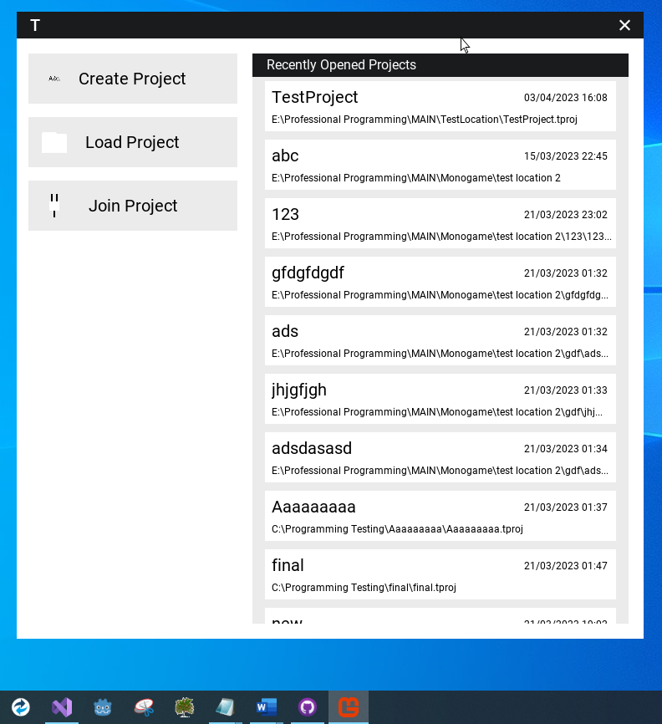

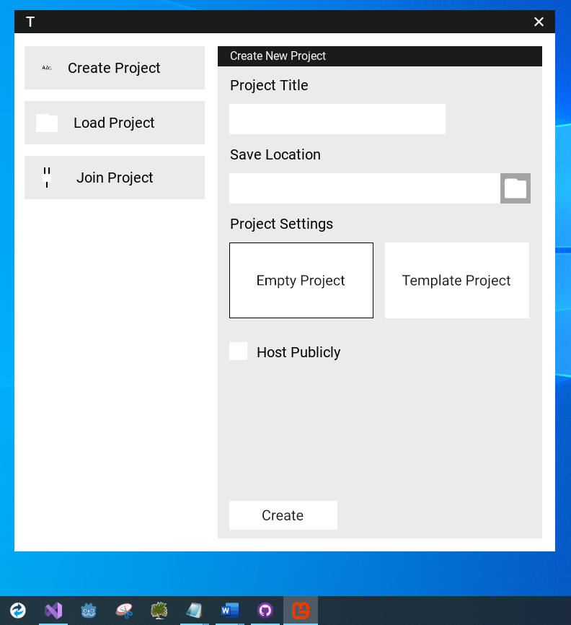

Once the user selects the create project button, they see this screen, which they must then fill out.

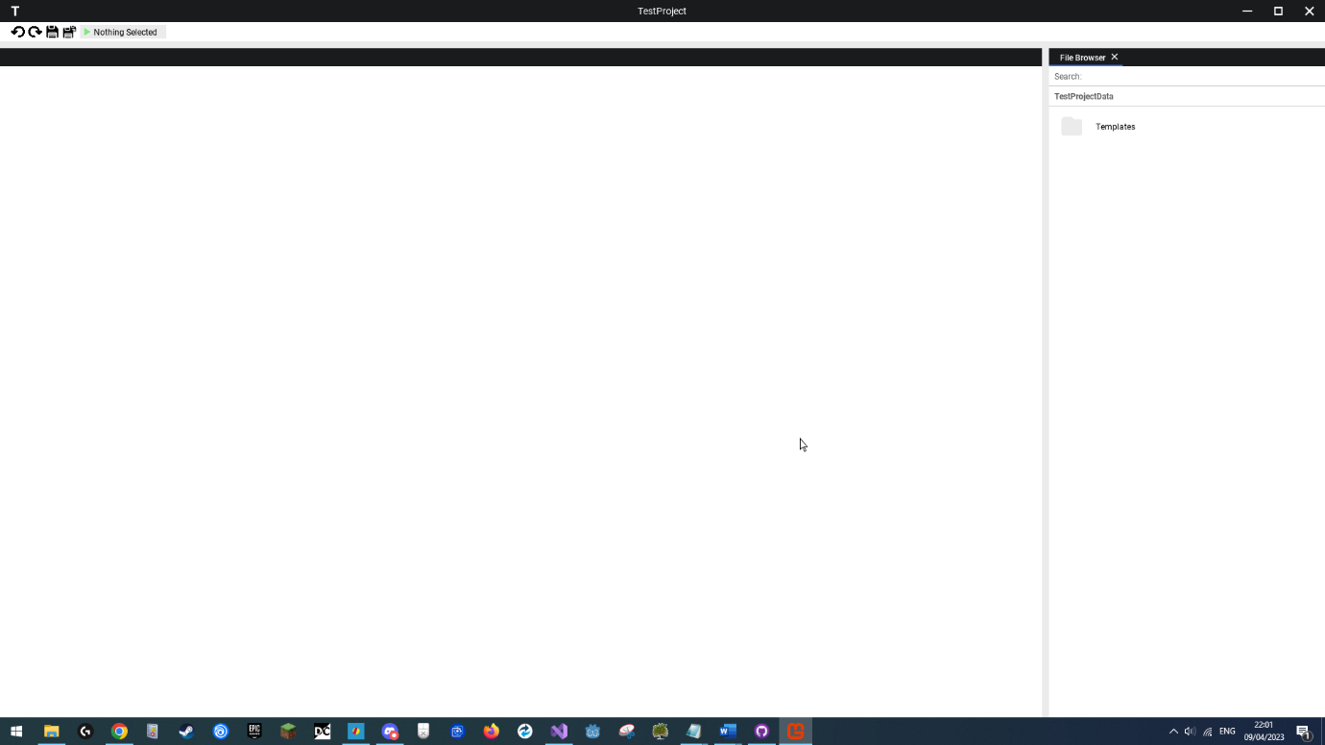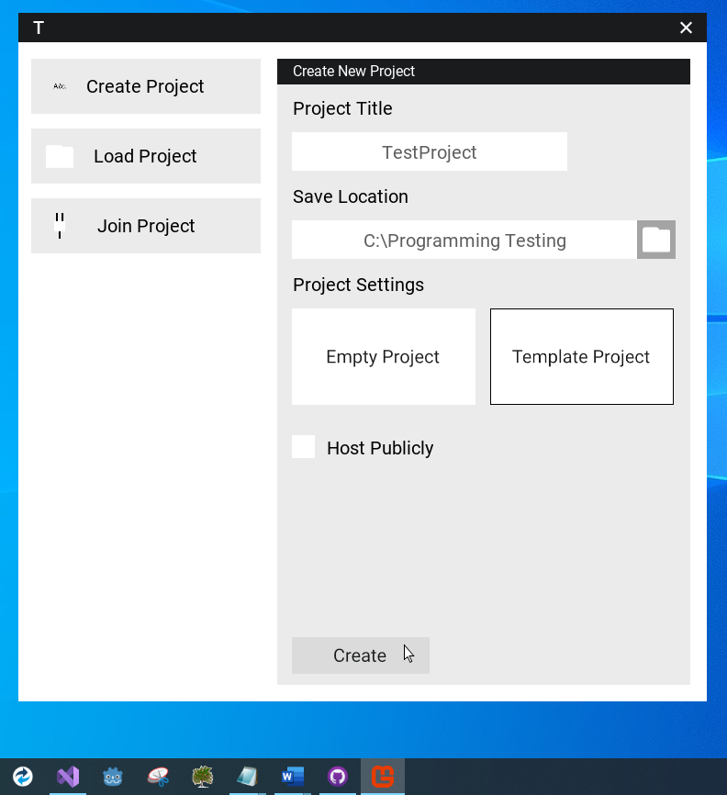

Here you can see the project screen which appears once the new project is created and then automatically opened.

This is an example project setup.

## Graphical user interface, text, application Description automatically generatedLoading a Project

The user can either load a project from the recently opened section, which immediately opens a past project without hosting (only client can connect) or they can select the load project button.

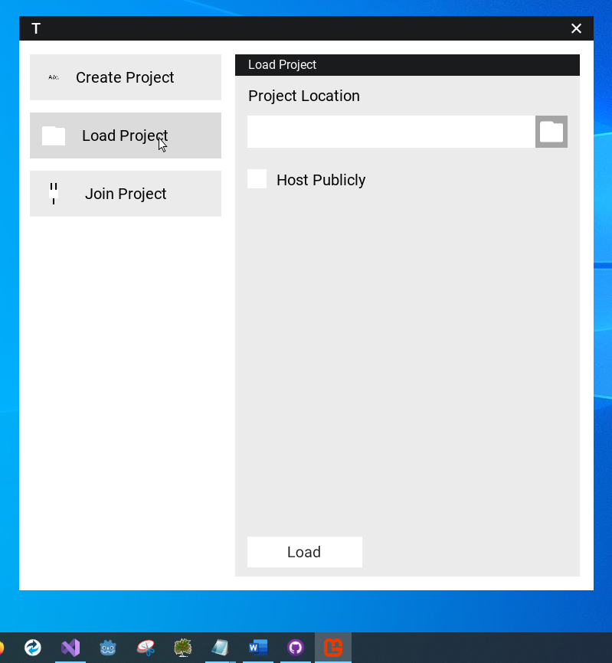

This is the load project menu.

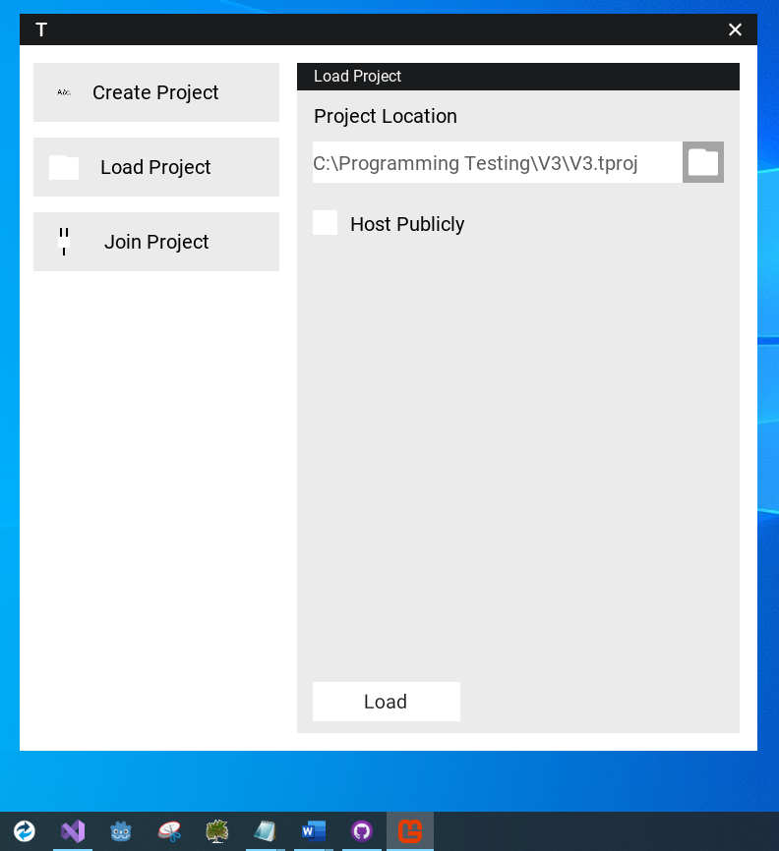

The user selected a project solution file.

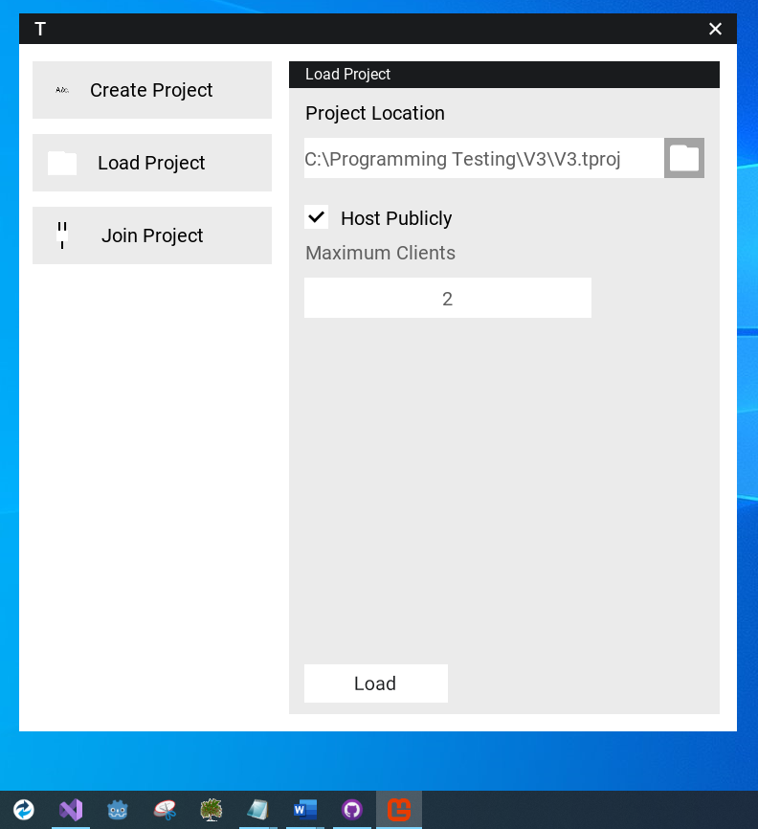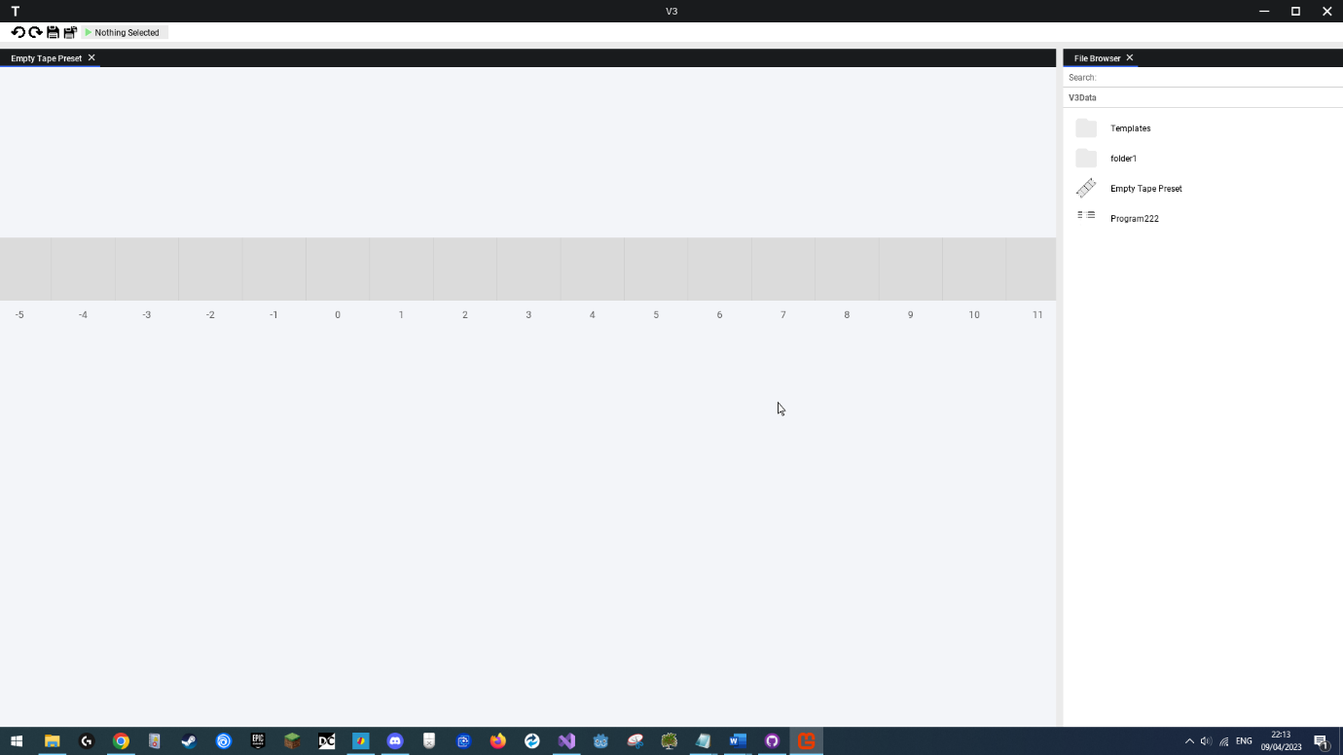

If the user wants to host the project, they can select the host publicly option and enter a max number of clients they wish can join (including themselves). The menu ensures a minimum of 1 is entered.

Successfully hosted project.

## Graphical user interface, application Description automatically generatedGraphical user interface, application Description automatically generatedConnecting to a Project

This is the join project menu.

The user can join an IP to enter. For simplicity we will join an active project already hosted on our device.

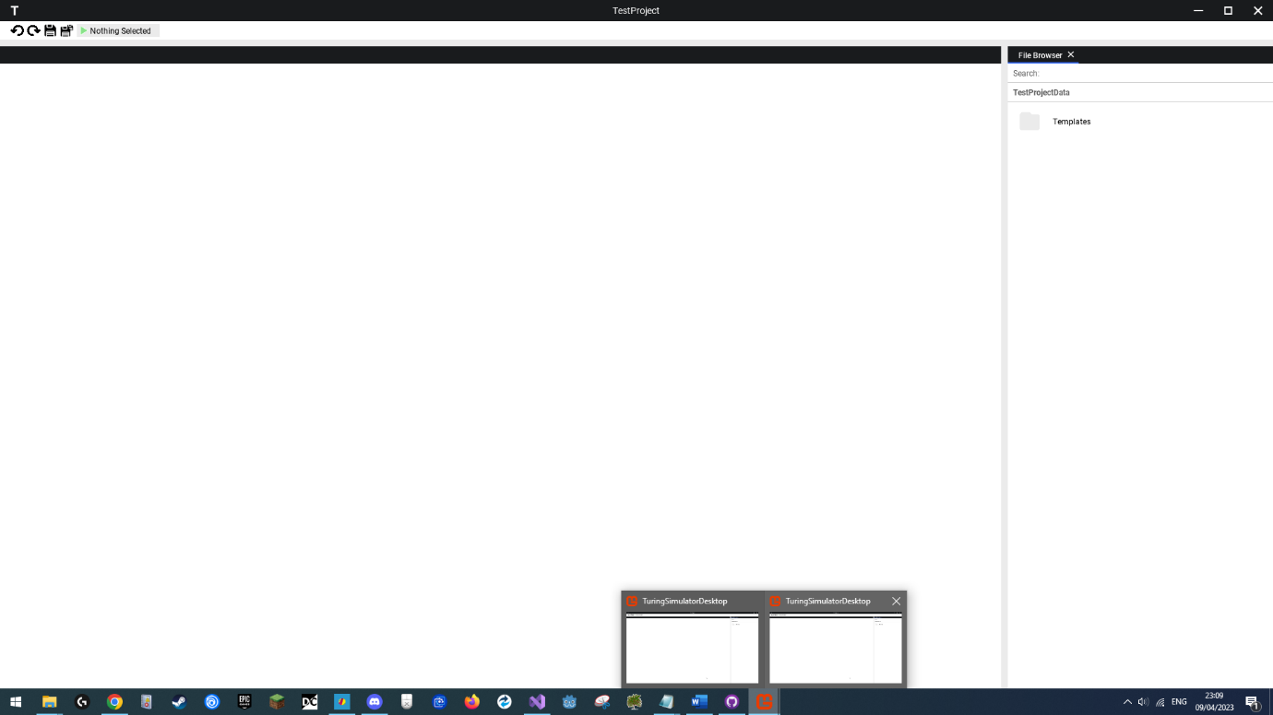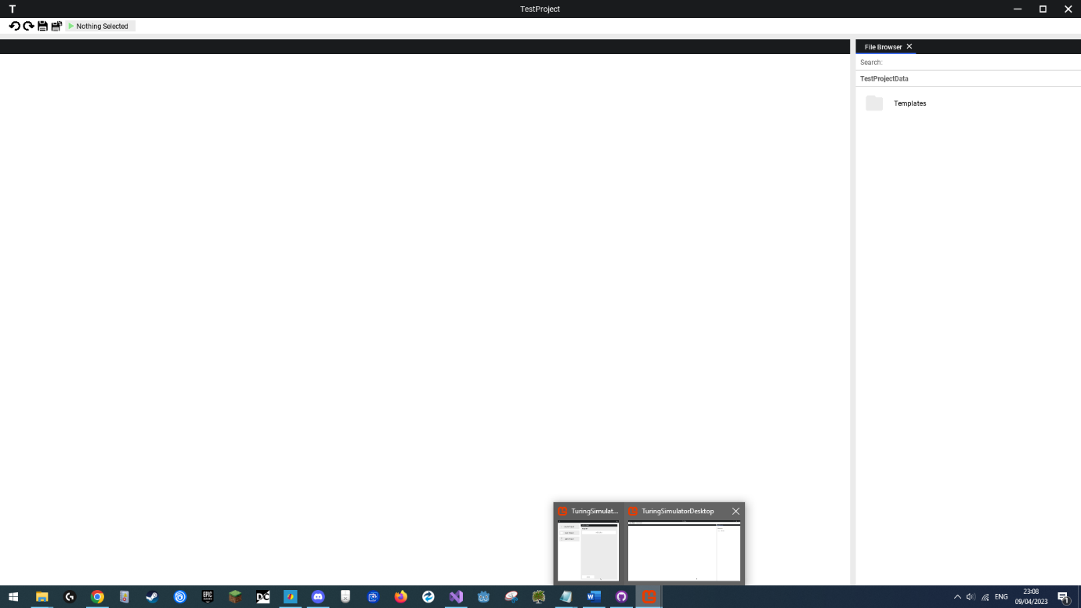

After clicking join we have successfully joined the project, and now have two identical views of it.

We are hosting the earlier created TestProject solution.

## A picture containing Word Description automatically generatedManaging Files

User clicks the file browser area, opening a context menu.

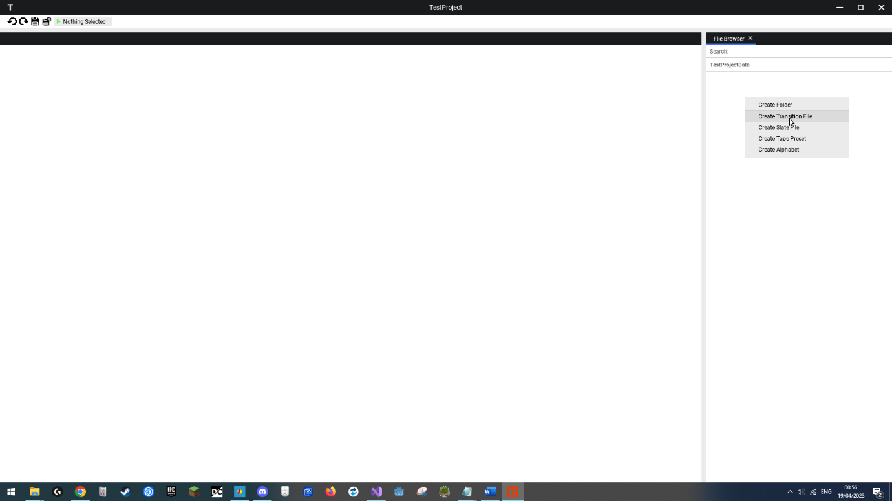

User selects create file option.

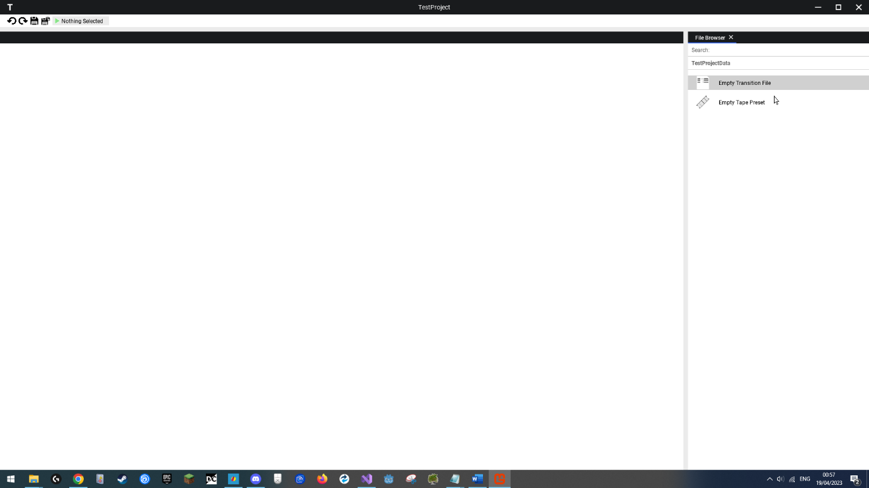

Process repeated, two files now exist in the base folder, user clicked and as such selected one.

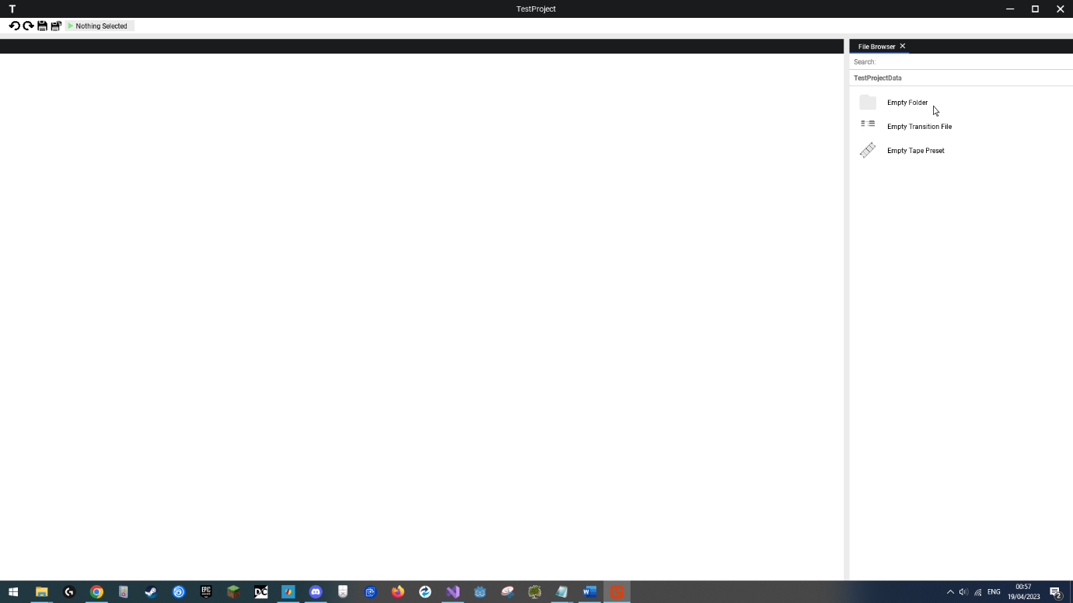

User creates folder.

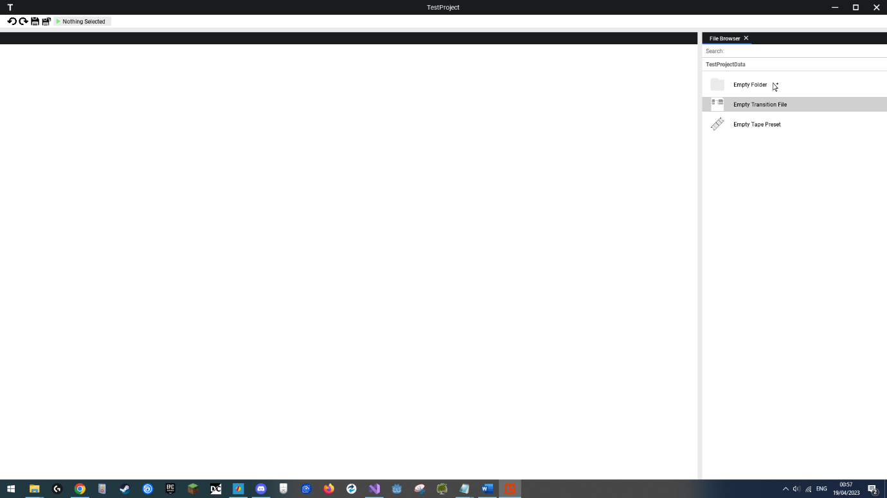User selects and drags file onto folder, mouse icon changed to indicate dragging.

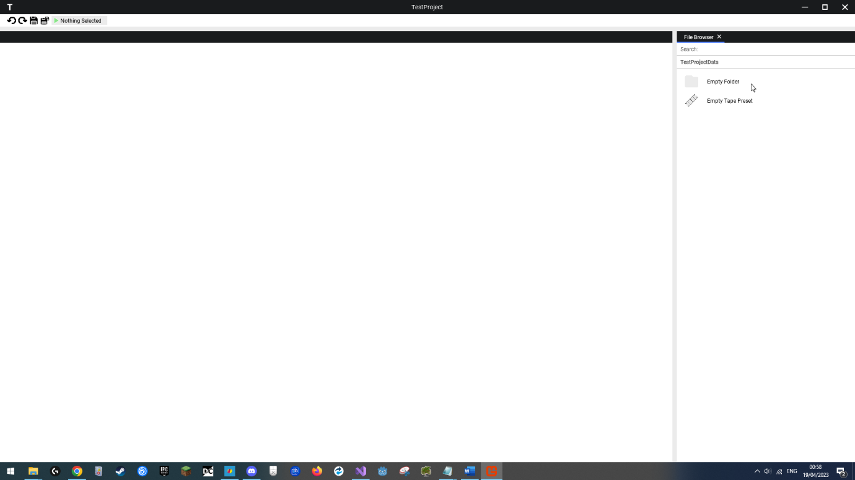

User lets go of left mouse button; file moved successfully.

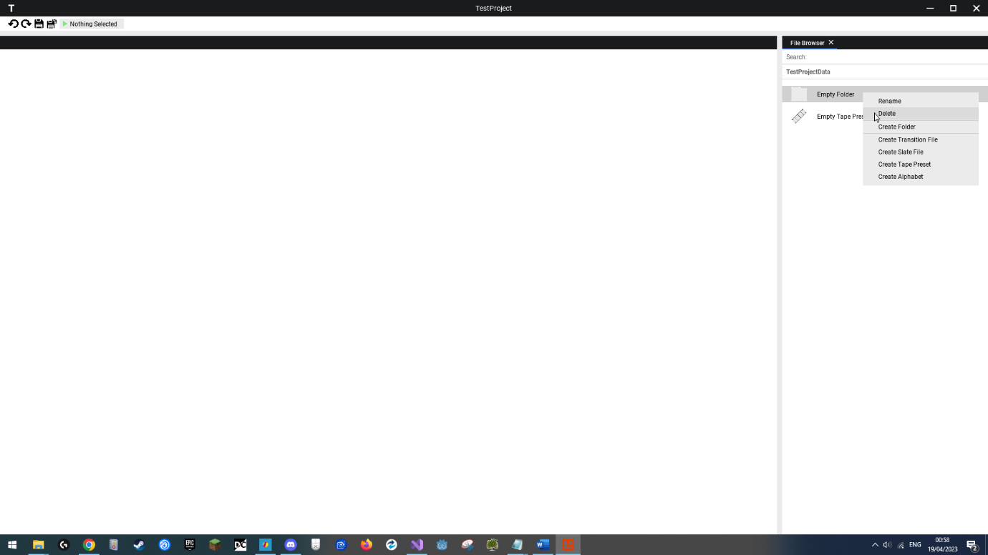

User right clicks folder and selects delete option.

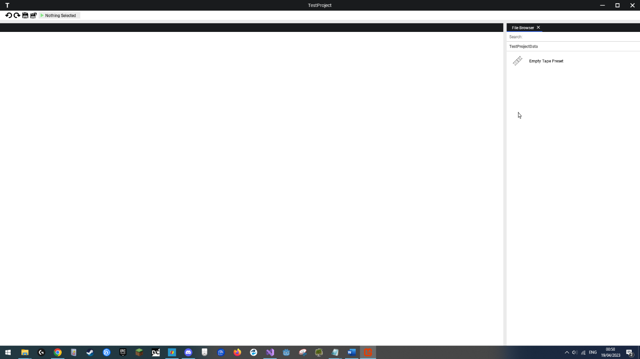

Folder and all subfiles deleted.

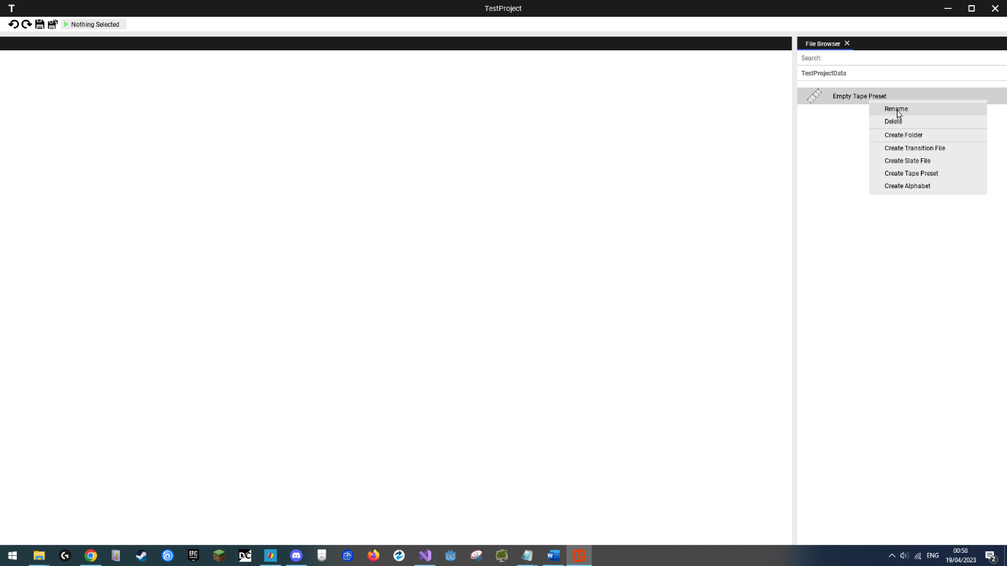

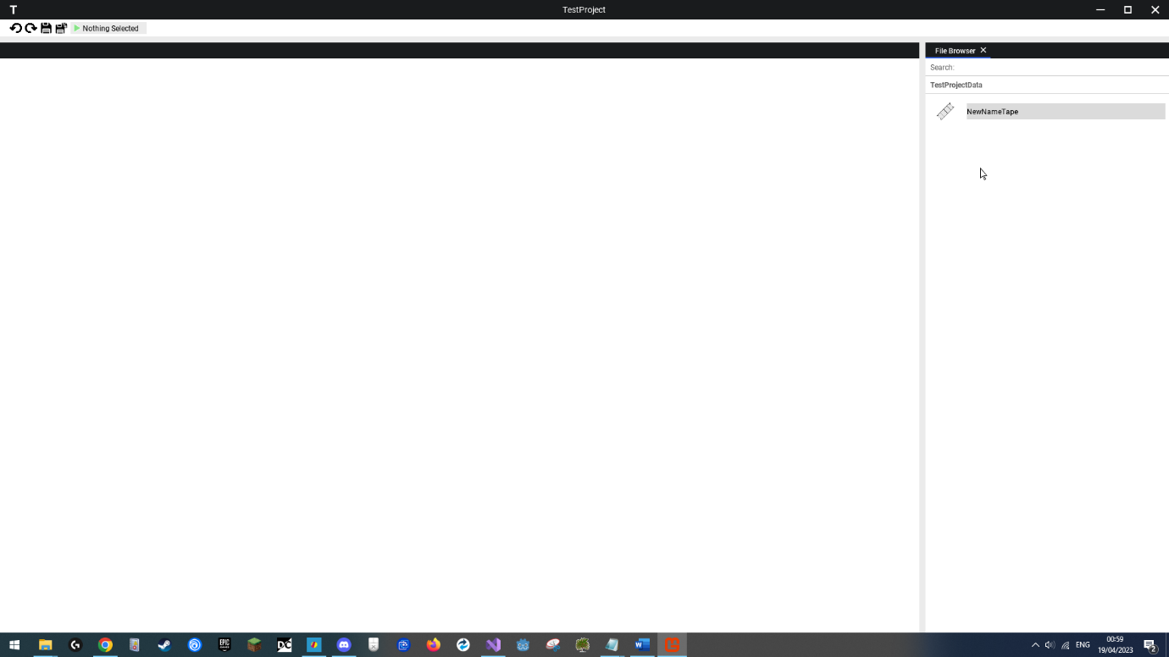User selects file to rename.

Rename selected, typing area appears and user types in new file name.

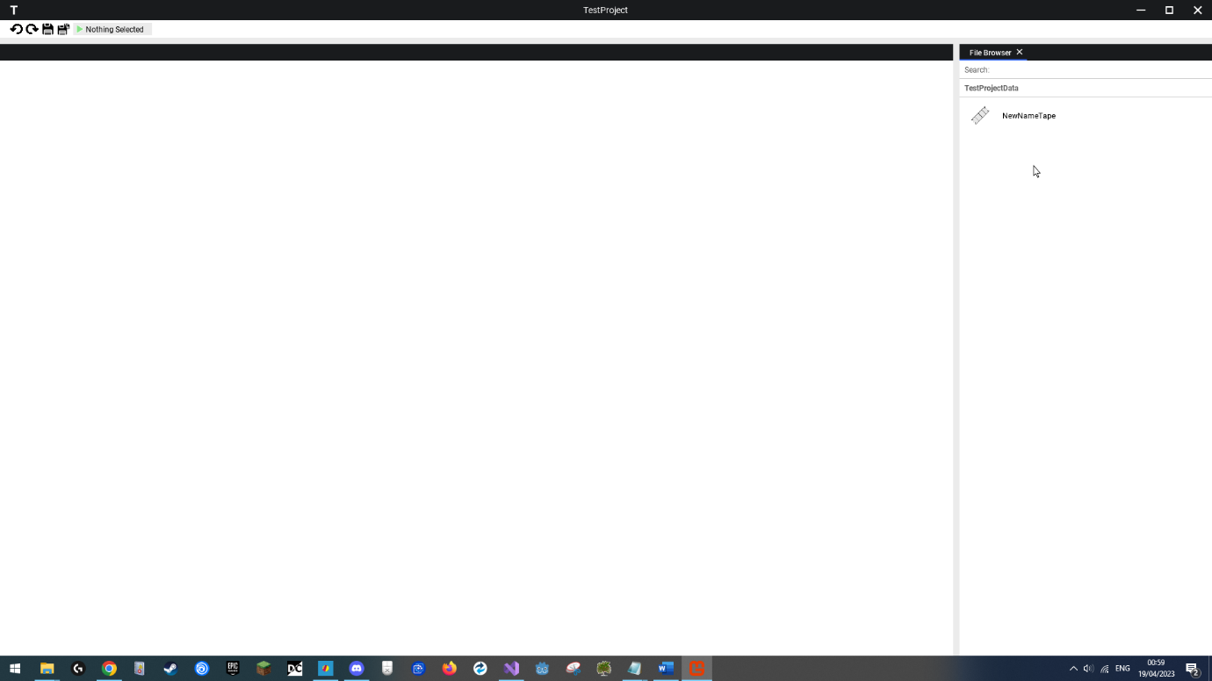

User hits enter and file successfully renamed.

## Graphical user interface, text, application, Word Description automatically generatedCreating an Alphabet, Program and Tape

User created empty alphabet through file browser and double clicked it.

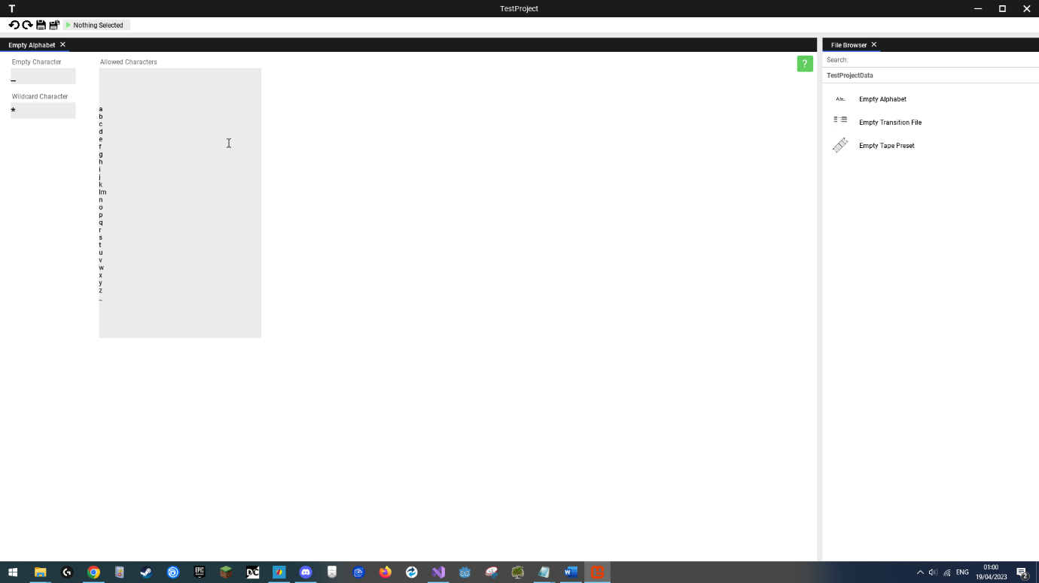

User typed in Latin alphabet and underscore for empty symbol. Alphabet is now defined.

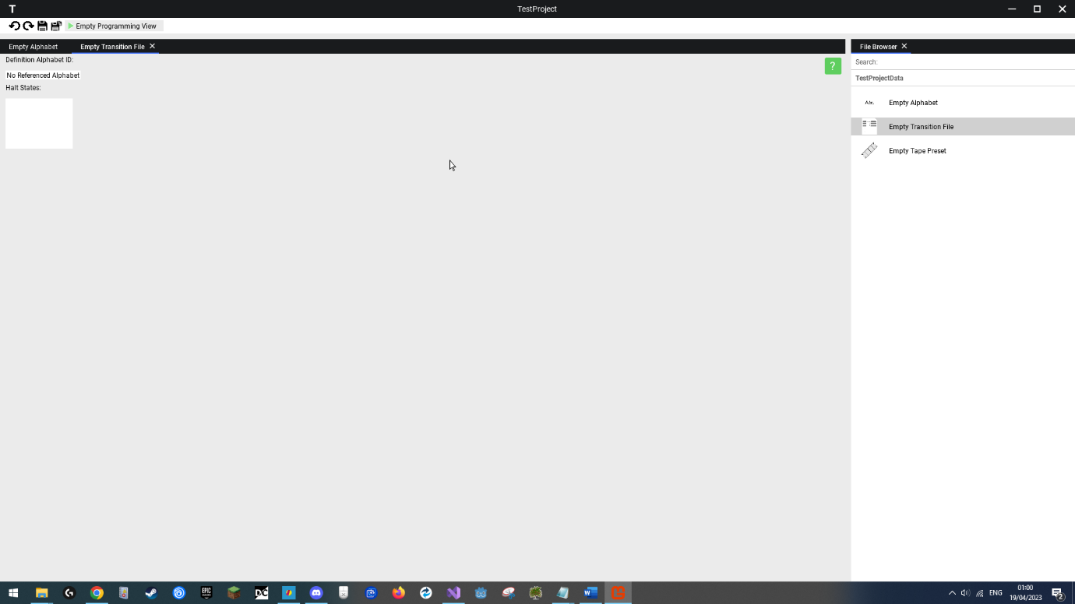

User opens new transition programming file.

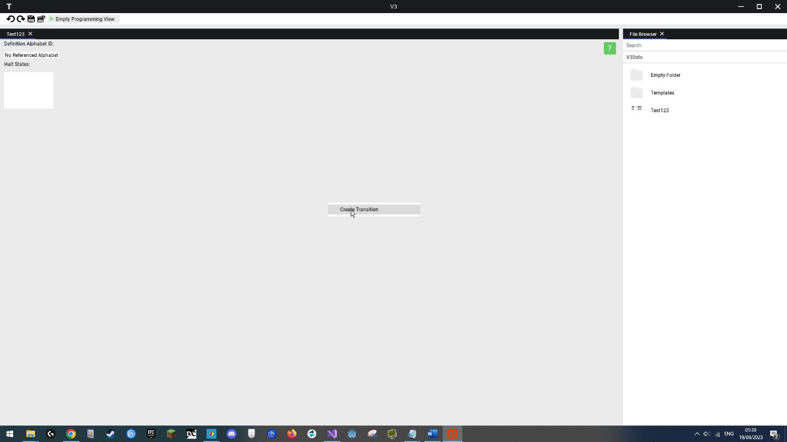

User right clicks canvas and has context menu appear, selects create transition option.

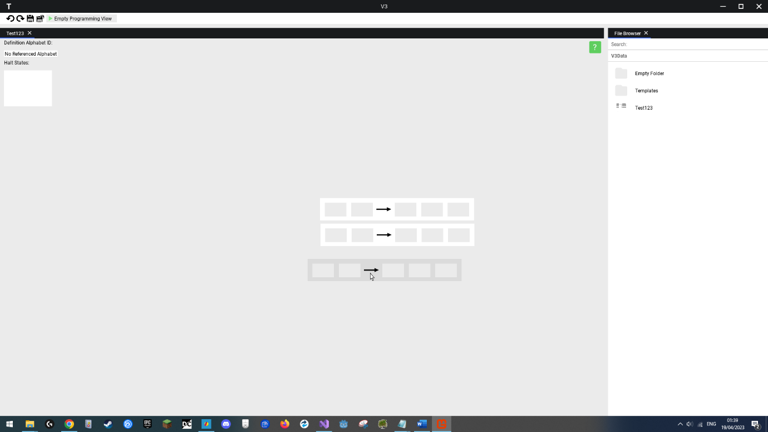

User created more transitions and clicks one to drag it.

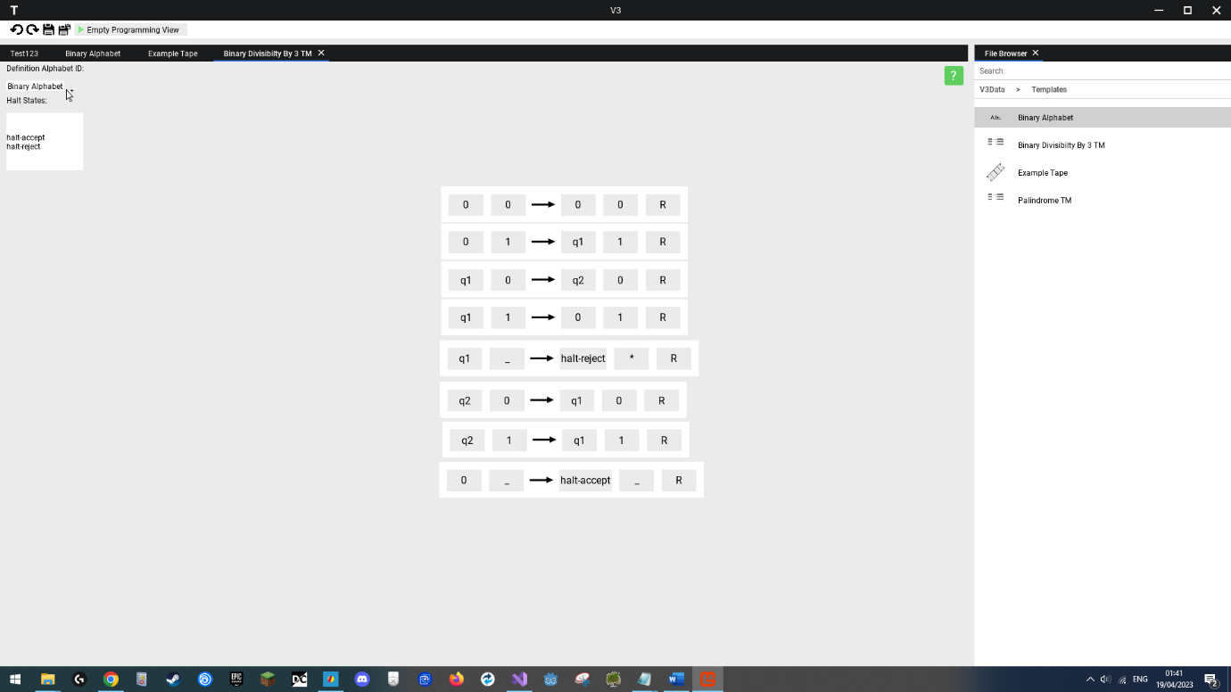

User filled in program and halt states by typing in appropriate states and values into text boxes. User can be seen dragging a definition alphabet into the top left drop area. Turing Program successfully created.

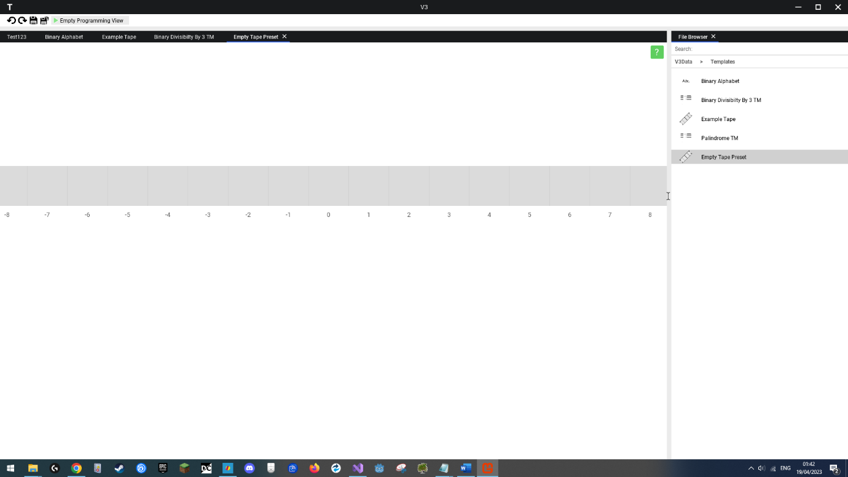

User opened new tape preset file.

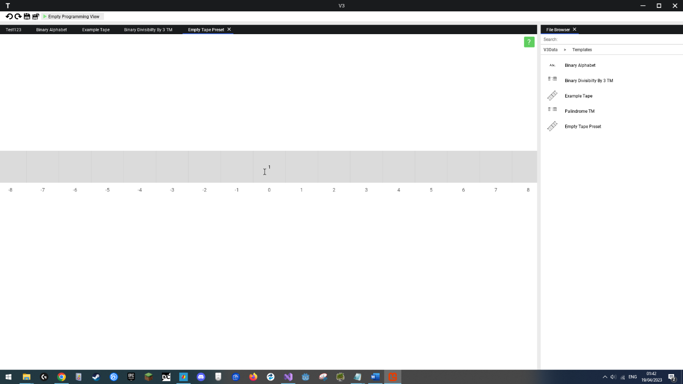

User moves mouse over tape cell and can select it to type in it.

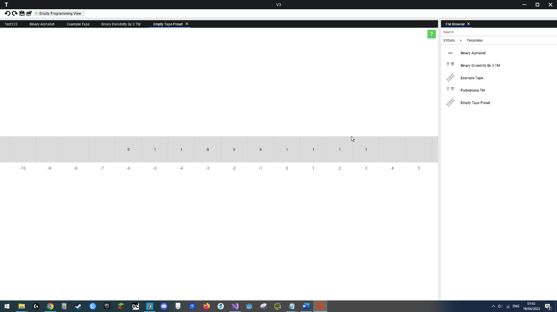

User types in preset values into tape. Preset tape successfully defined.

## Graphical user interface, application, table Description automatically generatedRunning a Program

User opens up ready program.

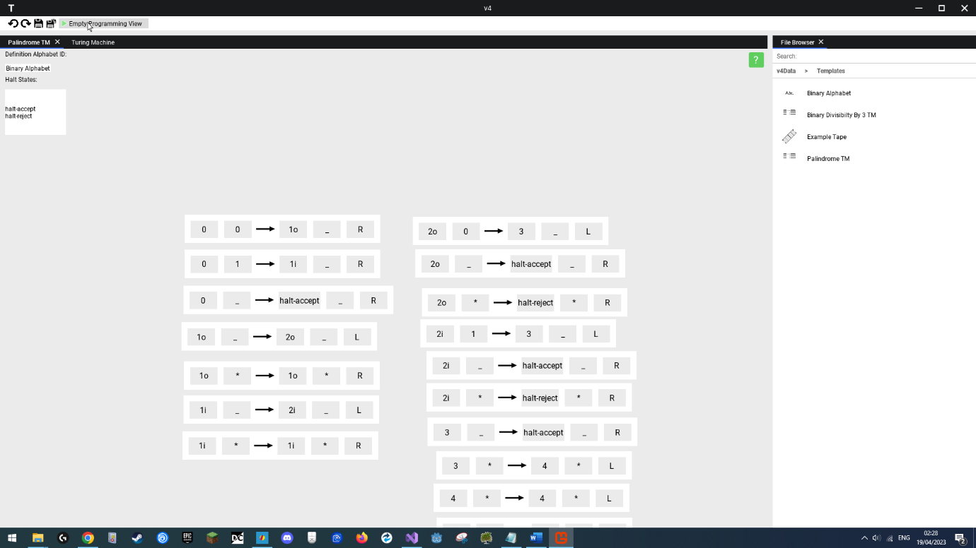

User selects the run button on the toolbar.

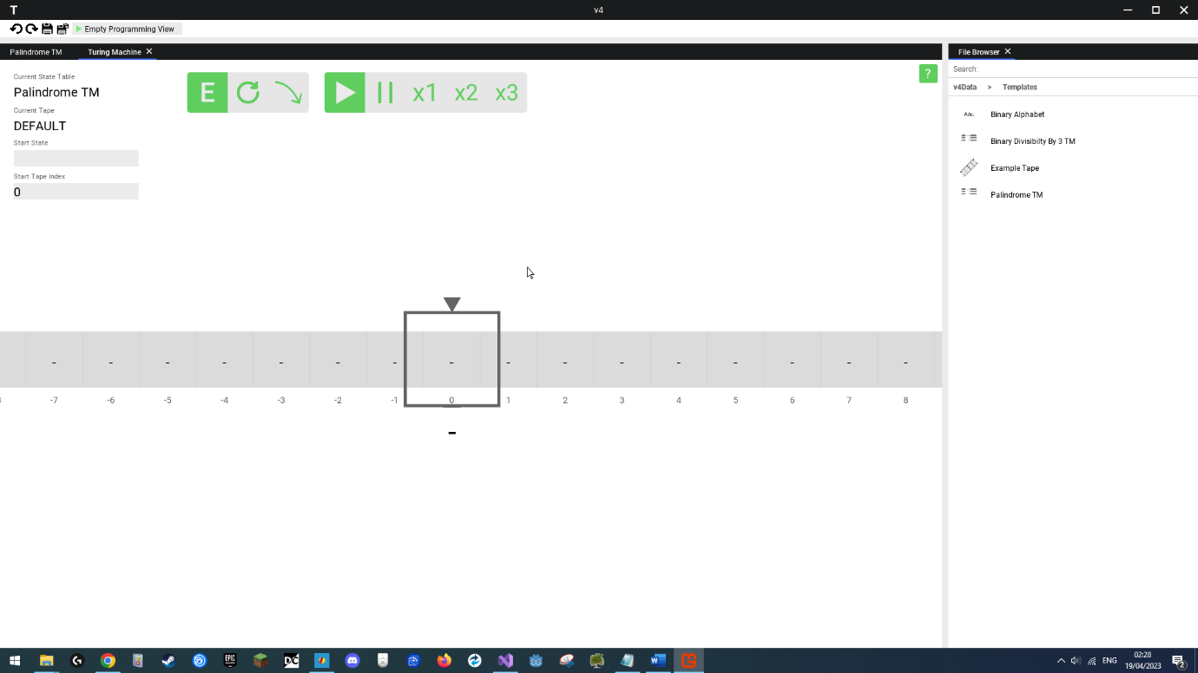

Turing Execution View appears, allowing user to run the program, program is loaded in automatically.

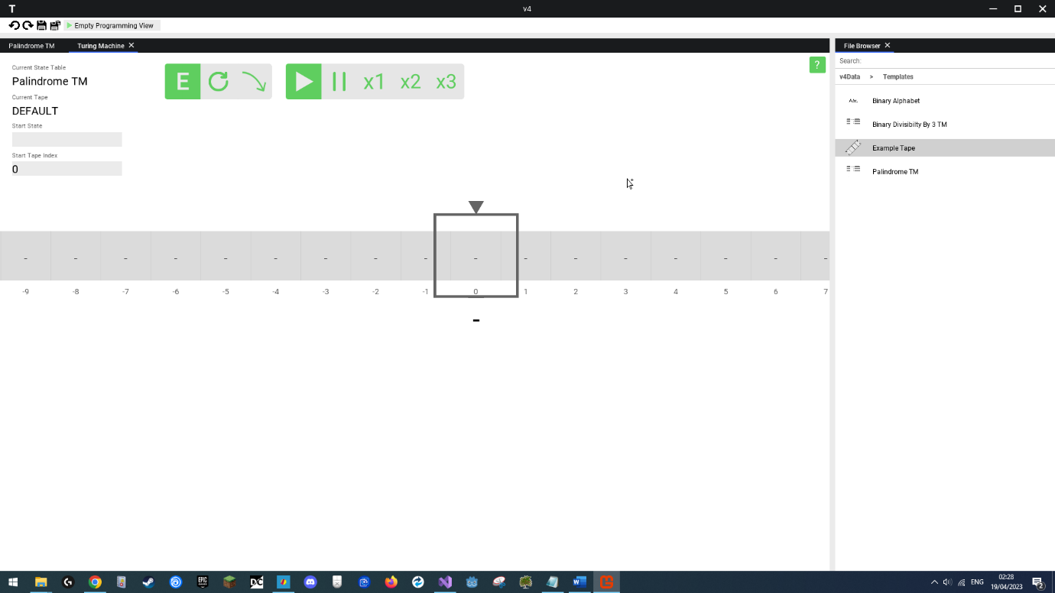

User drags in preset tape onto canvas.

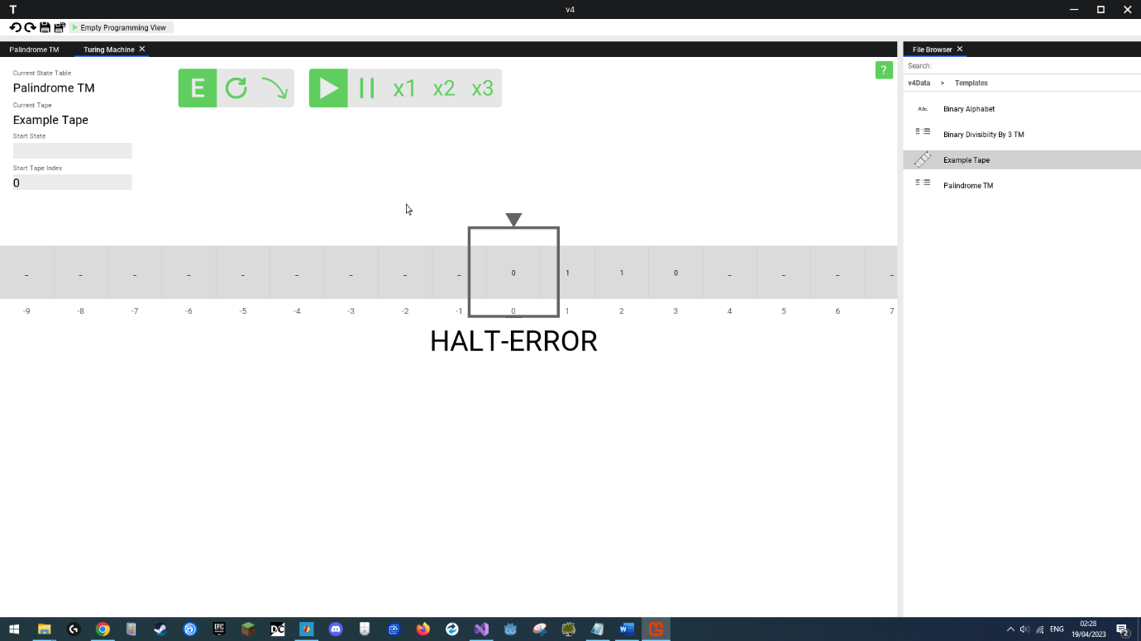

Tape data appears on machine, machine is restarted automatically, but does not recognise the empty start state on the left text box, as such show error state.

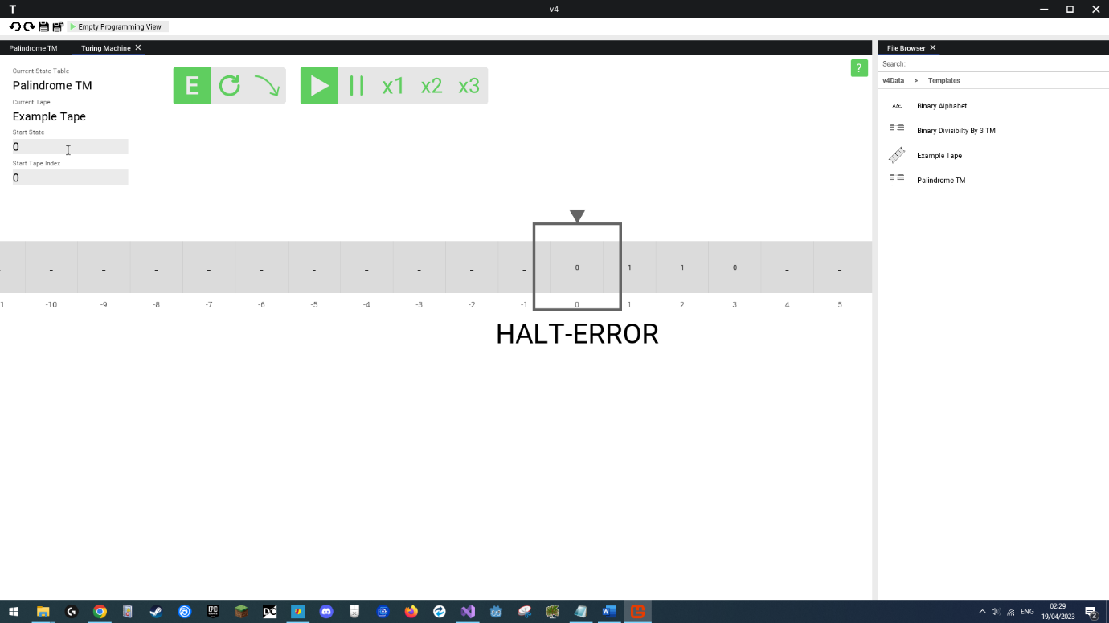

User types in a valid start state.

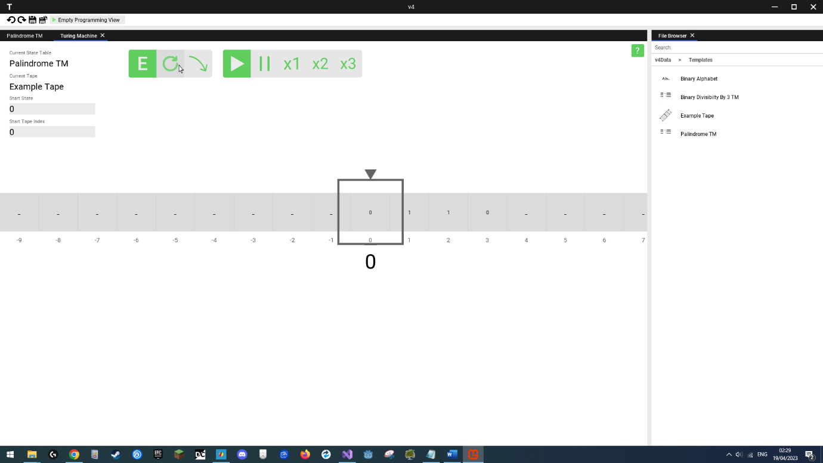

User restarts the Turing Machine. The machine accepts the start state.

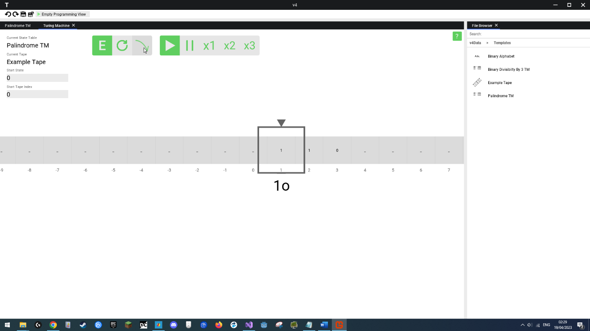

User clicks the step button, stepping the program forward one instruction.

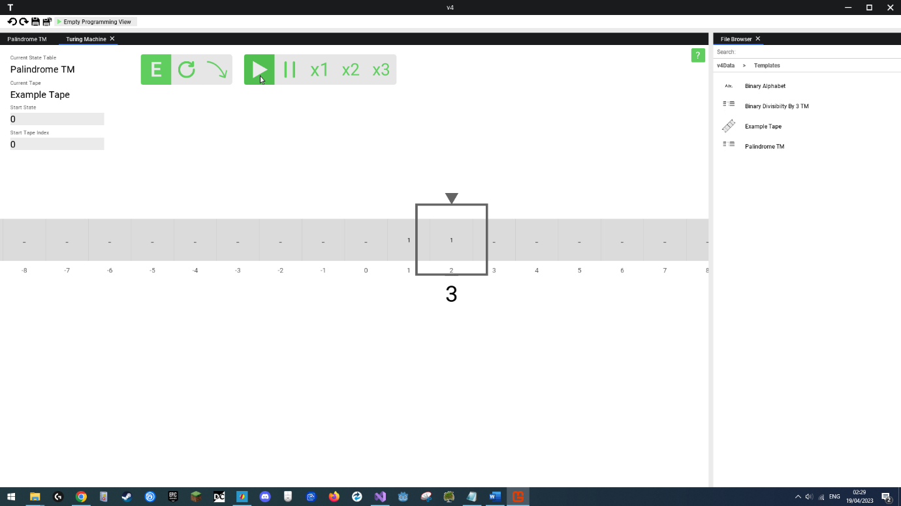

User hits the autorun button. The Turing Machine automatically steps the program forward.

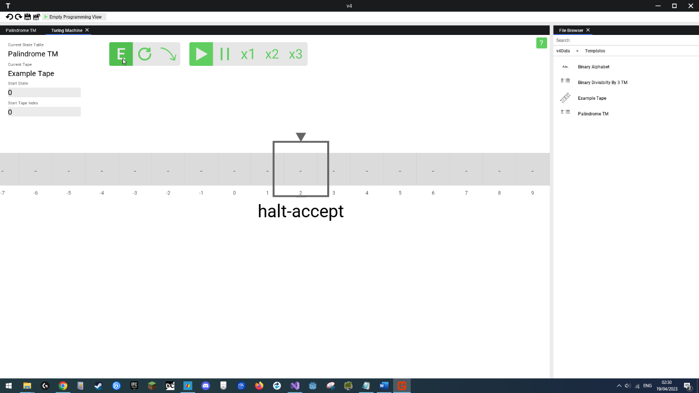

User hits execute. The program completes immediately, reaching end state.

The binary palindrome template program was run, and was provided with an input of 0110, which is a palindrome, and as such the user would expect the end state of the Turing Machine to be an accept state, which as we can see above is what happened. The Turing Machie simulated the program successfully.

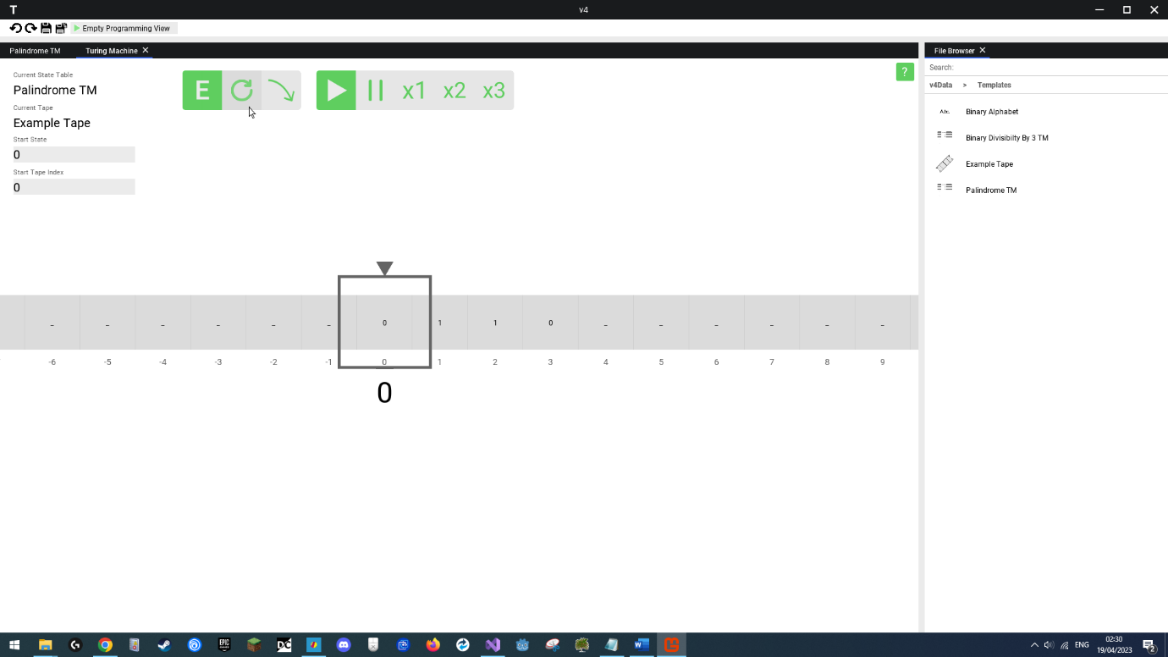

User hits the restart button, restarting the while Turing machine to its original state.

## Graphical user interface, text, application Description automatically generatedViewing Help Menu

User selects help menu option.

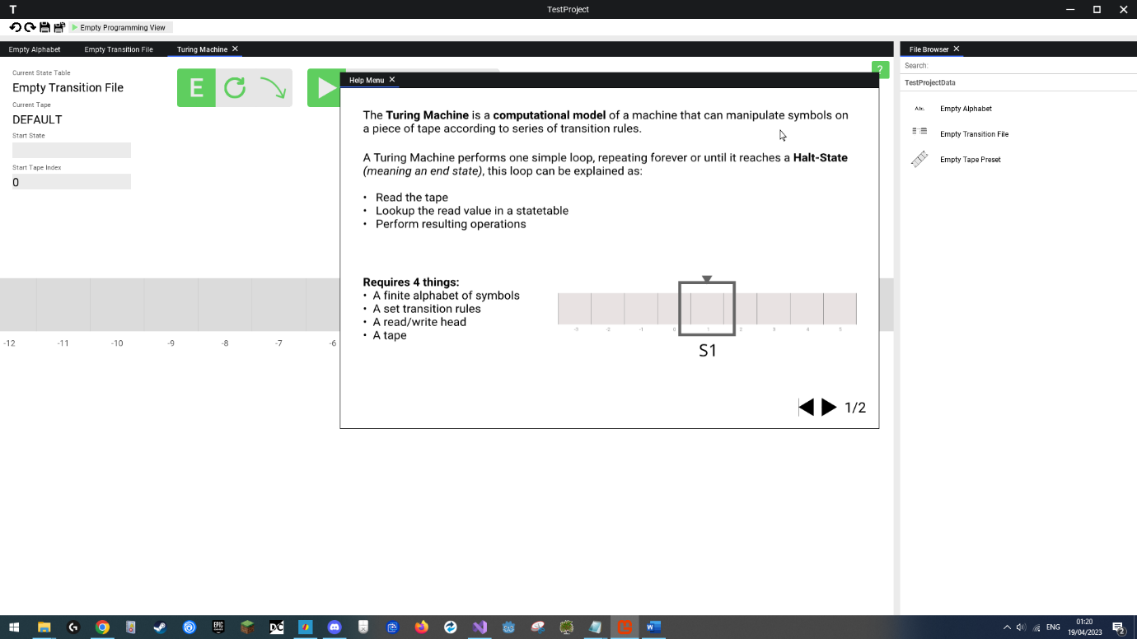

Help menu opens in new window.

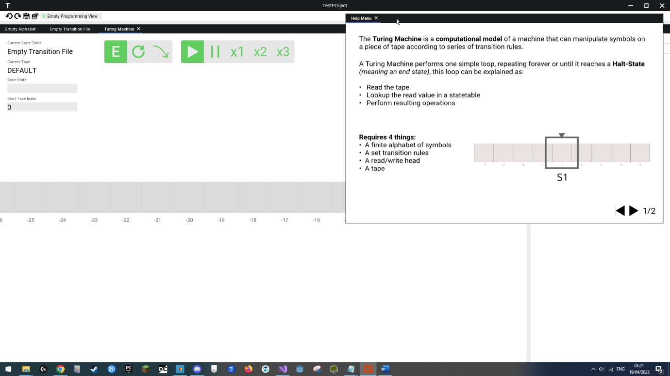

User drags help menu window.

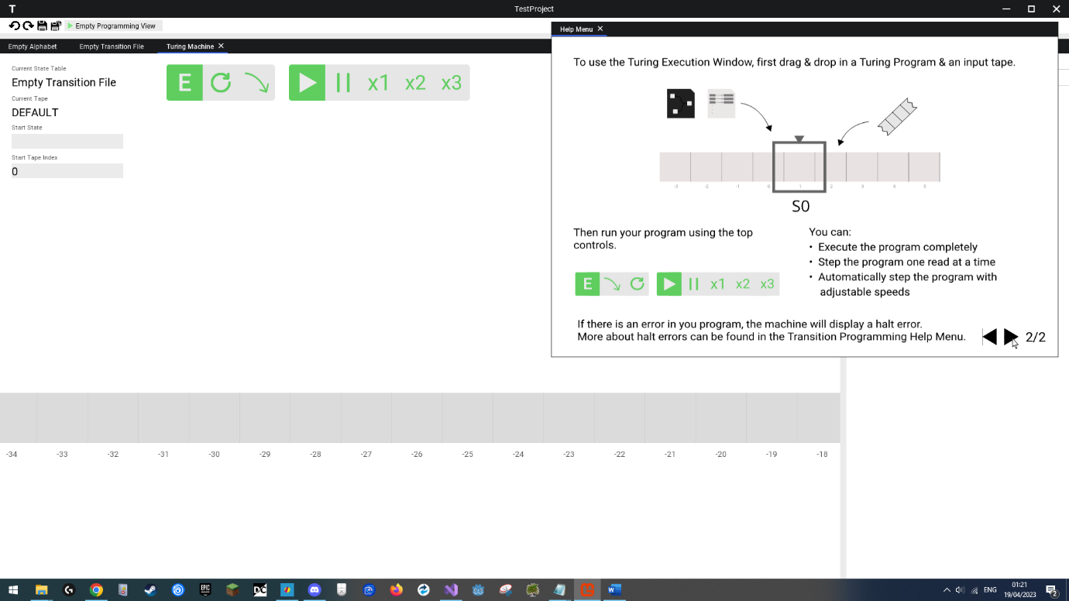

User cycles through help menu screens.

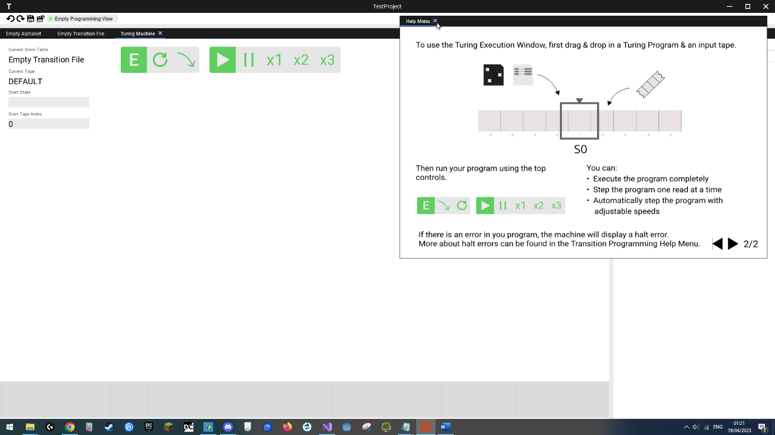

User selects close menu button.

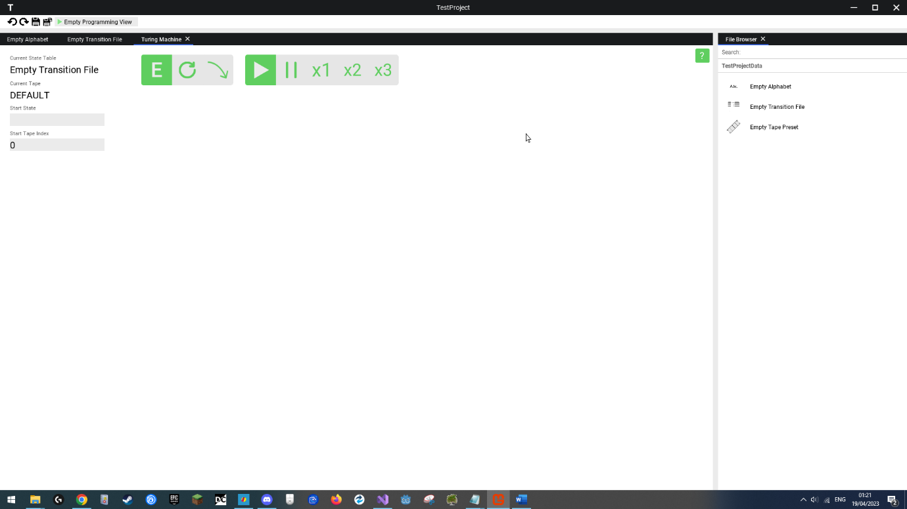

Menu gets closed and empty window automatically also closes.

## Videos

Video functional demonstration are available from the testing section, which contain a variety of functionality being tested and displayed in video form.

Copies of the links to these videos are below:

* **Test 1 - Creating & Loading Project Locally**

<https://youtu.be/MWDNRBeiZ_A>

* **Test 2 - Connecting To A Project On Another Device**

<https://youtu.be/AUCAtEg3O9g>

<https://youtu.be/x2ngAt0rFEs>

<https://youtu.be/hh5w-9WtaEI>

* **Tests 3, 8 & 10 - Template, Toolbar and Save Systems**

<https://youtu.be/46dwrYQwrHQ>

* **Test 4 - Executing Valid Turing Program**

<https://youtu.be/efPsRrCv_qs>

* **Test 5 - Valid Non-Classical Turing Program**

<https://youtu.be/-foiRxpaqps>

* **Test 6 - Window System Test**

<https://youtu.be/AA-XNl-ueNo>

* **Test 7 - Drag & Drop Test**

<https://youtu.be/yc0OIV2ripE>

* **Tests 9 & 12 - Help Menu, Running on Windows**

<https://youtu.be/_XBN5RAr6Cs>

* **Tests 11 - File & File Contents Updates Disseminated To Other Clients**

<https://youtu.be/Ti6HIwAC1sM>

<https://youtu.be/O3rcbH80Zm4>

<https://youtu.be/HlqbRTinldU>

* **Test 13 - MAC OS Test**

[**https://youtu.be/TSCVGa7v5QM**](https://youtu.be/TSCVGa7v5QM)

* **Test 14 - Linux Test**

<https://youtu.be/XkA16BMGdYw>

* **Test 15 - Invalid IP Address**

<https://youtu.be/DaPEfdl0dxU>

* **Test 16 - Invalid IP Address 2**

<https://youtu.be/yLmHUIjN-cE>

* **Test 17 - Valid IP Address But No Server**

<https://youtu.be/99mkxludMUY>

* **Test 18 - Non Integer Count**

<https://youtu.be/SjBHIZak5zE>

* **Test 19 - 0 Client Count**

<https://youtu.be/vbQF2F292F0>

* **Test 20 - 1 Client Count**

<https://youtu.be/dWqoQ9QVZmo>

* **Test 21- Executing Invalid Turing Program**

<https://youtu.be/JO2D6Mxsy6M>

* **Test 22 - Saving Invalid Alphabet**

<https://youtu.be/7lYZUtvrF5I>

* **Test 23 - Invalid Drag & Drop**

<https://youtu.be/Izg5lJNKoYw>

* **Test 24 - Client Attempts To Join Server With 1 Slot Left**

<https://youtu.be/h55ruAuqpKU>

* **Test 25 - Client Attempts To Join Full Server**

[https://youtu.be/Vs0OxpfkqY4#](https://youtu.be/Vs0OxpfkqY4)

* **Test 26 - Client Disconnects Unexpectedly**

<https://youtu.be/oy0ngaExB_k>

* **Test 27 - Invalid Packet Sent**

<https://youtu.be/CPIiA3IcApE>

* **Test 28 - Invalid Packet Sent 2**

<https://youtu.be/pvWusYtuw2I>

* **Test 29 - Old Update Packet Sent**

<https://youtu.be/e6nHmub5ZiI>

* **Test 30 - Loading Corrupt Project**

<https://youtu.be/5XMuuEPWp0M>

* **Test 31 - Loading Corrupt Files**

<https://youtu.be/wjefsHv5eis>

* **Test 32 - Loading Corrupt Local User Data**

<https://youtu.be/oWJdyKN6UX4>

# Testing

In this section, we will perform tests against two main categories to determine the usability and success of the final program:

**Objective Testing**

This means testing features of the program against the SMART objectives initially set out in the project analysis for this coursework to determine if each objective has been met and to what extent.

**Stability Testing**

This means testing the program for:

* Runtime stability – Making sure that interacting with the application does not make the program crash.
* Completeness – Making sure that the UI elements are working as intended, not performing unexpected or no actions.
* Data Sanitation – Checking against unexpected user inputs and interactions, making sure the program correctly normalises any data inputted into the correct formats to be then saved/used.

Each test will be numbered and link to a short video, displaying the testing being performed.

**Testing Table of Contents**

Objective Tests

|  |  |  |  |  |
| --- | --- | --- | --- | --- |
| Test Number | Title | Data/Interaction Type | Status | Page |
| **1** | **Creating & Loading A Project Locally** | **Functional Test** | **Success** | **793** |
| **2** | **Connecting To A Project On Another Device** | **Functional Test** | **Success** | **795** |
| **3** | **Creating a Template Project** | **Functional Test** | **Success** | **798** |
| **4** | **Executing a Valid Turing Program** | **Functional Test** | **Success** | **799** |
| **5** | **Executing a Valid Non-Classical Turing Program** | **Functional Test** | **Success** | **801** |
| **6** | **Window System Interaction** | **Functional Test** | **Success** | **802** |
| **7** | **Drag & Drop System Interaction** | **Functional Test** | **Success** | **804** |
| **8** | **Toolbar System Interaction** | **Functional Test** | **Success** | **805** |
| **9** | **Help Menu System Interaction** | **Functional Test** | **Success** | **807** |
| **10** | **Saving Files** | **Functional Test** | **Success** | **808** |
| **11** | **File Update Disseminated To Other Clients** | **Functional Test** | **Success** | **809** |
| **12** | **Running on a Windows Device** | **Functional Test** | **Success** | **815** |
| **13** | **Running on a Mac OS Device** | **Functional Test** | **Fail** | **816** |
| **14** | **Running on a Linux Device** | **Functional Test** | **Success** | **817** |

Stability Tests

|  |  |  |  |  |  |
| --- | --- | --- | --- | --- | --- |
| Test Number | Title | Data/Interaction Type | Input | Status | Page |
| **15** | **Invalid IP Address** | **Erroneous** | **abc.123** | **Success** | **818** |
| **16** | **Invalid IP Address 2** | **Erroneous** | **257.128.0.23** | **Success** | **819** |
| **17** | **Valid IP Address But No Server** | **Erroneous** | **127.0.0.1** | **Success** | **820** |
| **18** | **Non Integer Client Count** | **Erroneous** | **test** | **Success** | **821** |
| **19** | **0 Client Count** | **Erroneous Boundary** | **0** | **Success** | **822** |
| **20** | **1 Client Count** | **Boundary** | **1** | **Success** | **823** |
| **21** | **Executing Invalid Turing Program** | **Erroneous** | **(See Image Attached)** | **Success** | **824** |
| **22** | **Saving Invalid Alphabet** | **Erroneous** | **(See Image Attached)** | **Success** | **827** |
| **23** | **Invalid Drag & Drop** | **Erroneous** | **(See Image Attached)** | **Success** | **828** |
| **24** | **Client Attempts To Join Server With 1 Slot Left** | **Boundary** | **Server Max Clients: 2**  **Second Client Join IP: 127.0.0.1** | **Success** | **829** |
| **25** | **Client Attempts To Join Full Server** | **Erroneous Boundary** | **Server Max Clients: 1**  **Second Client Join IP: 127.0.0.1** | **Success** | **830** |
| **26** | **Client Disconnects Unexpectedly** | **Erroneous** | **Task Manager Close** | **Success** | **832** |
| **27** | **Invalid Packet Sent** | **Erroneous** | **(See Image Attached)** | **Success** | **834** |
| **28** | **Invalid Packet Sent 2** | **Erroneous** | **(See Image Attached)** | **Success** | **837** |
| **29** | **Old Update Packet Sent** | **Erroneous** | **(See Image Attached)** | **Success** | **840** |
| **30** | **Loading Corrupt Project** | **Erroneous** | **(See Image Attached)** | **Success** | **844** |
| **31** | **Loading Corrupt Files** | **Erroneous** | **(See Image Attached)** | **Success** | **846** |
| **32** | **Loading Corrupt Local User Data** | **Erroneous** | **(See Image Attached)** | **Success** | **847** |

## Objective Testing

### Test 1

**Creating & Loading Project Locally**

**Functional Test**

Link: https://youtu.be/MWDNRBeiZ_A

**Objective**

Whenever the user wants to start using the program, they will first have to create a project to work with, the objective of this test is to ensure that the file management system implemented works as was designed in the design stage, creating the appropriate folder/data structure on disk so that the program can correctly interpret and load it, finally allowing the user to have an instance of a project they can interact with.

In this test we will create a new project in a folder on disk, and then load the created project.

**Test Method & Reproduction**

We will first open the application, then go to the create menu.

Here we will title the new project “**TestProject**”, set its **location** to be on out primary disk (disk “**C:**”), in the base **folder** titled “**Programming Testing**”, and select it to be an empty project. Once we hit create, the project should successfully be created and automatically load in, leading us to the project screen. In the project we will also create a new file by right clicking the file browser and selecting “**Create Transition File**”.

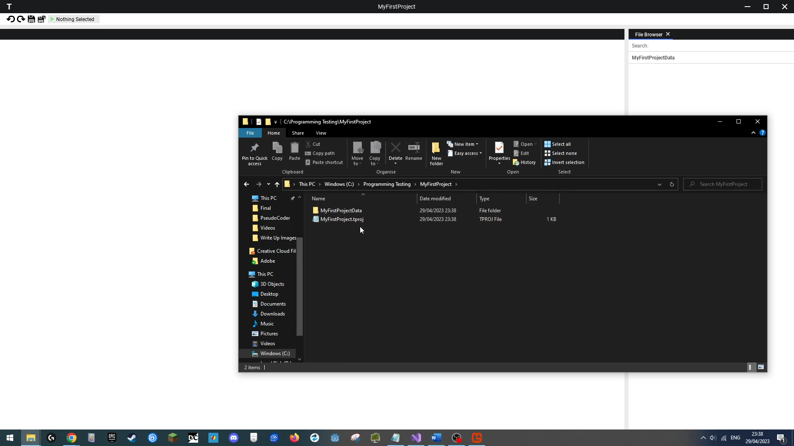We will also then open the file browser and view through the contents of the newly created folder to verify that the created folders/files fit our design brief structure.

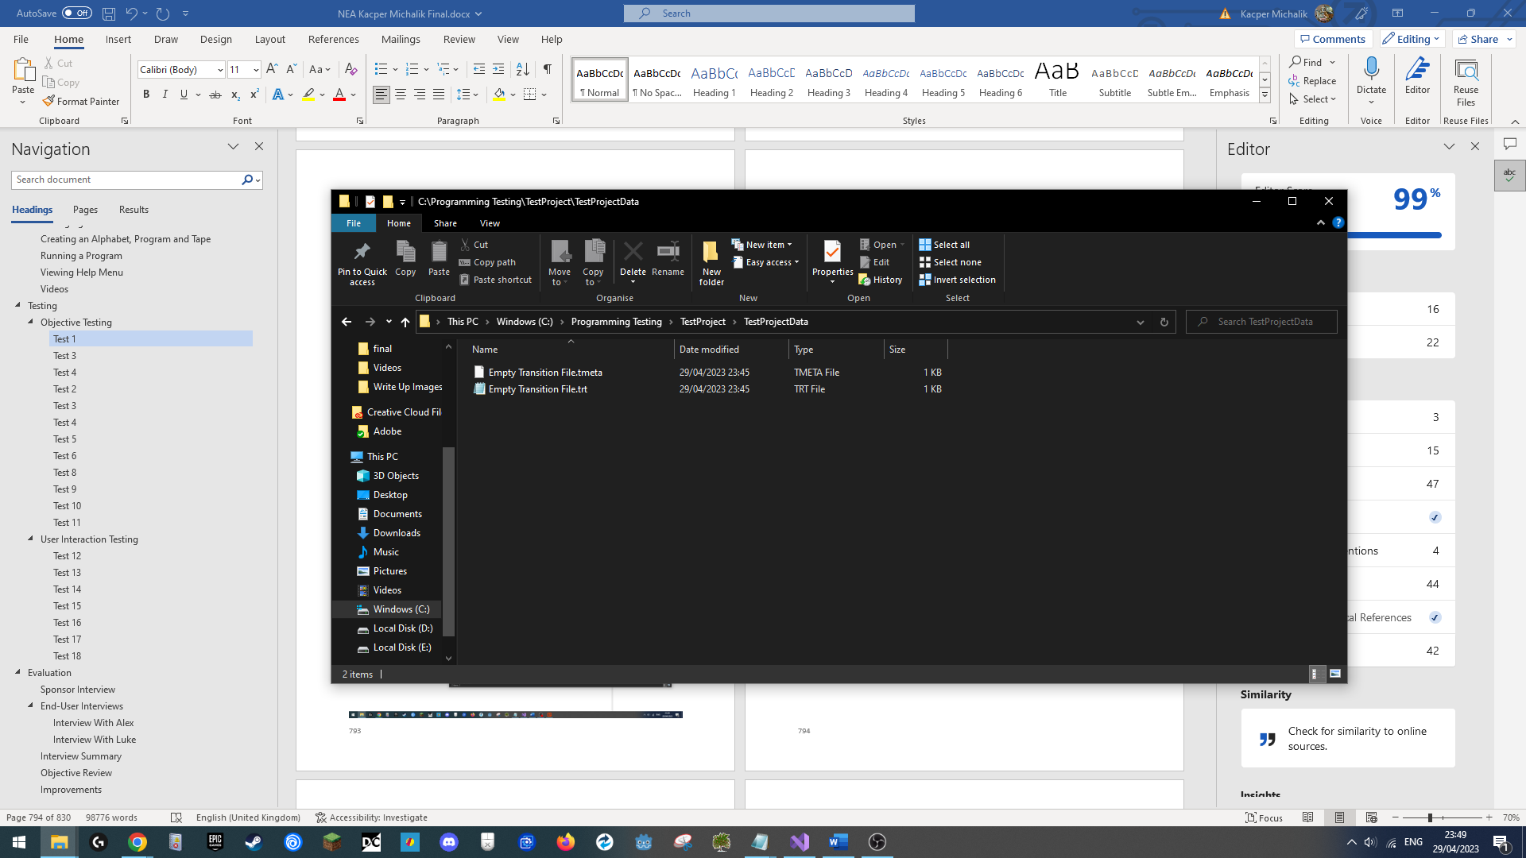





**Outcome**

|  |
| --- |
| **Success**  I was successfully able to create a new project, have it automatically loaded, and when viewing the data structures created on our disk, it matched the ones in our design brief (attached above). |

### Test 2

**Connecting To A Project On Another Device**

**Functional Test**

Links: Host View: <https://youtu.be/AUCAtEg3O9g>

Client View: <https://youtu.be/x2ngAt0rFEs>

Overlapped Views: <https://youtu.be/hh5w-9WtaEI>

**Objective**

One of the goals of this project, and a significant design wise, was the networking ability of the project. The goal of this project is to see whether the networking system works between two different devices running the software on the same home network.

**Test Method & Reproduction**

Both users will first boot up their application. Next, the host will create a new template project titled “**NetworkTest**”, with a max client count of **2**. Next the client will enter the join menu, and input in the hosts’ devices’ IP address on the local network, then click join.

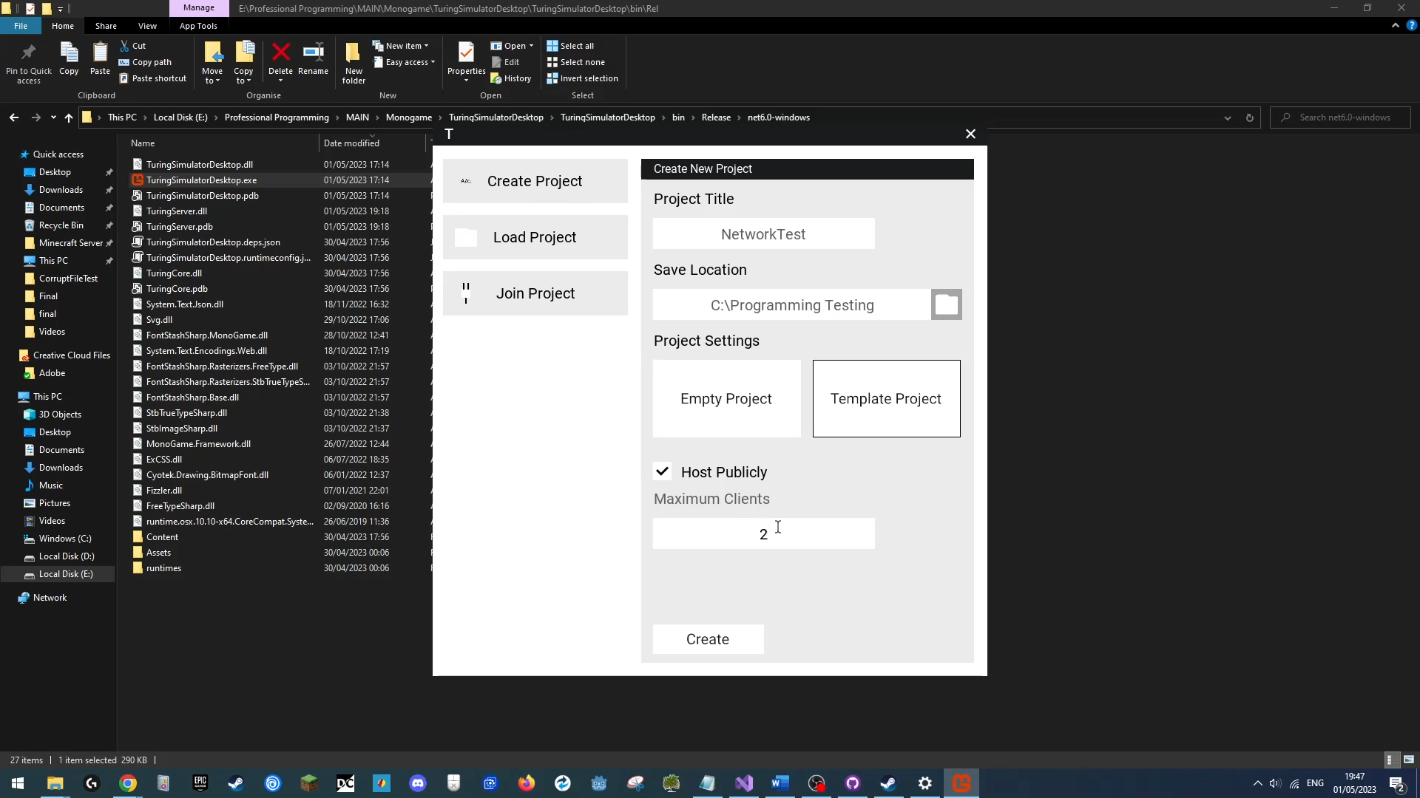

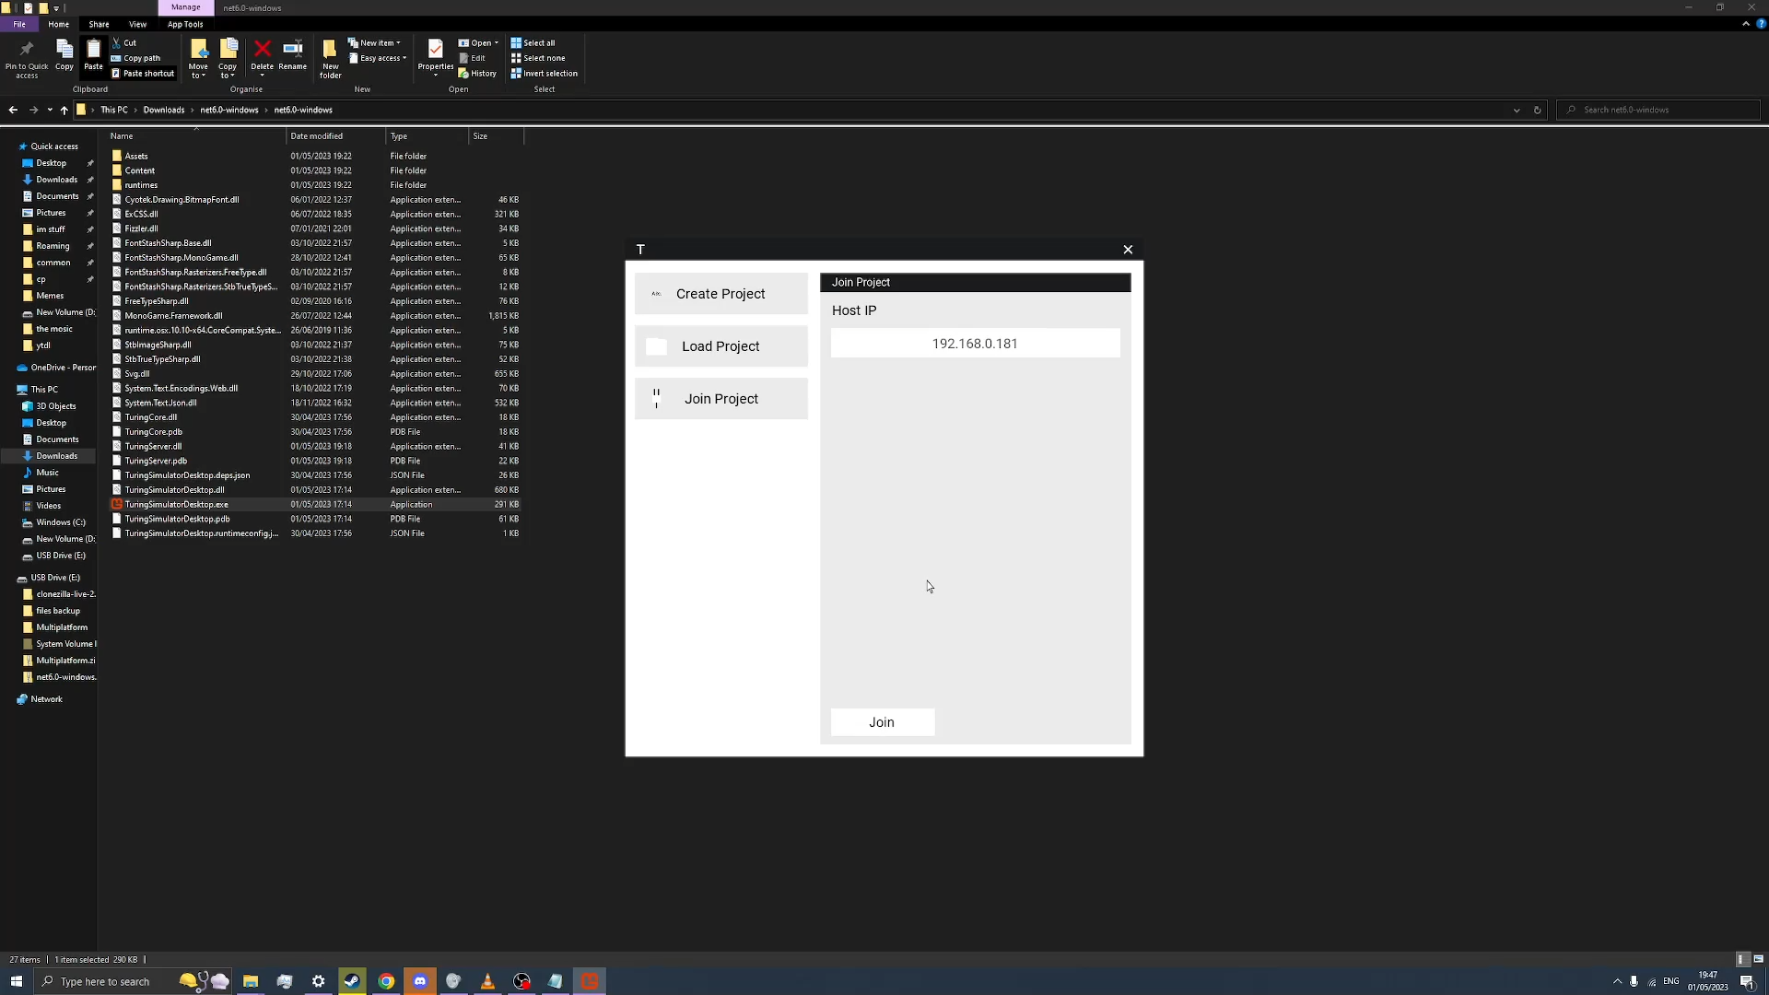

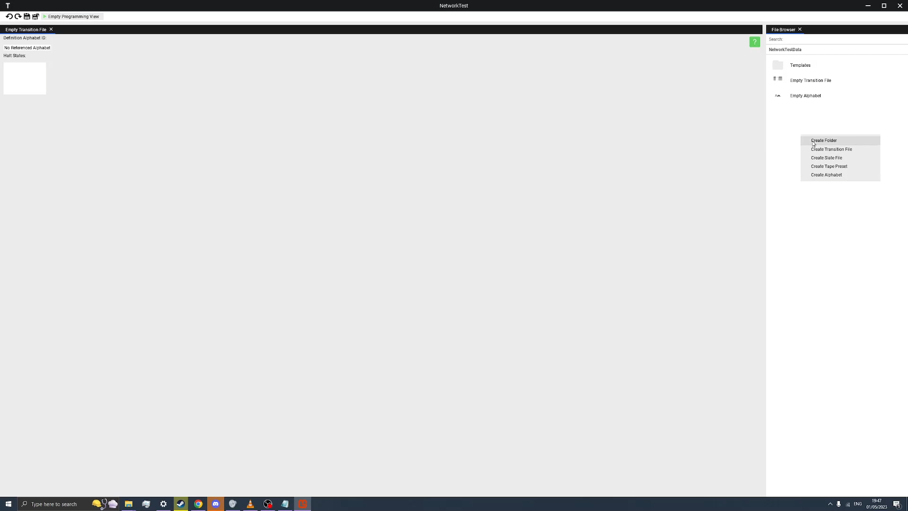The client device should successfully connect to the hosts device, and be able to see and interact with the project, which will be shown by having the client create some files and folders in the base project data folder.

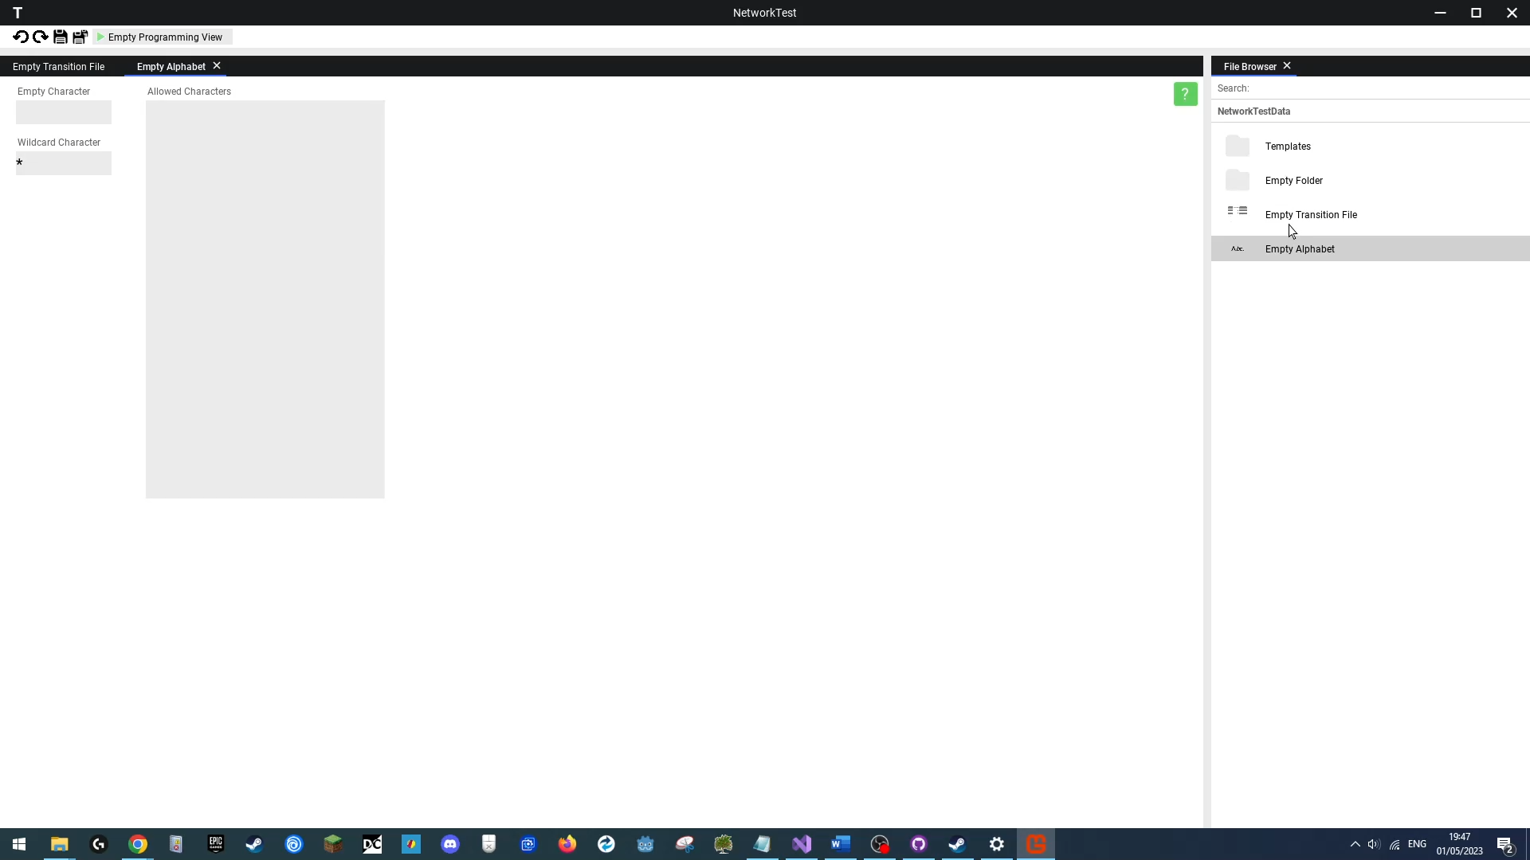

**Outcome**

|  |
| --- |
| **Success**  The client was able to successfully connect to the project hosted by another device, and was able to create files and folders that both users could see and interact with. |

### Test 3

**Creating a Template Project**

**Functional Test**

Link: https://youtu.be/46dwrYQwrHQ

**Objective**

This test will involve creating a new project with template files that the user can view edit and run.

**Test Method & Reproduction**

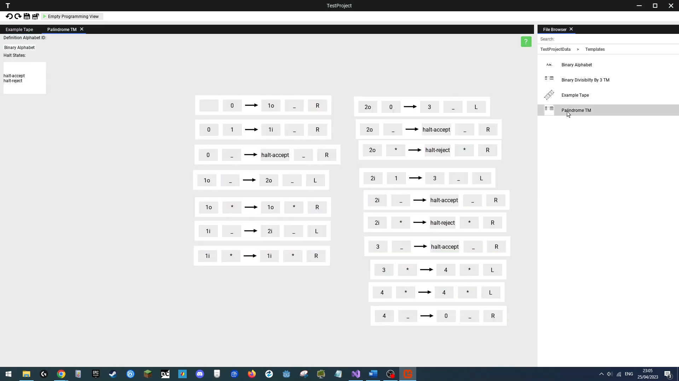A new project will be created on the local user disk in “**C:\Windows\Programming Testin**g”, this will be selected to be a **template** **project**. Once we create and load the project we will open the newly generated “**Templates**” folder and open the “**Palindrome TM**” file to view and edit and then open the “**Example Tape**” file, which we also view and edit, to demonstrate that these template files are perfectly usable.

**Outcome**

|  |
| --- |
| **Success**  We successfully created a new template project and were able to view, interact with and use the bundled template files. |

### Test 4

**Executing a Valid Turing Program**

**Functional Test**

Link: https://youtu.be/efPsRrCv_qs

**Objective**

The user should be able to run and view a Turing Program that follows the rules of a theoretically correct Turing machine.

The objective of this test is to determine the validity of our Turing Machine algorithm, whether it simulates a program as expected.

**Test Method & Reproduction**

In this test I will run a “copy routine” program, sourced from Wikipedia:

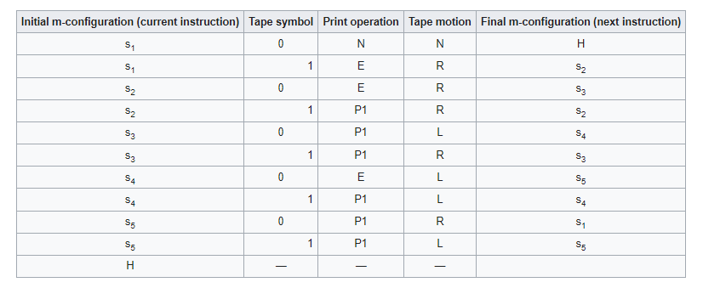<https://en.wikipedia.org/wiki/Turing_machine_examples>

Its goal is to read the input series of “1” symbols, write a 0 symbol after them and write an identical series of “1” symbols after the 0.

We will first create an empty project file title “ValidTuringTest”, then create a tape template file, fill it with the symbol “**1**” in each cell starting from **cells indexed -2 to 0** (inclusive), and save it.

Then we will create a new alphabet, open it and define the characters “**0**”, “” and “**1**”, we will also set the “**0**” character as the empty character.

Next we will create the state transition program file, into which we will program the transition table from the Wikipedia source (which will be identical except tape motion has to be inverted as we program using head motion, not tape), and hit the top “Run” button to start the execution window.

We will then drag the “Empty Tape” file we created, into our Turing execution Window.

Next we will type in the “**s1**” start state and “**0**” start index, and then finally hit the restart button on the interaction strip.

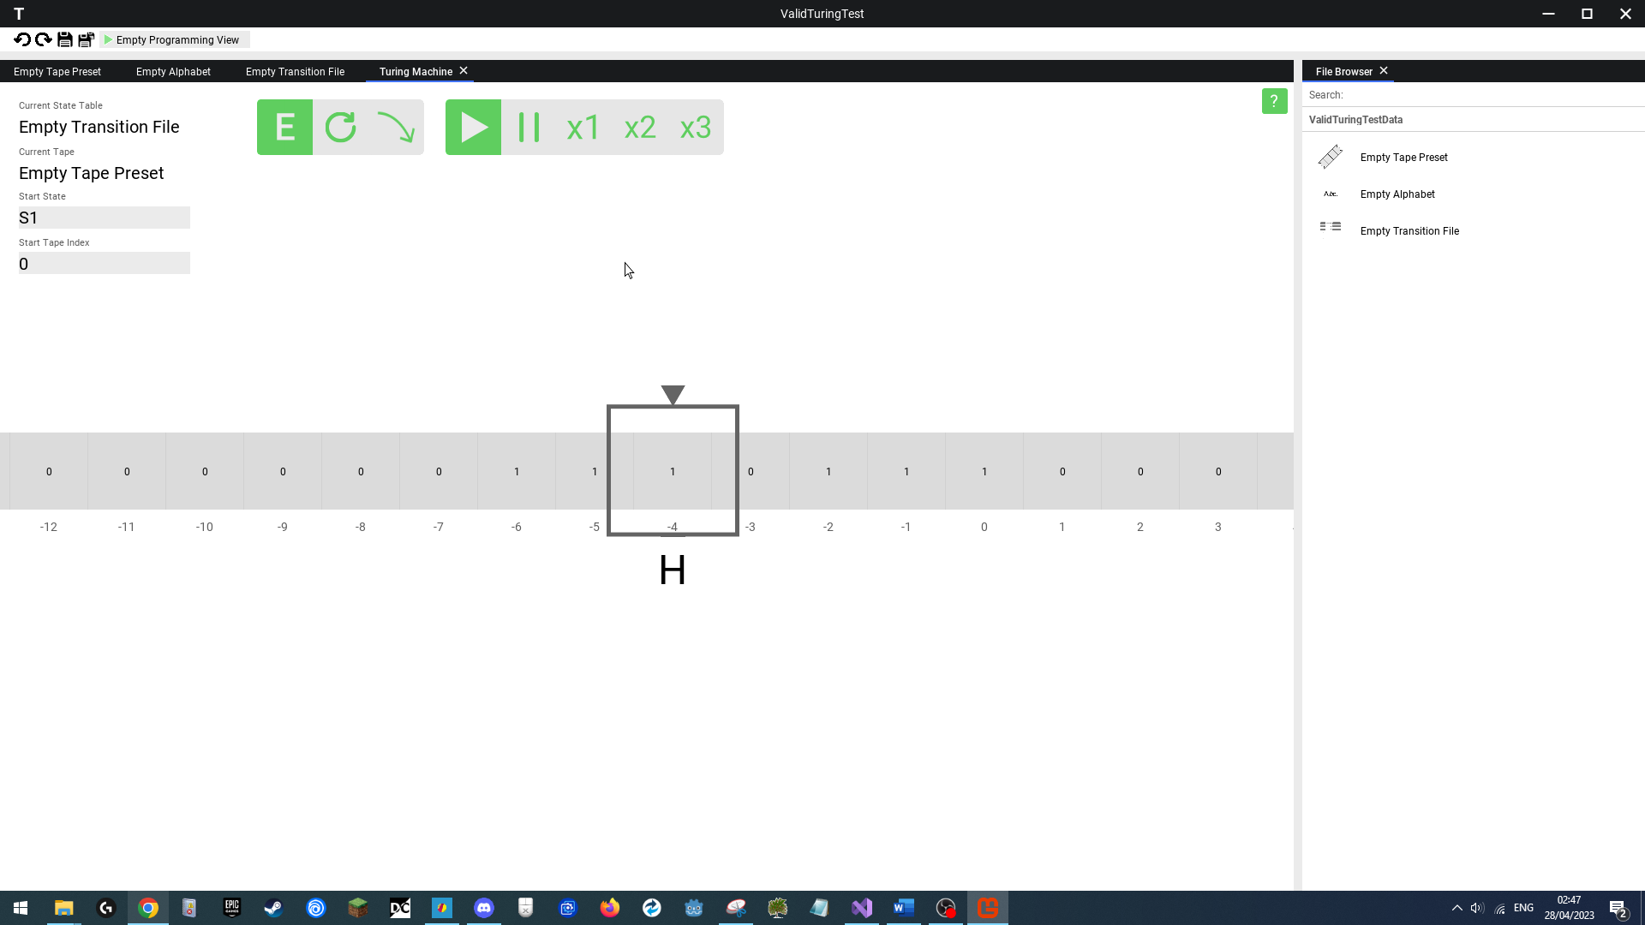We will finally hit the execute button, and expect the visible tape to have the following characters: “1110111” and for the TM to halt with the state “**H**”.

**Outcome**

|  |
| --- |
| **Success**  The Turing Machine successfully executed the program, giving the expected result. |

### Test 5

**Executing a Valid Non-Classical Turing Program**

**Functional Test**

Link: https://youtu.be/-foiRxpaqps

**Objective**

In this test we will run a non-classical Turing Program, which tests if an input string of “1”s and “0”s is palindrome.

**Test Method & Reproduction**

First we will create a new template project. Nex we will open the “**Palindrome TM**” program and run it. Next we will go to our “E**xample Tape”** and input the string “**100001**”. We will then run the Palindrome TM with this input, expecting a final result of “**Halt-Accept**”.

For our reject testing, we will alter the Example Tape to “**10110**”, we will then restart our TM in the Turing Execution Window, and then run this program again, and now expect a “**Halt-Reject**” final output from the TM.

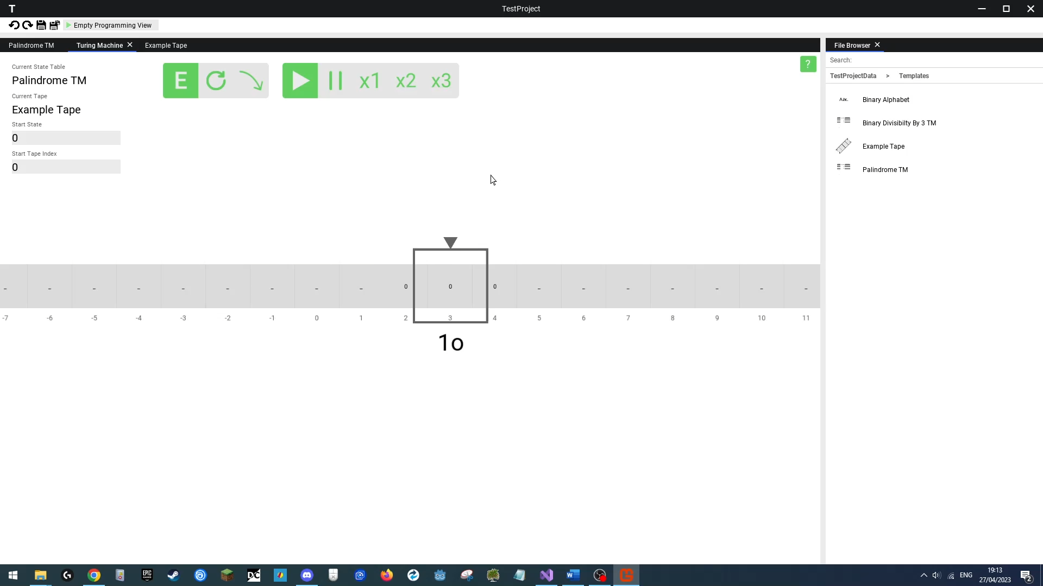

**Outcome**

|  |
| --- |
| **Success**  The Turing Program successfully executed and returned the expected results. |

### Test 6

**Window System Interaction**

**Functional Test**

Link: https://youtu.be/AA-XNl-ueNo

**Objective**

Following the UI design section, the user should be able to open new windows within which they can use specific views to work with the project.

In this test I will open a template project, and open a variety of files, switch between them, edit them and save them separately or save all of them at once, the objective being to test each tabbed window keeps its state when switched between and that the overall window closes when all tabbed windows in them are closed.

**Test Method & Reproduction**

We will first open an empty project.

Next we will create 3 files using the file browser. These files will be “Empty Alphabet”, “Empty Tape Preset” & “Empty State Transition Program”.

We will then open each of those files in the above order, then we will select the window tab that leads us to the “Empty Alphabet” editor, in which we will type in the characters “1” & “0” in the characters section, then we will select the “Empty Tape preset” window tab, and type in the values “1” “1” and “0” onto the tape in cells 0, 1, and 2 respectively. Without pressing save we will switch between all the open tabbed windows and then switch back to the Alphabet Editor which should have kept its state. We will then switch back to the state transition program and run it. Here we expect a new window tab to appear within the window and that we be automatically switched to it. Next we will open the help menu in the newly created Turing Execution View, where the help menu should open in a new window, we will drag this window around and close the help menu tab, which should cause the overall window to close.

Finally we will close all 3 views using he tab close buttons, where each view should shut down and the window containing them should disappear.

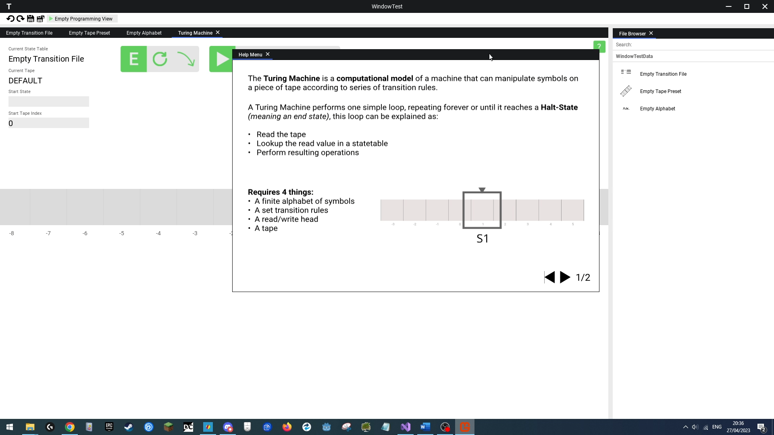

**Outcome**

|  |
| --- |
| **Success**  I was successfully able to open windows to work on specific files, switch between tabbed windows without losing their state, drag windows, and then close a window once all contained tabbed windows were closed. |

### Test 7

**Drag & Drop System Interaction**

**Functional Test**

Link: https://youtu.be/yc0OIV2ripE

**Objective**

As to make the interface intuitive the user should be able to drag a file from the file browser, see their mouse cursor change state to indicate a dragged file, and then be able to drop the file in an open window to load the currently selected file to work on, or supply to an element of the interface.

**Test Method & Reproduction**

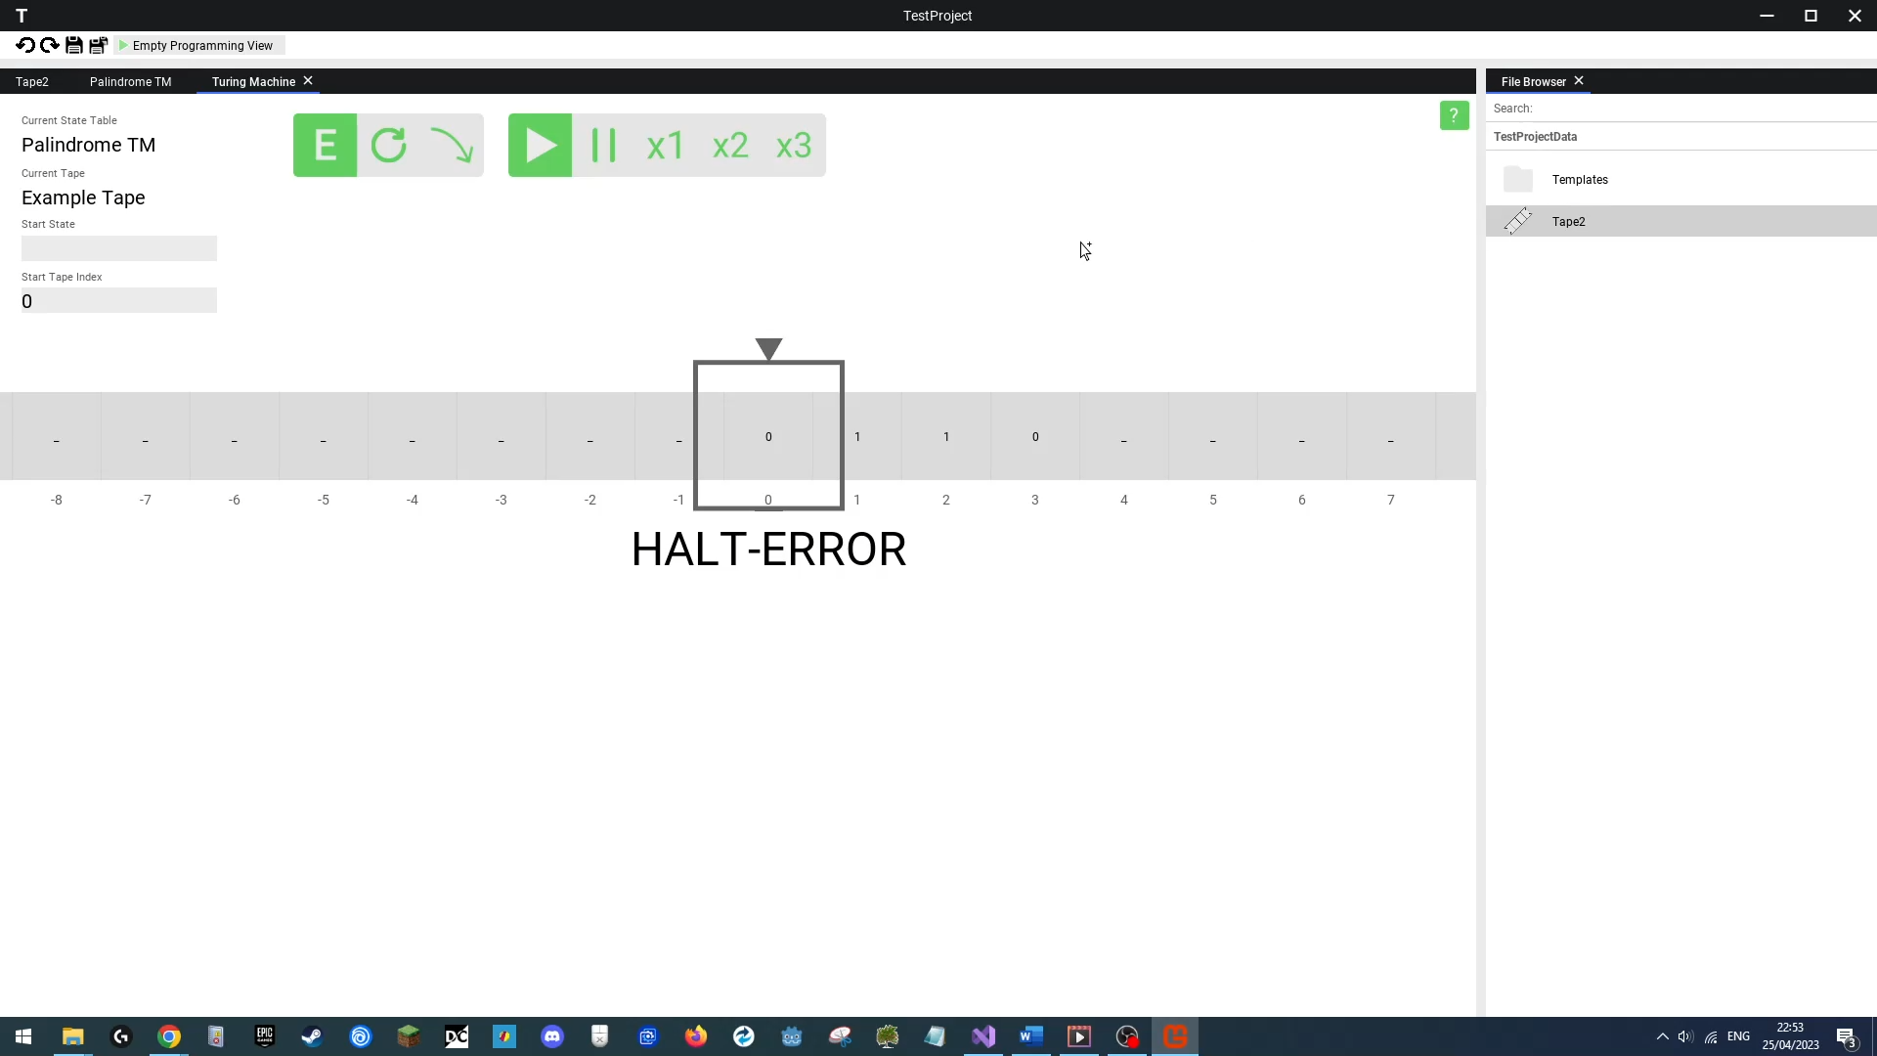In this test we create a new template project. We will create a new tape preset called “**Tape2**”, open it and fill in the cells **0, 1 and 2** with the symbol “**0**”, then save that tape. We will then open and run the “**Palindrome TM**” state transition file. Once in the Turing Execution window, we will drag & drop the “**Example Tape**“ tape preset file into the Execution view. We expect this to cause the filled in values on the tape to appear on the tape in the Execution View. Then we will drag & drop thew “**Tape 2**” file, and see it’s values appear instead.

**Outcome**

|  |
| --- |
| **Success**  I was able to successfully drag a tape file, see my mouse cursor change state, and then be able to drop the tape files into a Turing Execution Window. |

### Test 8

**Toolbar System Interaction**

**Functional Test**

Link: https://youtu.be/46dwrYQwrHQ

**Objective**

The user should be able to use the save, save all, undo and redo buttons without problem.

The test will show usage of all of these toolbar options.

**Test Method & Reproduction**

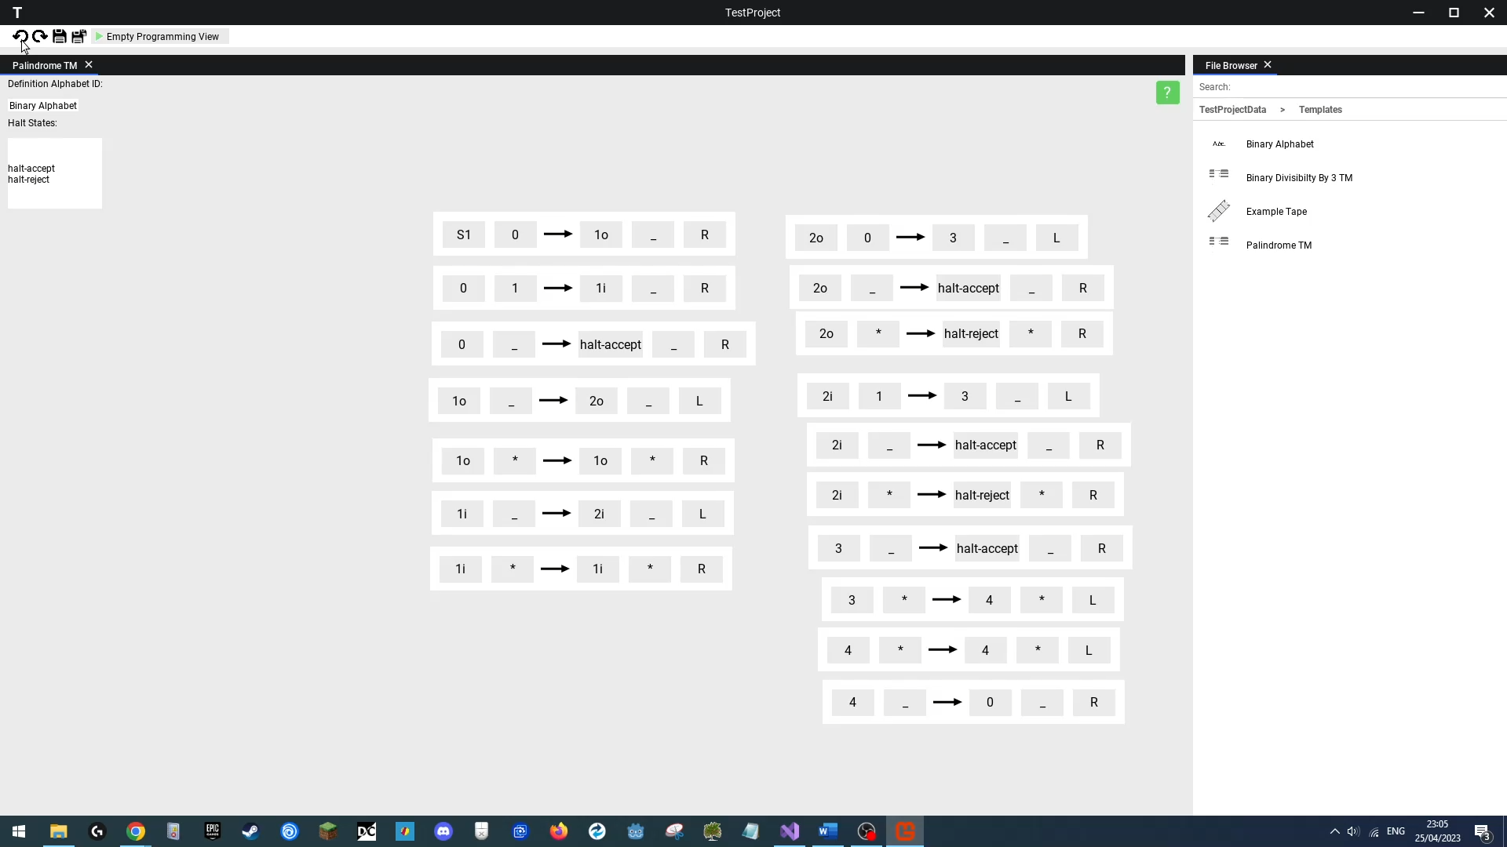We first create a fresh template project, then we will access the file named “**Palindrome TM**” and edit the first state transitions initial state field to “**S2**”, then change that same transitions write value to “**1**”. We will then hit undo twice, expecting the last two changes to the state transitions be undone, then click redo once, we then click the save button, expecting the changes to be saved. Then we will open the “**Example Tape**“ present file. We will then close the “**Palindrome TM**” window and reopen the file, and it should have preserved its contents. We will then perform another change to the first state transition, making the initial state **“ ”**. We will then switch back to our “**Example Tape**” window and amend the value in cells 0, 1, 2, 3 to **“0”, “0”, “0” and “ ”** then hit save all, close the “**Palindrome TM**” window, and then re-open the “**Palindrome TM**” file, and expect the window to show the updated file that was saved through the save all button.

**Outcome**

|  |
| --- |
| **Success**  I was able to save, undo and redo changes made to a Turing Program and able to save all changes made to both windows. |

### Test 9

**Help Menu System Interaction**

**Functional Test**

Link: https://youtu.be/_XBN5RAr6Cs

**Objective**

The user should be able to see spec related information about Turing Machines when they choose to. This test will involve opening a help menu that will teach the user what Turing Machine is and explain the model to them.

**Test Method & Reproduction**

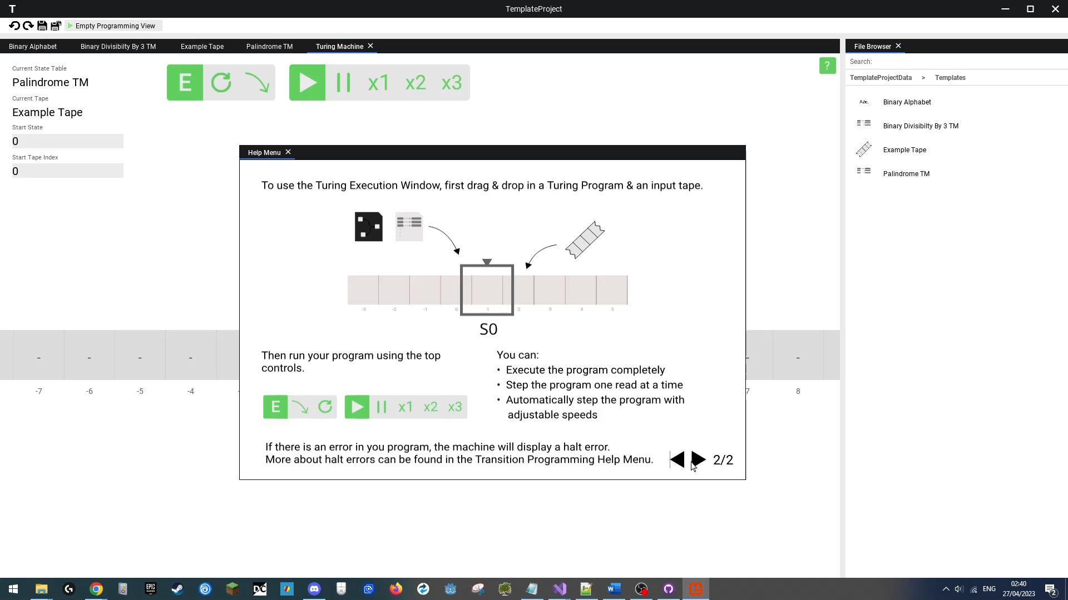In this test, we will create a new project titled “Template Project”, open all the files in the project, and then finally switch to the “**Palindrome TM**” program. We will then run this program and enter the **Turing Execution View**. There we will **click** the “**Help Button**” and a new help menu should appear with information about what a Turing machine is. We will then click on the right arrow on the menu to see the second screen, and then click the left arrow to go back to the first screen and repeat this process once more, to verify cycling through menus is working correctly. We will then drag the help menu across the screen to verify it can be moved around, and then finally close the help menu.

**Outcome**

|  |
| --- |
| **Success**  I was able to successfully open and switch through a help menu with relevant information to what a Turing Machine is and how it works. |

### Test 10

**Saving Files**

**Functional Test**

Link: https://youtu.be/46dwrYQwrHQ

**Objective**

The user should be able to edit a file, save the changes to it, and then reopen the file for future use.

**Test Method & Reproduction**

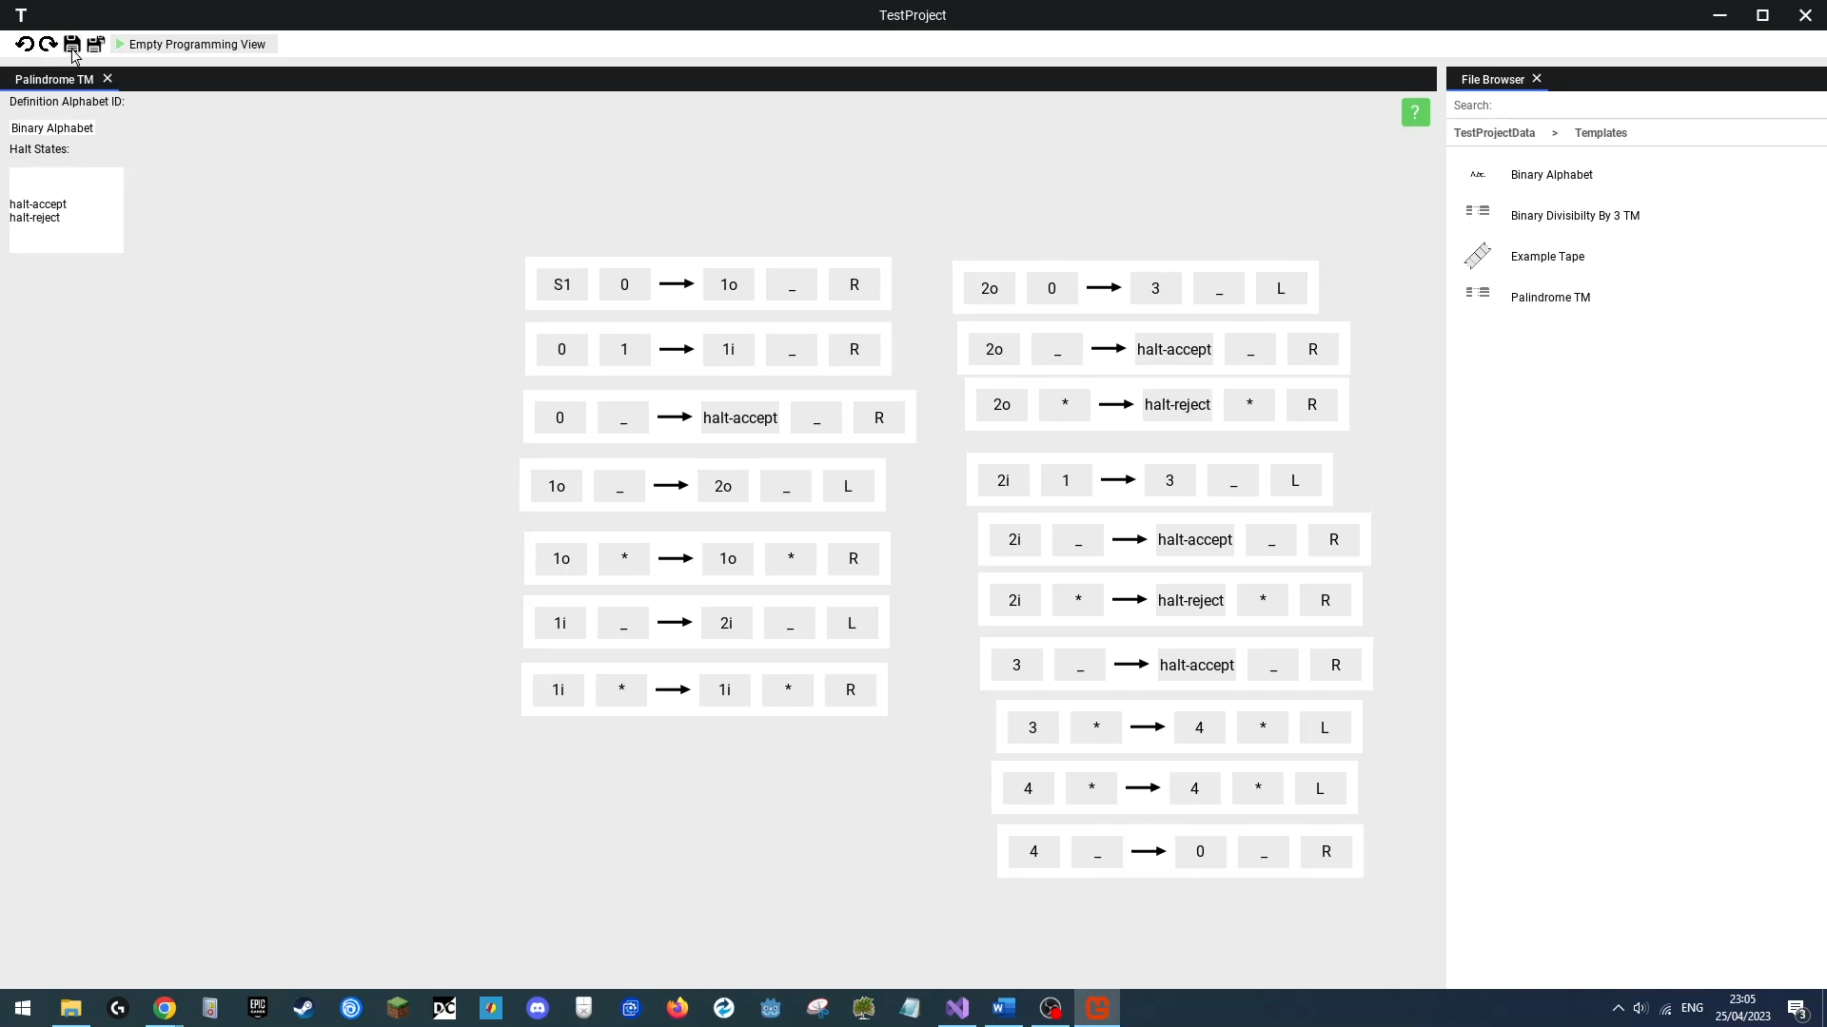We first create a fresh template project, then access the file named “**Palindrome TM**” and edit the first state transitions initial state field to “**S2**”, then change that same transitions write value to “**1**”. We will then hit undo twice, then click redo once, and then click the save button, expecting the changes to be saved. Then we will open the “**Example Tape**“ present file. We will then close the “**Palindrome TM**” window and reopen the file, and it should have preserved its contents. We will then perform another change to the first state transition, making the initial state **“ ”**. We will then switch back to our “**Example Tape**” window and amend the value in cells 0, 1, 2, 3 to **“0”, “0”, “0” and “ ”** then hit save all, close the “**Palindrome TM**” window, and then re-open the “**Palindrome TM**” file, and expect the window to show the updated file that was saved through the save all button.

**Outcome**

|  |
| --- |
| **Success**  I was able to save changes made to a Turing Program and able to save all changes made to the other open window. |

### Test 11

**File & File Contents Updates Disseminated To Other Clients**

**Functional Test**

Link: Host View: https://youtu.be/Ti6HIwAC1sM

Client View: https://youtu.be/O3rcbH80Zm4

Overlapped Views: https://youtu.be/HlqbRTinldU

**Objective**

One of the core features of the application is that after saving a file, other clients connected to the project who have the file opened should see the file update live, and whenever the contents of the project (file and folder wise) get updated, the clients should all see the updates in their file browsers. In this test we will test updating the contents of files, and updating the projects file/folder contents.

**Test Method & Reproduction**

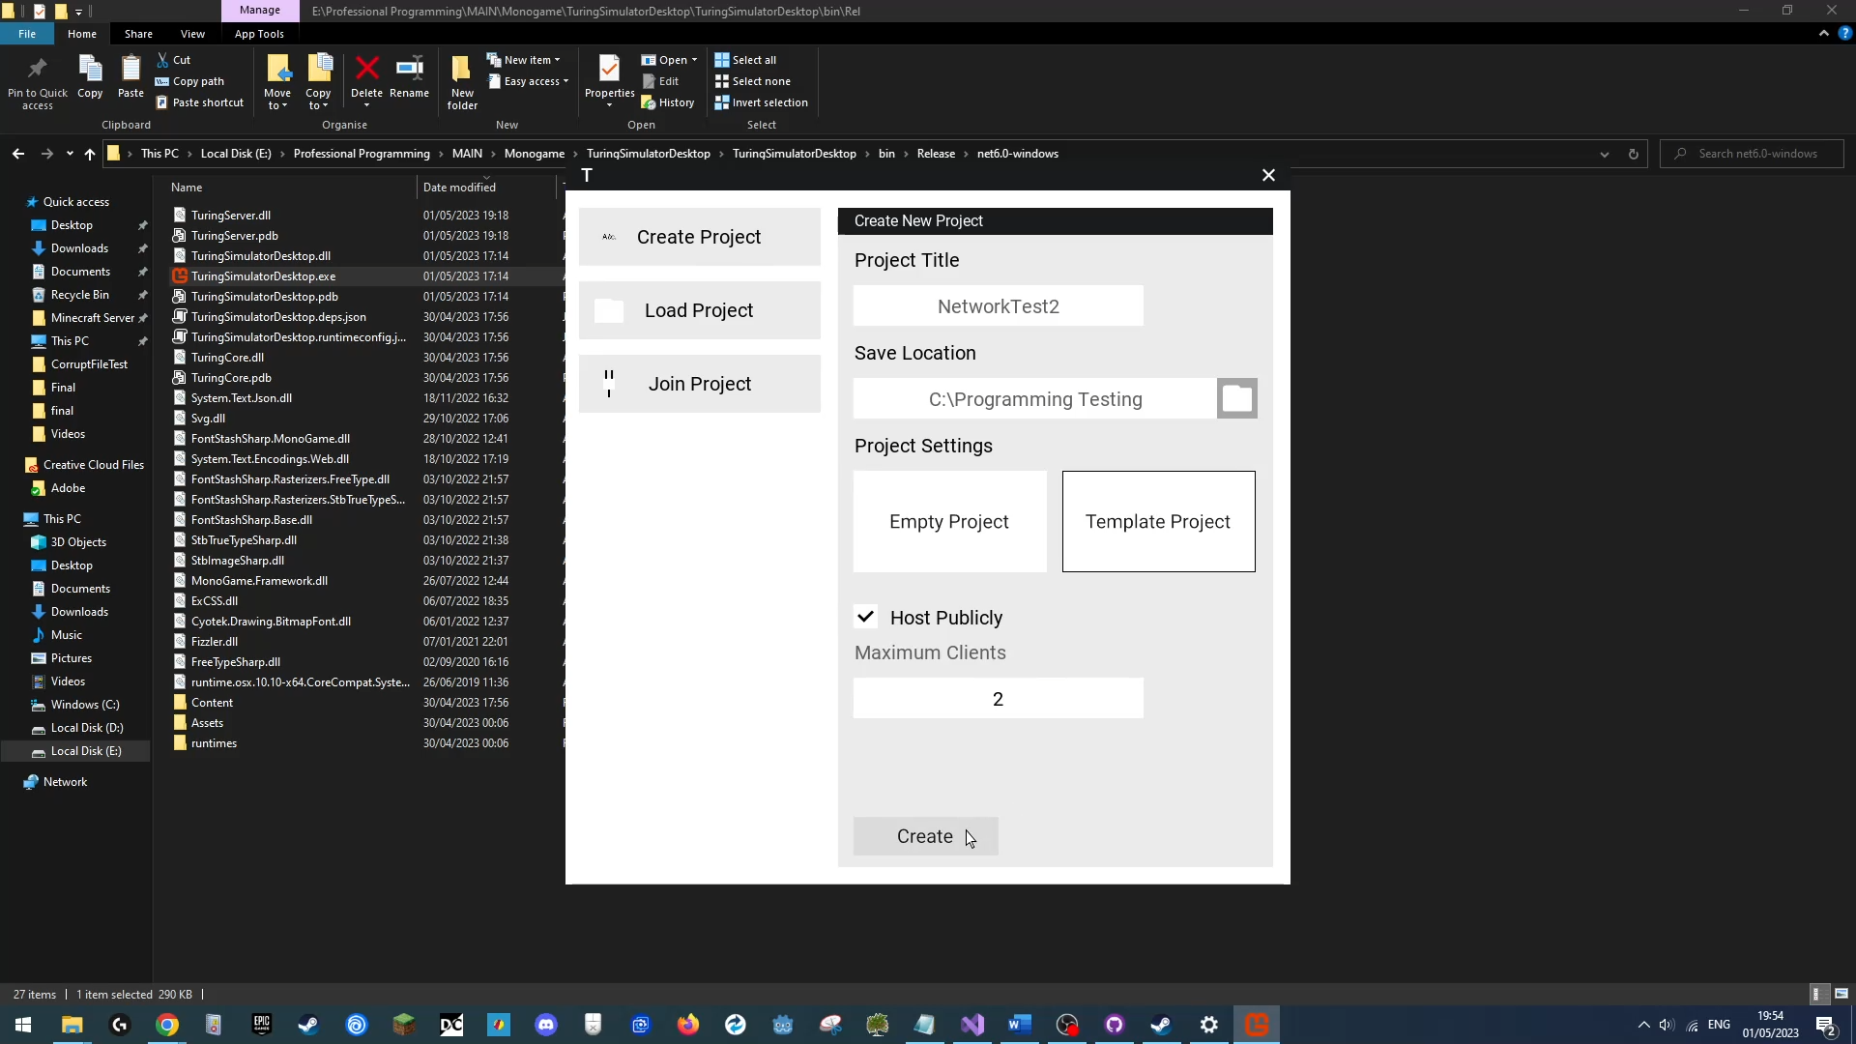First, the host will cerate a new template project titled “**NetworkTest2**”, with a max client count of 2.

Once the server is up, the second user will connect their device to the server using the hosts IP address on the home network.

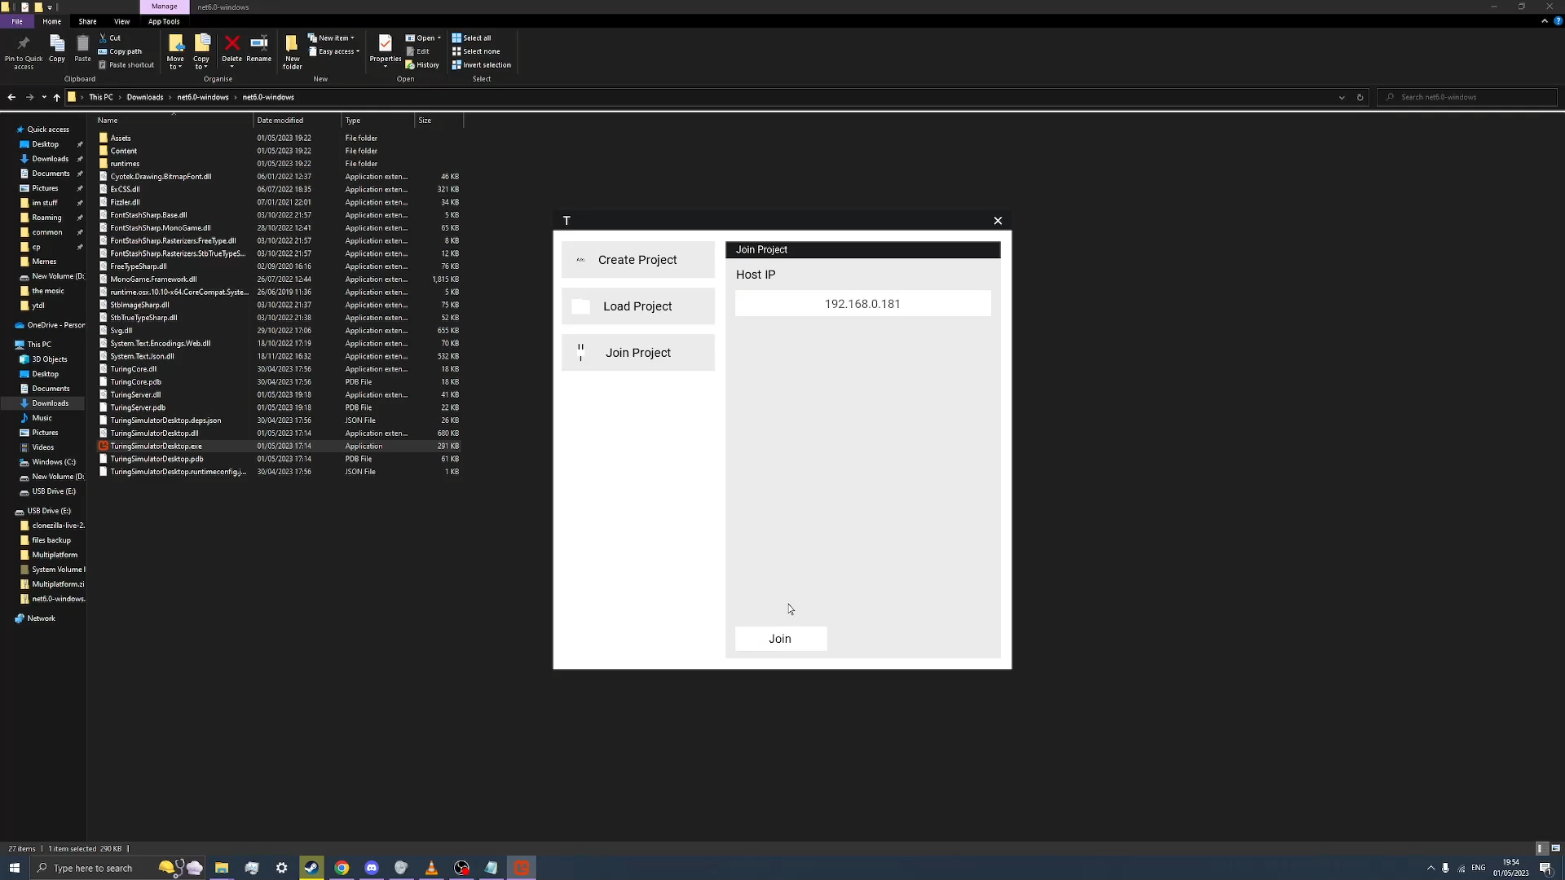

Once connected, both users will open the “Palindrome TM” template file, following which the host will alter the file and save it, expecting the second client to see the file update be disseminated to them.

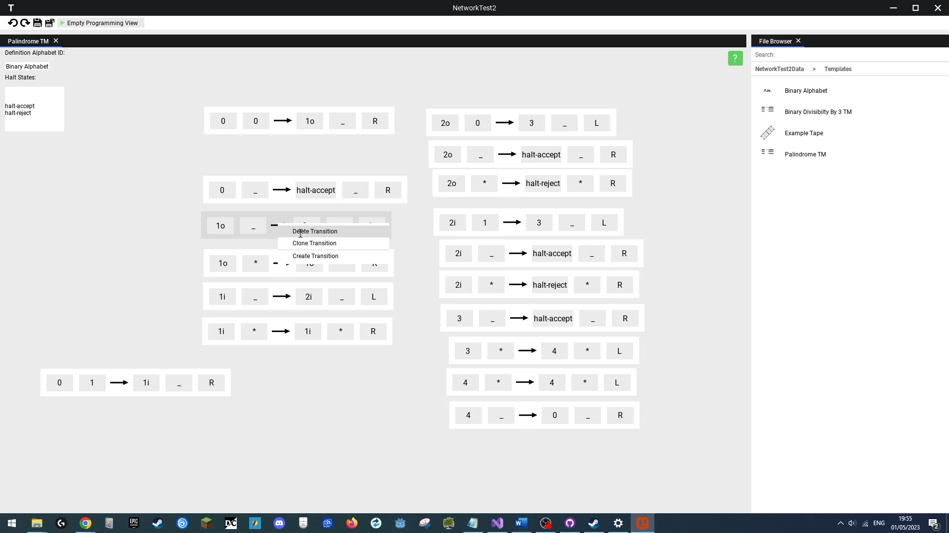(Host editing file)

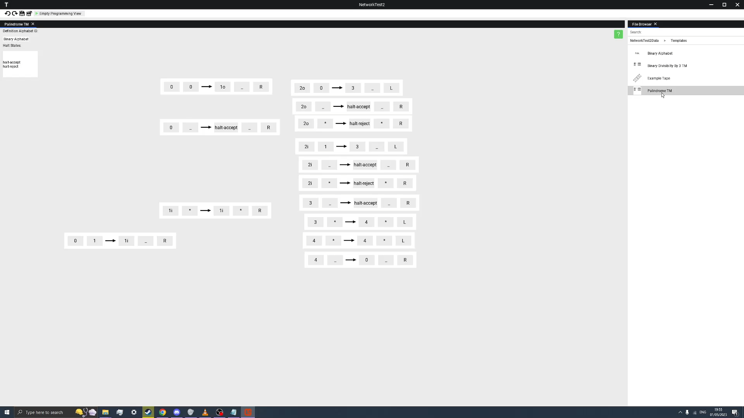(Client view after they received update)

The users will then switch roles, and have the client alter the file, and save it, expecting the hosts view to update.

Next, we will have the client create a variety of new files and a folder int the templates folder, expecting the file browser updates to be seen on the hosts view.

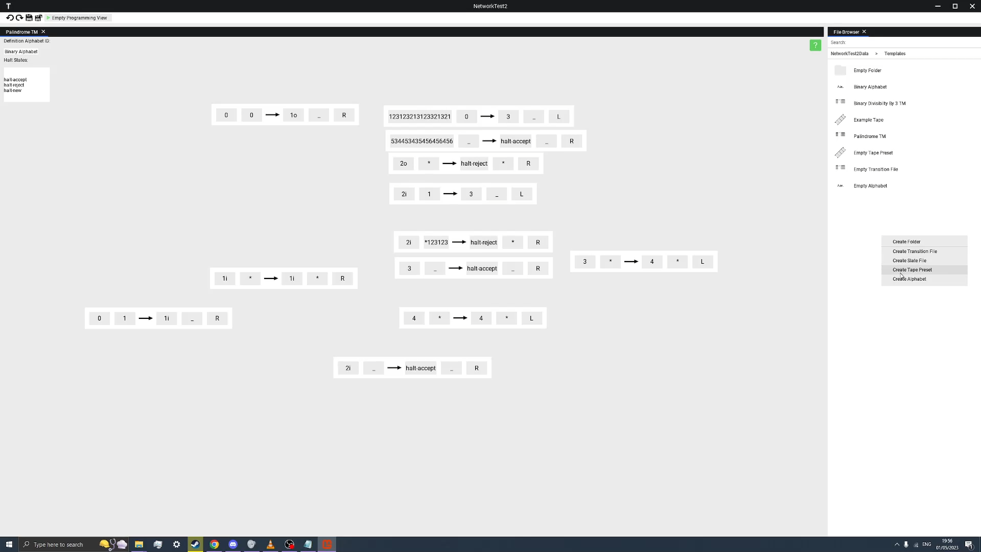(Client creating files)

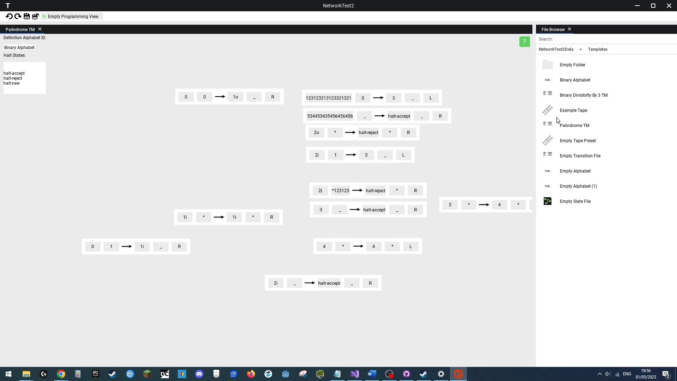

The next part of the test is renaming, the client device will rename the file titled **“Example Tape”** to **“testname”**, expecting the rename update to be seen on both users applications.

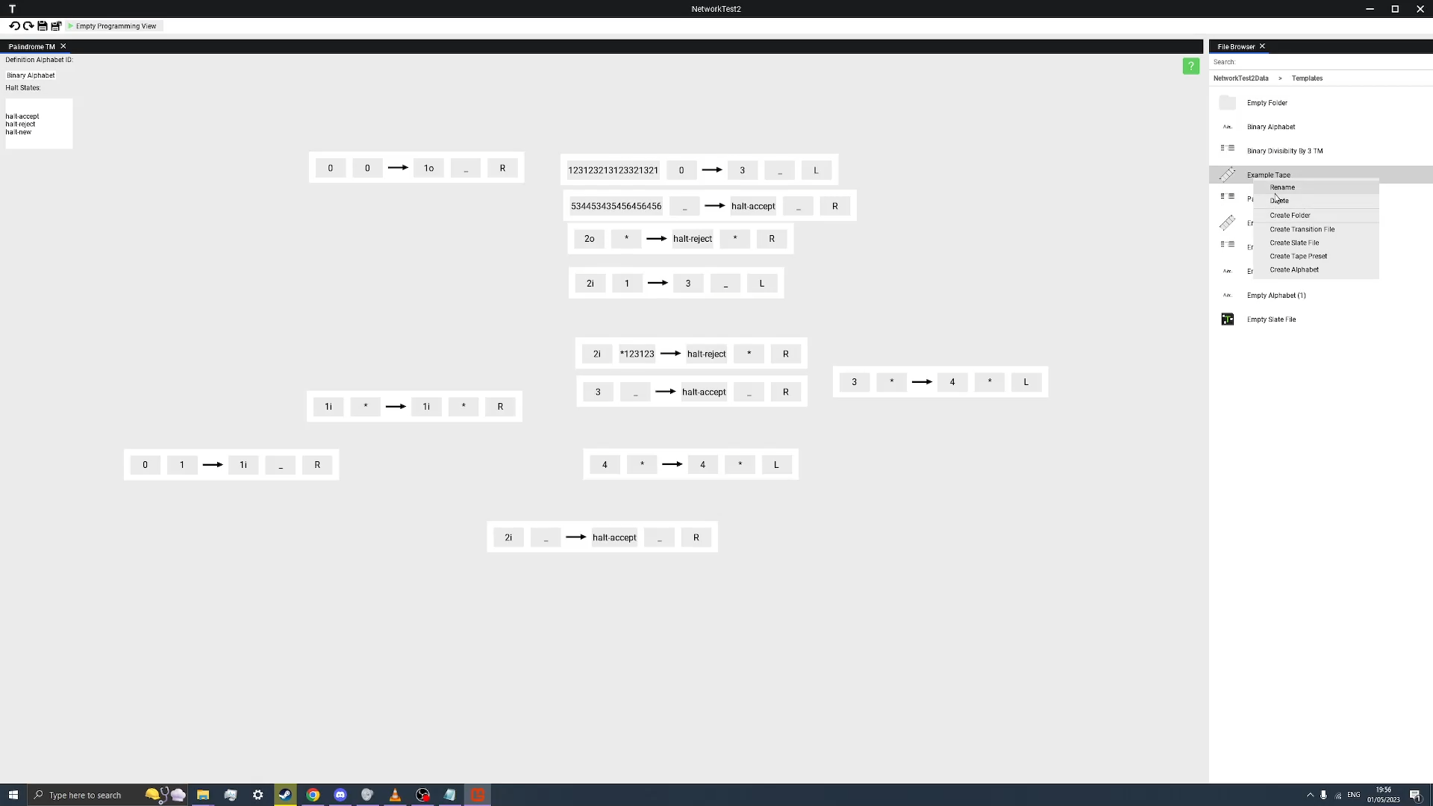(Client renaming)

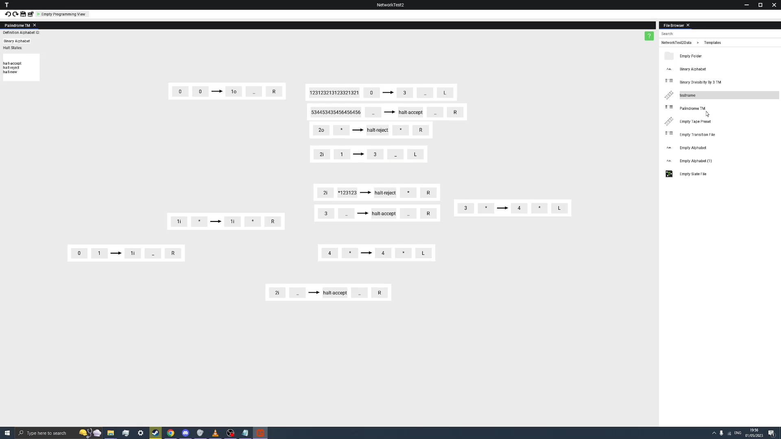

(Host seeing renamed file)

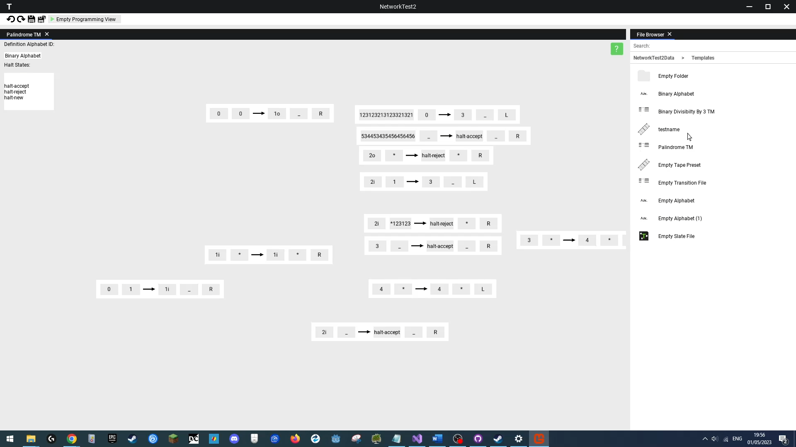

Finally, we host will delete some files in the currently opened “Templates” folder, and expect both users to see the files deleted from the file browser.

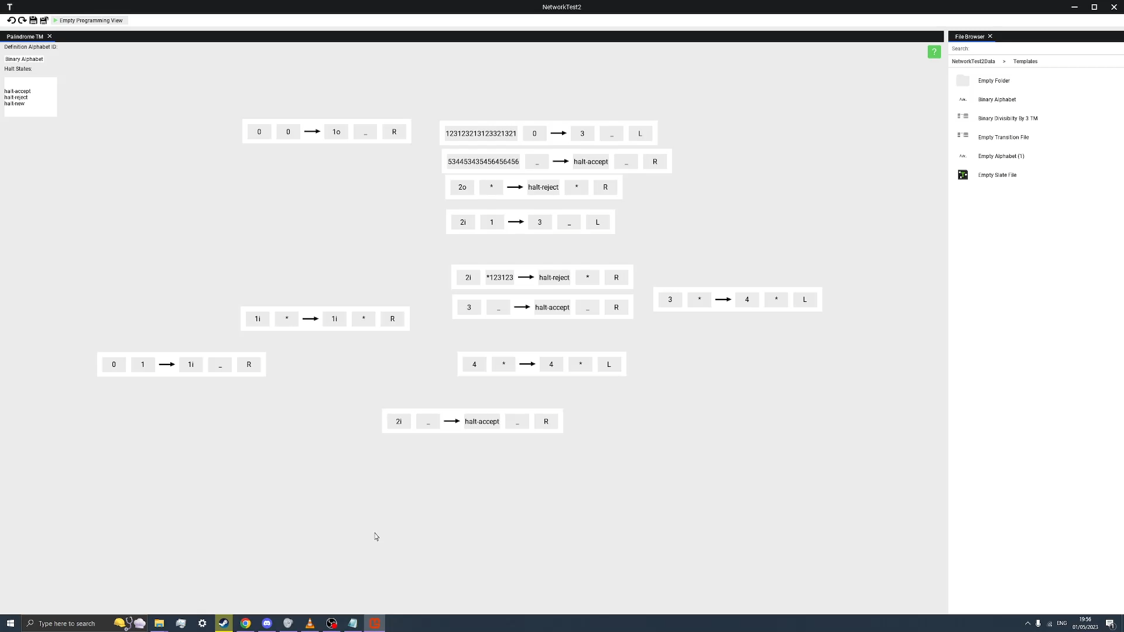(Client sees deleted files)

**Outcome**

|  |
| --- |
| **Success**  We have successfully seen both users be able to edit, save and see updates to the contents of files, and to alterations to the file/folder contents of the project itself. |

### Test 12

**Running On A Windows Device**

**Functional Test**

Link: https://youtu.be/_XBN5RAr6Cs

**Objective**

This software should be compatible with Windows, Mac and Linux devices, as such we will run the final executable on Linux to see if it launches successfully.

**Test Method & Reproduction**

In this test, we launch the application and will create a new project titled “Template Project”, open all the files in the project, and then finally switch to the “**Palindrome TM**” program. We will then run this program and enter the **Turing Execution View**. There we will test some of the features like the help menu, window dragging. Should all these features run we will have successfully used the application on Windows.

**Outcome**

|  |
| --- |
| **Success**  The program successfully opened and worked on a Windows 10 Device. |

### Test 13

**Running On A Mac OS Device**

**Functional Test**

Link: https://youtu.be/TSCVGa7v5QM

**Objective**

This software should be compatible with Windows, Mac and Linux devices, as such we will run the final executable on MAC OS to see if it launches successfully.

**Test Method & Reproduction**

Mono was installed and command line opened to run the downloaded executable using the “**mono**” command.

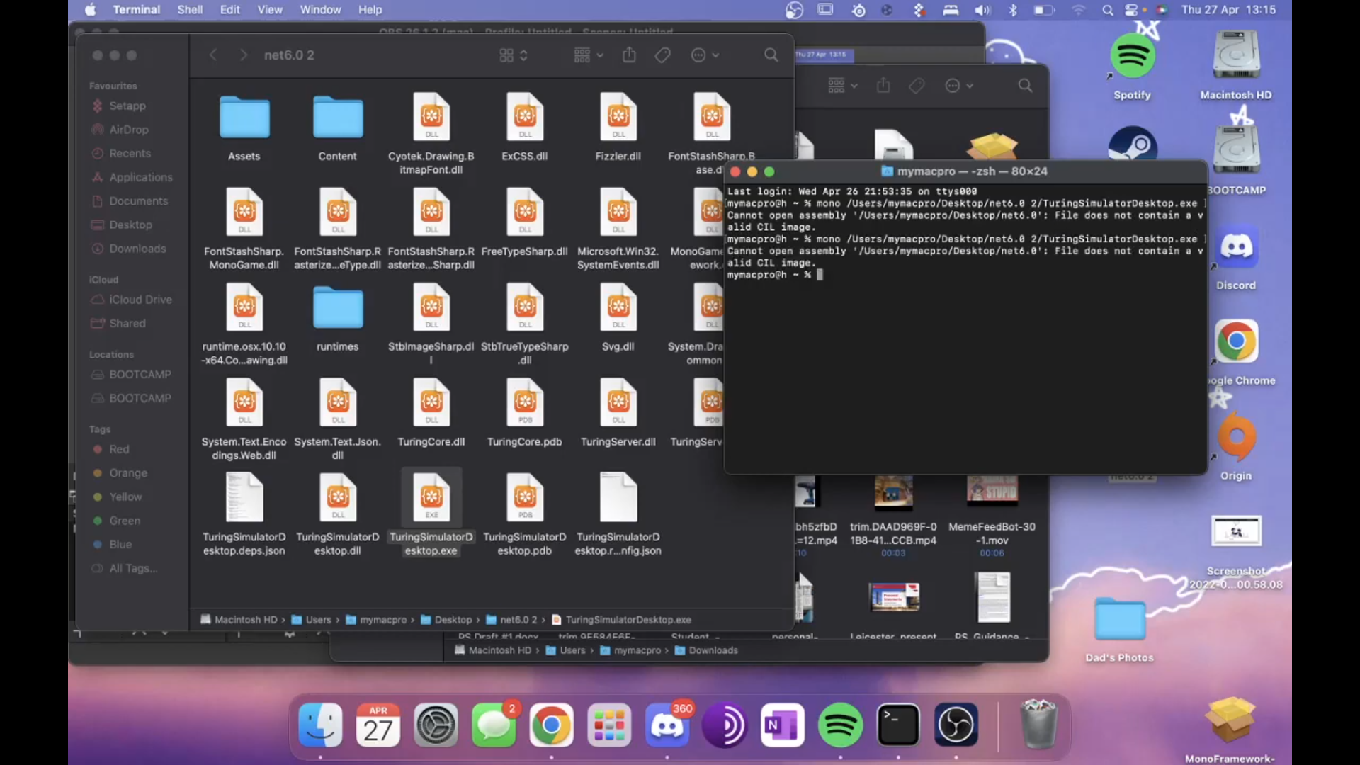

**Outcome**

|  |
| --- |
| **Fail**  There seems to be a problem with running the exe on MAC, with an error of “File does not contain a valid CIL Image”, initial remedies attempted off screen, such as recompiling, moving the executable to a different place, reinstalling mono, installing .Net 6.0 runtime, did not fix the problem. An alternative method for building to MAC will have to be found. |

### Test 14

**Running On A Linux Device**

**Functional Test**

Link: https://youtu.be/XkA16BMGdYw

**Objective**

This software should be compatible with Windows, Mac and Linux devices, as such we will run the final executable on Linux to see if it launches successfully.

**Test Method & Reproduction**

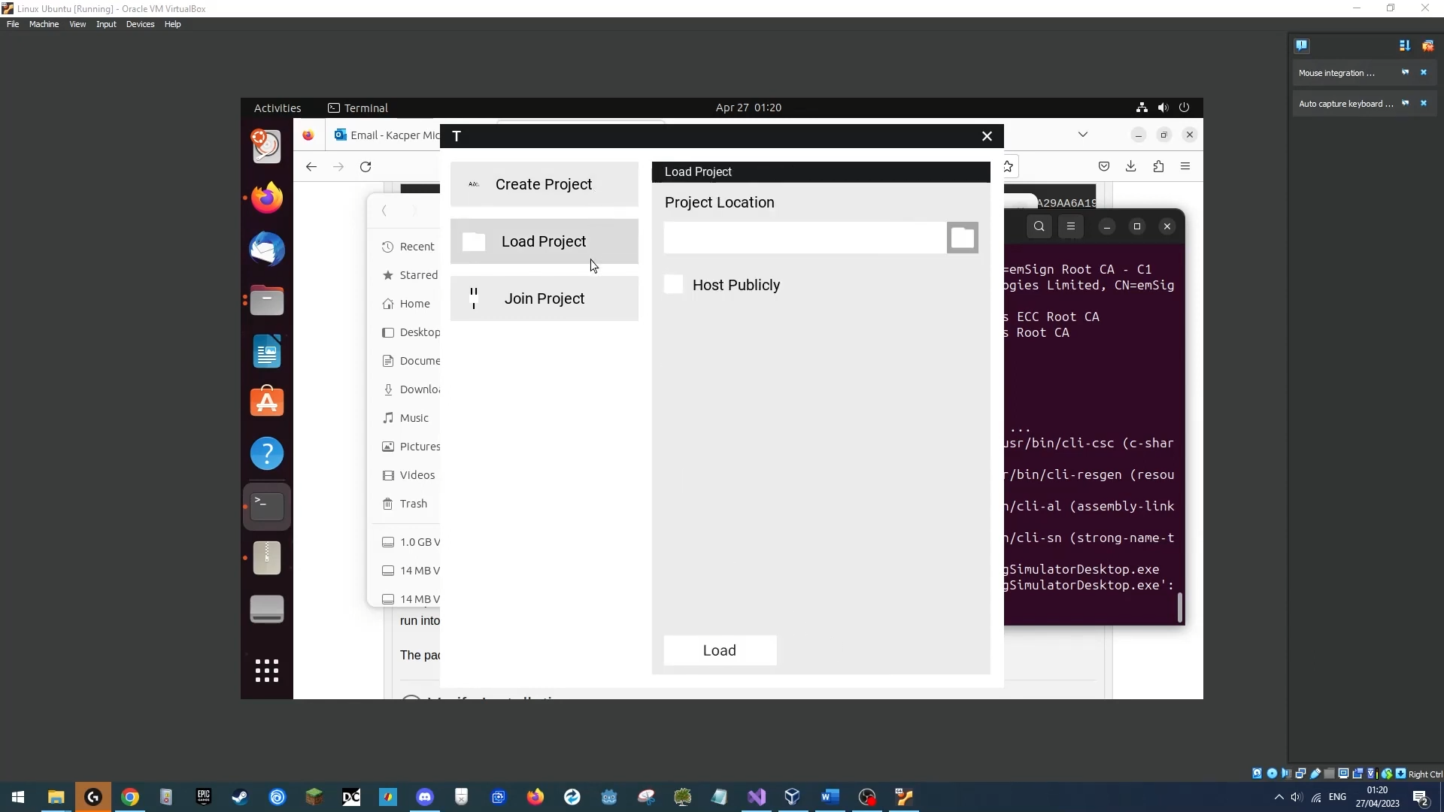We will use an Ubuntu 23.04 virtual machine with mono downloaded on it. Within the OS, we will use the “mono” command in the terminal, alongside an argument pointing towards our download of the executable, which will cause mono to launch and execute the program. Once the program is launched we will jump through the create, join and load menus, and then drag the application window, to verify it accepts inputs correctly.

**Outcome**

|  |
| --- |
| **Success**  The program successfully opened and worked on a Linux Device. |

## User Interaction Testing

### Test 15

**Invalid IP Address**

**Erroneous Data Test**

Link: https://youtu.be/DaPEfdl0dxU

**Objective**

Users will commonly misinput values into fields, as such checking the validity of inputs is important to prevent runtime errors. When trying to connect to another device, the system should only take in valid IP addresses to connect to, and if a user tries to connect with an invalid IP, an error should be displayed.

**Test Method & Reproduction**

We will start the application, and go to the Join Project men screen, there we will type in “**abc.123**”, and proceed to press the “Join” button, to connect to a project.

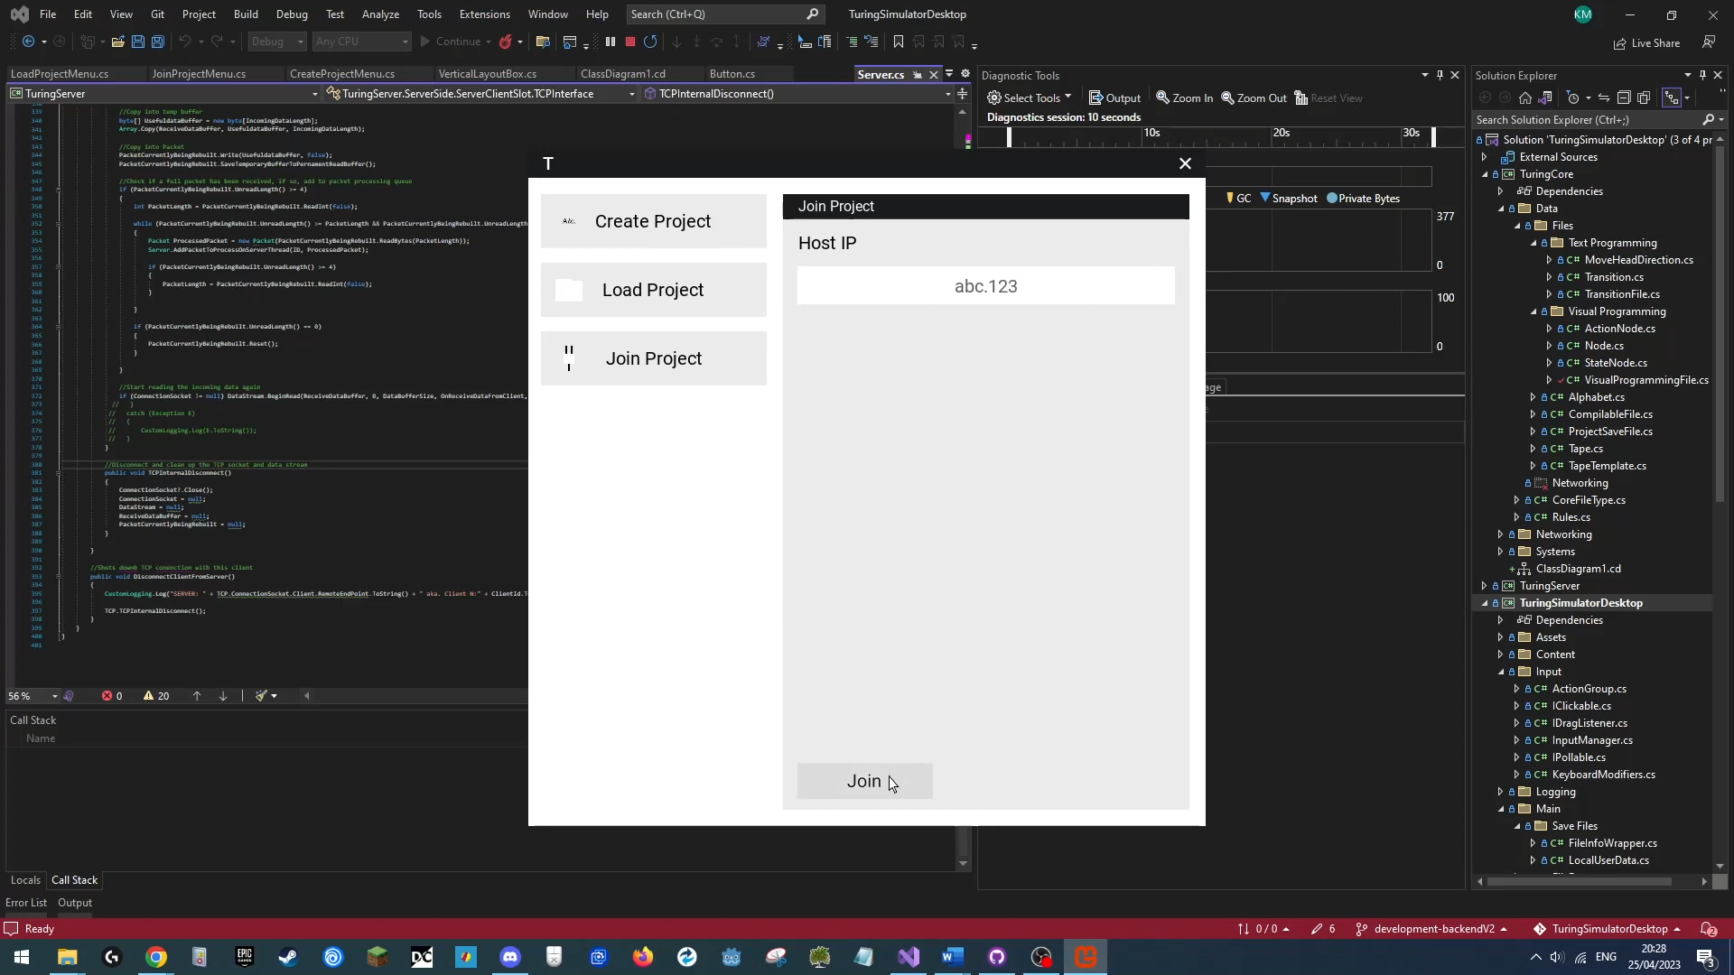The program should not attempt to use the IP as a valid one, and should tell us that the IP is invalid.

**Outcome**

|  |
| --- |
| **Success**  Error text was displayed in the IP input field and no connection was attempted; program continues normally. |

### Test 16

**Invalid IP Address 2**

**Erroneous Data Test**

Link: https://youtu.be/yLmHUIjN-cE

**Objective**

Users will commonly misinput values into fields, as such checking the validity of inputs is important to prevent runtime errors. When trying to connect to another device, the system should only take in valid IP addresses to connect to, and if a user tries to connect with an invalid IP, an error should be displayed.

**Test Method & Reproduction**

We will start the application, and go to the Join Project men screen, there we will type in “**257.128.0.23**”, and proceed to press the “Join” button, to connect to a project.

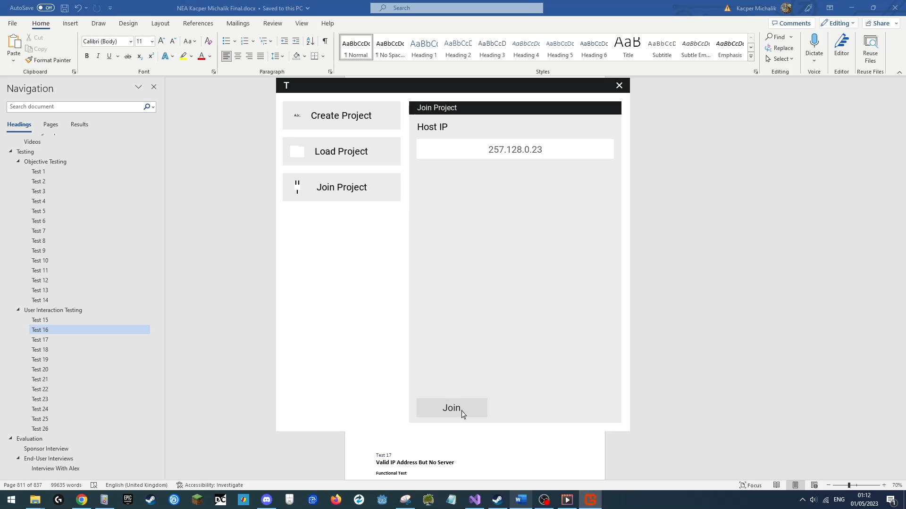The program should not attempt to use the IP as a valid one, and should tell us that the IP is invalid.

**Outcome**

|  |
| --- |
| **Success**  Error text was displayed in the IP input field and no connection was attempted; program continues normally. |

### Test 17

**Valid IP Address But No Server**

**Erroneous Test**

Link: https://youtu.be/99mkxludMUY

**Objective**

Users will commonly misinput values into fields, as such checking the validity of inputs is important to prevent runtime errors. The application already checks for invalid IP addresses, the next question then becomes, what happens if a valid IP is put in despite there not being a valid host at that IP. The application should normally try to connect to it but timeout and fail as expected, allowing the program to continue and the user to try another IP address with a potentially valid host.

**Test Method & Reproduction**

We will start the application, and go to the Join Project men screen, there we will type in “**127.0.0.1**”, and proceed to press the “Join” button, to connect to a server that isn’t running on our device. The program should attempt a connection, wait, timeout and then display to the user a failed a connection attempt, allowing the application to continue normally.

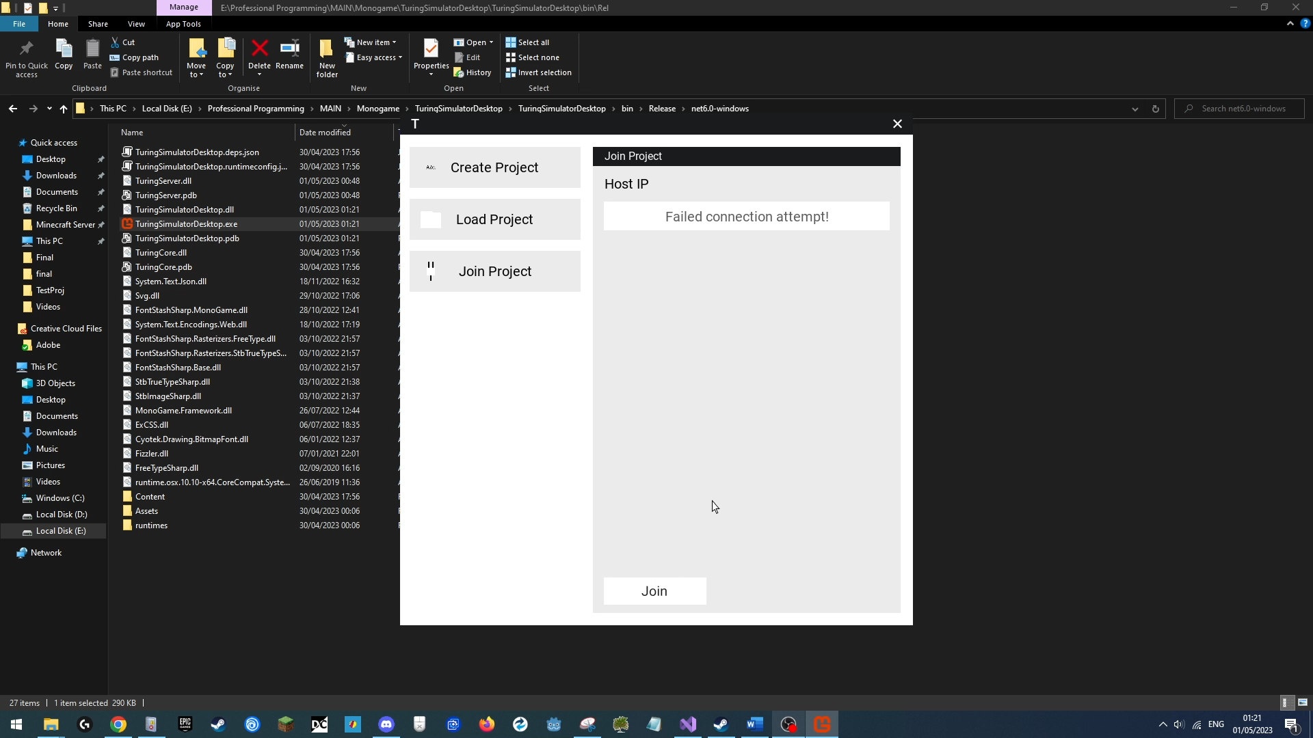

**Outcome**

|  |
| --- |
| **Success**  A connection was attempted, timed out, and an error was shown to the user; program continues normally. |

### Test 18

**Non Integer Client Count**

**Erroneous Data Test**

Link: https://youtu.be/SjBHIZak5zE

**Objective**

Users will commonly misinput non integer values into integer only fields, checking for or blocking non integer values as such is important to prevent runtime errors.

The user should not be able to type in non-integer values input the client field when creating a project and any successful attempts to do so should cause the field to be changed to a 1 on deselection.

**Test Method & Reproduction**

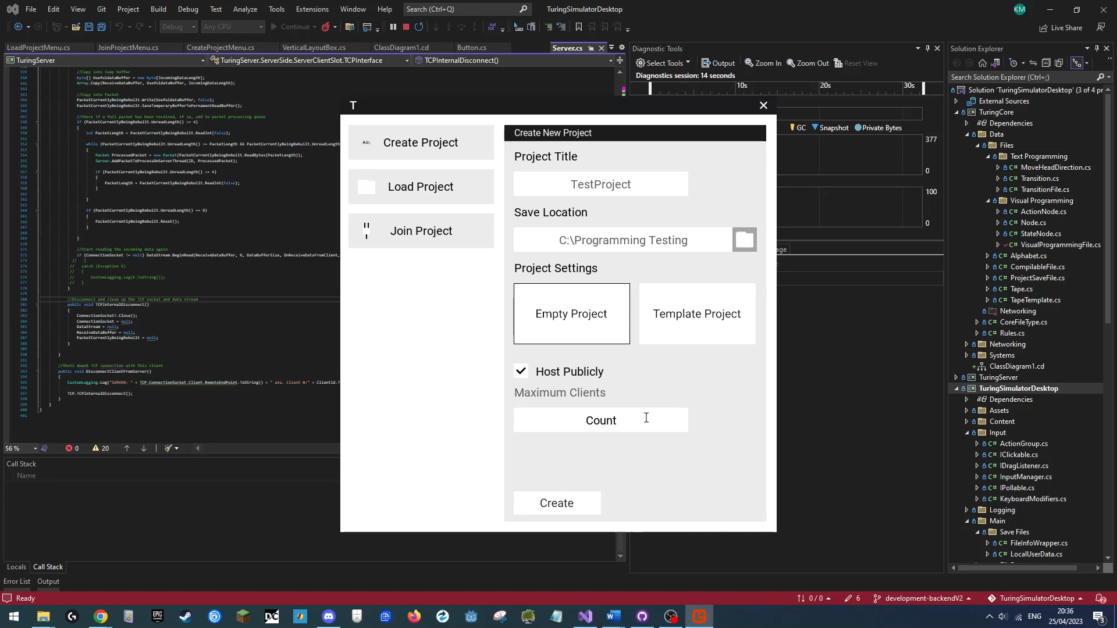The user will attempt to create a new project title “TestProject”, that is empty, and will enable hosting for the project, and attempt to input “**test**” number of clients, which should not actually be accepted by the input field, making it not be written to the field.

**Outcome**

|  |
| --- |
| **Success**  The user cannot type in symbols that are not integer values, and if they attempt to leave the count empty, it is filled with the number 1, program continues normally. |

### Test 19

**0 Client Count**

**Erroneous Boundary Data Test**

Link: https://youtu.be/vbQF2F292F0

**Objective**

A project cannot have 0 maximum clients, it must have at least 1, earlier we have tested for non-integer values been typed in, now we must consider boundary values.

The user will try to type in 0 max clients, and the interface should rectify this erroneous value by replacing it with 1.

**Test Method & Reproduction**

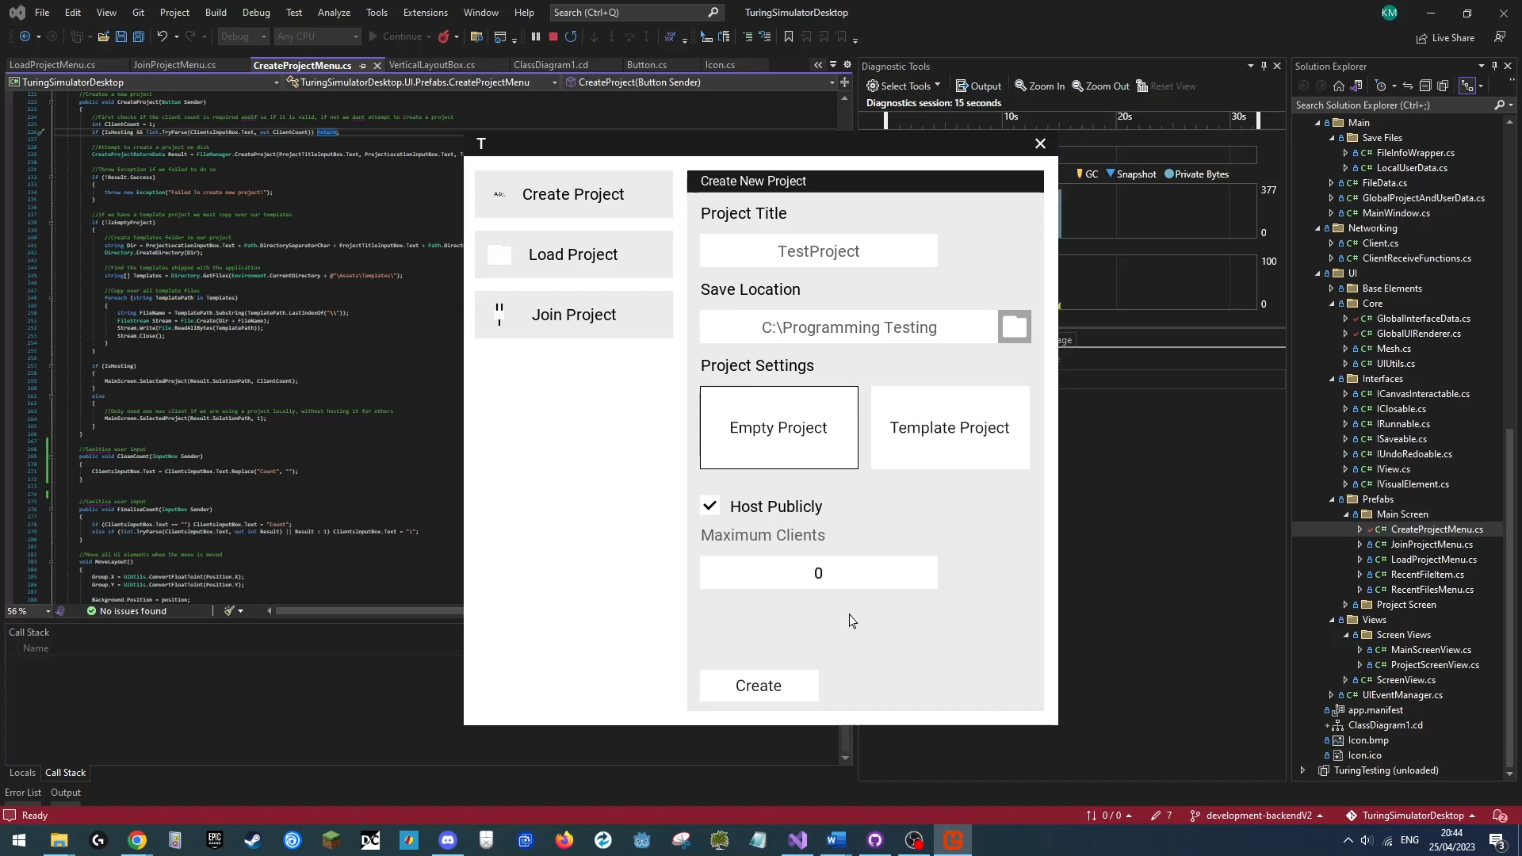The user will attempt to create a new project title “TestProject”, that is empty, and will enable hosting for the project, and attempt to input “**0**” number of clients, which on deselection of the input field, should be automatically corrected to “1”.

**Outcome**

|  |
| --- |
| **Success**  The program successfully corrected the users’ mistake, setting the max clients to 1, the minimum allowed value. |

### Test 20

**1 Client Count**

**Boundary Data Test**

Link: https://youtu.be/dWqoQ9QVZmo

**Objective**

This is the lowest valid number of clients to input in this field, this field automatically performs a variety of checks on inputs, so we must sure that it safely allows this input to pass since it is valid, where failing to accept a boundary value is a common bug in programs that check input.

**Test Method & Reproduction**

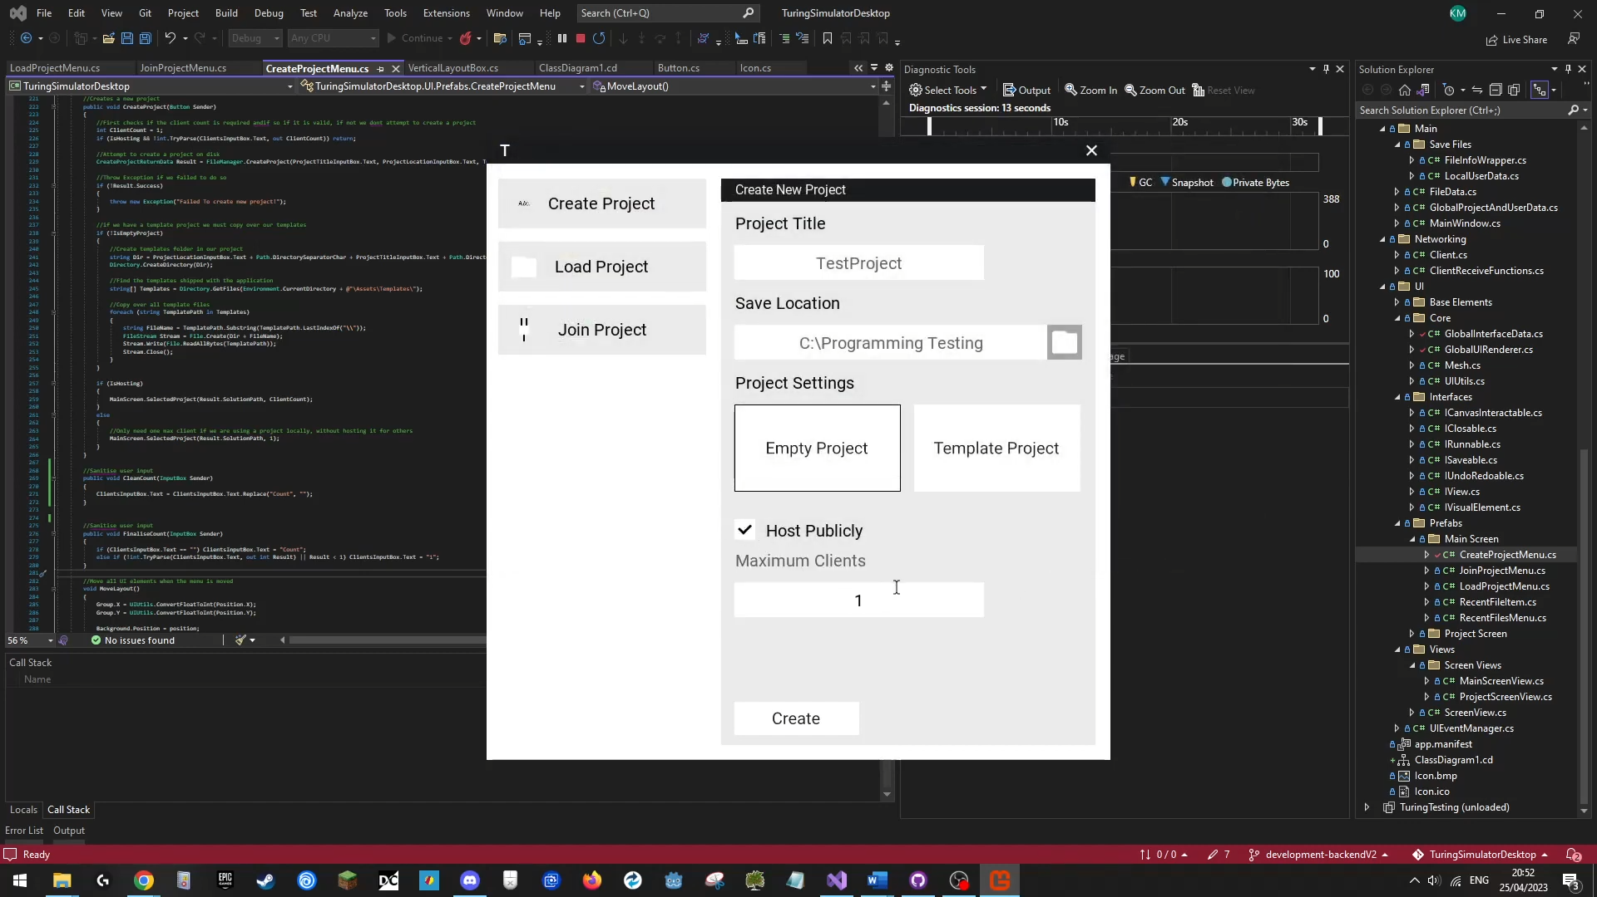The user will attempt to create a new project title “TestProject”, that is empty, and will enable hosting for the project, and attempt to input “**1**” number of clients, which on deselection of the input field, should remain the same, and allows us to start a project.

**Outcome**

|  |
| --- |
| **Success**  The program successfully accepts the users’ input and allows the user to create a project. |

### Test 21

**Executing Invalid Turing Program**

**Erroneous Test**

Link: https://youtu.be/JO2D6Mxsy6M

**Objective**

Users may try to program TM that is invalid, for example missing a necessary instruction, this kind of runtime error should be displayed to the user when a Turing Program is being executed.

A faulty program that is missing instruction will be run, when an error occurs, it should be displayed to the user and the application should continue running normally.

**Test Method & Reproduction**

We will first create a new template project titled “**InvalidTMProj**”. Next we will open an existing Turing Program that we know works, as shown in Test 5, and we will edit its state transition to a series of non sensical values – to states that don’t exist and to write values that are not part of the alphabet. See exact changes below:

(Before)

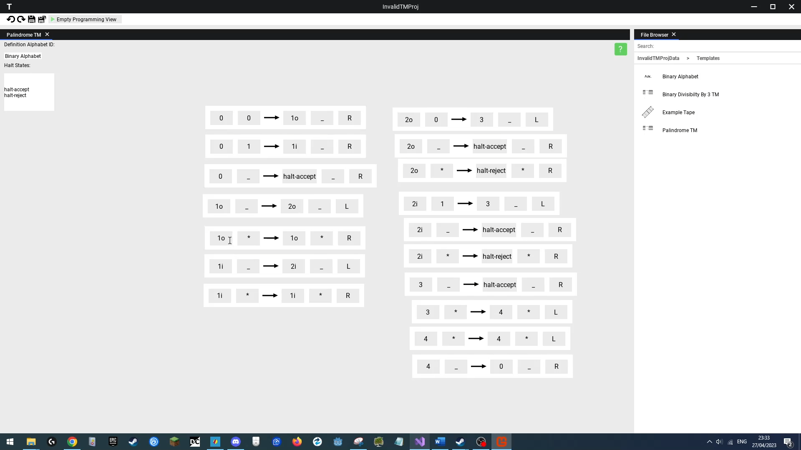

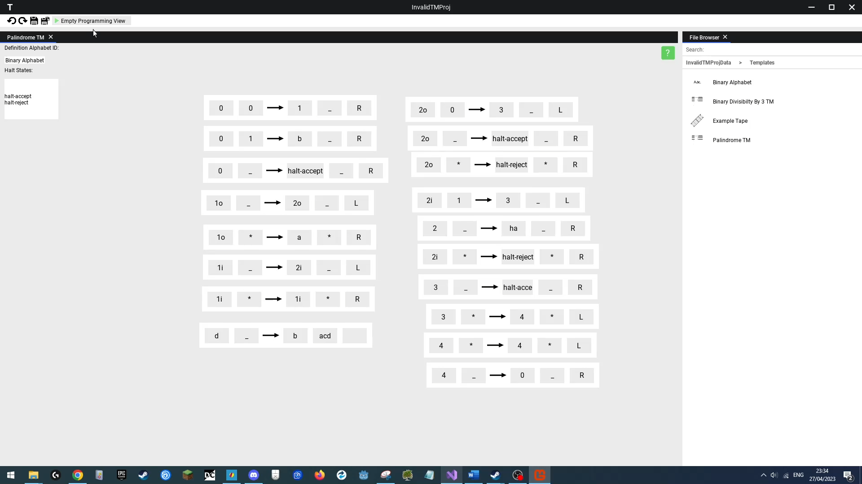(After)

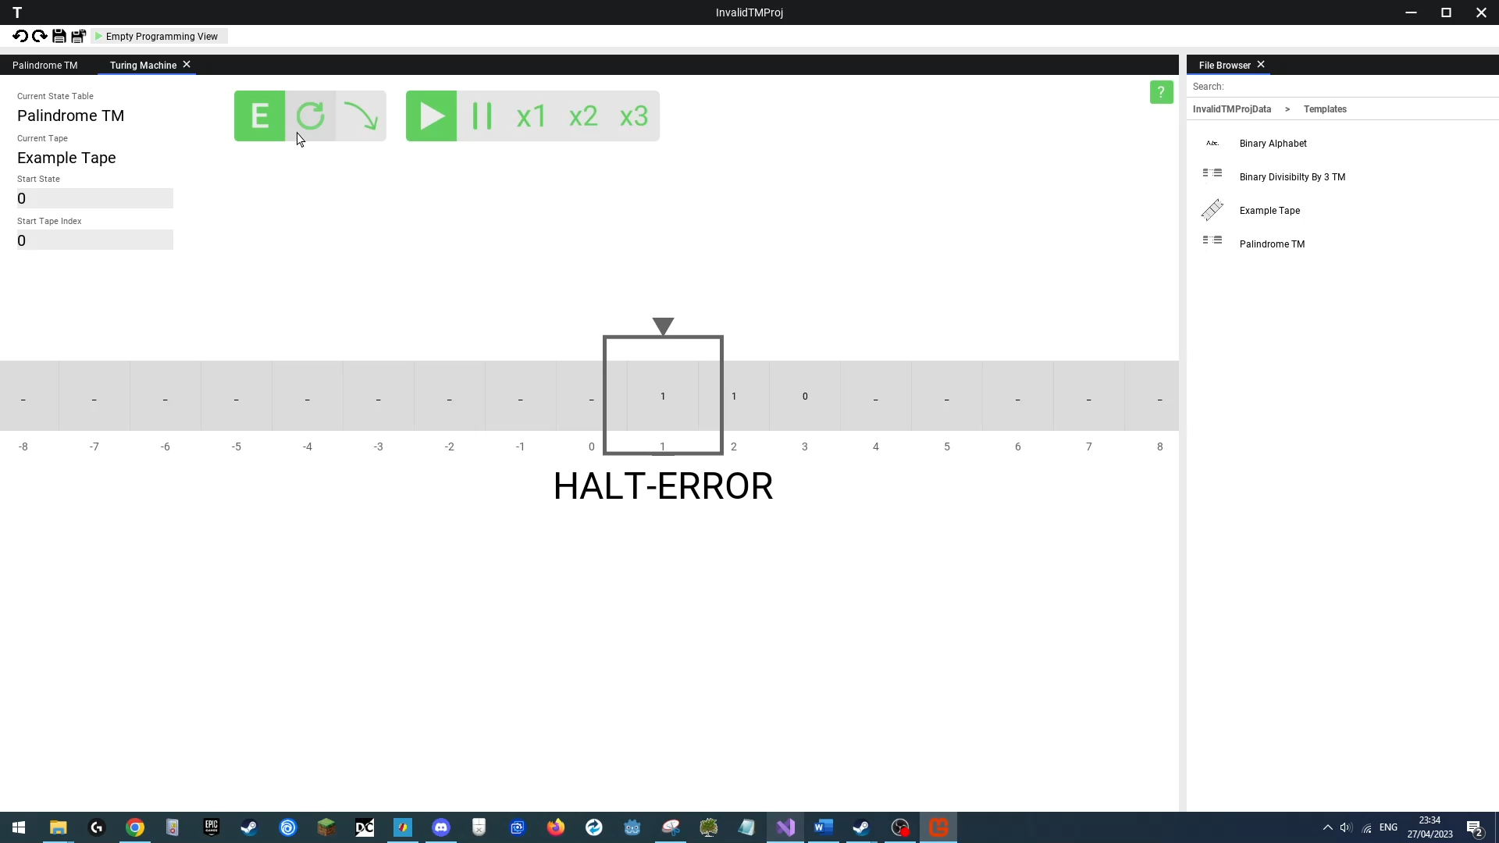We will then run this program, and at one point it will perform one of these broken state transitions, eventually being unable to find an appropriate transition for its current state (that didn’t previously exist, as such there is no state transition for), once this occurs the TM should display a “HALT-ERROR” state, indicating to the user there was an error with their program.

**Outcome**

|  |
| --- |
| **Success**  The TM in the Turing Simulation Window shows a “Halt-Error” state alongside its current position on the tape, showing the user a runtime error, the application continues normally. |

### Test 22

**Saving Invalid Alphabet**

**Erroneous Data Test**

Link: https://youtu.be/7lYZUtvrF5I

**Objective**

When defining an alphabet users may accidentally define the same symbol twice or miss out defining the symbols they placed as the empty and wild card symbols, the program should be able to handle this and collapse all characters to a single instance/add missing symbols to the definition list.

**Test Method & Reproduction**

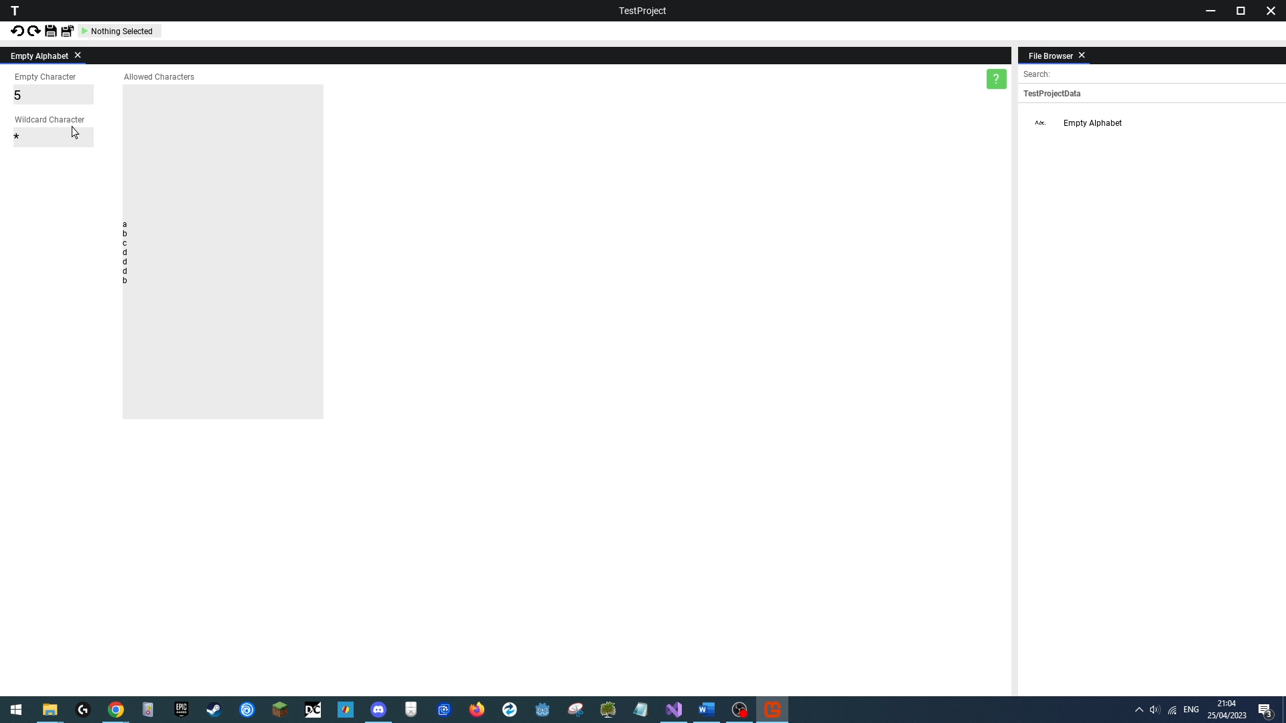The user will create a new alphabet within an empty project, and define the alphabet as **{a, b, c, d, d, d, b}**, set the empty symbol as **“5”**, leave the wildcard symbol as **“*”** and save the alphabet definition. The program should remove all repeated symbols (the repeats of “d” and “b”), leaving only one and should add the missing symbols “5” and “*” to the character definition set.

**Outcome**

|  |
| --- |
| **Success**  The program successfully corrected the users’ mistakes, adding missing symbols/deleting copies of symbols, and the application continued normally. |

### Test 23

**Invalid Drag & Drop Data**

**Erroneous Data Test**

Link: https://youtu.be/Izg5lJNKoYw

**Objective**

The user may attempt to drag in the wrong data into a window, for example dragging in an alphabet definition into a Turing Execution Window, which is not a file the window expects, the program should handle this by ignoring this irrelevant data, allowing the program to continue normally.

**Test Method & Reproduction**

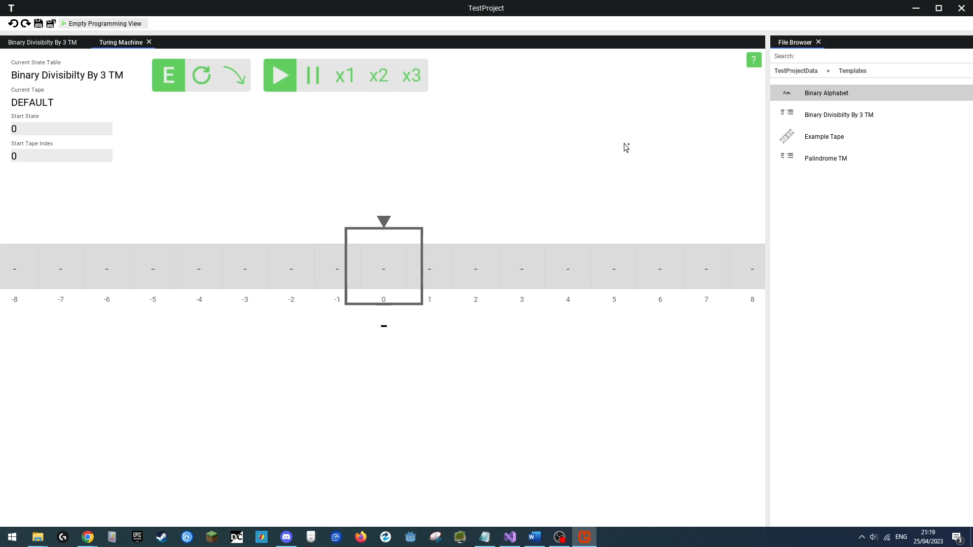The user will create a template project titled “**TestProject**”, open the “**Binary Divisibility by 3 TM**” state transition program and then click the run button. Once in the Turing Execution Window, the user will input the appropriate start state into the top left input field, and then will attempt to **drag and drop** the “**Binary Alphabet**” template alphabet definition file, twice, **into the Turing Execution Window** and the program should handle this incorrect file drag & drop by ignoring it, doing nothing, and continuing normally, allowing the user to then drag & drop a valid file, that being the “**Example Tape**” tape preset file, which loads in correctly in the Turing Execution Window.

**Outcome**

|  |
| --- |
| **Success**  The TM execution window successfully ignored the alphabet definition file and the application continued normally, allowing the user to drag & drop the appropriate tape preset file. |

### Test 24

**Client Attempts To Join Server With 1 Slot Left**

**Boundary Test**

Link: https://youtu.be/h55ruAuqpKU

**Objective**

The server host is able to set a maximum number of clients for their server, where the server will start to reject connection attempts once the server is full. We want to ensure that on the boundary condition where there is one slot left, the server does not falsely reject the clients connection to the server.

**Test Method & Reproduction**

We will open an existing project titled “**TestProj**”, with the hosting option enabled and client count set to **2**. We will then open a second application instance and attempt to connect to the server. The second client should successfully connect and be able to interact with the project server.

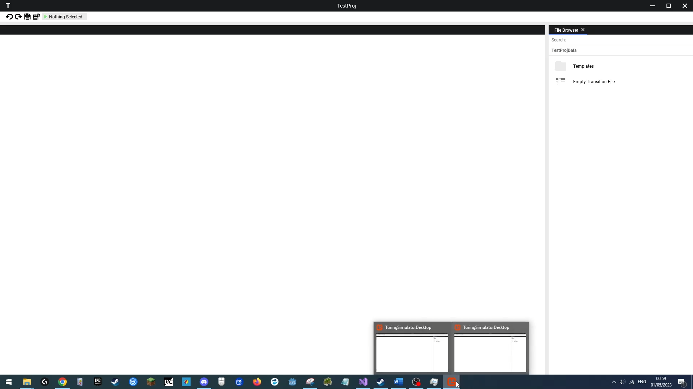

**Outcome**

|  |
| --- |
| **Success**  The server successfully accepted the connection attempt and continued normally, serving responses to our connected client. |

### Test 25

**Client Attempts To Join Full Server**

**Erroneous Boundary Test**

Link: https://youtu.be/Vs0OxpfkqY4

**Objective**

Users may sometimes try to join a server that they are not meant to – where the number of clients can be controlled by the server host setting a max client count. Once the user attempts to connect to a full server, the server should reject the connection attempt and both the server and client should continue normally, allowing the server to keep processing requests and the client can keep using the menu to try and connect to a different server.

**Test Method & Reproduction**

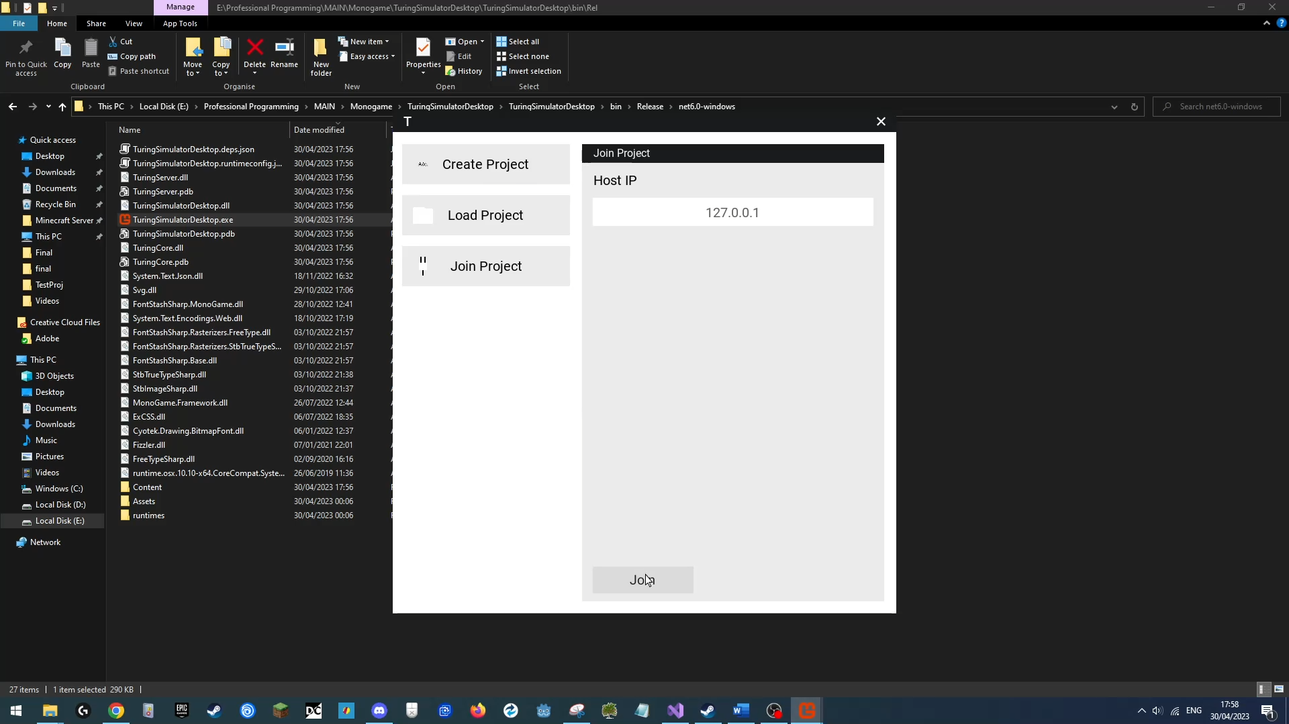In this test, we will load an existing project titled “**TestProj**”, and enable hosting on it, setting the max client count to **1**. The application instance that loads hosts this project should automatically connect to the server, filling this one slot, filling in the entire server. We will then launch a second instance of the application, go to the join menu and then try to join this hosted project using the localhost IP (“**127.0.0.1**”). The connection attempt should fail and both the server and client should continue normally, to show this we will then click through the main menu options through the unconnected client to show it is running normally, and then go to the connected application instance and interact with the project by opening some files to show the server is still functioning normally.

**Outcome**

|  |
| --- |
| **Success**  The server successfully rejected the connection attempt and continued normally, serving responses to our connected client, while the client that attempted to connect after being rejected was able to continue using the main menu normally. |

### Test 26

**Client Disconnects Unexpectedly**

**Erroneous Test**

Link: https://youtu.be/oy0ngaExB_k

**Objective**

Users may sometimes have their application shut down improperly, without performing appropriate disconnection/TCP shutdown code, be it if their device runs out of power, they internet connection or the user end tasks the application. We need to ensure the server properly handles an unexpected disconnection from a client.

**Test Method & Reproduction**

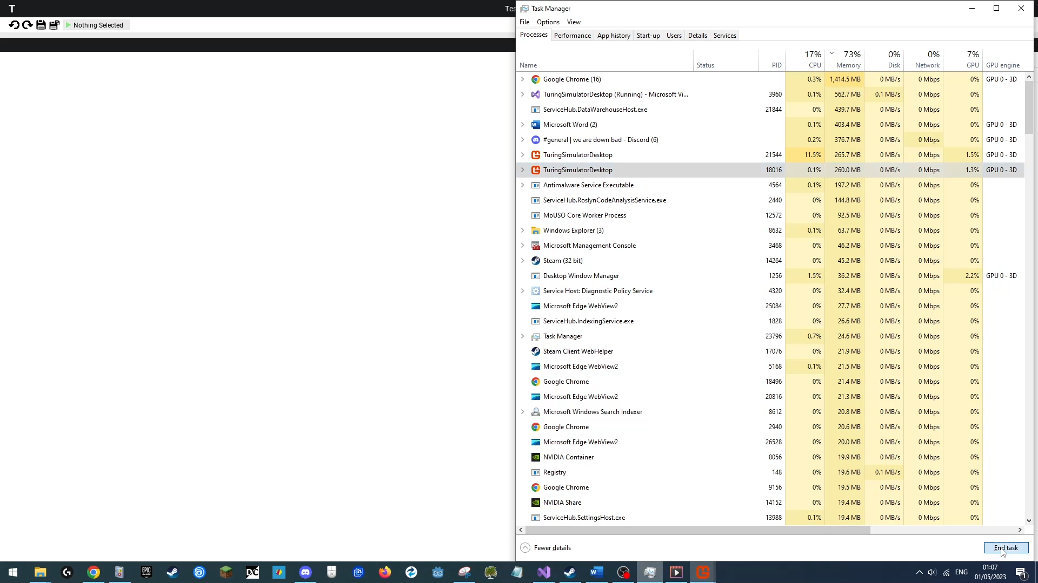In this test, we will load an existing project titled “**TestProj**”, and enable hosting on it, setting the max client count to **2**. The application instance that loads hosts this project should automatically connect to the server, filling this one slot. We will then launch a second instance of the application, go to the join menu and then join this hosted project using the localhost IP (“**127.0.0.1**”). Once we are connected, we will go to task manager and shut down the non-hosting application instance. Following this we will go back to our application instance that is still running, and try opening the template files contained within to ensure the server is still functioning normally and responding to requests.

**Outcome**

|  |
| --- |
| **Success**  The server successfully continued normally, serving responses to our connected client, after another client disconnected unexpectedly. |

### Test 27

**Invalid Packet Sent**

**Erroneous Test**

Link: https://youtu.be/CPIiA3IcApE

**Objective**

One of the important considerations of the projects networking system was security and reliability. Should a client send an invalid or malicious packet, the server should be able to drop the packet and continue functioning normally. In this test we will send an incorrectly formatted packet, where we will send a packet with only half of the required header information and nothing more.

**Test Method & Reproduction**

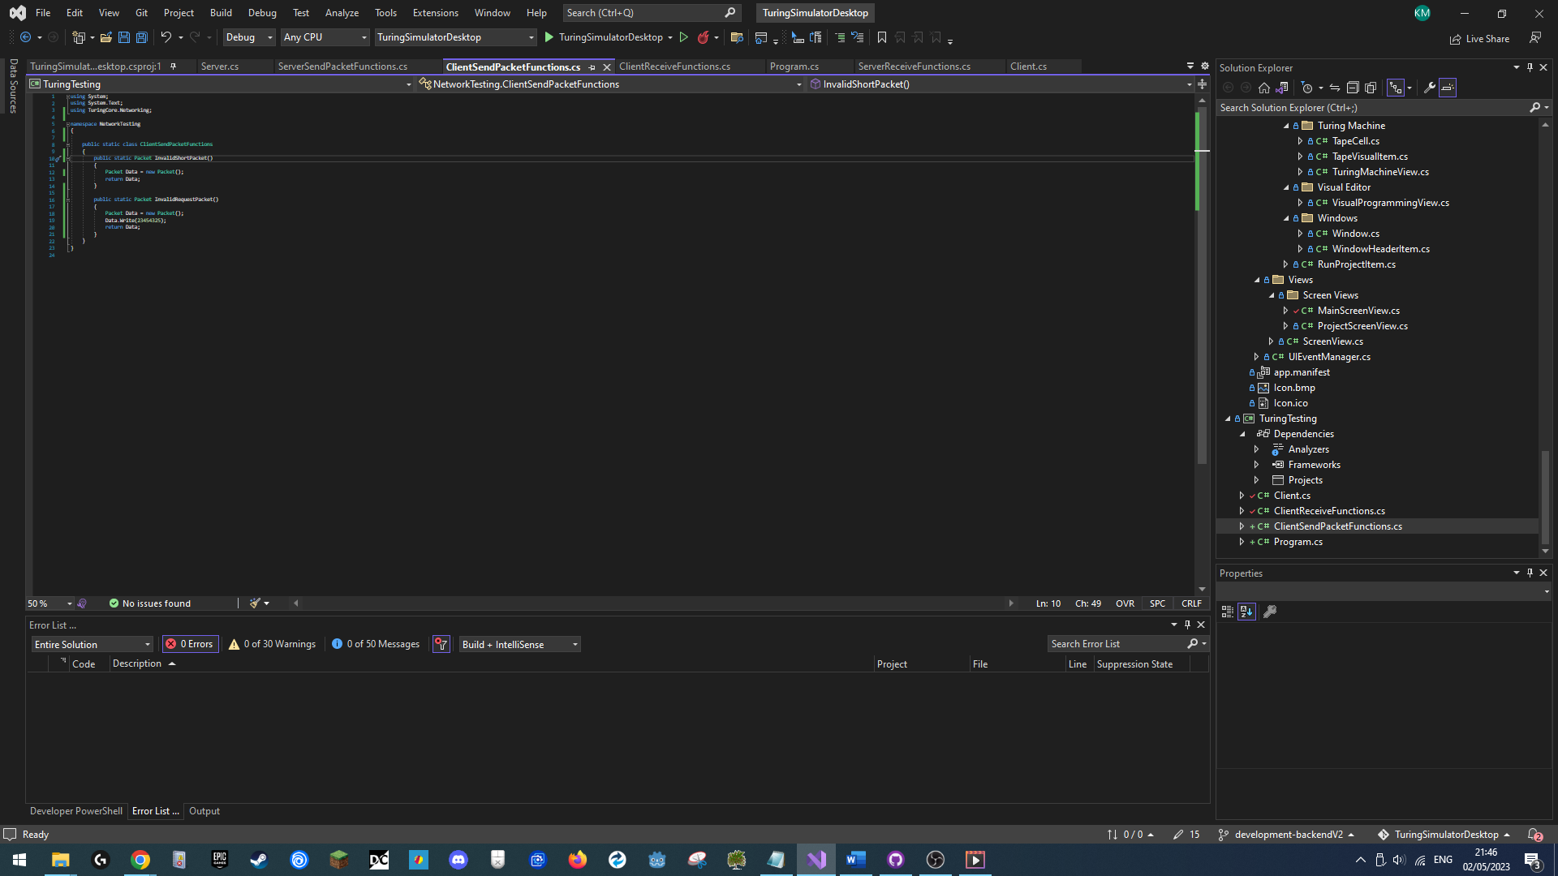A program was written that would submit invalid packets to the server:

We used our application to create and host a new template project titled **“CorruptPacketTesting”**, with a max client count of 2. We then connected to the host with our console application and send a request for packet that only contained no request type or any other data, having only a length in its header.

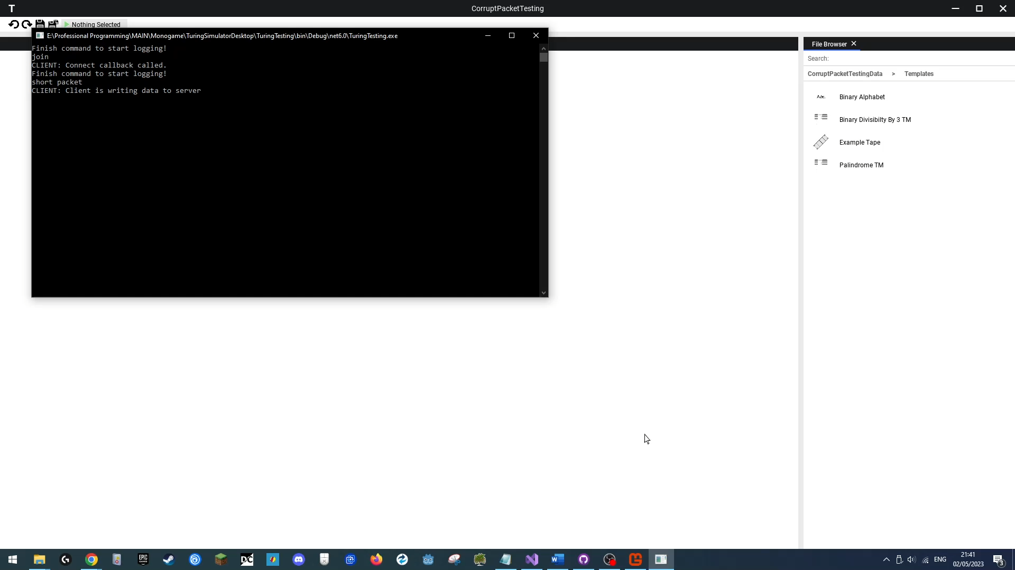

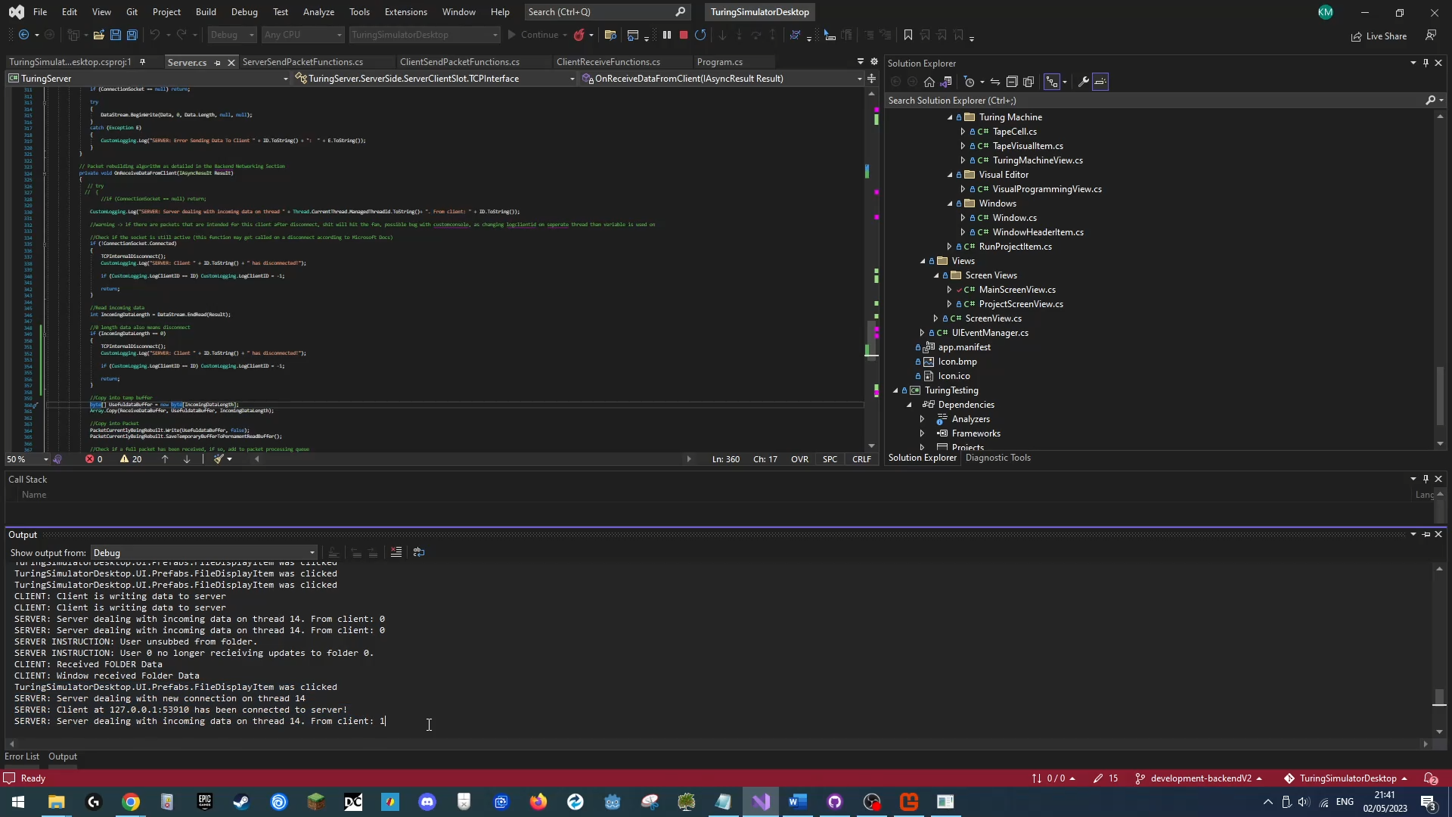Seeing the debug log from the program, we can see the packet weas received but ignored after processing:

We then will test the program to see if it continues normally and allows us to keep interacting with it, which would signify the server is still working normally.

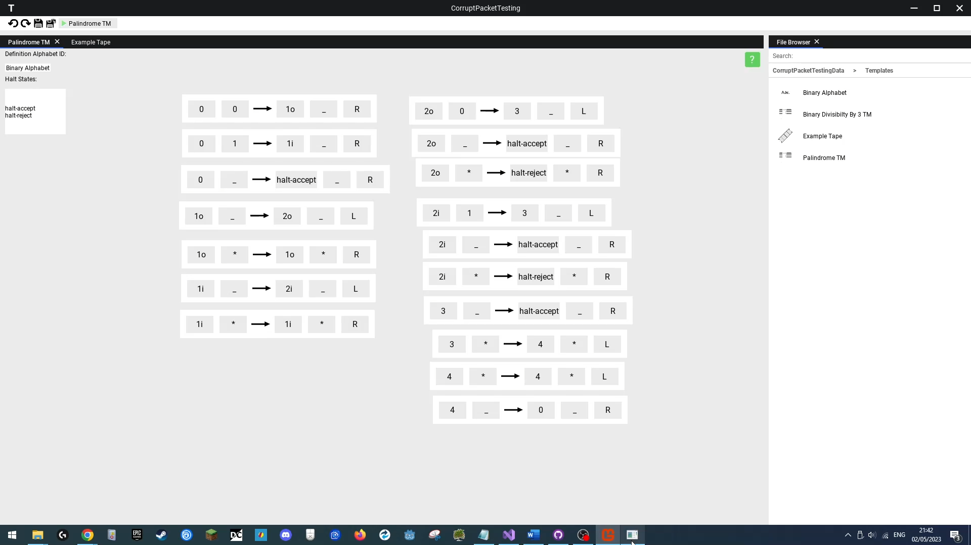

**Outcome**

|  |
| --- |
| **Success**  The server ignored the packet and continued working normally, allowing us to keep interacting with the loaded project. |

### Test 28

**Invalid Packet Sent 2**

**Erroneous Test**

Link: https://youtu.be/pvWusYtuw2I

**Objective**

One of the important considerations of the projects networking system was security and reliability. Should a client send an invalid or malicious packet, the server should be able to drop the packet and continue functioning normally. In this test we will send an incorrectly formatted packet, where we will send a packet with a request type that does not exist.

**Test Method & Reproduction**

We continued the same host and client instance from the previous test. (See test 27). Now we used the client to send a second invalid packet, this one containing a request type that doesn’t exist.



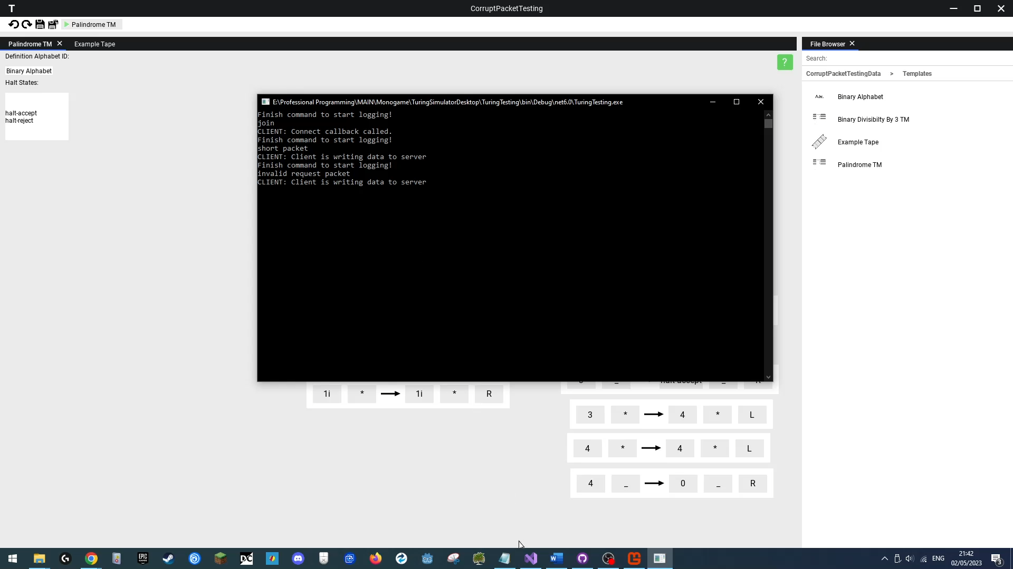

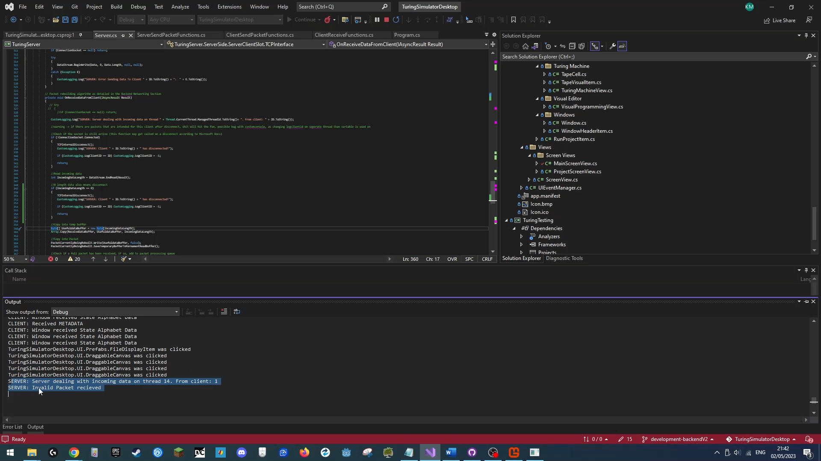**S**eeing the debug log of the application, we will be able to see if the recieved valid was invalid:

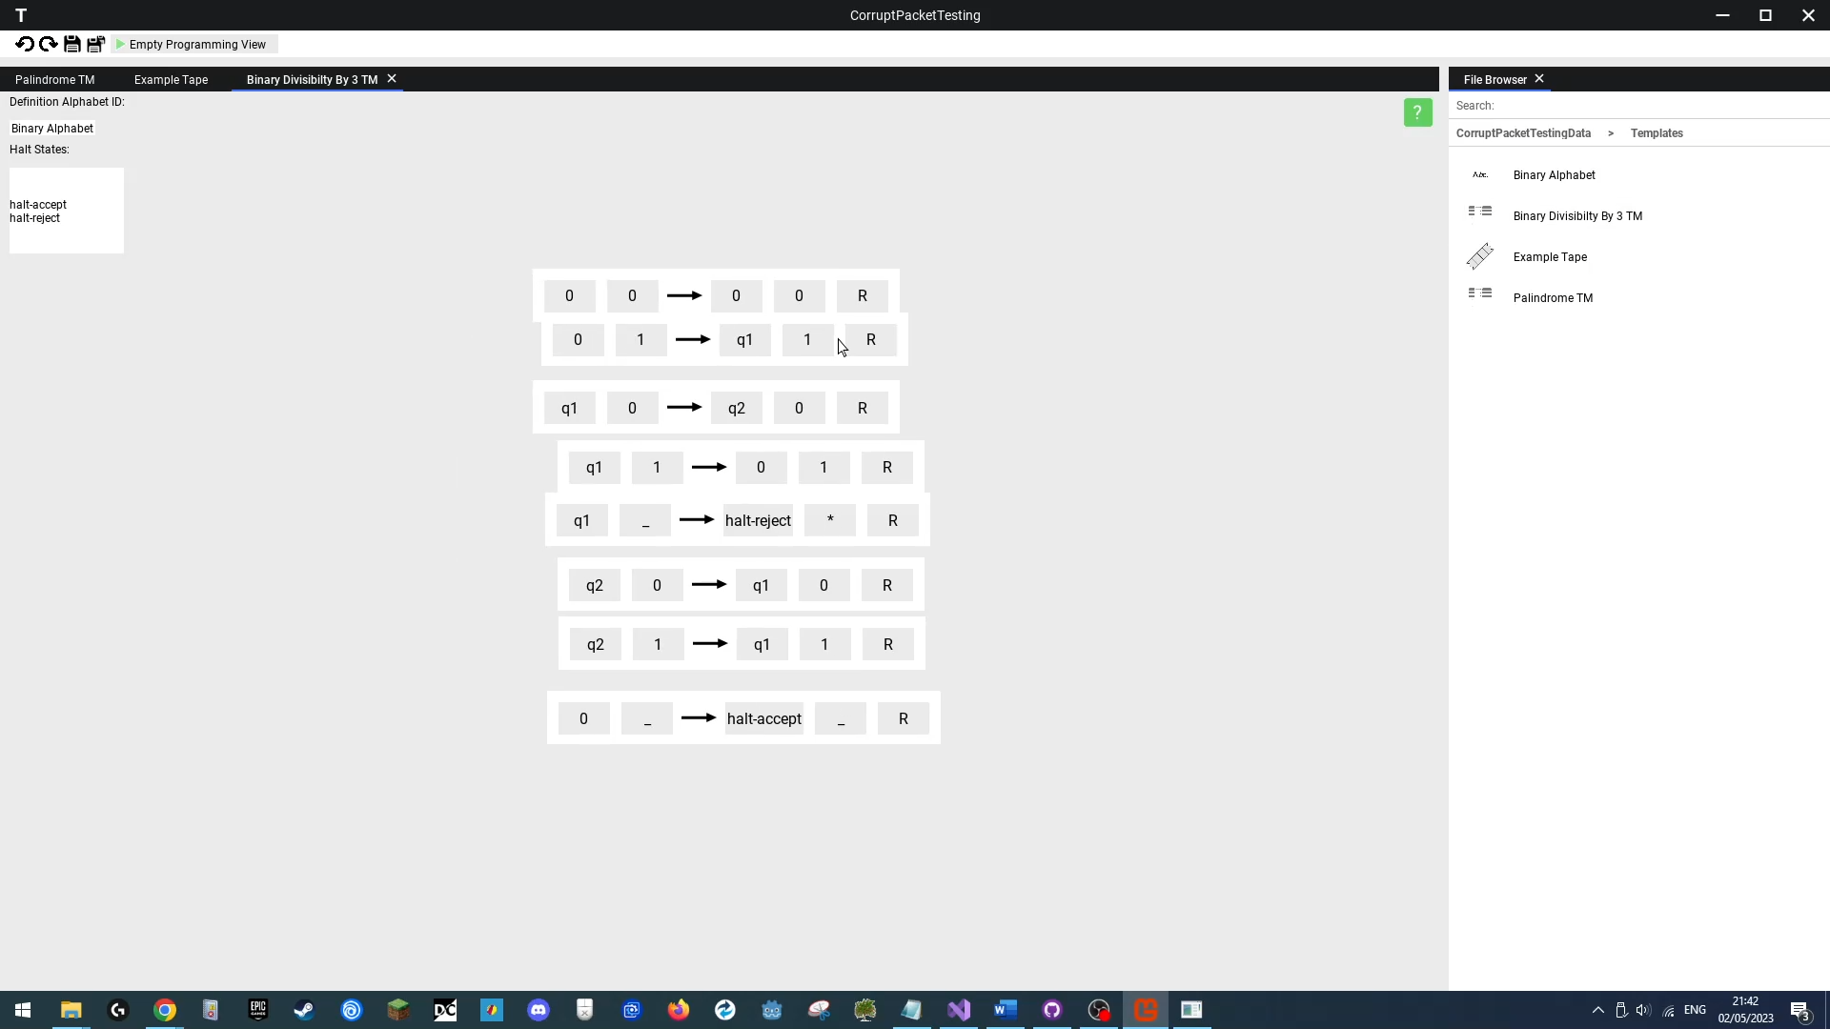We then will test the program to see if it continues normally and allows us to keep interacting with it, which would signify the server is still working normally.

**Outcome**

|  |
| --- |
| **Success**  The server ignored the packet and continued working normally, allowing us to keep interacting with the loaded project. |

### Test 29

**Old Update Packet Sent**

**Erroneous Test**

Link: https://youtu.be/e6nHmub5ZiI

**Objective**

One of the important considerations of the projects networking system was security and reliability. Should a client send an invalid or malicious packet, the server should be able to drop the packet and continue functioning normally. In this test we will send a correctly formatted update packet, but will send it saying it is updating an older version of the file, which is not allowed.

**Test Method & Reproduction**

First we ex pended the program from tests 27 & 28, to also now be able to send a valid update packet.

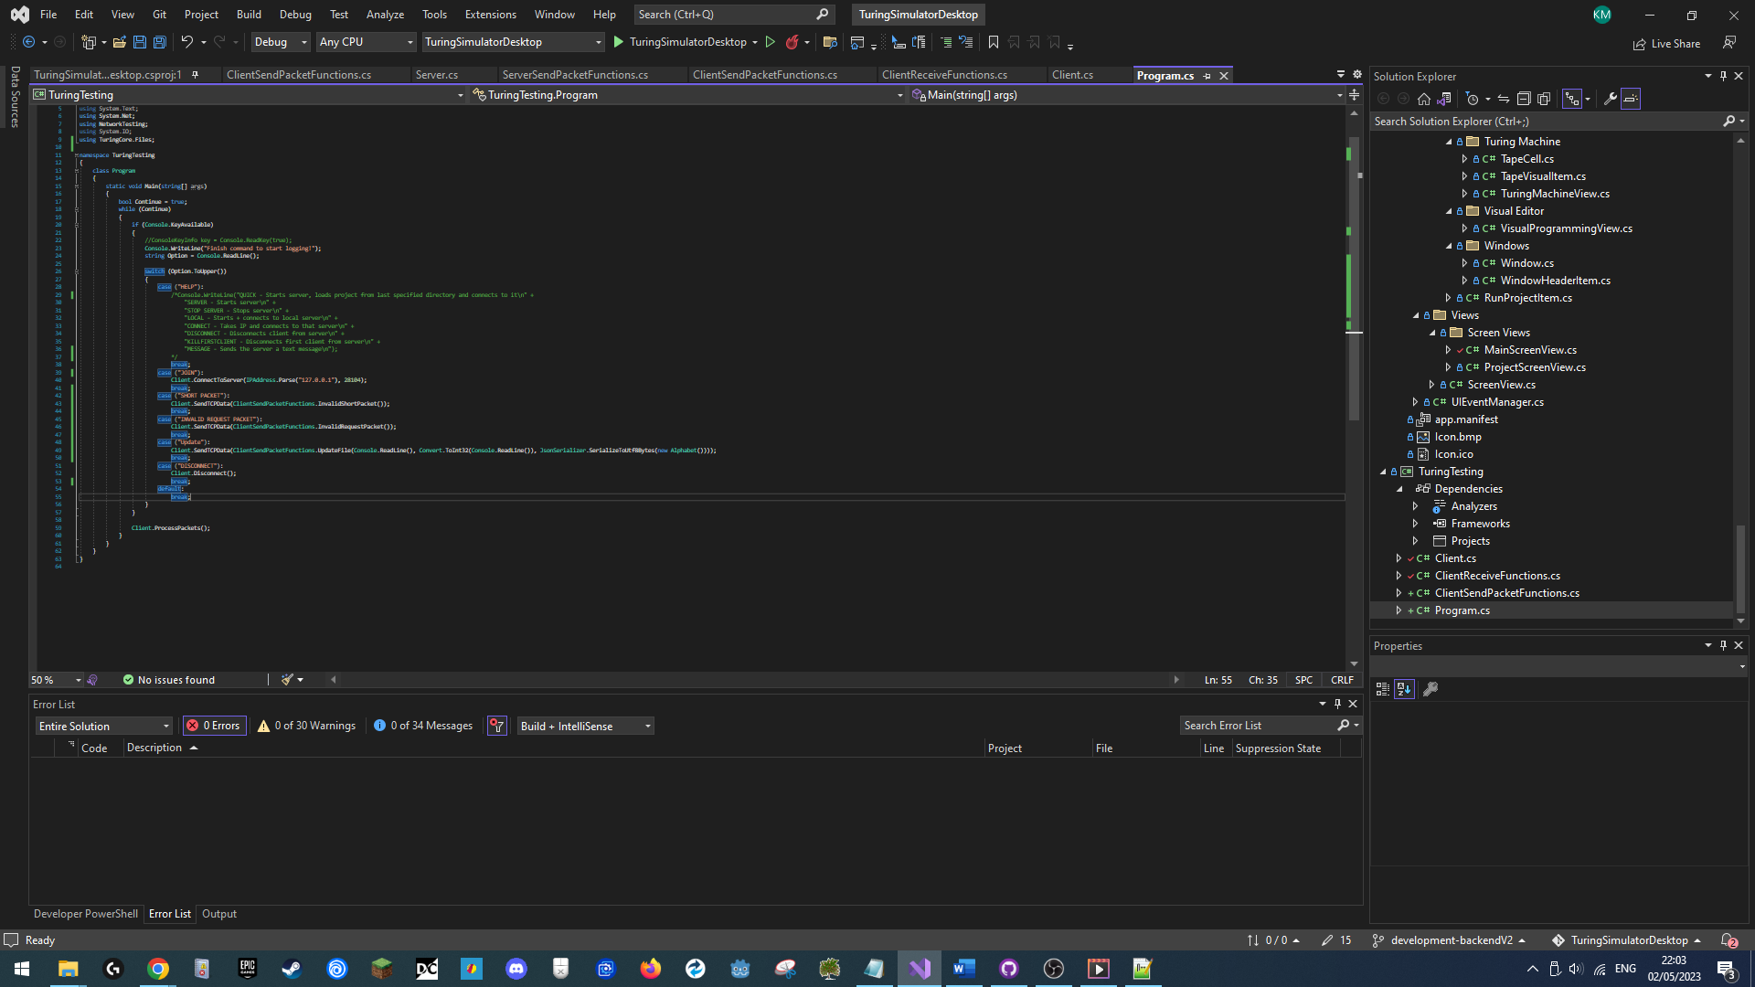

Next, we loaded up the previous project “”**CorruptPacketTesting**”, to verify it was in working order, after having it successfully boot, we went and searched using file explorer for the folder containing the templates files included in the project.

We will try to update our “**Binary Alphabet**” file, first using an invalid “old” update packet, which the server should reject and log, then we will try updating the file using a valid packet to verify the update system still works.

Once we locate the “Binary Alphabet” file using file explorer, we open the associated metadata file and copy the files GUID, and will use that as part of the data in the first packet we will send.

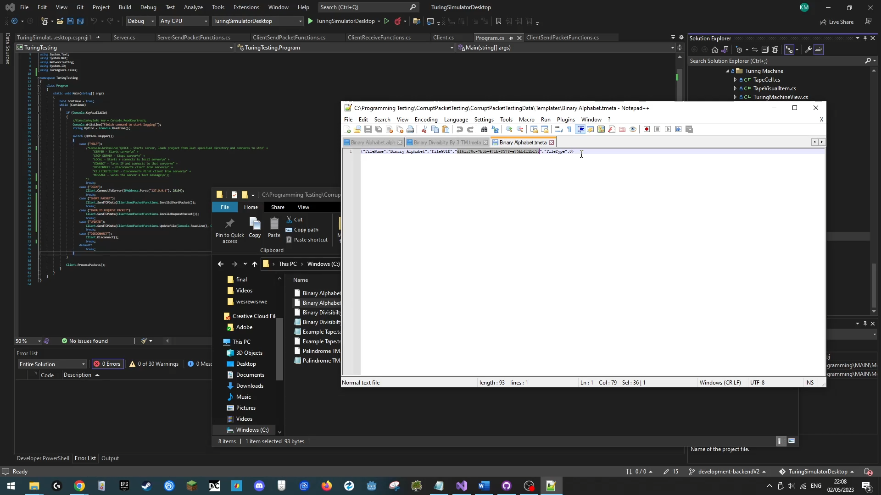

Now that we have the GUID in our clipboard, we launch our application and host the project with a max client count of 2, and then use our testing console app to connect to the server as an additional client.

Once connected, we will send our first update packet, an invalid old update packet, where ewe will set our arguments as such:

Target File GUID : “df61a80c-7b5b-471b-8573-e75bbff2b156”

Current File Version: “2”

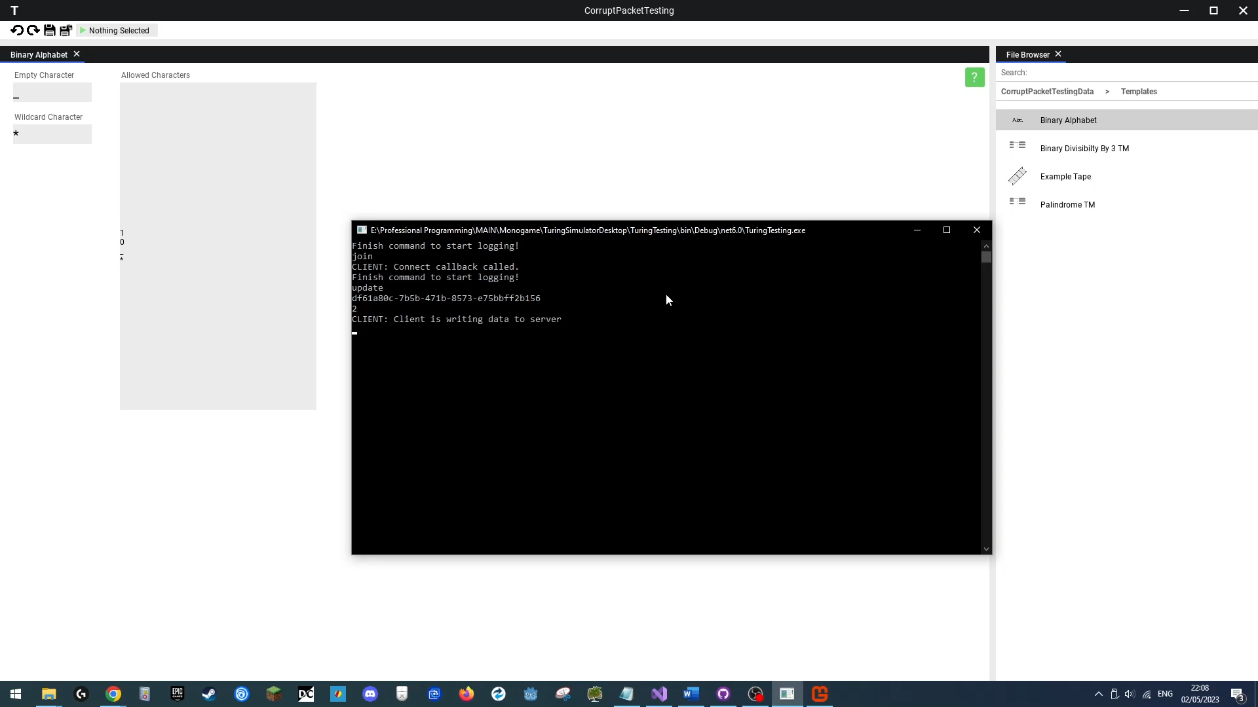The packet will try to update the current alphabet with an empty one.

Once the server receives the update file, it should see it is invalid, as the current file version is “1” (on boot all files have a file version of 1), and reject the update, which would result in this being logged and us seeing no changes to the alphabet.

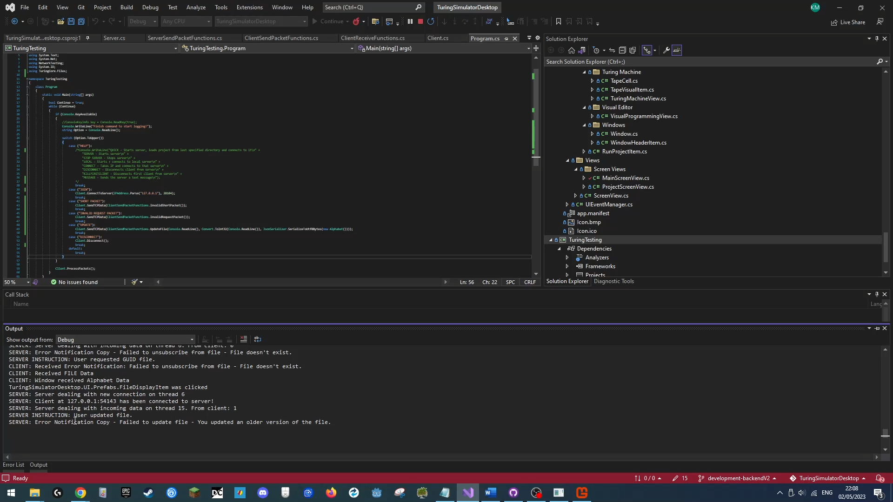

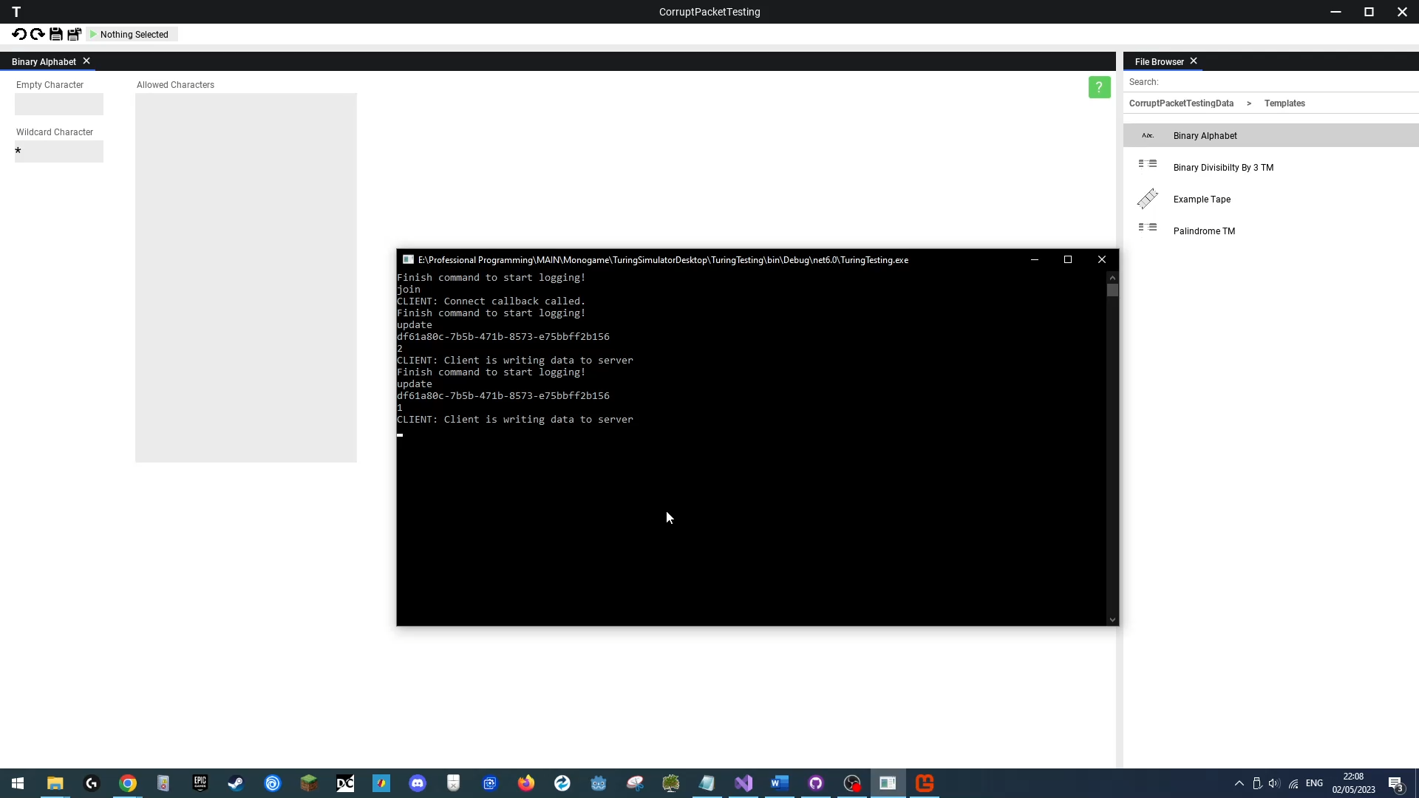We will then send the exact same packet but with a file version of “1” instead of “2”. The server should see this as valid and update the alphabet file with an empty one, which is the updated version in this test.

**Outcome**

|  |
| --- |
| **Success**  The server processed the packet, checked it was for an outdated file, rejected the update, notified the sender, and continued functioning normally allowing us to update the file with thew correct file version. |

### Test 30

**Loading Corrupt Project**

**Erroneous Data Test**

Link: https://youtu.be/5XMuuEPWp0M

**Objective**

Any file on disk has the risk of being in some capacity corrupted at some point, should a user try to load such a corrupted file, the application should not crash, but instead simply not load the project, and allow the user to try loading another one.

**Test Method & Reproduction**

In this test, we create a new template project titled “**CorruptProj**”. After is created and loaded, we will open a file to see it has been created correctly. Next we will shut down our application and find the created project solution file. There we will open the main project file, and alter it to become corrupted:

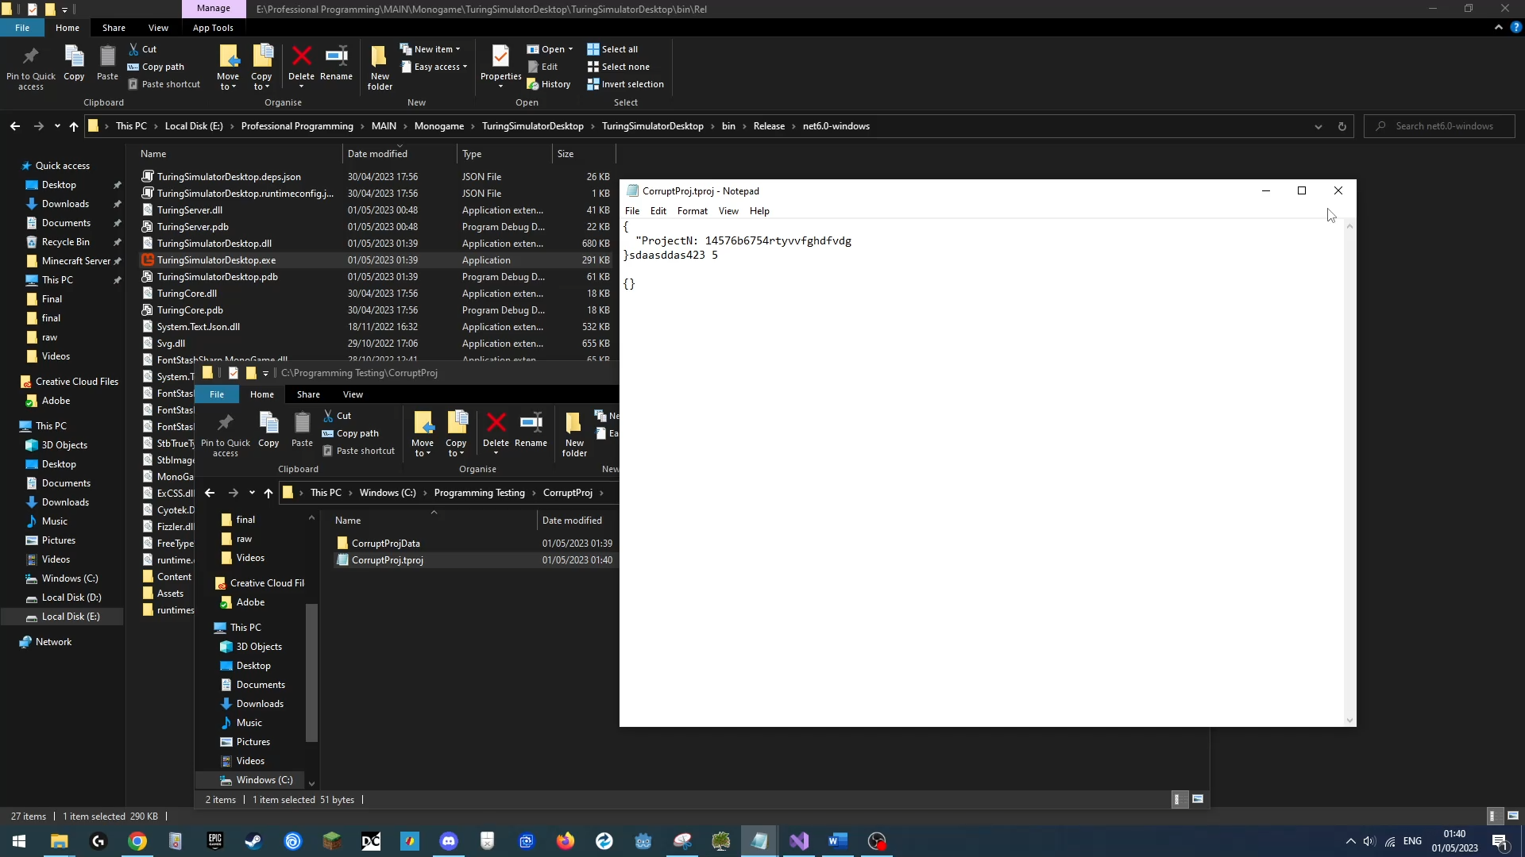

We will now save this file. Next we will run our application again, and first use the recently loaded files menu to try loading the corrupt project. Clicking on the project button should make nothing happen, and allow the application to continue normally.

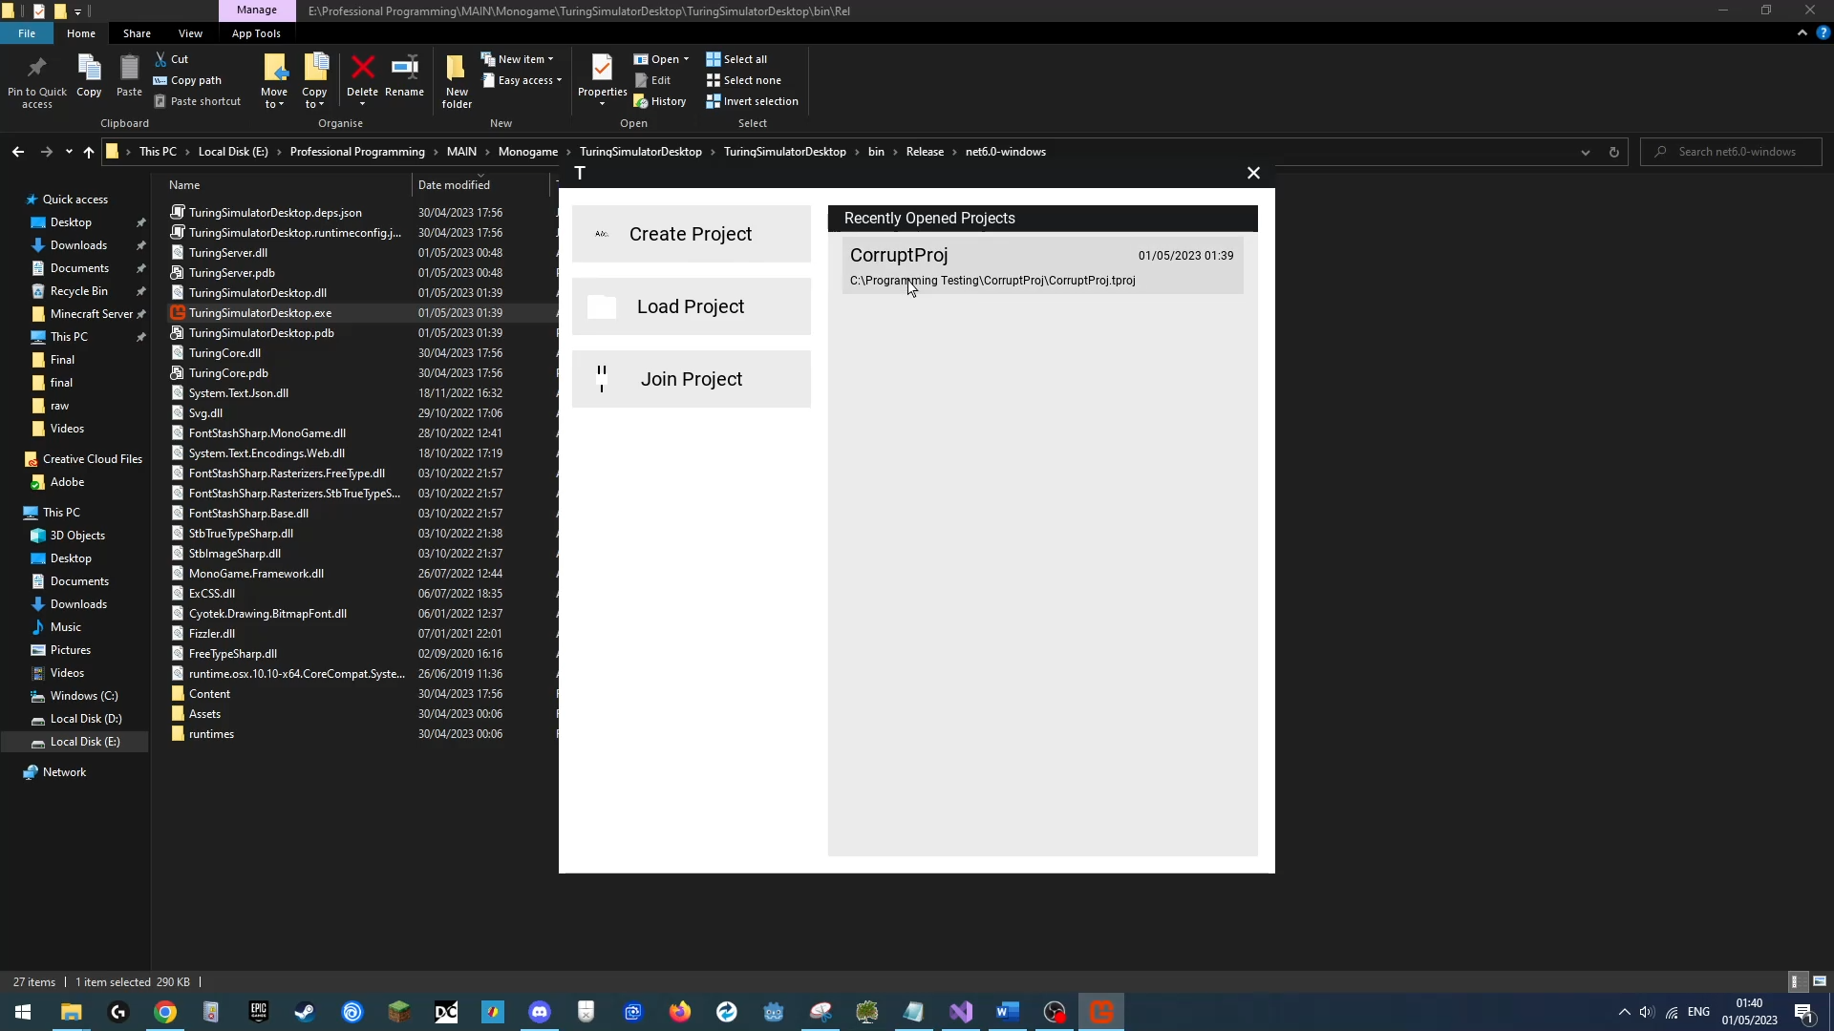

Next we will try using the load menu to load the project, there clicking load should again yield no result, allowing the application to continue normally.

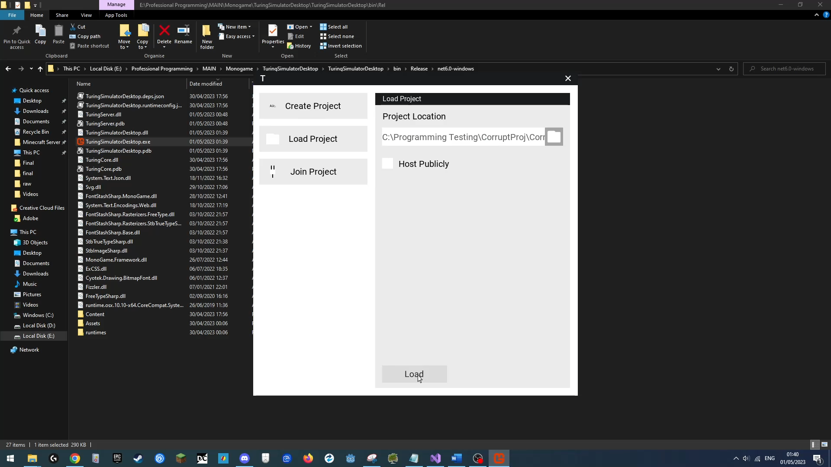

**Outcome**

|  |
| --- |
| **Success**  The application did not load the corrupt project and successfully continued normally. |

### Test 31

**Loading Corrupt Files**

**Erroneous Data Test**

Link: https://youtu.be/wjefsHv5eis

**Objective**

Any file on disk has the risk of being in some capacity corrupted at some point, when a user tries to load a valid project, should certain files within the project be corrupt, those files shouldn’t stop the rest of the project from being usable, as such the program should ignore invalid files, and allow the user to use the rest of the project normally.

**Test Method & Reproduction**

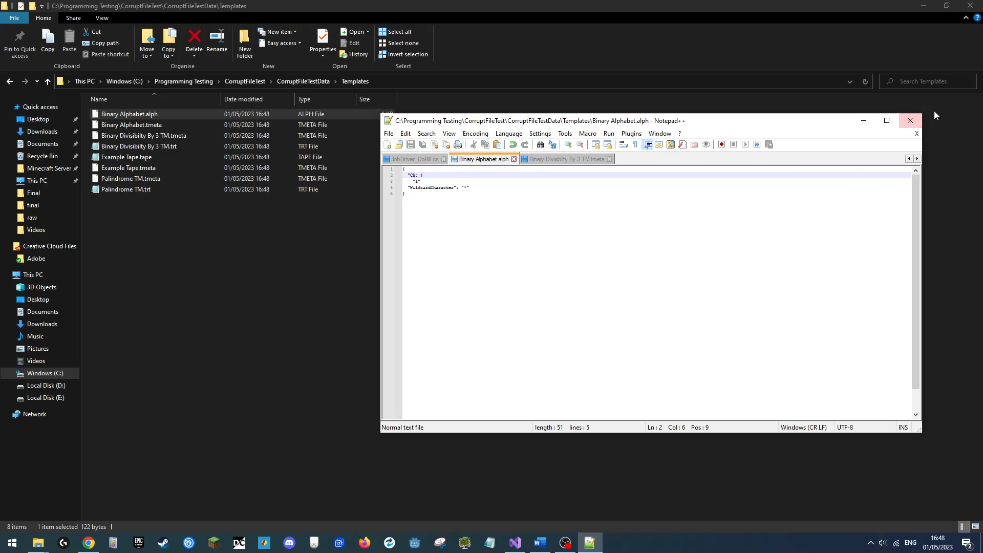In this test, we create a new template project titled “**CorruptFileTest**”. After is created and loaded, we will open a file to see it has been created correctly. Next we will shut down our application and find the created project solution folder. There we will open the data and alter two files. For the first file, “**Binary Alphabet**” , we will **corrupt** the contents of the **JSON object file**. For the second file, “**Binary Divisibility By 3 TM**”, we will alter and **corrupt** the **metadata** **file**:

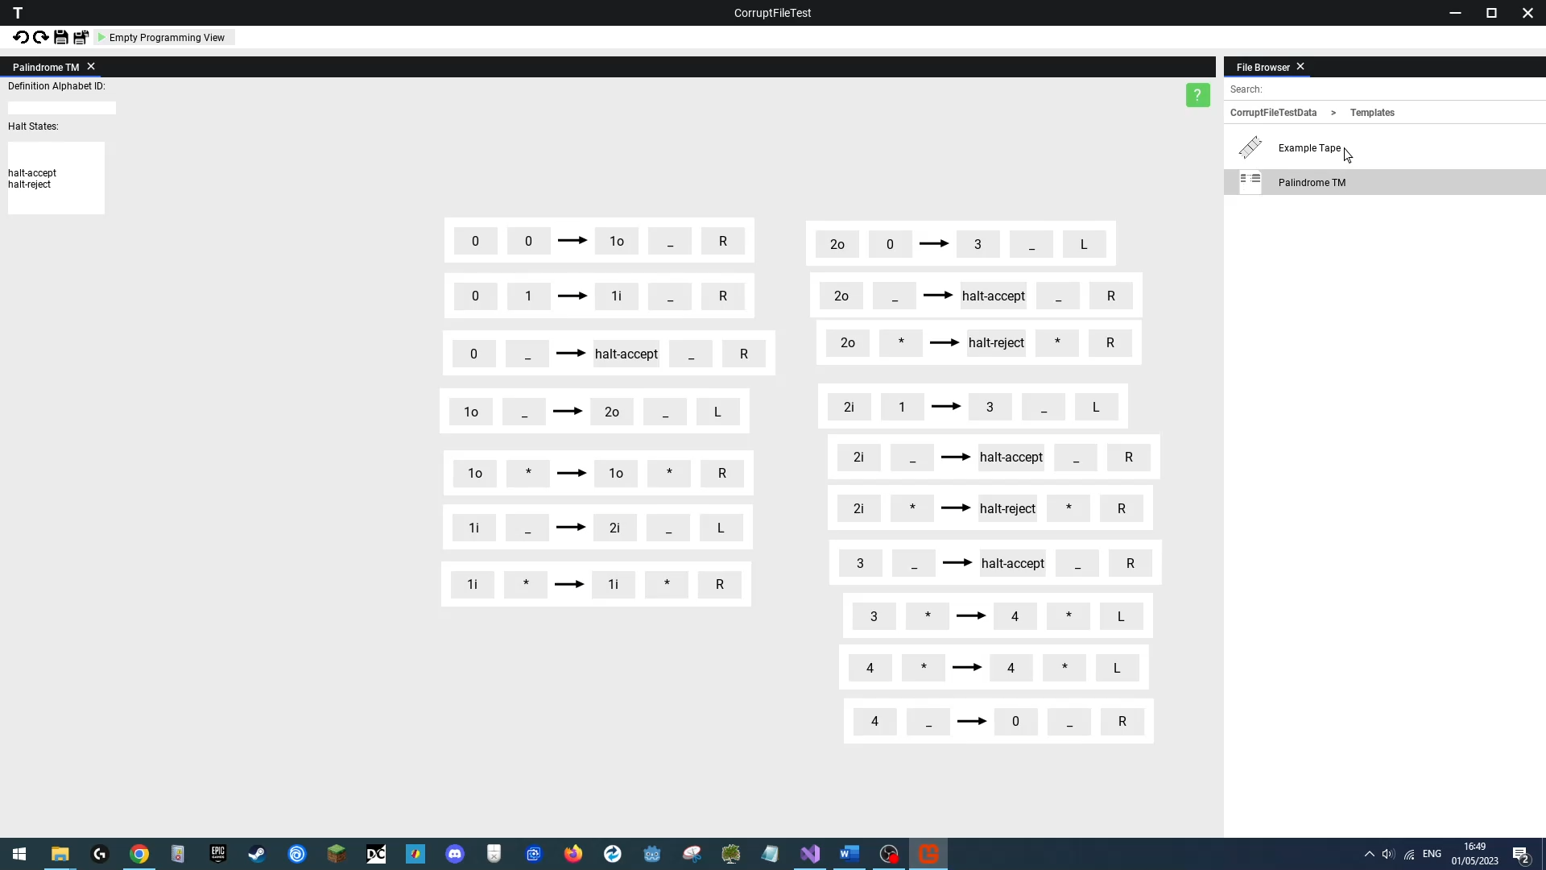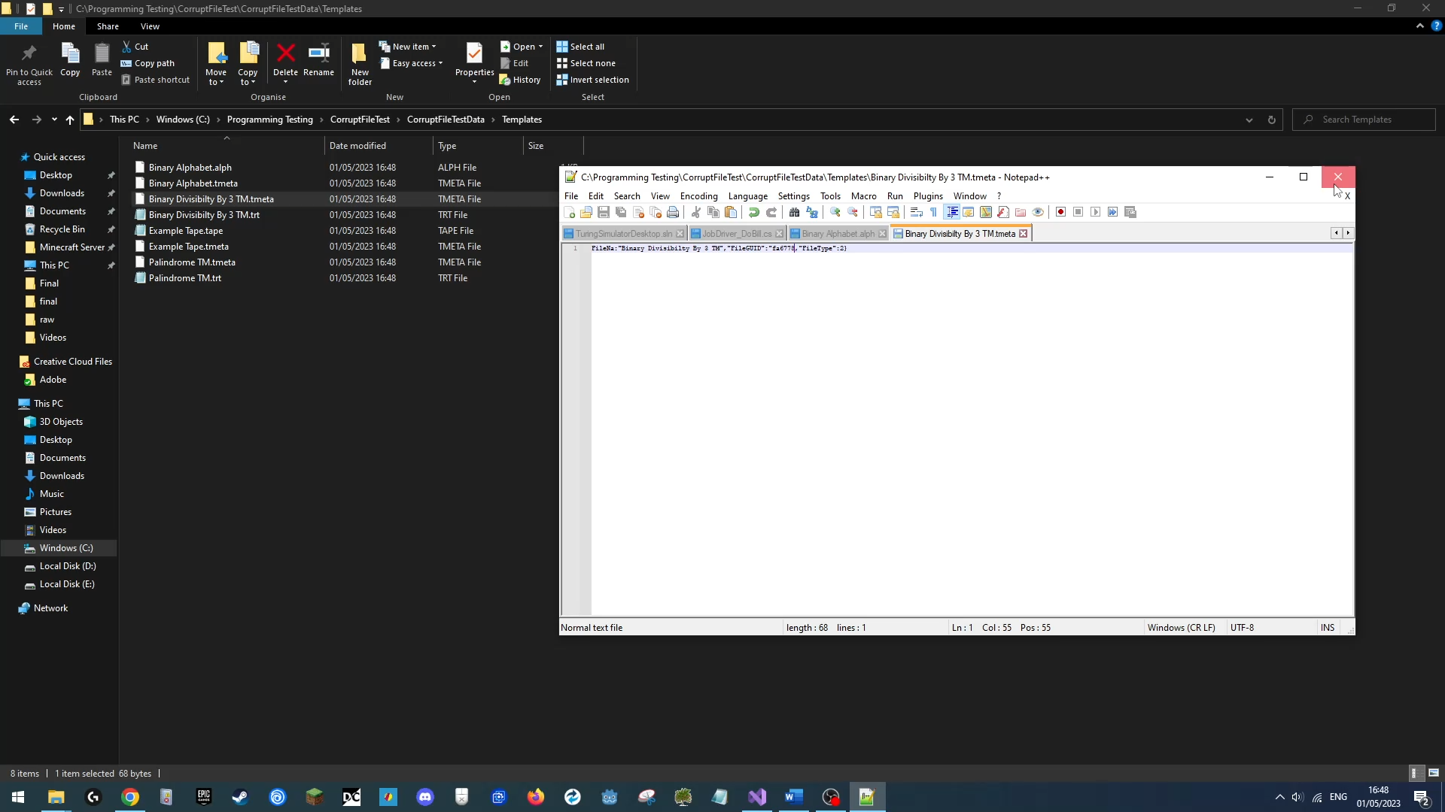Next we will launch our application again, and reload the project. The application should the project, and skip the two corrupt files, letting us use the remaining two “**Example Tape**”, “**Palindrome TM**” files.

**Outcome**

|  |
| --- |
| **Success**  The application successfully loaded the project, loading only non-corrupt files. |

### Test 32

**Loading Corrupt Local User Data**

**Erroneous Data Test**

Link: https://youtu.be/oWJdyKN6UX4

**Objective**

Any file on disk has the risk of being in some capacity corrupted at some point, when a user tries to load the application, should the user data file be corrupt or inaccessible, that file shouldn’t stop the application from being usable, as such the program should simply not load the corrupt local user data, overwrite it with a valid version, and allow the user to use the rest of the application normally.

**Test Method & Reproduction**

In this test we first use launch the application to ensure we have a local user data file on our disk, we will also then open a recently opened project (from the previous test) to show the user local data was loaded in correctly and gave us valid projects.

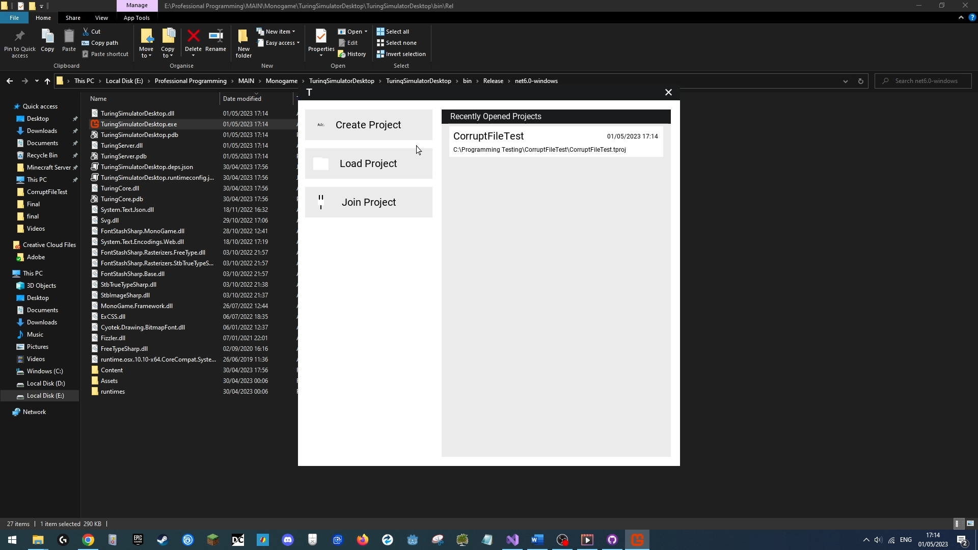

Next we will use file explorer to locate the folder in which the local user data sits in, then open and alter the local user data file to corrupt it.

(Before)

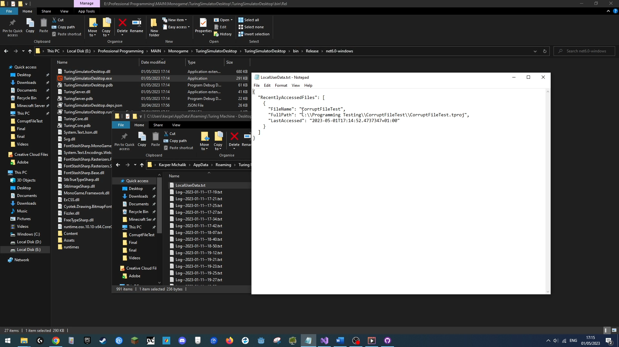

(After)

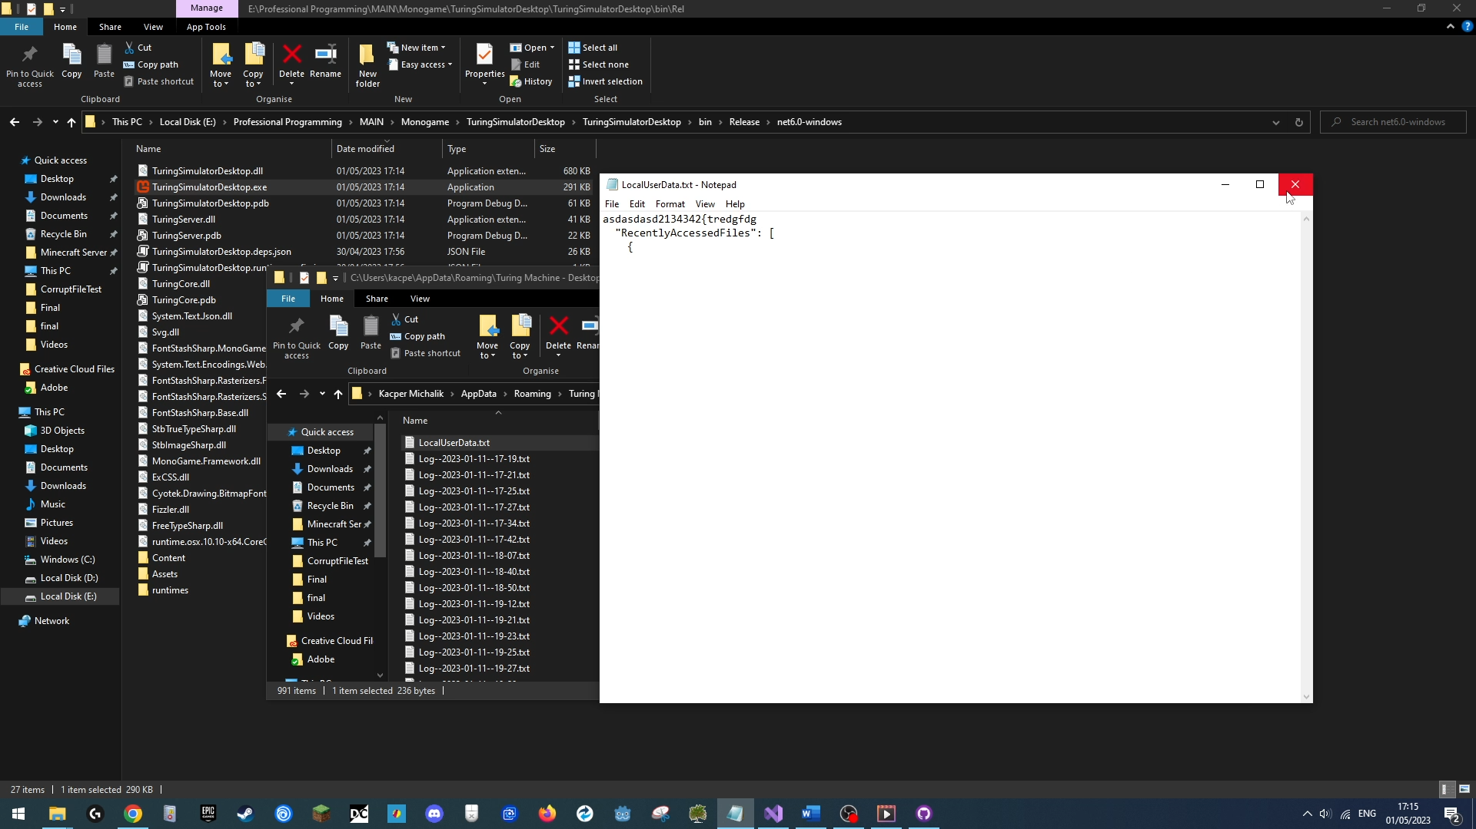

After saving this file we close it and restart our application.

We should expect the application to have booted successfully, simply having not loaded in the user local data, as such meaning an empty recent projects list, but otherwise fully normally behaving application.

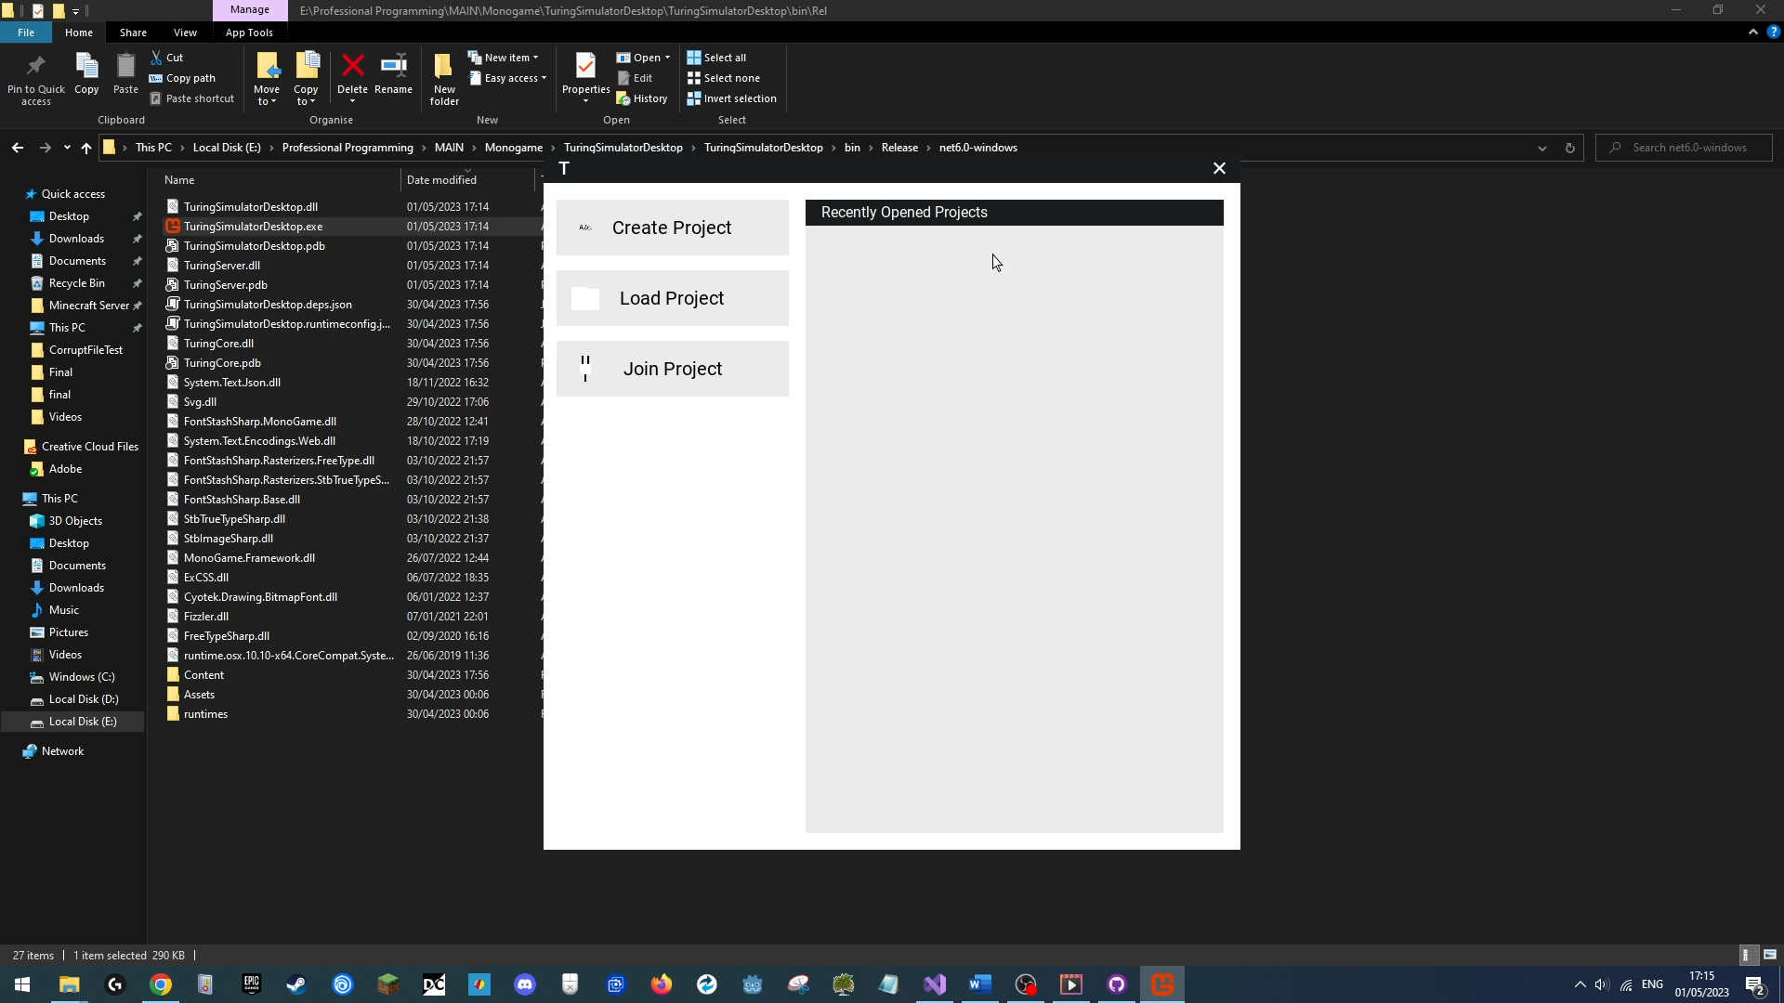

We will also then open the same project using the manual open menu to show that the application still works normally and lets us load in the project.

**Outcome**

|  |
| --- |
| **Success**  The application booted successfully after corrupting the local user data file and let us use the application normally to open up the same project as we did using the quick open menu originally. |

# Evaluation

In this section I will go back to my project sponsor and previously interviewed end users, show them the completed project, and then interview them again on their views whether the result has met their expectations and needs.

## Sponsor Interview

The sponsor of this project is **Mr Maher**, my computer science teacher.

The final questions will be as follow:

|  |  |
| --- | --- |
| **Question** | **Purpose** |
| “What do you think of the end product?” | Gauges general user opinion on final application. |
| “Do you think it has met all your requirements stated in the requirements analysis stage?” | Gauges how well we listened to, worked with and implemented our requirements, and finds specific successes/failures in our process. |
| “Do you think this is a suitable alternative for teaching Turing Machines compared to TuringKara?” | Gauges general user opinion on final application. |
| “How accessible do you think this solution is? | The sponsors long experience in teaching makes them a perfect source for determining for how well we met our objectives of the final product being intuitive and portable. |
| “Do you have any suggestions for improvement of this product?” | Important feedback for future development of the product. |

**What do you think of the end product?**

*The final product suitably demonstrates the working of Turing Machines, gives students the ability to program them and work collaboratively on them, so I would call it a success, seeing the testing shown, it being able to work on multiple OS’s for students to be able to use anywhere is a very good feature and the help menus do meet the information required by the course specification.*

**Do you think it has met all your requirements stated in the requirements analysis stage?**

*One of the features I wanted to see was the graph programming, which unfortunately was not finished, while the requirements in of themselves have been met, the features I was interested in mainly when told about later, is incomplete, so I would call it a mixed result.*

**Do you think this is a suitable alternative for teaching Turing Machines compared to TuringKara?**

*Yes, I think it is an appropriate alternative with the informational menus and template programs the users can see and use.*

**How accessible do you think this solution is?**

*I think it is suitable for all the students I have, the interface is simple to use and has appropriate helpful information, and from a technical accessibility viewpoint, it runs on multiple OS’s and runs well on the low power school computers, meaning it can be used by any students with any computer, overall making it very accessible.*

**Do you have any suggestions for improvement of this product?**

*Yes, I would like to see the graph programming menu finished.*

## End-User Interviews

In the initial requirement analysis, two fellow computer science students were interviewed on their requirements for the projects, these same two will be interviewed again regarding their opinion on the finished project.

The questions will be as follows:

|  |  |
| --- | --- |
| **Question** | **Purpose** |
| “What do you think of the end product?” | Gauges general user opinion on final application. |
| “Do you think this solution engages you and keeps your focus well?” | Relevant to how well we have fulfilled our objectives of the project being intuitive, and being designed for helping users learn. |
| “Do you think this is a suitable alternative for teaching Turing Machines compared to TuringKara & PowerPoints?” | Gauges how well we performed compared to existing/alternate solutions, where outperforming these is important for a new product. |
| “Does this solution perform well enough on your own devices?” | Relevant to how well we have fulfilled out objective of the application being compatible on many devices. |
| “Do you have any suggestions for improvement of this product?” | Important feedback for future development of the product. |

### Interview With Alex

**What do you think of the end product?**

*The final app is definitely an improvement over TuringKara and is much more intuitive to use than other methods I’ve come across so far.*

**Do you think this solution engages you and keeps your focus well?**

*This definitely keeps my attention when I’m using it.*

**Do you think this is a suitable alternative for teaching Turing Machines compared to TuringKara & PowerPoints?**

*As mentioned in the first question, it definitely is an improvement, being able to actually save and use the programs I write for a turing machine and being a lot easier to program in using transitions. The help menus are very informative and useful, but some of the PowerPoints are more concise and as such more suitable I find in certain cases.*

**Does this solution perform well enough on your own devices?**

*Yes, the app runs without a problem on my Windows 11 laptop and on my Windows 10 desktop at home.*

**Do you have any suggestions for improvement of this product?**

*Yes, the graph programming not being fully complete is a bit annoying, as I very much wanted to see that work, too when I worked with Luke on a project, I couldn’t see what files he had open and what he was editing, showing that would be a nice feature.*

### Interview With Luke

**What do you think of the end product?**

*It does its job well, being able to work on some program with Alex was fun and the help menus actually gave me some information I didn’t remember seeing on the PowerPoints.*

**Do you think this solution engages you and keeps your focus well?**

*Yes, it keeps me focused when working on a specific program, there isn’t much that stops my process, having me have to figure out how to use it, like what happened in TuringKara.*

**Do you think this is a suitable alternative for teaching Turing Machines compared to TuringKara & PowerPoints?**

*Yes, it is definitely an improvement over TuringKara, and the help menus give some good information, so I will definitely use it in my revision schedule.*

**Does this solution perform well enough on your own devices?**

*Yes, I had no problem running it on my laptop.* (Windows 10 Device)

**Do you have any suggestions for improvement of this product?**

*Yeah, the graph programming isn’t finished yet, although the transition system does allow me to do everything I required to do so far, what I would want to see in the future though is when I run a program on the Turing Machine, I would want it to generate a trace table of the tape, the TM’s state and head position, which would help me with marking my trace tables in questions I do when revising*

## Interview Summary

Summarising our interviews, we can see the final product has been an overall success. According to them, the final product matches our objectives related to visual design, portability and functionality, meets our sponsors and end users original needs, and beats the current solutions students use, making this product is a viable alternative for future users to turn to.

Despite our successes, there is some critical feedback within the interviews, mainly focused about the lack of the alternative programming method, ad some quality of life features like seeing who is working on what file at a given time. This feedback will be taken into consideration, and possible steps to tackle these issues in our Improvements section.

## Objective Review

|  |  |
| --- | --- |
| **1. Project should simulate classical TM’s** | |
| **Evaluation** | **Justification** |
| This objective has been met as the final product accurately allows for the programming of and simulation of classical Turing Programs. | This is justified by test number 4 proving the TM simulator works exactly as expected on classical turing programs using a real classical program and input/expected output sourced from Wikipedia. The result is further reinforced by test number 5, which while showing non classical Turing programs simulating successfully, necessitates that classical programs run correctly for the former to be true. |

|  |  |
| --- | --- |
| **2. User interface should be intuitive, interactive, and engaging** | |
| **Evaluation** | **Justification** |
| This objective has been met as the product has an intuitive interface using a window based and drag and drop interaction system. All the interviewed users were satisfied with the interface and found it modern and visually consistent. This belief is further reinforced by the end user interviews which confirmed the users found the interface suitably engaging. | This is demonstrated by tests 6, 7, 8, 9 and 10 which all demonstrate the variety of interaction with the UI, and the simplicity of it. Too they demonstrate the consistent interface colouring and styling. The stability tests also display a variety of intuitive UI features, such as automatically correcting invalid inputs, such as in tests 19 or 22, and showing errors through specific input boxes. such as test 17. |

|  |  |
| --- | --- |
| **3. User should be able to visually and/or textually program Turing Machines** | |
| **Evaluation** | **Justification** |
| This objective has been met as the user can create Turing Programs using state transition nodes which can then be textually programmed.  The alternative graph-only programming method has not been fully complete unfortunately, but this is simply an alternative programming method intended for only programming non classical Turing Programs, as such it is not a requirement but an extension, for meeting this objective. | This is demonstrated by tests number 4 and 5, both which demonstrate the state transition programming method being used to successfully create Turing Programs. |

|  |  |
| --- | --- |
| **4. Interface should contain optional educational guides/information on functioning and usage of TM’s** | |
| **Evaluation** | **Justification** |
| This objective has been met as the user can open and read a variety of help menus, which contain A-level specification relevant information, that appear in appropriate contexts in the UI. | This is supported by test number 9, which shows a help menu being opened and containing formatted, easy to read information. |

|  |  |
| --- | --- |
| **5. User should be able to view predefined templates/projects** | |
| **Evaluation** | **Justification** |
| This objective has been met as the user can start a project and program/execute Turing Machines from a template project which they can alter and save.  However, there is only one template project available due to time constraints. | This is evidenced in tests number 3, 7, 8, 9, 10, and 12, where the user creates a template project, and then edits/uses these templates however they want. |

|  |  |
| --- | --- |
| **6. User should be able to save created TM’s for later reference** | |
| **Evaluation** | **Justification** |
| This objective has been met as the user can create and save a variety of files which they can access whenever they want. | This is evidenced by tests 4, 6, 8, and 10, within which you can see the user browse, create, edit, or save files which they then reopen and see preserve their state. |

|  |  |
| --- | --- |
| **7. Project must be portable and capable of running on a low power Windows 10/11, Linux, or Mac OS machine** | |
| **Evaluation** | **Justification** |
| This objective has been met as the product has been tested on a variety of platforms and devices, ranging from school computers, home computers, laptops to operating systems like Windows 10, 11 and Mac OS.  Unfortunately, the program failed to run on the MAC OS device, whilst running on a variety of other Windows 10 and a Linux machine, as such this goal was only met partially. | Success is demonstrated by tests 12 and 13, where test 12 shows the program running on a home windows 10 computer, and test 13 shows the program being run on a virtual Linux (Ubuntu 23.05) machine. From end user interviews we can also know the program runs successfully on windows 11. Test 14 unfortunately shows the program failing to run on a low power Mac OS Laptop, meaning that we only partially met our objective. |

|  |  |
| --- | --- |
| **8. Project must be complete before exam season** | |
| **Evaluation** | **Justification** |
| This project has successfully implemented all features required by the project brief/requirements and met all its other objectives successfully, all having been done so before the 2023 exams.  Unfortunately, the alternative custom graph programming method has not been fully completed due to time constraints, but this is simply an alternative programming method intended for only programming non classical Turing Programs, as such it is not a requirement but an extension, for meeting this objective. | This can be demonstrated by all the tests done, showing that the interface, with the exception of an extension feature, is fully usable, handles unexpected inputs correctly, and gives the user all functionality that could require. |

|  |  |
| --- | --- |
| **9. Project should simulate non-classical TM’s** | |
| **Evaluation** | **Justification** |
| This objective has been met as the user can create non-classical Turing Programs which execute successfully. | This is demonstrated in test number 5 which demonstrates non classical Turing Programs having been created using state transitions, which utilise wild card symbols, running successfully. |

## Improvements

**Finishing Extension Programming Method**

The biggest improvement that could be immediately seen by all users, and supported so from the end user interviews, is the alternative Turing machine programming methodology, that being the custom graph one.

This method would allow a more in depth programming method for non-classical Turing Machines than the transition based programming one, allowing users to make a Turing Machine behave in more ways, for example move a multiple number of places only or writing a list of values to the tape when performing an action, too it would be visually more intuitive as all action would be drawn as nodes and connected using arrows.

**Fixing Mac Compatibility**

The second big improvement for this program is fixing it in order to run on MAC OS, since the regular single executable export method does not seem to work on MAC, MonoGame offers compiling natively for MAC OS, but this requires additional manual work to then package the resulting program into the appropriate .app package that MAC OS can recognise and then run. Learning how to properly setup the application in .app format will be important to allow future compatibility with Mac OS as to meet our goal of portability.

**Internet Browser Specific Compatibility**

One of the important design considerations of the project from a technical standpoint was the ability for multiple front ends to be used with the backend, one of the most important being a future web-based frontend.

Web browsers unfortunately aren’t compatible with other networking protocol, instead only allowing for HTTP messaging and no pure TCP socket communication, this was only discovered after the networking system was already designed and implemented, as such currently when a web browser wants to communicate with the backend, the web server that would serve the web page/interface would additionally need programmed on top a method for translating HTTP messages from the web clients into appropriate equivalents in our protocol for the web clients to be able to interact with the backend, while this works and satisfies our needs, this is not ideal.

An improvement here is to rewrite out networking protocol to use HTML messaging, which would allow web browsers to directly communicate with our back end, other front ends can easily also implement HTML messaging, making it universally compatible.

**Platform Specific Features**

Adding platform specific features would be a large improvement, currently only windows users can use the native OS file browser to quickly open projects in the create/load project menus, Mac and Linux users must currently manually type in or copy paste the path on disk into these spaces. Adding these OS specific features would a large quality of life improvement.

**Tooltips**

Adding tooltip-based information would be a further improvement upon the help menu the interface currently implements. These would serve as more compact but quick to use bits of information that would improve the quality-of-life for users and make the interface more intuitive, which was one of the main goals this project strived for.

**Adding More Templates**

Due to time constraints, the number of temple programs and example tapes available was heavily limited, in the future adding more such templates and labelling them with additional information may help the pace at which the users understand the example programs and themselves learn to create their own Turing Programs.

**Trace Table generation**

As requested by the user interviews, a very useful feature that I had overlooked in the design phase of the project is a trace table generating feature, where whenever a user executes a Turing Program, not only would the turing machine execute it visually, it would create a trace table visually or as a text file for the user to then be able to access and use, for example in marking trace tables they do in past exam papers questions when revising. This feature would be very useful to students using the product.

**Improved Collaboration**

As demanded by the end user interviews, making it visually clearer when other users are accessing or editing a file is a very important improvement for the interface in the future. This may come in the form of when joining a project picking a user colour and username, which then may be displayed as a small icon or tooltip on files that person is currently editing, and making it so that when a file is opened and being edited, the other users don’t only see the file change when save was hit, but see changes with every actual action made by other users.

## Summary

Concluding, I believe this project to be a huge success. The end product I created, despite having some hiccups in the process such as incomplete feature, or failing to work on Mac OS, meets in at least partial success all objectives and requirements that were initially set out in the analysis stage, and personally I am very satisfied with the quality of the design created. The end users of this product have been impressed with its features and are happy with its usability.

This project itself has taught me a great amount of information, be it learning about networking, networking protocols and their implementation, graphics rendering, and features of the languages I use, be it about function pointers in C# or asynchronous communications, or vital industry knowledge such as understanding how to work with version control, specifically with GitHub, which was vital to the development of this project, and will be very important in my future career.

This project has thoroughly interested me and after exams I hope to return to it and implement a variety of improvements mentioned previously and want to deliver a great product that future students will use for a long period of time.